INTRODUCTION

Too often the most important missing element in development programs was genuine (two-way) communication between the decision makers, the experts, and the so-called beneficiaries to bring about meaningful and sustainable results. Two-way communication, used to understand, assess, explore, and facilitate decision making related to change, combined with the effective use of one-way communication approaches, has been proven to significantly enhance results and the sustainability of development initiatives. Media, no matter how technologically advanced, messages, no matter how skillfully packaged and information, no matter how relevant, are not enough to bring about meaningful and sustainable results. These results can only be achieved if the people involved (stakeholders) are part of the process leading to change. Development Communication which is conceived as an inter – disciplinary field not only facilitates effective dissemination of information but also uses empirical research and two-way communication among stakeholders for sustained and meaningful change. In this context, the present seminar has been conceptualised with the following objectives :

1. To conceptualise the evolution of interdisciplinary field of Development Communication and provide an overview of the main theoretical frameworks.
2. To study the wide range of methodological and practical applications of development communication.
3. To document the way development communication is positioned and applied at the World Bank.
4. To review related case studies.

CONCEPT OF DEVELOPMENT COMMUNICATION

The term “development communication” was first coined in 1972 by Nora C Quebral, who defined the field as:
“The art and science of human communication linked to a society’s planned transformation from a state of poverty to one of dynamic socioeconomic growth that makes for greater equity and the larger unfolding of individual potential.”
Among the various definitions of development communication, the following two provide a consistent understanding of the boundaries that define this field of study and work. The first is derived from the Development Communication Division of the World Bank (DevComm), which considers development communication as an interdisciplinary field based on empirical research that helps to build consensus while it facilitates the sharing of knowledge to achieve positive change in development initiatives. It is not only about effective dissemination of information but also about using empirical research and two-way communication among stakeholders. It is also a key management tool that helps assess sociopolitical risks and opportunities. The second definition emerged at the First World Congress of Communication for Development, held in Rome in October 2006 in which the more than 900 participants of the Congress agreed to conceive it as a social process based on dialog using a broad range of tools and methods. It is also about seeking change at different levels, including listening, building trust, sharing knowledge and skills, building policies, debating, and learning for sustained and meaningful change. It is not public relations or corporate communication.
REFLECTIONS ON THE THEORY AND PRACTICE OF DEVELOPMENT

The theories and practice of development communication sprang from the many challenges and opportunities that faced development oriented institutions in the last century. Since then, different schools of development communication have arisen in different places over time (Manyozo 2006). These schools include the Bretton Woods School being the dominant paradigm in international literature and the other schools being the Latin American, Indian, Los Banos, African and participatory development schools. Leading theorists of the dominant paradigm were Daniel Lerner, Wilbur Schramm and Everett Rogers. The paradigm advocated the production and planting of development communication in indigenous and uncivilized societies. The African school of development communication on the other hand, sprang from the content’s post-colonial experience. Africa saw the use of radio to promote educational, health and agricultural development especially in francophone countries. With support from FAO, some development programmes in Africa have used participatory communication approaches such as Participatory Rural Communication Appraisal (PRCA) to enhance project results and sustainability (Mayonzo 2006). The Asian School of thought on the other hand, spearheaded by the University of Philippines, Los Banos (Guebral 1972), introduced the concepts of extension, cybernetics approach, participatory development and community participation in development communication.
Since World War II, there have been three theoretical approaches dominating the development context and, consequently, the field of development communication :

- MODERNIZATION PARADIGM
The modernization paradigm arose soon after World War II. It envisioned development as a challenge to bring the “underdeveloped countries” out of their conditions of poverty by modernizing them and by promoting economic growth spurred by free-market approaches. The best way, if not the only way, to achieve these goals consisted in the diffusion and adoption of the values, principles, and models that ensured the success of the way of life in wealthier countries. The modernization paradigm promoted by political scientists and scholars of Western countries became so strong and so pervasive in every dimension of social life that it became also known as the “dominant paradigm.”

Within this paradigm, the conception of development is a linear one based on trust in science, reason, technology, and the free market. The main role of communication was to persuade people to embrace the core values and practices of modernization. Communication in the dominant paradigm is basically associated with the linear, mass media model aimed at transmitting information and messages from one point to another or many others, usually in a vertical or top-down fashion. This idea was rooted in the strong belief in the persuasive power of media, especially until the 1970s. Development communication was associated with the use of media to persuade people to achieve, maintain, and strengthen development goals, and media’s role was paramount. UNESCO, for example, considered media to be a crucial means for promoting changes, and in the 1960s, it provided guidelines about a country’s desirable per capita consumption of television sets, radio receivers, newspapers, and cinema seats. This heavy emphasis on media was owing to the belief that this form of communication, when used properly, was capable of changing people’s mindsets and attitudes. In 1948 Lasswell provided a blueprint to decision-makers and managers on how to use communication to persuade audiences to change behaviours. Its model can be summarized in the following five questions: WHO, says WHAT, in WHICH channel, to WHOM, with what EFFECT. Until the late 1980s, most development institutions conceived and applied communication primarily for the dissemination of information and adoption of innovations. The emphasis placed on tangible communication products neglected the potential of communication as a dialogic, cross-cutting investigative tool.

- DEPENDENCY AND WORLD-SYSTEM THEORIES
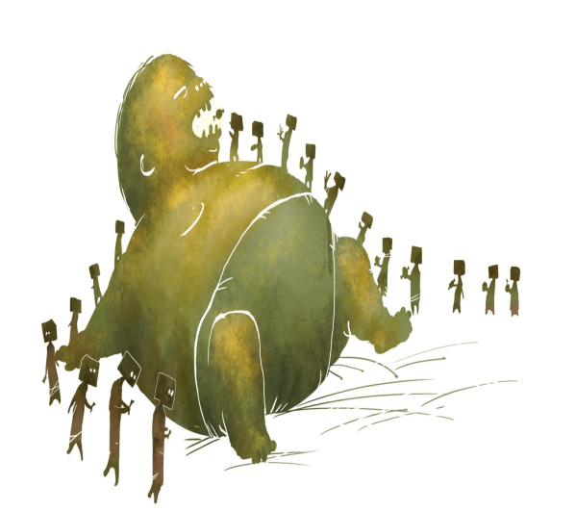
Latin America was the place where, the dependency theory originated. This is another example of a major alternative theoretical framework that is rooted in a political-economy perspective. One of its founding fathers,A.G. Frank (1969), reflected critically on the assumptions of modernization which placed full responsibility and blame on developing countries for their conditions of underdevelopment. On the basis of a structural analysis of the international capitalist system, he considered development and underdevelopment as two faces of the same coin, shaped by specific historical, economic, and political factors. Hence, neither the causes nor the solutions of underdevelopment should be sought exclusively, or even mostly, within the poorest countries, but within the broader international scenario and forms of exploitation such as the richest countries’ colonial past.
Dependency theory claims that the imbalances in the world’s state of affairs were mainly owing to the international division of labor and to the continuation of past patterns of domination. The world was separated into two blocs: the core, composed of a few rich countries, and the periphery, composed of many poor countries. According to this perspective, core countries took advantage of their technological knowhow, superior infrastructure, and economic power to strengthen their lead. The main role of the peripheral countries was restricted to that of supplying raw materials and cheap labor to the richer ones, making it impossible for them to ever catch up.

Dependency theories are also criticized for how little attention they paid to the differences in political-economic status among developing countries, resulting in big and potentially rich countries such as Brazil or India being put in the same category as much smaller and poorer ones. Wallerstein’s world-system theory, while remaining within the dependency perspective, addresses this key concern and provides a more appropriate representation of international relations. Wallerstein, the main thinker behind this world-system theory, addresses and refines the major flaws of the theoretical model of dependency by adopting a more holistic approach, encompassing national and international dynamics within a unified world system. His historical analysis puts the origin of the modern world system in the 16th century. This world system, based on capitalism, is divided into a core, dominated by a few rich countries; a periphery, inhabited by the many poorer countries in Africa, Asia, and Latin America; and a semi-periphery, including major countries such as Egypt,Mexico, Brazil, India, and others, with higher levels of resources than the majority of developing countries. This intermediate layer, the semi-periphery, addresses the criticisms received by dependency theorists for the oversimplified division into two spheres of rich and poor countries.
The proponents of the dependency theory vigorously supported rethinking the communication agenda along the lines of a more balanced flow of communication at the international level. Yet, at the national level, they often neglected to consider the horizontal component of communication within countries and failed to giveproper attention to the potential of privately owned media and community media. While arguing against the “free-flow” argument proposed by the United States and its allies, the “dependentistas” remained rooted in the classic media-centric conception of communication, mostly from the state perspective. Despite significant differences between modernization and dependency theories, their communication model was basically the same - a one way communication flow, with the main difference between the two theories being who was controlling and sending the message and for what purpose.

- THE EMERGING PARTICIPATORY PARADIGM
The search for a different and better vision in development practices is currently linked to people’s participation and empowerment. Participation is a concept that has been gaining increasing recognition and prestige in the development discourse and its practices. Participatory approaches require a shift in the way individuals are considered, from passive recipients to active agents of development efforts. Common features of this perspective are the emphasis on people, the endogenous vision of development, and the attention to power and rights issues. Development efforts have been refocused to increasingly engage stakeholders and pay attention to aspects of social life previously neglected (culture, education, and so forth). The new priorities, well beyond the economic dimension are reflected in the Millennium Development Goals, or MDGs, adopted in the 1990s by the United Nations and other development organizations as key challenges to be addressed successfully. In addition to poverty reduction, they include objectives in education, gender equality, and health issues. Most development priorities are outlined within political frameworks based on the adherence to good governance and democratic principles (for example, freedom and human rights), and people’s participation is also key in this context.
There are many reasons for the adoption of participation in development, some of which relate directly to the enhancement of project results.As early as 1982,White summarized the major reasons for the adoption of this approach in development initiatives :
(1) services can be provided at a lower cost
(2) participation has intrinsic values for participants, alleviating feelings of alienation and powerlessness
(3) participation is a catalyst for further development efforts
(4) participation leads to a sense of responsibility for the project
(5) participation ensures the use of indigenous knowledge

Mefalopolus identified four types of participation :
(1) Passive participation - when stakeholders attend meetings to be informed
(2) Participation by consultation - when stakeholders are consulted but the decision making rests in the hands of the experts
(3) Functional participation - when stakeholders are allowed to have some input, although not necessarily from the beginning of the process and not in equal partnership
(4) Empowered participation - when relevant stakeholders take part throughout the whole cycle of the development initiative and have an equal influence on the decision-making process.

The newly appreciated horizontal model of communication opens up new spaces for dialog among stakeholders and facilitates the exchange of knowledge, empowering people to participate actively in the process affecting their own lives. In this perspective, media are no longer the central element of communication, but one of the tools to be used according to the circumstances. The linear communication model loses part of its pervasive dominance and is complemented by a simpler, at the same time also more complex, two-way circular model where the sender is at the same time the receiver and vice versa. The combination of these elements in the emerging development paradigm is shifting the focus from media to people, from persuasion to participation.

COMBINING THEORY WITH PRACTISE : THE MULTITRACK MODEL
This model combines different approaches within a flexible framework that is particularly effective in development projects and programs. Its theoretical roots are grounded in the two-way dialogic mode, but it also incorporates monologic approaches and methods. The theoretical conception of the multitrack model considers communication fundamentally as a horizontal and participatory process, at least in the crucial initial stages, where issues and priorities are assessed and defined. It also acknowledges that in development there are information gaps and areas of needed change that can be effectively supported by approaches linked to the linear flow of monologic models. In the multitrack model, the monologic approaches, or communication tracks, are to be used only after the horizontal communicative process occurs and determines the objectives of the intervention in a participatory way.
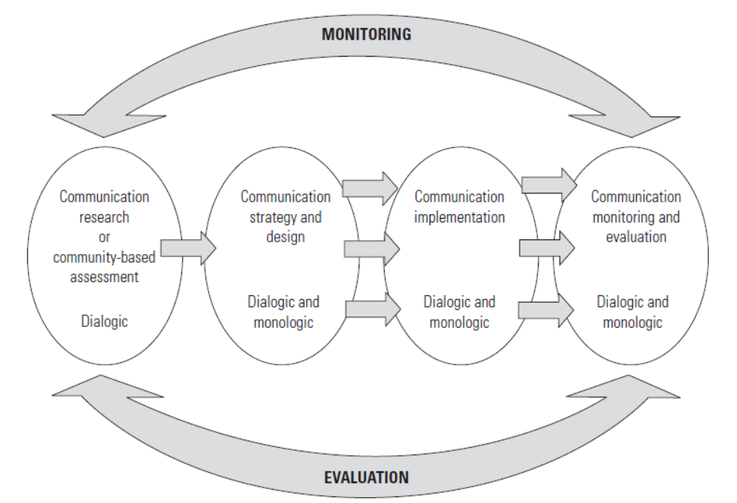
To conclude, the multitrack approach combines the theoretical potential of the two main communication perspectives with their great range of practical applications. It uses two-way communication in the research phase to engage stakeholders who are investigating key issues and defining objectives.

Figure 1 illustrates the model. The single arrow linking the research phase with the strategy design phase indicates the requirement of always using the dialogic mode at the beginning. From the second phase a number of different approaches in any (or a combination) of the two modes can be applied based on the situation— hence the additional arrows. Monitoring and evaluation, while positioned as the last phase, should also be considered at the start to be effective—as indicated by the peripheral arrows at the top and bottom.

BASIC PRINCIPLES OF DEVELOPMENT COMMUNICATION

Dialogic—Dialog is the heart of the new communication paradigm. The professional application of dialog, the two-way model of communication, is widely endorsed by most development institutions and should be the basis of any initiative. Development communication should foster dialog to facilitate mutual understanding, to assess the situation, and to seek wider consensus. Dialogic approaches guarantee that relevant stakeholders have their voices heard and that project priorities are aligned with people priorities. Professionally directed, dialog is an invaluable research tool and is absolutely to build trust, optimize knowledge, minimize risks, and reconcile different positions.

Inclusive—Inclusion is a first step in any situation analysis, to identify, define, hear, and understand relevant stakeholders. Omitting a group from the assessment on a basis that might not seem relevant can cause problems further along and can increase the risk factors in the successful achievement of the intervention.Two-way communication should always pay special attention to groups that are marginalized or at a disadvantage in society. Gender issues are always a primary concern in this context, as well as issues related to the poor, or any other vulnerable group.

Heuristic—The investigative use of communication to discover or solve problems during the initial phases of a development initiative is essential. Communication is often defined as a way of sharing meanings or “as a process in which two or more people share information and converge toward mutual understanding, mutual agreement, and collective action” (Yum 1989). This definition denotes the sharing of information and knowledge, which usually generates more knowledge that in turn can lead to effective collective action.

Analytical—Going beyond communicatin. A large amount of work, such as the assessment of political risks and opportunities, is analytical. In this context, the communication function is not about relating messages but about uncovering and generating knowledge to design better projects and programs that lead to sustainable change. The effectiveness of diffusion and dissemination activities depends significantly on how appropriately the analytical work is conducted and how effectively people are empowered to voice their perceptions and opinions.

Participatory—While rarely employed in practice to its ideal and fullest extent, participation is applied in different degrees according to the intervention. Its relevance is echoed in virtually all development organizations and communities, at the national and international levels. Only genuine communication can facilitate effective participation, especially in its most advanced forms. The Johari Window is a tool originally developed by Joseph Luft and Harry Ingham (hence the name) to better understand human interactions and communication. It also is used to map interaction leading to change at a broader level, highlighting the value of a participatory approach in communication (Anyaegbunam et al. 2004). The window illustrates the process that starts from common knowledge shared by both parties (that is, community and project) and aims to address the unknown by combining and applying knowledge exclusive to each group.

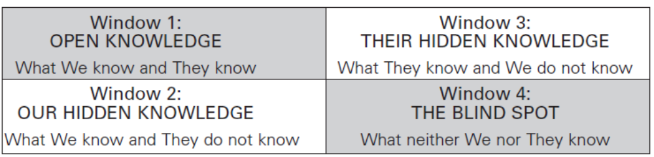

For simplicity’s sake in this context, the term “They” refers to the various groups of external stakeholders (for example, Bank specialists, consultants, and so forth), while “We” refers to local stakeholders (for example, citizens, community groups, civil society organizations, and so forth). The first window describes the time and space where outside experts and other local stakeholder groups begin to interact, making sure that they understand each other. Window two is where local knowledge is disclosed and accepted. Next it is the turn of the outside experts to disclose their knowledge by exchanging notes with other stakeholders in window three. Finally, the last and more critical part of the process occurs in window four, the blind spot, representing the problem to address or the intended change.

Contextual—There is no precooked universal formula applied a priori in development communication. Even if the overall process of a communication intervention (that is, executing communication-based assessment, designing communication strategies, and implementing and evaluating related activities) is consistently similar, the tools, content, and modes of applications vary significantly according to the specific situation.

Persuasive - The renowned Greek philosopher Aristotle considered it as an effective way to communicate. In development communication, persuasion can be used to induce voluntary changes in individuals. Healthy two-way persuasive approaches ensure that the best available options among the various parties are considered and agreed upon, leading to sustainable change.

METHODOLOGICAL FRAMEWORK OF DEVELOPMENT COMMUNICATION
The methodology of development communication programs can be divided into four stages, or phases, each of which builds on the previous one but maintains its own specific scope, methods, and set of tools. The pyramid in figure 2 illustrates the four phases of development communication and represents not only their sequence but also their relevance in achieving the expected results. The physical area in the pyramid also represents the importance, workload, and time needed for each phase within the overall methodological process. The foundation of the pyramid, or the research phase, constitutes the broadest and most important part of the whole; it is from this base that the strategy is rooted and, subsequently, all activities are implemented and evaluated. The amount of work and resources invested in the research phase is a significant factor in the achievement of the communication objectives at the top of the pyramid.

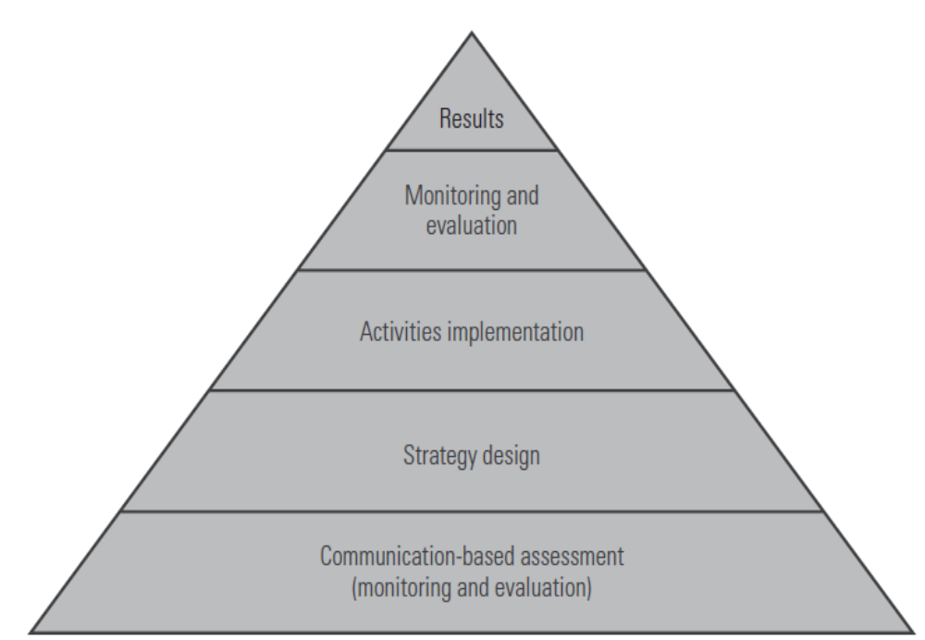

- COMMUNICATION BASED ASSESSMENT

Communication-based assessment, or CBA, offers a comprehensive investigation of a situation and should be the first step of any development initiative, regardless of the sector. Given its interdisciplinary and cross-cutting nature, communication-based assessment is of particular value in exploring and assessing the overall circumstances, building trust, and minimizing sociopolitical risks. CBA addresses the what, who, and why of each situation investigated by involving all relevant stakeholders. CBA is, most of all, a type of field research. A CBA identifies, refines, or validates the causes and differences in the positions and perceptions of the groups relevant to the development initiative. This crucial information can address and prevent possible problems and diffuse potential crises through appropriate channels, messages, or methods, contributing to successful outcomes. it should be emphasized that communication-based assessment is not simply a tool, but a set of methods and tools to assess the development situation and to engage relevant stakeholders in key issues related to the intended change. It is instrumental in providing the inputs needed for the communication strategy design.
In CBA the first part of the analysis usually focuses on the “why”of the situation. This is done through qualitative techniques such as interviews, focus groups, and rapid diagnostics. The second part is expected to probe deeper, addressing the “what” and “how much” of the circumstances, in order to triangulate the initial findings and to quantify them. Opinion polls and surveys are some of the tools frequently used to this end.

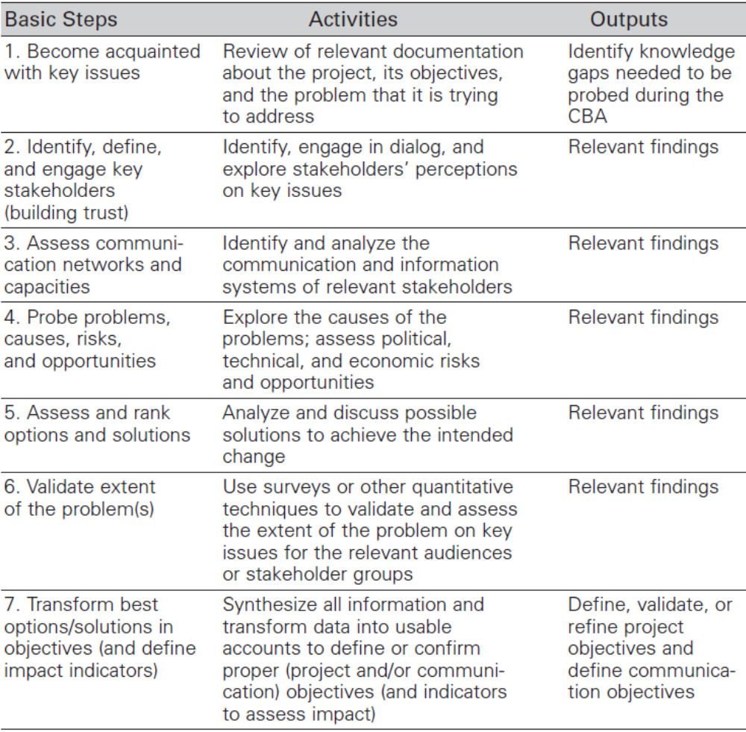
Tools used for CBA

PARTICIPATORY RURAL COMMUNICATION APPRAISAL
Different from the other tools in this section, participatory rural communication appraisal, or PRCA, is not a specific tool or technique but rather a practical methodological approach that includes a set of methods and techniques to address a wide range of research situations, including those involving stakeholders with limited, or a lack of, literacy skills. Because a PRCA has a strong participatory connotation, it is particularly appropriate for community driven development projects and other programs with a high emphasis on people’s participation. PRCA was first developed in Africa to fill a gap that emerged during the initial phase of a project meant to promote the use of participatory communication in the Southern Africa Development Community (SADC) region.
PRCA can be defined as an empowerment communication research approach, based on dialog. It involves people, especially rural people, in the decision-making process to design effective strategies to address their problems. Capacity building and individual empowerment are two of its major concerns, but these are attained while dealing with specific, practical issues addressed by communication. Four sequential phases in PRCA are :
- to warm up, get to know each other and build trust among stakeholders
- to know the community better and to be acquainted with stakeholders’ perceptions and their preferred information channels and communication resources
- to assess the situation (that is needs, opportunities, problems, and solutions), prioritize problems, and address the main causes
- to identify the best options and opportunities that can be addressed through communication.

The techniques and tools that can be used to achieve the above objectives are numerous. The following list highlights some of the most renowned tools.
- Sketch Map
- Transect Walk
- Time lines
- Seasonal Calendars
- Problem Tree
- Ranking
- Livelihood map
- Venn Diagram

- COMMUNICATION STRATEGY DESIGN
The following example illustrates and clarifies some of the key issues involved in the logical organization of strategy design, which must always begin from a clearly defined objective. A major conservation project in one of the world’s principal forests has been implementing a multifold strategy to maintain and protect certain areas of that forest. A communication specialist was called in to assist on a specific component, dealing with a major problem—the destruction of significant parts of the forest caused by farmers who burn their fields at the outskirts of the protected area. The project manager asked the specialist to devise a strategy to eliminate, or at least greatly reduce, this problem based on the data available. Table shows the simplified analysis of the situation presented to the communication specialist.

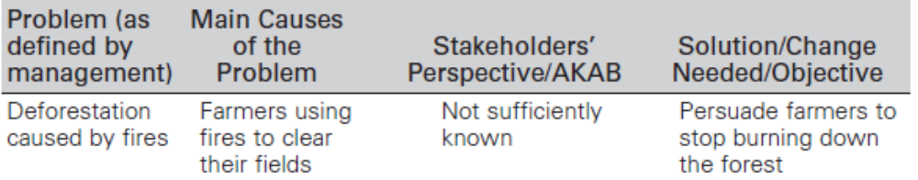

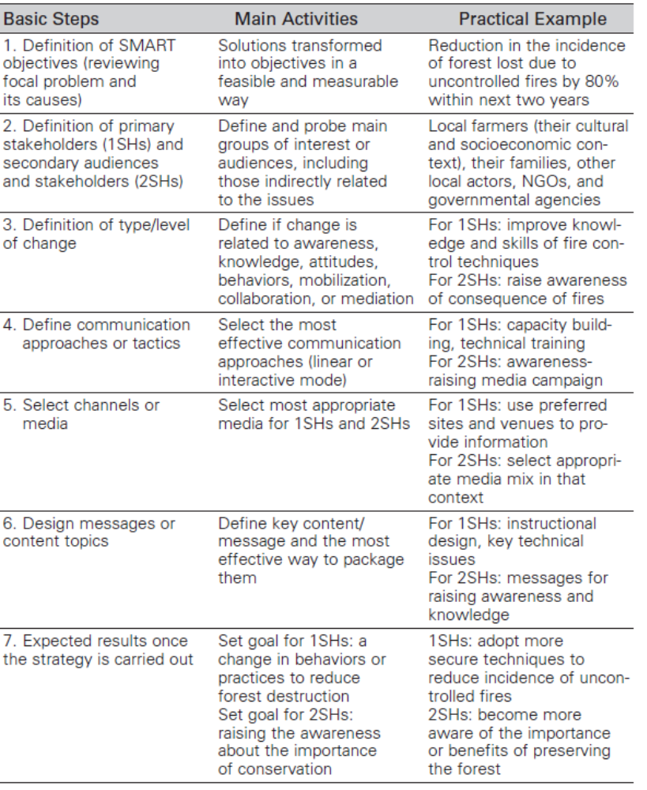
The communication strategy design phase is the most creative one, and, because of that, it is not possible to define a one-size-fits-all formula for it. Nevertheless, there are some methods and steps that help in designing and managing an effective communication strategy. A method frequently used by DevComm is known as the Five Management Decisions. This Five Management Decisions (FMD) template is of particular value in managing and monitoring initiatives with straightforward objectives requiring clearly defined behavior changes in the monologic/diffusion mode. The template is used as a tool to strengthen the understanding of the main elements forming a communication strategy. It addresses five basic communication concepts, closely resembling the Lasswell (1948) five question model: WHO, says WHAT, in WHICH channel, to WHOM, with what EFFECT.

- IMPLEMENTING THE COMMUNICATION PLAN
This phase encompasses the activities necessary to implement the work plan (for example, design of communication materials, training of relevant staff, and so forth) and to produce and distribute media and information products. This part of the process is the most resource-intensive in both human and financial terms, but it is not necessarily the most crucial phase. If the work in the previous two phases was done properly, the implementation is the most straightforward phase, needing only the professional application of tasks and competencies identified to ensure the achievement of the objectives. Usually this is done through an action plan, which can be considered a map indicating what needs to be done, by whom, when, and at what cost.

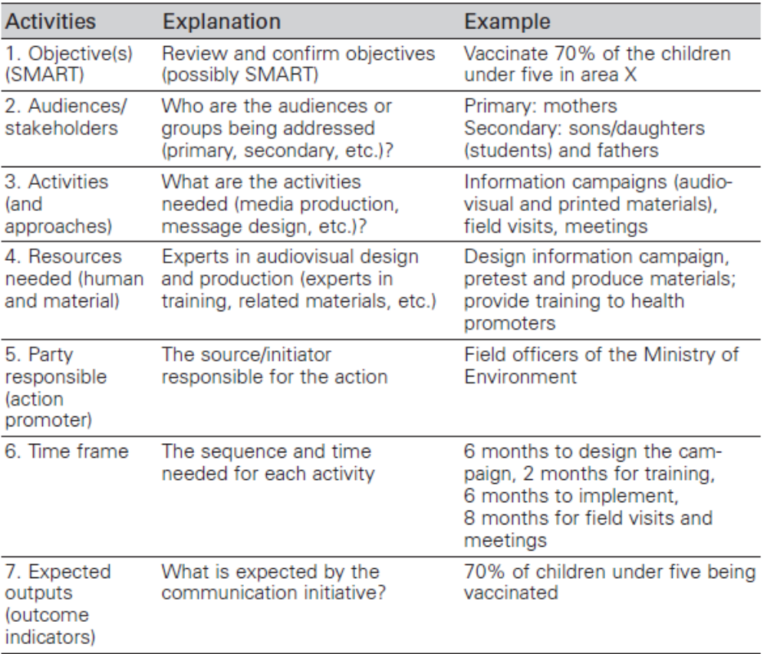

The steps involved in implementing the communication plan includes:

- Setting the communication objectives
The communication objectives (possibly expressed in SMART form) constitute the “North Star” of the strategy when drafting the action plan, thus shaping the activities to be implemented. The action plan should state clearly who is responsible for each activity and what is the expected outcome once the activities are implemented. In other words, the action plan is a way to organize and enhance the management and implementation of decisions taken in the design of the strategy.

- Pretesting the communication material
Most important, communication specialists should always pretest the materials being produced, no matter how well done they are and how carefully they are revised by other experts. Pretesting should be conducted with pilot groups and representatives of the intended populations before reaching the stage of mass production.

- Putting the Pieces Together: Drawing Up an Action Plan
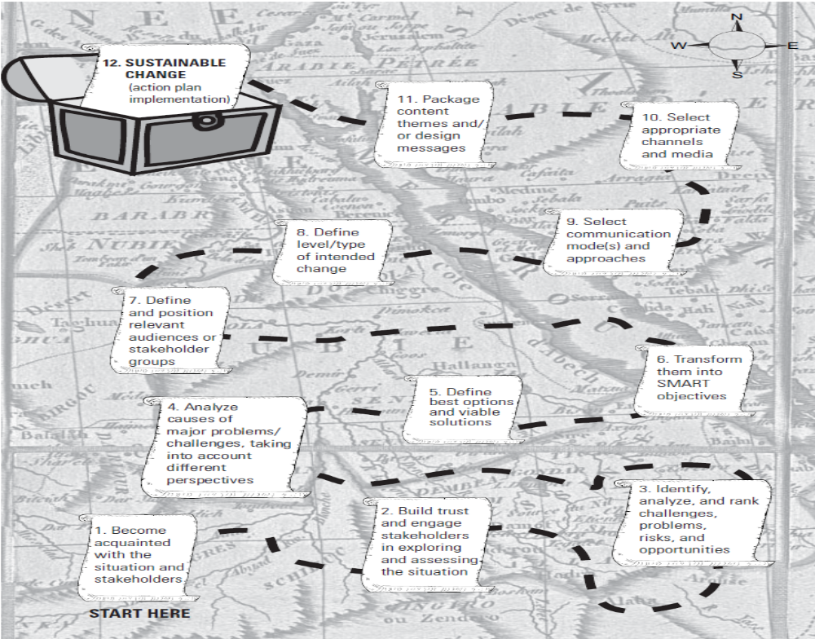

- Communication for monitoring and evaluation
Evaluation can be defined as the process of determining whether, and to what extent, a certain intervention has produced the intended result (Babbie 2002). Evaluation is considered one of the most important components of development initiatives. Evaluation is usually divided into formative evaluation, also referred to as monitoring, and summative evaluation. The first, formative evaluation or monitoring, assesses the work in progress, checking that the design and implementation of the activities remain in line with the objectives and relative planning. The other type, summative, is concerned with measuring the final impact of the intervention, and it is referred to in a number of ways in the literature, such as summative, research evaluation, program evaluations, or, more simply, evaluation. In 2005, the World Bank, in collaboration with other partners, sponsored an e-forum on measuring the impact of communication for development. It confirmed the following reasons for evaluating the impact of communication:
• Assessing the role of a particular project or process in contributing to a development
project or social change
• Gaining advocacy with decision makers
• Refining and fine-tuning the process of implementation
• Learning from past mistakes, what has worked and not worked
• Ensuring a positive process for the community and the stakeholders
• Ensuring good management and accountability to donors and decision makers
• Making continued funding possible
• Improving research and evaluation methods and approaches

Evaluation is always concerned with measuring change in its various forms: behavior, social, and structural. If the goal of development is to improve people’s quality of life, evaluation will need to assess if such an improvement took place. The crucial point in this respect is to define what is meant by quality of life and what are the best indicators to measure it. Indicators are units of measurement, used to assess change. They help provide the rigor needed to evaluate the results in a reliable manner. Indicators can be of quantitative or qualitative nature.When the aim is to gain community support toward decentralization, the indicators could still have a quantitative connotation and be focused, for instance, on the knowledge level; that is, how much do citizens know about decentralization and about what is required to achieve it. To address the qualitative dimension involving the realm of attitudes and practices, the indicator could be defined as people’s engagement in decentralization activities, which needs to be identified and clearly operationalized.

Traditionally, research in evaluation design has been divided primarily into three broad categories, each of which contains a number of different specific designs clustered around a core set of principles.
Experimental designs usually require the study of two population samples, selected through rigorous randomization methods. The first, the treatment group, is subjected to the intervention, while the second, the control group, is not. Hence, the difference in the specific issue being studied should measure the impact of the intervention, assuming that all other variables are considered. Accounting for all variables in a social setting is a nearly impossible task, which is why this research design is effective in tightly controlled laboratory situations but has proved to be not as effective in less controllable social environments.
Quasi-experimental designs differ from experimental designs primarily in their lack of random assignments to the treatment and control groups. Control groups can be chosen in ways that are less rigorous and demanding, thus reducing the costs. On the other hand, this also reduces the reliability and accuracy of the measurements and increases the problem of the selection bias.
Qualitative research designs, sometimes referred to as non - experimental designs, are less structured and pay more attention to qualitative issues than quantitative ones. They are particularly valuable in identifying and assessing issues not easily measurable, such as participation, empowerment, or accountability. They are also valuable in providing insights that can later be triangulated and assessed more precisely by quantitative methods. Qualitative methods appear to be most useful in understanding and interpreting a situation, while quantitative methods appear to be better in measuring the extent of that situation. According to Babbie (2002), “the most effective evaluation research is one that combines qualitative and quantitative components.”

DEVELOPMENT COMMUNICATION SERVICES AND EXPERIENCES AT THE WORLD BANK

DevComm is a Division in the External Affairs, Communications and United Nations Affairs Vice-Presidency. Primary clients are Bank operational staff and client country personnel. It works in 18 languages, delivering programs in 7 languages. There are four units in the Division:
- Operational Support
- Sustainable Development in Operations
- Knowledge and Capacity Building
- Public Opinion Research
Its main goal is to enhance the design and the impact of operations through the professional use of development communication. The following are DevComm’s main goals:
• Strategically integrate communication components into operations to mitigate nonfinancial risks and maximize development outcomes
• Explore and assess stakeholders’ motivations and perceptions toward reforms and other development initiatives, using two-way communication approaches, public opinion surveys, and other empirical research methods
• Strengthen development communication capacities among clients and Bank staff to enhance results
• Build global partnerships in development communication

These objectives are reflected in the services DevComm provides to regions, sectors, specific operations, and client countries within the World Bank framework and with external partners. In the beginning, such services were restricted to a handful of projects in a few countries. Within a few years, the demand for these services grew steadily, and an inventory taken in 2004 indicated that DevComm was working on 93 projects in a wide range of different sectors, as indicated in figure. Another snapshot taken two years later revealed that DevComm was now involved in 126 projects.
155

DevComm SERVICE LINES
DevComm bases its functions on a demand-driven model with service lines devoted to World Bank priorities: (1) communication in operations, (2) public opinion research, and (3) knowledge and learning.

- Communication in Operations concerns the application of communication approaches and methods for behavior and social change in development projects, reform programs, and economic and sector work in support of World Bank initiatives. DevComm is actively involved in more than 100 projects a year in various sectors and areas, such as environment, infrastructure, public sector governance, health, and social development. Because of the increasing relevance of development communication,DevComm has received a number of trust-fund donations from donor countries to augment its capacity, to focus on specific areas of work, and to effectively address the growing demand for its services. Two of these funds led to the establishment of thematic units within the division. The Communication for Sustainable Development in Operations (DevComm-SDO) Unit was the first in the division to be supported by a trust-fund donation. This unit was established in 2001, and it was consolidated in 2002 with a contribution from the Italian Ministry of Foreign Affairs. The other major trust-fund donation was made by the United Kingdom Department for International Development (DFID), which is the original donor to the Communication for Governance and Accountability Program (CommGAP). CommGap was launched in 2006, and it is currently funded through what has become a multidonor trust fund of several million dollars.

- The Communication for Governance and Accountability Program (CommGAP) seeks to promote good and accountable governance through the use of innovative communication approaches and techniques that strengthen the public sphere.
- The Communication for Sustainable Development in Operations Unit (Dev- Comm-SDO) was created in 2001 with a mandate to mainstream development communication into development projects and programs.

- The Public Opinion Research Unit conducts analysis on a global, regional, sectoral, and project level. This research creates valuable knowledge about perceptions on relevant issues, provides strategic guidance for development initiatives, and improves operational outcomes. About 30 polls per year are designed, delivered, and integrated into the World Bank strategic planning.

- The Knowledge and Learning Unit activities help Bank staff, governments, and local partners build capacities in communication, strengthening knowledge and skills in communication-related aspects. DevComm Knowledge and Learning Unit has a menu of core courses and also develops and delivers training programs customized to clients needs for specific projects and programs.

THE WORLD OF PRACTICE : SOME EXPERIENCES

- Communication for better public services

An often-told story is that of the Ugandan newspaper campaign which encouraged schools and parents to monitor a large-scale grant programme by publishing evidence of the degree to which money was leaking out of the system. The newspaper successfully prompted greater transparency on the part of the government and the flow of funds increased dramatically – from an average of 13 percent reaching schools in 1991–95 to about 80 percent in early 2001 (Reinikka and Svensson, 2004). Though the impact of the information campaign may have been overstated in this case (other contextual factors were important), subsequent studies have concluded that it did play a critical role in curbing corruption (Hubbard, 2007).

- Media, democracy and development

A well known study in India (Besley and Burgess, 2002) found that having an informed and politically active electorate strengthens incentives for government responsiveness. This study found that state governments were more responsive to falls in food production and crop flood damage where newspaper circulation and electoral accountability were higher: a 1% increase in newspaper circulation was associated with a 2.4% increase in public food distribution. In other words, states with higher levels of media development were more active in protecting vulnerable citizens.

Similarly, the groundbreaking Bangladesh Sanglap TV program has facilitated more accountable and responsive government by providing an open forum for ordinary citizens to ask questions of elected officials and for officials to explain their policies and decisions. The show has been running since 2005 with a weekly audience of 7 million people. There is evidence that it has succeeded in encouraging active citizen participation, mobilizing civil society, generating demand for debate and accountability, and encouraging political leaders to become more accepting of the media‟s legitimate role in questioning public authorities. Surveys have shown that between 80-90% of Sanglap audiences believe the programme has improved political debate, helped raise the 'voice of the people', especially those from deprived backgrounds, and established a good standard for political discussions programmes on TV and radio (Prosser 2008, Survey information available on: BBC World Service website: „Creating Political Dialogue in Bangladesh.

- Participatory Communication

In their study of an entertainment-education radio soap opera in India, Papa and others (2000) found that exposure to the radio soap opera set off a series communication processes that produced village-level social changes. Audience members initially developed parasocial interactions by identifying themselves with the characters in the radio program. Parasocial interactions then stimulated horizontal conversations among audience members on issues raised in the radio broadcast. The interpersonal communication finally led to the formation of collective listening groups in the village, not only to listen to and talk about the radio program together but to collectively address and act upon real social issues in their locale (Inagaki, 2007)

Sherly, (2014) opined that Participatory Rural Communication Appraisal (PRCA) is suitable tool to identify, prioritize and analyze of needs and problems of the people, while opportunities and solutions existing in the community are discovered. PRCA specifically seeks to discover issues to resolution through the application of communication. Through PRCA, rural people express and share what they already know, investigate and observe add to their knowledge, analyze and become more aware and reach new understanding plan and implement what they have planned take command, and further learn through the experience of action. The participatory orientation of PRCA has given new impetus to the development of methods.

Singh (2011) observed that participation and awareness created in Namma Dhwani programmes had great impact on leadership behaviour. Leadership was accorded with the highest mean score of 0.7 and ranked first; followed by health and sanitation, education, food habit. Dimensions such as leadership, family system, savings, education, health and sanitation, etc have brought about significant changes in the life of the people in Budikote. Hence, community radio can play a catalytic role in changing the life of the rural people.

CONCLUSION

As Nelson Mandela highlighted, it is people that make the difference. Communication is about people. Communication for Development is essential to making the difference happen. Communication for Development is a social process based on dialogue using a broad range of tools and methods. It is also about seeking change at different levels including listening, building trust, sharing knowledge and skills, building policies, debating and learning for sustained and meaningful change.

REFERENCES

INAGAKI, R., 2007, Communicating the Impact of Communication for Development: Recent Trends in Empirical Research, World Bank, Washington D.C.
PAULO, M., 2008, Development Communication Sourcebook, Broadening the boundaries of Communication, World Bank, Washington D. C.
PROSSER, D., 2008, “We Didn‟t Know People Like Me Could Ask Questions Like This”: A Dialogue in e Bangladesh, in Governance Reform Under Real World Conditions: Citizens, Stakeholders and Voice, World Bank, Washington D. C.
REINIKKA, R., AND SVENSSON, J., 2004, The Power of Information: Evidence from a Newspaper Campaign to Reduce Capture‟, Working Paper 3239, World Bank, Washington D.C.
SHIRLY, K., 2014, Application Participatory Rural Communication Appraisal (PRCA) A New Tool for Rural Development, Life Sci. Jrnl. 8 (1) :352-355
SINGH, B., K., AND RAKESH, K., 2011, Social Impact of Community Radio in Karnataka,
Indian Res. J. Ext. Edu. 10 (2): 10-14
www.worldbank.org

QUESTIONS POSED DURING DISCUSSION

- To incorporate a case study done by Shirly in Kerala on participatory approach.

- How does Development communication help the Societty
Ans : It helps the society in the following ways.
- Better Governance
- Improve the economic status of people
- Ensure quality life by involving stakeholders in the decision making process

- How can Berlo’s model be incorporated into Development communication?
Ans : At the early stages of Development Communication only one way linear model of Lasswell was advocated. But in the present scenario participatory approaches are emerging, in the context of which Berlo’s model plays a significant role as it incorporates the element offeedback.

- How was Hypodermic Needle improved ? Which President implemented it?
Ans : Hypodermic needle was improved by incorporating opinion leaders into it, ie., From Mass media sources information passes to opinion leaders and from them to other people. It was implemented by President Roosevelt during his presidential elections.

- What is the main drawback of Community Radio?
Ans : It’s reach


UNIVERSITY OF AGRICULTURAL SCIENCES ,BANGALORE
DEPARTMENT OF AGRICULTURAL EXTENSION
GKVK, BANGALORE-560 065

Name:Aswathy Chandrakumar Date: 05.12.2015
ID No: PALB 4112 Time: 9.30 am
Class: Sr.M.Sc Venue:Seminar hall
SEMINAR -1
DEVELOPMENT COMMUNICATION – METHODOLOGICAL FRAMEWORK AND ITS APPLICATIONS
SYNOPSIS
Too often the most important missing element in development programs was genuine (two-way) communication between the decision makers, the experts, and the so-called beneficiaries to bring about meaningful and sustainable results. These results can only be achieved if the people involved (stakeholders) are part of the process leading to change. Development Communication which is conceived as an inter – disciplinary field not only facilitates effective dissemination of information but also uses empirical research and two-way communication among stakeholders for sustained and meaningful change. In this context, the present seminar is conceptualised with the following objectives :
1. To conceptualise the evolution of interdisciplinary field of Development Communication and provide an overview of the main theoretical frameworks.
2. To study the wide range of methodological and practical applications of development communication.
3. To document the way development communication is positioned and applied at the World Bank.
4. To review related case studies.

1. Concept of Development Communication

The term “Development Communication’’ was first coined by Nora C. Quebral in 1972. It is defined as the “Art and science of human communication linked to a society’s planned transformation from a state of poverty to one of dynamic socio-economic growth that makes for greater equity & the larger unfolding of individual potential.”
There have been three theoretical approaches dominating the development context and, consequently, the field of development communication: 1) the modernization paradigm, 2) the dependency theory, 3) the participatory paradigm.
The methodology of development communication programs can be divided into four stages, or phases, as follows: Communication based assessment → communication strategy design → implementation → monitoring and evaluation

2. Development Communication Services and Experiences at the World Bank

DevComm was established in the year 1998 to enhance the design and the impact of operations through the professional use of development communication. DevComm bases its functions on a demand-driven model with service lines devoted to World Bank priorities : (1) communication in operations, (2) public opinion research, and (3) knowledge and learning.

3. Empirical Evidences

Reinikka, and Svensson (2004) concluded that Newspaper campaign in Uganda successfully prompted greater transparency on the part of the government.

Inagaki (2007) found that horizontal communication among participants allowed people to identify, acknowledge and produce bottom-up solutions to identified community problems.

Prosser (2008) opined that Bangladesh Sanglap TV program has succeeded in encouraging active citizen participation, and encouraging political leaders to become more accepting of the media‟s legitimate role in questioning public authorities.

Conclusion: As Nelson Mandela highlighted, it is people that make the difference. Communication is about people. Communication for Development is essential to making the difference happen.

REFERENCES
INAGAKI, R., 2007, Communicating the Impact of Communication for Development: Recent Trends in Empirical Research, World Bank, Washington D.C.

PAULO, M., 2008, Development Communication Sourcebook, Broadening the
boundaries of Communication, World Bank, Washington D. C.

PROSSER, D., 2008, “We Didn‟t Know People Like Me Could Ask Questions Like This”: A Dialogue in e Bangladesh, in Governance Reform Under Real World Conditions: Citizens, Stakeholders and Voice, World Bank, Washington D. C.

REINIKKA, R. AND SVENSSON, J., 2004, „The Power of Information: Evidence from a Newspaper Campaign to Reduce Capture‟, Working Paper 3239, World Bank, Washington D.C.

