DIGITAL GREEN’s ICT Initatives in Agricultural Extension

Introduction
India is primarily an agricultural country. Over 60% of the population relies on agriculture for its livelihood. Though a generational vocation, farming has been unable to maintain its traditional heritage because of social, economic, and environmental change. (Glenn Davis Stone, 2010). The livelihoods of small and marginal farmers are in jeopardy in fragmented agricultural systems such as the one in India. Increasing debt and declining returns have led many to make desperate choices, which include selling their land below market rates and sometimes even taking their own lives. Farmers perceive that their options are limited because agricultural knowledge is often protected by the interests of chemical and seed manufacturers and market access is restricted by middle-men. Government extension officers are usually unable to visit with farmers for various reasons and agricultural broadcast programs lack relevancy. Farmers tend to find refuge in their own intuition and the hearsay of fellow villagers, which sometimes results in a downward spiral of poor decision-making. Hence Digital green international Nongovernmental organization has attend to fill these information gap with extension staffs that train farmers and visit fields to promote better practices through participatory videos. Keeping these aspects in view, the present seminar has been conceptualized with the following objectives,
- To know the background and concept of Digital Green
- To know the components and work flow of Digital Green system
- To know impact of Digital Green in India
Background of the Digital Green
Indian agriculture currently faces the twin challenges of meeting the rising food demand of an increasing population in a sustainable manner and making resources and technology for enhancing the production and productivity of the agricultural sector. The very nature of Indian agriculture has been on a change - increasing resource (land and water, mainly) degradation, changes in demand and consumption pattern, changing farming systems with a focus on horticultural crops etc, declining public investments in agriculture, liberalization of agricultural trade and such like. Farmers require a different type of support (training, problem-solving consultancy, marketing advice etc) to deal with these changes in agricultural practices.

Today, extension remains the focus of many government programs; India, for example, has the second largest number of extension workers in the world at over 100,000. The scale of actual impact, however, is confounded by logistical and resource challenges that include the sheer number of households that are assigned to a single extension officer, as well as the difficulty of individual officers to establish rapport with their potential clients. Extension officers tend to restrict their work to richer farmers who work at larger scale in each village, as they are initially the most willing to take in input. Extension systems aim to use these farmers as models, but the field staff is rarely able to showcase the progress of these farmers to wider audiences due to social and resource limitations. But the DG system aims to improve the efficiency of the field staff by reducing these journeys to only those that are required and enabling each staff member to reach a wider audience of farmers. It is in this context the present Digital Green, a technology-supported means of agriculture extension and initially inspired by a project called Digital Study Hall for rural education.

Concept of the Digital Green

DG is a system to disseminate targeted agricultural information to small and marginal farmers in India through digital video. The system, called Digital Green, sustains relevancy in a community by developing a framework for participatory learning. The system includes a digital video database, which is produced by farmers and experts. The content within this repository is of various types, and sequencing enables farmers to progressively become better farmers. Content is produced and distributed over a hub and spokes-based architecture in which farmers are motivated and trained by the recorded experiences of local peers and extension staff. In contrast to traditional extension systems, we follow two important principles: (1) cost realism, essential if we are to scale the system up to a significant number of villages and farmers; and (2) building systems that solve end-to-end agricultural issues with interactivity that develops relationships between people and content.

Digital Green’s mission is to integrate innovative technology with global development efforts in order to improve human wellbeing. It brings together innovative technology and social organization to amplify the effectiveness of development efforts around the world. Over the past several years, Digital Green has focused on improving the reach and effectiveness of agriculture extension systems. It is now extending its approach to other domains such as health and nutrition.

The Digital Green approach includes (1) a participatory process for video production on improved livelihood practices, (2) a human-mediated learning model for video dissemination and training, (3) a hardware and software technology platform for exchanging data in areas with limited Internet and electrical grid connectivity, and (4) an iterative model to progressively address the needs and interests of the community with analytical tools and interactive phone-based feedback channels.

Digital Green believes that information and communication technology by itself cannot bring about change in peoples’ attitudes or behaviors unless it is blended with existing, people-based extension models. The Digital Green approach blends technology with social organizations in which village-level mediators’ use locally produced videos to motivate and train community members in adopting new and improved practices and technologies. While video provides a point of focus, it is people and social dynamics that ultimately make Digital Green work. Local social networks are tapped to connect community members with experts; the thrill of appearing “on video” motivates them; and homophily is leveraged to minimize the distance between teacher and learner.

In each district, Digital Green’s partners and community video producers create 2-6 videos each month by modularizing locally relevant practices into short, 8-12 minute segments. The videos feature local community members on a variety of topics. Videos are shot by members of the community trained to use pocket video cameras. The videos are then vetted by a panel of internal and external domain experts and are distributed to the mediators for playback on battery-operated, pico projectors in each village. Small groups of 15-20 community members participate in weekly screenings of the videos, which are mediated by facilitators from the community in an interactive, reflective forum. Digital Green’s website provides a platform for institutional sharing of the videos produced in the field and tracks each video’s reach, the feedback of farmers, and the adoption of featured practices and technologies. This information flow is supported by an open-source data management framework developed by Digital Green, called COCO (Connect Online, Connect Offline), which allows relational data to be captured and analyzed in locations with limited or intermittent Internet connectivity. The feedback and data captured by these systems assist in targeting videos based on location- and time sensitivities as well as a partner’s existing interventions.

Digital Green typically works through partnerships with local NGOs, Government agencies or public foundations that have domain expertise, strong community linkages and reasonable scale. Digital Green builds on the existing extension systems of the partners by providing technical support in capacity enhancement and technology development.

Partners of Digital Green

Local NGO’s:
ACCESS works in the areas of livelihood and microfinance development in six Indian states
BAIF works in 47,000 villages in 12 states in India focused on the areas of livestock and land resource development.
PRADAN promotes self-help groups, develops locally suitable economic activities, and introduces systems to improve livelihoods.
Society for Elimination of Rural Poverty is an autonomous society of Department of Rural Development, Government of Andhra Pradesh.
Action for Social Advancement is working with 120,000 families across 1,000 villages in 15 districts of Madhya Pradesh and Bihar.
PRAGATI works in the areas of soil and water conservation, promotion of sustainable agriculture and introduction of new crop production technologies.
Samaj Pragati Sahayog ensures water and livelihood security for the tribal communities living in backward districts.
VARRAT is working in the area of livelihood and rural development to empower village communities to enable their sustainability.

RESEARCH AND TECHNOLOGY PARTNERS

D-Rev is working to build an affordable device that will enable farmers' ready access to suitable and value-adding agricultural practices.
Microsoft's team incubated the Digital Green project as a pilot initiative that evolved from a research exploration into a spinoff, non-profit organization.
University of California, Berkeley works with us to conduct a randomized controlled trial evaluation of the Digital Green system as its operations are extended to scale.
GREEN Foundation focuses on the conservation of indigenous seed varieties and promotes sustainable agricultural practices based in Karnataka.
Digital Study Hall uses innovative approaches to improve education for the poor children in slum and rural schools in India.
Awaaz.De is a voice-based question and answer service, information portal, forum, asynchronous call center and narrow-cast radio platform.

INVESTORS OF DIGITAL GREEN

Bill & Melinda Gates Foundation works to help all people lead healthy, productive lives. In developing countries, it focuses on improving people’s health and giving them the chance to lift themselves out of hunger and extreme poverty.
Deshpande Foundation has established a "sandbox" in the northwestern region of Karnataka state to promote innovation and organizational collaboration which supports Digital Green's work there.
Ford Foundation supports Digital Green's efforts to engage policy makers and the broader public in bring-ing systemic change to the agriculture sector.
The Ministry of Rural Development, Government of India is entrusted with the task of accelerating socioeconomic development of rural India. Its focus is on areas like agricultural productivity, sanitation solutions, employment generation, food security etc.

Work flow of Digital Green System or standard operating procedure of DG

Standard operating procedures (SOPs) - a step-by-step guide to implementing the Digital Green approach. These may be adapted to the different contexts, geographies, domains and partner organizations. Digital Green and partner staffs involved in the implementation of the Digital Green approach follow these SOPs to ensure a consistent level of quality in all its operations to achieve desired outcomes. There may be need for some variation or customization in different locations, but this should be done in consultation with Digital Green’s authorized representatives. These SOPs are applicable to all personnel involved in the planning, coordination, execution, reporting, and evaluation of field operations of the Digital Green approach.

Components of Digital Green Approach

Digital Green’s approach has three main components - Initiation, Production and Diffusion as represented below.

Fig.1 workflow of Digital Green System

1.0 INITIATION:
Objectives are
- Establish partnership
- Develop work plan
- Form team
Roles & Responsibilities
DG: Establish partnership; Share Digital Green approach; Build local capacity
Partner: Select villages; Develop village profiles; Conduct baseline surveys; Facilitate meetings with community organizations; select and train local teams on video Production and dissemination
1.1 Mobilization
- Hold strategy meeting with partner
- Develop detailed plans with expected outputs and timelines
- Identify partner staff at village and district levels
- Clarify roles and responsibilities of DG and partner staff and reporting requirements
- Develop village selection criteria / village grading
- Share Digital Green approach with local community

Mobilization is bringing together partner and DG team in determining the modalities involved in introducing the DG model in identified villages or cluster of villages, developing clarity about who does what and when, and developing detailed plans for implementation of the model.

1.1.1 Strategy planning meeting
DG and the partner hold a joint strategy and planning meeting to develop a roadmap for the implementation of DG model in the identified location. A collaboration plan is drawn based on SWOT analysis of partner’s interventions. The areas covered in the meeting are:
- Determining possible roles of DG and the partner
- Mutual expectations
- Detailed work plan with tasks, sub tasks, indicators/metrics and timelines
- Scheduling events primarily for training (creating training calendar)
- Local partner team selection criteria
- Local intermediaries’ selection criteria
- Village selection criteria

1.2 Situational Analysis
- Develop list of villages with name of groups
- Form clusters of villages
- List community organizations working in each cluster and their details
- Identify intervention and controlled villages for impact assessment as per selection criteria
- Conduct baseline survey at household and village levels
- Identify local team for video production, editing, screening and data collection, and reporting

Situational analysis involves collecting data on several aspects of the villages proposed for DG intervention, collating and analyzing this data to understand the socioeconomic profile of the villages, capacity of community based organizations and the level of awareness about proposed intervention among the community members. DG intervention and controlled villages are then selected.

1.2.1 Village identification
In order to identify DG intervention and controlled villages in a district, villages are graded on the following parameters for matching purposes:

a) Socio-economic aspects
- Community resources and their utilization such as average land holding, utilization patterns, acres, productivity and irrigation facilities, land on mortgage; quality of livestock and access to services for livestock management; focused livelihood, sources of income and expenditure patterns; dependency on forest resources;
- Community assets and infrastructures such as household asset, housing pattern, road connectivity and access to basic infrastructure/services
- Collective awareness such as access to government schemes and services, awareness and access to health and sanitation, religious and political awareness, community process, consciousness around social and development challenges
- Human resource such as skilled/ unskilled / idle workforce, literacy among people, migration (short term & long term)

b) Strength of Groups
- Financial parameters viz. financially viable MFIs, strong internal loan disbursement, credit linkages and financial appraisal models of groups
- Functional parameters: meeting regularity, adherence to group norms and by-laws, and cohesiveness
- Scale-up parameters: pulling up family resources to scale up income generation activities for upward socio-economic mobility
- Transformational and well-being parameters: addressing well-being issues, problem solving approaches, peer pressure, collective decisions, social actions around social issues, conflict management and dealing with financial and institutional collaterals; awareness about their rights and entitlements, gender sensitivity, community participation in formal /informal institutions
c) Length of partners’ operations/interventions in the village (long associations are helpful in seeding the concept)
d) Geographical proximity of villages to one other to form clusters or patches of villages.

1.2.2 Facilitation meeting with community-based organizations

The partner arranges meetings with the members of community-based organizations in identified villages to share the conceptual and operational aspects of the Digital Green model. Having a Digital Green representative during the initial set of meetings is helpful. After an introduction of the program by the local team, the Digital Green model is shared with the community in a systematic and sequential manner to ensure that the community understands the model, its relationship with existing interventions, and the criticality of the community’s role in the model. It is helpful for the partner to screen videos on the Digital Green model.

The meetings should ensure that the following aspects are covered:

- Concerns and queries of the community are adequately addressed so that they have a clear understanding of model as well as the commitment required of the community. This may require multiple visits to a particular village.

- After the community has an appreciable understanding of the model, it is important to assess the following:
- Their interest and willingness to participate in the program
- Their commitment to participate in the video disseminations on a regular basis on convenient day, time, and place
- Their willingness to contribute to the program monetarily. For this, a variety of revenue models can be shared with the community. A specific revenue model can be chosen by the community or the community could suggest a model of its own. The model may also be integrated with local community institutions as a part of a package of services. Community ownership is necessary for sustainability of the intervention.
- Their ability to hold facilitators accountable for regularly mediating disseminations and establish mechanisms to express feedback to partner staff.

1.2.3 Village randomization
Final list of villages (with grading and categorization) prepared by partner is shared with DG representatives for random selection of villages. These are grouped in the following subsets:
- 50% of the total villages are randomly selected where DG activities will be conducted – known as DG villages
- 20% of DG villages are selected for intensive evaluation
- Remaining 50% of the listed villages are considered as control villages where data will be gathered by the partner on the inputs and outcomes of its existing extension model without DG interventions
- 20% of these control villages are selected for intensive evaluation

1.2.4 Baseline surveys
Usually, three baseline surveys are conducted before implementation of the Digital Green model in a particular village:
- Village baseline survey: To be conducted by partner before program begins, in all villages (both Digital Green as well as control).
- Household survey: To be conducted before program begins in 10% of households in all villages (both Digital Green as well as control).
- Intensive evaluation of practices/techniques:
- To be conducted before video dissemination starts in Digital Green villages selected for intensive evaluation, covering 100% of households in 20% of selected villages for Digital Green intervention. This survey should be completed before the screening of each new technique/practice/ subject /content begins in the village. The intensive survey should be
- Initiated, designed and conducted by the appropriate subject matter specialist of a partner
- Designed for each unique topic of content
- Conducted prior to and after each screening of a unique topic of content.
- To be conducted before the intervention starts in control villages selected for intensive evaluation, covering 100% of households in 20% of selected control villages. This survey should be completed before introducing each new technique/practice/subject/content in the village. The intensive survey should be:
- Initiated, designed and conducted by the appropriate subject matter specialist of a partner
- Designed for each unique topic of content
- Conducted prior to and after each unique intervention (techniques/practice/subject/content).

1.2.5 Team formation
Partner identifies persons from the community who have interest and ability to become resource persons for implementing DG interventions in their villages. Teams are formed based on the following guidelines for effective implementation of program:

- Video production: 4-6 individuals in each district for storyboarding, shooting videos, and editing videos. Each video shoot requires a video production team / crew consisting of camera operator, facilitator, director, and people for technical support. The facilitator guides the interview or discussion with the featured community member by asking probing questions or providing complementary information. Since editing of video involves working on software, the person identified for this role should preferably be computer literate.

- Video dissemination and adoption: Individuals (usually one for each village) who can facilitate screening of videos for the community by evoking their interest, responding to their questions and clarifying doubts. This person should have subject knowledge and be able to track adoptions/practice and record this data into COCO.

1.2.6 Deployment of dissemination equipment
Disseminations use Pico projectors and other hardware to screen videos to the viewer groups. These equipments are maintained by a designated, responsible village-level organization. This equipment includes:
1. Pico projector set (with charger, tripod, remote, and cables)
2. Speakers
3. Rechargeable batteries
4. Battery charger
5. Projection screen
6. Voltage stabilizers

One set of dissemination equipment is typically shared between 4-8 groups of 15-20 viewers across 1-3 villages. The number of groups sharing one set of equipment depends on the number of groups in a village, number of screenings each group attends each month, and the geographic proximity of groups. As many groups as possible should share one set of equipment to optimally utilize it while ensuring that disseminations occur on a sustained, regular schedule for each group with proper maintenance of the equipments.

1.3 Capacity building
- Train key partner staff and local village intermediaries in all aspects of video production
- Train key partner staff and local village team in facilitating video screenings to community members
- Train local team in data capture, and entry into COCO

Digital Green trainers introduce the components of the Digital Green approach to relevant members of the local team identified by the partner. There are various training modules for rolling out DG model but the three major trainings that DG conducts during the initiation phase are:
- Video production
- Video editing
- Video dissemination, and
- Data management

There are other trainings like orientation, quality assurance, monitoring and evaluation, concept seeding and refresher trainings. Each of these trainings consists of several modules that have been designed carefully using adult learning principles and keeping in mind the target audience. DG trainings are activity based and demands participation from every individual attending these trainings. DG’s training manual details the content and methodology of these trainings.

Some elements that must be followed during the training process are:
- Training should be well planned. The date, time and place should be scheduled in consultation with everybody involved as per mutual convenience.
- Training venue should have all the training facilities and should be conducive for learning.
- Build an enabling and conducive environment before initiating because people might hesitate to listen from strangers.
- Straight away diving into subject matter is not advisable. Instead, the trainer should consider opening a training session with an ice breaker-type of activity.
- Build curiosity on the skills that the trainees will be learning to improve their engagement.
- Gauge the level of understanding of trainees in the first 10-15 minutes and how much they will be able to absorb in a single training session. Training approach should be flexible and should take into account the individual needs of the trainees. Train people by starting on their own terms and where they are coming from. Let the audience know what they are going to be trained on upfront and then learn about their expectations after a brief orientation.
- Circulate the training schedule well in advance.
- Give space for trainees to speak their minds and interests to increase their level of comfort.
- Maintain an optimal pace dependent on the grasping capacity for the whole group – neither too fast for the slowest trainee nor too slow for the fastest one
- Avoid unrelated discussions to ensure focus and minimize distractions.
- Mediate arguments with trainees or among trainees and address them immediately to reduce any disruption to the activities.
- Set rules before beginning the training program. Rules could include: no use of mobile, no speaking out of turn, no leaving the training room, punctuality, etc.

DG constantly provides required handholding to its partners for building their capacity in training the communities for production and dissemination. Quality assurance framework addresses this aspect of supportive supervision and follow up training, wherein mechanisms have been setup to constantly enhance the quality of trainings, receive regular feedback from communities, identify the gaps in implementation and improve upon them.

2.0 PRODUCTION
Objectives
- Identify content
- Develop storyboard
- Produce good quality video
- Treatment of video

Roles & Responsibilities
- DG: Facilitate identification of video content through regular data collection and analysis around community needs and interests, adoption of new practices and feedback
- Partner: Identifies content, develops storyboards, edits and stores videos, and records and enters data into COCO

The Digital Green approach represents a unique combination of technology and social organization for improving the socio-economic status of the rural communities. The main ingredients are videos, featuring members of the local community demonstrating a particular technique and its benefits by creating awareness. This ignites a chain reaction in the rest of the community for adopting improved practices or putting learning to practice. The key aspect in this process is producing good quality relevant videos that generates and maintains the interest of the community. This section describes the set of procedures for generating these videos and applying quality standards and feedback mechanisms for enhancing the quality of content as well as its identification.

2.1 Content Identification
Each video should have a focus on a particular piece of information or content that it aims to communicate to its target audience. The selection of the topic is based on a variety of factors: the knowledgebase of partners’ extension program, local relevance, community’s interest and their needs and validation by subject matter specialists.

2.1.1 Tapping the resources for content
Based on their strong linkages with local community, partners often have a good understanding of local contexts. They also perform community assessments on the needs and interests. This forms the basis of initial round of topics that are identified for video production. However, DG videos disseminated in the location becomes another major source of topic identification. The production team and subject matter specialists discuss the list of relevant topics. They also research subjects through literature, researchers and internet-based reviews from trusted sources as a part of the content identification process. A Technical Advisory Committee (TAC) constituted recently also makes recommendations about certain topics that might be of relevance to the local context and these are also an important resource.

2.1.2 Types of content
Partners should plan to constantly iterate the content that they produce to ensure socio-economic and cultural relevance. The introduction of videos should be based on the local context (agro-climatic zones, awareness programs, etc.) and season (suitable time for creating awareness) to achieve the greatest impact for the desired indicators. The broad areas of the content generation include:
- Techniques that partners have demonstrated successfully in the local area and are being actively disseminated through conventional extension methods
- Improved techniques, practiced by local progressive members from the community
- Innovative practices or topics from other domains that might be relevant to the local community
- Traditional sustainable practices
- New and improved practices / learning adopted by community members from other regions that is relevant to the local context.
- Agriculture, livestock and dairy related topics
- Community-based institution building and management
- Health, nutrition and hygiene
- Water and sanitation
- Educational such as financial literacy
- Complementary support services (e.g. microfinance), government policies (e.g. NREGA), and non-livelihood-related issues (e.g. gender sensitivity).

2.2 Video Production
From identified list of topics, partners analyze and prioritize the topics for videos to be produced based on season/time, agro-ecological conditions/relevance for agriculture related videos, needs and interests of community. Each partner then selects teams of individuals, usually 2-6 per district (depending on the scale of operations) who can serve as community video producers/resource. Various types of roles for this community video production team are storyboarding, camera operation, facilitation, on-field technical support and editing. These are typically part-time roles. Though these roles are largely self-explanatory, the role of the facilitator is to help lead actors remain focused by posing simple moderating interview questions and, if necessary, involving themselves in the video shoot when an actor is not comfortable.
Apart from the community video production team, partners and DG representatives should identify internal and external resources to provide domain-specific expertise. Subject-matter specialists also provide domain knowledge to add captions during the editing process and assess the technical accuracy and completeness of the information contained in a video.

2.2.1 Storyboarding
The first step to produce a video is to create a storyboard. Videos should be designed – with the help of a storyboard – to authentically capture a lead actor’s free flowing conversation while ensuring accuracy and completeness. Storyboarding helps to organize and sequence a story or process, into a clear and understandable flow. This is different from an AV script, which is an extremely detailed, line-byline description of a movie including dialogues. Storyboards provide the overall gist of each shot and serve as a general guide to the video production team and featured participants. In the absence of the storyboard, the output of a demonstration or discussion may become highly variable which may lead to capturing confusing or wrong information. Further, without storyboard, it will be difficult to maintain the output quality and the entire process may become unnecessarily time consuming.
Good storyboarding effectively saves time and reduces the gap in understanding between the persons who write the script and those who shoot the video. Consequently, it is important that the storyboard be very clearly written in a step-by step manner according to the storyboard format. Before storyboarding, some research must be conducted by discussing the topic with experts in the team, professionals and subject-matter specialists. In order to be effective, storyboard should be developed by asking questions about details that may not be easily observed. Storyboards should not contain dialogues. Dialogues depend on the location and language where the film is shot. Featured persons may change but the process of storyboard development should remain consistent.

Creating a Storyboard
Once all the information is gathered from a subject-matter specialist on a topic for video shooting, the team must brainstorm how to organize this information into storyboard form. Based on the topic, a context-setting scene should be established at a high-level before proceeding with storyboarding. Storyboards should mention the running time, the location where the shooting will take place, what ingredients or materials will be required, who will participate in discussion, how the material and process will be demonstrated, background setting, and the sequence of events. Storyboard format may vary but is generally divided into two segments: Header and panels.

1. Header
  - Author: Name of the storyboard writer
  - Topic Name: Title of the story (based on the content)
  - Topic Type: Categorized as demonstration, success stories, discussions, and interviews on topics like social mobilization, agricultural practices, animal husbandry, health, nutrition, institutional building, etc.
  - Expected length of interaction: Time needed to communicate the story

2. Panels
This section of the storyboard is the pictorial representation of the story. The desired process is drawn in various sequential panels that tell the entire story. These panels are equivalent to a scene as would be narrated by various sequential posters. Each panel is a pre-visualization of the shot/scene. Alongside the panel is narrative of the scene. This narration details the scene as pre-visualized in the panel. Panel drawing does not require artistic skills. These could be a rough sketch or stick figures of people.

2.2.2 Video shooting
Once a storyboard has been created, video shooting can begin. Before initiating a shoot, the production team should ensure that the requisite material is available and ready in advance. Ensure that the video production team has had ample time to practice how to use the camcorders and accessories, like microphones and tripods.

Prerequisites
  - Technically verified and thematically approved storyboard.
  - Make all necessary arrangements, seek permissions, and set schedule before visiting the site
  - All actors and facilitator should be conversant in topic and the storyboard should be discussed in advance with all participants including actors.
  - Camera should be properly charged. For 10 minutes of video shooting, camera must have battery power for at least 120 minutes.
  - If a wireless microphone is used, batteries should have sufficient power.
  - For SD-memory card-based video cameras, memory card should have sufficient recording space. For a 10-minute movie, camera must indicate memory space for at least 45 minutes of recording.

Shooting
For recording a shot, at a minimum, the video production team must understand the different types of shots, framing, focus, lighting, stability, sound, and timing. Pre-visualization is the best way to have a sense of how the final video will look like at a given location and condition.

The vital roles during recording are as follows:
- The video production team comprises of a camera operator who directs the production as per the storyboard. S/he handles the camera and makes the actual recordings. A facilitator aids actors in the scene to ensure that the message is covered as per the storyboard. S/he fills gaps during moments of silence, plays the role of an interviewer by asking probing questions, and makes an actor comfortable in being on-camera. Other crew members provide support on lighting and sound.

- Featured actor: Most videos will feature a local community member as an actor. The decision as to who should appear in a video depends on the actor’s willingness and availability to participate, video’s topic, learning objectives and style. An actor who has had success with a particular practice can become a featured star in the video. When approaching an actor to ask for their participation, be sure to explain how the video will be used and let them know why you are asking them. Get a consent letter signed by the farmer to avoid any untoward claim at a later stage.

For sequencing the shoot, there are director’s cue, which helps the crew and the actors to understand the next step (start and stop) during the shooting. Director’s cues are detailed in the training guide. If the video for a segment seems fine, the camera operator should note the clip details (e.g., clip number in case of digital camcorder) and proceed to the next section of the storyboard. Do not forget to turn off all equipment in between shoots (long gaps).

2.2.3 Video editing
To edit a video, download the raw files from the camera to the PC loaded with editing software. It may be necessary (depending on the movie editor) to first convert the format of the video file for editing. While recording, several video clips are often shot for each section of a storyboard. These clips should be organized properly for easy retrieval and arrangement.

Organizing video clips
As part of the organization process, the editor should watch all clips that have been recorded and select those that are likely to be used. In the process, keep a track of how each clip shall be used. Note the details of these clips (clip number and timeframe). Store all the raw clips in a separate folder.

Editing the video
Video editing is a post-production process that involves
- Rearranging, adding and/or removing sections of video clips called stitching
- Adding and/or removing audio information.
- Applying color correction, filters and other enhancements.
- Create transitions between clips, of necessary.
- Adding annotations

Once the raw files are imported to Windows Live Movie Maker, save this as a project file with appropriate name (same as the video title). The video can then be enhanced by adding text, photos, or music. Clips are split and trimmed for the smooth transition between segments. Annotations can also be inserted at appropriate intervals in the videos to emphasize important points, summarize information, and/or provide mediation clues to facilitator. Voice-over dubbing in the local language can also be considered at times. Once finalized, the edited video can be published and saved as in Windows Media format and later convert it to AVI-format for Pico projection.

Video storage
Once video editing is complete, the final video is stored in formats compatible for the pico projector used for dissemination. In Windows Live Movie Maker, this option is called ‘Save Movie File’. The file is saved in the same raw file folder with the same name. The file is then reviewed for subject-matter and aesthetic approval. Once accepted, video information details are uploaded in COCO and the video file itself is uploaded on YouTube, after conversion.

2.3 Video quality assurance
Before releasing a video, thematic and aesthetic quality approvals are required. Partner’s quality assurance team and technical experts analyze the technical accuracy and completeness of the content contained in the video and the aesthetic visual, audio, and motivational aspects of the video as well. Partners should develop a feasible, well-defined process for thematic approval. Each video should be evaluated and approved. Based on the comments given by quality assurance team, the video is further modified, rejected or revised prior to dissemination.
The actual vetting of the content is typically done by partner subject-matter specialists at various stages of the video production process: i.e., from identifying relevant topics, to ensuring the correctness and completeness of storyboards, to reviewing the final video prior to its distribution. These domain experts are typically based at the district or block level locations in which the Digital Green approach has been deployed and have expertise in the subject on which the video is being produced.
Approved videos can be copied into pico projectors or micro SD memory cards for distribution in appropriate villages. Each video should focus on just one practice at a time. For each practice (or video), checklists are developed to support the community mediators involved in video disseminations to reference its core components as well as to physically verify whether the practice that community members adopt are adopted correctly, incorrectly, partially or adapted innovatively. Viewer feedback and usage data captured during video disseminations in local communities better aligns the video production process to their needs and interests over time.

3.0 DIFFUSION:
Objectives
• Effective dissemination of videos
• Observation and recording adoptions
• Capture feedback

Roles & Responsibilities
DG: Assist partners monitor disseminations and adoptions. Analyze community feedback and data to better align program with community needs and interests.
Partner: Conduct regular screenings, capture interests of participants, data on adoptions after field verifications and assist participants in learning about practices.

Once videos are produced and approved, they are loaded on to pico projectors (via USB or micro SD memory cards) for dissemination. This section describes the diffusion process which includes dissemination, data capture, data entry into COCO, adoption verification, and feedback analysis to better align the program to the needs and interests of the local community. Mediators play a critical role in disseminating videos to existing social organizations, like women self-help groups or CBOs. Mediators are trained to use videos as a catalyst to engage groups in an interactive dialogue, pausing and rewinding the video to ensure that concepts are grasped, and record the data in standard formats. This data and feedback is analyzed to progressively improve the program in an iterative manner.

3.1 Dissemination
Dissemination is the process of screening videos to small groups in an interactive and engaging manner to encourage them to adopt practices, behaviours or technologies featuring in the videos to improve their socio-economic situation. Mediators, often from the same locations where they disseminate videos, are trained in the art of facilitating videos in a participatory manner that involves the participants completely.

3.1.1 Preparing for dissemination
Prior to initiating disseminations, a plan must be in place as to how many trained mediators are needed, the equipment required is available and in working condition, and a schedule for screening of videos is developed.

Planning dissemination schedules
A regular dissemination schedule should be set with each group in order to have continuous flow of information. These discussions should consider accessibility issues, like timing and locations, as well as frequency. Planning should incorporate the following:
- Number of screenings per month each group has committed to attend
- Topics of interest for each group for various times of year
- Subjects that partner wants to promote
- Integration with existing extension interventions of partner in village

Mediation skills
The credibility of dissemination is largely dependent on the skills with which the mediator screens the videos. Viewers may lose interest, for instance, if a mediator is unprepared. Therefore, it is very important that the mediator is well-trained in various aspects of dissemination; from handling pico projector, posing and responding to questions , engaging audiences in an interactive, reflective dialogue to recording feedback and observations from the community. Some characteristics of a good mediator include:
- Ensure that the topic of the video has local relevance to target groups
- Anticipate various types of questions (for the topic/content) to spur discussion and reflection
- Actively listen and respond to the group
- Appropriately use and maintain pico projector and other dissemination Equipment

Conducting dissemination
Before dissemination, it is crucial that the mediator reviews the selected video to fully understand its learning objectives and rehearse responses to likely questions that may be raised from the group. Video should be appropriate based on group interests, time-sensitivities, and location-specificities (local context). In order to ensure that mediators are prepared before each screening, the following checklist can be used to:
- Confirm dissemination time and location with group
- Review the video prior to its screenings
- Prepare answers to potential questions
- Check equipment and accessories
- Prepare requisite documentation
- Pack dissemination equipment, accessories, and documentation

Feedback on the quality of dissemination
Regular team meetings are organized by the partner to evaluate the quality of dissemination, discuss and improvise the content of dissemination based on the feedback received from the community during the dissemination process. Mediators are given regular constructive feedback on the quality of delivery of dissemination sessions. This feedback if used constructively to improve the quality of disseminations will help them to perform their tasks better.

3.1.2 Dissemination process
Disseminations are typically conducted among existing groups formed by community based organizations such as Self Help Groups or Common Interest Groups comprising of 15-20 individuals. Each group attends two to four disseminations each month. Each dissemination includes a video screening and follow-on discussion lasts for about one hour. Mediators should follow a consistent approach at each dissemination

During the dissemination, mediator must:
- Welcome group members and ensure the environment is comfortable for the Group
- Share the purpose of attending the dissemination Invite feedback on last dissemination and adoptions that some may have tried. S/he records the names of individuals who have adopted previously screened videos.
- Provide an introduction of the subject of the video and explain its applicability to the group
- Play video on pico projector and engage in a purposefully led conversation at appropriate intervals
- Once the screening is complete, initiate discussion with the group on all critical / non-negotiable points of the topic
- Over the course of the discussion, the s/he or a representative from the group summarizes the main points of the video
- Record attendance, those expressing an interest or questions on the video shown.
- Ask participants about which video / topic they would like to be screened or discussed in the next dissemination.
- Thank participants and confirm the time and location for next dissemination

3.2 Adoption
Each group attends disseminations regularly (usually, twice or four times a month) and each video focuses on practice/awareness that a viewer can adopt/practice. For each video, adoption checklists (for critical or nonnegotiable aspects of the practice) are developed to support mediators involved in disseminations to reference its core components as well as to physically verify whether the practices that community members adopt was done correctly, incorrectly, partially or adapted innovatively.

3.2.1 Follow-up and recording of adoptions
During disseminations, mediators record the names of viewers who claim to have adopted a practice/learning featured in an earlier dissemination. During observation visits, the mediator verifies whether the adopter actually adopted the practice and if so how was it adopted.

Follow-up for adoption:
- Record the names of group members who express an interest in adopting the practices shown in the dissemination
- Ask if they need any help in doing so
- Visit viewers who expressed interested to provide support as appropriate and feasible
Adoption verification:
- Visit all group members who claim to have adopted a practice featured during an earlier dissemination
- Visit place of adoption during daytime and check whether that person has adopted the practice accurately and completely
- For those practices that cannot be observed, as a less preferable option, interview the person to assess whether s/he did so accurately and completely
- Complete adoption checklist marking whether critical adoption/practice points have been followed
- Provide guidance to the group members for further steps and/or corrections
- Record adoption details including name, date of adoption, and scale (e.g., area, volume, quantity, duration, etc.), if possible

3.2.2 Validation
Analysis of adoption and its impact is vital to further iterate the process of constant improvement. Therefore, recording of adoption requires an additional layer of validation by the partner and Digital Green. Once mediator records the number of adoptions for each screenings, Digital Green and partners choose a random sample of adoptions for cross verification. As an additional check, DG has instituted a system of biannual audit by a third party. This will be done through random sampling of villages and will involve structured interactions with community intermediaries, participants (as well as non-participants) in the community, and partner staff at various levels to assess the coherence and consistency in the Digital Green approach as well as the impact and feedback of members of the community to provide recommendations on aspects that could be improved.

3.3 Feedback and data capture
Once the videos are produced, disseminated, and adopted, it is important to capture and incorporate its usage data and feedback from the community into the model for iteratively informed and better content development.

3.3.1 Data Management Model

Connecting Online Connecting Offline (COCO)
Digital Green’s technology stack, which includes the Connect Online, Connect Offline (COCO) data management framework as well as analytics suite of dashboards, provides an open-access, easy-to-use platform to have insight on what is going well and what might need further attention. These essentially capture interactions of individual community members with Digital Green and its partners as they appear in videos, attend video disseminations, express particular interests or ask questions, and adopt featured practices for themselves over the course of time. The source of this data is largely the facilitators and mediators who are involved in video production and dissemination. The data is initially recorded on paper forms and then digitally transcribed at block or district level.

Once logged into COCO, one is presented with a list of relational dashboards that include villages, partners, facilitators, mediators assigned, groups, persons, etc.

The 3 major components of recording data by data entry operators are:

1) Videos: Basic information about the video such as its title, type, production start and end date, language, and storyboard. Raw files as well as final edited
Movie Maker files are archived through this module in the database. Other details about the video such as its camera operator, facilitator, actors, and other crew members are recorded. The thematic, video, and audio quality checks are entered for further reviews and set prior to dissemination.

2) Screening: Each screening is entered in COCO with title of the video, target group, members of group attending the screening, members who expressed their interest for taking a new practice/learning, expressed adoptions/practices, and mediator’s name.

3) Adoption: Once the mediator has verified an adoption/practice, in the field or at home, the captured data is entered in this module. Once you select the name of community member who viewed the screening, all the adopted video list of the person is displayed in the drop down. Select video and add the observations regarding quality, quantity and date of adoption.

The first time data entry in COCO will follow this flow of entering title of video, its screening and then adoptions. Once video has been entered in the model, screening and adoption data against that video is captured in the model. Another important aspect of COCO is “Connect Offline Connect Online” functionality. Offline mode is implemented to have access to information even when you are not connected to internet. User will be able to add information while offline, be able to view, and modify (except screening) the information. This information gets synchronized with global database whenever connectivity is available and upload happens. In order to work in offline mode, user need to have prerequisite applications (Mozilla Firefox v3.5 with gears) and should download the data of required location of work from the main server. Once data is downloaded, click on “Go Offline” mode. Offline model can now work independent of internet. Data entry techniques are same in both online and offline mode. Once data is added, user can go to online mode and synchronize data with main server. The entry in COCO is verified using the checklist as per COCO data verification form.
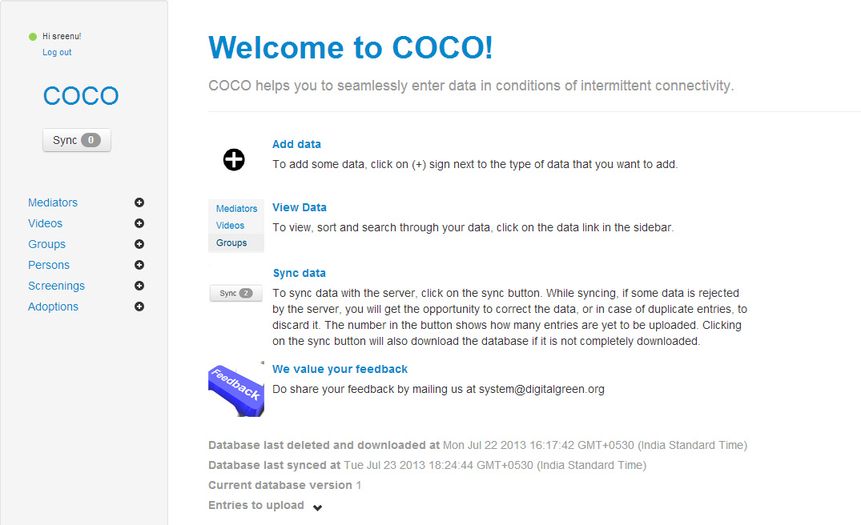
Fig.2 Connect online and connect offline web page
Analytics
The interactive real-time reports (both data as well as graphical representation) helps to have a bird’s eye-view of key statistics as well as retrieve details of each video with drill down approach. The richness of the data allows both for aggregated and disaggregated analysis in various time, geographic, and partner based dimensions and provides opportunities for sharing. This dataset also allows evaluation of quality of the mediations conducted using proximate metrics like the questions asked and interests expressed during disseminations and provides insight into those practices that may be the most (or least) popular in a particular location at a particular time.

The key statistics on number of videos produced, screened and adopted helps to view the progress of program in each region. This can be broken down from state to the village level through district and block levels. The searches can further be filtered according to partner organizations. The performance snapshots are presented in line graphs which can be easily interpreted.
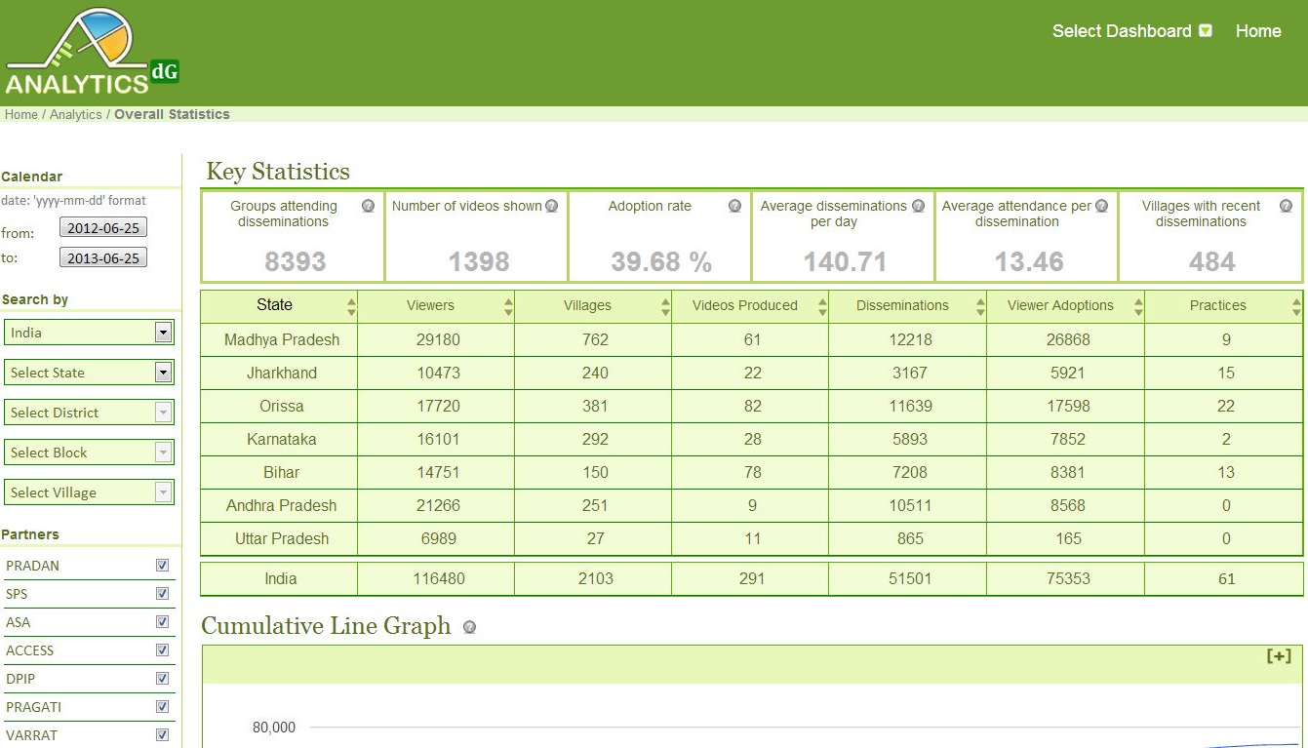
Fig.3 Analytics dashboard data management software

Video Search
All the videos produced from all the regions on various thematic areas are uploaded on the global repository by the partner staff. Video search helps in getting relevant content from the global repository of Digital Green videos. Videos can be located based on location it was produced, theme, practice, seasonality, and similar categories. This page also provides information about number of disseminations, adoptions and what questions were asked by since the video has been disseminated.

3.3.2 Quality assurance
As the Digital Green system scales, we are proactively committed to maintaining quality both in terms of (1) the efficiency of the extension system, which includes the production and dissemination of locally relevant content, as well as (2) its impact, which includes the increased uptake of modern sustainable agricultural practices and the ultimate sustainable improvement in the socioeconomic status and self-efficacy of the communities that we work with.

To support these protocols, we will establish a directorate of quality assurance to anchor these processes and to coordinate exchanges and learning’s across the organization. The directorate will also work with Digital Green's partners and create supportive structures to manage the process quality and content quality assurance mechanisms. For instance, a technical advisory panel of experts will be constituted to provide input into assessing and documenting the quality of content and assuring the ultimate impact that we seek to make in improving livelihoods and empowering the community. Digital Green captures a variety of process, output, and outcome metrics that are both qualitative and quantitative in nature. This data is captured, analyzed, and shared across our technology stack: our online/offline data management framework, analytics suite of dashboards, videos library, and public website. To ensure the quality of this data, our technology stack provides automated consistency checking functionality are used for cross validation in the field. Technical dimensions of produced videos and mediated instruction of video disseminations are assessed through checklists and surveys.
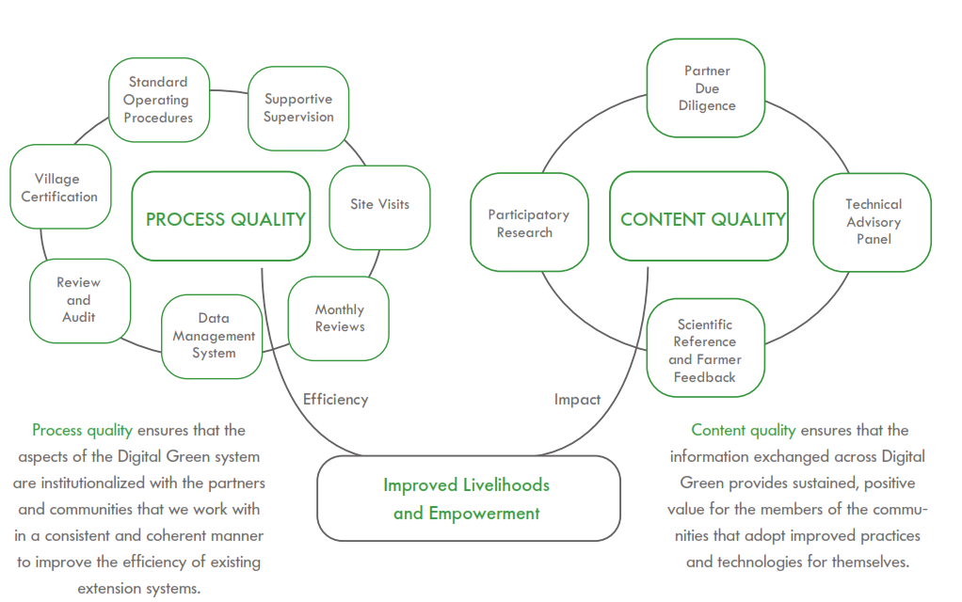
Fig.4 quality assurance process

Village certification
DG has defined a process of “certifying” villages in which the Digital Green model has been operational for at least six months. At the individual village level, it ensures that all aspects of the Digital Green approach, as defined by our standard operating procedures, meet process standards as well as outcome and impact that DG seeks to achieve with partners and communities. Villages are re-certified biannually upon completion of the formal review and audit procedures.

Impact assessment
The whole process of production, dissemination, and adoption is not complete without assessing its impact on end user – the community. Apart from quality assurance of both content and process, Digital Green is involved in assessing the impact of its approach using various evaluation methods. The question of how to measure impact of DG videos on communities is an important one. DG is working with team of experts to conduct rigorous assessments such as Randomized Controlled Trials (RCT) in the DG project areas. The results of these studies will not only help in reporting benefits but also in determining which of the interventions are having the most impact.

Impact of Digital Green in India
DG approach continues to inspire confidence in its ability to impact the lives of community they serve. While it takes time to determine how the uptake of improved practices results in bettering the lives of communities, DG developed intermediate indicators that track the progress. These indicators include the number of local intermediaries train to produce and disseminate videos and the number of community members attend these screenings and adopt new practices.

Across seven states in India, 72 per cent of community members have watching videos and 54% of individuals adopting new practices are women, 271 community members are trained in video production, 1,771 are trained in video dissemination and 219,827 have adopted of new farm and health practices (Anon., 2012).
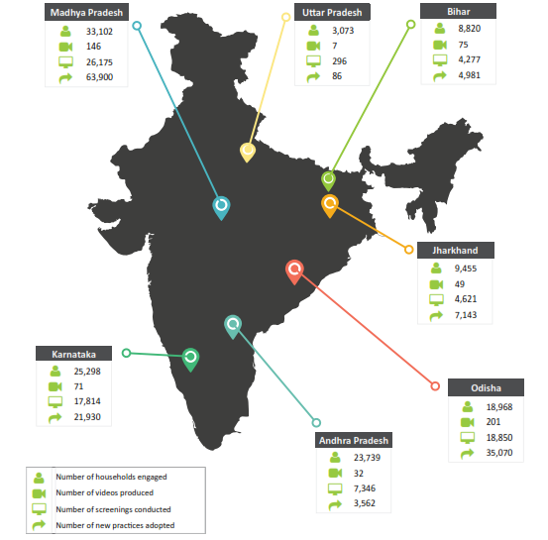
Fig. 5 Impact of DG in different states during 2014
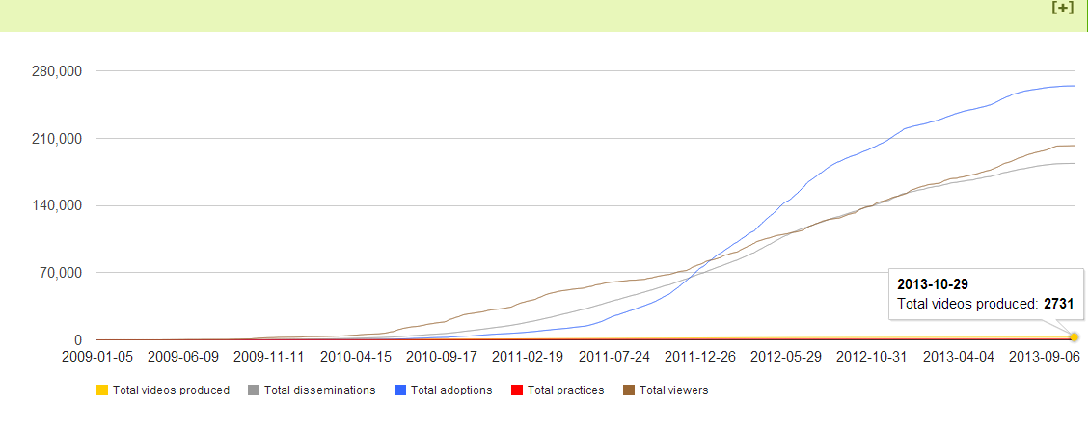Fig.6 total videos produced till 2013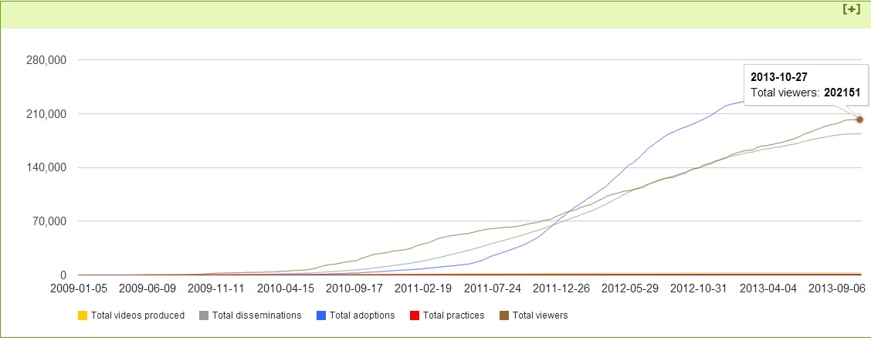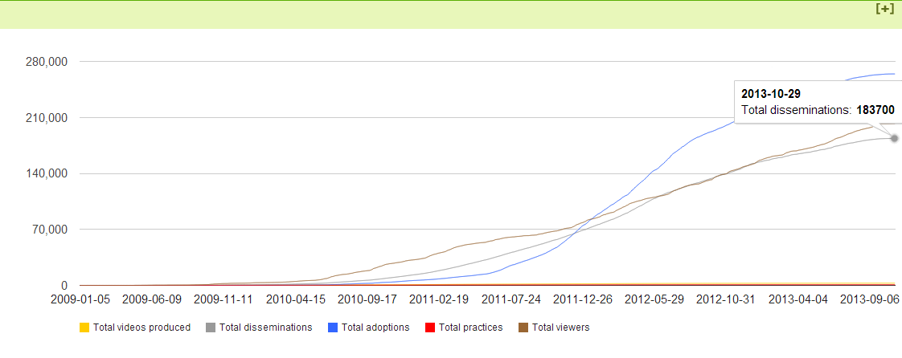 Fig.8 total disseminations till 2013
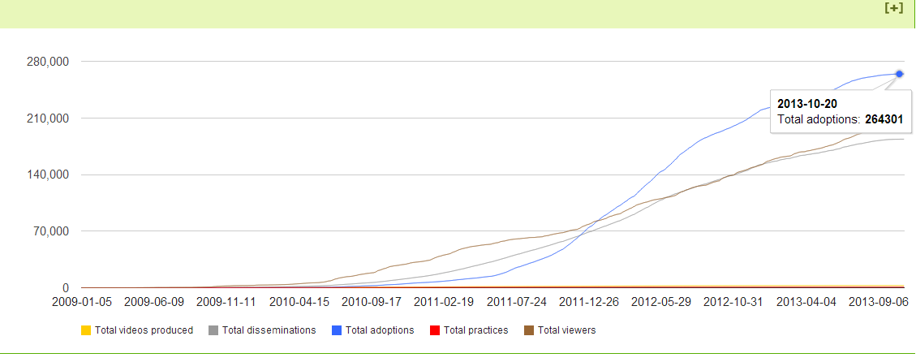Fig.9 total adoptions till 2013
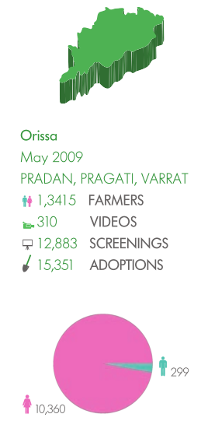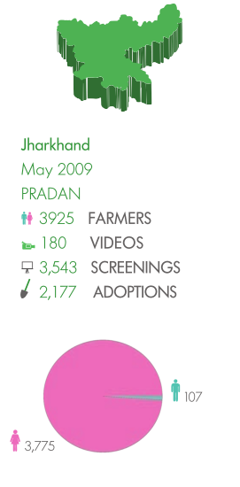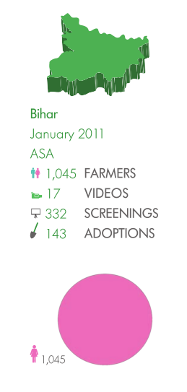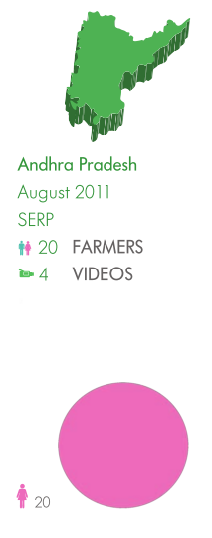
Fig.10 Impact of DG during 2013-14
Conclusion
Digital Green believes that information and communication technology by itself cannot bring about change in peoples’ attitudes or behaviors unless it is blended with existing participatory mode. The DG approach blends technology with social organizations in which village-level mediators use locally produced videos to motivate and train community members in adopting new and improved practices and technologies. The system is efficient in delivering the message to a wider audience and enabling farmers to better manage their farming operations with reduced work load to extension workers.

References
ANONYMOUS, 2005, Access to Modern Technology for Farming, Situation Assessment Survey of Farmers, National Sample Survey Organization (NSSO), Government of India, Ministry of Statistics and Programme Implementation, New Delhi.

ANONYMOUS, 2012, Digital Green Annual Report, www.digitalgreen.org.

ANTHOLT, C. H., 1998, International Agricultural Development, The John Hopkins University Press. Pp.354-369.

COLDEVIN, G., 2003, Participatory communication: a key to rural learning systems, The Food and Agriculture Organization of the United Nations, Rome.

GLENN DAVIS STONE, 2007, Biodiversity and the Law: Intellectual Property, Biotechnology and Traditional Knowledge, Earthscan, UK and USA. Pp.207-238.

GLENN DAVIS STONE, 2007, Agricultural Deskilling and the Spread of Genetically Modified Cotton in Warangal, Curr. Anthrop., 48(1): 67-103.

R. J. ANDERSON, M. DICKEY AND H. PERKINS, 2001, “Experiences with tutored video instruction for introductory programming courses,” SIGCSE: 347-351.

RIKIN GANDHI, 2007, “Digital Green Experiments,” Working Draft, Microsoft Research India, Bangalore.

WANG, R., SAHNI, U., SOBTI, S., GARG, N., SINGH, J. P., KAM, M., A. KRISHNAMURTHY, AND T. ANDERSON, 2005, “The Digital Study Hall,” Technical Report TR-723-05, Computer Science Department, Princeton University.

Discussion
- How the video production is different from usage of TV?
Ans: In TV they will broadcast general information but in Digital Green they disseminate targeted information that too 8-10 minutes video based on needs and interests of the community members.
- Where it exists, is there any website?
Ans: yes, website name is www.digitalgreen.org
- By this have you inculcate the ability to do video production?
Ans: yes sir, I know the procedure how to develop but I don’t know how to use software and all equipments.
- In Karnataka where this institution located? In which district they are operating?
Ans: In Bangalore, they focusing more in North Karnataka
- All videos are available?
Ans: yes sir they have maintained one repository in which we can get all videos.
- Is it recognized by government of India?
Ans: Yes, they have got Norman Borlaug award in 2012for best extension services.
- Any impact studies have conducted on this? What’s the rate of adoption?
Ans: yes, Digital Green team itself conducted and rate of adoption is 39%.
- Who kind the term Digital Green?
Ans: Rikin Gandhi
- What Digital Green refers?
Ans: Digital means video and Green means related to agriculture, overall using video disseminating agricultural information.
- Is it organization?
Ans: yes
- COCO is data management software or film projector?
Ans: It is data management software.



