FOOD PROCESSING INDUSTRIES IN INDIA:
Importance & prospects
Introduction:
Food processing could be defined as set of techno-economic activities carried out for conservation and handling of agricultural produce and to make it usable as food, feed, fiber, fuel or industrial raw material. Hence, the scope of the agro-processing industry encompasses all operations from the stage of harvest till the material reaches the end users in the desired form, packaging, quantity, quality and price. Ancient Indian scriptures contain vivid account of the post harvest and processing practices for preservation and processing of agricultural produce for food and medicinal uses. Inadequate attention to the agro-processing sector in the past put both the producer and the consumer at a disadvantage and it also hurt the economy of the Country Agro-processing is now regarded as the sunrise sector of the Indian economy in view of its large potential for growth and likely socioeconomic impact specifically on employment and income generation. Some estimates suggest that in developed countries, up to 14 percent of the total work force is engaged in agro-processing sector directly or indirectly. However, in India, only about 3 per cent of the work force finds employment in this sector revealing its underdeveloped state and vast untapped potential for employment. Properly developed, agro-processing sector can make India a major player at the global level for marketing and supply of processed food, feed and a wide range of other plant and animal products.

Processing of Traditional Foods

India has a very strong base of traditional food products, which have been developed under varied agro climatic, geographical and socio-cultural situations over the centuries. Besides, conventional Chapattis , these may include expended, puffed, flaked, extruded, fermented products, sweets, instant mixes, breakfast foods, bakery products, beverages, health and special foods. The production of traditional foods during 1996-97 has been estimated nearly 30 times more than that of all western style high cost processed foods in the Indian market. There is an urgent need to upgrade the conventional foods technology so that the industrial manufacturing of products can be promoted and the scope of marketing expanded. There can be substantial domestic and export demand for traditional foods. Production of Bikaneri Bhujia for export and frozen Idli for domestic markets are some of the successful examples. A chapatti making machine developed at CFTRI, Mysore for defence canteens and hotels is a fine example of modernization of traditional food sector. Similarly, long life chapatti and parotha technology developed at DFRL,

Export Trends And Opportunities

India has been a traditional exporter of raw agricultural products like spices. Export of raw products has resulted in huge loss to Indian economy. After GATT agreement and WTO membership, processed products manufactured as per international norms only offered at competitive prices, can be exported. However, our processed products mostly do not meet the international standards. India’s share in over US$ 300 billion world trade in agricultural commodities is less than 1%. Agricultural exports used to be of the order of 30.6% of the total exports during 1980-81, which came down to 19.4% by 1990-91. Currently, it is at about 16%due to rapid growth in other sectors as well. Processed fruit and vegetable products have considerable export potentials and if it is properly utilized, growers, processors, traders as well as national economy will benefit. It requires correct assessment of world market ,high quality of raw produce, high quality of processed product and competitive production cost.

Food processing is now regarded as the sunrise sector of the Indian economy in view of its large potential for growth and likely socio economic impact specifically on employment and income generation. Some estimates suggest that in developed countries, up to 14 per cent of the total work force is engaged in food processing sector directly or indirectly. However, in India, only about 3 per cent of the work force finds employment in this sector revealing its underdeveloped state and vast untapped potential for employment. Properly developed, food processing sector can make India a major player at the global level for marketing and supply of processed food, feed and a wide range of other plant and animal products. With this background the present seminar is conceptualized with following objectives.

- To understand the concept of Food processing and its importance
- To discuss the present scenario of Food Processing Industries (FPI)
- Government support to promote FPI at national and state level
- To review the research evidences of Food processing industries

Concept of Food processing and its importance

Kachru (2014), Food processing could be defined as set of techno economic activities carried out for conservation and handling of agricultural produce and to make it usable as food, feed or industrial raw material.
FAO (2008), A common and traditional definition of Food processing industry refers to the subset of manufacturing that processes raw materials and intermediate products derived from the agricultural sector. Food processing industry thus means transforming products originating from agriculture and fisheries.

HISTORICAL PERSPECTIVE: By the middle of the nineteenth century, common food processing industries included hand pounding units for rice, water power driven flour mills, bullock driven Oil ghanies, bullock operated sugarcane crushers, papermaking units, spinning wheels and handloom units for weaving. In British India, during the year 1863, a note was written by the Governor of Madras state, Sir William Denison to the government of Madras state for laying greater stress on agriculture and agro processing (Royal Commission, 1928).Based on this, a set of improved machinery was brought from England for demonstration and adoption. It included threshing machines, winnowers, and chaff cutters, besides steam ploughs, steam harrows, cultivators, seed drills and horse hoes. The demonstration continued at Saidapet near Madras till 1871 with little outcome. Importance of agro-processing sector was first realized and documented after the disastrous famine of Bengal during 1870’s. Report of the Famine Commission, set up by the British Government, in its report submitted in 1880, clearly stated the need for agricultural improvement and improved post harvest infrastructural development specifically, rail network. Need was also felt for incorporating chemical interventions in the agricultural sector and precision farming through agricultural mechanization manned by engineers.

Food Processing Industry: Concepts, Issues And Its Scenario In India And The World
Right from the cultivation and harvest of crop, upto the consumption of product by consumer, there is certain degree of value addition in every product. This value addition can be of numerous types. As it goes from producer, to wholesaler, to retailer and finally to consumer, every stage adds some value to the product. In this value chain there may be value addition by Sorting, grading, packaging, branding etc. These activities not makes product attractive, more usable, gives choice and awareness to customers and also enhances shelf life of products. Apart from this service rendered by intermediaries to pass on product from producer to customer is also valuable.
Most of the agricultural products are not consumable in their original form, for which they are processed. Wheat is converted into flour, Paddy into rice, sugarcane into jagery, Sugar, ethanol, alcohol etc. These products can be further processed such as flour into bread. Apart from this, left over part of crop such as risk husk can also be processed to get some useful product for e.g. Rice Bran oil, cattle feed, Sugarcane bagasse can be used for power cogeneration.
Hence, food processing not merely adds value to the agro products, but also increases their utility. We know that activities in an economy are broadly divided into Agriculture, industry and Services. Food processing Industry is the product of agriculture and Industry.
Where India stands and why food processing is important?
India Food Processing Industry is estimated at $135 billion industry which is growing at about 8% annually. This growth rate is significantly more than agricultural growth rate which remains around 4%. These signals indicate toward phenomenal shift toward food processing from traditional ways. GDP by processing constitute about 10% that of agriculture. But given potential of India, this is an underachievement.
India has about 26 types of different climatic conditions, 46 varieties of soils are there in India out of total 60 types of soils worldwide. 127 ‘agro climatic zones’ have been identified in India. Also, Indian food is known worldwide for its unique taste and aroma.
India’s regional and cultural diversity is perfectly reflected in food. Every state in India has something unique to offer. For e.g. South Indian, Gujrati, Bengali, Rajasthani and Punjabi delicacies are different and are admired in many parts of the world. But they haven’t been able to make inroads in other countries the way Mc Donald’s, Domino’s etc. has done in India. This is because lack of creativeness, innovation, branding and most importantly shallow pockets of Indian manufacturers.
India is largest producer of Pulses, Mangoes, Banana, Milk, ginger, Buffalo meat and 2nd largest producer of rice, wheat, potato, garlic, cashew nut, groundnut, dry onion, green peas, pumpkin, gourds, cauliflowers, sugarcane, and tea in the world. We produce 17 per cent of the global total of vegetables and 14 per cent in the case of fruits. About 40 percent of the world’s mangoes and 30 per cent of the world’s bananas and papayas are produced in India. Further, India has many unique things to offer such as Alphonso Mangoes and wheat of Madhya Pradesh is uniquely protein rich.
No surprise, that India is net exporter of agricultural products. But value addition of Indian product remains quite low. Indian Manufacturers haven’t moved much ahead in value chain. Say If mangoes are processed in to Mango Juice or pulp; it will result in more value addition, industry, employment, GDP and foreign exchange, but we export mainly mangoes as it is.
Indian agriculture is infested with post-harvest wastage problem. In category of fruits and vegetables it is about 30-40%. Overall, cost of wastage is estimated at about 18% ranging from 50000 crores to 1 lakh crore. Wastage is attributable to several factors including non-availability of facilities for sorting, grading, packaging, storage, transportation, cold chain and low level of processing of agricultural produce. Food processing can halve this loss. Consequently farmer will able to get more value and consumer will get products cheaper.
Consumption patterns in India are rapidly shifting from cereals to protein rich foods and horticulture. Also India has significant proportion of population which is undernutrition (1/3 of population), stunted and wasted. Horticulture and fruits are much desirable for this problem and wastage reduction will have decisive impact here.
Food processing has potential to turnaround whole economy. Indian economy is still agrarian, because about 55% population is directly dependent upon agriculture. FPI directly targets farming sector as it attempts to create more types of products out of single crop. This will increase demand for farmers and hence more remunerative prices.
India’s demographic dividend is much talked about and most of this lies in rural India. Indian youth is turning away from agriculture because of low profitability. FPI is perhaps best bet to seize opportunity of demographic dividend. It can give us a genre of progressive rural entrepreneurs. Prosperous countryside will have multiplier positive impact on socio-economic and political problems. In short, FPI can narrow gap between rural and urban India.
Apart from this India’s economy is under transition, Income classes are moving upward. Every year millions of households are coming out of poverty to be part of middle class. Per capita income is Increasing as GDP growth rate is much higher than population growth rate. This is complimented by growing urban culture, nuclear families, working couples. This makes case for processed food compelling. Consumption in India is gradually tilting towards packaged and ready-to-eat foods. Demand is bound to increase, but it has to be seen that to what extent opportunity is seized by Indian industry and how much is left for foreign companies.
FPI is employment intensive industry; it can be an answer to jobless growth of past decade. Currently, only 3 % of employment is in FPI, while in developed countries it handles 14% population. Again, much of the employment will be created into rural India. This can remedy problem of distress migration. Growth in direct employment in the organized food processing sector stands at 6 % between 2011-12.
Also, strategic geographic location and proximity to food-importing nations (Middle East and Africa) makes India favorable for the export of processed foods.
Last but not the least, world economies are integrating even rapidly year by year. So a country has no option but to remain competitive.

Present scenario of Food Processing Industries (FPI)

Significant increase has taken place after early fifties in the number of institutions engaged in food processing research. Among R&D organizations in the area of food processing, ICAR has Institutes with some component of Post Harvest Technology (PHT), CSIR has laboratories, State Agricultural Universities have degree programmes and 11 other organizations have similar programme. India has been a traditional exporter of raw agricultural products like spices. Export of raw products has resulted in huge loss to Indian economy. After GATT agreement and WTO membership, processed products manufactured as per international norms only offered at competitive prices, can be exported. However, our processed products mostly do not meet the international standards. India’s share in over US$ 300 billion world trade in agricultural commodities is less than 1%. Agricultural exports used to be of the order of 30.6% of the total exports during 1980-81,Currently, it is at about 16% due to rapid growth in other sectors as well.

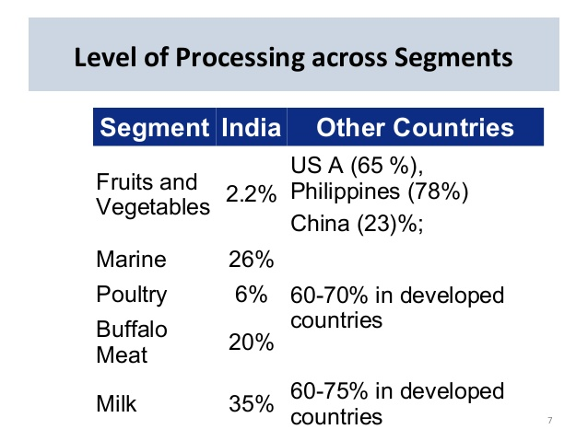

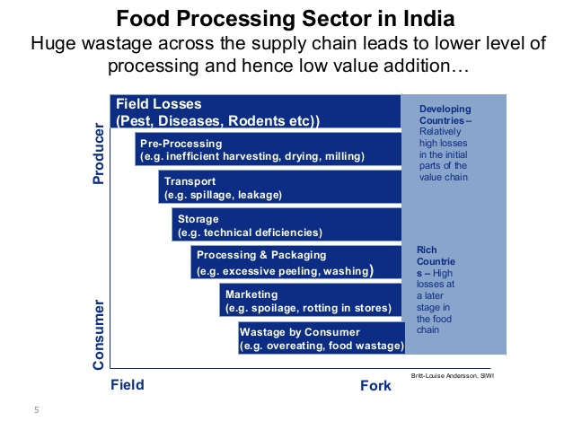

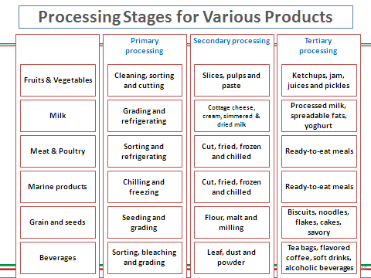

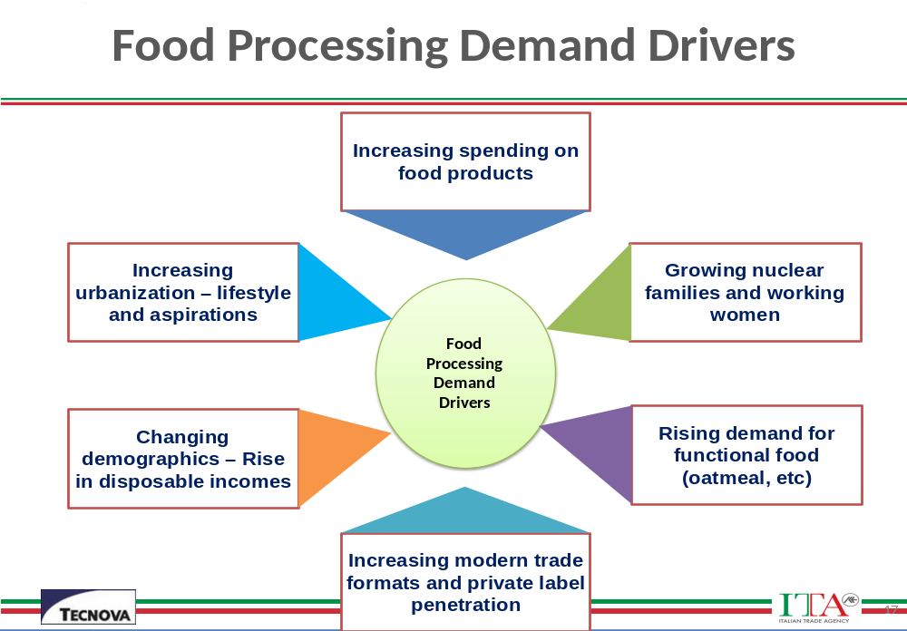

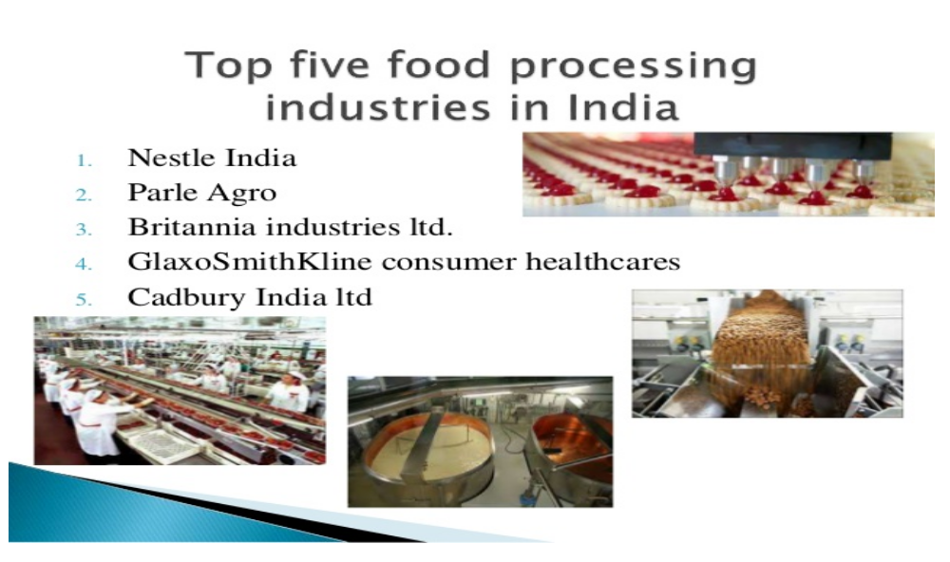

SWOT ANALYSIS OF AGRO/FOOD -PROCESSINGINDUSTRY INFRASTRUCTURE IN INDIA

Strengths
1. Round the year availability of raw materials.
2.Social acceptability of agro-processing as important area and support from the central government.
3. Vast network of manufacturing facilities all over the country.
4. Vast domestic market.

Weaknesses
1. High requirement of working capital
2. Low availability of new reliable and better accuracy instruments and equipments
3.Inadequate automation w.r.t. information management
4.Remuneration less attractive for talent in comparison to contemporary disciplines.
5. Inadequately developed linkages between R&D labs and industry.

Opportunities
- Large crop and material base in the country due to agro-ecological variability offers vast potential for agro processing activities
2. Integration of developments in contemporary technologies such as electronics, material science, computer, bio-technology etc. offer vast scope for rapid improvement and progress
3. Opening of global markets may lead to export of our developed technologies and facilitate generation of additional income and employment opportunities.

Threats
1. Competition from global players
2. Loss of trained manpower to other industries and other professions due to better working
conditions prevailing there may lead to further shortage of manpower.
3. Rapid developments in contemporary and requirements of the industry may lead to fast
obsolescence.

AGRO & FOOD PROCESSING : National Level and Govt. Support
- 194.39 million Hectares of Gross Cropped Area in 2012-13(P)
- 66.10 million Hectares of Net Irrigated Area in 2012-13(P)
- 127 agro-climactic zones
- 42 mega food parks being set up with an allocated investment of USD 2.38 billion
REASONS TO INVEST
- A rich agriculture resource base-India was ranked No. I in the world in 2013 in terms of production of Arecanut, Bananas, Castor oil seed, Chick peas, Chillies & Peppers dry, Ginger, Lemons & limes, Mangoes, Mangosteens, guavas, Millet, Okra, Papayas, Pigeon peas, Meat- buffalo, Milk-whole fresh buffalo & goat, Ghee, butter oil of cow milk, Ghee of buffalo milk, sesame seed.
- India ranks second in the world in the production of Anise, fennel, coriander, beans-dry, cabbages and other brassicas, cauliflower & broccoli, Egg plants (aubergines), Garlic, Groundnuts with shell, Lentil, Onions dry, Peas green, Potatoes, Pumpkins, Squash and Gourds, Rice/Paddy, Safflower seed, Sugar cane, Tea, Tomatoes, Wheat, Meat-goat, Milk whole fresh cow. Further, India is at third position in the production of Cashew nuts, with shell, Coconuts, Lettuce and chicory, Nutmeg, mace and cardamoms, Pepper (piper spp.), Rapeseed.
- The Countrys gross cropped area amounts to 194.39 million Hectares, with cropping intensity of 139%. The net irrigated area is 66.10 million hectare in 2012- 13(P).
- A total of 127 agro-climatic zones have been identified in India.
- Strategic geographic location and proximity to food-importing nations makes India favourable for the export of processed foods.
- Extensive network of food processing training, academic and research institutes.
- 42 Mega Food Parks (MFP) are being setup with an investment of USD 2.38 billion. The parks have around 1250 developed plots with basic enabled infrastructure that entrepreneurs can take on lease for the setting up of food processing and ancillary units. As on 25.07.2016, out of 42 MFP projects 8 projects have been operationalised.
- The cost of skilled manpower is relatively low as compared to other countries.
- Attractive fiscal incentives have been instated by central and state governments and these include capital subsidies, tax rebates, depreciation benefits, as well as reduced custom and excise duties for processed food and machinery.
- Major global players in the food domain are already present in India.
- 134 cold chain projects are being setup to develop supply chain infrastructure. As on 22.07.2016, out of 134 Cold Chain Projects 87 projects have been completed.
STATISTICS
- India ranked 12th in the World in exports of food and food products in 2015
- Major industries constituting the food processing sector are grain milling, sugar, edible oils, beverages, fruits & vegetables processing and dairy products.
- The contribution of the food processing sector to the Gross Value Addition (GVA) in 2014-15 amounts to USD 22 billion at 2011-12 prices. In 2014-15, GVA in food processing grew by 5.78%
- The share of Food Processing Sector in GVA of manufacturing sector was 8.6% in 2014-15
- Investment in fixed Capital in registered food processing sector had grown from USD 24.5 billion in 2012-13 to USD 25.85 billion in 2013-14, making a growth rate of 6%
- The number of registered food processing units has increased from 37,175 in 2012-13 to 37,445 in 2013-14.
- Food processing industry is one of the major employment intensive segments contributing 11.69% of employment generated in all Registered Factory sector in 2013-14.
GROWTH DRIVERS
- Liberalisation and the growth of organised retail has made the Indian market more attractive for global players; with a large agricultural resource base, abundant livestock and cost competitiveness, India is fast emerging as a sourcing hub of processed foods
- With a population size of 1.22 billion of which 604 million were under the age of 24 in 2011, this rising youth population is likely to increase India’s overall food consumption.
- Rising income levels, affluence and a growing middle-class.
- One-third of the population will be living in urban areas by 2020.
- Increasing desire for branded food as well as increased spending power.
- Large distinct consumer segments to support customised offerings/ new categories and brands within each segment.
- Consumption in India is driven towards packaged and ready-to-eat foods.
- Favourable economic & cultural transformation, shift in attitudes & lifestyles, consumers are experimenting with different cuisines, tastes and new brands. There is an increase in awareness and concern for wellness and health, high protein, low fat, wholegrain and organic food.
- Exports of food items have been rising steadily, the main export destinations being Middle East and South East Asia.
FDI POLICY
- 100% FDI is permitted under the automatic route in food processing industries
- 100% FDI is allowed through government approval route for trading, including through e-commerce in respect of food products manufactured or produced in India.
SECTOR POLICY
- Food processing is recognised as a priority sector in the new manufacturing policy in 2011.
- Government has set up a special fund called "Food Processing Fund" of approximately USD 300 million (at Rs. 67.25 to 1 USD) in National Bank for Agriculture and Rural Development (NABARD) for extending affordable credit to designated food parks and the individual food processing units in the designated food parks. As on 31.05.2016 about a quarter of the fund as term loan has been sanctioned to 12 mega food parks projects.
- Reserve Bank of India has classified loan to food & agro-based processing units and Cold Chain under agriculture activities for Priority Sector Lending (PSL) subject to aggregate sanctioned limit of USD 15.38 million per borrower from the banking system. It will ensure greater flow of credit to entrepreneurs for setting up of food processing units and attract investment in the sector.
FINANCIAL SUPPORT
- Services of pre-conditioning, pre-cooling, ripening, waxing, retail packing, labeling of fruits and vegetables have been exempted from Service Tax (Full Exemption Ref. Service Tax notification No. 25/2012- Service Tax dated 20th June 2012 as amended by Notification 3/2013 dated 1st March 2013 and 6/2015 dated 1st March 2015 issued under Section 93 Chapter V of the Finance Act, 1994- Power to grant exemption from service tax).
- Exemption to transportation of 'food stuff' by rail, or vessels or road will be limited to transportation of food grains including rice and pulses, flours, milk and salt only. Transportation of agricultural produce is granted full exemption (Ref. Service Tax notification No. 25/2012- Service Tax dated 20th June 2012 as amended by Notification 3/2013 dated 1st March 2013 and 612015 dated 1st March 2015 issued under Section 93 Chapter V of the Finance Act, 1994- Power to grant exemption from service tax).
- For generating more employment, an amendment regarding eligibility threshold of minimum 100 workmen has been reduced to 50, is made in the provisions of section 8OJJAA of the Income-Tax Act (w.e.f. 01/04/2016).
- The entry "waters, including mineral waters and aerated waters, containing added sugar or other sweetening matter or flavoured" in the Seventh Schedule to the Finance Act 2005 related to levy of additional duty of excise @ 5% has been omitted.

INCOME TAX:

Deduction in Expenditure:
Deduction for expenditure incurred on investment is allowed if the investment is wholly and exclusively for the purpose of any specified business (details given below). However, this deduction is allowed only for the investment made in the previous year and prior to commencement of its operations.
- Business allowed 100% deduction (provided the tax payer has commenced its business on or after 01.04.2016)
  - Setting up and operating a cold chain facility (not available for expansion of the unit)
  - Setting up and operating warehousing facilities for storage of agriculture produce (not available for expansion of unit) (Section 35-AD of the Income tax Act 196 I).
- Business allowed 100% deduction
  - Bee-keeping and the production of honey and beeswax.
  - The setting up and operation of a warehousing facility for the storage of sugar. (Section 35-AD of the Income Tax Act 1961, deduction for expenditure incurred on investment is allowed if this investment is wholly and exclusively for the purpose).

DEDUCTION OF TAX FROM PROFIT:
- This tax incentive is available as 100% tax exemption for the first five years' of operation, and after that, at the rate of 25% of the profits being exempted from tax; 30% in case of a company. This benefit is available only for 10 years for new units (i.e. not formed by splitting up or by way of reconstruction of an existing business) in the business of processing, preservation and packaging of fruits or vegetables, meat & meat products, poultry, marine or dairy products provided such business had commenced on or after 01.04.2001. (Under Section 80 IB (IlA) of the Income Tax Act, 1961).
- If any business relating to meat, meat products, poultry, marine products or dairy products has started after 01.04.2009, the above benefit would be available, but not to the unit operating in such business before 01.04.2009. (Under Section 80 IB (IlA) of the Income Tax Act, 1961).

SERVICE TAX:

Negative List
- Service tax is not leviable on items contained in the Negative List. Services including processes carried out at an agricultural farm including tending, pruning, cutting, harvesting, drying, cleaning, trimming, sun drying, fumigating, curing, sorting, grading, cooling or bulk packaging and such like operations which do not alter the essentials characteristics of agricultural produce but make it only marketable for the primary market.
The following services are covered under exempted category from service tax:
  - Construction, erection, commissioning or installation of original works pertaining to post-harvest storage infrastructure for agriculture produce including cold storages for such purposes. (Ref. Service Tax notification No. 25/2012- Service Tax dated 20th June 2012 as amended by Notification 3/2013 dated 1st March 2013 and 6/2015 dated 1st March 2015 issued under Section 93 Chapter V of the Finance Act, 1994- Power to grant exemption from service tax.)
  - Mechanised Food grain handling system, machinery or equipment for units processing agricultural produce as food stuff excluding alcoholic beverages. (Ref. Service Tax notification No. 25/2012- Service Tax dated 20th June 2012 as amended by Notification 3/2013 dated 1st March 2013 and 6/2015 dated 1st March 2015 issued under Section 93 Chapter V of the Finance Act, 1994- Power to grant exemption from service tax.)
  - Services of loading, unloading, packing, storage or warehousing of agricultural produce. (Ref. Service Tax notification No. 25/2012- Service Tax dated 20th June 2012 as amended by Notification 3/2013 dated 1st March 2013 and 6/2015 dated 1st March 2015 issued under Section 93 Chapter V of the Finance Act, 1994- Power to grant exemption from service tax.)
  - Services of pre-conditioning, pre-cooling, ripening, waxing, retail packing, labeling of fruits and vegetables. (Ref. Service Tax notification No. 25/2012.. Service Tax dated 20th June 2012 as amended by Notification 3/2013 dated 1st March 2013 and 6/2015 dated 1st March 2015 issued under Section 93 Chapter V of the Finance Act, 1994- Power to grant exemption from service tax.)
  - Services provided by National Centre for Cold Chain development under Department of Agriculture, Cooperation and Farmers Welfare, Government of India by way of knowledge dissemination. (Ref. Notification No. 9/2016-Service Tax dated: 1st March, 2016).
  - Services provided by a goods transport agency, by way of transport in a goods carriage of agricultural produce, foodstuff including flours, tea, coffee, jiggery, sugar, milk, products, salt and edible oil, excluding alcoholic beverages. (Ref. Notification No. 3/2013- Service Tax, Para (1-V) Dated: 1st March, 2013).

CUSTOMS DUTY:
- Government has extended Project Imports’ benefits to the following projects:
  - Projects for the installation of mechanised food grain handling systems and pallet racking systems in ‘mandis’ and warehouses for food grains and sugar.
  - Cold storage, cold room (including for farm level pre-cooling) or industrial projects for preservation, storage or processing of agricultural, apiary, horticultural, dairy, poultry, aquatic and marine produce and meat.
  - Consequently, all goods related to Food Processing, imported as part of the project, irrespective of their tariff classification, would be entitled to uniform assessment at concessional basic Customs Duty (Ref. Notification No.12/2012 - CUS dated 17.03.2012).
- Concessional Basic Customs Duty as presently available under project imports for cold storage, cold room (including for farm level pre-cooling) also extended for 'cold chain including pre-cooling unit, pack houses, sorting and grading lines and ripening chambers' from 10% to 5%.
- Customs Duty on Hazelnuts has been reduced from 30% to 10%. (Ref. Notification No. 12/2013-Customs dated: 01.03.2013).
- Customs Duty on De-hulled Oat Grains has been reduced from 30% to 15%. (Ref. Notification No. 12/2013-Customs dated: 1st March, 2013).
- Customs Duty on Refrigerated containers has been reduced from 10% to 5%. (In the Budget 2016-17).
CENTRAL EXCISE DUTY:

Food Products:
- Nil excise duty in milk, milk products, vegetables, nuts & fruits- both fresh and dried.
- Against a standard excise duty of 12%, processed fruits and vegetables carries a merit rate of 2% without CENVAT or 6% with CENVAT.
- Soya milk drinks, flavoured milk of animal origin also carry a duty of 2% without CENVAT or 6% with CENVAT.
- Excise duty on waters including mineral waters and aerated waters, containing added sugar or other sweetening matter or flavored has been changed from 18% to 21% in budget 2016-17.

Food Processing Machinery:
- Excise duty on machinery for the preparation of meat, poultry, fruits, nuts or vegetables and on presses, crushers and similar machinery used in the manufacture of wine, cider, fruit juices or similar beverages and on packing machinery is reduced from 10% to 6% in budget 2014-15.
- All refrigeration machinery and parts used for the installation of cold storage, cold room or refrigerated vehicles for the preservation, storage, transport or processing of agricultural, apiary, horticultural and marine produce as well as dairy and poultry, are exempt from excise duty. (Ref. Notification No. 12/2014- Central Excise dated: 11th July, 2014).
- Pasturing, drying, evaporating etc. machinery used in Dairy sector is exempted from excise duty. (Ref. Notification No. 12/2012-Central Excise dated: 17th March, 2012).
- Excise Duty on Machinery including refrigerated containers has been reduced from 12.5% to 6%. (In the Budget 2016-17).
- Nil excise duty on capital goods and spares thereof, raw materials, parts & material handling equipments for cargo vessel of various kinds including refrigerator vessels for the transport of meat, fruit or the like. (Ref. Notification No, 12/2016- Central Excise, Dated: 1st March, 2016).
- Nil excise duty on floating factories of all kinds (for processing whales, preserving fish or the like), whale catchers. (Ref. Notification No. 12/2016- Central Excise, Dated: 1st March, 2016).
- Nil excise duty on trawlers and other fishing vessels. (Ref. Notification No. 12/2016- Central Excise, Dated: 1st March, 2016).
INVESTMENT OPPORTUNITIES
- Fruits and vegetables: preserved, candied, glazed and crystallised fruits and vegetables, juices, jams, jellies, purees, soups, powders, dehydrated vegetables, flakes, shreds and ready-to-eat curries.
- Food preservation by fermentation: wine, beer, vinegar, yeast preparation, alcoholic beverages.
- Beverages: fruit-based, cereal-based.
- Dairy: liquid milk, curd, flavoured yoghurt, processed cheese, cottage cheese, Swiss cheese, blue cheese, ice cream, milk-based sweets.
- Food additives and nutraceuticals.
- Confectionery and bakery: cookies and crackers, biscuits, breads, cakes and frozen dough.
- Meat and poultry: eggs, egg powder, cut meats, sausages and other value added products.
- Fish, seafood and fish processing – processing and freezing units.
- Grain processing – oil milling sector, rice, pulse milling and flour milling sectors.
- Food preservation and packaging: metal cans, aseptic packs.
- Food processing equipment: canning, dairy and food processing, specialty processing, packaging, frozen food/refrigeration and thermo-processing.
- Consumer food: packaged food, aerated soft drinks and packaged drinking water.
- Spice pastes.
- Supply chain infrastructure – this niche has investment potential in food processing infrastructure, the government’s main focus is on supply chain related infrastructure like cold storage, abattoirs and food parks.
- The establishment of food parks – a unique opportunity for entrepreneurs, including foreign investors to enter in the Indian food processing sector.
AGENCIES
- Ministry of Food Processing Industries
- Food Safety and Standards Authority of India
- Agriculture and Processed Foods Export Development Authority
- National Insitute for Food Technology and Entrepreneurship Management
- All India Food Processors Association
- Commodity Boards under the Ministry of Commerce and the Ministry of Agriculture/Ministry of Food Processing: coffee, tea, spice, meat and grapes.
- Indian Grape Processing Board
AGRO & FOOD PROCESSING : In Karnataka
- The Karnataka is a major producer of spices, flowers, fruits and vegetables.
- Food Processing SEZ at Hassan.
- Karnataka contributes 7% of Agricultural production of the country.
- Presence of 7 National level Research Institutes in Agriculture & Horticulture sectors.
- Presence of 4 dedicated Food Parks and one Food Processing SEZ.
- The overall exports of Agriculture and Processed Food Products, Coffee, Cashew and Cashew Kernels and spices aggregated to USD 1424.1 million in 2015-16.
- Agro and Processed Food Products are exported to Belgium, France, USA, Australia, Canada, Spain, South Korea, Srilanka etc.
COFFEE :
- The State contributes 89% of India’s coffee.
- Coffee production in Karnataka is concentrated in Hassan, Chikkamagaluru, Kodagu & Mysuru Districts and covers approximately 1.26 lakh ha.of land.
- Coffee exports from Karnataka stood at USD 473.32 million in 2015-16.
- The destination countries for coffee exports from Karnataka include Italy, Germany, Belgium, Jordon.
SPICES :
- The State is a major contributor to the total National production with respect to spices like vanilla, cinnamon, tamarind, chilli and ginger.
- The State is one of the major exporters of spices in the country.
- Spice exports from Karnataka stood at USD 49.34 million in 2015-16.
- The primary spice growing regions in the State include Mangaluru and Madikeri.
It is proposed to set up Spice Parks at Kushalnagar & Haveri to give fillip to Exports.
CASHEW AND CASHEW KERNELS :
- After Kerala and Goa, Karnataka is the third largest producer of raw cashew nuts in the Country.
- Cashew is primarily grown in Dakshina Kannada, Udupi, Kodagu and Chikkaballapura districts in the State.
- Cashew and Cashew Kernel exports from Karnataka stood at USD 109.88 million in 2015-16.
- The destination countries of cashew exports from Karnataka include US, UAE, Netherlands, etc.
- Cashew processing industry mainly depends on imported raw-material especially from South Africa.

ROSE ONION :
- Karnataka is the only State in India growing Rose Onion, which has also been registered as a Geographical Indication of the State.
- The crop is grown in about 1300 acres mainly in Kolar, Tumakuru, Hassan, Davanagere and Bagalkot districts.
- Rose onion exports from the State stood at USD 45.87 million during 2015-16.
- APEDA and KAPPEC have been promoting the crop in Far East (Malaysia, Singapore, Indonesia and Brunei) and a few countries in West Asia such as Bahrain, Dubai.
- The exports of rose onion have witnessed significant growth subsequent to the establishment of the Agri Export Zone (AEZ) for Rose Onion in Karnataka.
- Rose onions which are exclusively grown by the small and marginal farmers of the State are meant for exports and their local consumption is meagre.
GHERKINS :
- India has today emerged as the origin of the finest gherkin cultivation, processing and exports to the ever-growing world requirement.
- The history of Gherkin cultivation, processing and exports in India dates back to the early 1990s.
- With a modest beginning in Karnataka State, it subsequently extended to the neighbouring States of Tamil Nadu and Andhra Pradesh, with Gherkin cultivation having reached an impressive tonnage of 4,00,000 MTs.
- Exports of Gherkins from Karnataka stood at USD 201 million in 2015-16.
- The export of processed gherkins is undertaken by about 51 companies located in Karnataka, Tamil Nadu and Andhra Pradesh.
- Gherkins are grown in contract farming with small and marginal farmers.
- Currently there are more than one lakh small and marginal farmers who are engaged in the production of gherkins.
- Export destinations include all major countries like USA, France, Germany, Australia, Spain, South Korea, Canada, Japan, Belgium, Russia, China, Srilanka, Israel.
- A major initiative in the sector was the setting up of a separate “Agri Export Zone” for gherkins in Karnataka with a financial implication of USD 2.33 millions.
FLORICULTURE :
- Karnataka is one of the leading exporters of floriculture from India.
- Floriculture exports from Karnataka stood at USD 7.65 million in 2015-16.
- The setting up of international air cargo services and cold storage at the Bengaluru Airport has resulted in boosting of the floriculture sector.
- International Flower Auction Bengaluru (IFAB) has also helped growth of floriculture sector.
The objectives of Agro/Food-processing programmes in India should be to:

- Minimize product losses,- add maximum value,- achieve high quality standards,- keep processing cost low,- ensure that a fair share of added value goes to the producer

To achieve these objectives following strategy is suggested:

- National plan for improvement and extension of agro-processing technology at farm, traditional small industry and modern industry levels should be prepared. The plan should take into account the diversity in resources and needs of different regions in the Country. It should include programme details and implementation schedule for the first four or five years. The progress of plan implementation should be periodically reviewed to allow adjustments and corrective measures, and to develop programme details for the years beyond the period under review.

(b) Thrust areas for research and development should be identified and medium term research and development programme should be prepared and implemented to support the national plan for improvement and extension of agro-processing technology at different levels. Treatment and utilization of effluents from agro-processing industry should be included in the R.D. programme.
(c) Emphasis should be put on the establishment of new agro-industrial plants in the production catchments to minimize transport cost, make use lower cost land and more abundant water supply, create employment opportunity in the rural sector and utilize process waste and by-products for feed, irrigation and manure.

(d) Infrastructure in the production catchments selected for agro-industrial development should be improved. Because of uncertain grid power supply to rural areas, decentralized power generation using locally available resources may become an integral part of agro-industrial development. Similarly, if the raw materials and processed products are perishable or semi perishable in nature, cold chain will have to be established.

(e) The national plan should provide for management of agro-industrial activities in the catchment area, both by private companies and individuals as well as cooperatives.

(f) Financial incentives and support should be provided on liberal scale to promote the modernization of agro-processing industry and for establishing new such industries in production catchments.

(g) Arrangements to supply market information to the farmer and agro-processor should be put in place.

Research evidences of Food processing industries

ECONOMICS OF PRODUCTION AND MARKETING OF DESICCATED COCONUT POWDER IN KARNATAKA.
Arjuman Banu, B M Shashidhara, T N Venkata Reddy, G N Nagaraj, and K B Umesh
University of Agricultural Sciences, GKVK, Bangalore
India is one of the leading coconuts producing country in the world. Yet, it does not figure in the list of leading exporting countries of desiccated coconut. The study makes an attempt to examine the Economics of production and marketing of desiccated coconut. The study was conducted in Tiptur taluk of Tumkur district. The primary data was collected from the 10 desiccated coconut entrepreneurs from Tiptur taluk of Tumkur district of Karnataka.
Desiccated coconut is the main product while processing coconut, and hence constitutes the major component of gross returns. Byproducts obtained in desiccated coconut production are pairing and shells. Even though the investment was higher in larger sized desiccated coconut units, the total cost per tonne of coconut processed was (Rs 77,694.15, Rs 1,49,735.5 and Rs.1,91,652.4 in case of small, medium and larger sized desiccated coconut units respectively), less compared to other sized units. The gross returns realized per tonne is more in large sized units (Lakh Rs. 265.2) compared to medium (Lakh Rs. 530.4) and small sized (Lakh Rs. 689.52) units because small sized units sell their product whenever price of product is high whereas in case of medium and larger sized units selling of product is on contract basis at a particular price. Net returns realized per tonne are high in large processing units (Rs. 114.56, Rs. 81.19 and Rs. 32.12 in case of large, medium and small sized desiccated coconut units respectively). The higher net returns among large sized desiccated coconut units were mainly due to the economies of large scale production. Thus, it is clear that the large sized desiccated coconut units earn more profit by more efficient as well as large scale production of desiccated coconut and byproducts. Though desiccated coconut units of all sizes are net gainers (ranging from lakh Rs. 32.12 in case of small sized units and lakh Rs.81.19 in large sized units lakh Rs.114.56), the results indicate profitability and the size of the unit are directly proportional. The net returns in all the units indicate positive value addition..

Table 1: Return from desiccated coconut units of different sizes

Sl. No. | Particulars | Size of DC unit |  |  | Pooled
Sl. No. | Particulars | Small | Medium | Large | Pooled
1 | Quantity of coconut processed (tonnes/year) | 1200 | 2400 | 3120 | 2256
2 | Quantity of desiccated coconut obtained (tonnes) | 300 | 600 | 780 | 564
3 | Quantity of byproduct obtained (tonnes)
 | - Parings | 60 | 120 | 156 | 112.8
 | - Shell | 240 | 480 | 624 | 451.2
 | Total (tonnes) | 300 | 600 | 780 | 564
4 | Price of DC realized (Rs./tonnes) | 78000 | 156000 | 202800 | 146640
5 | Price of parings realized (Rs./tonnes) | 30000 | 60000 | 78000 | 56400
6 | Price of shell realized (Rs./tonnes) | 5500 | 11000 | 14300 | 10340
7 | Value of main product (lakh Rs.) | 234 | 468 | 608.4 | 439.9
8 | Value of by-product
 | - Parings | 18 | 36 | 46.8 | 33.8
 | - Shell | 13.2 | 26.4 | 34.3 | 24.8
 | Total (lakh Rs.) | 31.2 | 62.4 | 81.1 | 58.6
9 | Gross returns (lakh Rs.) | 265.2 | 530.4 | 689.5 | 498.5
10 | Total cost / day (lakh Rs.) | 77694.1 | 149735.5 | 191652.4 | 149294.6
11 | Total cost (lakh Rs.) | 233.0 | 449.2 | 574.9 | 447.8
12 | Net returns (lakh Rs.) | 32.1 | 81.1 | 114.5 | 50.6

Arjuman et al (2012),

PROBLEMS AND PROSPECTS OF SMALL SCALE AGRO BASED INDUSTRIES: AN ANALYSIS OF PATIALA DISTRICT.

DR. PAWAN KUMAR DHIMAN*; MS. AMITA RANI** *Associate Professor, Sant Longowal Institute of Engineering & Technology, Longowal, Punjab, India. **Research Scholar, Sant Longowal Institute of Engineering & Technology, Longowal, Punjab, India.

International Journal of Multidisciplinary Research Vol.1 Issue 4, August 2011, ISSN 2231 5780
The present research is an attempt to find out the current status of rice mill industry in Patiala district of Punjab and to analyze the various factors not encouraging the small scale entrepreneurs for generating effective outcomes. Punjab is situated in the North West of India. It is bounded by Pakistan on the west , the Indian states of Jammu & Kashmir on the North, Himachal Pradesh on its North east and Haryana and Rajasthan to its South.

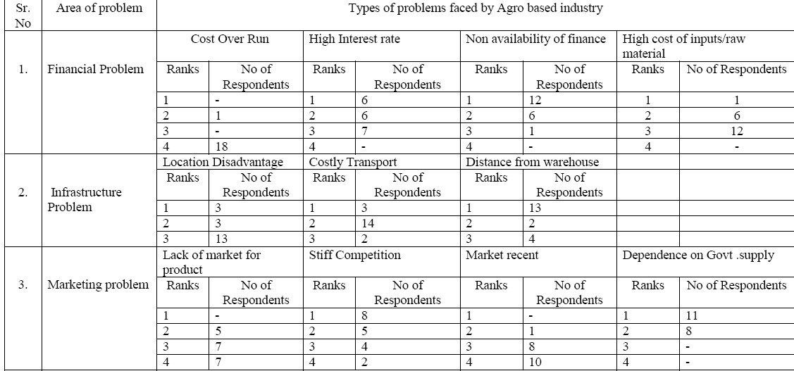

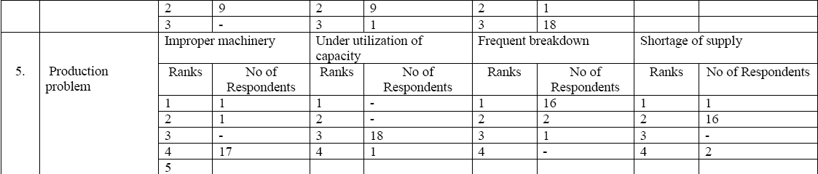

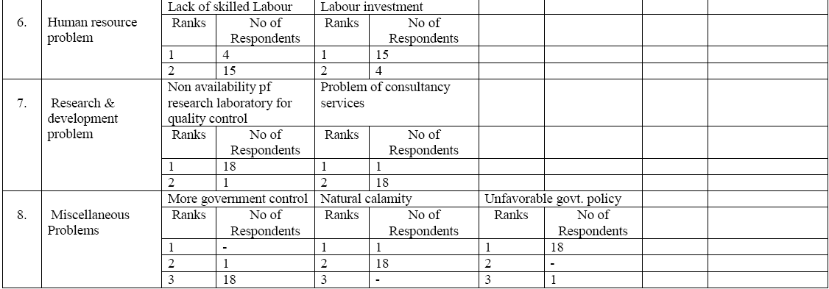

The above tables reveals the real portrait of various problems being faced by rice mill industry in Patiala district of Punjab are facing many problems are as :

FINANCIAL PROBLEM : It has been observed that agro based rice mills in Patiala district are facing numerous financial problems as lack of finance by the financial institutions. Majority of the surveyed units have given 1st ranking to the lack of finance whereas second priority was given to high interest rate and least priority was given to cost overrun The data also depicts that the highest average scale was 3.57 for lack of finance. In addition to it these industries have to face: overrun cost, high interest rates from financial institutions and high cost of raw materials etc and their weighted average scores and ranking were found 1.10, 2.94 and 2.42 respectively. It has also been found due to financial constraints these units are not running smoothly.

INFRASTRUCTURE PROBLEM : For creating industrial culture in any reason infrastructural facilities are required without these no industrial enterprise can survive and sustain for long. As regards infrastructural problems of Patiala district is concerned no any industrial estates have been created by the state government. Many industries have been set up by the entrepreneurs as their own efforts and availability of land. Due to this there is not ant proper connectivity among these industries. In the surveyed units it has been found that among rice mill units, the various infrastructure problems for entrepreneurs are distance from warehouse having highest weighted average score and gave 1st ranking to this problem. Entrepreneurs are also facing the problem of costly transportation cost due to the availability of ware houses in far flung and remote location from the cities. It has also been observed that due to this reason agro based industries have to pay more for raw materials and sending the finished products in the open market.

MARKETING PROBLEM :The industries have very less market to sell their products in the nearby areas and have to remain dependent up on supply to government agencies like food Supply Corporation of India and other agencies , In addition to it industries are also facing stiff competition, changing conditions of market and lack of appropriate and viable market for the product with calculated weighted average score of 3.00, 1.52 and 1.89 respectively. It clearly indicates that if rice mill units do not fetch appropriate market to sell their products at competitive prices the units may be at the stage of closure
.
MANAGEMENT PROBLEM: Many units are facing various problems due to lack of professional management. In the surveyed units it has been found that none of the units have appointed professional manager in their enterprises. Majority of the units are in partnership form of the organization and due to vested interest of the some partner, there is a dispute and lot of litigations among the partner. It has been observed that in majority of the units entrepreneurs have invested huge amount of money in constructing buildings as a dead assets. Some of the units have diversified the funds of the industry in constructing their homes. The money required in industry have been diversified in other dead assets as a result these industries are not earning good profits.. it was also observed that the main reason of management problem is in large investment in fixed assets(WAS 2.52), diversification of funds(2.56) and disputes among partners(1.26) respectively.

PRODUCTION PROBLEM: The production problem is one of the major problems in agro based industries in Patiala district due to less capacity utilization. The first rank was given to power break down by the promoters of the surveyed industries. Due to this industries are not producing the finished products as a result industrial workers have to sit idle for a long time and profit margin is declining year after year. In some of the industries it has been found that they have obsolete machinery.
HUMAN RESOURCE PROBLEM: The main asset of any enterprise is its manpower. If industries get right number and skilled manpower the profitability and productivity enhance manifold. In agro based industries of Patiala district the industries have to hire labour from other states at very high prices. After that some time labours have to impart training also which enhances the cost of the unit as well. It has been observed that in surveyed units, lack of skilled Labour (WAS 1.21) and labour investment (1.78) respectively.

RESEARCH & DEVELOPMENT PROBLEM: Research and Development occupies an important place for inculcating industrialization and inculcating entrepreneurial culture. In the Patiala district there is not any well equipped lab available for testing the agro based products. Units have to move for testing their products in different parts of the countries as a result the cost of production increases to a great extent. The various R & D problems in agro based industries comprises the non- availability of research lab for quality control having score of analysis 1.94 and lack of consultancy services (1.00 score). It shows that major constraint for rice mill industry in Patiala district was the non availability of research laboratory for testing and quality control. It also revealed that due to this reasons entrepreneurs have to move from pillar to post for small testing etc. In addition to it there are some other problems are there as:- a) Higher cost of production of the agro-based products: Absence of cheap and easy transport services increases the cost of production of industrial products, which in turn reduces the competitiveness of the product in the international market; (b) Increasing loss of perishable products: The lack of quick and easy transport facilities increases the magnitude of the loss of products and in turn increases the cost of agro-based products. Consequently, this affects the competitiveness of the product in the international market. At the same time it increases environmental hazards; (c) Delay in the delivery of goods: Agro-based industrial products are special consumption goods and have special characteristics. They must be available when consumers need them. In other words postponement of consumption of food is not possible. Therefore, any delay in delivery reduces the confidence of consumers. Delay in delivery also damages the products, especially fruits and vegetables, and fish and fish products; (d) Urban concentration of agro-based industries: The lack of proper transport services in the rural areas forces industries to locate in the urban areas where transport services are easily available. This defeats the concept of rural poverty alleviation through industrialization;

Conclusion:
India is one of the largest food producers in the world and offers vast opportunities to food processing companies; the sector has been growing at 15% CAGR and is expected grow at a much faster rate of 25% in the coming years. Its priority sector status and significant support from the government (setting up mega food parks, etc) makes it a very attractive sector for investment. Competition within the food processing sector is intense with few large players in each segment competing for organized market share, however, companies with robust and innovative product offerings, customized to suit Indian palate, have good potential to become leading players in the Indian market

References:
ARJUMAN BANU, B M SHASHIDHARA, T N VENKATA REDDY, G N NAGARAJ, AND K B UMESH, 2012, Economics of Production and Marketing of Desiccated Coconut Powder in Karnataka. M.Sc Thesis (Unpub.) Univ. of Agric. Sci, Bengaluru.

FAO (2008), The Agro processing Industry And Economic Development. Economic and Social Development Department report. Rome.
KACHRU R. P, 2014, Agro-Processing Industries in India—Growth, Status and Prospects, Online International Interdisciplinary Research Journal, {Bi-Monthly}, ISSN2249-9598, Volume-IV, Issue-V,
PAWAN KUMAR DHIMAN and AMITA RANI, 2011, Problems and Prospects of Small Scale Agro Based Industries: An Analysis of Patiala District. International Journal of Multidisciplinary Research Vol.1 Issue 4, August 2011, ISSN 2231 5780.

