Social Audit-A Tool for Transparency and Accountability
Introduction
In India, the Ministry of Rural Development is a portfolio that entails a staggering annual expenditure forming 8% of the government's budget. By the means of the February 2013 budget, the allocation for the rural development ministry has been raised by 46% to Rs. 80,194 Crores. The Mahatma Gandhi National Rural Employment Guarantee programme, which ensures 100 days of employment at the minimum wage rate accounts for majority of the ministry's disbursal. With India’s demographics, management of such schemes is cumbersome. Elements of corruption undermine the idea of social welfare. Everywhere, villagers complain of delayed or no payments, no maintenance of records, no job cards and corrupt officials who don’t set the machinery running without bribes. In India, after death of an individual, it isn’t the family of the individual which benefits from the myriad pension schemes supported by the government. It is the middle men or public servants who cheat the state subsidy system or swindle wages. This phenomenon is common across all welfare schemes. Welfare schemes whose outlay is around 50% of the government’s expenditure! Social audit assists in verifying the social performance claims of these government schemes and revolves around the principles of equity, social responsibility, trust, accountability, transparency, inclusiveness and community benefit. As defined by the Grameen Bharat, a monthly newsletter by Ministry of Rural Development (MoRD) ‘Social Audit’ is “a public assembly where all the details of the project are scrutinized”. It is “a way of measuring, understanding, reporting and ultimately improving an organization’s social and ethical performance” as per the National Institute of Rural Development (NIRD) Keeping these aspects in view, the present seminar has been conceptualized with the following objectives.
- To understand the concept and principles of social audit
- To know the scope and models of social audit
- To review the selected case studies

CONCEPT OF SOCIAL AUDIT
The concept of Corporate Social Responsibility (CSR) followed by corporations around the world lays the foundation of social audits. Social audit serves as an instrument for the measurement of social accountability of an organization. It is an in depth scrutiny and analysis of the working of an entity in which the public is involved vis a vis its social relevance. It provides critical inputs to correctly assess the impact of government activities on the social well-being of citizens; determines the social cost and gauges the benefit to the society.
Roots of Social Audit: ‘Audit’ is a Latin word which is translated as ‘to hear’ in English. Audit is not a recent activity but is a practice that was adopted in the ancient time by emperors to analyse the public sentiment towards their rule and policies. The input of masses was then used to alter the policies. Thus encompassing the whole society in the decision making process of matters of governance.
Global: The concept of social audit was in its nascent stages in early 1940s when the depression era academician Theodore Kerps called on companies to acknowledge responsibility towards citizens. The term Social was proposed by Howard R. Bowen in 1953, in his article on “Social Responsibilities of a Businessman”. The term social audits emerged in the United Kingdom and Europe in the mid-1970s. It was used to describe evaluations that focused on the likely impact on jobs, community and the environment. The term social audit was used in such evaluations in order to emphasize that these evaluations had a social angle to them and were not concerned with the economic function of government policies, industry trends or actions of trade unions.
India: In India, the initiative of conducting social audits was taken by Tata Iron and Steel Company Limited (TISCO), Jamshedpur in the year 1979. Social audit gained significance after the 73rd amendment of the constitution relating to Panchayat Raj institutions. The approach paper to the ninth five year plan (2002-07) emphasized upon social audit for effective functioning of Panchayat Raj institutions. That empowered the gram sabhas to conduct Social Audits in addition to its other functions. In order to eliminate the loopholes in scheme implementation
(contractors and middlemen), the Society for Social Audit, Accountability and Transparency, an autonomous body insulated from government interference, was set up in Andhra Pradesh.

Purpose of the Social Audit:

This tool is designed to be a handy, easy to use reference that not only answers basic questions about Social Audit, reasons for conducting Social Audit, and most importantly gives easy‐to‐follow steps for all those interested in using Social Audit.
The purpose of conducting Social Audit is not to find fault with the individual functionaries but to assess the performance in terms of social, environmental and community goals of the organisation. It is a way of measuring the extent to which an organisation lives up to the shared values and objectives it has committed itself to. It provides an assessment of the impact of an organisation’s non‐financial objectives through systematic and regular monitoring, based on the views of its stakeholders.

Need for Social Audit:
The main reason for the push for social audit is the huge disconnect between what people want and what people get. This is mainly because of the game of bribes and swindling of public fund for vested interest as shown in figure 1. Programmes are developed by the politicians and implemented under the guidance of the bureaucrats for development of the society. However, the play of margins, cuts, commissions and bribes deflect the public funds from the direction of the intended beneficiary’s figure-1.

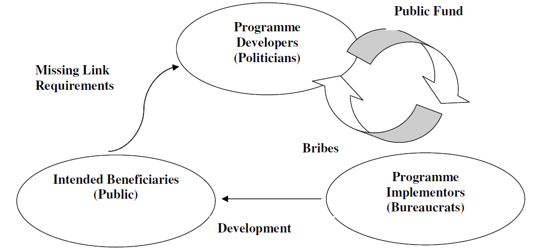

Principles of Social Audit:
- Multi‐Perspective: Aims to reflect the views (voices) of all those people (stakeholders) involved with or affected by the organisation.

- Comprehensive. Aims to (eventually) report on all aspects of the organisationʹs work and performance.

- Participatory. Encourages participation of stakeholders and sharing of their values.

- Multidirectional. Stakeholders share and give feedback on multiple aspects.

- Regular. Aims to produce social accounts on a regular basis so that the concept and the practice become embedded in the culture of the organisation covering all the activities.

- Comparative. Provides a means, whereby, the organisation can compare its own performance each year and against appropriate external norms or benchmarks; and provide for comparisons with organisations doing similar work and reporting in similar fashion.

- Verification. Ensures that the social accounts are audited by a suitably experienced person or agency with no vested interest in the organisation.

- Disclosure. Ensures that the audited accounts are disclosed to stakeholders and the wider community in the interests of accountability and transparency.

Upholding Universal values through Social Audit
These are the pillars of Social Audit, where socio‐cultural, administrative, legal and democratic settings form the foundation for operationalizing Social Audit. The Social Audit process is intended as a means for social engagement, transparency and communication of information, leading to greater accountability of decision‐makers, representatives, managers and officials. The underlying ideas are directly linked to concepts of democracy and participation. The application of Social Audit at the village level holds tremendous potential for contributing to good local governance and increased transparency and accountability of the local bodies.
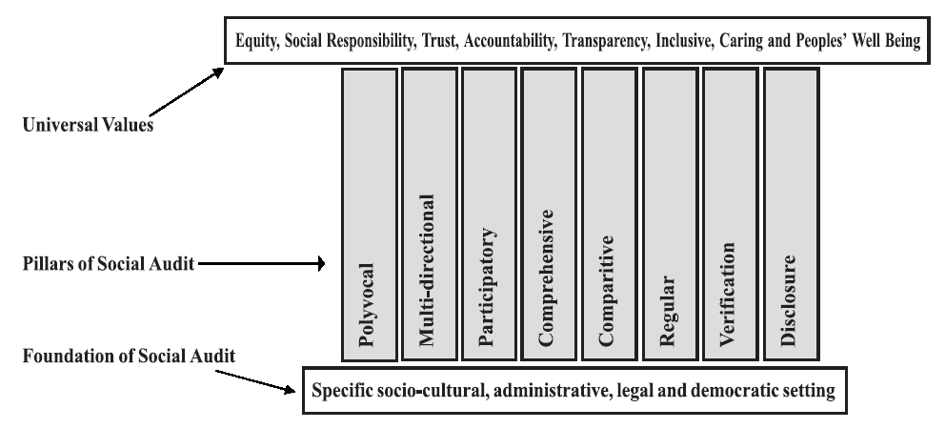

Objectives of Social Audit
- Assessing the physical and financial gaps between needs and resources available for local development.
- Creating awareness among beneficiaries and providers of local social and productive services.
- Increasing efficacy and effectiveness of local development programmes.
- Scrutiny of various policy decisions, keeping in view stakeholder interests and priorities, particularly of rural poor.
- Estimation of the opportunity cost for stakeholders of not getting timely access to public services.

Advantages of social audit
(a) Trains the community on participatory local planning.
(b) Encourages local democracy.
(c) Encourages community participation.
(d) Benefits disadvantaged groups.
(e) Promotes collective decision making and sharing responsibilities.
(f) Develops human resources and social capital

To be effective, the social auditor must have the right to:
- seek clarifications from the implementing agency about any decision-making, activity, scheme, income and expenditure incurred by the agency;
- consider and scrutinize existing schemes and local activities of the agency; and
- Access registers and documents relating to all development activities undertaken by the implementing agency or by any other government department.
This requires transparency in the decision-making and activities of the implementing agencies. In a way, social audit includes measures for enhancing transparency by enforcing the right to information in the planning and implementation of local development activities.
How to Enhance Local Capacities for Social Audit?
- Organization of a mass campaign to increase public awareness about the meaning, scope, purpose and objectives of social audit.
- Establishment of a team of social audit experts in each district who are responsible for training social audit committee members (stakeholders).
- Implementation of training programmes on social auditing methods conducting and preparing social audit reports, and presentation at Gram Sabha

Steps in social audit in local bodies
- Clarity of purpose and goal of the local elected body.
- Identify stakeholders with a focus on their specific roles and duties. Social auditing aims to ensure a say for all stakeholders. It is particularly important that marginalized social groups, which are normally excluded, have a say on local development issues and activities and have their views on the actual performance of local elected bodies.
- Definition of performance indicators which must be understood and accepted by all. Indicator data must be collected by stakeholders on a regular basis.
- Regular meetings to review and discuss data/information on performance indicators.
- Follow-up of social audit meeting with the panchayat body reviewing stakeholders’ actions, activities and viewpoints, making commitments on changes and agreeing on future action as recommended by the stakeholders.
- Establishment of a group of trusted local people including elderly people, teachers and others who are committed and independent, to be involved in the verification and to judge if the decisions based upon social audit have been implemented.
- The findings of the social audit should be shared with all local stakeholders. This encourages transparency and accountability. A report of the social audit meeting should be distributed for Gram Panchayat auditing. In addition, key decisions should be written on walls and boards and communicated orally.
Who can use the Tool? :
Social Audit Toolkit can be used by government departments, private enterprises as well as the civil society. However, the scope in terms of audit boundaries would be specific to that of a government department, private organization, an NGO or a community. In case of private organizations, the emphasis may be on balancing financial viability with its impact on the community and environment. In case of NGOs, in addition to using them to maximize the impact of their intervention programme, they could also be used as effective advocacy tools. Depending on the resources available Social Audit could be comprehensive, state‐wide, and can also be localized to the community level.

Models of Social Audit:
- Village Social Auditors (VSA) : In Andhra Pradesh government has permitted appointment of two Village Social Auditors (VSA) for each Gram Panchayat under the NREGS. The VSAs also help the Gram Sabha to form a social audit team comprising educated youth, members from community based organisations, representatives of the beneficiaries or workers etc.
- Vigilance and Monitoring Committee (VMC): This model is being adopted in Rajasthan. VMCs are constituted with the beneficiaries, social workers, retired civil or defence or private sector officials, other retired employees like teachers, representatives from SC/ST/Women. These VMCs with proper training and orientation can also be a Social Audit team and their findings are placed and discussed in Gram Sabha.
Applying the Tool

The six steps of Social Auditing are:
1. Preparatory activities
2. Defining audit boundaries and identifying stakeholders
3. Social accounting and book‐keeping
4. Preparing and using social accounts
5. Social audit and dissemination
6. Feedback and institutionalisation of social audit

The first two steps are critical when a department decides to incorporate social accounting, social book‐keeping and social auditing. The department needs to look at its vision, goals, current practices and activities to identify those that are amenable to social auditing purposes. Small work groups (say, seven persons) are to be formed which would spend about two days each to list down the social vision, core values, social objectives and map stakeholders and their involvement. Ensure involvement of various functionaries with due representation to gender, while forming small groups. The small groups should have access to project documents, process documentation, department guidelines and policy notes.
The next activity would be to assign the task of matching the activities with the social objectives and identifying gaps. This again could be carried out by a small group drawn from the managerial cadre and execution/implementation groups at the field level. All this information would be then looked into; to develop a plan for Social Auditing, including who would be responsible in the department, monitoring and identifying the resources required. This responsibility again could be given to a small group of three individuals.

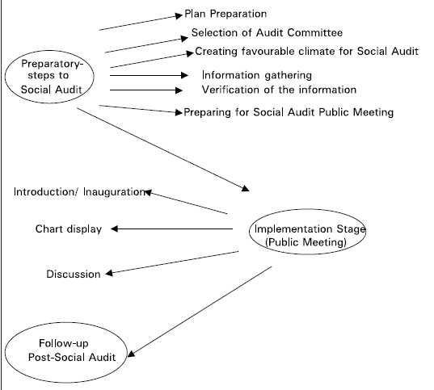

Social Audit of the New Economic Foundation

The New Economic Foundation (NEF), London, established in 1984, started to work on Social Audit in conjunction with the Strathclyde Community Business Ltd. (SCB) in the early 1990s, and brought out the first comprehensive Social Audit Toolkit. The model proposed by the NEF represents most of the features mentioned above, covering policy or document review, management systems, stakeholder dialogue, performance indicators and benchmarks, disclosure and verification. Currently, this is one of the most accepted social audit toolkit. The audit cycle followed by New Economic Foundation is presented in the following diagram (Figure: Source – NEF 1998). Using this model, they worked with Tradecraft Plc. (a fair trade NGO) and issued the first set of accounts in 1993. Thereafter, a number of private companies that wished to measure their performance started using social audit. These included Body Shop (1993), Shared Earth (1993), and Ben and Jerry’s (1995). In 1997 Social Enterprise Partnership developed the first European Social Audit programme involving groups from Ireland, Spain, Finland, Sweden, Denmark England, France, Belgium and Italy.

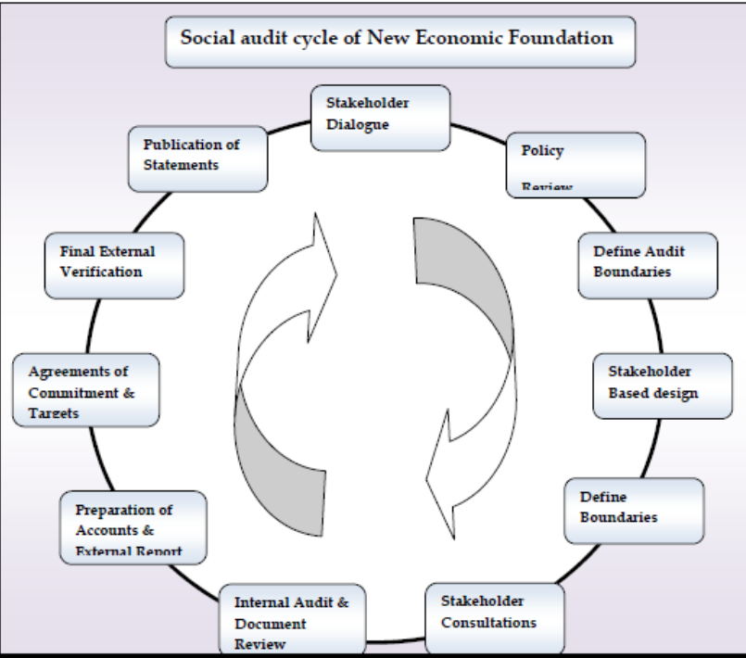

How does one conduct a social audit of a scheme or programme
Step 1: Study the details of the scheme and the Right to Information Act.
Step 2: Identify the various stages of the scheme, especially those where decisions have to be made, beneficiaries identified, sites selected, strategies determined, details specified, etc.
Step 3: For each of these stages, identify the vulnerabilities, in terms of what can go wrong, what can be corrupted, what distortions can occur.
Step 4: Identify for each stage, the appropriate measures to be taken to ensure that the identified vulnerabilities are addressed through the relevant social audit mechanisms.
Step 5: Identify the functionaries and institutions that would be responsible for ensuring that the social audit is conducted, and conducted properly.
Step 6: Call a meeting of the village or community and discuss the principles and method of social auditing in detail with them.
Step 7: Ensure that the identified institution and functionary complies with all the requirements of a social audit.
Step 8: Every six months, prepare for a public hearing. In this, hearing the affected persons collectively review the process of social audit. Also reviewed the progress of the scheme.
Benefits of Social Audit for Government departments:
- Enhance reputation
- Alerts policymakers to stakeholder trends
- Increases accountability
- Assist in re-orienting and re-focusing priorities
- Provides increased confidence in social areas

SOCIAL AUDIT APPROACHES
Several approaches have been developed for the measurement and reporting of the social accounting and auditing. The following are the analytical framework of some of the commonly used ones (Filio, 1984)
i. The perceived reality approach
According to this approach, a prerequisite to the social audit is the development of a standard of the public's expectations on a given issue. Here what matters is not the real but the perceived ranking on a given social issue (e.g. pollution) by either the general public or special groups whose opinions are considered important?
The advantage of the 'perceived reality' approach is that it helps to set goals in tune with public expectations. Evolving shifts in public expectations can also be spotted so that necessary changes in long-rang objectives can be made. Its main disadvantage is that a totally external intervention in goal determination does not take into account inherited strengths and weaknesses in indicating certain problems and May therefore result in a distorted allocation of resources. Furthermore it narrows the discretion that can be exercised by management both in selecting certain projects and in the time frame within which they can be efficiently executed.
Primary aim of this approach is argued to be the development of long-range goals and medium-range strategies responding to following four types of external constraint:
• Existing legal constraints;
• anticipated legal constraints;
• Pressure from the general public and special-interest groups; and
• Performance of other companies with which a firm is likely to compared

The basic rationale of the perceived reality approach is that it ' imperative to define those constituencies to which project activity is most relevant-employees, customers, stockholders, 'the community', and so on- and survey these constituencies to determine the aspects of social performance for which they hold the project responsible and what their expectations are. This procedure establishes a 'definable domain' for corporate social action in a quite different fashion from the pain other approaches follow and its main defensive advantage is public attitudes as they are expressed by the aforementioned four constraints or otherwise.

ii. The cost or outlay approach

According to this approach the social activities indicating the amount spent on each activity of the project is disclosed. Additional information of a quantitative but non-financial nature might also be provided, such as number of pounds of sulphur emitted into the air, etc. The originator of such a presentation is D.F. Linowes who calls his systematic tabulation of socia-economic financial measurements'Socio-economic operating statement' (SEOS). The SEOS exhibit is meant to include that which a business has given to or held back from society, and would be prepared periodically along with a balance sheet and the profit and loss statement. Furthermore, in the SEOS exhibit, positive and negative social impacts of corporate actions are classified in one of the following groups:
- Relations with people;
- Relations with environment; and
- Relations with product
However, the SEOS fails to measure the quality of the outputs, the results of the
Social programs.

iii) The benefit-cost approach

According to this approach the business firm di9c1oses its socially responsible activities, the amount spent on them and the value of each expenditure. This approach is different from the "progran1me management" discussed next, in that the real value of the programme must: be determined. In the programme management approach, some surrogate for benefit is used, such as the number of lands given to minority enterprises, the r1umber of students who graduated from college because of student loans, etc.
iv. The programme-management approach
This approach examines the social responsiveness programmes; indicates the amounts spent on each programme and whether so of the programme have been met. The programme management approach borrows elements from public sector accounting and management information systems for non-profit entities to apply them upon decentralized departments whose main concern are the corporate social programmes. It presupposes, therefore, the institution of corporate social activism.

v. The Inventory approach - The process audit

The inventory approach is the basic level of social measurement and consists of determining and disclosing all the activities of a business enterprise that are socially relevant (taking an inventory) an inventory listing has some informal value, and operationally it would not be difficult to develop, but two drawbacks exist. First, the list could be endless, since in one way or another most activities of the enterprise can construed as being socially relevant. Second, comparison between business firms would be extremely difficult because no standard could be used to measure the company's social awareness except on the basis of how well the company explained its social activities.

vi. The state interference approach
In the environment of profit maximization only strict legislation could ensure drawing up coherent social policies at an acceptable social cost. Such a "state interference" approach has proved to be quite effective in dealing with sine qua non changes in our Society.

vii. The Social goal programming approach
This approach describes the goal fulfilment of the different participants as well as how these different goals are related to the significant effects of policies and operations. The basic step in this approach is the establishment of a goal hierarchy with clear distinction of its different levels of goal fulfilment. The second step is the establishment of connections between the operations and the goals of the different participant groups. The extent to which each goal of a participant group is fulfilled becomes an entry into the "profit and loss report" of this participant group.
The attainment of the goals of participant groups is necessarily associated with the concept of "effectiveness" since measures of effectiveness indicate the degree to which each goal or objective is attained. The construction of an index of suitability, desirability, sufficiency, etc. (or their absence) is in essence the construction of a non-financial measure of effectiveness. Since such measures are included aggregation is extremely difficult and therefore the production of a total social" profit and loss" for any company is almost impossible.
The main advantage of the social goal-programming approach is that it can become integrated by including a socio-economic goal oriented managerial accounting system as well as a social budgeting system. This is important because real changes in organizational behaviour will stem most probably from such internal systems.
Case studies related to Social audit

- Social audit in Jharnipalli Panchayat, Agaipur block, Bolangir district, Orissa.
In October 2001, the gram sabha members of Jharnipalli Panchayat conducted a one day social audit of development works. This audit took place with the active participation of many individuals and agencies, including block and district administration officials, MKSS [Mazdoor Kisan shakti Sanghatan], NCPRI (National Campaign for People’s Right to Information) and Action Aid India.
The audit found that
- Although the works were not carried out, the sanctioned funds were shown in the records as having been utilized.
- Contractors were banned under government guidelines, but 31 contractors were working on the project.
- Muster rolls were not maintained by the contractors.
- Instead of the target of 100 man-days of employment for families below the poverty line (BPL), only 12 half days of work were generated.
- The BPL families could not buy subsidized food from the public distribution system (PDS) shops as partial wages because they did not possess the needed ration cards.

- Micro-development planning as part of social audit:
A voluntary development organization Samarthan and PRIA
Collaborated in a participatory micro-planning exercise with local officials, Panchayat members, members of different castes. This led to the identification of several goals. Every member of the Gram Sabha developed a sense of ownership of the project. The Gram Sabha monitors the work. Gram Panchayat representatives also hold regular ward-level meetings.
- Social Audit in Delhi initiated by Parivartan:
A social audit was conducted by Parivartan, a citizen's initiative, along with the local residents of two resettlement colonies of North East Delhi. A social audit of the Corporation of Delhi showed that public money is routinely redirected away from the purposes it is intended. After the initiatives of Parivartan, a number of people from different parts of Delhi have filed applications under the Delhi Right to Information Act and sought the records of their ration shopkeepers.
- HAMARA PAISA, HAMARA HISAAB: initiated by Mazdoor Kisaan Shakti Sangathan (MKSS), Rajasthan.
- The MKSS- 1990, is a big grassroots organisation
People in Rajasthan have always had difficulty getting paid the minimum wages.
- The campaign of Mazdoor Kisaan Shakti Sangathan in Rajasthan is known as Hamara Paisa, Hamara Hisaab.
- Initially, demands to see the muster rolls were met with refusal on the grounds that these were ‘secret documents’.
- The MKSS brought people together and simply read out official documents.
- People who would have been intimidated on their own now had a platform where they could speak out.
MKSS in Rajasthan demanded and got information on minimum wages and government infrastructure programmes
- How effective are social audits under MGNREGS ? LESSON FROM KARNATAKA.
This case study on social audits under MGNREGS in Karnataka aims to provide suggestions on how to improve the design and implementation of social audits in the state. With the help of the primary data collected from five Gram panchayats in Chitradurga district.
Some of the constraints
- Lack of participation of women
- Relative ineffectiveness of the VMCs
- Lack of independent auditors
- Inadequate training provided to villagers for conducting social audits
- Insufficient scrutiny of the possession and distribution of job cards
- Complaints by labourers that not enough work was available under MGNREGS.

- Social Audits in India - Gahlot Sushmita (2013)
This article aims at analysing the current scenario in the field of social audits in implementation of government schemes in India and traces the evolution of the concept over the time span of last 3 decades. Through an example of Andhra Pradesh, Rajasthan and the North Eastern states, it discusses the evolution problems faced while conducting social audits and also suggests measures to improve upon social audits of the various government schemes.

Social Audits across the Country: Andhra Pradesh:
The year 2006 marked the starting of social audits in the state of AP. From the observations of the surveyors it could be concluded that out of 22 gram panchayats in which social audits were conducted, 17 reported mis- utilization of funds. The survey was conducted over a period of over 8 days by a team of twenty district resource persons, two state resource persons, and 31 village social auditors (VSAs). The audit report highlighted dishonesty and inefficiency of field assistants, who were the main implementers of the program in a village. The field assistants were charged with assigning less work to the beneficiaries, making mistakes in filling out attendance in worksite muster rolls, failing to issue job cards to all applicants, measuring the work improperly and demanding bribes. B the end of the initial set of audits, the district collector had dismissed all field assistants in 12 GPs and warned the rest. Social audits conducted afterwards revealed that after the initial set of audits, the discrepancies in procedures had reduced. A cross section of stakeholders including worksite beneficiaries was aware of the audit and its findings. Interaction with the laborers revealed that after the after the first social audit, wages were being paid on time. The only problem that still troubled the villagers was the weak follow up action in retrieving the swindled sums and poor enforcement of rules. After the introduction of SSAAT, the social audit scenario in AP changed. Set up by the Department of Rural Development, Government of Andhra Pradesh, the Society for Social Audit, Accountability and Transparency (SSAAT) majorly concerns itself with the audits of Mahatma Gandhi National Rural Employment Guarantee Scheme (MGNREGS). As per the Act, social audits of MGNREGS have to carried out every six months.
Rajasthan: In the year 2009, under the initiatives of Member of Parliament, Mr. C.P. Joshi, social audits were conducted in the Bhilwara region of Rajasthan. From October 1 for 12 days 135 teams of social auditors went to 1,000 villages in 381 panchayats to find out how NREGA was being implemented. Eleven teams were chosen by Mr. CP Joshi through a lottery to conduct a social audit in 11 panchayats. These were Govardhanpura, Para, Tasvariya, Tirodi, Sangwa, Baran, Khachrol, Devariya, Lakhola, Dabla Kachra and Budliyas. The exercise in social audits not only brought to light the loopholes in scheme implementation but also served as a training ground in auditing for the local population.
North – Eastern States: Through the letter of the MGNREGA Director, to the Ministry of Rural Development dated 5th July 2012, an appraisal of the MGNREGS in the North Eastern states was presented along with suggestive measures to improve the implementation of the scheme, which are as under: i. Selection of master trainers/ resource persons, ii. Identification of blocks for pilot social audit, iii. Training of master trainers at NIRD, IV. Preparation of state specific manuals, v. setting up of social audit units this hints at efforts being made in the north eastern states to improve social accountability through the means of social audits.

CONCLUSION
Social audits have potentials for making a meaningful impact on the effectiveness of the programme delivery system, the potential of which is needed to be fully utilized. There should be involvement of social audit in all the developmental programmes.

REFERENCES
ANONYMOUS, 2005, Social Audit: A Guide for performance improvement and outcome measurement- A toolkit. Centre for Good Governance, Hyderabad.

NAGANAGOND, S. P.AND ULIVEPPA, H. H., 2012, Is Social Audit Effective Under MGNREGA? Findings from a Survey. Jharkhand Journal of Social Development, 4(1 & 2).

SRIVASTAVA K. B., 2012, Training Module on Social Auditing. Centre for Panchayati Raj, National Institute of Rural Development (NIRD), Hyderabad.

Questions raised during discussion in the seminar
- what is the difference between evaluation and monitoring:

Evaluation is defined as an assessment either after the completion of a scheme or project or on an on-going or continuing basis, of the processes and end results or impact of a project or scheme.

Monitoring is a continuous assessment that aims at providing all stakeholders with early detailed information on the progress or delay of the ongoing assessed activities. It is an oversight of the activity's implementation stage. Its purpose is to determine if the outputs, deliveries and schedules planned have been reached so that action can be taken to correct the deficiencies as quickly as possible.
2. Which are the institutions involved in social audit in Karnataka?
- Indian institute of Management
- MYRADA
- Sujala watershed

- Why social audit is needed in any organization?
To make transparency and accountability in implementation to avoid corruption in the organization.

- In which area this social audit can be done?
In rural development programmes especially in MGNREGA and social welfare programmes.


UNIVERSITY OF AGRICULTURAL SCIENCES
DEPARTMENT OF AGRICULTURAL EXTENSION
GKVK, BANGALORE-560065
Name : Chaithra, G. J. Date: 20-06-2016
ID. No.: PALB 4018 Time: 1:00 PM
Class: II PhD Venue: Model class room
Seminar
On
Social Audit-A Tool for Transparency and Accountability
Synopsis

Governments are facing an ever growing demand to be more accountable and socially responsible and the people are becoming more assertive about their rights to be informed and to influence government’s decision making processes. Faced with these vociferous demands, the executive and the legislature are looking for new ways to evaluate their performance. Civil society organizations are also undertaking social audits to monitor and verify the social performance claims of the organizations and institutions. Increasing awareness of public towards their rights to be served by the government services and their stake in influencing the decision making process necessitates exhibition of greater transparency and accountability. Social audit is a more relevant tool to address the issues of accountability and transparency. Social audit creates an impact upon governance. It values the voice of stakeholders including marginalized or poor groups whose voices are rarely heard. Social audit is taken up for the purpose of enhancing local governance, particularly for strengthening accountability and transparency in local bodies (Naganagond, 2012).
With this background the seminar has been conceptualized with the following objectives.
- To understand the concept and principles of social audit
- To know the scope and models of social audit
- To review the selected case studies

Concept of Social Audit

Social audit is a process in which people work with the government to monitor the planning and implementation of the policies or programme which are intended for the beneficiaries (people) (Anon, 2005).
Social audit is a way of measuring, understanding, reporting and ultimately improving an organization’s social and ethical performance. It helps to narrow gaps between vision/goal and reality, between efficiency and effectiveness. It is a technique to understand, measure, verify, report and to improve the social performance of the organization. (Srivastava, 2012).

Principles of social audit

- Multi‐Perspective: Aims to reflect the views (voices) of people
- Comprehensive : Aims to (eventually) report on all aspects
- Participatory: Encourages participation of stakeholders
- Multidirectional: Stakeholders share and give feedback
- Regular: Aims to produce social accounts on a regular basis
- Comparative: Organization can compare its own performance
- Verification: Ensures that the social accounts are audited
- Disclosure: Ensures that the audited accounts are disclosed to stakeholders

Objectives of Social Audit

- Assessing the physical and financial gaps
- Creating awareness among beneficiaries
- Increasing efficacy and effectiveness of local development programmes
- Scrutiny of various policy decisions
- Estimation of the opportunity cost

Models of Social Audit

- Village Social Auditors (VSA)
- Vigilance and Monitoring Committee(VMC)

CASE STUDIES

- Social audit in Jharnipalli Panchayat, Agaipur block, Bolangir district, Orissa
The audit found that although the works were not carried out, the sanctioned funds were shown in the records as having been utilized. Contractors were banned under government guidelines, but 31 contractors were working on the project. Muster rolls were not maintained by the contractors.

- Social Audit in Delhi initiated by Parivartan
A social audit of the Corporation of Delhi showed that public money is routinely redirected away from the purposes it is intended. After the initiatives of Parivartan, a number of people from different parts of Delhi have filed applications under the Delhi Right to Information Act and sought the records of their ration shopkeepers.

Conclusion

Social audits have potentials for making a meaningful impact on the effectiveness of the programme delivery system, the potential of which is needed to be fully utilized. There should be involvement of social audit in all the developmental programmes.

References

ANONYMOUS, 2005, Social Audit: A Guide for performance improvement and outcome measurement- A toolkit. Centre for Good Governance, Hyderabad.

NAGANAGOND, S. P.AND ULIVEPPA, H. H., 2012, Is Social Audit Effective Under MGNREGA? Findings from a Survey. Jharkhand Journal of Social Development, 4(1 & 2).

SRIVASTAVA K. B., 2012, Training Module on Social Auditing. Centre for Panchayati Raj, National Institute of Rural Development (NIRD), Hyderabad.

