INTRODUCTION
The Idea Of Action Research
The principle behind action research is that it combines action with research. It is a
process in which learning (research) is done to enable action to be carried out more
effectively and, at the same time, learning occurs through action, through lessons
learned by trying things. Action research can be defined as
“A process in which a group of people with a shared issue of concern collaboratively, systematically and deliberately plan, implement and evaluate actions. Action research combines action and investigation. The investigation informs action and the researchers learn from critical reflection on the action. “
-(Lewin, 1946)

Action research is an approach which is adaptive, flexible and participatory. It can be applied quite usefully in community development and related fields such as agricultural research and extension.
As the name suggests, action research is a methodology which has the dual aims of action and research,action to bring about change in some community or organisation or program,research to increase understanding on the part of the researcher or the client, or both (and often some wider community).
There are in fact action research methods whose main emphasis is on action, with research as a fringe benefit. At the extreme, the “research” may take the form of increased understanding on the part of those most directly involved. For this form of action research the outcomes are change, and learning for those who take part.
In other forms, research is the primary focus. The action is then often a by-product. Such approaches typically seek publication to reach a wider audience of researchers. In these, more attention is often given to the design of the research than to other aspects. In both approaches it is possible for action to inform understanding, and understanding to assist action.
Action research is often presented as a cyclical process with repeated cycles of planning, action, evaluation and replanning. Kemmis and McTaggart (1988a) have presented this as an action research spiral. The process of action and research is iterative, rather than being a linear process of research/planning followed by action. In this respect it differs from the more common approach to applied research where research is done to investigate a problem and then the action (applying the solution) is implemented. It is possible to think of action
research as a form of applied research, but one in which the action and research occur in parallel.
Almost all writers appear to regard it as cyclic (or a spiral), either explicitly or implicitly. At the very least, intention or planning precedes action, and critique or review follows. It provides a mix of responsiveness and rigour, thus meeting both the action and research requirements.
For some writers action research is primarily qualitative. Qualitative research can be more responsive to the situation. A need for responsiveness is
one of the most compelling reasons for choosing action research.
Another characteristic of action research is that it normally is a group activity, involving a group of people going through the cyclical process (a core team). Some proponents of action research state that all action research must be participatory (eg Kemmis and McTaggart 1998a).
Participation is another requirement for some writers. Some, in fact, insist on this. Participation can generate greater commitment and hence action. When change is a desired outcome, and it is more easily achieved if people are committed to the change, some participative form of action research is often indicated.
There are many conditions under which qualitative data and client participation increase the value of the action research. However, to insist on these seems unnecessary. It seems reasonable that there can be choices between action research and other paradigms, and within action research a choice of approaches.
The choice you make will depend upon your weighing up of the many advantages and disadvantages. in action research a second objective is to make a contribution to public knowledge. Research is a planned and organised attempt to find answers to questions and usually implies the intention of contributing to “public” knowledge, not just individual learning or learning by those involved in the research.

According toFisher and Jackson (1998)
Action research is also a type of research, in the sense that it contributes to “public” knowledge. Experience in a specific situation generates insights and
understanding which can inform actions in similar situations. The word inform
is important here. The intention is not to provide recipes for implementation, but
rather to provide insights which others may find useful in other contexts. This
aspect of generalising from learning in a specific situation is the research element.

Why would anyone use action research?
There are a number of reasons why you might choose to do action research,
including for thesis research...
Action research lends itself to use in work or community situations. Practitioners, people who work as agents of change, can use it as part of their normal activities.
Mainstream research paradigms in some field situations can be more difficult to use. There is evidence, for instance from Barlow, Hayes and
Nelson (1984), that most US practitioners do very little research, and don’t
even read all that much. Martin (1989) presents similar evidence for Australian
and English psychologists.
When practitioners use action research it has the potential to increase the
amount they learn consciously from their experience. The action research
cycle can also be regarded as a learning cycle (see Kolb, 1984). The educator
Schön (1983, 1987) argues strongly that systematic reflection is an effective
way for practitioners to learn. Further conversation reveals that in their normal practice they almost all omit deliberate and conscious reflection, and sceptical challenging of interpretations. To my mind, these are crucial features of effective action research (and, for that matter, of effective learning).
It looks good on your resumé to have done a thesis which has direct and obvious relevance to practice. If it has generated some worthwhile outcomes
for the client, then that is a further bonus. (There are other research methodologies, including some conventional forms, which also offer this advantage.)
Action research is usually participative. This implies a partnership between you and your clients. You may find this more ethically satisfying. For some purposes it may also be more occupationally relevant.

So why doesn’t everyone use it?
The main reason, I suspect, is that it isn’t well known. Psychology has ignored action research almost completely.There is less debate in academic psychology about research methods and their underlying philosophy than in most other social sciences.
At the 1986 annual psychology conference the theme was “bridging the gap between theory, research and practice”. This was a priority need in psychology, to judge by the choice of theme. Although some of the papers were about applied research in field settings, to my knowledge no paper given at the conference specifically mentioned action research. Yet in action research there need be no gap between theory, research and practice. The three can be integrated.
An ignorance of action research isn’t a reason to avoid it. There are good reasons, however, why you may decide to stay within mainstream research. For example, here are some of the costs of choosing action research as your research paradigm.
It is harder to do than conventional research. You take on responsibilities forchange as well as for research. In addition, as with other field research, it
involves you in more work to set it up, and you don’t get any credit for that.
It doesn’t accord with the expectations of some examiners. Deliberately and for good reason it ignores some requirements which have become part of the ideology of some conventional research. In that sense, it is counter-cultural.
Because of this, some examiners find it hard to judge it on its merits. They do
not recognise that it has a different tradition, and is based on a methodological
perspective and principles different to their own. (At a deeper level some
of the differences disappear.
We probably can’t use a conventional format to write it up effectively.
Again, that means you have to learn some new skills. In psychology there is
a strong expectation that the format recommended by the American Psychological Association (APA) will be used. A non-APA format may alienate
some examiners. Again, this may be more of an issue for people working
within the discipline of psychology than in some other social sciences. However, most disciplines have their ideologies about how research should be
reported.
The library work for action research is more demanding. In conventional
research you know ahead of time what literature is relevant. In most forms
of action research, the relevant literature is defined by the data you collect
and your interpretation of it. That means that you begin collecting data first,
and then go to the literature to challenge your findings. This is also true of
some other forms of field research, though certainly not all.
Action research is much harder to report, at least for thesis purposes. If you stay close to the research mainstream you don’t have to take the same pains
to justify what you do. For action research, you have to justify your overall
approach. You have to do this well enough that even if examiners don’t
agree with your approach, they have to acknowledge that you have provided an adequate rationale. (This may be true for other methodologies outside
the research mainstream too.)
All else being equal, an action research thesis is likely to be longer than a conventional thesis. As already mentioned, you have to provide a more compelling justification for what you do. In effect, you have to write two theses.
One reports your method, results and interpretation. The other explains
why these were appropriate for the research situation. In addition, if you use
qualitative data (and you probably will) that also tends to take more space to
report.

Action research can be a suitable methodology in the following types of situations:
􀂉 a problem being investigated is very complex (involving diverse elements);
􀂉 people don’t know where to start in solving a problem (and especially when they
lack confidence due to the complexity of the problem);
􀂉 change involves people with differing perspectives or conflicting objectives and
there is a need for a common vision or negotiated compromise;
􀂉 the situation or context is changing.
Most conventional research methods gain their rigour by control, standardisation,
objectivity, and the use of numerical and statistical procedures. This sacrifices
flexibility during a given experiment—if you change the procedure in midstream
you don’t know what you are doing to the odds that your results
occurred by chance.
In action research, standardisation defeats the purpose. The virtue of action research is its “Responsiveness”. It is what allows you to turn unpromising beginnings into effective endings. It is what allows you to improve both action and research outcomes through a process of iteration. As in many numerical procedures, repeated cycles allow you to converge on an appropriate conclusion.
If your action research methodology is not responsive to the situation you can’t aspire to action outcomes. In some settings that is too high a price to pay. You can’t expect to pursue change and do good mainstream research within a single experiment and at the same time. Good action research is like good social consultancy or community or organisational change. It draws on the same skills and procedures. It offers the same satisfactions. The costs are that it takes time, energy and creativity. And at the end of it you may have to satisfy examiners who are not field practitioners.
In most forms of research, the research is framed around specific research questions. In action research, the focus of the activity is a “thematic concern”, a general problem area that the researchers and other participants want to improve. The actual research questions may change for different cycles. For example in an action research project where the thematic concern is to improve pumpkin production for a market, the research question for the first cycle might be “what characteristics does the market require in terms of type, quality and timing?” the second cycle might ask “how can we produce pumpkins that are of the regular size required by the market?”; the third question might ask how can the farmers, transporters and exporters arrange their production and coordinate arrangements so that the pumpkins will arrive at the market in peak condition at the appropriate time. The second and third questions could not be asked (probably not even predicted) until the first question was answered. The
third question has all sorts of subsidiary questions, some technical, some
organisational. All of these are crucial to successful marketing.
The first explicit formulation of the idea of action research was made by Kurt Lewin, in the context of work with minority communities in urban areas in the Unites States (Lewin 1946). Lewin differentiated between two types of social research. One type dealt with “the study of general laws of group life” and the other dealt with “the diagnosis of a specific situation”. He argues that an engineer or surgeon needs to understand both the general “laws” and the specific situation, which is determined by diagnosis. Action research operates at the level of the specific situation, and also assumes that just diagnosing isn’t enough to create change. There is a need to complement “the diagnosis… by experimental comparative studies of the effectiveness of various techniques of change”. Later action researchers added new elements. Friere (1982) focused on research based on “learning to do it by doing it”. He introduced a strong activist or emancipator element into action research. In this approach to action research the focus is on empowering people by allowing them to take control of the research process and addressing their own needs. Emancipatory learning and empowerment are strong thematic trends within the action research literature (see Selener 1997). This is very relevant to community development.
- The term "action research" was coined by the social psychologist Kurt Lewin in about 1944 (Marrow, 1969).
- He used the term to describe a form of research which could marry the experimental approach of social science with programs of social action in response to major social problems of the day.
- The social psychologist Lewin was intensely concerned with all of these problems.A German Jew, he had fled Germany in 1933.He is known for his development of a "field - theoretic" approach in social psychology.Apart from "action research", he was also the originator of the terms Groupdynamics" and "sensitivity training".
- Through action research, Lewin argued, advances in theory and needed social changes might simultaneously be achieved.
- Action research, according to Lewin, "consisted of
- analysis,
- fact-finding,
- conceptualisation,
- planning,
- execution,
- more fact-finding or evaluation;
- and then a repetition of this whole circle of activities; indeed a spiral of such circles

When is Action Research used ?
- Action research is used in real situations, rather than in contrived, experimental studies, since its primary focus is on solving real problems.
- It can, however, be used by social scientists for preliminary or pilot research, especially when the situation is too ambiguous to frame a precise research question.
- Mostly, though, in accordance with its principles, it is chosen when circumstances require flexibility, the involvement of the people in the research, or change must take place quickly or holistically.
- It is often the case that those who apply this approach are practitioners who wish to improve understanding of their practice,
- social change activists trying to mount an action campaign, or,
- more likely, academics who have been invited into an organization (or other domain) by decision-makers aware of a problem requiring action research, but lacking the requisite methodological knowledge to deal with it.
Characteristics of action research
1)Cyclic (or a spiral)
2)Qualitative
3)Participative
4) Adaptive and flexible
Action research can be a suitable methodology in the following types of situations:
- a problem being investigated is very complex (involving diverse elements)
- people don’t know where to start in solving a problem (and especially when they lack confidence due to the complexity of the problem)
- change involves people with differing perspectives or conflicting objectives and
- there is a need for a common vision or negotiated compromise;
- the situation or context is changing.
In any event, there are ways in which you can reduce the risk of doing action research. The two most important actions you can take are:-
• At all times collect and interpret your data in defensible ways. In particular, know your overall methodology before you begin. At least, know how you intend to start, and check that it is defensible. You will change your mind about your methodology in the light of your experience; but because the changes are motivated by evidence, they too will then be defensible. Always use methods for data collection and interpretation which test or challenge your emerging interpretations. That is, seek out disconfirming evidence.Integrate your library research with your data collection and interpretation. There, too, seek out this
confirmation.

• Justify your methodology carefully in the eventual thesis. Carefully explain
your reasons for using action research, qualitative data collection, and the
specific methods you use. Be careful to do so without being evangelistic, and
without implying even the mildest criticism of other research paradigms.

How to do action research?
There are many ways to do action research. It is a research paradigm which subsumes a variety of research approaches. Within the paradigm there are several established methodologies. Some examples are Patton’s (1990) approach to evaluation, Checkland’s (1981) soft systems analysis, Argyris’ (1985) action science, and Kemmis’ critical action research (Carr and Kemmis, 1986). Each of these methodologies draws on a number of methods for information collection and interpretation, for example interviewing and content analysis.
These are choices you have to make—paradigm, methodology, methods. Each choice has to be justified in your eventual thesis. The aim in making the choice is to achieve action and research outcomes in such a way that each enriches the other. That is an important point.
Provided that the fuzzy answer allows you To refine both question and methods , you eventually converge towards precision. It is the spiral process which allows both responsiveness and rigour at the same time. In any event, the whole purpose of action research is to determine simultaneously an understanding of the social system and the best opportunities for change. If you are to be adequately responsive to the situation, you can’t begin the exercise with a precise question. The question arises from the study.
It is important to remember that many examiners are likely to suspect action research of being far less rigorous than more conventional research. It need not be, but much of it in the past has been. Whatever your choice of methods, therefore, focus on rigour: on the quality of your data and your interpretations. The most effective way of doing this is to follow two guidelines:-

1) Use a cyclic (or “spiral”) procedure. In the later cycles you can then challenge the information and interpretation from earlier cycles. Both the data you collect, and the literature you read, are part of this. In effect, your study becomes a process of iteration. Within this process you gradually refine your understanding of the situation you are studying.
Conventional research works best when you can start with a very precise research question. You can then design a study to answer that question, also with precision. In action research your initial research question is likely to be fuzzy. This is mainly because of the nature of social systems. It is also because you are more likely to achieve your action outcomes if you take the needs and wishes of your clients into account. Your methodology will be fuzzy too. After all, it derives from the research question, which is fuzzy, and the situation, which is partly unknown. If you address a fuzzy question with a fuzzy methodology the best you can hope for initially is a fuzzy answer .This, I think, explains some of the opposition that action research draws from some quarters.
As it happens, one of the key principles of action research is: let the data
decide. At each step, use the information so far available to determine the
next step.

2) At all times try to work with multiple information sources, preferably independent or partly independent. There are ways in which you can use the similarities and differences between data sources to increase the accuracy of your information. This might be called dialectic . It is similar to what is often called triangulation in research (Jick, 1979). For more background on this important topic you might read some of the material on multimethod research.
Examples include Brewer and Hunter (1989), Cohen and Manion (1985), and Fielding and Fielding (1986). Any two or more sources of information can serve your purpose of creating a dialectic.

We may use...
• different informants, or different but equivalent samples of informants;
• different research settings (as a bonus, this increases the generalisability
of your results);
• the same informant responding to different questions which address the
same topic from somewhat different directions;
• information collected at different times;
• different researchers;
• or, as in triangulation, different methods.

Differences between traditional research and Action research
Characteristics | Action research | Traditional research
Type of problem | Practical problem(directly or indirectly experienced by research practitioner) | Research problem(identified based on gap in review of literature)
Ultimate goal | Address a practical problem and improve professional practice | Fill a gap in the literature and contribute to the knowledge in a field
Level of involvement | Participants could be actively involved in the study since the beginning to the end | Participants are normally involved in the data collection stage

Major Theories of Action research
1) Chris Argyris' Action Science
- Chris Argyris' Action Science begins with the study of how human beings design their actions in difficult situations.
- According to him,humans design their actions to achieve intended consequences and are governed by a set of environment variables
- How those governing variables are treated in designing actions are the key differences between single-loop learning and double-loop learning.
2) John Heron and Peter Reason's cooperative inquiry
- Major idea of cooperative inquiry is to "research 'with' rather than 'on' people.”
- It emphasizes that all active participants are fully involved in research decisions as co-researchers.
3) Paulo Freire's participatory action research (PAR)
- PAR builds on the critical pedagogy put forward by Paulo Freire as a response to the traditional formal models of education where the “teacher” stands at the front and "imparts" information to the "students" who are passive recipients.
- This was further developed in "adult education" models throughout Latin America.
4) William Barry's living educational theory approach to action research
- The mission of the LET action researcher is to overcome workplace norms and self- behavior which contradict the researcher's values and beliefs.
- The vision of the LET researcher is to make an original contribution to knowledge through generating an educational theory proven to improve the learning of people within a social learning space.

ACTION RESEARCH TOOLS
- Action Research is more of a holistic approach to problem-solving, rather than a single method for collecting and analyzing data.
- Generally common to the qualitative research paradigm, include:
- keeping a research journal, document collection and analysis, participant observation recordings, questionnaire surveys, structured and unstructured interviews, and case studies.
Role of the Action Researcher
- Roles of an action researcher are that of planner, leader, catalyser, facilitator, teacher, designer, listener, observer, synthesizer and reporter
- Main role is to nurture local leaders to the point where they can take responsibility for the process.
- This point is reached they understand the methods and are able to carry on when the initiating researcher leaves.
ACTION RESEARCH PROCESS
There are three processes of action researcher
1) Reactive
2) Proactive
3) Innovative

Reactive Action Research Process

Proactive Action Research Process

Innovative Action Research Process

Components of Action Research
- Problem
- Practical problem
- Researchable problem
- Research
- Purpose statement
- Research questions
- Research method
- Data collection strategy
- Data analysis
- Solution
- Findings
- Action Plan
- Action
- Implementation
- Evaluation
Nature of the problem
- Identified in the natural setting
- Occurs in a specific environment
- Specific and narrow in nature
- Refined based on review of literature
- Refined based on exploration of best practices
Strategies For Group/Self Evaluation
- Daily informal personal reflection
- Weekly reviews(journal entry or informal meetings)
- Special effort evaluations for particular aspects of practice
- Monthly collective problem pooling sessions
- Annual “what we have achieved” and “where we are heading next year” workshops
Ethical Considerations
Richard Winter (1996) lists a number of principles:
- Make sure that the relevant persons, committees and authorities have been consulted, and that the principles guiding the work are accepted in advance by all.
- All participants must be allowed to influence the work, and the wishes of those who do not wish to participate must be respected.
- The development of the work must remain visible and open to suggestions from others.
- Permission must be obtained before making observations or examining documents produced for other purposes.
- Descriptions of others’ work and points of view must be negotiated with those concerned before being published.
- The researcher must accept responsibility for maintaining confidentiality
Differences between Action Research and Participatory Action Research
Action Research | Participatory Action Research
Researcher achieves learning, and larger group may also learn. | Participants (and researcher) achieve learning within larger group
The researcher facilitates the process, and collaborates with clients to create or actualize change. Researcher typically does not engage in change actions. | Actions taken through process – action is incorporated into research itself
Researcher collaborates with “clients” | Researcher works with “participants”
Researcher and clients engage in self-reflection | Participant issues, actions and learning highlighted / No Expert
3rd party researcher engages in change as expert | 3rd party group works to change self and larger groups
Subjective | Holistic
Emergent property: improved capacity and wisdom | Emergent property: creativity

Benefits of Action Research
- For Kurt Lewin and many others, action research is a process of empowering those on the front lines of action to conduct research into their own practices,rather than relying on and more importantly –being subject to research findings of outsiders
Criticisms
- Lengthy and time taking
- Potential for bias can question validity of research
- Results can’t be generalized

Models of Action Research
1. Stringer’s Action Research Interacting Spiral
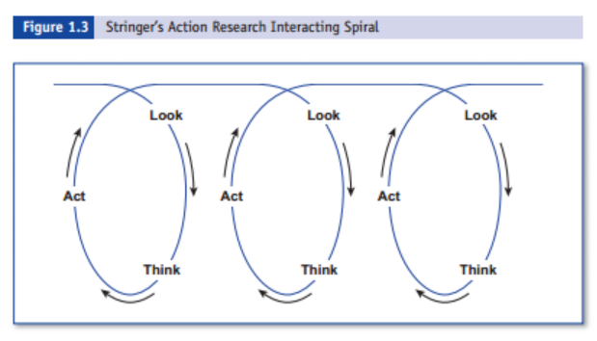

2. Kurt Lewin’s model of Action Research
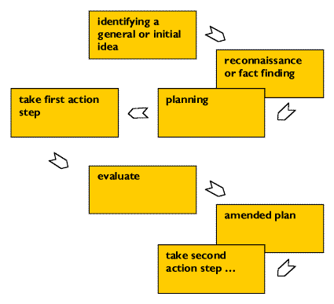

3.Systems model of Action Research
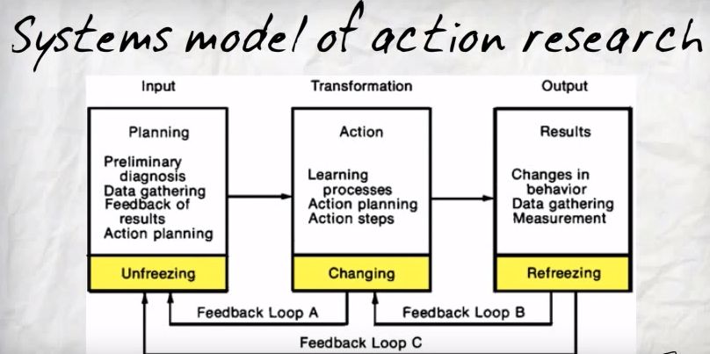

4. Calhoun’s (1994) action research cycle

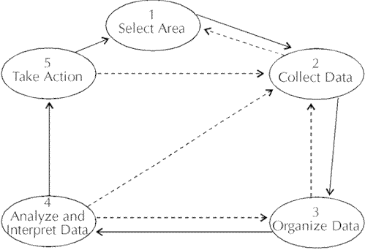

Case Study
Action research to improve irrigation operations: Example from India
THE PALIGANJ DISTRIBUTARY CANAL, SONE COMMAND
-D.L. Vermilion and J.D. Brewer, Irrigation Specialists, International Irrigation Management Institute, Colombo, Sri Lanka,2006

- There was creation of a farmers' distributary canal committee
- There came introduction of new operational procedures for enhancing equity and management control in the Paliganj Distributary Canal of the Sone Command in Bihar, India.
- Involvement of farmers, agency staff and researchers in problem identification, proposing solutions, implementation and evaluation was essential in achieving results.
- Canal officers supply water to each outlet, from where sattadar(a farmer) provides water to the farmers on request.
- Farmers near the outlet block the water to use as much water as they want.
- The agency tended to assume that all farmers within the command received water and all were assessed water charges, irrespective of whether water was actually delivered.
- The Water and Land Management Institute (WALMI) was created in 1993 to train Bihar State irrigation engineers and others in improved irrigation and land management.
- In 1998, with support from the United States Agency for International Development (US AID), WALMI staff organized an Action Research Programme (ARP) at the Paliganj Distributary to improve the performance of the canal network so as to improve the productivity and profitability of irrigated agriculture in the area.
- Defining the problem
- Farmers and the AR team found many water distribution problems, including, among others:
- unreliable supply at the head of the Paliganj Distributary
- unavailability of water when required and excess water when not needed
- poor condition of the canals and structures, including broken and missing regulators
- open cuts in the canal banks to take water
- failure of agency officers to visit the area
- no channels for communication between farmers and officers
- and lack of a system for inter-village cooperation.
- Devising solutions
- formation of a Farmers' Committee which represented 20 villages. Farmers and the AR team identified three problems for priority action:
- 'unattended' operation of the distributary canal
- lack of farmer involvement in irrigation management
- lack of communication between users and system managers.
- Farmers' Ad Hoc Canal Operation Committee was formed for handing operation of the system.
- Group 'walk-throughs' along the distributary canal were made by Committee members to identify problems with obstructions and unwanted water tapping
- Committee began implementing new arrangements for patrolling and removal of canal obstructions and tapping, rotational irrigation and maintenance.
- Implementing innovations in canal operations
- By early Oct.’99, farmers were removing canal obstructions and informing farmers of a new collective plan for improving operations.
- Water began reaching the tail end for the first time in ten years.
- For the 2000 kharif season, the Farmers' Committee adopted a simple operations plan developed with the help of the ARP team.
- The plan rotated water among five blocks - head, middle, tail, and Chandos and Bharatpura sub-distributaries - within the standard 10 day rotation for the whole distributary.
Performance outcome
- Between 1998 and 2003, the equity of kharif season water distribution among the five blocks of the Paliganj Distributary improved significantly.
- Tail areas now receive a significantly higher fraction of the water.
- The tail-end section of Paliganj Distributary Canal serves 30.7% of the irrigable area. Before the action research, this portion of the canal received only 10 to 12% of the water diverted into the canal.
- Between 2000 and 2003, the area irrigated by the Paliganj Distributary Canal during the kharif season rose from 3,614 ha in 2000 to 4,350 ha in 2003.
CONCLUSION
- Action research can be particularly useful in community development, agricultural research and extension.
- One of the key points is that “promoting” change requires very close attention to the specific rural context and that action research is a very good means of working in such conditions, especially where it is difficult to know where to start because much is unknown.
- Action research is one way to avoid being paralysed by lack of detailed understanding.

