Climate Change Knowledge Network In Indian Agriculture(CCKN-IA)
Climate change presents India with major challenges. In the course of the 21st century, the average decade temperature in the country increased by 0.6°C, and the trend continues upward. Rainfall is becoming scarce but intense, increasingly affecting the use of natural resources and agricultural production. Almost 60 per cent of agriculture in India is rain-fed and nearly 90 million farmers are small and marginal, especially vulnerable to climate changes. Farmers are in need of timely, authentic and localized knowledge in order to cope better and adapt to the effects of climate change (both over a short term and a long-term period). While there are existing organizations, experts and institutions regularly updating knowledge and expertise on climate change adaptation, better integration, exchange and localization of such knowledge is important. Thus, revamping the existing Agricultural Knowledge and Information Networks and Systems (AKINS) and making it more dynamic, responsive and relevant to all stakeholders (policy makers, extension agents, intermediaries), especially Indian farmers, is the core thrust area of Climate Change Knowledge Network in Indian Agriculture project. Keeping these aspects in view, the present seminar has been conceptualized with the following objectives.
- To know the background and concept of Climate Change Knowledge Network in Indian Agriculture (CCKN-IA)
- To know the work flow of Climate Change Knowledge Network in Indian Agriculture
- To review the research studies related to the Climate Change Knowledge Network

Background and Concept of CCKN-IA
Climate change can adversely impact the rural households through its negative effect on agricultural productivity, water and biomass availability, health, infrastructure, among others. The main agricultural livelihoods of the poor (crop cultivation, livestock, fisheries, etc.) are mainly dependent on natural resources such as rainfall, fodder, water bodies. Climatic hazards that affect the availability of these natural resources, adversely affect the livelihoods of the poor by impacting agriculture production, affecting incomes and preventing building up of assets. Low access to productive resources, financial services and information as well as low assets and high debt, greatly enhances the vulnerability of the rural poor to climate related shocks and stresses. Households exposed to repeat climate hazards face further deprivation due to distress sale of assets, high debt burden, etc. Hence, there is a need to build the adaptive capacity in the rural-poor communities through multiple interventions.
The Indian Council of Agricultural Research (ICAR) through the ‘National Initiative on Climate Resilient Agriculture (NICRA)’ is involved in developing adaptation and mitigation strategies for a climate smart agriculture. The recent report of the Intergovernmental Panel on Climate Change (IPCC) concluded that increased frequency of heat stress, drought and floods negatively affect crop yields and livestock beyond the impact of mean climate change. Unfortunately, small and marginal farmers who depend on rain fed agriculture often bear a disproportionate burden of direct damage from catastrophes and climate change (Source: DPR-CCKN-IA).

About the project

The Ministry of Agriculture, Government of India is implementing the project ‘Establishment of Climate Change Knowledge Network in Indian Agriculture, called as CCKN-IA’ with technical support from Deutsche Gesellschaft für Internationale Zusammenarbeit (GIZ). The specific objective of the CCKN-IA is to develop a network of agricultural knowledge and extension services for the stakeholders in 3 selected states on a pilot basis (Jharkhand, Maharashtra and Odisha). The network of National and State level partners will have facilities for a two-way flow of communication for sharing data, solutions and relevant agricultural and climate information to different stakeholders at different levels including the farmers.
The project aims at increasing the efficiency and effectiveness of public and private resources for improving the agricultural extension service delivery to contribute towards sustainable agricultural development under the context of climate change adaptation. The project adopts a participatory and partnership approach by forming a multi-institutional “entity” (e.g. consortium) of most relevant partners and converging their strengths and expertise with appropriate capacity development measures. Such collaborative efforts will contribute towards innovative ways to meet the farmers’ demand for timely information on various agricultural activities supporting the farming systems through a systemic process.
CCKN-IA is a four year project, initiated in September, 2013 and has two phases - Inception phase of one year and Implementation phase of three years to ensure full participation of all stakeholders, right from the planning stage. The Phase 1, Inception phase included development of detailed baselines for the project to understand the profile of the farmers, access and use of various ICT media to get information on agriculture and climate change related information, preference of ICT media and limitations of the existing information dissemination systems. The Phase 2, Implementation phase will execute the project strategies and interventions through iterative learning processes. The main focus of the implementation phase will be to develop mechanisms and institutional frameworks for integrating and effectively disseminating quality and timely information around climate change adaptation in agriculture, especially to small holder agriculture and related sectors (animal husbandry, horticulture, fisheries etc.).
It is expected that the learnings and successes under the pilot from the operational villages under the CCKN-IA project will be scaled up to cover all operational blocks at the State level in the future. The knowledge management platform will ensure appropriate coordination and synergy with the National Initiative on Climate Resilient Agriculture (NICRA) and other such initiatives under the Ministry of Agriculture, Government of India. This will require leveraging resources, convergence and coordination between various Government flagship schemes, programmes, infrastructure, institutions and expertise at the state and national level. The project will work with relevant development actors including the Government, private, NGOs, academics and other institutions at the National, State, District, Block level and Village level to ensure timely and quality advisories on climate change to farmers.
CCKN-IA facilitates through technical as well as institutional mechanisms to link different ‘Agricultural Knowledge and Information Networks (AKINs)’ available in the country and strengthen the knowledge hub and networks. Efforts will be made to integrate relevant climate change adaptation practices from authentic technical resource agency websites and knowledge portals/NeGP-A under CCKN-IA. The technology platform will support the content, knowledge and climate information for all the thematic components under the NMSA. This technology platform will be useful to mainstream CCA interventions, adaptation and mitigation strategies, innovations and options for NMSA

Project locations
CCKN-IA project is being implemented in three states namely Jharkhand, Maharashtra and Odisha on a pilot basis in 6 districts (two districts in each state) and 12 blocks (2 blocks per selected district) to validate the measures/technologies developed under the project. Operational area in Jharkhand includes East Singhbhum District with Boram and Patamda Blocks and Ranchi District with Angara and Ormanjhi Blocks, in Maharashtra, Ahmednagar District with Nagar and Rahata Blocks and Pune District with Junnar and Velha Blocks and in Odisha, Dhenkanal District with Dhenkanal Sadar and Kankadahad Blocks and Ganjam District with Chhatrapur and Sanakhemundi Blocks.

Partners and Stakeholders
Nation level :The core partner at the National level is the Ministry of Agriculture (MoA), GoI. The other key stakeholders include the India Meteorological Department (IMD), Indian Council of Agriculture Research (ICAR), Department of Agricultural Research and Education (DARE), Department of Land Resources (DoLR), National Centre of Organic Farming (NCOF), Central Arid Zone Research Institute (CAZRI), Central Research Institute for Dryland Agriculture (CRIDA) and others including private sector and NGOs

State Level :The main partner at the State level is the Department of Agriculture (DoA). The other key stakeholders include the Directorate of Extension, State Agricultural University (SAU), Agricultural Technology Management Agency (ATMA), State level Agriculture Management and Training development Institute (SAMETI, IMAGE, RAMETI under VANAMETI etc.), Climate Change Cell (CCC), Inter Agency Working Group (IAWG), Subject Matter Specialists/Trainers, private actors, State Advisors on Agriculture, Agricultural Technology Information Centre (ATIC), private agriculture extension service providers and NGOs.
District, Block and Village level: Krishi Vigyan Kendras (KVKs), Regional Research and Technology Transfer Station (RRTS), Agriculture Extension personnel including Agriculture Extension Officers (AEOs), District Agriculture Officer (DAO), Block Agriculture Extension Officers (BAEOs), Block Technology Manager (BTM), Assistant Agriculture Officer (AAO), Village Level Extension Workers (VLEWs), Input Suppliers, Sarpanch, Ward member, Block Agriculture Officer (BAO), NGOs, Village Agricultural Workers (VAWs), Krishak Mitras and the reference farming communities in operational villages
Proposed interventions, expected outputs/outcomes: The project interventions include assessment of existing agricultural information and knowledge flows at the national level and in the pilot states/districts and establishment of an “entity” (e.g. consortium) to operate and manage the CCKN-IA project at the state level. The project will establish institutional and technical support systems and mechanisms for sharing information and coordination among relevant stakeholders for operationalizing the CCKN-IA project at national, state, district/block levels. This will include establishment and operationalization of a web based Technology platform for CCKN-IA, Technical and capacity building support, roll out of CCKN-IA in 3 pilot states and at the national level, strengthening Monitoring, Evaluation and Learning (MEL) frameworks, collection of feedback from relevant stakeholders, development of Knowledge products, dissemination, outreach and suggest models for upscaling of the project. Engagement with Private Service providers, NGOs and other development actors at state, national and international levels in the network will bring in value added components and innovations.
The major activities include:
1. Developing NICE (Network for Information on Climate (ex) Change) as web-based, open access and customizable technology platform for effective integration and exchange of information on climate change across all stakeholders.
2. Developing Quality Content: The project has a strong emphasis on quality of content developed and disseminated through NICE to the farmers. This will be ensured through established processes and engagement of domain experts.
3. Effective Dissemination: The CCKN-IA project will integrate various modes of dissemination to the farmers as well as other stakeholders that include SMS, out bound calls, videos, posters and others. The project will focus on creating capacities of extension cadre to effectively disseminate and support adoption of CCA practices.
4. Leverage Resources to support adoption of knowledge generated: through various innovations and interventions the project envisages to establish a successful model to demonstrate optimization of existing resources (human, financial, infrastructure and others) of the partners (MoA and DoA) towards climate resilient agriculture. GIZ, as part of technical cooperation agreement with MoA, will provide needed technological and technical support to establish such models and will build on existing resources and programs of the DoA and MoA.
5. Capacity Building: Capacity Building will an intrinsic and critical part of all the interventions. This will include building capacities of human resources as well as institutional capacities.
6. Quality Assurance: Not only does the project has focus on quality of content but also on other processes like dissemination, performance of extension cadre etc. Various processes will be developed in consultation with partners to ensure the quality

7.Upscaling: The successful pilot will provide learning and strategies to roll out the CCKN-IA across other geographies under NMSA as well as other national and regional programs on agricultural development

Learnings from the Inception Phase
During the Inception Phase, baseline studies, SWOT analysis of potential partners and understanding related policies were conducted. In India, many institutions (both public as well as private) are involved in either developing climate resilient measures / technologies or disseminating these technologies to farmers. For example, the ICAR has launched a project entitled, ‘National Initiative on Climate Resilient Agriculture (NICRA)’ in 2011. This project has developed ‘District Level Contingency Plans for Climate Resilient Agriculture’ to combat the impacts of climate change. There are several technologies for dissemination of knowledge like showing videos/documentaries to farmers, knowledge dissemination through Outbound Dialler (OBD) calls, Short Message Service (SMS), posters, pamphlets, crop calendars, TV and community radios. Another dissemination channel like KCC (Kisan Call Centre) an initiative by the Government of India, scaled across the country has infrastructure and human resources to cater to queries from farmers. Most common mode of agriculture extension has been the ‘training and visit’ approach wherein the field cadre i.e. agriculture extension workers play a critical role.
Baseline Studies: At present, access to knowledge and flow of information on climate resilience practices at grass-root level (farmers, NGO practitioners and extension workers) is either sub-optimal or inaccurate, not conforming to localized needs. Socio-economic baseline studies tailored to the needs of the project have been conducted in Jharkhand, Maharashtra and Odisha during 2014 in order to find out how at present, grass-root level information is received and used by the farmers. As an outcome of the baseline studies it was learnt that there is a need to bridge the gap in knowledge information flow services at various stakeholder levels so that improved access to updated, timely, authentic and situation specific information would enable the farmers, rural women but also extension service providers, decision makers and policy planners get better equipped to deal with ill effects of weather variability thereby minimising the climate change impacts. The project envisages looking into agriculture – weather – market – insurance - contingent planning continuum to facilitate information flow, e.g. for researchers and implementers working on climate smart technologies and hence localized advisories and support to the farmers.

SWOT Analysis : Knowledge and Technology providers: During the inception phase of the project, a Strength, Weakness, Opportunities and Threat (SWOT) analysis of stakeholders and potential partner agencies, institutions and organizations at state, national, regional and international level comprising of public and private agencies, academia, technical research and resource organizations and other development actors was conducted. Key stakeholders and partners atnational and state levels (Jharkhand, Maharashtra and Odisha) were identified to explore possible areas of convergence, integration and leverage and develop related programmatic strategies. It was assessed that there are diverse public and private agriculture extension institutions and agencies working with the agrarian communities. The core problem for carrying out an effective climate change adaptation and mitigation programme is the lack of an effective and comprehensive Agricultural Knowledge and Information Network (AKIN) for all the stakeholders even though several AKINs are available in the country.

Policy Analysis: The success of the network as envisaged by CCKN-IA, is based on the cooperation of the different network partners. Partners include government institutions and departments as well as NGOs and private service providers who have their own objectives and strategies. It will be a challenge for the project to apply common strategy across all partners towards realizing the objectives of the project and achieve maximum cooperation from all partners. The implementation of the project will require a strong policy and coordination support from the Ministry of Agriculture, specifically the National Mission for Sustainable Agriculture and the respective State Departments of Agriculture and the Directorate of Extension is needed to make this CCKN-IA a success story.

Institutional Set up and Implementation of CCKN-IA
Consortium Approach
Contracting expertise of partners in the state based on specific localized climate change adaptation needs
•Coordination with CCKN-IA consortium partners and experts to develop and validate location- and time-sensitive appropriate technologies and practices on climate change adaptation;
•Support and coordinate implementation of CCKN-IA in the identified project locations
•Provide assistance and capacity building support to network partners and stakeholders in the state, specifically the farmers, village level extension cadre, trainers and managers on access, use and dissemination of climate change knowledge and technologies through use of CCKN-IA technology platform
•Facilitate in creating capable, accredited cadre of trainers to provide information and trainings of climate change adaptation technologie

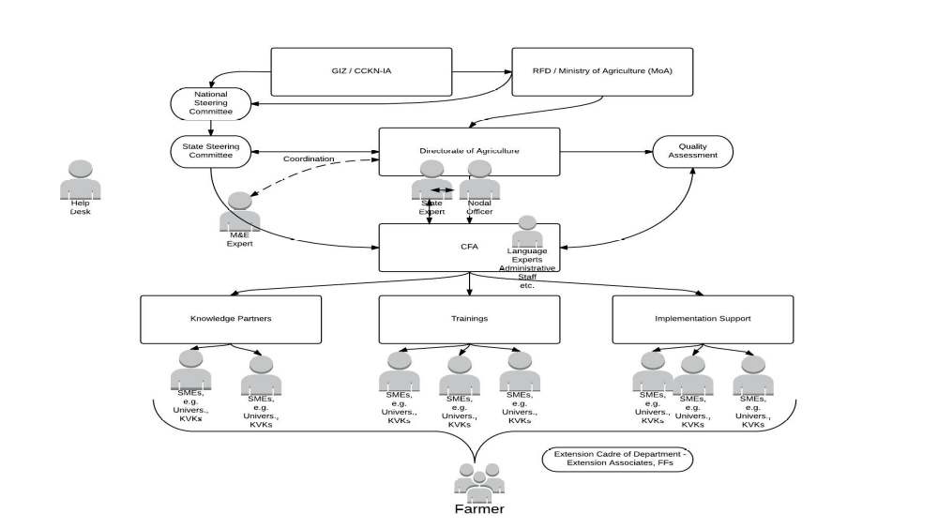

Consortium Approach
CCKN-IA consortium approach’ that would provide a platform for converging knowledge and expertise of diverse agencies at various levels. Mechanisms like National Steering Committees (NSC), State Steering Committees (SSCs) and District Steering Committees (DCSs)/ District Working Groups (DWGs) have been established to provide the needed platform for bringing on board diverse partners to collectively think, guide and support the CCKN-IA project
Consortium Facilitation Agency
The Government nominated leading institute at state level appointed as ‘Consortium Facilitation Agency’ (CFA) CFA coordinate and leverage skills and expertise of various existing and potential partners for implementation CCKN-IA at the state level.

Parameters for identification of the Consortium Facilitation Agency (CFA)

- Should be a registered entity appointed and nominated by Central/State Government and demonstrated experience of minimum five (05) years of facilitating capacity building in the agriculture sector
- Should have the ability to work across the state and at least in the project districts
- Availability of dedicated resources and facilities for designing and conducting trainings on climate smart agriculture
- Should have sound financial management systems and processes to be able to receive and manage foreign funds

Objective II . Work flow of CCKN-IA
OPERATIONALIZING ‘NICE’ OR Network for Information on Climate (Ex) change - TECHNOLOGY PLATFORM FOR CCKN-IA
CCKN-IA has developed a web based technology platform - ‘NICE’ OR Network for Information on Climate (Ex) change. The technology platform has been institutionalized under the project and will be piloted in 3 states – Jharkhand, Maharashtra and Odisha during in co-ordination with all relevant stakeholders and partners.

Develop and operationalize the CCKN-IA Technology Platform: The CCKN-IA is using advanced Web 2.0 and Web 3.0 technologies to establish the Climate Change Knowledge Network for Indian Agriculture. CCKN-IA will adopt the Web 2.0 platform to allow existing knowledge nodes (knowledge producing organizations such as IMD, ICAR institutions, CGIAR institutions and other agencies working on agriculture development and climate change) to interact and collaborate with each other. Once the knowledge node links are established the knowledge organizations populate the platform with dynamic content and enable the knowledge repository to grow day by day. The knowledge repository requires finer advanced semantic searches to enable users to arrive on the right information they are looking for. The CCKN-IA platform will use web 3.0 technologies to enable semantic searches. The Topic Map and/or Resource Description Framework (RDF) of Web 3.0 technologies will be integrated to the CCKN-IA platform that will allow block level delivery agencies (KVKs, NGOs, etc.) to retrieve the information from the knowledge repository and deliver it to the farmers in multi-mode approach. The “entity” will adopt the hub and spoke model for two way communication to achieve the objective of delivering knowledge and information in a timely manner which is contextualised and up-to-date. The central hub will initially be located at the Ministry of Agriculture, will be linked to different nodes which will be the spokes in the hub and spoke model. The Secretariat of the CCKN-IA is established at the Rainfed Farming Systems Division (RFS), Department of Agriculture and Cooperation under the Ministry of Agriculture (MoA), Government of India.

Creating Quality Content: CCKN-IA focuses on hyper-localized, relevant and valid content on climate change adaptation that can be used by different stakeholders to develop agro-advisories and strategize extension efforts catering to the localized needs and agro-climatic situations of the small and marginal farmers to adapt to impacts of climate change.

a. Existing Content: There are various agencies, institutions and experts from public as well as private sector, who are involved in generating and dissemination information related to agriculture and climate change. CRIDA, through its institutional mandate and expertise, provides district level ‘contingency plans’ that advice farmers to help them adapt to changing climatic impacts (droughts, floods, cyclones, earthquakes etc.). Similarly, various state and national expert institutions like the ICAR and the State Agricultural Universities provide agro-advisory services; India Meteorological Department (IMD) provides various predictions on weather and related services; Kisan Call Centres (KCC) provide individual need based advisories and information to farmers, as well as the extension efforts of local NGOs, KVKs and ATMAs. Private sector organisations provide innovative solutions like market information and related agro-advisories to farmers, community videos, community-based plant pest and disease management, out bound dialler calls and other services. CCKN-IA through facilitation by Ministry of Agriculture or through partnership arrangements will leverage these contents and knowledge products.
b. Localised need based Content: CCKN-IA through the ‘network approach’ would be leveraging and integrating these existing knowledge through its technological framework to further improve the efficiency of these existing mainstream agricultural extension efforts and provide timely and effective solution to farmers. The Department of Agriculture at the State level, facilitated by the Consortium Facilitating Agency, will leverage the expertise of the State level institutions and experts to develop and refine the localized content related to climate change adaptation, on ‘as on need’ basis. The content topics will be developed based on feedback and needs of farmers, climate change trends and predictions as per the local agro-climatic needs. The focus would be on creating content at the Gram Panchayat and Block level to address the localized needs. CCKN-IA will strengthen the capacities of the community based extension workers and farmers, to capture local needs and also suggest and develop content.

c. Indigenous Technical Knowledge (ITKs): There are proven indigenous technical knowledge in agriculture and allied sectors around climate change adaptation. The ITKs have evolved through experimentation and experiential learnings and practices of agrarian communities. CCKN-IA will be map and capture the relevant ITK practices for further potential exchange and dissemination.

Identifying local content topics: The local content topics will be identified through the following processes:

a. Experiences and expertise of local institutions like SAUs, KVKs and local NGOs: The Department of Agriculture facilitated by the CFA will form a small (3-5 members) Content Advisory Group (CAG) constituting of experts from the SAUs, KVKs, NGOs and other relevant departments/Technical Training Institutions/Research and resource agencies/private sector. The CAG will advise on the content topics on Climate Change adaptation (CCA) as well as suggest experts to develop these further. The Consortium Facilitating Agency (CFA) in turn will leverage these expertise and services (as and when needed) to develop the localized content. Content creation and validation process will mostly be done at the block and district level to make the system adopt a more decentralised and effective approach. This will include furthering the ongoing efforts to localise the existing content i.e. develop block level contingency plans based on existing district level contingency plans, develop climate/weather based advisories at block levels and other similar advisories and information at more localized levels.

b. Feedback from the agrarian community: The CCKN-IA project through an iterative process, will be capturing the feedback and queries from the farmers and other recipients of the climate change adaptation knowledge network. A ‘participatory vulnerability assessment’ will be commissioned by CCKN-IA that will provide useful insights and inputs on localized needs of farmers based on local agro-climatic conditions. These localized needs and feedback will be taken into cognizance by the Content Advisory Group (CAG) to further develop and refine the content.

c. Community generated content: CCKN-IA has a mandate to strengthen the existing extension systems and efforts of the Department of Agriculture. The final mile interface with the agrarian community are the field extension agents like farmer friends, village agricultural workers and lead farmers. CCKN-IA through tailored interventions will be strengthening this cadre of field extension agents. Efforts to enhance the knowledge and capacities of frontline extension cadre in providing timely and valid advisories to the farmers will be consciously supported under the project. CCKN-IA and CFA will co-ordinate with all relevant stakeholders to ensure creation of create content based on local and immediate needs of the farmers under specific agro-climatic zones.

Identify Experts to develop content: The Department of Agriculture at state level, through the appointed CFA in the state, will identify the experts from the local network based on the identified topics. These individual experts will then through formal arrangements with the CFA, develop the localized content.

Identify and detail the Indigenous Technical Knowledge in climate change adaptation: A detailed study will be commissioned by CCKN-IA for identifying and documentation through expert/s in the pilot states. State Agricultural Universities (SAUs), KVKs and other technical research and resource agencies will contribute to topics such as adaptation strategies and solutions. CCKN-IA will leverage the existing documented indigenous technical knowledge and practices in the training modules and the technology platform for dissemination and use by relevant stakeholders. ICT tools such as crop simulation models, community videos, water balance models and weather prediction 10 models, Geographical Information System (GIS), remote sensing etc., to generate and disseminate appropriate information and knowledge needed for the network. Contents will be in 4 different formats - SMS, word or pdf files, pictures/posters and videos.

Content Review: CCKN-IA technology framework has a built-in ‘approval processes’ for the content created. First level of quality assurance would be through a peer-review process wherein the content created will be validated by subject experts and the CAG constituted at the state levels. The validated content would then be finally approved for dissemination by the expert/s identified in consultation with the DoA. The CAG members will review the localized contents and validate/fine-tuned as per the farmer needs. Only the approved content will be disseminated to the farmers and other stakeholders. The protocols for quality assurance is being developed by CCKN-IA and will be further detailed in the document “CCKN-IA Quality Assurance Protocols”. The quality of the content will be assured on following parameters:
- Timeliness: The advisories created are aligned to the concurrent needs of farmers and timely delivered
- Complete: the content should be complete (logically as well as technically)
- Understandable: the advisories thus created should be in local language and use simple terms that could be understandable by a farmer
- Relevance of the content: aligned to concurrent and local needs of the farmers (avoid generic advisories)

Content Management: Content management entails ensuring that the quality content is developed, approved and disseminated on a timely manner and as per the local needs and contexts. The role of ‘content manager’ will be played by the ‘Coordinator’ of the Consortium Facilitating Agency (CFA) supported by State Advisors (under CCKN-IA).
The responsibilities include:
- Ensure that climate change adaptation content and topics are identified as per the local needs and contexts
- Experts are identified and assigned the responsibility to develop location specific content on climate change adaptation practices
- Follow-up and make sure that content is created, reviewed and approved on a time-sensitive manner

Translation and Review: Once the content is developed, reviewed and approved; it would be translated into local languages by a language expert. The project through the CFA will take the services of the language expert for professional translation of the content in local language. Finally the translated content will be reviewed and approved by experts identified by the DoA at the State level for further dissemination.

Dissemination and Outreach: CCKN-IA will support partners in dissemination of climate smart agricultural information and advisories to all stakeholders. This includes:
• Direct information to farmers through SMS, posters, Outbound Dialler (OBDs) and video
• Integration with existing Kisan Call Centres (KCCs)
• Building capacities of existing extension cadre - Farmers friends, Krishak Mitras, Assistant Agriculture Officer as thematic support to community cadre/farmers will use of tablets and other ICTs for dissemination of messages to farmers
• Leverage dissemination and outreach capacities from the existing community platforms like Farmer groups, Self Help Groups (SHGs), Farmers Field Schools (FFS), Farmer Information Centres and others
• Local climate change advisory groups of expert trained farmers 3-4 member groups in each village who have adopted the Climate Change adaptation (CCA) practices
• Other Private partners working in the region may also be engaged for effective dissemination. Such partnerships will be managed by state partner i.e. Department of Agriculture.

Dissemination to wider Knowledge users and Stakeholders: The CCKN-IA technology framework is an open source platform providing users the flexibility to adapt to their knowledge and information needs. The online platform provides an integrated knowledge repository for the users (build from leveraging and converging various information sources) on climate change adaptation for Indian agriculture. The users can browse and use the relevant climate change information from the CCKN-IA web-based platform for use and further dissemination. The platform provides the opportunity to the registered users to create, add and disseminate validated content.

Direct dissemination to farmers through Mobile and KCCs: The CCKN-IA platform will directly disseminate the climate change adaptation knowledge and information to registered farmers through SMSs, outbound dialler calls, Videos and posters. CCKN-IA knowledge repository will be used to support and upgrade the services of the KCCs. The project will support personalised dissemination of CCA messages and package of practices, on-site demonstrations, posters and pamphlets through the existing extension cadres for better adaptation of farmers and wider dissemination and outreach.
Feedback and Queries from Farmers: To ensure that the content on climate change adaptation is localized and meets the local needs and demands of farmers in the specific agro-climatic zones, CCKN-IA technology framework has an in-built module for capturing farmer feedback and queries. The module will enable the farmers to – a) provide feedback on the quality, timeliness, specificity and effectiveness of the medium (SMS, videos, OBD, posters etc.), b) post queries/clarifications on the content as well as future needs. The feedback and queries can be captured in two ways:
▪ Farmers post the feedback and queries through the extension cadre or expert farmers using tablets/smart phones / web
▪ The extension agent/expert farmer compiles the feedback and queries and posts it on CCKN-IA technology framework
.
Review progress and Reports: The usage and progress data of the climate smart agriculture content created and disseminated will be available (on almost near real time basis) on the CCKN-IA technology platform. The managers can view or download the reports as per the need. Customized reports can be generated from the technology platform catering to the specific information needs of various clientele and decision/policy makers from Village to National levels. CCKN-IA will partner with and seek collaboration with other expert institutions providing innovative ICT based solutions for agrarian community as well as strengthen existing extension systems like Kisan Call Centres, KVKs etc., to disseminate climate change adaptation knowledge and information.

Operational structure of NICE platform
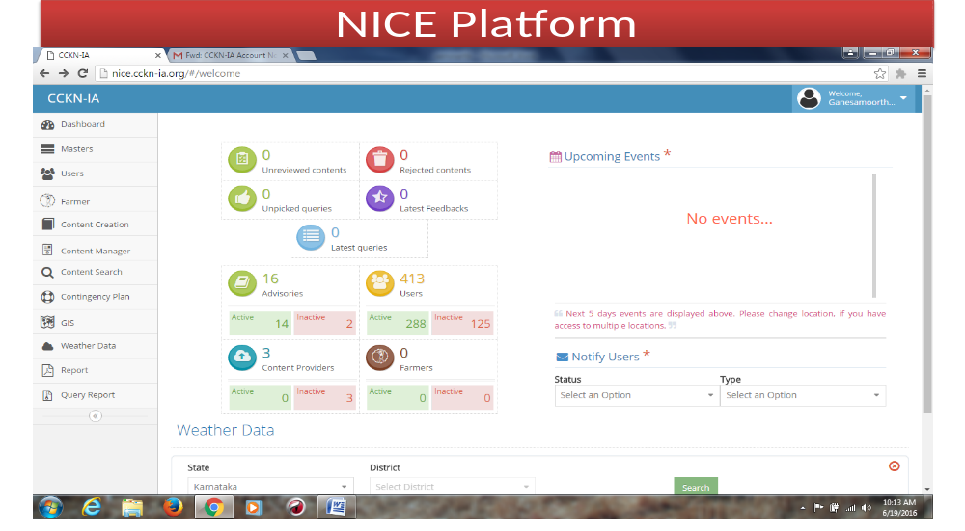

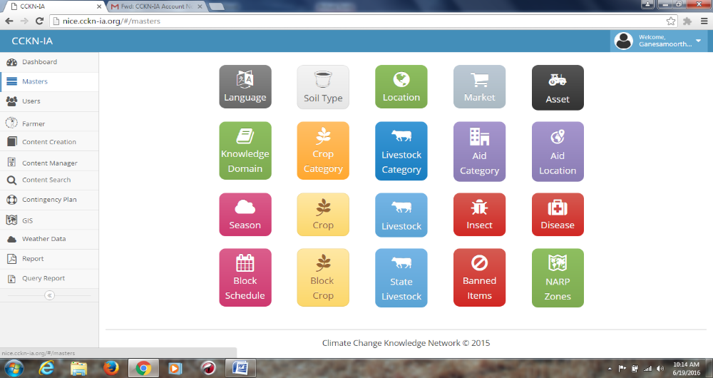

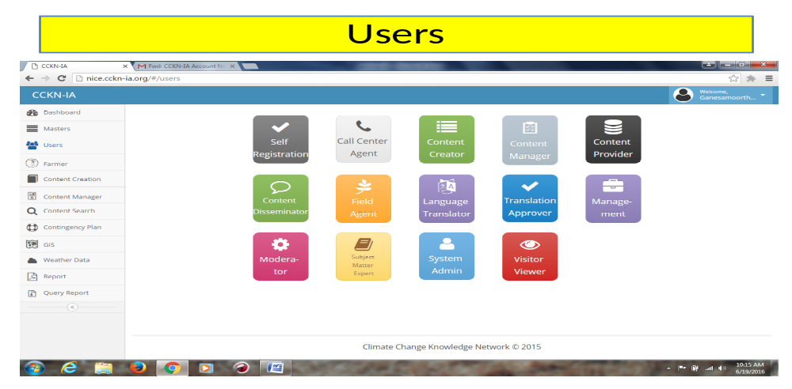

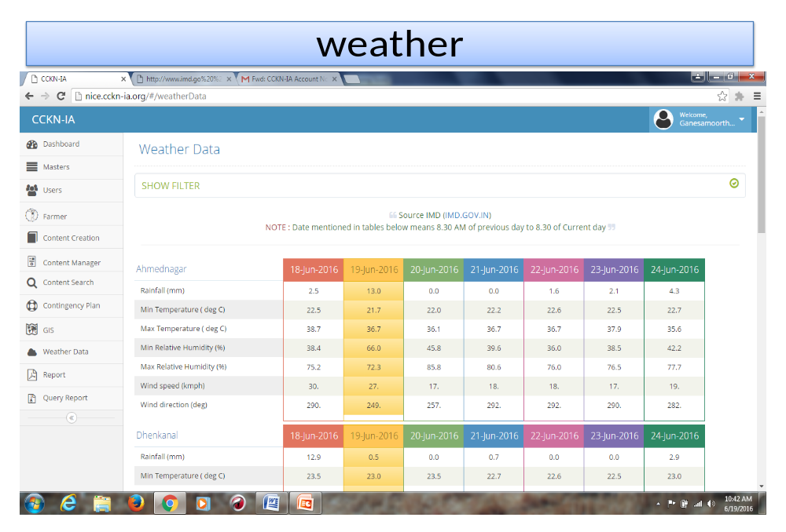
Creating quality content
- Creating content is an important stage in CCKN-IA project.
Content need assessment is conducted every season in close consultation with farmers and scientist from agriculture science centers based on inputs content is developed through
- Existing content: Partnership leverage exist contents and knowledge products
- Localized need based :The content topics will be developed based on feedback and needs of farmers, climate change trends and predictions as per the local agro-climatic needs
- Indigenous technical knowledge: CCKN-IA will be map and capture the relevant ITK practices for content creation
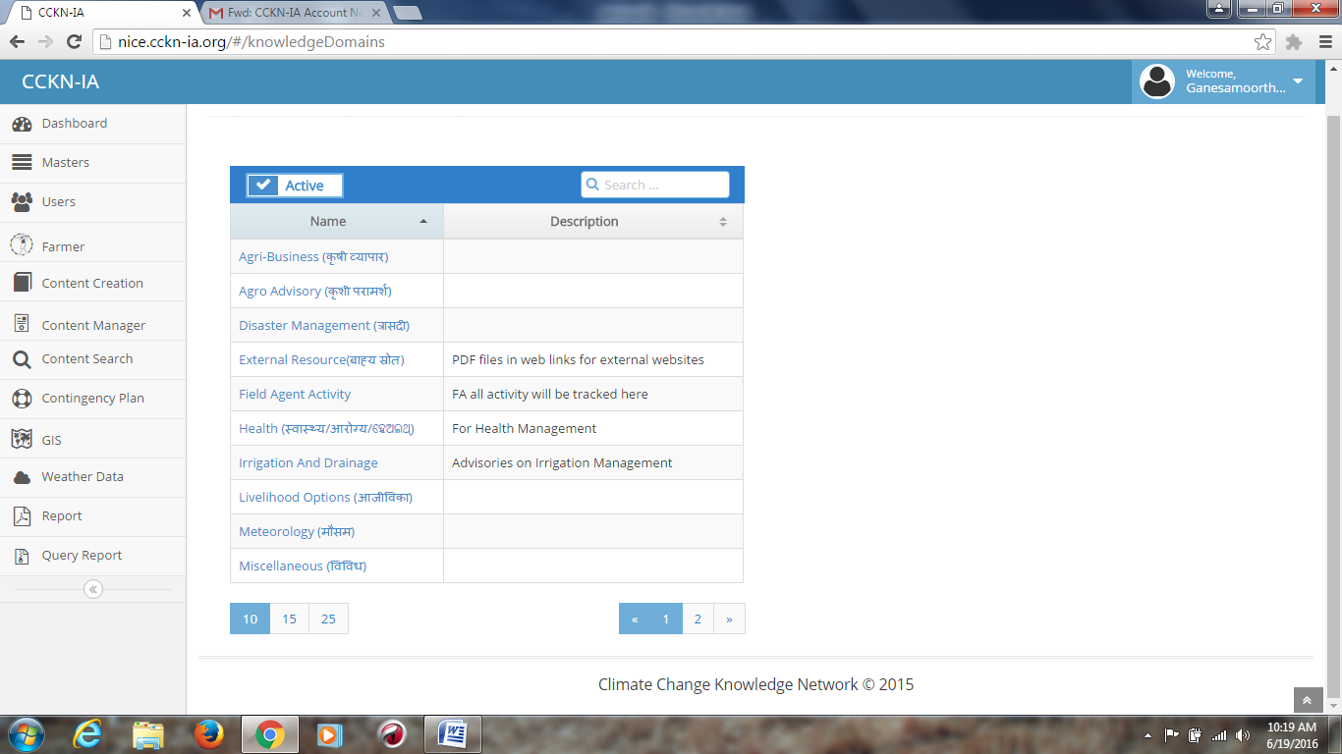
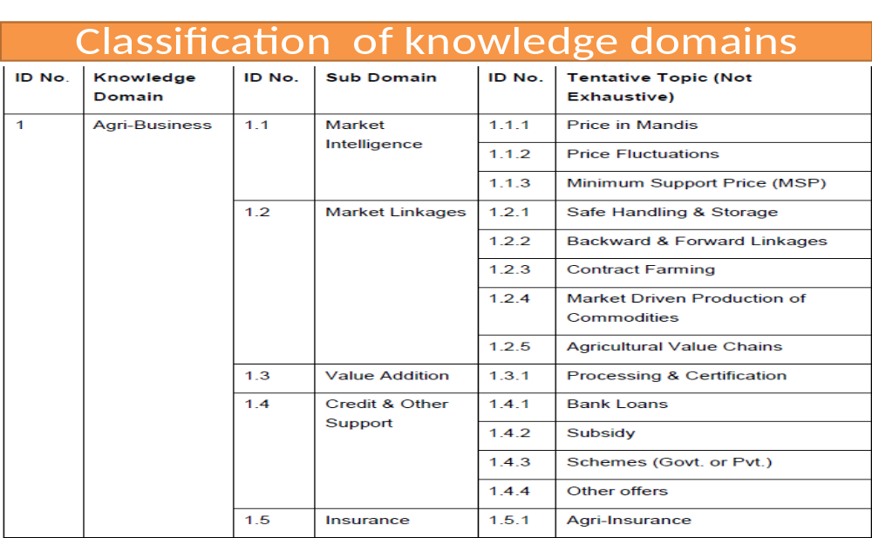
Content review
CCKN-IA technology framework has a built-in ‘approval processes’ for the content created. The CFA members will review the localized contents and validate/fine-tuned as per the farmer needs. Only the approved content will be disseminated to the farmers and other stakeholders

The quality of the content will be assured on following parameters
- Timeliness: The advisories created are aligned to the concurrent needs of farmers and timely delivered
- Complete: the content should be complete (logically as well as technically)
- Understandable: the advisories thus created should be in local language and use simple terms that could be understandable by a farmer
- Relevance of the content: aligned to concurrent and local needs of the farmers
Translation
Once the content is developed, reviewed and approved; it would be translated into local languages by a language expert. Finally the translated content send to the further process

Dissemination
CCKN-IA support to the partners in dissemination of climate smart agricultural information and advisories to all stakeholders. This includes
- Direct information to farmers through SMS, posters and videos
- Integration with existing Kisan Call Centres (KCCs)
- For effective dissemination of information to farmers CCKN-IA use cadre of
- extension agents equipped with NICE application on the tablet .

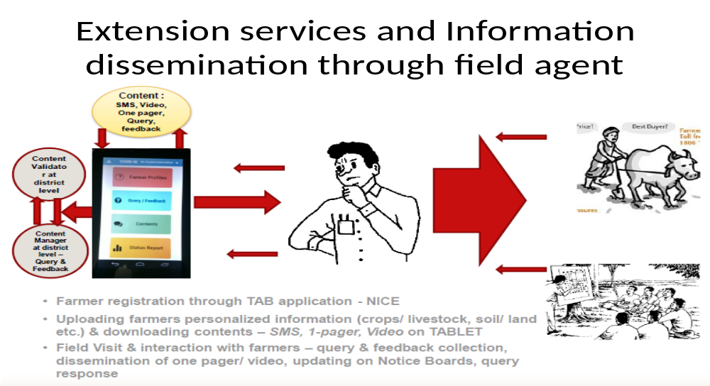
The extension agents receive Bi-weekly agro metrology advisory that contain information on weather forecast, weekly agriculture advisory, climate change adoption practices. This information regularly hand written on black board that have been constructed at the center at village.This is read, analyzed and discussed with farmers to adopt climate change adoptions.
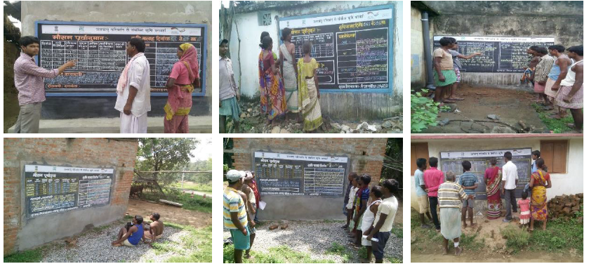
CAPACITY BUILDING
Technical support for design, installation, capacity building support, initial handholding and roll out of the technology platform at the state level will be the responsibility of the CCKN-IA team. CFAs will facilitate the training of the extension functionaries and farmers in operational villages in close co-ordination with subject matter specialists/trainers and other relevant stakeholders. The Extension Training Centres at the State level will ensure that the Training Plan/Training Calendar is in place, roaster of experts, maintain attendance, validate training data, collect training feedback/evaluation on quality of content, training methodology, IEC materials, training facilities and infrastructure, quality of trainers, other necessary reports and have systems to capture the outcomes of the training programmes required for the Government, CCKN-IA team and other stakeholders.

Linking with and strengthening existing State Agricultural Extension Systems: CCKN-IA will link with and strengthen existing State agricultural extension systems and agricultural extension institutions like Krishi Vigyan Kendras (KVKs), Extension Education Institutes (EEIs), Agricultural Extension Training Centres (ETCs), Farmers Training Centres (FTC), State Agricultural Management and Extension Training Institutes (SAMETIs) etc. These linkages will be facilitated by the State Department of Agriculture and the Ministry of Agriculture, Government of India. CFAs and State Advisors will play a coordination and facilitation role of linking all relevant stakeholders at the State level under the project.
Types of capacity building interventions:
Knowledge and skill building of Extension Functionaries and Farmers: Generic knowledge and skills of extension functionaries and farmers will be enhanced through structured thematic trainings/capacity development initiatives/exposure visits on climate-smart agriculture principles and practices to institutions and organizations working on Climate smart agriculture. Such improved knowledge and skills can be field tested and fine-tuned by the targeted clientele to better adapt to the local agro-climatic conditions. Best practices, models and innovations at the state, national and international experiences will be shared with the targeted clientele from village, block, district, state and national levels through various trainings/capacity development initiatives, exposure visits, field days, videos and others.

Use of CCKN-IA Technology Framework: Focussed trainings and capacity building initiatives will be supported at the State and National level to enhance the knowledge and capacities of the agricultural extension functionaries and the farming communities on the use of the technology platform. Design, installation, roll out, initial handholding and post installation technical support will be imparted by the CCKN-IA team to all stakeholders at the National and State levels.

Adoption and application of climate smart agricultural practices by Farmers: Agricultural extension functionaries and farming communities will be encouraged for adoption and application of climate smart agricultural technologies and practices. Platforms for peer learnings, sharing of innovations and farmers’ best practices will be supported and institutionalized under the project with relevant stakeholders. An objective based incentive system is being developed for supporting the extension cadre under the CCKN-IA to ensure that CCA practices and models are adopted by farmers in operational villages.

Clientele for trainings and capacity building:
1. MoA: Orientation and exposure visits on climate smart agriculture, innovative technologies and use of ICTs primarily on the technology platform, best practices, models and innovations from states, national and international experiences.

2. State level Managers and Implementers: Orientation and exposure visits, cross learnings from the experiences of other states and development actors, innovative technologies and use of ICTs including the CCKN-IA technology platform and CCA best practices, models and innovations from national and international experiences.
3. District and Block level Managers and Implementers: Training of Trainers (TOTs), Thematic and technical trainings on climate smart agriculture, Cross-learnings, field exposures, use of CCKN-IA technology platform, management and effective dissemination of localized climate smart technologies. Further, as needed, the extension cadre and manager of other private sector, NGOs and CBOs can be trained on CCA and its effective dissemination
4. Extension Cadre (Krishak Mitras, Village Agricultural Workers, Village Agricultural Extension Workers and Others2): Thematic and technical trainings on climate smart agriculture, exposures, field demonstrations, peer-experience sharing, use of CCKN-IA technology platform, management and effective dissemination of localized climate smart technologies, interfacing and exchanges with relevant stakeholders.
5. Farmers: peer learning, trainings on climate smart agriculture, exposure visits, use of ICTs including the CCKN-IA technology platform, on-site demonstrations, peer-experience sharing.
6. Experts responsible for creating and validating climate smart agriculture content: orientation and trainings on climate smart agriculture, field visits and exposures, peer learning and sharing.

Role of Department of Agriculture and State level agriculture training institutes:
- Provision and support to existing Extension Cadre: The DoA will ensure the provision/allocation of the necessary human resources including agriculture extension personnel and the existing extension cadre at village, block, district and state levels for smooth implementation of the CCKN-IA project in operational villages.
- Provision and support to training efforts: The State level agriculture training and management institutions and the DoA will be responsible for the identification of experts, Trainers/Master Trainers, organise trainings, exposures and field demonstrations with farmers in operational villages in co-ordination with all stakeholders. The DoA to ensure provision of all the costs for the trainings/exposure including development and printing of IEC materials/training materials, logistics, TA/DA of trainees (if applicable), lodging & boarding costs, food costs and training infrastructure costs including Audio-Visual aids.
- Identification of Master Trainers for TOTs and Scale-up: Master trainers from the state agricultural extension department, KVKs, SAMETI, innovative / progressive farmers from the farming communities in the operational villages will be identified by the DoA and the State level agriculture training and management institutions for facilitating Training of Trainers (TOTs) and future scale up.
- Mainstream Climate Change Adaptation Modules in state level training efforts: Training modules will be tailor-made to ensure mainstreaming of Climate Change Adaptation components in the existing state training modules for extension functionaries and farmers.
- Institutionalize Systems for Accreditation of quality Trainers: DoA and the State level agricultural training and management institutions will help institutionalize accreditation systems to identify good qualified technical resource persons and trainers and maintain a roaster. The accreditation process for all individual technical resource persons and trainers will need to be updated on an annual basis.
- Mainstream follow-up and hand-holding support of Trainers and Trainees: DoA and the State level agriculture training and management institutions will ensure systems and processes to track follow up and provide hand-holding support of trainers and trainees for continuous learning, improvement and engagements under the CCKN-IA.

Support from CCKN-IA: CCKN-IA will support all costs for technical expertise like supporting external technical resource persons/consultants who can support and add value to the training programmes on demand/necessity.
The areas of support include:
- Experts/Consultants to develop Climate Change Adaptation training modules and delivery
- Orientation of key experts (to act as trainers subsequently) on developed CCA modules
- Technology platform
- Advise on institutional set-up, technology platform and capacity building efforts
- Provision of Tablets for village level extension workers
- Provision of Incentives for community extension cadre as per need
- Facilitating exposures, workshops and other trainings of extension functionaries, farmers and other stakeholders
- Creation, consolidation and dissemination of tailored knowledge products on agriculture and climate information

Monitoring and Evaluation of trainings provided to master trainers, extension agents and farmers:
- Delivery of trainings as per the designed state level training calendars for extension functionaries and farmers.
- Attendance of trainees (Gender disaggregated information - male and female), regularity, drop outs.
- Pre and post training assessment including evaluation of trainings by trainees on quality of training including technical sessions facilitated, content/IEC materials, relevance, methodology, duration, effectiveness and use, assessment of the trainer/master trainers, assessment of the training infrastructure and facilities etc.
- Follow-ups including actions taken by extension agents after the training sessions at the community level in operational villages with farmers and relevant stakeholders, organization of Refresher trainings, exposures and on-site technical handholding support

Development of knowledge components
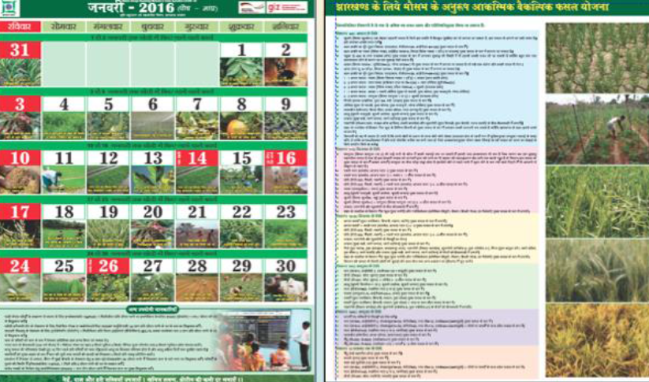

Publications
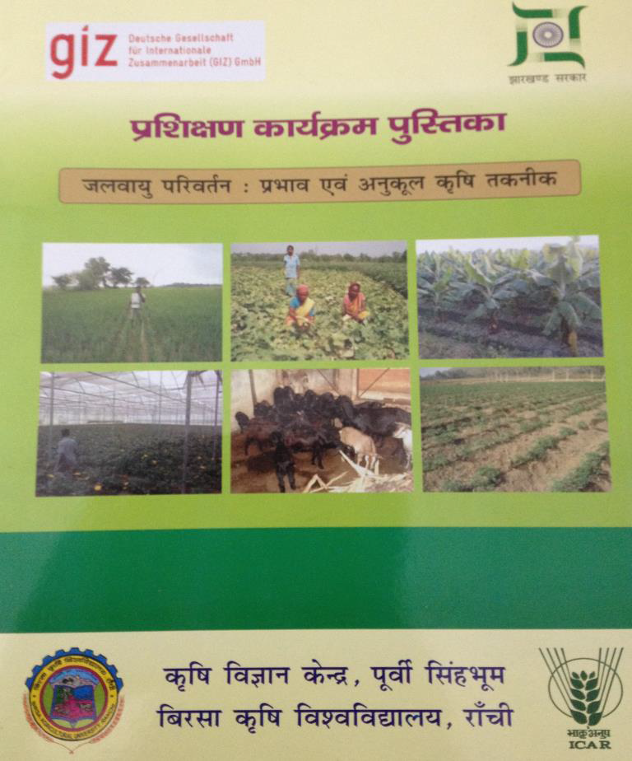
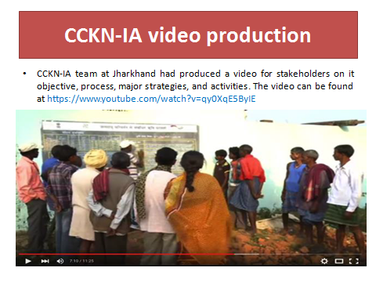
III Objective : Review of research studies
Farmers’ knowledge and communication network regarding climate and weather parameters in relation to crop management (Ravi kumar2013)
Knowledge network needs of the farmers about climate and weather in relation to crop management (N=120)
S.I | Knowledge network needed areas | Frequency and percentage of respondents
S.I | Knowledge network needed areas | Not needed | Some what needed | Most needed
1 | General climate and weather parameters | 47  (39.2) | 65  (54.2) | 08  (6.6)
2 | Crop planning | 32  (26.6) | 65  ( 54.2) | 23  (19.2)
3 | Crop production | 0 | 26  (21.7) | 94  (78.3)
4 | Crop protection | 0 | 20  (16.7) | 100  (83.3)
5 | Post harvest management | 17  (14.2) | 80  (70.6) | 19  (15.2)

Training needs of the farmers about climate and weather in relation to crop management (N=120)
S.I | Training needed areas | Frequency and percentage of respondents
S.I | Training needed areas | Not needed | Some what needed | Most needed
1 | General climate and weather parameters | 42  (35.0) | 65  (59.2) | 07  (5.8)
2 | Crop planning | 18  (15.0) | 72  ( 60.0) | 30  (25.0)
3 | Crop production | 0 | 32  (26.7) | 88  (73.3)
4 | Crop protection | 0 | 23  (19.2) | 97  (80.8)
5 | Post harvest management | 14  (11.7) | 88  (73.0) | 18  (15.0)
Information needs of the farmers about climate and weather in relation to crop management is most needed for crop protection (83.33%),where as information need for crop production was 78.3 per cent.54.2 per cent of farmers needed some what similar for general climate and weather parameters. But, in case of post harvest management only 19 per cent farmers opinioned it as most needed information
CCKN-IA Project review
Technology platform will be useful to mainstream CCA interventions, adaptation and mitigation strategies, innovations and it covered about 278 villages across three states in India, 78 organizations attending in dissemination and 14,789 farmers registered with having 15 thematic domains
Conclusion

CCKN-IA believes that information is power. In order to adapt for climate change, CCKN-IA provides timely, relevant and hyper localized information to the farmers. It has shown to have important cross sectorial knowledge management in the field of the climate change adaption with high level ICT penetration in rural areas and also it provides very unique solution for using technology to leverage of information for the benefits of farmers

Discussion
- Where it exists, is there any website?
Ans: yes, website name is www.cckn-ia.org

- Any impact studies have conducted on this? What’s the rate of adoption?
Ans: yes, itself conducted and rate of adoption is 39%.
3)Is it organization?
Ans: yes
4)NICE is data management software or website?
Ans: It is data management software.

