Introduction:-

Information and Communication Technology (ICT) plays a major role in all aspects of national life: in politics, in economic life, as well as in social and cultural development. It is rapidly transforming our lives, the way we do business, access information and services, communicate with each other and entertain ourselves. It fuels the global economy. It also relates to human rights, helping, at best, to support freedom of expression and right to information according to the Article 19 of the Universal Declaration of Human Rights.
Extreme poverty, experienced by about 1.2 billion people is considered by many to be the worst human right violation in the world. Consequently, the global development community has endorsed in the Millennium Development Goals its commitment to halving the number of people living under one dollar a day by 2015.
In 1998 OECD member countries agreed to define the ICT sector as a combination of manufacturing and services industries that capture, transmit and display data and information electronically. The important factor in this broad definition is that, as it breaks the traditional dichotomy between manufacturing and services, activities producing and distributing ICT products can be found everywhere in the economy. (OECD 2002). The definition, thus, paves way for understanding the multi-dimensionality of the ICT and its applicapability in helping reduce poverty across various sectors.
The manufacturing sector of ICT hardware and software contributes to the economic growth and creates employment in countries like China, Malaysia and Mexico. India, on the other hand, has been a beneficiary of global software outsourcing, achieving spectacular growth in this sector. India exports software to 95 countries around the world and serves as a major outsourcing hub. The main market for the Indian software has been the USA, and to a lesser degree Europe. 185 Fortune 500 companies outsourced their software requirements in India alone. ICT industry generated $7.7 billion in 1999 creating 180,000 jobs in India in 1998. (UNDP 2001b). Since these sectors rarely create direct employment for the very poor, who are mostly uneducated, we need to review mainly the service role of the ICT.

Information and knowledge are critical components of poverty alleviation strategies, and ICTs offer the promise of easy access to huge amounts of information useful for the poor. However, the digital divide is argued to be the result rather than the cause of poverty, and efforts to bridge it must be embedded within effective strategies that address the causes of poverty. Moreover, earlier patterns of adoption and diffusion of technology suggest that ICTs will not achieve their full potential without suitable attention being paid to the wider processes that they are intended to assist and to the context within which they are being implemented.
So far, the use of ICTs for poverty alleviation has not achieved the status of a mass movement, despite the many promising results that have emerged from experimental installations. Aside from the difficulties of measuring their impact, which should not be
underestimated, there are considerable challenges in turning a promising experiment into a mass deployment. The widespread diffusion of a technology beyond the pioneering adopters requires a number of key enabling factors that serve to reduce the uncertainties of adoption. Advocates of the use of ICTs for poverty have yet to formulate these enabling factors, although they are getting there.

Poverty:

Poverty is general scarcity, dearth, or the state of one who lacks a certain amount of material possessions or money. It is a multifaceted concept, which includes social, economic, and political elements.

Absolute poverty or destitution refers to the deprivation of basic human needs, which commonly includes food, water, sanitation, clothing, shelter and health care. Relative poverty is defined contextually as economic inequality in the location or society in which people live.

According to 2011 World Bank Report,
- 17 percent of people in the developing world live at or below $1.25 a day
- As of 2015 (2011 statistics), there were over 1 billion poor people in developing countries who live on $1.25 a day or less.

The World Bank view goes beyond the view of income levels in its definition of poverty, suggesting that poverty includes powerlessness, voicelessness , vulnerability, and fear.

Poverty is also being deprived of the information needed to participate in the wider society, at the local, national or global level.

Why Information is so important??

- Information is regarded by economists as a critical element in the efficient functioning of markets.
For example:
the law of one price (i.e., the price of a good should not differ between any two markets by more than the transport cost between them) are based on the assumption that economic agents have the necessary information (Jensen 2007).
- Access to information - essential for the emergence of global information and knowledge based economy
- Information has the ability to empower poor communities,
- Information enhance skills, and link various institutions involved in poverty reduction.
- Hence, a knowledge gap an important determinant of persistent poverty.
- There is a need for policies that encourage greater communication and information flows both within and between countries.
- One of the best possible ways to achieve this is through greater interaction is through the use of ICTs.
- First use of ICTs for development (ICT4D) was in 1956, with the installation of a computer to support analysis for government planning in the Indian Institute of Statistics (Heeks, 2009).
- It was used for internal use within government organisations for data processing and management information system

- In 1998, one of every 100 inhabitants in a developing country was an Internet user.
- By 2013, that figure was estimated to have risen to 31 per 100, and annual growth rates have been over 15% .
- Rise for mobile phone subscriptions has been even greater.
- 2% of the developing world’s population in 1998 posessed mobile phones .
- By 2013,the no.has risen to 89%, with an annual growth rate of 29% .

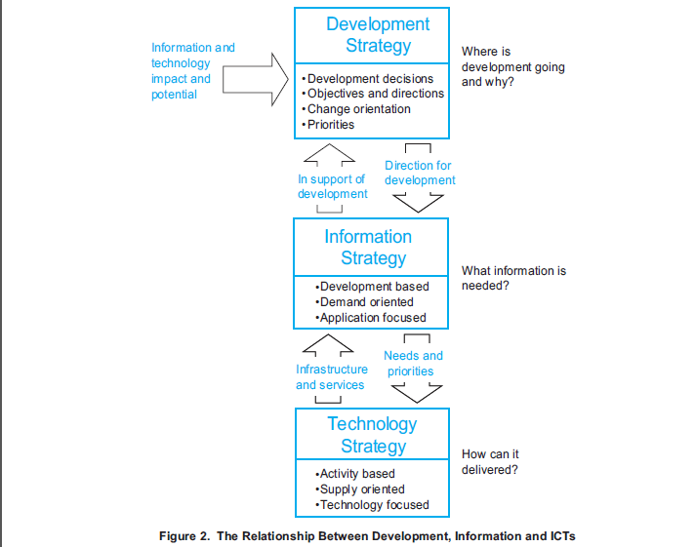
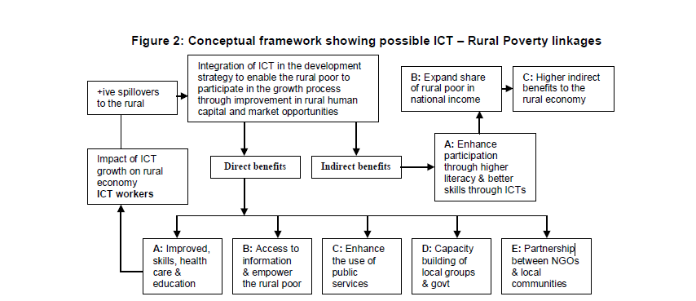

What strategies for poverty alleviation have been successfully pursued
with the use of ICTs?

- Distributing locally relevant information

- Village Information Shops in Pondicherry -uses Tamil language and Tamil script in the computers. (Sentilkumaran and Arunachalam, 2002)
- Centre in Villianur – generated no. of databases for local use in Tamil.
- Centres collect information on indigenous knowledge systems and
develop useful brochures in Tamil.

- Targeting disadvantaged and marginalized groups

- Disadvantaged and marginalized sections of society usually face impediments to using, and making good use of, ICTs especially women.
- likely to use ICTs in different ways, and have different information requirements than men.
- The Honey Bee network in India collects local innovations, inventions and remedies, stores them on-line and helps owners obtain incomes from local patents and commercialization of inventions.
- The database contains more than 1,300 innovations.
- Promoting local entrepreneurship

ICTs have the potential to impact the livelihood strategies of small-scale enterprises and local entrepreneurs in the following areas:

- Natural capital - opportunities for accessing national government policies.
- Financial capital - communication with lending organizations
e.g: for micro-credit
- Human capital - increased knowledge of new skills through distance learning and processes required for certification
- Social capital - cultivating contacts beyond the immediate community.
- Physical capital - for the provision of basic infrastructure

- In Gujarat, computerized milk collection centres using embedded chip technology- help ensure fair prices for small farmers who sell milk to dairy cooperatives.
- Computerized milk collection now increases transparency, expedites processing.
- It helps provide immediate payments to farmers (World Bank, 2002).

- Improving poor people’s health

- ICTs help facilitate remote consultation, diagnosis, and treatment.
- Several new malaria Internet sites for health professionals include innovative “teach-and-test” self-assessment modules.
eg: healthnet.com
- Centralized data repositories connected to ICT networks enable remote health care professionals to keep abreast of the rapidly evolving stock of medical knowledge.
- Public broadcast media -radio and television have a long history of effectively facilitating the dissemination of public health messages and disease prevention techniques.
- Internet is gaining importance as it provides vast information to to users within a short period of time
- In Andhra Pradesh, handheld computers are enabling auxiliary nurse midwives to eliminate redundant paperwork and data entry, freeing time to deliver health care to poor people.
- Midwives provide most health services in the state’s vast rural areas, with each serving about 5,000 people, typically across multiple villages and hamlets.
- They usually spend 15–20 days a month collecting and registering data. But with handheld computers can cut that time by up to 40%, increasing the impact and reach of limited resources (World Bank, 2002).

- Strengthening education

- ITCs like internet can be used to educate more people for less money.
- Such factors have led to growth of distance education.
- On-line education facilitates student and tutor interaction, flexibility and offers choice to the learners.
- MOOC(Massive Open Online Courses) are gaining large foothold among the people due to the immense benefits it offers
- In 2000, Sugata Mitra of NIIT Ltd. placed an Internet-capable personal computer behind a glass screen in a wall of his office building that looked out to a piece of land occupied by street kids
- This was known as “Hole in the Wall” experiment and the children very quickly learned an impressive range of computer skills without any tuition at all.
- As one child learned something new from experimentation, he/she passed it on to the next child.

- Promoting trade and e-commerce

- E-Commerce is now spreading its wings
- M-commerce refers to buying and selling of goods and services using wireless handheld devices like mobiles or personal data assistants (PDA)
- Main areas of m-commerce include text messaging or SMS , micro-payments, financial services, logistics, information services and wireless customer relationship management
- The Safal National Exchange of India Limited (SNX), Bangalore, promoted online trading in banana and mango through the Agricultural Technology Management Agency (ATMA).
- It traded 9,000 tonnes of mangoes grown in Krishnagiri district in Tamil Nadu, Chittoor district in Andhra Pradesh and in Bangalore in 2005.
Supporting good governance
- E-governance has the potential to alleviate the powerlessness, voicelessness, vulnerability and fear dimensions of poverty.
- It can be used to break down traditional patterns of exclusion, opaqueness, inefficiency and neglect in public interactions with government officials.
- Bhoomi a project is responsible for online delivery of land titles in Karnataka, -it has helped computerize 20 million records of land ownership of 6.7 million farmers in the state.
- It is helpful in overcoming the unnecessary lengthy procedures and red tapism ,delays, harassment and bribes.
- Now, farmers can get a RTC for any parcel of land and a Khata extract (statement of total land holdings of an individual) in 5-30 minutes from an RTC information kiosk at the taluk headquarters.
- Building capacity and capability

- ICTs can be used in the form of multimedia community centres/telecentres, especially at rural level -nodal point for:
- community connectivity, local capacity building, content development and communications, and serve as hubs for applications, such as distance education, telemedicine
- To provide support to small,medium sized and micro-credit enterprises, promotion of electronic commerce
- Environmental management, and empowerment of women and youth.
- 2,20,000 women members of India’s Self-Employed Women’s Association(SEWA) - earn a living through their own labour or through small businesses - started using telecommunications as a tool for capacity building among the rural population.
- They use a combination of landline and satellite communication to conduct educational programs on community development by distance learning.
- Community development themes covered in the education programs delivered include organizing, leadership building, forestry, water conservation, health education,child development, the Panchayati Raj System and financial services.

- Supporting agriculture

- ICTs can be utilized for crop care and animal husbandry, fertilizer and feedstock inputs, drought mitigation, pest control, irrigation, weather forecasting, seed sourcing and market prices.
- They enable farmers to participate in advocacy and cooperative activities.
- Some examples are AGMARKNET,E-choupal ,E-sagu ,E-organic,Weatherwatch ,Agriindia

- Creating employment opportunities opportunities in two ways

ICTs help in providing employment

- Unemployed people can use ICTs to discover job opportunities.
Ex- naukri.com
- It helps the unemployed people to become employed in the new jobs that are created through the deployment of ICTs
Ex-Online sites by SEWA’s member organizations to sell their products in global virtual market place

FOREGROUNDING DEBATES
Information and communication technologies are viewed as heralding the onset of an
information society in nations and communities historically excluded from the fruits of
development and progress.

ICT’s are widely recognized for the contradictory twin roles they simultaneously play in society:
- the immense potential to meet development goals and
- to widen the gulf between information rich and poor communities overlapping with existing socio-economic divides.

They also cover a broad range of meanings, approaches and practices from curing perennial poverty through capacity building to mushrooming back-end processing offices (BPO’s) in urban sectors generating rapid employment.
But, it is universally regarded as a ‘good thing’. ICT for development is the new mantra for initiatives to transform developing nations to superpowers or underdeveloped countries to clean and healthy ones.
India is witness to rapid IT driven socio-economic boom with its GDP growth reaching all
time high. Indian urban landscapes are dotted with IT parks, global support centers and
special economic zones. The government introduces pro-active policies to quicken the pace of economic upswing in the country. But this is barley a portion of the overall scenario.

Despite, a booming economy, the majority of suburban, peri-urban and rural India is yet to experience the fruits of prosperity.
Seeking to gain momentum through India’s mission of digital inclusion, many such
ideologically driven processes (even those driven by government and private sector
partnerships), find inconsistent adoption and sustainability in communities aspiring for entry
into the larger information culture.

Nevertheless, consumption of ICT value-oriented services is growing, with 6.6 million mobile phones added in October 2006 in India.
In this backdrop of increasing Indians interfacing with market driven ICT, we argue that the notional preponderance of development in challenging digital exclusion, evade or turn way from social processes, not in alignment with presumed development goals, where ICT’s find better routes of immersion.

To recollect a brief history of internet in India, the government introduced the first
international telecom carrier in 1995. The Indian Government has been propelling towards
“information age” and “convergence” by announcing enabling policies toward development
and progress with an ultimate goal of “Internet for All”. However, implementation of some
of these policies have been beset with various operational, procedural, regulatory issues and
supporting legal framework, which is inhibiting the reach and benefit of the Internet to masses in the country.

A current survey by the Internet and Mobile association of India, IAMAI, puts India’s Internet User Base At 37 Million touching 54 Million By March 2008. The e-Technology group at Indian Market Research Bureau, IMRB, felt “The next round of growth will be driven by new and innovative applications such as blogs, P2P, video on demand and
online gaming. While the old favorites such as email, chat and IM will drive first time users to the medium”.

The poverty-reducing potential of ICT
TheWorld Development Report 2000/01: Attacking Poverty identifies three priority areas for reducing poverty:
- increasing opportunity,
- enhancing empowerment,
- and improving security.

Opportunity makes markets work for the poor and expands poor people’s assets. Empowerment makes state institutions work better for poor people and removes social barriers. Security helps poor people manage risk. In light of current experiences in rural India and elsewhere in the developing world, it is apparent that ICT -defined as the set of activities that facilitates the capturing, storage, processing, transmission and display
of information by electronic means - can be utilized to support poverty reduction strategies.

The use of ICT applications can enhance poor people’s opportunities by improving their access to markets, health, and education. Furthermore, ICT can empower the poor by expanding the use of government services, and reduce risks by widening access to microfinance.

ICT projects for poverty reduction in rural India
Although most of the rural poor in India are isolated from the information revolution, there are several examples in rural India where ICT is used to contribute to poverty reduction in the areas of opportunity, empowerment and security.
The following highlight ICT applications that are attempting to realize the potential of ICT. The first two focus on improving opportunity, the third is on improving empowerment and the last on security.

Supporting pro-poor market development: Computerized milk collection centers
Small farmers and artisans living in rural areas typically lack access to information about prices, data on crops, weather conditions, credit facilities, and market opportunities. ICT can remedy such information asymmetries and stimulate poor people’s entrepreneurship by better connecting them to markets .

In Gujarat, computerized milk collection centers with integrated electronic weights, electronic fat testing machines and plastic card readers are ensuring fair prices for farmers who sell milk to dairy cooperatives. Traditionally, the fat content in milk was calculated through a cumbersome measurement process hours after the milk was received. Although farmers delivered milk on a daily basis, they were only paid every ten days and had to trust the cooperative society staff’s manual calculations of the quality and quantity of milk.

Malfeasance and under-payment to farmers, although difficult to substantiate, were commonly alleged. Computerized milk collection centers have increased transparency, led to faster processing, shorter queues and immediate payment to farmers.
Furthermore, the Dairy Information System Kiosk (DISK) software developed by the Centre for Electronic Governance at the Indian Institute of Management, Ahmedabad (CEG-IIMA) provides relevant information to farmers through a database that contains complete histories of all milch cattle owned by members of the cooperative and a dairy
portal connected to the Internet. The 50,000 dairy farmers who use the computerized system benefit from a more transparent and efficient cooperative system .

Improving access to basic services: India Healthcare Delivery project
ICT can also improve health care delivery to the poor. Telemedicine can diminish the cost and hardship of long distance travel for medical attention and diagnosis, and medical list-serves can deliver at minimal cost recent medical findings to health workers lacking research and technological facilities. Furthermore, ICT can simplify medical data collection, record management and paper filing .
Handheld computers, or Personal Digital Assistants (PDAs), are allowing auxiliary nurse midwives (ANMs) participating in the India Healthcare Delivery project to reduce redundant paperwork and data entry, freeing up time for healthcare delivery to the poor. ANMs shoulder most of the responsibility for healthcare delivery in vast and densely populated rural areas.

Their duty is to administer immunization, offer advice on family planning, educate people on mother-child health programs, and collect data on the rural population’s growth, birth, and immunization rates. Each ANM serves 5,000 people, typically residing in different villages and hamlets, often located several kilometers apart.
ANMs usually spend 15–20 days per month on data collection and registration. PDAs are facilitating data collection and transmission, saving up to 40 percent of ANMs’ work time. Redundant data entry prevalent in paper registers is eliminated and reports are generated automatically.
These gains in efficiency multiply the impact and reach of limited resources, thus expanding access to basic services .

Improving access to government services: Gyandoot
ICT can be used by government agencies to transform relations with citizens and businesses. In India, as in much of the developing world, it is not uncommon for rural villagers to travel long distances to government district headquarters in order to submit applications, meet officials, obtain copies of public records, or seek information regarding prevailing prices in commodity markets.
This involves the loss of a day’s income as well as the cost of transportation. Once at the government office, the relevant official, record, or information could be unavailable, forcing repeated visits and additional expenses. In effect, government officials working with paper records enjoy a monopoly over information and records.

Villagers may also face discomfort, harassment, and corruption on the part of public officials and are often given incorrect information about government programs and market prices . In fact, compared to middle or upper classes, the poor end up paying a disproportionate share of their income on bribes.
With ICT, it is possible to locate service centers that provide documents, land records and other public services physically closer to citizens. Such centers may consist of an unattended kiosk in a government agency, or a service kiosk located close to the client. Potential benefits include increased transparency, less corruption, better delivery of government services and greater government responsiveness .

Information disclosure and the possibility of interacting with public officials also build pressure for government accountability. The poor become empowered because they feel they are getting a service rather than a favor. Since January 2000, Gyandoot -a government-owned computer network- has been trying to make government more accessible to villagers in the poor and drought-prone Dhar district of Madhya Pradesh.

Gyandoot attempts to reduce the time and money people spend trying to communicate with public officials and to provide immediate, transparent access to local government data and documentation. For minimal fees, Intranet kiosks -or telekiosks-2 provide caste, income, and domicile certificates, avoiding villagers the common practice of paying bribes. The telekiosks also allow farmers to track crop prices in the region’s wholesale markets-enabling them to negotiate better terms. Other services include information on school results and on the names of people included in the below poverty line list, and a public complaint line for reporting broken irrigation pumps, unfair prices, absentee teachers, and other problems. Telekiosks are run by local operators along commercial lines and are placed in villages located on major roads or holding weekly markets, so that each of them can serve 25 to 30 villages.

Improving access to microfinance: Smart Cards
Microfinance is an important tool for poor people to reduce, mitigate and cope with risk. Computerization, Smart Cards, and software systems providing loan tracking, financial projections and branch management information can reduce costs and help microfinance institutions reach clients more efficiently.

Smart Cards with an embedded microchip containing information on clients’ credit histories are helping SKS, a microfinance institution operating in the Medak district of Andhra Pradesh to reduce transaction costs. One of the main problems faced by SKS, which follows the peer-lending model developed by the Grameen Bank, is the high cost of service delivery to the poor. All cash transactions take place at village group meetings and each transaction takes about 90 seconds per person. Much time is spent not only on paperwork but also discussing terms and conditions and counting coins. Office computerization alone would not bring much time savings because staff would have more free time during the day, but
not in the mornings and evenings when people in villages are available for meetings.

Smart Cards have been identified as a solution to the high cost of delivery, because they can lead to gains in efficiency, eliminating paperwork, reducing errors, fraud and meeting time. Potential savings in operations are estimated to be around 18 percent. Once all of SKS operations are conducted with handheld computers, a read-only device will be left in each village for clients to check the information stored on the Smart Cards.
Microfinance projects like SKS enable poor people and their microbusinesses to gain broader access to financial services.

Achieving low-cost connectivity: A necessary condition for pro-poor ICT
While many factors contribute to the success of ICT projects in rural areas of developing countries, lowcost access to information infrastructure is the basic necessary condition to reach the poor. Inadequate or absent connectivity and unstable power supply clearly reduce the economic viability of ICT projects.
Gyandoot, for instance, faces problems with dial-up connections because most of the local rural telephone exchanges do not operate with optical fiber cable. Given that it is not realistic to provide telephone lines or computers to all households in developing countries, government and regulators should be concerned with policy instruments for achieving
“universal access”. The latter is generally defined as the presence of a public telecom booth in every village, or within reasonable distance. India is striving to achieve universal access through its national telecom policies focused on the provision of telecom facilities to every village at “affordable and reasonable prices” but almost 40 percent of rural communities still lack shared access to a telephone

Fostering competition
Fostering competition in the telecom sector can significantly reduce communication costs, and thus improve physical access to ICT by the poor. In countries that reformed their telecommunications sector, teledensity (the number of telephone mainlines per 1,000 people) grew at a much higher rate between 1996 and 2000 than in countries where reform had not taken place. In India, teledensity has significantly improved between 1997 and 2000 . This has been mainly the result of market-oriented reforms in the telecom sector.

Role for small entrepreneurs
Large telecom operators tend to limit their operations to higher-income urban areas because of the lower revenue potential of poor rural areas and the higher cost of servicing them. Small entrepreneurs, on the other hand, see the opportunity to make a profit even in a lower revenue environment, and thus have the proper incentive to enter rural markets. A good example of this is cable TV in India. Typically, micro entrepreneurs install dish antennas for cable TV and provide service to subscribers within a 700-meters radius. Operators sell the connection and visit homes to collect charges, typically between US$1.50 and US$4 per month.

Customers know the operator personally, and the service operator is available to rectify problems anytime of the week. For these reasons, cable services in India are considered superior to telephone services, although cable technology is significantly more complicated
than telephone technology. Consequently, it can be argued that privatization should be opened up to allow small entrepreneurs or Local Service Providers to supply telecom services in rural areas

Regulatory mechanisms
However, the market by itself might not be able to provide a sufficient level of connectivity to the poorest and most isolated rural areas. The key to achieving connectivity for these areas is to determine how far market forces will carry the rollout of voice and data networks. The gaps left by the private sector can then be remedied by public intervention. Regulatory mechanisms that can help extend access to information infrastructure include geographic coverage requirements and universal access funds.

Project design lessons
Even if information infrastructure reaches rural areas, there is no guarantee that the poor will access ICT applications. Many of the projects that attempt to provide access to the Internet in rural India, for instance, end up favouring middle and upper-class men Rural women tend to be excluded because of their restricted mobility, lack of education, and, in some cases, male control over information and media.How can we ensure that ICT projects reach poor women and men?

Grassroots intermediaries
In rural India, as in much of the developing world, direct ownership and use of ICT –for instancethrough a PC with Internet access- applies only to a very small fraction of the population. Although the availability of content in local languages and the use of graphic and voice interfaces can make ICT applications more accessible to poor people, illiteracy, low levels of education are all powerful obstacles to the use of computers and other ICT tools.
It follows that, in most cases, poor people have to rely on a human intermediary between them and ICT, in what is termed a “reintermediation model”. The profile of the intermediaries who add human skills and knowledge to the presence of ICT is thus critical
for projects that want to reach the poor .
Successful examples of ICT projects for poverty reduction are conducted by intermediaries that have the appropriate incentives and proven track record working with poor people. In Andhra Pradesh, ANMs have been working with poor villagers on a daily basis for years. SKS, the microfinance institution, adheres to a philosophy of reaching out to the poorest women in rural areas. In Gujarat, dairy cooperatives have been the best agent to target small farmers. If these intermediaries are grassroots-based and understand the potential of ICT for social change, they can be tremendously effective in promoting local ownership of ICT projects.
In rural India, many telekiosks operators are young, educated, computersavvy, and very attached to their communities. They are also extremely entrepreneurial. In the case of
Gyandoot, successful telekiosk operators – besides offering e-government services – often create and manage database and work on data entry for private clients, offer PC training, provide voice, fax, copy, Internet and many other services. Given the right incentives and opportunities, these grassroots intermediaries are keen to make access to information easily available for everybody and are willing to train others in the villages.

Community involvement
Applications developed by or with the collaboration of local staff are more likely to be appropriate for local conditions when there is continuous involvement and feedback from the community. Local ownership fosters the success and resilience of ICT projects. Outside control and top-down approaches, on the other hand, often waste resources in the initial periods of projects endangering their future sustainability.

In the case of e-governance projects, the local administrative and political machinery needs to be involved in the implementation of the project, or otherwise the chance of failure is almost certain. Information technology officers working on the CARD (Computer Aided Registration Department) e-governance project in Andhra Pradesh have also learned that it is important to develop constituencies outside the political and administrative system, i.e. with citizens themselves.
By involving citizens, the administration can, among other things, ensure that the move to introduce computerization does not get wedded to the political fortunes of the party in power.
In Rajasthan, the state-sponsored Raj Nidhi e-governance program has failed to deliver, despite the fact that the software is easy to use and in Hindi, because of extremely centralized planning that did not take local conditions into consideration. Content, in fact, lacks regular updating because of communication problems between the state and the local government.

Information needs, locally-contextualized information and pro-poor services
Local, governmental, non governmental and international organizations planning ICT projects in the field should thoroughly assess the information needs of a community should be thoroughly assessed before launching ICT projects. Rapid, participatory rural appraisals and other survey instruments have been used for several years to ensure community ownership of development programs. These tools could be used in the context of ICT initiatives.
Content provided through ICT should not be limited to the knowledge that can be accessed from outside sources, but rather extended to ensure that the poor have the means to speak for themselves. The poor know a great deal: they know their needs, circumstances, worries and aspirations better than anybody. In sum, the poor may demand access to locally-contextualized information, more than access to existing information from an alien context .

The Honey Bee Network, with its database of solutions to local development problems, is an excellent example of the creation of relevant content for the lives of poor people. Innovative solutions presented in the database include a tilting bullock cart, a simple device to fill nursery bags, an improved pulley for drawing water, and a gum scrapper to enable women to
collect gum from thorny bushes or trees. The database also features a large number of small machineries, herbal pesticides, veterinary medicines, new plant varieties, and agronomic pesticides developed by small farmers. Many of these innovations are extremely simple but can significantly improve the efficiency of farm workers and small farmers.

Awareness-raising and training
Raising awareness among the poor about the potential of ICT is another important aspect of successful ICT projects. In the Dhar district of Madhya Pradesh, poor people are generally not aware of the services offered by Gyandoot. Although some efforts have been undertaken to raise awareness, by designing posters with pictorial depictions of the services offered at the telekiosks and by displaying prominent Gyandoot signs outside the telekiosks, more could be done . Word of mouth is often a very powerful tool for publicity.

The leaders of poor communities, as well as school children, could be brought to the telekiosks for a demonstration showing what ICT can do for them. Furthermore, the provision of content that is not directly related to development goals, such as news, matrimonials and entertainment information could also be a winning strategy to raise awareness about telekiosks. A recent survey from rural India found that entertainment programs, together with news, are the types of information most frequently accessed by the rural poor. Training poor women and men in information technology skills is also important. Failure to get the poor involved in the use of technology can lead to further marginalization.
Participatory communications approaches require innovative and interactive training processes, since learning is more effective through practice. SEWA (the Self Employed Women Association), for instance, has successfully trained poor women in the use of video cameras and audiovisual equipment. A team of 8 full-time and 20 part-time members is now producing videotapes as a tool for learning, education, development, and policy action.

Financial sustainability, monitoring and evaluation
Finally, a major challenge for ICT projects is reaching financial sustainability. Connectivity can be particularly expensive. In urban areas of India, each fixed line telephone connection costs more than US$650. A phone booth operator needs to earn at least US$190 per year to break even. Telephones in rural areas are even dearer – a line can cost US$1,500–1,700. To break even, the annual revenue per line would have to be around US$425. Since most ICT projects are recent and not expected to reach self-sustainability for three or four years, experience on sustainability is limited.
Gyandoot, which started operating in 2000, has seen few tele kiosks reach commercial viability. How will we know whether the benefits derived from ICT projects outweigh the costs? In order to answer this and other questions, rigorous monitoring and evaluation (M&E) of the social and economic benefits of ICT projects in rural areas are needed. M&E measure performance, identify and correct potential problems early on, and improve the understanding of the relationship between different poverty outcomes and ICT policies.

M&E are especially needed to measure the success of many pilots currently under way. In fact, in the case of pilots, successful outcomes might be implicitly biased due to the choice of favourable places and conditions. Projects might not yield the same results in more challenging and realistic situations.

The Other Side of the Coin: ICT Costs and Inequality

So far, the focus has been on the positive impacts that ICT can have on the lives of the poor. However, it must be recognised that there are other impacts associated with the technology. Important impacts within the socio-cultural realm, such as exacerbation of intra-household tensions and incidents of domestic violence (Wakunuma 2007), are not discussed here. Instead, the focus will be on the financial and economic.

The direct and obvious such impact is the financial cost of ICTs for the poor. There appears to be relatively little evidence to date on Internet/PC-related expenditure but we do know (e.g. James 2013, Sey et al 2013) that ownership of these is not possible for the poor; diffusion and use in poor communities is still relatively limited (the Internet user figures cited above lie largely outside these communities); many telecentre initiatives provide free or subsided-cost access; and a leitmotif of research on public access ICT venues is first the limited accessibility to those on lowest incomes (“generally users are of middle-income backgrounds” and “these venues do not serve the very poor” and second, the problem of financial sustainability due to lack of expenditure by poor communities. A survey across Africa in 2011/12 – taking a cross-section of households rather than a specific focus on poor communities – found less than 6% of those households had Internet access and less than 16% were Internet users (including mobile and public Internet usage) (Stork et al 2013). Given the known skews in Internet access and use by income, this means Internet costs for the lowest income quartile will be close to zero because usage will be close zero (Norris & Inglehart 2013, Pearce & Rice 2013).
ICTs and Inequality
These expenditure figures do reflect the value of mobile telecommunications to poor users. But such users also face a high cost of telecommunications; a cost premium for poor users compared to richer users mainly due to their use of pre-paid tariffs (Barrantes & Galperin 2008).
The poor are thus paying more in absolute terms. And, of course, they are paying more in relative terms. Compared to the 34.7% figure given above, the richest quintile in Asia spend only 4.4% of income on mobile (Aguero et al 2011), and compared to the 11-27% figure, the richest quartile in Africa spend only 5-8% of income on mobile (Gillwald & Stork 2008).

Within the OECD, by comparison, average expenditure on all telecommunications was just 2.7% of income (OECD 2013). On the expenditure side, then, there is evidence that ICTs are technologies of inequality; imposing greater costs on the poor than on the rich. The much more difficult question is whether the benefit side of the equation compensates. Prima facie, it is difficult to see why ICTs should bring more benefits to the poor than they do to the rich given, for example, the greater difficulties in delivering “information impact chain” resources required to allow ICTs to deliver development outcomes (see Box 2 and Heeks & Kanashiro 2009a, Forestier et al 2002). The high proportion of income spent on ICTs – mobile particularly – and the evidence of other spending foregone could suggest ICT-derived expenditure exceeds ICT-derived income.

Looking at financial benefits, the poor themselves seem to see problems. 25% of those surveyed in Sri Lanka had concerns about negative cost-benefit balance of mobile ownership; 75% of mobile owners surveyed in rural Tanzania felt costs exceeded benefits (de Silva et al 2008; Mpogole et al 2008).
But this is hardly surprising given the likely interpretation by survey respondents of “benefits” in a cost-benefit question as relating to income generation. Ask the average OECD household if they earn more money from their telephone than they spend and they would look at you in bemusement. Just as in poor communities of the global South, the phone is used much more for social (including emergency) purposes than economic purposes (Duncombe 2012, Rahman et al 2013), with social development uses of other ICTs also dominating over income-generating uses (Sey et al 2013).
Looking more specifically at income-generating uses of ICTs, at least four – already described – can be identified. Two fall particularly under the “Other ICT Uses” heading: first, cost savings and possible income gained due to journeys foregone; second, use of ICTs – especially mobile phones – for financial purposes by poor consumers; for example, as described above, they can facilitate an inflow of remittance money (from social contacts; showing the porosity of any notional social-economic division of use).

Third, there will be use of ICTs by existing enterprises to increase income, relating particularly to use of enterprise-related information dealing with supply, process, and sales.
Finally, there is the use of digital technologies to create new ICT sector jobs. Yet again, the evidence is that a very large pool of livelihoods has been created via ICTs: some 70% of the telecommunications-related jobs created in Pakistan – around 900,000 in total – were payphone operators and airtime retailers of the type found in poor communities (UNCTAD 2010).
Other studies report significant numbers of livelihoods, especially related to mobile, being created in low-income communities. 41% of a convenience sample in rural areas of Nigeria made money from offering public mobile phone call services, selling recharge cards sent from urban relatives, or charging mobile phone batteries (Baro & Endouware 2013); and there are similar reports of the density of ICT-related livelihoods in low-income urban areas (e.g. Rangaswamy & Nair 2012; Foster 2013).
It is impossible to gauge whether these benefit streams will be greater for the rich than the poor. ICT-enabled remittances may be progressive financial flows from (in relative terms) rich to poor, but the non-poor will also use ICTs – likely more effectively – to produce income in their enterprises; and they will be the recipients of almost all formal ICT sector jobs. Jumping from the micro to the macro, this tendency of the rich to benefit from ICTs more than the poor has certainly been the case at the level of nations (Heeks & Kenny 2002).

Cost-Benefit Analysis

Finally, can one get any sense of overall economic costs and benefits of ICTs for the poor? Looking at the types of use identified, it seems likely that under the “Other ICT Uses” heading, ICTs are economically more cost than benefit; as noted, this is to be expected since ICTs act here mainly like a consumption good akin to a radio or furniture, delivering non-economic rather than economic benefits (to the extent that one can separate these). In the “ICT Sector” category, the balance is almost all economic benefit: ICT sector workers are gaining wages; ICT sector entrepreneurs are gaining income and hopefully some profit. In the “Enterprise ICT Uses” category, economic cost-benefit data is slim but it does exist.
Jensen (2007), for example, shows Kerala fishermen using mobile phones to gain Rs.205 per day in increased revenue, but paying Rs.72 per day in mobile costs; a net gain of Rs.133 (c.US$3) per day.

Even slimmer is the data on cost-benefit for those who do not own ICTs. To understand this, a nuanced model of the digital divide is required , dividing poor citizens into one of four camps.

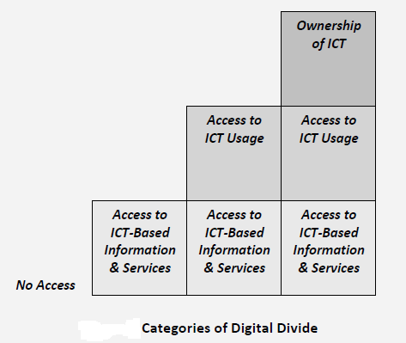

Those without any access are truly on the wrong side of the digital divide. They have no ICT costs but evidence about benefits is mixed. Some find they have no benefits, which are only gained by those with access. For example, micro-producers in Nigeria without mobile phones found they were losing orders – and, hence, income – to those who had mobile phones (Jagun et al 2008).

On the other hand, there is sometimes evidence of a “digital provide”: a general increase in welfare from the presence of ICTs within a community even for those with no access.

This was seen through two rather less-publicised outcomes from the case of the Kerala fishermen using mobile phones to check market prices, noted above (Jensen 2007). Those fishermen without mobile phones also saw their profit rise by an average Rs.97 (c.US$2) per day as a result of the general improvements in market efficiency which phones introduced.

This was about half the profit increase seen by phone owners and meant, even allowing for the additional costs, that returns to phone ownership were greater than those for non ownership. In addition, the revenue gains by all fishermen arose because they wasted less (i.e. sold more) of the fish they caught. But the actual price per kg for fish decreased due to the increase in supply arising from less waste. This delivered a second digital provide benefit: fish consumers now paid less than previously thanks to the mobile-induced efficiency gains.
There is also evidence of those in the second and third digital divide categories gaining from a digital provide.
For example, farmers in the third category in Northern Ghana were able to borrow mobile phones from neighbours and gather agricultural guidance information, or market price information (Smith 2010). Even those who did not themselves use the phone benefited from information passed on from phone owners, including more frequent meetings with agricultural extension officers; meetings that were coordinated by phone owners. Phone owners benefited more, so the overall conclusion – as with the fishermen, and forgiving the pun – is that ICTs are a rising tide that lifts all boats, but with the boats of ICT owners (typically the richer members of the community) being lifted further.

CASE STUDIES
1) How Mobile Phones Contribute To Growth Of Small Farmers?Evidence From India,2012
By Mittal, S. And Mehar, M.
OBJECTIVES
- To provide evidence on how mobile phones are being used to meet the information needs of farmers.
- To provide evidence on the impact mobile phones and mobile phone based services have on farm income and cost of production in India.
METHOD
- The focus group surveys of 1200 farmers in five states (Punjab, Haryana, Uttar Pradesh, Bihar and West Bengal )of which 64% of farmers have small or marginal land holdings.
- focus group discussions and individual interviews.

RESULTS

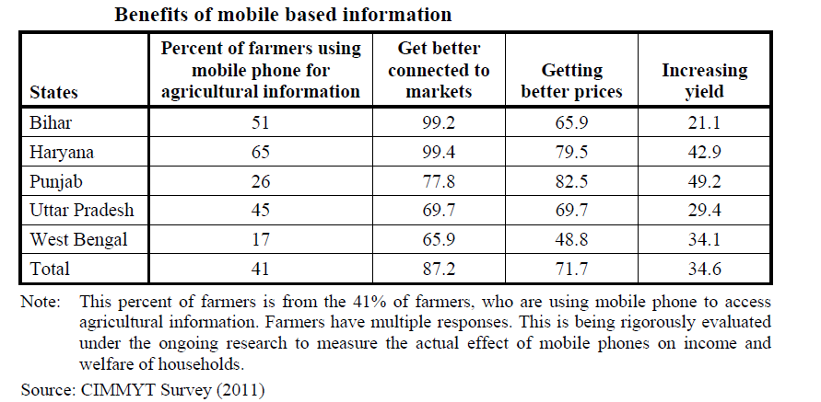
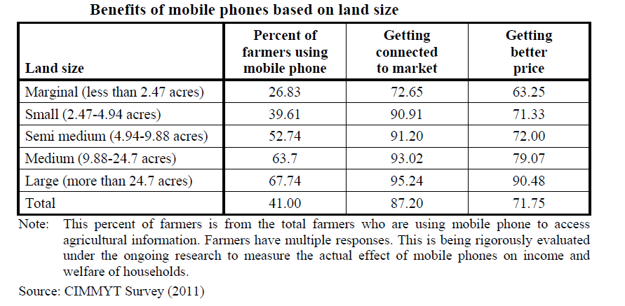

2) Electronic Government And The Rural Poor: The Case Of Gyandoot, INDIA,2013
By Cecchini, S. And Raina, M., 2013
INTRODUCTION
- It is an Intranet based Government to Citizen (G2C) .
- It is a service delivery portal.
- Was commissioned in Dhar district of Madhya Pradesh in January 2000.
OBJECTIVES OF THE STUDY
- Identifying and evaluating the benefits of Gyandoot among the intended stakeholders.
- Assessing the impact of Gyandoot on transparency, accountability and corruption within the district administration.
- Identifying gaps in usage patterns and providing suggestions for a sustainable socioeconomic impact.
RESULTS
Service | % of Cost Savings
Khasara Nakal Avedan | 94
Driving License  Service | 89
Domicile Certificate | 20
Grievance Redressal | 30

Other results
- Respondents said it helped them obtain Mandi prices through inexpensive telephone calls to the agricultural produce markets.
- They experienced significant convenience and a reliable source.
IMPACT | % USERS
Awareness of computers | 72
Computer education | 66
New employment opportunity | 16

CONCLUSION
Poverty is multidimensional, so too is the role of ICTs. It is not an end in themselves but a means or mechanism that can make a significant contribution to the fight for poverty reduction. ICTs cannot solve poverty on their own, but they can make a contribution to the processes .
First, a new “inclusive innovation” approach to ICTs is required that not merely allows for, but actively supports, two types of innovation:-
- Collaborative (“para-poor”) innovation -done working alongside poor communities.It will enable the designs of ICT systems that are developed outside these communities to be adapted in ways that are appropriate; thus increasing their effective contribution to development.
- Grassroots (“per-poor”) innovation is innovation by and within poor communities.Their designs are already likely to be appropriate.It will also come from a “harvesting” system that can systematically scan for such innovations, and then provide a mechanism to share and scale them when identified. (a model already in practice for other technologies, for example, via the Honey Bee Network).
- Second, there need to be means to change those realities so that they match closer to ICT design expectations.For example,
rolling out the electricity and telecommunications infrastructure to fill in the current “blank areas on the map”, Increasing the availability of microfinance schemes etc.
- By doing both of these :–
- changing ICT designs to match closer to poor community realities.
- and changing poor community realities to match closer to ICT designs.
There will be greater opportunities for ICTs to be a technology of poverty eradication rather than a technology of inequality. This will allow for appropriation, even innovation, of the technology within poor communities. This, in turn, will allow poor individuals to move further up the ICT role ladder, and thus capture more of the gains from the “digital revolution”.

