
DEPARTMENT OF AGRICULTURAL EXTENSION
SEMINAR REPORT ON
Application of distribution theories in Social Science Research
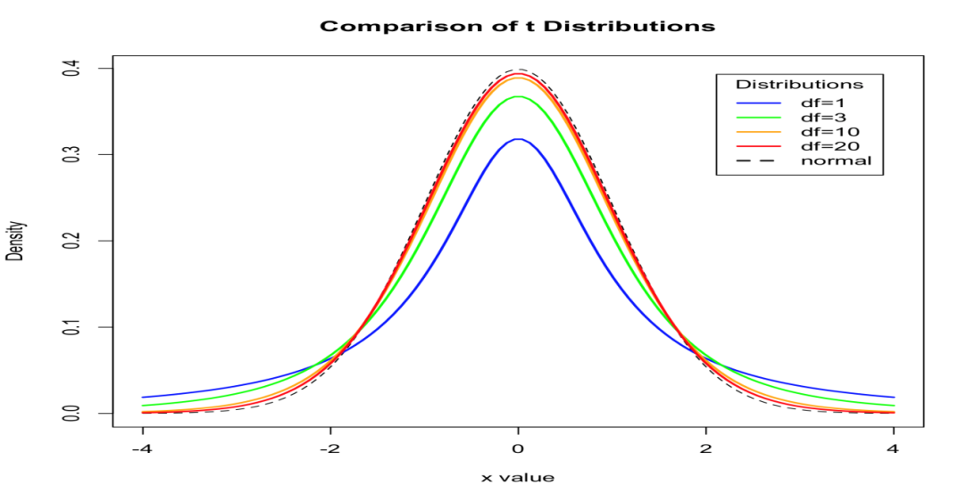
SUBMITTED TO SUBMITTED BY
Seminar Teacher SUDHA, C. K
Dept. of Agril. Extn. PALB3019
UAS, GKVK III Ph. D.
Bangalore-65

SL. No. | PARTICULARS | PAGE NO.
1 | Introduction | 1
2 | Objectives | 2
3 | Concept distribution theory | 2-4
4 | Types of distribution theory | 5
5 | Observed frequency distribution | 5-11
6 | Probability frequency distribution | 11-13
7 | Discrete Probability distribution  Binominal distribution  Poisson distribution  Its application in social science research | 13-19
8 | Continuous Probability distribution  Normal distribution  Its application in social science research | 19-22
9 | Fitting Normal distribution  Its significance | 22-24
10 | conclusion | 24
11 | Discussion | 25
12 | synopsis | 26-27
13 | Reference | 28

LIST OF TABLES

SL. NO. | TITLE | PAGE NO.
1. | Frequency distribution | 5
2. | Discrete Frequency Distributions | 6
3. | Showing frequency distribution of temperature in a city for 50 days | 7
4. | Inclusive Class Interval | 7
5. | Exclusive Class Interval: | 7
6. | Probability Distributions | 12
7. | Cumulative Probability Distributions | 13
8. | Fitting a Normal Distribution by Area Method | 22
9. | Chi square test / Goodness of fit | 23

Introduction
Statistics is a set of tools used to organize and analyze data. Data must either be numeric in origin or transformed by researchers into numbers. Statistics is also frequently used for purposes of prediction. Prediction is based on the concept of generalizability: if enough data is compiled about a particular context (e.g., students studying writing in a specific set of classrooms), the patterns revealed through analysis of the data collected about that context can be generalized (or predicted to occur in) similar contexts. The prediction of what will happen in a similar context is probabilistic. That is, the researcher is not certain that the same things will happen in other contexts; instead, the researcher can only reasonably expect that the same things will happen and also Statistics is the science of collecting, analyzing and making inference from data. Statistics is a particularly useful branch of mathematics that is not only studied theoretically by advanced mathematicians but one that is used by researchers in many fields to organize, analyze, and summarize data. Statistical methods and analyses are often used to communicate research findings and to support hypotheses and give credibility to research methodology and conclusions. It is important for researchers and also consumers of research to understand statistics so that they can be informed, evaluate the credibility and usefulness of information, and make appropriate decisions. In Social science research distribution plays a important role like how the observed data should be tabulated and also appropriate distribution type can be assigned based on understanding of the data and type of the data being collected, it decide the shape of the distribution. This shape will help for which are all statistical tests should be used for interpreting the data. A distribution is a graphic representation of data. The line formed by connecting data points is called a frequency distribution. This line may take many shapes. The single most important shape is that of the bell-shaped curve, which characterizes the distribution as "normal." A perfectly normal distribution is only a theoretical ideal. This ideal, however, is an essential ingredient in statistical decision-making (Levin, 1991). A perfectly normal distribution is a mathematical construct which carries with it certain mathematical properties helpful in describing the attributes of the distribution. Although frequency distribution based on actual data points seldom, if ever, completely matches a perfectly normal distribution, a frequency distribution often can approach such a normal curve.
The closer a frequency distribution resembles a normal curve, the more probable that the distribution maintains those same mathematical properties as the normal curve. This is an important factor in describing the characteristics of a frequency distribution. As a frequency distribution approaches a normal curve, generalizations about the data set from which the distribution was derived can be made with greater certainty. And it is this notion of generalizability upon which statistics is founded. It is important to remember that not all frequency distributions approach a normal curve. Some are skewed. When a frequency distribution is skewed, the characteristics inherent to a normal curve no longer apply. Keeping these aspects in view, the present seminar has been conceptualized with the following objectives:
- To know the concept of distribution theory
- To know the existing distributions in Social Science Research
- Applications of distribution in Social Science Research

- Concept of statistical distribution theory
Statistics- Latin- Status – Political state
“Statistics may be defined as the science of collection, presentation, analysis and interpretation of numerical data” - Croxton & Cowden
Functions of statistics:
The various functions performed by statistics in modern times are discussed under:
1. Simplification of Complex Facts:
The foremost purpose of the statistics is to simplify huge collection of numerical data. It is beyond the reach of human mind to remember and recollect the huge facts and figures. Statistical method makes it possible to understand the whole in the short span of time and in a better way.
2. Comparison:
Comparison of data is yet another function of statistics, simplifying the data; it can be correlated or compared by certain mathematical question like averages, ratios, coefficients etc.
In this regard Boddingtons opined that the object of statistics is to enable comparison to be made between past and present results will a view to ascertain the reasons for changes which have taken place and the effect of such changes in the future.
3. Relationship between Facts:
Statistical methods are used to investigate the cause and effect relationship between two or more facts. The relationship between demand and supply, money-supply and price level can be best understood with the help of statistical methods.
4. Formulation and Testing of Hypothesis:
The most theoretical function of statistics is to test the various types of hypothesis and discover a new theory. For instance, by using appropriate statistical tools we can test the hypothesis whether a particular coin is fair or not, whether Indian consumers are brand loyal etc.
5. Forecasting:
Statistical methods are of great use to predict the future course of action of the phenomenon. It is only on the basis of statistical techniques that I planners in India prepare future estimates for production, consumption, investment etc.
6. Enlarges Individual Knowledge:
Statistical methods sharpen the faculty of rational thinking and reasoning of an individual. It is a master-key that solves problems of mankind in every sphere of life. Thus, Whipple has rightly opined statistics enables one to enlarge his horizon.
7. To Indicate Trend Behaviour:
Statistics helps to indicate trend behaviour certain fields of enquiry. The statistical techniques like Analysis of Time Series Extrapolation etc. are highly used to know the trend behaviour of the enquiry in question
8. Classification of Data:
Classification refers to a process of splitting up the data into certain parts which helps in the matters of comparison and interpretation of the various features of the data. This is done by the various improved techniques statistics.
9. To Measure Uncertainty:
In most of the social fields, comprising of business, commerce, economics, it becomes necessary to take decisions in the face of uncertainty and study the change of occurrence of certain events and their effect on the polio adopted.
10. To Draw Rational Conclusion:
In various fields of uncertainty like business and commerce, it is very much necessary to draw rational conclusions on the basis of facts collected and analyzed. For this, the mind of the decision maker should be free from any bias and prejudices.
Limitations
Some important limitations of statistics are the following:
1. Statistics does not study qualitative phenomena:
Statistics deals with facts and figures. So the quality aspect of a variable or the subjective phenomenon falls out of the scope of statistics. For example, qualities like beauty, honesty, intelligence etc. cannot be numerically expressed. So these characteristics cannot be examined statistically. This limits the scope of the subject.
2. Statistical laws are not exact:
Statistical laws are not exact as incase of natural sciences. These laws are true only on average. They hold good under certain conditions. They cannot be universally applied. So statistics has less practical utility.
3. Statistics does not study individuals:
Statistics deals with aggregate of facts. Single or isolated figures are not statistics. This is considered to be a major handicap of statistics.
4. Statistics can be misused:
Statistics is mostly a tool of analysis. Statistical techniques are used to analyze and interpret the collected information in an enquiry. As it is, statistics does not prove or disprove anything. It is just a means to an end. Statements supported by statistics are more appealing and are commonly believed. For this, statistics is often misused. Statistical methods rightly used are beneficial but if misused these become harmful. Statistical methods used by less expert hands will lead to inaccurate results. Here the fault does not lie with the subject of statistics but with the person who makes wrong use of it. Statistics does not deal with isolated measurement
Random variable: variable whose value is determined by the outcome of a random experiment. It may be discrete or continuous
Discrete variable : variable which assumes some specified value in a given range
Continuous variable : variable which assumes all the values in a given range
Distribution theory
Distribution : An order or pattern formed by the tendency of a sufficiently large number of observations to group themselves around a central value.
- It gives us a law
- Applied in decision making
- Help for interpreting the data (Graphically)

Types of distributions
- Observed frequency distribution
- Probability distribution
Observed frequency distribution

Frequency distribution is more manageable and efficient than precision matching. Instead of one-to-one matching that must be administered in precision matching, frequency distribution allows the comparison of an experimental and control group through relevant variables. If three Communications majors and four English majors are chosen for the control group, then an equal proportion of three Communications major and four English majors should be allotted to the experiment group. Of course, beyond their majors, the characteristics of the matched sets of participants may in fact be vastly different.Although, in theory, matching tends to produce valid conclusions, a rather obvious difficulty arises in finding subjects which are compatible. Researchers may even believe that experimental and control groups are identical when, in fact, a number of variables have been overlooked. For these reasons, researchers tend to reject matching methods in favor of random sampling.

Frequency (f) : number of times a particular item is repeated.

Eg. 3 2 5 6 3 6 3

Frequency distribution : arrangement of the data which gives the frequency corresponding to each successive value of the variable.

Table 1
Class | no. of students (f) | Cumulative f
1 | 15 | 15
2 | 12 | 27
3 | 10 | 37

Relative frequency (f/n): frequency of class / total number

Cumulative Frequency : is the tally or count of the number of data values in a class plus the frequencies for all lower classes.

Types of Frequency Distributions
  - Discrete Frequency Distributions
Discrete data is generated by counting; each and every observation is exact. When an observation is repeated. It is counted the number for which the observation is repeated is called frequency of that observation. The class limits in discrete data are true class limit; there are no class boundaries in discrete data.

Table 2
Marks ( variable) | No. of students (frequency)
10 | 3
22 | 1
24 | 3
35 | 8
36 | 4
37 | 2
39 | 7
41 | 3
46 | 4
Total | N= 35

  - Continuous Frequency Distributions
For a continuous variable if we take a class for each distinct value of the variable, the number of classes will become unduly large, thus defeating the purpose of tabulation. In fact, since a continuous variable can assume an infinite number of values within its range of variation, the classification or sub-division of such data is necessarily artificial. Some guidelines that should be followed while dividing continuous data into classes are as follows:
- The classes should be mutually exclusive, i.e., non-overlapping. No two classes should contain the same interval of values of the variable.
- The classes should be exhaustive, i.e., they must cover the entire range of the data.
- The number of classes and the width of each class should neither be too small nor too large. In other words, there should be relatively fewer classes if the difference between the least value of the variable and its highest value is small and relatively more classes if the same difference is large. This difference between the least value of the variable and the greatest value of the variable is called the range of the variable or the data set.
- The classes should, preferably, be of equal width.
Let us consider the following example regarding daily maximum temperatures in in a city for 50 days.
28 28 31 29 35 33 28 31 34 29
25 27 29 33 30 31 32 26 26 21
21 20 22 24 28 30 34 33 35 29
23 21 20 19 19 18 19 17 20 19
18 18 19 27 17 18 20 21 18 19
Minimum Value= 17
Maximum Value=35
Range=35-17=18
Number of classes=5 (say)
width of each class=4
Table No. 3: Showing frequency distribution of temperature in a city for 50 days.
Class Intervals(Temperatures in ) | Frequency
17-20 | 17
21-24 | 7
25-28 | 10
29-32 | 9
33-36 | 7
Total | 50

Inclusive Class Interval:
When the lower and the upper class limit is included, then it is an inclusive class interval. Usually in the case of discrete variate, inclusive type of class intervals are used.

Table 4

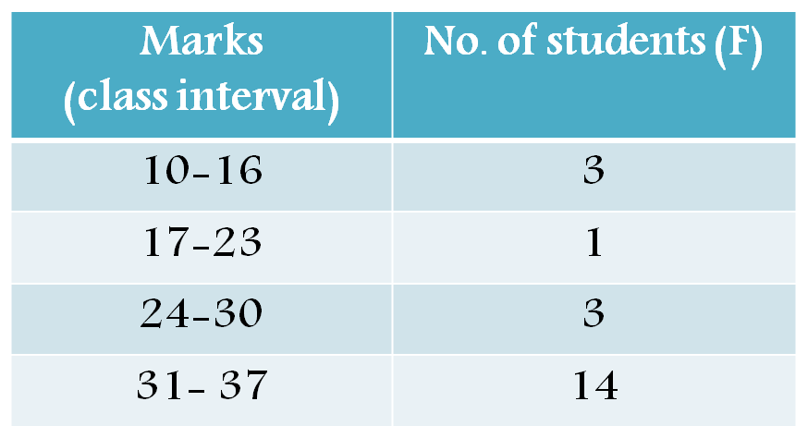
Exclusive Class Interval:
When the lower limit is included, but the upper limit is excluded, then it is an exclusive class interval. Usually in the case of continuous variate, exclusive type of class intervals are used.

Table 5

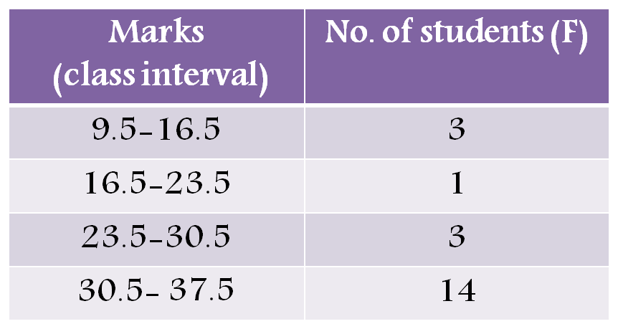

Defining few terms
Class Interval: The whole range of variable values is classified in some groups in the form of intervals. Each interval is called a class interval.
Class Frequency: The number of observations in a class is termed as the frequency of the class or class frequency.
Relative Frequency: Relative frequency is defined as the proportion of observations corresponding to a particular value of the variable or a class of values of the variable. Relative frequency of a particular value of the variable or a class of values of the variable is obtained by dividing the frequency corresponding to that particular value or that particular class by the total number of observations in the data set, i.e., the total frequency.
Relative frequency of any value or any class lies between 0 and 1. We calculate relative frequency if we want an idea about the relative importance of the particular value or class in relation to the total frequency.
Percent Frequency: Sometimes Relative frequency is expressed in percent as 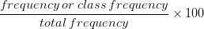 i.e., which is known as percent frequency. Expressed as percents, the percent frequency of all values or all the classes must add up to 100.
Class limits and Class boundaries:
Class limits are the two endpoints of a class interval which are used for the construction of a frequency distribution.The lowest value of the variable that can be included in a class interval is called the lower class limit of that class interval. The highest value of the variable that can be included in a class interval is called the upper class limit of that class interval. These are not the real limits or endpoints of a class interval. Hence, class limits are called apparent limits of a class.
Let us take for example, Table No. 3. The class intervals are 17-20, 21-24, 25-28, 29-32 and 33-36. Here, say for the class 17-20, the lower class limit is 17 and the upper class limit is 20. However, if there was an observation of 20.5, it would not be included in this class. An observation of 20.5 would be included in the class 21-24. Again if there was an observation of 16.5 it would be included in the class 17-20. Hence, effectively, the two actual endpoints of the class 17-20 are 16.5 and 20.5. These are actual or true limits of the class.
The two real endpoints of a class interval are called class boundaries. These are also called the real class limits. The basic rule is that class limits should have the same decimal place as the data set, but class boundaries should have one decimal place more. For example, let us say that we have the following data set on weight of a group of students (in Kg): 50.5, 50.8, 63.6, 48.4, 58.6, and 60.2. Here the class limits should have one decimal place and the class boundaries two decimal places. We obtain class boundaries from class limits by dividing the difference between the upper limit of a class and the lower limit of the next higher class into two equal parts. Say, we are considering the classes 17-20 and 21-24. 21-20=1. Again we have . We add 0.5 to the upper class limit of each class and subtract 0.5 from the lower class limit of each class. So, the class boundaries are 16.5-20.5, 20.5-24.5 and so on. For the class 16.5-20.5, 16.5 is the lower class boundary and 20.5 is the upper class boundary. It should be noted that the upper class boundary of the lower class coincides with the upper class boundary of the next higher class. This will give rise to confusion. Where should we include an observation which reads 20.5? The answer is 20.5 should be included in the class 20.5-24.5. This is because the rule is that the frequency corresponding to a class denotes the number of observations Lower Class Boundary but Upper Class Boundary. This is called the method of left inclusion. By including the lower class boundary but not the upper class boundary in the class we eliminate confusion about where to place an observation that happens to fall on a class boundary point.
Open-end classes: It may be so that some values in the data set are extremely small compared to the other values of the data set and similarly some values are extremely large in comparison. Then what we do is we do not use the lower limit of the first class and the upper limit of the last class. Such classes are called open end classes.
Class width: The length of the class is called the class width. It is also known as class size.
,
U.C.B. is Upper Class Boundary
L.C.B. is Lower Class Boundary
Class mark: The midpoint of a class interval is called class mark. It is the representative value of the entire class.
Frequency Density: It is the frequency per unit width of the class. It is given by:
Frequency densities are essential to compare two classes of unequal width. For classes equal class widths frequency densities are proportional to the class frequencies.
Relative Frequency Density: Relative frequency density of a class is relative frequency divided by the class width. It is given by:

Why Frequency Distributions?
- To organize the data for interpretation
- To compare different data sets
- To simplify the computation for measures of average and speed
- To determine the shape distribution
- To draw charts and graphs for data
- Probability distribution
Mathematical models
Certain hypothesis is assumed, it is some time possible to derive under mathematical models the FD of a certain population OR
It is the frequency distribution of a certain events in which frequencies are obtained by mathematical computation
Probability Distribution Prerequisites
To understand probability distributions, it is important to understand variables. random variables, and some notation.
- A variable is a symbol (A, B, x, y, etc.) that can take on any of a specified set of values.
- When the value of a variable is the outcome of a statistical experiment, that variable is arandom variable.
Generally, statisticians use a capital letter to represent a random variable and a lower-case letter, to represent one of its values. For example,
- X represents the random variable X.
- P(X) represents the probability of X.
- P(X = x) refers to the probability that the random variable X is equal to a particular value, denoted by x. As an example, P(X = 1) refers to the probability that the random variable X is equal to 1.

Probability Distributions
An example will make clear the relationship between random variables and probability distributions. Suppose you flip a coin two times. This simple statistical experiment can have four possible outcomes: HH, HT, TH, and TT. Now, let the variable X represent the number of Heads that result from this experiment. The variable X can take on the values 0, 1, or 2. In this example, X is a random variable; because its value is determined by the outcome of a statistical experiment.
A probability distribution is a table or an equation that links each outcome of a statistical experiment with its probability of occurrence. Consider the coin flip experiment described above. The table below, which associates each outcome with its probability, is an example of a probability distribution.
Table 6
Events | P(x)
0 | 0.25 (1/4)
1 | 0.50 (2/4)
2 | 0.25 (1/4)

Cumulative Probability Distributions
A cumulative probability refers to the probability that the value of a random variable falls within a specified range.
Let us return to the coin flip experiment. If we flip a coin two times, we might ask: What is the probability that the coin flips would result in one or fewer heads? The answer would be a cumulative probability. It would be the probability that the coin flip experiment results in zero heads plus the probability that the experiment results in one head.
P(X < 1) = P(X = 0) + P(X = 1) = 0.25 + 0.50 = 0.75
Like a probability distribution, a cumulative probability distribution can be represented by a table or an equation. In the table below, the cumulative probability refers to the probability than the random variable X is less than or equal to x.
Table 7
Events | P(x) | Cp(x)
0 | 0.25 (1/4) | 0.25
1 | 0.50 (2/4) | 0.75
2 | 0.25 (1/4) | 1.00

Types of Probability Distributions
  - Discrete probability distributions
If a random variable is a discrete variable, its probability distribution is called a discrete probability distribution. An example will make this clear. Suppose you flip a coin two times. This simple statistical experiment can have four possible outcomes: HH, HT, TH, and TT. Now, let the random variable X represent the number of Heads that result from this experiment. The random variable X can only take on the values 0, 1, or 2, so it is a discrete random variable.
Types of Discrete probability distributions
- Binomial Probability Distribution
Events / experiments carried out getting dichotomous out comes.
- It was developed - James Bernoulli
- Determined by two parameters
- Mean- np
- Variance – npq
- Mean>variance
Definition

Where:
x: number of successes in trail
n: number of trials
n-x : no. of failures in trail
p: probability of success
q: probability of failure (1 - p)
Assumptions
- Out comes expected with dichotomous
- No. of trails conducted should be fixed (n)
- Sum of probability of outcome (p&q) should be =1
- Trail should be independent
- Variables should be discrete

Application in social science research
If taking adoption maize crop about 6 farmers what is the probability of adopting 3 farmers?
Ans:
No. of trails – 6
P(x)= 3
Online calculation
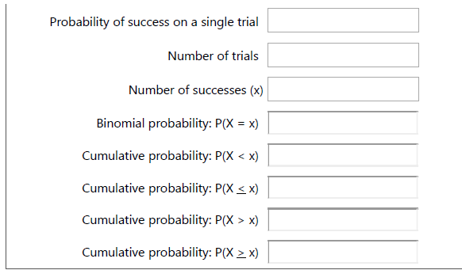
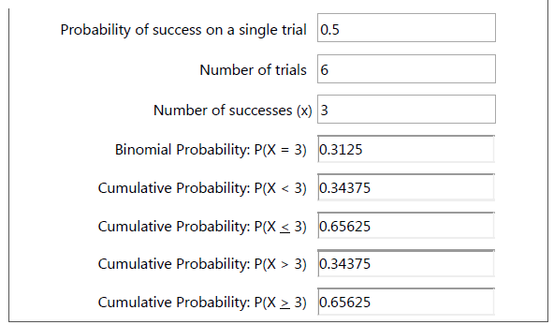
The answer is 0.3125 means probability of adoption of maize variety

b. Poisson Distribution
Developed – S D Poisson
- When no. trails are very large (n-infinity)
- It used to describe the behaviour of random events that occur rarely over a time / space
Time
- The no. of insects caught in a trap in one hour
Space
- No. of wilt affected coconut trees in a locality
- No. of accidents on road in particular time interval
- No. of printing mistakes in each page of a book
Properties
- Only one parameter
- Mean- ƛ
- Variance – ƛ
- Mean = variance
Definition

X – no. of times the events occurred
ƛ=np= mean no. of times an event occurred
e - 2.71828.
Application in social science
Ex. 1. Suppose a book of 585 pages contains 43 typographical errors. If these errors randomly distributed through out the book, what is the probability that 10 pages selected at random, will be free from error?
Ans. Given n= 10, p = 43/ 585= 0.0735
np = 10*0.0735 = 0.735
P(x=0) = (e^{-μ}) (μ^{x}) / x!
= 0.4795

Ex. 2: Suppose the average number of lions seen on a 1-day safari is 5. What is the probability that tourists will see fewer than four lions on the next 1-day safari?
Solution:
Where,
μ = 5; since 5 lions are seen per safari, on average.
x = 0, 1, 2, or 3.
e = 2.71828
Thus, we need to calculate the sum of four probabilities:

P(0; 5) + P(1; 5) + P(2; 5) + P(3; 5)
P(x < 3, 5) = P(0; 5) + P(1; 5) + P(2; 5) + P(3; 5)
P(0; 5) + P(1; 5) + P(2; 5) + P(3; 5)
P(x < 3, 5) = P(0; 5) + P(1; 5) + P(2; 5) + P(3; 5)
P(x < 3, 5) = P(0; 5) + P(1; 5) + P(2; 5) + P(3; 5)
P(x < 3, 5) = [ (e⁻⁵)(5⁰) / 0! ] + [ (e⁻⁵)(5¹) / 1! ] + [ (e⁻⁵)(5²) / 2! ] + [ (e⁻⁵)(5³) / 3! ]
P(x < 3, 5) = [ (0.006738)(1) / 1 ] + [ (0.006738)(5) / 1 ] + [ (0.006738)(25) / 2 ] + [ (0.006738)(125) / 6 ]
P(x < 3, 5) = [ 0.0067 ] + [ 0.03369 ] + [ 0.084224 ] + [ 0.140375 ]
P(x < 3, 5) = 0.2650
Thus, the probability of seeing at no more than 3 lions is 0.2650.

Online calculation
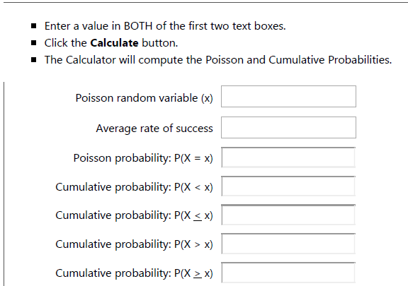

If we apply values in this calculator
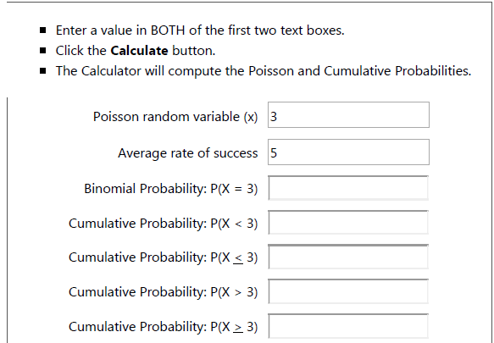
If we apply values in this calculator we will get answer

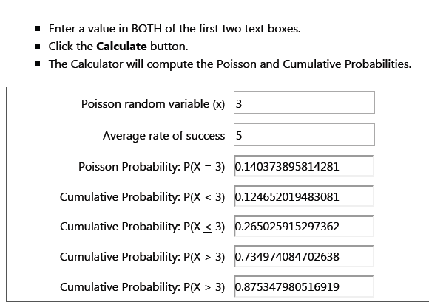

  - Continuous probability distributions
If a random variable is a continuous variable, its probability distribution is called a continuous probability distribution.
Normal distribution
- First applied to the description of measurement errors
- 1835 Adolphe Quetelet - Physical attributes, such as height,
- 1869 Francis Galton - individual differences in ability
- Psychometric instruments in which test scores are actually defined according to the normal distribution the IQ scores on most intelligence tests are assigned in terms of a person’s position in the distribution.
What is the Normal Distribution?
- Every real life data must similar to the bell shaped curve
- When no. of trails are very large (n- infinite) for any fixed value of probability for success for a trail

Normal Equation
Y = { 1/[ σ * sqrt(2π) ] } * e^{-(x - μ)2/2σ2}
Where π – 3.142
e- 2.718
^{μ-} population mean
σ- population standard mean
x- given value of the random variable
Standard Normal Distribution
- A random variable Z, normal distribution with mean= 0 and SD= 1
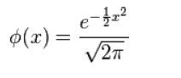
To find out Z value between any two value
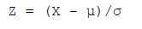
Normal Curve
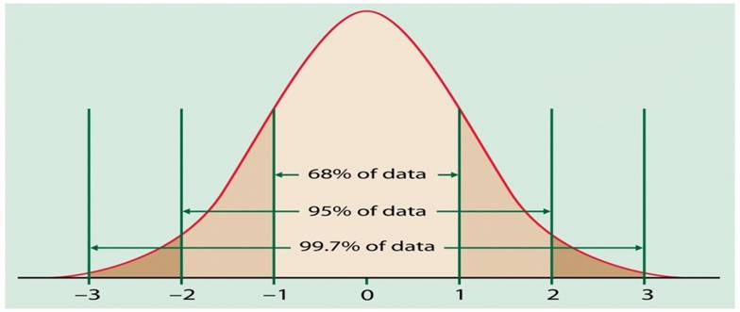
Characteristics of Normal Distribution
- Symmetric
- Unimodal
- Asymptotic
- Mean, median and mode are all equal
- The total area under the normal curve is equal to 1
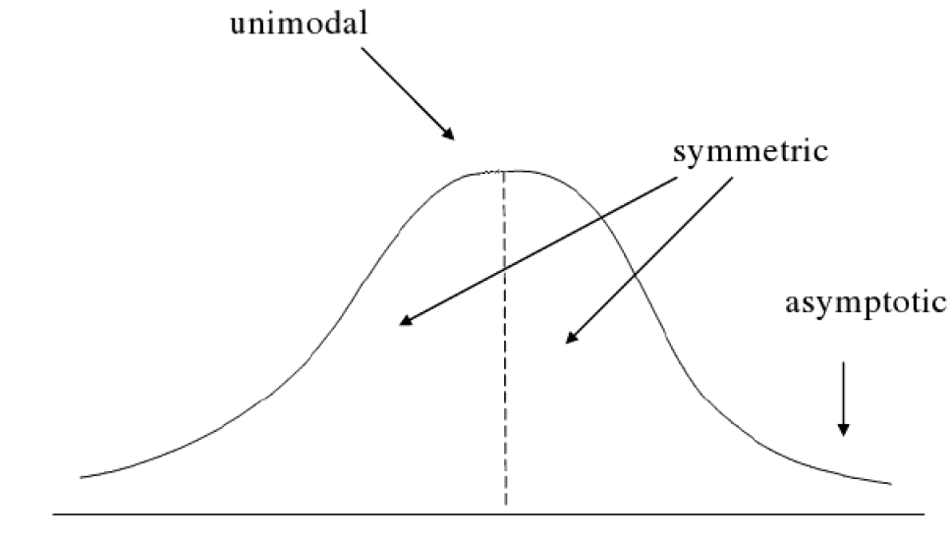
Normal Curve
- Mean - location of the center of the graph
- Standard deviation - height and width of the graph
- Standard deviation is large, the curve is short and wide
- Standard deviation is small, the curve is tall and narrow
- All normal distributions look like a symmetric, bell-shaped curve

Assume the mean height of children to be 68.22cm with the variance of 10.8 cm. How many children in a school of 1000 would you expect to be over 72 cm tall?
Ans : X- variate – mean – 68.22
SD- √10.8
= 72-68.22 / √10.8 = 1.15
Now P(x>72)= P(Z>1.15)
z=0 to z=1.15
= 0.5000- 0.3749
= 0.1251
Expected no. of children to be above 72cm out of 1000
= 1000*0.1251
= 125
Fitting a Normal Distribution by Area Method
- To judge the whether the normal curve is good fit to the sample data
- To estimate the characteristics of population
Table 8
Example
Class interval | 11-20 | 21-30 | 31-40 | 41-50 | 51-60 | 61-70 | 71-80
f | 12 | 28 | 40 | 60 | 31 | 20 | 8
Mean = 43.7, SD= 14.8 ( σ)
Fitting the normal distribution by area method

Class Interval | Lower Class | D=x-μ | Z= x-μ  σ | Area from  0 to Z | Area in class interval | Expected fre quencies
10.5-20.5 | 10.5 | -33.2 | -2.24 | 0.4875 | 0.0457 | 9
20.5-30.5 | 20.5 | -23.2 | -1.57 | 0.4418 | 0.1285 | 26
30.5-40.5 | 30.5 | -13.2 | -0.89 | 0.3133 | 0.2262 | 45
40.5-50.5 | 40.5 | -3.2 | -0.22 | 0.0871 | 0.2643 | 54
50.5-60.5 | 50.5 | 6.8 | 0.46 | 0.1772 | 0.1936 | 40
60.5-70.5 | 60.5 | 16.8 | 1.13 | 0.3708 | 0.0941 | 20
70.5-80.5 | 70.5 | 26.8 | 1.81 | 0.4649 | 0.0285 | 6
 | 80.5 | 36.8 | 2.48 | 0.4934
Total |  |  |  |  |  | N=200
Above table shows that, almost expected and observe frequencies are equal this shows that the observed frequencies are draw the conclusion of population. And observed frequencies are true.
Chi square test / Goodness of fit
- It is useful to measure of comparing experimentally obtained results with those expected theoretically and also based on hypothesis
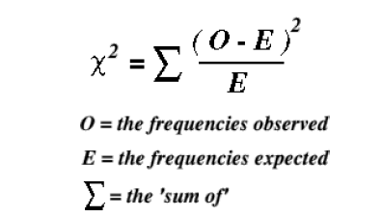
For calculating significance here we taken observed frequency and expected frequencies of previous example of fitting of goodness.
Step1: subtract the expected frequency from observed frequency
Step2: squaring the values of column 3
Step 3: dividing the column 4 by expected frequency
Step 5: summing column 5 we will get the chi square value
Table 9
O | E | O-E | (O-E)2 | (O-E)2/E
12 | 9 | 3 | 9 | 1
28 | 26 | 2 | 4 | 0.15
40 | 45 | -5 | 25 | 0.55
60 | 54 | 6 | 36 | 0.66
32 | 40 | -8 | 64 | 1.6
20 | 20 | 0 | 0 | 0
8 | 6 | 2 | 4 | 0.66

- Σ (o-E)2/E= 4.63 df= 6
- Since the calculated value is < table value so, accept the null hypothesis
- Here table value is 3.16 so calculated value is more than the table value so reject the null hypothesis
- Conclusion there is no difference between the expected frequency and observed frequency
Other Significance tests
- Z -distribution
- t -distribution
t = X - µ / SD
BD, PD----- ND: so many times binominal and Poisson distribution lead to normal distribution. Conditions are
- If the sample size should be more – normal distribution N ≥ 30/ 40
- It must be Mean ≥ 5
SD ≥ 5
Conclusion
Statistics plays a major role in social science research, observed data is normally distributed and it gives bell shaped curve we can apply parametric tests called t- test, z- test and f-test. If the normal distribution curved is positively/ negatively / any deviation from the standard normal curve we can go for non parametric test.

Discussion

  - Why we cont have use t test for above 30 sample?
In t table values are present only up to 30 so for continuity we have to use z table. It is the continuity of t table



UNIVERSITY OF AGRICULTURAL SCIENCES
DEPARTMENT OF AGRICULTURAL EXTENSION
GKVK, BANGALORE-560065

Name: SUDHA, C. K Date: 19/12/2015
ID No: PALB 3019 Time: 10.00 AM
Class: III Ph. D. Venue: Model class room
III Seminar
Application of distribution theories in Social Science Research

Statistics is the science of collecting, analyzing and making inference from data. Statistics is a particularly useful branch of mathematics that is not only studied theoretically by advanced mathematicians but one that is used by researchers in many fields to organize, analyze, and summarize data. Statistical methods and analyses are often used to communicate research findings and to support hypotheses and give credibility to research methodology and conclusions. It is important for researchers and also consumers of research to understand statistics so that they can be informed, evaluate the credibility and usefulness of information, and make appropriate decisions. In Social science research distribution plays a important role like how the observed data should be tabulated and also appropriate distribution type can be assigned based on understanding of the data and type of the data being collected, it decide the shape of the distribution. This shape will help for which are all statistical tests should be used for interpreting the data. Keeping these aspects in view, the present seminar has been conceptualized with the following objectives:
- To know the concept of distribution theory
- To know the existing distributions in Social Science Research
- Applications of distribution in Social Science Research
Definition:
Distribution: An order or pattern formed by the tendency of a sufficiently large number of observations to group themselves around a central value. The familiar bell-shaped curve is an example of normal distribution - Wikipedia

Types of distribution theory
- Observed Frequency distribution: is the organization of raw data into a table using categories for the data in one column and the frequencies for each category in the second column.
- Theoretical Probability distribution: is a table or an equation that links each outcome of a statistical experiment with its probability of occurrence (Gupta and Kapoor, 2003).
Types of Observed Frequency distribution
- Discrete Frequency Distribution
- Continuous Frequency Distribution
- Cumulative Frequency Distribution

Existing Distributions in Social Science Research
Discrete probability distributions: If a random variable is a discrete variable, its probability distribution is called a discrete probability distribution.
Continuous probability distributions: If a random variable is a continuous variable, its probability distribution is called a continuous probability distribution.
Types of Discrete probability distributions
Binominal distribution:
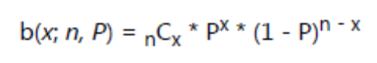
Poisson distribution:
P(x; μ) = (e^{-μ}) (μ^{x}) / x!
Types of continuous probability distributions
Normal distribution:
Y= {1/[σ *√2π] } * e^{-(x - μ)2/2σ2}
Conclusion
Statistics plays a major role in social science research, observed data is normally distributed and it gives bell shaped curve we can apply parametric tests called t- test, z- test and f-test. If the normal distribution curved is positively/ negatively / any deviation from the standard normal curve we can go for non parametric test.

References:

GUPTA, S. C, AND KAPOOR, V. K., 2003, Fundamentals of mathematical statistics, Sulthan Chand and Sons educational publishers, New Delhi.

http://www.businessdictionary.com/definition/distribution.html#ixzz3u7ynvPqO
http://www.stattrek.com/probability-distributions/t-distribution.aspx?Tutorial=AP
https://www.google.co.in/#q=Fitting+a+normal+distribution
https://en.wikipedia.org/wiki/Distribution_fitting
http://stattrek.com/probability-distributions/binomial.aspx

