

Seminar report
on

SCALING TECHNIQUES IN SOCIAL SCIENCE RESEARCH

Presented by:

Sujay Kumar, S. III Ph.D ID.NO: PALB 3020

Department of Agril. Extension, UAS, GKVK, Bangalore-65

Submitted to:
Dr. Ganeshmoorthy, S. Assistant professor
Course teacher
Department of Agricultural Extension
UAS, GKVK, Bangalore- 560065

Contents

Sl . no | Particulars | Page no
 | Cover page & Content sheet | i & ii
 | Introduction | 3
 | Objectives | 3
 | Concept, criteria an importance of scaling techniques | 4
 | Types of scaling techniques  - Comparative scaling techniques | 4-10
 | - Non-Comparative scaling techniques | 11-18
 | Steps in Scale construction | 19-26
 | Research studies | 27-30
 | Conclusion | 31
 | References | 31

Signature of course teacher:

Marks obtained:

SCALING TECHNIQUES IN SOCIAL SCIENCE RESEARCH
Introduction:
Human behaviour is so complex in nature than any other nature and mysterious too. So there is a branch of a science which study human behaviour in the society is known as social science. The main objective of social science research is to find out solution to the problems of human society. Generally in social science phenomenon are qualitative in nature, it is very difficult to measure the data which are in qualitative nature because they are not easily amicable for direct measurement. So it is possible only by scientific way of measurement and data analysis. We can measure three important psychometric techniques; scale, test and projection techniques. So it is essential for the researcher to acquire and familiarize with various tools and techniques of research.
In recent days greater emphasis is laid on the measuring instruments in social science research. Scaling is a technique used for a measurement of some aspects of human behaviour by means of precise scale and also it is a procedure for assignment of numbers or symbols to a property or object in order to impart some of the characteristics of numbers to the property in question.
Scaling techniques are used to find out the solution to the problems of human society. It is possible only by scientific way of analysing a problem. So it is essential for the researcher to acquire and familiarize with various tools and techniques of research. Keeping these aspects in view, the present seminar has been conceptualized with the following objectives.

Seminar Objectives are as followings.
- To understand the concept of scale and scaling techniques
- To know the different methods and types of scaling techniques
- To understand procedure involved in Q-sort scale and semantic differential scale
- To discuss steps involved in scale construction
- To review the empirical evidence

Concept of scaling techniques:
- Scaling methods are methods through which stimuli or individuals are sorted according to some known and specified attributes.
- When these methods are applied for sorting purposes, their results automatically yield a continuum which is called scale.

- Importance of scaling techniques
  - Helps to reduce the complexity of data
  - Presents a single score but that represents several variables
  - To test hypothesis by means of quantifying different dimensions of a single underlying concept
  - To reduce error in measurement
  - To increase the reliability of analysis
  - These are useful in measuring the social behaviour and personality of individuals.

- 14 criteria for scale development enunciated by Edwards and Chave (1969)

- Avoid statement that refer to past rather than present
- Factual/ numerical
- Interpreted more than one way.
- Irrelevant to psychological aspect under consideration
- Likely to be endorsed by almost everyone/ almost none.
- Select statements that are believe to cover the entire range of affective scale of interest.
- Keep the language of statements simple, clear and direct.
- Statement should be short rarely exceeding 20 words.
- Each statement should have only one complete thought
- Statements containing universal such as All, Always, None & Never often it
reduce ambiguity & it should be avoided
- Words such as only just, merely and others of a similar nature should be
used with care
- Statements should be in simple sentences
- Avoid use of words that may not be understood
- Avoid the use of double negatives
II. To discuss about different types of scaling techniques in social science research.
Depending upon the classes of stimuli, scaling methods are generally classified into two types
- Psychophysical scaling methods:
  - Stimuli presented have a physical referent
Example: grams, centimeters, decibels, minutes etc
- Psychological scaling methods: are procedures for constructing scales for the measurement of psychological attributes.
Example: Knowledge, attitude, intelligence, personality etc
Types of Psychological scaling methods are as below:
    - Method of rank order
    - Method of paired comparison
    - Method of successive categories
1. Method of rank order
- This method is also known as “Order of merit method”
- This is the simplest psychological method of ordering or ranking for objects, persons, events and other items.
- This is developed by Cattell and Spearman (1903-04)
- In this method all stimuli are presented simultaneously to the subject who is requested to rank them in order from high to low.
- Lower number indicates superior position (Rank 1) and higher number indicates inferior position (Rank 9)
- Most suited when the number of individuals or objects to be ranked is small.
- The scale resulting from the method of rank order is known as an ‘ordinal scale’
- Following are the formulas used in this method of rank order.
C= n-r
1. Whereas, C= choice score, r= rank assigned

2. 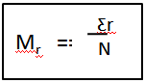
        - Whereas, Mr= mean rank of an object
Ƹr= sum of ranks assigned
N= number of ranks (or judges)
3. To find out the mean choice score

M_{c}= n – M_{r}

  - whereas: M_{c}= mean choice score
      - n= number of objects ranked
      - M_{r}= mean rank
- Subsequently the value of M_{c} is converted into p values as under: 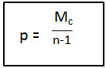

- Here each p value is converted into z values with the help of Woodsworth and Scholosberg, 1954. seminar tables .docx
Table 1: Calculate method of rank order
Judges | ACTORS/AGRI ENTREPRENEURS
Judges | A | B | C | D | E | F | G | H | I | j
1 | 1 | 2 | 3 | 5 | 4 | 6 | 8 | 7 | 10 | 9
2 | 2 | 4 | 3 | 1 | 5 | 7 | 6 | 8 | 9 | 10
3 | 1 | 3 | 4 | 2 | 6 | 7 | 8 | 9 | 5 | 10
4 | 1 | 2 | 3 | 4 | 6 | 7 | 5 | 8 | 9 | 10
5 | 1 | 2 | 3 | 4 | 5 | 6 | 7 | 8 | 10 | 9
6 | 1 | 2 | 4 | 3 | 5 | 6 | 8 | 7 | 9 | 10
7 | 1 | 3 | 4 | 2 | 5 | 6 | 8 | 7 | 9 | 10
8 | 1 | 4 | 2 | 3 | 5 | 6 | 8 | 7 | 10 | 9
9 | 2 | 3 | 1 | 4 | 5 | 6 | 7 | 8 | 9 | 10
10 | 1 | 2 | 3 | 4 | 6 | 5 | 7 | 8 | 9 | 10
Sum | 12 | 27 | 30 | 32 | 52 | 62 | 72 | 77 | 89 | 97
Mr | 1.2 | 2.7 | 3.0 | 3.2 | 5.2 | 6.2 | 7.2 | 7.7 | 8.9 | 9.7
Mc= n-Mr | 8.8 | 7.3 | 7.0 | 6.8 | 4.8 | 3.8 | 2.8 | 2.3 | 1.1 | 0.3
P=Mc (n-1) | 0.98 | 0.81 | 0.78 | 0.76 | 0.53 | 0.42 | 0.31 | 0.26 | 0.12 | 0.03
Z= | +2.05 | +0.8 | +0.77 | +0.71 | +0.08 | -0.20 | -0.50 | -0.64 | -1.18 | -1.88

- Advantages:
- Judges are left with no way to commit the error of central
- It forces the judges to use all parts of the scale
- Judges requires differentiating every item from every other item.

II. Method of paired comparisons
- Introduced by the COHN (1894)
- Psychological scaling method, which is based on the Thurstone’s ‘Law of comparative Judgement’
- If there are n stimuli, the number of pairs which may be obtained by using n(n-1)/2.
- Each stimulus served as standard stimulus because each stimulus is compared with every other stimulus.
- It has wider applicability
- It can be applied whenever stimuli can be presented in pairs either simultaneously or in succession.
- It has been widely used in determination of affective values and aesthetic values.
- For example: colors, designs, names of personalities, names of countries
- Authors view about this method is that hope that this method will soon replace the rating scales where more exacting practical or experimental work needs to be done.

Criteria : Number of stimuli to be scaled should be small
Example: to know the most important factors preventing the widespread adoption of animal drawn mould board plough????
- There are five important factors:
  - Does not ridge
  - Does not work for inter-cropping
  - Far too expensive
  - New technology too risky
  - Too difficult to carry
- Suppose organisations want to know which factors is foremost in the farmer’s mind.
- If organisation goes for re-design of product means, it would be more expensive and time consuming.
- So need to go for set of process of rank ordering the objections from most to least, this is the best approach through questioning technique is known as “paired comparison”
- Sl.no | - Factors
- A | - Does not ridge
- B | - Does not work for inter-cropping
- C | - Far too expensive
- D | - New technology too risky
- E | - Too difficulty to carry

- By using this formula n (n-1)/2, will get number of pairs of factors, so put n=5 as in that formula, will be getting the 10 pairs.
- For example set of pairs of factors
- 1st set of pair (B+C)
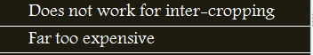
- 2nd set of pair (D+E)


- Assume that 200 farmers have been interviewed and responses are arranged in preference matrix grid as below.
- If the grid is carefully read, it can be seen that the rank order of the factors is- 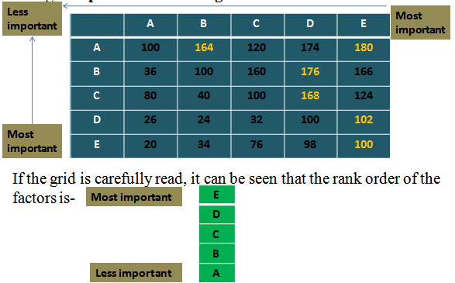

III. Method of successive categories
- Developed by Thurstone and published by Saffir in the year1954.
- Involves each subject is required to make a single judgment for each statement
- Method is convenient one, especially when number of statements to scaled large. It is relatively easy method to calculate but involves assumptions of equally spaced intervals.
- Sorting of each statement in any one of nine categories as mentioned below.
- After the various statements have been rated into the various successive categories
  - judges will put those statements in a separate categories based on rating

- Types of Scaling Techniques

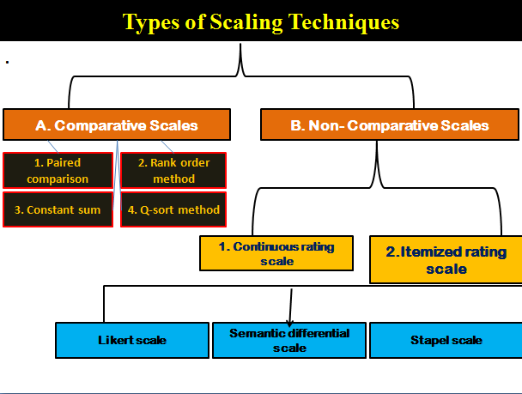

The various types of scaling techniques used in research can be classified into two categories:
(a) Comparative scales, and (b) Non-comparative scales.
(a) Comparative scales: The respondent is asked to compare one object with another.
For example, the researcher can ask the respondents whether they prefer jaya or prakash of rice varieties.
(b) Non-comparative scales: respondents need only evaluate a single object. Their evaluation is independent of the other object which the researcher is studying. Respondents using a non- comparative scale employ whatever rating standard seems appropriate to them.

    - Comparative scaling techniques
- Pairwise comparison scale or Paired comparison
- Rasch model scaling
- Rank-ordering
- Bogardus social distance scale
- Q-Sort
- Guttmann scale
- Constant sum scale
- Magnitude estimation scale
- Mathematically derived scale

    - Non- Comparative scaling techniques
- Continuous rating scale
- Likert scale
- Phrase completion scales
- Semantic differential scale
- Stapel scale
- Thurstone scale

1.Pairwise comparison or paired comparison:
  - A respondent is presented with two items at a time and asked to select one
  - This is an ordinal level technique
This is a comparative scaling technique in which a respondent is presented with two objects at a time and asked to select one object (rate between two objects at a time) according to some criterion. The data obtained are ordinal in nature. For example, there are four varieties of ragi – indaf 5, indaf 8, indaf 9 and MR 1. The respondents can prefer indaf 5 to indaf 8 or indaf 9 to MR 1, etc. In all we can have the following six comparisons.
Indaf 5– indaf 8, indaf 5– indaf 9, indaf 5– MR 1, indaf 8– indaf 9, indaf 8– MR 1, indaf 9– MR 1
In general, with n varieties we have $N=n\left(n-1\right)÷2$
N = number of judgments, n= number of stimuli or objects

2. Rasch model scaling:
  - Respondents interact with items and comparisons are inferred between items
  - Based on the responses will obtain scale values.
3.Rank-ordering:
This is another type of comparative scaling technique in which respondents are presented with several items simultaneously and asked to rank them in the order of priority. This is an ordinal scale that describes the favoured and unfavoured objects, but does not reveal the distance between the objects. For example, if you are interested in ranking the preference of some selected varieties of ragi, you may use the following format for recording the responses. Rank the following varieties of ragi in order of preference. Begin by picking out the one variety you like most and assign it a number1. Then find the second most preferred variety and assign it a number 2. Continue this procedure until you have ranked all the varieties of ragi in order of preference. The least preferred variety should be assigned a rank of 4. Also remember no two varieties receive the same rank order.
Indaf 5- 1, Indaf 8- 2, Indaf 9- 3 and MR 1- 4
Like paired comparison, the rank order scale, is also comparative in nature. The resultant data in rank order is ordinal data. This method is more realistic in obtaining the responses and it yields better results when direct comparison is required between the given objects. The major disadvantage of this technique is that only ordinal data can be generated.
  - A respondent is presented with several items simultaneously and asked to rank them from 0-5.
  - This is also an ordinal technique.
Example: researcher asks farmers to rank the five brands of pesticides based on order of preference
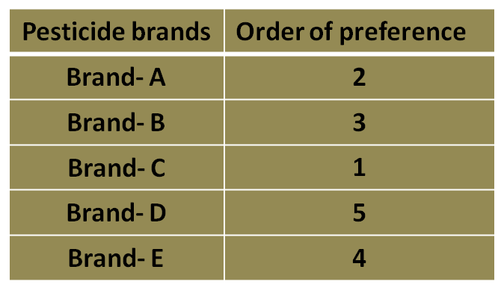
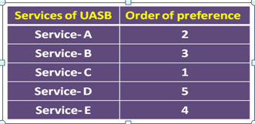

4. Bogardus social distance scale:
  - Created by Emory. S. Bogardus
    - Empirically measures the degree to which a person is willing to associate with a members of other class or social groups.
    - It is a cumulative scale
Eg: I would like to have innovator as my best friend- complete acceptance / partial acceptance / rejection

    - Bogardus social distance scale as below:
Sl.no | Bogardus group | Score
1 | A close relative by marriage | 1.00
2 | As my close personal friend | 2.00
3 | As neighbours on the same street | 3.00
4 | As co-workers in the same occupation | 4.00
5 | As citizens in the my country | 5.00
6 | As only visitors in my country | 6.00
7 | Would exclude from my country | 7.00

5. Constant sum scale:
  - A respondent is given a constant sum of money, points and asked to allocate these to various items
  - This is an ordinal level technique.
  - Example : If you had 100 rupees to spend on food products, how much would you spend on product A, on product B, on product C, product D, etc,.
- In this scale, the respondents are asked to allocate a constant sum of units such as points, rupees, or chips among a set of stimulus objects with respect to some criterion. For example, you may wish to determine how important the attributes of price, fragrance, packaging, taste and shelf life of a mango 11 items are to consumers. Respondents might be asked to divide a constant sum to indicate the relative importance of the attributes using the following format.
Price _____ points
Fragrance _____ points
Packing _____ points
Taste ____ points
Shelf life _____ points
100 points
- Between attributes of items please allocate 100 points among the attributes so that your allocation reflects the relative importance you attach to each attribute. The more points an attribute receives, the more important the attribute is. If an attribute is not at all important, assign it zero points. If an attribute is twice as important as some other attribute, it should receive twice as many points.

d) Q-Sort Scale: This is a comparative scale that uses a rank order procedure to sort objects based on similarity with respect to some criterion. The important characteristic of this methodology is that it is more important to make comparisons among different responses of a respondent than the responses between different respondents. Therefore, it is a comparative method of scaling rather than an absolute rating scale. In this method the respondent is given statements in a large number for describing the characteristics of a product or a large number of brands of a product. For example, you may wish to determine the preference from among a large number of magazines. The bag given to you contain pictures of 90 magazines. Please choose 10 magazines you ‘prefer most’, 20 magazines you ‘like’, 30 magazines to which you are ‘neutral (neither like nor dislike)’, 20 magazines you ‘dislike’, and 10 magazines you ‘prefer least’. Please list the sorted magazine names in the respective columns of the form provided to you. Note that the number of responses to be sorted should not be less than 60 or not more than 140. A reasonable range is 60 to 90 responses that result in a normal or quasi-normal distribution. This method is faster and less tedious than paired comparison measures. It also forces the subject to conform to quotas at each point of scale so as to yield a quasi-normal distribution. The utility of Q-sort in marketing research is to derive clusters of individuals who display similar preferences, thus representing unique market segments.

6. Guttmann scale:
It is also known as Scalogram analysis or cumulative scoring
- This is a procedure to determine whether a set of items can be rank-ordered on a unidimensional scale
- Intense of survey is to give score upto where the respondent is agree to the statements.
- Statements are listed in order of importance or effectiveness.
The rating is scaled by summing all responses until the first negative response in the list.

B. Non- Comparative scaling techniques
  - Respondents rate items/objects by placing a mark on a line.
  - The line is usually labeled at each end.

The non-comparative scaling techniques can be further divided into:
(a) Continuous Rating Scale, and (b) Itemised Rating Scale.
a) Continuous Rating Scales: It is very simple and highly useful. In continuous rating scale, the respondent’s rate the objects by placing a mark at the appropriate position on a continuous line that runs from one extreme of the criterion variable to the other. Examples of continuous rating scale are given below:
Question: How would you rate the TV advertisement as a guide for buying?
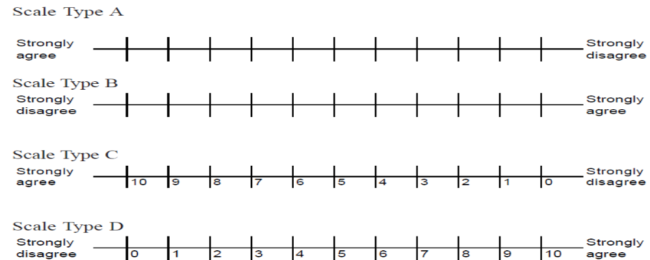

When scale type A and B are used, the respondents score is determined either by dividing the line into as many categories as desired and assigning the respondent a score based on the category into which his/her mark falls, or by measuring distance, in millimeters, centimeters, or inches from either end of the scale. Whichever of the above continuous scale is used, the results are normally analysed as interval scaled.
b) Itemised Rating Scales: Itemised rating scale is a scale having numbers or brief descriptions associated with each category. The categories are ordered in terms of scale position and the respondents are required to select one of the limited number of categories that best describes the product, brand, company, or product attribute being rated. Itemised rating scales are widely used in marketing research.
The itemized rating scales can be in the form of: (a) graphic, (b) verbal, or (c) numeric as shown below:
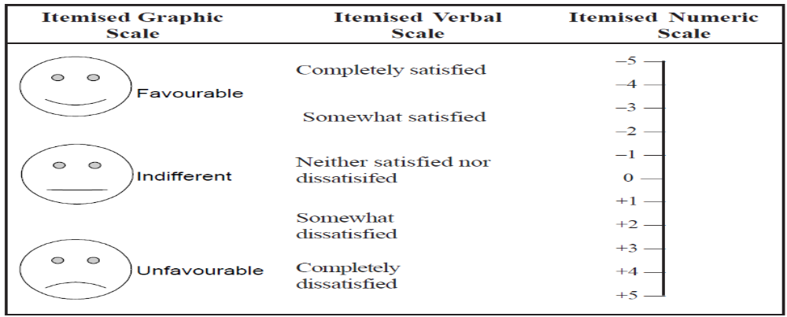

Some rating scales may have only two response categories such as : agree and disagree. Inclusion of more response categories provides the respondent more flexibility in the rating task. Consider the following questions::
- How often do you visit the market located in your nearest town?
• Never, • Rarely, • Sometimes, • Often, • Very often
2. In your case how important is the price of fertilizer when you buy?
• Very important, • Fairly important, • Neutral, • Not so important
Each of the above category scales is a more sensitive measure than a scale with only two responses since they provide more information.
There are Three itemized rating scales, namely
(a) Likert scale,
(b) Semantic Differential Scale, and
(c) Stapel Scale.

a) Likert Scale: In business research, the Likert scale, developed by Rensis Likert, is extremely popular for measuring attitudes, because, the method is simple to administer. With the Likert scale, the respondents indicate their own attitudes by checking how strongly they agree or disagree with carefully worded statements that range from very positive to very negative towards the attitudinal object. Respondents generally choose from five alternatives (say strongly agree, agree, neither agree nor disagree, disagree, strongly disagree). This ordinal scale and provides the ranking of individuals in terms of their favourable attitude towards a particular object.

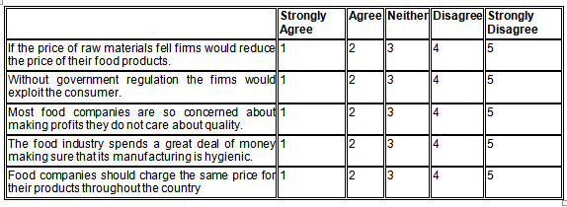
b) Semantic Differential Scale: This is a seven point rating scale with end points associated with bipolar labels (such as good and bad, complex and simple) that have semantic meaning. The Semantic Differential scale is used for a variety of purposes. It can be used to find whether a respondent has a positive or negative attitude towards an object. It has been widely used in comparing brands, products and company images. It has also been used to develop advertising and promotion strategies and in a new product development study.
- Developed by E. Osgood et.al, 1957
- This is a seven point rating scale with end points associated with bipolar labels that have semantic meaning.
- Example:
- Evaluate: good-bad, clean-dirty, fair-unfair etc
- Activity: fast-slow, sharp-dull, active-passive etc
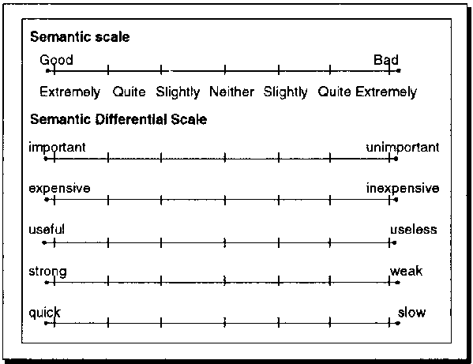

c) Stapel Scale: The Stapel scale was originally developed to measure the direction and intensity of an attitude simultaneously. Modern versions of the Stapel scale place a single adjective as a substitute for the Semantic differential when it is difficult to create pairs of bipolar adjectives. The modified Stapel scale places a single adjective in the centre of an even number of numerical
values (say, +3, +2, +1, 0, –1, –2, –3). This scale measures how close to or how distant from the adjective a given stimulus is perceived to be.

- Rating scales

- It refers to a set of opinion, which describes varying degree of dimensions of an attitude being observed.

- Popular because of ease in use.
- Wide use in many types of basic research
- Logically these fall under the heading of the successive interval scales
- It may be 3 point, 5 point, 7 point, etc

- Uses of rating scales
- Evaluation of individuals
- Assessing the individuals reactions
- Evaluation of individuals products
- Psychological evaluation of stimuli
- To evaluate skills, product outcome, activities, interest, etc.
- It helps to measure how much or how well something has been happened.
- Helps to make quantitative judgements about qualitative attributes
Eg: How was the Krishimela in UASB?
Types of Rating scales (Acc to Guilford)

Third objective

STEPS IN SCALE CONSTRUCTION
There are many numbers of steps involved in the scale construction varying from one to another based on the variable considered for the scale construction. The General steps involved in the construction of Scale are as follows:
- Item collection
- Item Selection
- Relevancy Analysis
- Item Analysis
- Standardization of scale
- Reliability of the scale
- Validity of the scale
- Administering the scale to respondents
- Item Collection
To collect items for the scale, first of all a clear understanding of the universe of content pertaining to the psychological object must be arrived at, Ex: If a scale is being constructed on attitude towards High Yielding Variety, then all aspects of attitude to HYV in terms of its quality, productivity, input requirements, usage as food, fodder, color, texture etc., must be first delineated and then items pertaining to all the aspects will be collected. Once the final list of items/statements are decided these have to be ordered on a psychological continuum. There are several methods that one can follow to order the items on the psychological continuum based on judgment of experts. It requires understanding of various scale construction techniques.
2. Item Selection
Based on the experts review, the most relevant one which are specific to particular area, must be scorable, must be good indicator and reflecting the components considered for the study will be selected among the items selected in previous step. For Item analysis and Item selection various approaches like arbitary approach, consensus scale approach, item analysis

approach, cumulative scales approach and factor approach will be used based on the title of the research and the variables considered in the study.
3. Relevancy Analysis
For Relevancy analysis, Relevancy weightage and Mean Relevancy Score will be calculated. Experts on the particular research topic will be selected to critically evaluate each item as to its relevancy to measure and give their response on five point continuum viz., most relevant (MR), relevant (R), somewhat relevant (SWR), less relevant (LR) and not relevant (NR). In all, 49 judges could respond in time. The relevancy score for each item was found out by adding the scores on the rating scale for all the judges. From the data so gathered ‘Relevancy weightage’ and ‘Mean relevancy score’ were worked out for all the items by using the following formulae:
Relevancy weightage = | MR+R+SWR+LR+NR
Relevancy weightage = | No. of judges responded x Maximum score

Mean relevancy score = | MR+R+SWR+LR+NR
Mean relevancy score = | No. of judges responded
Using these two criteria, individual items were screened for these relevancies. Accordingly, items having Relevancy weightage of 0.80 and above and Mean relevancy score of 2.75 and above will be considered for final selection. The range of these values considered will vary from researcher to researcher based on his purview.
4. Item Analysis
For final selection of the Items for the scale item analysis will be done using t-test, Discrimination Index and Difficulty Index
t-test:
A schedule will be prepared and used for personally interviewing the respondents on a three or five or seven point continuum from non-sample area. For item analysis, the respondents will be arranged in ascending order based on scores. Twenty five per cent of the subject with the highest of subjects total score and 25 per cent with the lowest total scores will be selected. These two groups provided the criterion groups in terms of which item analysis will be conducted and critical ratio will be calculated by using the following formula:
t = | X _{H} -X_{L}
t = | √∑ X² H – (∑ XH)² x ∑ X² L – (∑ XL)²  n n
t = | n(n-1)
Where, X_{H} = Individual scores in the high group
X_{L} = Individual scores in the low group
N = Number of respondents
Based on the item analysis (‘t’ value), non-significant items will be removed, items that found significant will be retained for final scale.
Item Discrimination Index
The most important index is the Item Discrimination Index (IDI). It indicates whether the items measured what is designed to measure. Discriminating value refers to making distinctions between persons having greater or lesser knowledge or skill in the areas measured by the evaluator. A item possess adequate discriminating power when it is capable of differentiating between superior and inferior farmers. Here in group we will select the upper and lower 25 % groups to make extreme groups as large as possible and to make it different.
IDI =$\left\{\left(S1-S2\right)\left(S5-S6\right)\right\}÷N/3$
Where, (S1-S2) = Number of correct answers in high groups
(S5-S6) = Number of correct answers in low groups
N = Number of respondents who took the test
Difficulty Index
$$DI= \frac{n}{N} 100$$
Where, n= Number of respondents who answered correctly
N = Total number of respondents who took the test
5. a. Validity of the scale
validity refers to whether scale measures what it desire to measure. It means what it measure and how to establish validity evidence must be obtain. Either by comparing test with establishing criteria or by obtaining objective source of information. So that we can say that the test is measuring what intend to measuring. Evidence obtained upon the purpose on which the test is constructed. Establishing validity is a fundamental aspect of scale development.
Types of Validity: Content validity, Criterion-related validity and Construct validity
1. Content validity: A scale has content validity if it measures knowledge of the content domain of which it was designed to measure knowledge. Content validity concerns, primarily, the adequacy with which the test items adequately and representatively sample the content area to be measured.
For e.g., a comprehensive math achievement test would lack content validity if good scores depended primarily on knowledge of English, or if it only had questions about one aspect of math (e.g., algebra). Expert judgement (not statistics) is the primary method used to determine whether a test has content validity. Nevertheless, the test should have a high correlation with other tests that purport to sample the same content domain.
2. Criterion-related validity: Criterion-related validity is a concern for tests that are designed to predict someone’s status on an external criterion measure. A test has criterion-related validity if it is useful for predicting a person’s behaviour in a specified situation.
2a) Concurrent and predictive validation:
First the term "validation" refers to the procedures used to determine how valid a predictor is. There are two types. In concurrent validation, the predictor and criterion data are collected at or about the same time. This kind of validation is appropriate for tests designed to asses a person’s current criterion status. It is good diagnostic screening tests when you want to diagnose.
In Predictive validation, the predictor scores are collected first and criterion data are collected at some later/future point. This is appropriate for tests designed to asses a person’s future status on a criterion.
2b) Standard Error of estimate
The standard error of estimate is used to estimate the range in which a person’s true score on a criterion is likely to fall, given his/her score as estimated by a predictor.
2c) Decision-Making
In many cases when using predictor tests, the goal is to predict whether or not a person will meet or exceed a minimum standard of criterion performance — the criterion cutoff point. For ex; who scores at or above the predictor cutoff is predicted to score at or above the criterion cut off.
3. Construct validity: A scale has construct validity if it accurately measures a theoretical, non-observable construct or trait. The construct validity of a test is worked out over a period of time on the basis of an accumulation of evidence.
3a) Convergent/divergent validation
A test has convergent validity if it has a high correlation with another test that measures the same construct. A test’s divergent validity is demonstrated through a low correlation with a test that measures a different construct.
3b) Factor analysis
Factor analysis is a complex statistical procedure which is conducted for a variety of purposes, one of which is to assess the construct validity of a test or a number of tests.
5.b. Reliability of the scale
Reliability is one of the important characteristic of any test. In its simplest sense reliability refers to the precision or accuracy of the measurement or score a well made scientific scale should yield accurate result both at present as well as overtime. In other words such an instrument should yield consistent results. Reliability refers to the consistency of the scores or measurements which is reflected in the reproducibility of the scores
The most common methods of estimating the reliability coefficient of test scores are: Test-retest reliability and Internal consistency reliability.
Test-retest reliability: a single form of the test is administered twice on the same sample with a reasonable time gap, say a fortnight. This yields two independent sets of scores. The correlation between the two sets of scores gives the value of the reliability coefficient, which is also known as temporal stability coefficient. A positive and significant correlation coefficient between the two sets of scores indicates that the test is reliable.
Internal consistency reliability: This method indicates homogeneity of the test. The most common is split-half method, in which a test is divided into two halves. One half (one set) contains the odd-numbered items (1, 3, 5, 7 etc.) and the other half (other set) the even numbered items (2, 4, 6, 8 etc.). A test should, however, not be divided into first-half and second-half of the items. A single administrations of the two sets of items to a sample of respondents, yields two sets of scores. A positive and significant correlation between the two sets of scores indicates that the test is reliable.
The advantage of the split-half method is that all data necessary for the computation of the reliability coefficient are obtained in a single administration of the test. Thus, the variability which may be produced by the difference in two administrations of the same test (as in test-retest method) is automatically eliminated
Factors influencing reliability of test scores
- Extrinsic factors
- Group variability: when the group of examinees being tested is homogeneous in ability the reliability of the test is likely to be lowered. But when the examinees vary widely in their ability then that is the group of heterogeneous then the reliability of the test is likely to be high.
- Guessing by examinees: guessing has two important effect on the total scores. First it tends to raise the scores and there by makes the reliability high and guessing contributes to the error score since the examinees differ in exersicing their luck over guessing correct answer.
- Environmental conditions: as for as possible the testing environment should be uniform. The arrangement should be such that light, sound and other comforts are equal and uniform to all the examinees otherwise it will tend to lower the reliability of the test scores.
- Momentary fluctuations: momentary fluctuations influence the test scores sometimes by raising the score and sometimes by lowering it accordingly they tend to affect the reliability. Ex. A broken pencil, momentary distraction by sound of the aeroplane, anxiety of not completing the home work, mistake in the giving correct answer knowing no way to change it.
- Intrinsic factors
- Length of the test: a longer test yields a higher reliability coefficient than a shorter test. Lengthening the test or averaging total test scores obtained from several repetitions of the same test tends to increase the reliability.
- Range of the total scores: obtained total scores on the test are very close to each other that if there is lesser variability among them then the reliability of the test is lowered. On the other hand if the total scores on the test vary widely then the reliability of the test is increases.
- Difficult value of the items: in general, items having difficulty index of 0.5 or close to it yields higher reliability than the items of extreme indexes of difficulty.
- Homogeneity of items: when the test items or heterogeneous the reliability will be low when all the items measures same function or trait then reliability will be high.
- Discrimination value: when the test is composed of discriminating items then total test correlation is likely to high and then reliability is also high but when items do not discriminate then i.e., when items have poor discrimination value then reliability will be low
How to improve reliability of the test scores?
- The group examinees should be heterogeneous that is the examinees should vary widely in their ability or trait being measured.
- Items should be homogeneous
- Test should be preferably be a longer one
- As for possible items should be of moderate difficult values should range from 0.40-0.50 or 0.50-0.60
- Items should be discriminatory ones

Relationship between Reliability and Validity
- If a measure is reasonably valid, it must be ipso-facto reasonably reliable also since any measure with a large error component can’t show such a constant relationship.
- A valid test is generally reliable. A test which is not valid, may not be reliable.
- A test which is reliable may or may not be valid.
- A high degree of reliability does not necessarily lead to high validity. It may reflect a high degree of constant error.
- A test that is not reliable, is never valid.
- In case of a heterogeneous test, reliability may be low but validity may be high.
- Lengthening of a homogenous test with similar items may increase its reliability without affecting validity.
- In case of a heterogeneous test battery, addition of more factors may increase validity without affecting reliability.
- High inter – item correlation, high reliability but low validity. On the other hand, low inter – item correlation, low reliability but may be high validity.
- A measure having high validity with good reliability is more useful than a measure having low validity but high reliability.
- If a test is unreliable, it cannot be valid.
- For a test to be valid, it must reliable.
- However, just because a test is reliable does not mean it will be valid.
- Reliability is a necessary but not sufficient condition for validity.

- Administering the Scale
The last and final step in scale construction is administering the developed scale to the respondents for data collection following different methods in different format.

RESEARCH STUDIES
          - Impact of watershed development programme on farmers of North Karnataka
Steps followed and components identified are:
- Collection of extensive literature related to watershed programme from KSDA, WDC, etc.
- Thorough discussion with a number of senior experienced extension specialists, extension experts and farmers.
- After rigorous exercise, 104 statements concerning the attitude of farmers towards various component of DWDP were identified.
- Components are:
  - Objective of the programme
  - Technical support activities on soil conservation, crop production and alternative land use system
  - Method of education used
  - Benefits of the programme
  - Services rendered by the extension personnel of DWDP
      - These were identified for construction of scale

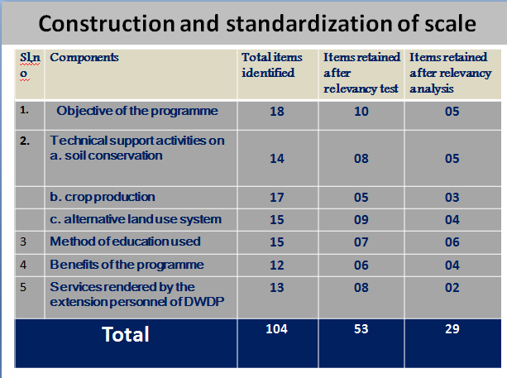
- Relevancy test
- Selected statements were mailed to 146 judges
- Evaluate items for their relevancy in four point continuum most relevant, relevant, least relevant, and not relevant with the scores of 4,3,2,1.
- Asked judges to make necessary modification, addition or deletion of items
- Out of 146 judges only 53 judges responded in time.
- Rating scale of all 53 judges were worked out,
- Then statements having relevancy parentage more than 75.00,
- relevancy weightage more than 0.75 and
- mean relevancy score of more than 3.00 were considered for final selection of statements.
- Relevancy analysis:
schedule consisting of 53 items was prepared and used for interview of 40 farmers and 24 extension personnel's from the non-sample area.
- Item Analysis: t-test, 29 items were retained with significant at 5% and 1% were retained.
- Reliability: Split-half reliability, 15 items in one half and 14 in another half , r =0.62, it indicates obtained internal consistency of the scale is quite high.
- Validity: Content Validity, universe opinion collected from various sources.
- Method of scoring followed Likerts’ summated rating sclae.

- II. People participation
- Summated rating scale technique recommended by Guilford (1954).
Steps were adopted in the process of development of people’s participation scale
- Identification of various components of people’s participation.
- Measurement of each sub-components of people’s participation.
- Development of people’s participation scale
- Reliability and validity of developed scale.
- Steps followed in the process of scale construction
- Item collection: 69 items - initial test.
- Practices selection: List of practices
- Framing of test items: 24 questions, check list (30 experts)
- Item analysis: 3 point continuum, 30 respondents
- Item difficulty index: n/N *100
- Discrimination index: (S1-S2)(S5-S6)/ (n/3)
- Selection of items: 6 out of 24 – 20 to 80% IDI, 0.20 to 0.80 DI.
- Reliability of constructed scale:
- Split-half reliablility, 30 respondents in non-sampled area, correlation co-efficient: 0.735** (** - significant at 1% level)
- Validity of constructed scale: Content Validity

- Performance of self help groups in Karnataka- An analysis
- Narayana Swamy. B (2005)
He has developed scale to measure the performance of Self Help Groups following the procedure advocated by Edwards (1957)
Operational Definition: It is defined as the achievements in terms of execution and outcome made by a SHG in relation to its set objectives at individual , group and community level.
Individual level
- Capacity building
- Economic activities
- Social status
- Communicability
- Self monitoring
Group Level
- Economic activities
- Social status
- Functional linkages
- Conflict management
- Transparency in functioning
Community (Village) level
- Social development
- Economic development
- Functional linkage
Methodology
Locale of the study: Sujala watershed
Respondents: 200 respondents, women SHGs
Research Design: Ex-post facto research design
Dependent Variables: Performance of SHG
Independent Variables: Age, Education, Achievement Motivation, Risk Willingness, Deferred gratification, Landholding, Farming Experience, Extension Participation, Cosmopoliteness
Steps followed in Scale Construction
- Pooling of experts opinion: Discussion with experts for performance at individual, group and village level
- Collection of items: 3 point continuum, 148 items selected, 114 items finalized
- Selection of judges to get opinion about the scale items: 146 judges i.e., Agriculture, extension experts, NABARD officials, NGO officials
- Judges ratings / opinion: 81 judges responded, 72 judges responses were considered
- Selection of items for the final scale:
Tabulated under three category (t-value) Individual (0.64), Group Level (0.68) and Community level (0.67); cut-off t-value: 0.60; Relevancy Test value > 0.75
A/c to Highest ‘t’ value: 27 statements- individual level, 25 statements – group level, 16 statements – community level. Totally 68 statements were selected out of 114 statements.
Reliability scale: 30 respondents from non-sampled area, split-half method (Brown-Prophecy formula)


Calc ‘r’ value at 1 %
- Individual level - 0.9009
- Group level - 0.9325
- Community level - 0.9154
Validity of the scale: Content Validity – discussion with experts and by reviewing the literature
Administering of the performance scale: Likert Procedure, 5 Point Continuum, Min Score: 68, Max Score: 340
Overall Performance of SHGs
(n=200)
Level | Categories | Percentage
Individual Level | Low | 30.5
Individual Level | Medium | 35.5
Individual Level | High | 34.0
Group  Level | Low | 28.5
Group  Level | Medium | 38.5
Group  Level | High | 33.0
Village Level | Low | 28.0
Village Level | Medium | 43.5
Village Level | High

CONCLUSION

In social science research, the phenomenons are generally qualitative in nature, which are not amicable to direct measurement. In this context, scaling techniques plays a major role to convert the qualitative facts into quantitative nature/series. The principles, criteria’s and procedures of the scale construction provide greater depth for the measurement of the selected variables. Therefore the planning, construction, administration and evaluation must be systematic and scientific, if they are to yield better results in social science research.
REFERENCES
EDWARDS, A.L., 1957, Technique of attitude scale construction, Appellation century crafts, INC., New York.:15-22.
GUILFORD., 1954, Psychometric Methods. New York: McGraw-Hill Book Co.
GUTTMAN, L., 1944, A Basis for scaling qualitative data, American Sociological Review, 9: 139-150.
KERLINGER, F.N., 1973, Foundations of behavioral research, Holt Rinehart and Winston, Inc., New York.
KOTHARI, R., 1990, New Delhi, Deep 7 Deep Publication, Research Methodology, Methods and techniques, New Delhi Wiley Eastern Ltd.
LIKERT, R., 1932, A technique for the measurement of attitude. Archology Psychology, No.140.
NARAYANA SWAMY, B., 2005, Performance of Self Help Groups in Karnataka – An Analysis, M.Sc.(Agri.) thesis (Unpub.), Univ. Agric. Sci., Bangalore.
RAY, G. L. AND SAGAR MANDAL., 2000, Research methods in Social science & Extension Education.


UNIVERSITY OF AGRICULTURAL SCIENCES
DEPARTMENT OF AGRICULTURAL EXTENSION
GKVK, BANGALORE-65

Name: Sujay Kumar, S. Seminar – III Date: 05-12-2015 ID No: PALB 3020 on Time: 10: 30 A.M
III Ph.D Ven: Dwarkinath hall
Scaling Techniques in Social Science Research
Synopsis

In recent days greater emphasis is laid on the measuring instruments in social science research. Scaling is a technique used for a measurement of some aspects of human behaviour by means of precise scale and also it is a procedure for assignment of numbers or symbols to a property or object in order to impart some of the characteristics of numbers to the property in question. It is used to find out solution to the problems of human society. It is possible only by scientific way of analysing a problem. Therefore, it is essential for the researcher to acquire and familiarize with various tools and techniques of research. Keeping these aspects in view, the present seminar has been conceptualized with the following objectives.
- To understand the concept of scale and scaling techniques
- To know the different methods and types of scaling techniques
- To understand procedure involved in Q-sort scale and semantic differential scale
- To discuss steps involved in scale construction
- To review the empirical evidence
Definition: Scaling techniques are methods through which stimuli or individuals are sorted according to some known and specified attributes. When these methods are applied for sorting purposes, their results automatically yield a continuum which is called scale. Scales do not ordinarily have the meanings of competition, and success or failure that tests do (Kerlinger, 1973).
Steps in Scale Construction:
1. Item Collection 2. Item Selection
3. Relevancy analysis 4. Transformation of items to the question format
5. Item analysis 6. Reliability and validity of the scale
7. Administering the scale

Types of Scaling Techniques
- Comparative Scaling Techniques
- Pairwise comparison scale or Paired comparison
- Rank-ordering
- Q-Sort
- Constant sum scale

- Non Comparative Scaling Techniques
- Continuous rating scale
- Itemized rating scale
- Likert scale
- Semantic differential scale
- Stapel scale

Scales developed for their Research studies as follows:

Nithya shree (1996) developed a scale to measure the perception of attributes of innovation by following semantic differential technique. Out of 75 judges, only 63 judges responded in time, worked out the relevancy scores on the rating scale of all the 63 judges and the steps followed were collection of items, selection of judges, judges rating, item selection for final scale, reliability, validity and administration of the scale.
Shivasharanappa (1995) developed a scale to measure the attitude of the watershed farmers’, scale that has been developed by use of procedure of Thurstone’s (1928) Technique of equal appearing interval scale and the Likert’s (1932) Technique of summated rating scale’. Out of 146 judges, only 53 judges responded in time, worked out the relevancy scores on the rating scale of all the 53 judges and the steps followed were collection of items, selection of judges, judges rating, item selection for final scale, reliability, validity and administration of the scale.

Conclusion:
In social science research the phenomenon are generally qualitative in nature, which are not subjected to direct measurement. In this context, scaling techniques plays a major role to convert this into quantitative nature. The principles, criteria’s and procedures for scale construction are provides greater depth into effective measurement of the selected variables.

References:

EDWARDS, A.L., 1957, Technique of attitude scale construction, Appellation century crafts, INC., New York.:15-22.
GUILFORD., 1954, Psychometric Methods. New York: McGraw-Hill Book Co.

KERLINGER, F.N., 1973, Foundations of behavioral research, Holt Rinehart and Winston, Inc., New York.
LIKERT, R., 1932, A technique for the measurement of attitude. Archology Psychology, No.140.

NITHYA SHREE, D. A., 1996, A critical analysis of the adopter categories and their characteristics, M.Sc. (Agri.) thesis (Unpub.), Univ.Agric. Sci., Bangalore.
SHIVASHARANAPPA, 1995, Impact of Watershed Development Programme on farmers of North Karnataka, Ph.D thesis (Unpub.), Univ. Agric. Sci., Dharwad.

