
UNIVERSITY OF AGRICULTURAL SCIENCES,
DEPARTMENT OF AGRICULTURAL EXTENSION, UAS ,GKVK, BANGALORE-560065


Seminar report
On
Producers organizations
and
Cooperatives

Submitted to Seminar teachers,
Dr.Shivamurthy,M., Professor
Dr.Ganeshamoorthy, Assistant Professor
Department of Agricultural Extension,
UAS, GKVK, Bengaluru
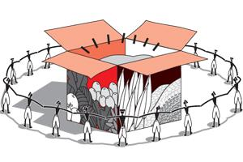

Submitted from,
Mr.Bharath Kumar, T.P,
PALB-1027
III Ph.D Student
Department of Agricultural Extension,
UAS, GKVK, Bengaluru

UNIVERSITY OF AGRICULTURAL SCIENCES,
DEPARTMENT OF AGRICULTURAL EXTENSION, UAS GKVK, BANGALORE-560065

Name: Bharath Kumar.T.P. Date: 17.12.2016
I.D No: PALB 1027 Time: 9.30 a.m.
Class: III Ph.D. (Agril.Extn.) Venue: Dwarkinath hall
Seminar On
“Producers organizations and Cooperatives”
Synopsis
Small and marginal farmers in India have been vulnerable to risks in agricultural production. Several organizational prototypes are emerging to integrate them into the value chain with the objectives of enhancing incomes and reduction in transaction costs. One such alternative is Producer Organizations (POs) and cooperatives. Producer’s organizations (POs) and cooperatives in many developing countries play a significant role in boosting rural economies. They facilitate small-scale producer’s access to natural resources such as land and water, information, communication and knowledge, markets, food and productive assets such as seeds and tools, and policy- and decision-making. They also enhance the bargaining power of farmers in the markets and in the value chains. POs and cooperatives need an adequate enabling environment to properly perform, flourish and meet their member’s needs in order to unleash this high potential towards poverty reduction and food security. With this background, the seminar has been conceptualized with the following objectives:
- To know the concept of Producers organizations and Cooperatives.
- To study the role of extension in strengthening of PO’s and Cooperatives.
- To know the steps in establishing PO’s and cooperatives.
- To review some of the studies related to PO’s and cooperatives.

Concept of Producer Organization (PO)
It is a legal entity formed by primary producers, viz. farmers, milk producers, fishermen, weavers, rural artisans, craftsmen. A PO can be a producer company, a cooperative society or any other legal form which provides for sharing of profits/benefits among the members

The producer organizations (POs) are formal rural organizations whose members are smallholder farmers who organize themselves with the objective of improving farm income through improved production, marketing, and local processing activities. (Anonymous.2004).

Cooperatives
Cooperatives are “autonomous associations of persons united voluntarily to meet their common economic, social and cultural needs and aspirations through a jointly owned and democratically controlled enterprise”
Basically designed and oriented to meet economic and societal needs of rural segments, particularly the poor. Starting with agricultural credit, cooperatives encompassed all rural economic activities.
Cooperative is a special type of enterprise. It is a social enterprise that balances two main goals:
1. Satisfying its members needs and
2. Pursuing profit and sustainability.

Role of Extension in Promotion of POs and Cooperatives
The role of extension vary with the role of the POs and cooperatives, the sectors in which the organization operates, the services offered, and the organizational form used. Several extension roles of POs and cooperatives are conceptualized to help rural communities to get organized into four different types. They include (1) Empowerment Role. (2) Community-Organizing Role. (3) Human Resource Development Role. (4) Problem-Solving and Education Role (Chamala, 1990).
Steps in Establishing Producers Organizations and cooperatives
Chamala (1990) has come out with simplified step-wise approach in establishing POs and cooperatives. They are (1) Understanding the village community, (2) Identifying potential leaders in the community, (3) Talking to the identified leaders and seeking cooperation from other, (4) Helping local leaders to call community meetings, (5) Nominating core group leaders to develop or establish the PO’s and cooperatives, (6) Developing an organizational structure for the PO’s and cooperatives, (7) Developing the PO’s and cooperatives management through education and action learning, (8) Gearing up for action, (9) Implementing selected activities and (10) Monitoring and evaluating the PO’s and cooperatives progress.
Studies related to PO’S and cooperatives.
Nalini et.al, (2015) Avirat facilitates purchase of government approved seeds with price advantages of up to 10-15% for the Kharif and the Rabi seasons, particularly seeds of Bt Cotton, groundnut, and cumin, pesticides, and other inputs like farm implements and equipment to the tune of up to 50%.
Gopala, (2014) in his study he revealed that 43.20 per cent of the CBA members had more favourable attitude and 40.40 per cent of CBA members were having high level of participation towards the CBAs.
Conclusion
Accumulated research and experience show that while small farmers acting alone did not benefit from higher food prices, those acting collectively in strong producer organizations and cooperatives were better able to take advantage of market opportunities and mitigate the negative effects of food and other crises. Small Farmers’ Organizations such as cooperatives and POs are expected to enhance incomes, reduce costs of input purchases along with transaction costs, create opportunities for involvement in value-addition including processing, distribution and marketing, enhance bargaining power, provide access to formal credit, reducing poverty, improving food security and generating employment opportunities. Thus, cooperatives and POs play a crucial role in contribution to global socio-economic development. Hence awareness on cooperatives and PO’s must be raised for overall development of small and marginal farmers.
References:
ANONYMOUS, 2004, Improving Agricultural Extension. A Reference Manual. Published by Natural Resources Management and Environment Department. FAO, Rome.
CHAMALA, S., 1990, Establishing a group: A participative action model. Brisbane: Australian Academic Press: 13-38.
GOPALA.Y.M, 2014, Impact analysis of commodity based associations, Ph.D.(Agri.)Thesis, UAS, Bangalore.
NALINI BIKKINA, RAMA MOHANA TURAGA AND VAIBHAV BHAMORIYA, 2015, IIMA Working Papers from Indian Institute of Management Ahmedabad, Research and Publication Department, No WP2015-01-05.

Producers organizations and Cooperatives
Introduction
The largest group of cultivators in Indian agriculture is constituted from Small and marginal farmers. Nearly 85% of operated holdings are smaller than or about two hectares and amongst these holdings, 66% are less than one hectare (Singh, 2012).
These farmers are struggling to survive where indebtedness is often cited as the immediate reason for distress (Reserve Bank of India, 2006, Satish, 2007), indepth issues are related to vulnerability to risks in agriculture production. These issues include lower scale of operation, lack of information, poor communication linkages with the wider markets and consequent exploitation by intermediaries in procuring inputs and marketing fresh produce, access to and cost of credit (Dev, 2005) and, in isolated cases, aggressive loan recovery practices. In fact, according to the Situation Assessment Survey of Farmers, for many small and marginal farmer households, monthly per capita consumption expenditure is higher than the monthly per capita income (Mishra, 2008). A variety of approaches have emerged in response to the problems faced by the small and marginal farmers. At the market end of agriculture value-chain, private participation is being promoted through contract farming, particularly after the amendment of the Agricultural Produce Marketing Committee (APMC) Act in 2003. Contract farming involves agricultural production based on an agreement between a corporation and the farmer for production and supply of agreed quantities of a product meeting certain quality standards (FAO, 2014). However, contract farming arrangements tend to exclude small producers and in many instances have benefited the buyers at the expense of the producers (Hellin et al., 2009).
The other approach is the facilitation of collective action by small and marginal farmers. Agricultural cooperatives, formed under the Co-operative Credit Societies Act, 1904, has long been the dominant form of farmer collectives, however, the experience with cooperatives point to many limitations that prevent effective collective action. Hence the Indian government has been promoting a new form of collectives called Producer Organizations (FPOs) to address the challenges faced by the small and marginal farmers, particularly those to do with enhanced access to investments, technological advancements, and efficient inputs and markets.
The extension worker: farmer ratio is very wide in India i.e. 1: 1000. At least, 25 percent of extension workers are administrations /supervisors. At least 50 percent of the time goes for administrative work, official correspondence, reports and travel to reach villages. Hence, taking care of this small and marginal farmer has become a challenging task to increase their livelihood status. Research studies shows that smallholders would be able to substantially increase their incomes from agriculture and allied activities if they participate in markets. As a result, the focus of development has shifted from enhancement of production to market connectivity. Small Farmers’ Organizations such as cooperatives and POs are expected to enhance incomes, reduce costs of input purchases along with transaction costs, create opportunities for involvement in value-addition including processing, distribution and marketing, enhance bargaining power and provide access to formal credit. Hence, this is there is a need of strong organization that too for primary producers organizations which will concentrate on uplifting of small and marginal farmers.
Producers Organizations
The purpose of establishing Producers Organization (POs) is to internalize extension services for its members and provide backward linkage (input, credit and technology) and Forward linkage (production facilities, market and value addition). The POs provides an effective channel for both dissemination of technology to large number of small and marginal farmers and feedback to research and extension.
Why to Organize Farmers into groups in India
Agriculture is the largest unorganized sector in India. Around 60 per cent of people depend on agriculture in India. Hardly 5-10% farmers are Progressive, Educated, Self-Moving and innovative. >40% Rural Youth is out of Farming. Farmers don’t have any vibrant model to organize themselves and link with the market. In order to overcome this problem and provide services through group approach the farmers needs to be organized in India.
Previous Attempt to Organize Farmers
During 1970s, India has introduced “Dairy Cooperatives” and it is successful. During this period the government of India introduced a new programme in the line of AMUL to promote the group marketing of milk by organizing primary milk producers in India. As a result, 60 per cent of milk produced in the country sold through organized milk producer’s cooperatives and it provides supplementary income to over 70 per cent of rural and urban households.
Current Attempts to Organize Farmer in India
- ATMA Organize farmers into groups (FIGs and CIGs).
- Innovation in Technology Dissemination (ITD) and NATP evaluating success stories and replicating the models.
- NGOs, PRIs organizing farmers groups. NABARD organizing farmers into SHGs and farmers clubs.
- Line departments forming producer groups through different commodity boards.
- SAUs forming groups through KVKs
With this background the current seminar has been conceptualized with following specific objectives
- To know the concept of Producers organizations and Cooperatives.
- To study the role of extension in strengthening of PO’s and Cooperatives.
- To know the steps in establishing PO’s and cooperatives.
- To review some of the studies related to PO’s and cooperatives.
Concept of the Producers Organisations(PO’s)
PO’s are groups of rural producers coming together based on the principle of membership, to pursue specific common interests of their members and developing technical and economic activities that benefit their members and maintaining relations with partners operating in their economic and institutional environment. (Anonymous.2004).
Producers Organizations (POs) are essential institutions for the empowerment, poverty alleviation and advancement of farmers and the rural poor.(FAO, 2006).
“Producers’ organizations should be promoted to combine the advantages of decentralized production and centralized services, post-harvest management, value addition and marketing” (National Commission on Farmers, 2004).
What is a Producer Organisation (PO)?
A Producer Organisation (PO) is a legal entity formed by primary producers, viz. farmers, milk producers, fishermen, weavers, rural artisans, craftsmen. A PO can be a producer company, a cooperative society or any other legal form which provides for sharing of profits/benefits among the members. In some forms like producer companies, institutions of primary producers can also become member of PO.
What is the need for PO?
The main aim of PO is to ensure better income for the producers through an organization of their own. Small producers do not have the volume individually (both inputs and produce) to get the benefit of economies of scale. Besides, in agricultural marketing, there is a long chain of intermediaries who very often work non-transparently leading to the situation where the producer receives only a small part of the value that the ultimate consumer pays. Through aggregation, the primary producers can avail the benefit of economies of scale. They will also have better bargaining power vis-à-vis the bulk buyers of produce and bulk suppliers of inputs.
What is a “Farmers Producer Organisation” (FPO)?
It is one type of PO where the members are farmers. Small Farmers’ Agribusiness Consortium (SFAC) is providing support for promotion of FPOs. PO is a generic name for an organization of producers of any produce, e.g., agricultural, non-farm products, artisan products, etc.
Can there be a PO for non-farmers?
Yes. The PO is an organization of the primary producers. If the produce in question is a non-farm item (for example, handloom or handicraft), then the PO will be that of non-farmers. The objective of the PO is to ensure better income realization to its members (who are producers) through aggregation and, if feasible, value addition.
What are the essential features of a PO?
a. It is formed by a group of producers for either farm or non-farm activities.
b. It is a registered body and a legal entity.
c. Producers are shareholders in the organization.
d. It deals with business activities related to the primary produce/product.
e. It works for the benefit of the member producers.
f. A part of the profit is shared amongst the producers.
g. Rest of the surplus is added to its owned funds for business expansion.

Who owns the PO?
The ownership of the PO is with its members. It is an organization of the producers, by the producers and for the producers. One or more institutions and/or individuals may have promoted the PO by way of assisting in mobilization, registration, business planning and operations. However, ownership control is always with members and management is through the representatives of the members.

Who can promote a PO?
Any individual or institution can promote a PO. Individual persons or institutions may promote PO using their own resources out of goodwill or with the noble objective of socio-economic development of producers. If, however, the facilitating agency wishes to seek financial and other support, then they have to meet the requirements of the donor/financing agency.
Who provides support for promotion of PO?
NABARD, SFAC, Government Departments, Corporates and Domestic & International Aid Agencies provide financial and/or technical support to the Producer Organisation Promoting Institution (POPI) for promotion and hand-holding of the PO. Each agency has its own criteria for selecting the project/promoting institution to support.
Can an NGO promote PO?
Yes, it can. The NGO may be a non-profit organization, but not the PO. The NGO can promote PO which will provide better income to the members. Sharing of profit among members is an important objective of the PO.
Different Types of Producers Organizations
- FIGs
- CIGs
- Cooperatives
- Farmers’ associations
- Federations
- Farmers producers organization
- Producer Company
- Non-Profit Society
- Trust
What are the different legal forms of PO?
Producer Organisation can be registered under any of the following legal provisions:
- Cooperative Societies Act/ Autonomous or Mutually Aided Cooperative Societies Act of the respective State
- Multi-State Cooperative Society Act, 2002
- Producer Company under Section 581(C) of Indian Companies Act, 1956, as amended in 2013
- Section 25 Company of Indian Companies Act, 1956, as amended as Section 8 in 2013
- Societies registered under Society Registration Act, 1860
- Public Trusts registered under Indian Trusts Act, 1882
What are the taxation systems / laws governing the POs
Immediately after incorporation, a PO has to procure
  - PAN number from the Income Tax Department
  - TIN number from the Commercial Tax Department
  - The company has to register itself for Service Tax from Commercial Tax Department and
  - VAT from Excise department
Is registration mandatory for a PO?
It is preferable for the PO to work as a legal entity. Only such an entity can enter into legally valid contracts including mobilization of funds from other institutions. There are specific Acts under which the PO could be registered. It is also possible for a PO to migrate from one legal form to another. While choosing a legal form, the following factors may be kept in view:
a. Primary producers should benefit from the surplus generated by the PO.
b. Process of Registration should not be too demanding in terms of time and resources.
c. The legal form needs to fit into its business needs, organizational priorities, social capital and management capacity.
What are the important activities of a PO?
The primary producers have skill and expertise in producing. However, they generally need support for marketing of what they produce. The PO will basically bridge this gap. The PO will take over the responsibility of any one or more activities in the value chain of the produce right from procurement of raw material to delivery of the final product at the ultimate consumers’ doorstep. In brief, the PO could undertake the following activities:
a. Procurement of inputs
b. Disseminating market information
c. Dissemination of technology and innovations
d. Facilitating finance for inputs
e. Aggregation and storage of produce
f. Primary processing like drying, cleaning and grading
g. Brand building, Packaging, Labeling and Standardization
h. Quality control
i. Marketing to institutional buyers
j. Participation in commodity exchanges
k. Export
How would a PO help the members?
A PO will support the members in getting more income by undertaking any/many/all of the activities listed above. By aggregating the demand for inputs, the PO can buy in bulk, thus procuring at cheaper price compared to individual purchase. Besides, by transporting in bulk, cost of transportation is reduced. Thus reducing the overall cost of production. Similarly, the PO may aggregate the produce of all members and market in bulk, thus, fetching better price per unit of produce. The PO can also provide market information to the producers to enable them hold on to their produce till the market price become favourable. All these interventions will result in more income to the primary producers.
What are other benefits for the members of a PO (other than better income)?
A PO is a collective of farmers (and non-farmers) who are the primary producers of a product (an agricultural produce or a manufactured product). It, therefore, can work as a platform to facilitate better access to government services, like PDS, MNREGA, Scholarships and Pensions, etc. It can liaison with the Government Departments for convergence of programmes, like drinking water, sanitation, health and hygiene.
Who can become member of a PO?
PO is an organization of the producers, specifically the primary producers. All primary producers residing in the relevant geography, and producing the same or similar produce, for which the PO has been formed, can become member of the PO. Membership is voluntary. The procedure for obtaining PO membership depends on the bye-laws of the PO. The founder-members are those who were there at the time of formation of the PO. Other members join the PO later. However, all members enjoy equal rights. A primary producer can become member of a PO by submitting an application and a nominal membership fee. Some POs also charge annual membership renewal fee. Although primary producers obtain membership of PO voluntarily, the promoting institution should make efforts to bring all producers into the PO, especially the small producers.
Who is a primary producer?
Any person engaged in any activity connected with or related to any primary produce will be treated as producer. Primary produce means the produce of farmers from agriculture and allied activities or produce of persons engaged in handloom, handicrafts and other cottage industries, including any by-product and product resulting from ancillary activities thereof. Primary produce also includes any activity intended to increase the production or quality of aforementioned products or activities. Persons engaged in agriculture, horticulture, animal husbandry, fishery, sericulture, apiary, handloom, handicrafts, etc., can become members of appropriate PO. Persons engaged in collection of minor forest produce are also eligible for membership of PO although they gather these from forests and strictly are not producers.
Can a person become member of more than one PO?
Family is the unit of production in rural areas. Benefits from the PO will accrue to members in proportion to the volume/value of produce given to the PO. Therefore, one person from a family can provide the whole produce of the family to the PO and get the same amount of benefit as multiple members providing the same volume/value. If however there are two different POs in the vicinity, each for a different type of produce, say vegetables and milk, one person can become member of both these POs, if the family produces both milk and vegetables.
Who will manage the PO?
Each PO will have an elected Board of Management / Board of Directors as per the bye-laws. The Board can engage professionals to manage its affairs. In the initial years, professional and managerial assistance is usually extended by the POPI. As the leaders of the PO gain experience, they should take over the affairs of the PO completely.
How much expenses will be incurred for registration of a PO?
Expenditure towards registration fee, stamp duty, preparation of documents and facilitation charges etc., will depend on the legal structure of the PO. In general, establishment of a producer company is more expensive than other legal forms. The estimated cost of incorporating a producer company is given below:

Estimated cost for incorporation of a producer company Particulars | Item of expenditure | Amount (Rs.)
Application for Name of PC | Fees | 500
Digital signature | Fees | 2600
Stamp duty | Memorandum of Association and Articles of Association | 1500
Registration/Filing fees | MoA, AoA, Form-1, Form-18, Form-32 | 17200
Fees of Chartered Accountant or Company Secretary | Consultancy charges | 10000
Stamps cancellation |  | 300
Affidavit expenses | Fees of Notary | 500
Share transfer fees and  processing |  | 5000
Miscellaneous expenses |  | 2000
Total |  | 39600

What is the optimal size of a Producer Organisation (PO) and what are the parameters?
a. It is desirable to have a Farmer Producer Organisation (FPO) for farmers having their lands in contiguous micro-watersheds to address the issues relating to sustainability.
b. The productive land under an FPO may be around 4000 ha.
c. The PO may cover generally one or two contiguous Gram Panchayats for ease of management.
d. The number of farmer producers that need to be covered may be around 700 to 1000.
e. The cost of managing a Producer Organisation of the above nature may be around Rs. 2 lakh per month or Rs. 24 lakh per annum.
f. The total value of the produce of the farmers/non-farmers handled by the Producer Organisation may be around Rs. 2.5 crore, assuming that approximately 10% of the total turnover of the PO may be reasonably spent towards cost of management.
g. Further, the markets selected for the Producer Organisation for selling their produce may be within 200 KM to make their marketing activities viable.
What should be the minimum and maximum number of members in a PO?
The minimum number of membership depends on the legal form of the PO. For example, 10 or more primary producers can incorporate a Producer Company under Section 581(C) of Indian Companies Act 1956 (same provisions are retained in the 2013 Act). There is no restriction on the maximum number of membership. Generally, the PO will require certain minimum scale of operation to remain in business. This operation scale/volume is known as break-even level. Studies have shown that a PO will require about 700 to 1000 active producers as members for sustainable operation.
Who can become a Producer Organisation Promoting Institution (POPI)?
An NGO, a bank branch, a Government Department, a Cooperative Society or any Association or Federation can become a POPI. Basically, the POPI needs to be a legal entity so that it can enter into legally valid contracts with other institutions including the PO which they seek to promote. Support is available for POPIs from SFAC and NABARD for meeting part of the recurring cost incurred for promotion of the PO based on individual project considerations. Details are available in the website of NABARD, SFAC and Ministry of Agriculture, Government of India.
What are the roles and responsibilities of POPI?
The primary responsibility of the POPI is to see that the PO reaches sustainable level of business and the staff of the PO acquire technical and managerial capability to run the business successfully when the POPI withdraws its support. The principal role of the POPI is, therefore, to build the capabilities of the Staff and Management of the PO through training and continuous hand-holding. The broad responsibilities of a POPI are indicated below:
a. Cluster identification
b. Diagnostic and Feasibility Studies
c. Business Planning
d. Mobilisation of Producers and Registration/Incorporation of PO
e. Resource Mobilisation
f. Development of Management Systems and Procedures
g. Business Operations
h. Assessment and Audit
What support is available for PO from SFAC?
Mainly two types of support is available to the POs from the Small Farmers Agribusiness Consortium (SFAC). Details are available at www.sfacindia.com.
a. SFAC operates a Credit Guarantee Fund to mitigate credit risks of financial institutions which lend to the Farmers Producer Companies (registered as Producer Company under Part IX-A of Companies Act) without collateral. This helps the FPCs (one form of PO) to access credit from mainstream financial institutions for establishing and operating businesses.
b. SFAC provides matching equity grant up to Rs. 10 lakh to the FPCs to enhance borrowing power, and thus enables the entities to access bank finance.
What type of financial support is available for PO from NABARD?
NABARD provides financial support to the POs only through project mode through two financial products. A fund titled “Producers Organisation Development Fund” has been created by NABARD towards this end. Details are available at www.nabard.org (Financing and Supporting Producer Organisations).
a. Lending to POs for contribution towards share capital on matching basis (1:1 ratio) to enable the PO to access higher credit from banks. This is a loan without collateral which will have to be repaid by the PO after specified time. The maximum amount of such assistance is Rs. 25 lakh per PO with a cap of Rs. 25,000 per member.
b. Credit support against collateral security for business operations. Also, credit support without collateral security for business operations to FPCs which are eligible under Credit Guarantee scheme of SFAC. The credit product can be customised as per requirement of the business. In general, credit support is available for business activities and creation of assets like building, machinery, equipment, specially designed vehicles for transportation etc. and/or working capital requirements including administrative and other recurring costs connected with the project as composite loan. Capital expenditures like purchase of land, vehicles for general transportation & personal use, etc., will not be considered for support.
How can NABARD help the POs in marketing their produce?
NABARD also provides support to the POs to access markets for their produce. Some of these activities are as below:
a. Credit and/or grant support for setting up of marketing infrastructure facilities for sale of produce.
b. Support for marketing through rural haat and rural mart which had already been established through NABARD support.
c. NABARD may facilitate tie-ups with buyers for Producers Organization's produce.
d. Through existing schemes of National Horticulture Mission and Ministry of Agriculture, NABARD may support creation of infrastructure wherever possible.
What support is available to the POPIs from NABARD?
NABARD provides incentives for the POPI for taking care of the PO within the overall ceiling of 20% grant support to the PO. The incentive scheme is as below:
a. Max 5% of loan amount for POs up to 5 years old
b. Max 2.5% of loan amount for POs more than 5 years old
c. The incentive is given 10% in advance, 70% linked to timely repayment of instalments and rest 20% at the end subject to satisfactory repayment.
What support is available for PO from Government of India?
Government of India provides budgetary support to SFAC for its Equity Grant and Credit Guarantee Fund Scheme for the Farmer Producer Company. For creation of storage and other agricultural marketing infrastructure under the Integrated Scheme for Agricultural Marketing (Ministry of Agriculture, Government of India), FPOs are eligible to get higher subsidies. Details are available at www.agmarknet.nic.in. CAPART, Ministry of Rural Development also operates schemes through which support for some activities can be obtained by the PO. Details are available at www.capart.nic.in. Training institutions supported by the Ministry or Rural Development, Government of India (www. rural.nic.in) also impart skill and capacity building training which can be made use of by the PO for its members.
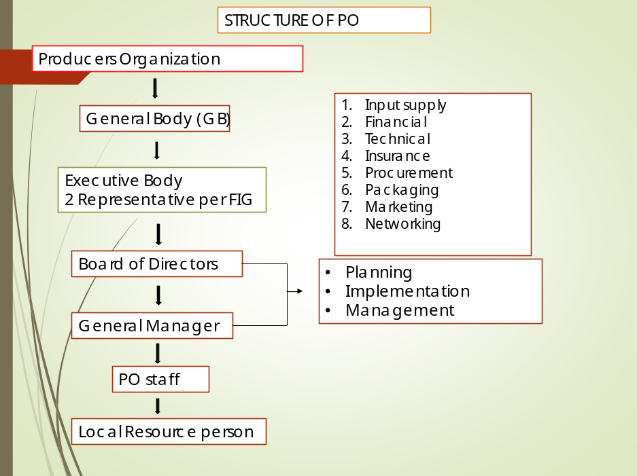

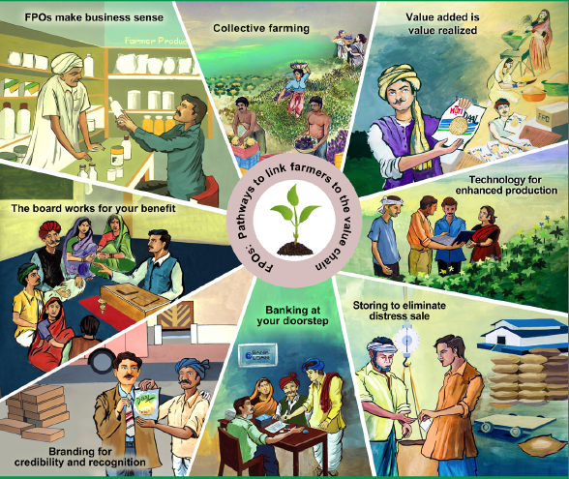
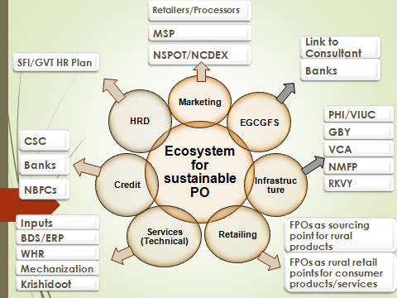
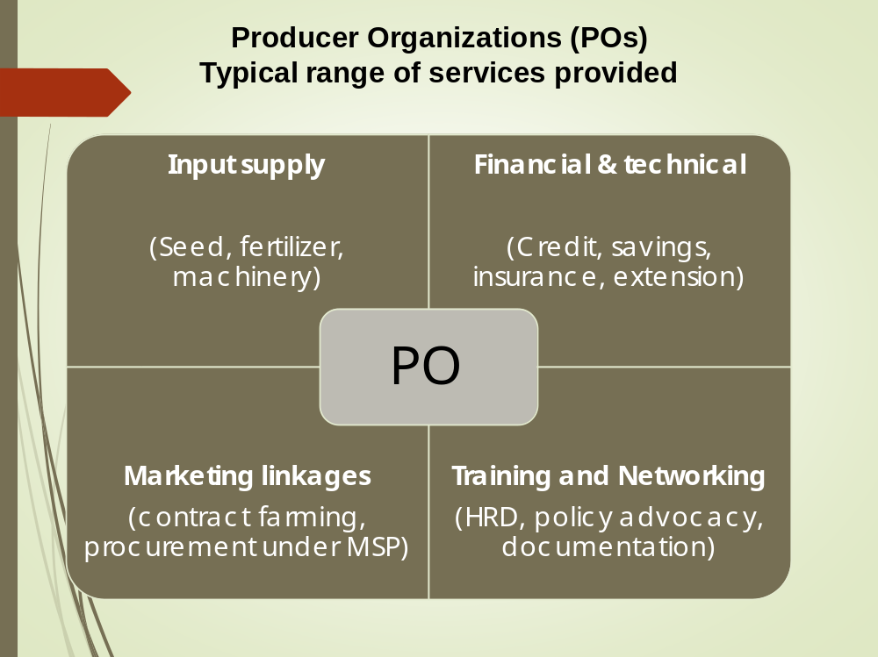
Limitations of Producer organizations
- A Producer organsiations should register as per the laws and act
- Registration of a Producer organisations is a bit difficult,
- Generally requiring the services of a consultant.
- The registration of a Producer organization is a sometimes time consuming process.
- The members cannot transfer their shares freely.
- Getting a professional CEO at an affordable cost is little difficult.
- The Producer organization should follow the statutory provisions of laws and -which is little difficult for the illiterate members to understand.
- Taking members in group is a biggest challenge

Concept of the cooperatives
- Cooperatives are “autonomous associations of persons united voluntarily to meet their common economic, social and cultural needs and aspirations through a jointly owned and democratically controlled enterprise”
Cooperatives - VEHICLE FOR AGRICULTURE/RURAL DEVELOPMENT
Cooperatives in Rural Milieu
“Cooperatives” - basically designed and oriented to meet economic and societal needs of rural segments, particularly the poor. Starting with agricultural credit, cooperatives encompassed all rural economic activities.
“Cooperatives” - single largest business model in the country account for 20% of rural credit supply, 35% of fertilizer supply, 60% of sugar production, 30% of wheat procurement, 45% of cotton procurement, 40% of cloth production, 48% of milk production etc.
MEANING OF CO-OPERATION
‘Co-operation’ Derived from the Latin word ‘ co-operari ‘ co ’ means ‘with’ and ‘ operari ’ means ‘to work’ Co-operation ’ means working together.
‘Section 4 of the Co-operative Societies Act, 1912 defines cooperatives "as a society which has its objectives the promotion of economic interest, its members in accordance with cooperative principles. “
Co-operative Society’ means
  - A voluntary association of persons;
  - Working together with common economic objective ;
  - Providing support to the members;
  - Self-help and mutual help ;
  - Non-profit motive;
  - Pooling individual resources for group welfare;
  - For common benefit .

The Cooperative Principles
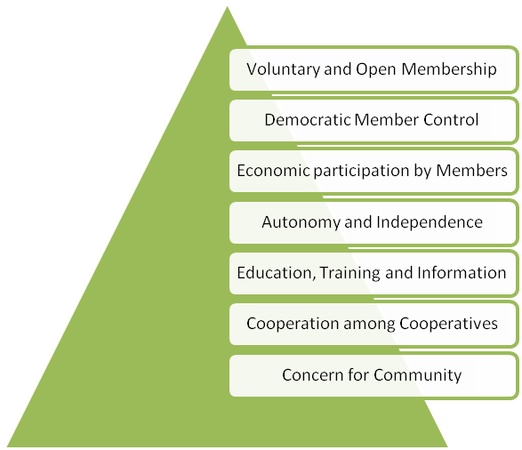
- Cooperatives are non-profit companies and their members’ liability is limited to the capital they invest.
- Cooperatives have extended across the entire country and there are currently an estimated 230 million members nationwide.
- Cooperatives have advanced more credit in the Indian agricultural sector than commercial banks
- 80% is concerned with agriculture
- 60% deal with credit only
- Cooperatives there are two types of benefits for members –
  - Monetary benefits and
  - Services

TYPES OF COOPERATIVES
The Co-operative Movement was introduced into India by the Government as the only method by which the farmers could overcome their burden of debt and keep them away from the clutches of the money-lenders. The Co-operative Credit Societies Act, 1904 was passed by the Government of India and rural credit societies were formed . Through the appointment of registrars and through vigorous propaganda, the Government attempted to popularize the Movement in the rural areas. Within a short period, the Government realized some of the shortcomings of the 1904 Act and, therefore, passed a more comprehensive Act, known as the Co-operative Societies Act of 1912. This Act recognized non-credit societies also. But the rural credit societies have continued to be predominant till now.
(1)The Primary Agricultural Credit/Service Societies --- The agricultural co-operative credit structure in the Punjab State is broadly divided into two sectors, one dealing with the short-terms and medium-terms finance and the other with the long-term credit. In the State, the short-term and medium-term credit structure is based on a three-tier system, i.e., the Apex Co-operative Bank at the State level, the Central Co-Coperative Bank at the district/tehsil level and the Primary Agricultural Credit Societies at the village level. The major objectives of the primary agricultural credit service societies are to supply agricultural credit to meet the requirements of funds for agricultural production, the distribution of essential consumer commodities, the provision of storage and marketing facilities and for light agricultural implements and machinery. Owing to an increasing emphasis on the development of land and agriculture, long term co-operative credit has assumed great importance. There is the Punjab State Land Mortgage Bank at the Apex and the Punjab Mortgage Bank at the district/tehsil level. These Primary Land Mortgage Banks advance loans to the farmers for long term purposes. At the operational level, there exists a primary co-operative to extend credit to the farmer. This unit epitomizes the vitality and service potential of the Co-operative Movement in India. The organization of these societies dates back to 1904, when the first Co-operative Societies Act was passed. These societies were started with the object of providing cheap credit to the agriculturists in order to free them from the clutches of the rapacious money-lenders. the agricultural primary credit society is the foundation-stone on which the whole co-operative edifice is built. Even now these societies dominate the co-operative picture. The first Agricultural Credit Society in the Firozpur District was registered on 4 October 1911, at the Village of Khalchi Kadim in the Firozpur Tehsil. Originally, the movement was confined to the credit societies only and, thus, credit dominated till the partition (1947). After the partition, the Co-operative Movement began to spread to other field, viz labour, construction and farming.In 1979-80, the number of agricultural cooperative credit societies in the District was 309 with a membership of 1,21,761. the loan advanced during the same year amounting to Rs. 2,180.35 lakh and the deposits to Rs. 26.84 lakh.
(2) Agricultural Non-Credit Societies --- While credit is and must remain for some time the chief concern of the Co-operative Movement relatively slow, since 1912, when the non-credit societies were brought officially under the aegis of the Movement. The World War II (1939-45) came as a God send boon with respect to the development of the Cooperative Movement. Prices of agricultural goods began to rise and touched new peaks. The repayment of loans was accelerated and deposits began to pour in. The number of societies also rose. Another interesting development in co-operative during the War was the extension of the Movement to non-credit activities, viz. consumer’s co-operative marketing societies, consolidation societies, etc. The number of agricultural non-credit societies in the district was 38 in 1978-79.
(3) Agricultural co-operative Marketing Societies-- Marketing has occupied a farm smaller place in the co-operative picture in India than in many countries, notably Denmark and the USA, but not other non-credit line of co-operation, with the possible exception of the consolidation of land holdings and joint farming enterprises, seems to hold greater possibilities of help to the agricultural population of India. The development of co-operative marketing in India is closely bound up with the problem of credit-the claims of the money-lenders commonly inhibiting the cultivator’s freedom of action in disposing of his crop. The full utilization of loans advanced depends upon the arrangements for the marketing of surplus produce. For this purpose, there the Punjab State Marketing Federation at the State Level, wholesale societies at the district level and marketing societies at the market level. These societies also provide other agricultural facilities and make arrangements for the supply of domestic items in the rural areas. In 1979-80, there were 10 agricultural co-operative marketing societies in the district, with a total membership of 5,982 (5,056 individuals and 926 societies). During the same year, their paid-up capital was Rs. 19.70 lakh and the working capital Rs. 558.52 lakh, and they marketed goods worth Rs. 992.08 lakh. At the State level, the Punjab State co-operative Supply and Marketing Federation (MARKFED) is playing an important role in building up an integrated structure for remunerative marketing and storing of agricultural produce. it has played an important role in hastening the Green Revolution in the State by arranging ready supplies of essential farm inputs needed by the cultivators.
(4 ) Co-operative Farming Societies.--- The Royal Commission on Agriculture in 1928 observed that it co-operation failed, there would fail the hope of the Indian agriculturist. Co-operative farming is a compromise between collective farming and the peasant proprietorship and gives all merits of large-scale farming without abolishing private property. It implies an organization of the farmers on the basis of common efforts for common interests. Under this system, all landowners in a village form a co-operative society for tilling the land. The land is pooled, but each farmer retains the right of property. The produce is distributed by each. They are allowed to withdraw from the cooperative farm whenever they desire. In India, the exceedingly small size of holdings is perhaps the most serious defect in our agriculture. If agriculture has to be improved, the size of the holdings must be enlarged. The co-operative farming societies, thus, enable the cultivators to enjoy the economies of large-scale farming through the pooling of land management resources.
CAUSES OF SLOW PROGRESS OF COOPERTIVES
Despite rapid growth the overall progress of cooperative movement during 100 years of its existence is not very impressive. It is therefore necessary to know the causes of poor performance of the movement and on that basis take such steps as would promote a faster growth of cooperative movement in India.
a. Government Interference:
The cooperative movement in India was initiated in 1904 under the auspices of British government. Right from the beginning the govt has adopted an attitude of patronizing the movement. Cooperative institutions were treated as if these were part and parcel of the administrative set up of the government. The govt interference thus became essential elements in the working of these institutions. As a result people’s enthusiasm for the movement did not grow. The movement’s independence and self-reliance existed only on paper and files. After attainment of independence in particular after beginning of the planning, some healthy changes in the attitude of the govt did take place. It was not given proper importance that it deserves in any plan. But even the cooperative movement has not become full-fledged people movement. Even today quite often cooperative societies are imposed upon the people. This does bring about an increase in the membership of the societies. But the spirit of cooperation cannot flower fully in these circumstances. Neither it growth took place according to any plan nor did it become a people’s movement. It just grew very slowly and that too haphazardly. It was a state driven institution.
b. Mismanagement and manipulation :
The essence of the cooperative movement is that it gives the farmers the status of shareholders and assures them agricultural, educational and medical facilities. Under the Maharashtra State Cooperatives Act, a minimum of 11 farmers is required to form a cooperative. Today the shareholder membership averages between 15,000 and 25,000 farmers. The relationship between the shareholder farmer and the cooperative is simple - the farmer is committed to contributing a certain amount of cane per season and the mill is bound to take this cane. The strength of the movement was the involvement of the farmers who were shareholders in the sugar mill regardless of the size of their holdings. Over the years, this truly democratic idea got corrupted and farmers with larger holdings grew more powerful. In practice, this altered the power structure of the cooperatives. In the elections to the governing bodies of the sugar factories, money became such a powerful tool that the top posts of chairman and vice-chairman usually went to the richest farmers even though the majority of members were farmers with small- or medium-sized holdings.
c. Lack of Awareness:
People are not well informed about the objectives of the movement, the contributions it can make in rebuilding the society and the rules and regulations of cooperative institutions. Unfortunately, no special efforts have been made in this direction. People look upon these institutions as means for obtaining facilities and concessions from the govt. So long as people expect to get something from the govt, they see to it that societies somehow continue to function. Lack of education, dirty politics of the village, casteridden elections to the offices of cooperative societies, bureaucratic attitudes of the govt officers at the lower rank are some of the hurdles in spreading the correct information about the cooperative movement and in educating the people abut its true character and vital role in the society.
d. Restricted Coverage: The cooperative movement has also suffered on account of two important limitations on its working. One is that the size of these societies has been very small. Most of these societies are confined to a few members and their operations extended to only one or two villages. As a result their resources remain limited, which I make it impossible for them to expand their means and extend their are of operations .Two, the most of the societies have been single purpose societies. For this reason these societies are unable to take a total view of the persons seeking help, nor can they analyze and solve problems from different angles. The help these societies render thus can not be adequate. By assessing the persons and the problems only from one angle, these societies neither help properly the person nor make a optimal use of their resources. Under these circumstances it has not been possible for these societies to make much progress.
e. Functional Weakness:
The cooperative movement has suffered from inadequacy of trained personnel right from its inception. Lack of trained personnel has been caused by two major factors. In the first place, there has been a lack of institutions fort this purpose of training personnel. Secondly because of it unsatisfactory working of cooperative institutions, efficient personnel did not feel attracted or motivated towards them. The functioning of the cooperative societies, too suffer from several weakness. Some of these are, taking no care of the need of credit seekers or their repaying capacity at the time of granting loans, making no adequate provision for the return of loans, unsatisfactory keeping of accounts, factional politics in it management, lack of coordination among various divisions of the cooperative structure, too much dependence on outside sources of finance, lack of adequate auditing. Such weakness have prevented theme from progressing on healthy lines. Thus there are several pitfalls. Poor infrastructure, lack of quality management, overdependence on government, dormant membership, non-conduct of elections, lack of strong human resources policy, neglect of professionalism, etc. are the limiting factors. Indian cooperatives are also unable to evolve strong communication and public relations strategies which can promote the concept of cooperation among the masses.
Characteristics of PO’s and cooperatives
- Membership Is Voluntary
- Members Have Strong Common Interests
- Members Own The Business, And Therefore Own Both The Tangible And Intangible Assets (Such As Brands And Reputation);
- Members Are Jointly Liable For The Enterprise’s Conduct And Actions
- It Is Intended That The Association Will Be Permanent.
Significant differences between Producer organization's and Cooperatives
Parameters | Producer organization's | Cooperatives
Registration | Indian Companies Act | Cooperative Societies Act
Area of Operation | Entire Union of India | Restricted Regionally
Nature of Business | Primarily agencies to provide marketing solutions to pooled produce | Primarily service and delivery agencies
Membership | Based on concept of shareholding | Based on ownership of land
Share | Not tradeable but transferable, limited to members on par value | Non-tradeable Not
Profit sharing | Commensurate with volume of business | Limited dividends on shares
Voting rights | One member, one vote. Members not having transactions with company cannot vote | One member, one vote, but Government and Registrar of Cooperatives hold veto power
Governance | Stand-alone, self-reliant bodies with self-governing capabilities | Federated into the District Central Cooperative Banks (DCCB). Business conducted is based on the policies of the DCCB.  Receive financial, technical and administrative support from the government
Reserves | Mandatory | Created if there are profits
Borrowing Power | More freedom and more alternatives available. POs are allowed to raise capital from external sources | Restricted to loans granted and disbursed by the cooperative bank to which the PAC is linked

Advantages of PO’s and cooperatives
- Increased Capacity And Bargaining Power
- Access To New Markets Through Alternative Marketing Channels
- Access To Credit And Support Programmes
- Access To Better Technical And Market Information
- More Opportunities For Exchanging Experiences
- Greater Access To Training Programmes.
Challenges of PO’s and cooperatives
- To Achieve Clear And Efficient Internal Organization
- To Build Trust In The Managers’ Decisions
- To Get Members To Pledge To Deliver Products, Abiding By Previously Agreed Volumes, Conditions And Deadlines
- To Run Associations Profitably And Efficiently
- To Design And Implement Efficient And Transparent Administration Mechanisms
- To Establish Proper Communication And Participation Mechanisms

ROLE OF EXTENSION IN PROMOTION OF FARMERS ORGANIZATIONS
The role of extension vary with the role of the FOs, the sectors in which the organization operates, the services offered, and the organizational form used. The role of Extension in promotion of Farmers Organizations (Chamala, 1990) :
- Empowerment Role
- Community-Organizing Role
- Human Resource Development Role
- Problem-Solving and Education Role
- Empowerment Role
The empowerment role can be a cornerstone of the new approach to extension. Extension personnel need to develop a new philosophy where their role is to help farmers and rural communities organize themselves and take charge (empowerment) of their growth and development. Telling adults what to do provokes reaction, but showing them triggers the imagination, involving them gives understanding, and empowering them leads to commitment and action.
The term empower means to enable, to allow, or to permit and can be viewed as both self-initiated and initiated by others. For VEWs, empowering is an act of helping communities to build, develop, and increase their power through cooperation, sharing, and working together. The power in empowerment comes from releasing the latent energy hidden in the community and building collective actions for the common good, rather than from merely redistributing power from the haves to the have-nots. FOs can help harness this synergetic power for its members' survival, growth, and development. Empowered FOs can act as convergent points or platforms for solving local problems and mobilizing human and financial resources for sustainable development.
- Community-Organizing Role
Village extension workers must learn the principles of community-organizing and group management skills in order to help the community, especially the poor or weaker sections, to organize itself for development. Understanding the structures, by-laws, rules, and roles will help leaders to plan, implement, and monitor their programmes and to perform this new role effectively. Skills in conflict resolution, negotiation, and persuasive communication help VEWs to develop FO leaders and members.
- Human Resource Development Role
The human resource development approach empowers people and gives new meaning to all other roles. Development of technical capabilities must be combined with management capability. Training modules are now available to help develop individual and group management skills. The entire philosophy of human capacity building is to encourage rural communities to understand their personal and group styles of managing themselves and to improve their planning, implementation, and monitoring skills.
4. Problem-Solving and Education Role
Problem solving is an important role, but the role is changing from prescribing technical solutions to empowering FOs to solve their own problems. This is achieved by helping them to identify the problems and seek the right solutions by combining their indigenous knowledge with improved knowledge and by using their resources properly. Similarly, there is a shift in the education role from lectures, seminars, and training to learning by doing and encouraging farmers and FOs to conduct experiments and undertake action-learning projects.
STEPS IN ESTABLISHING FARMER ORGANIZATIONS
Some of the principles and steps for social action models, community organizations, and management are used in designing the simplified step-wise approach in establishing Fos (Chamala, 1990). Care needs to be taken in selecting a person or a group of people who will take the lead in establishing community-based or commodity-based farmer organizations. This person - from another FO or government or other organization, such as a village extension worker - needs to be acquainted with and convinced of how the FO can be used to increase the income of small producers. In the following steps, the term VEW will be used to refer to the person or group of people selected to establish the FO.
Step 1. Understanding the Village Community
VEWs should enter the community with an open mind and understand the community structure. They must understand the community power structure, problems, and opportunities for development. Walking around and talking to key people can help ease their entry into the community. VEWs should also develop an under-standing of the entire community, including the poor and marginal farmers and women. Some of the techniques that can help to understand the community are using key informant techniques, participating in the community meeting and tea stalls, and walking around.
Understanding the ownership of community resources and people's attitude, knowledge, and skills in the development of agricultural production will help the VEW learn about the community. The VEW can also understand the situation in more depth by collecting both qualitative and quantitative information on the levels of income and productivity, costs of cultivation, post-harvest losses, output utilization, and the likelihood of making striking improvements to each of these factors.
Step 2. Identifying Potential Leaders in the Community
The usual tendency is for the VEWs to talk to formal leaders and commercial sections of the community. By using the sociometry method they can identify potential leaders. However, it is also important to be sensitive to the leadership structures operating in that culture and to the knowledge and skills needed to be a successful leader of a farmer organization. In some cultures, it is wise to search for and contact middle-aged leaders of the area who are not too young or too old. Preferably, they should come from better-off families, have social status and respect, and be from farming households. Case studies of leaders who have established farmer organizations show that these leaders initially made considerable sacrifices, experienced financial losses, and had to be supported by their families. These leaders also had to struggle and negotiate with bankers, bureaucrats, politicians, critics, and others including their own farmer members. This family background and grooming helps these leaders to deal with situations which they will have to face with confidence and without being cowed. Leadership of an FO is not a job for a sincere but ordinary farmer.
Step 3. Talking to the Identified Leaders and Seeking Cooperation from Other Agencies
VEWs might talk to these leaders on general agricultural development and get ideas and information on FOs in the village. They might also seek cooperation from government agencies and especially from NGOs (if there are any in the area) to help establish FOs and support them in achieving success. Does the community have a farmer organization? If not, is there a need for such an organization? If the community has an FO, what is its structure and history of performance. How could the FO play a role in village or community development? VEWs can canvass for ideas from the community and add their own ideas on the need for and the role of FOs in the entire process of broad-based agricultural development. They can explain how FOs in other communities helped them in development. It is important to provide facts and figures to convince potential leaders of the possibilities and approaches for increasing the income of a sizeable number of farmers and for contributing to the economic development of the region. Good FO leaders might also receive political advantages through satisfied farmers and people living in the region. The leaders' support should be secured and key people encouraged to consult among themselves about the pros and cons of forming FOs in the community.
Step 4. Helping Local Leaders to Call Community Meetings.
VEWs can help enthusiastic local leaders to call for community meetings. Sometimes more than one meeting may be needed to discuss the need for and the role of FOs in agricultural development. FO leaders from neighboring villages can be invited to speak at these meetings. Farmer-to-farmer information exchange helps them. Sometimes smaller meetings can be held for low-resource (small and marginal) farmers and minority groups. They may prefer having a separate FO to serve their specific needs.
There is no harm in having more than one FO in a village. It is important that producers from all sectors in the village participate in these meetings because the success of an enterprise-based FO depends on the volume of raw material procured from member producers. Every small or big producer contributes to this volume. The volume itself is more important than the socioeconomic status of the supplier. Prospective members need to be convinced that everyone benefits in proportion to his or her contributions, not just the big farmers, as is widely perceived.
Step 5. Nominating Core Group Leaders to Develop or Establish the FO
From the community meetings, core group leaders are elected or nominated to design the FO with further community consultation. In some cultures, however, this approach may lead to the appointment of leaders who are unable to cope with the complexities of a farmer organization, as mentioned in step 2. If leaders are elected or nominated, VEWs should consider the issues raised in step 2 when assessing each candidate for election or nomination. In situations where it is more appropriate to appoint a leader, the search for a suitable person is critical and requires time and patience. It is also critical that the selected leader be involved in the search for a potential agro-based enterprise to act as a BASE (basic activity sustaining the enterprise) for economic development. This process requires time, patience, and interactive and intellectual inputs. The VEW can help the appointed FO leader in this process.
Step 6. Developing an Organizational Structure for the FO
The VEW can help the core group of leaders in developing an organizational structure for their farmer organization. In the past, the "blueprint" approach was taken without understanding the function that the FOs structure plays in its performance. Group discussions help to highlight the need for careful planning. The structure should serve the organization's functions and goals. Understanding various types of FOs is useful. Should they be commodity-based organizations, cooperatives, partnerships, groups, or syndicates? Should they be multipurpose? Should there be one FO for the entire village or several to cater to the needs of special-interest groups (low-resource farmers, women, craftsmen, small businesses, and the like)? Should they have subgroups and an advisory committee?. At this stage, the VEW should, as far as possible, play a passive role because the leaders are the ones who are building the FO. NGOs also may share their experience and help leaders to develop an organizational structure. Several less exacting chores also need to be taken care of at this stage. These include locating premises and negotiating for land, money, technology, personnel, construction, and infrastructure services such as power lines and telephones (if available).
Step 7. Developing the FO's Management through Education and Action Learning
An essential part of community empowerment is to help educate the leaders and members in management principles covering planning, implementing, and monitoring their projects and programmes. The following empowerment methods may be useful: ·
- Educating. Organize formal and informal learning activities. · Leading. Help the leaders to lead and to learn from their actions by reflection as a team.
- Mentoring and supporting. Help the members initially by mentoring or supporting them in their planning and implementation stages.
- Providing. Obtain the services of other stake holders, FOs, and VEWs in providing various services to nurture the FO in the early stages of development.
- Structuring. Help the FO to structure its meetings and various participative planning activities and to learn from their experience through reflection.
- Actualizing. Help them to reflect on the process of managing their FO.
Step 8. Gearing up for Action
In this step, FOs examine their action plans, and task groups are set up to mobilize human and financial resources. Understanding the participative action management (PAM) planning process is useful and help FO leaders in designing an inclusive and participative planning process. This is the stage to start considering the timing, scale, and content of the extension and research input of the FO.
Step 9. Implementing Selected Projects
In this step, the village extension worker can help the FO leaders implement the projects they have chosen.
The following process may be useful:
- Start implementing the selected project(s).
- Secure resources and allocate tasks.
- Develop a calendar of activities to achieve the goal.
- Develop monitoring processes for reflecting on events and activities regularly, either formally or informally.
- Ask committee members to meet to discuss actions periodically and report to general members regularly to keep them informed and involved.
Step 10. Monitoring and Evaluating the FO's Progress
Usually evaluation is done annually to meet formal requirements. But VEWs can encourage FOs to reflect on their activities more frequently so that they learn and improve their management skills. They need to watch for people who want to take over the FOs for their self-interest. It is important to take action against any negative influences. These monitoring or reflection processes help strengthen FOs and avoid self-defeating problems. Learning organizations are created through collective reflection and openness on financial and the other managerial matters. The success of the farmer organization can be evaluated by measuring the increase in the members' productivity, the increase in their net income, and the net reduction in the cost of cultivation due to bulk purchases of inputs by the organization. It is essential to conduct monitoring and periodic evaluations.

STUDIES RELATED TO PO’S AND COOPERATIVES
Study- 1 Farmer Producer Organizations as Farmer Collectives: A Case Study from India- Nalini Bikkina et al.(2015)
Avirat Agro Business Producer Company Limited
Abstract
Small and marginal farmers in India have been vulnerable to risks in agricultural production. Several organizational prototypes are emerging to integrate them into the value chain with the objectives of enhancing incomes and reduction in transaction costs. One such alternative is Farmer Producer Organizations (FPOs). We explore the potential of FPOs as collective institutions through a case study of Avirat, one of the first FPOs in Gujarat. Our analysis suggests that FPOs have the potential to provide benefits through effective collective action. The main challenge, however, is to raise sufficient capital that can maximize these benefits. We discuss the implications of our findings to policy.
Shikshan Ane Samaj Kalyan Kendra (SSKK), a network NGO of Sajjata Sangh active since 1980 in Amreli District of Gujarat, had established a farmers’ collective under the title Avirat Agro Business Producer Company Limited. Avirat was chosen for the study since it had been functioning for close to five years and would thereby enable an understanding of the performance of FPOs in the short to medium term.
In 1997, SSKK had initiated work on natural resource management around villages in Khambha as a Project Implementing Agency (PIA). SSKK was instrumental in establishing watershed associations at the village level. Activities related to watershed development came to fruition by 2004-05. Impressive impacts of watershed development generally reported include significant increase of crop production, generation of additional employment, restoration of water table, socially inclusive watershed committees and accumulation of a community owned development fund.
Watershed Committees, the existing form of institutions, were primarily formed as Project Implementing Agencies for watershed development activities. Once the watershed development work was completed, farmers felt the need for watershed-plus initiatives to capitalize on the gains of watershed development. Watershed-plus initiatives included land assessment, micro-irrigation, high yielding varieties of seeds, organic cultivation, efforts at reduction in costs of production, capacity-building and skill acquisition for improved methods of cultivation and increase in productivity along with an enhancement of selling price for farm produce through development of market linkages.
However, the members of the Watershed Committees felt that, this kind of institutional form (i.e., the watershed committees) that lacks legal authority is not appropriate for watershed-plus initiatives. An alternative institutional form was required to convert these associations into independent and sustainable entities with provisions for input supplies at dealer prices, participation in trading activities, and profit-making ventures by the primary producers. Registration under the Cooperative Act was considered by the members initially. However, considering the perceived grip of vested interests, rampant corruption and interference of political and government functionaries in the operations of cooperatives, the members registered the entity under the Producer Company Act which came into effect from 2005. As per the provisions of this Act under the Company Law, producer collectives could form companies.
Members therefore decided to form a Producer Company to enable trading and linkages with other public and private corporations. Representatives of watershed associations of 16 villages functioning in the area formed the first Board of Directors. Sixteen hundred farmer beneficiaries enrolled as members from 16 villages in Amreli. Initially, Rs. 5,000 was collected from each watershed association and a Chief Executive Officer was appointed from among the members.
Avirat established an Agro Service Centre to facilitate supply of quality pesticides at affordable prices. The Centre also operates a kiosk to provide information on agricultural products and practices to farmers who visit the Centre to purchase inputs. The Centre serves farmers from more than 50 villages around Amreli. The Centre had further extended its services to the Krushi Mall, a not-for-profit centre, in Khambha. Avirat functions like a developmental agency. However, it is working towards becoming an enterprise by itself rather than to rely on grants.
Major findings
Input supply:
- Avirat’s services facilitates purchase of government approved seeds with price advantages of up to 10-15%.
- Pesticides, and other inputs like farm implements and equipment to the tune of up to 50%.
- Avirat is able to provide these subsidies through negotiation with input suppliers on a bulk basis for price advantage.
- Farmer Members of Avirat have reported a collective benefit of up to Rs. 10-15 lakh through lower input prices.
Avirat provides inputs through two types of arrangements

Majorfindings
Technical services: Trainings, demonstrations and exposure visit
- Kalubhai Vora A Sarpanch of the Village gave a feedback that – “enhance the income of other farmers in the village through proactively seeking training programmes from Avirat. As a result of the efforts of Avirat there has been a decline in out- migration of farmers”
- Other Major technical service that Avirat provides through uses of information technology
- Particularly the internet, and mobile messaging
- Extensively to facilitate timely (2-3 times in a month)
The nature of information disseminated by Avirat using ICT
- Information Such As Market Trends
- Prices Of Commodities In The Market And Varieties
- Stock Positions, And Minimum Support Prices
- Rainfall Forecast
- New Irrigation Methods
- Innovations In Farm Implements and equipment
Financial services
- Extension of credit is critical for small farmers but is not being taken up by Avirat for two reasons.
  - First, regulatory provisions do not allow organizations such as Avirat to disburse loans.
  - Second, Avirat does not have enough capital on its own to disburse loans.
Insurance
Weather insurance to the farmers at affordable premiums
Market linkages
- Due to training of Avirat, produce were poolled by the farmers in the village and transported and sold in the urban areas at higher prices, thereby eliminating middlemen.
- This resulted in fetching higher prices for the produce in this area.
- Avirat also organize farmer melas seasonally to create visibility and enhance income of the farmers through sale of fresh produce directly to local consumers.
Networking support
- Avirat is reported - facilitated networking among farmers
- Avirat is networking with agricultural universities - in the state to update the farmers on latest farm technology and agricultural practices, thereby facilitating transfer of knowledge from lab to the farm.
Shyamjibhai Sarvaiya too state that:
- Membership of Avirat facilitated networking among farmers which lead to improved farmer-to-farmer learning.

Study- 2
Impact Analysis of Commodity Based Associations- GOPALA, Y.M.
Ten CBAs were established in the RBRC project area during the period of 2005-10
- Rural Biofuel Growers Association, Hadonahally
- Chawki Rearing Centre, Gangasundra
- Organic Farming Farmers Association, Karnala
- Jack Growers Association, Hadonahally
- Federation of Women SHGs, Tubagere
- Fish Farmers Association, Tubagere
- Flower Growers Association, Hadonahally
- Corn Growers Association, Hadonahally
- Fruits & Vegetables Growers Association, Hadonahally
- Agro Processing Centre, Melekote
Selection of the respondents for the study
Sl. No. | Name of the CBA | Members | Proportion | Sample
1. | Rural Bio-fuel Growers Association, Hadonahally | 80 | 0.08 | 21
2. | Chawki Rearing Centre, Gangasandra | 17 | 0.02 | 5
3. | Organic Farming Farmers Association, Karnala | 120 | 0.13 | 32
4. | Jack Growers Association, Hadonahally | 80 | 0.08 | 21
5. | Federation of Women SHGs, Tubagere | 272 | 0.29 | 72
6. | Fish Farmers Association, Tubagere | 140 | 0.15 | 37
7. | Flower Growers Association, Hadonahally | 50 | 0.05 | 13
8. | Corn Growers Association, Hadonahally | 51 | 0.05 | 13
9. | Fruits & Veg. Growers Association, Hadonahally | 120 | 0.13 | 32
10. | Agro Processing Centre, Melekote | 15 | 0.02 | 4
Total |  | 945 | 1.00 | 250

Overall attitude level of members towards commodity based associations

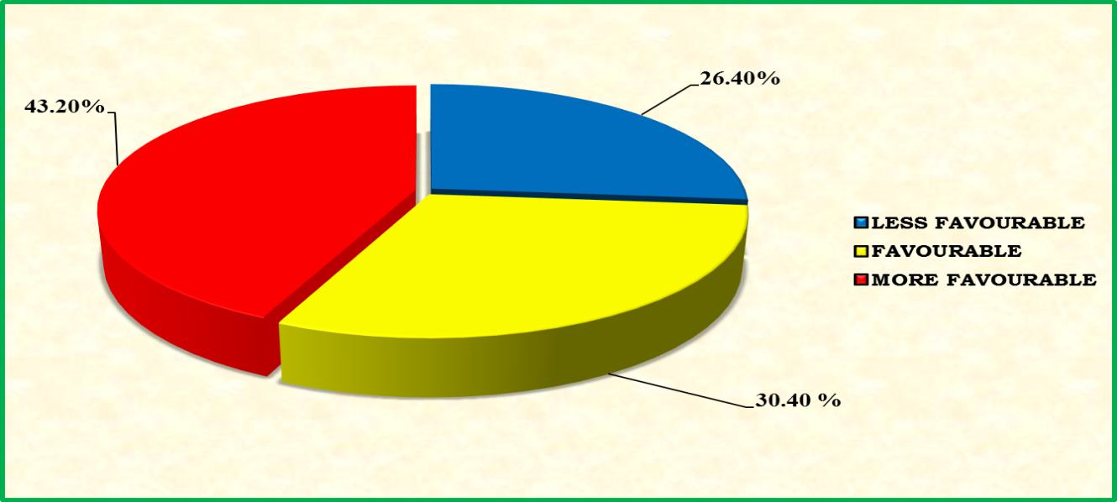
Overall participation of members in the activities of CBAs
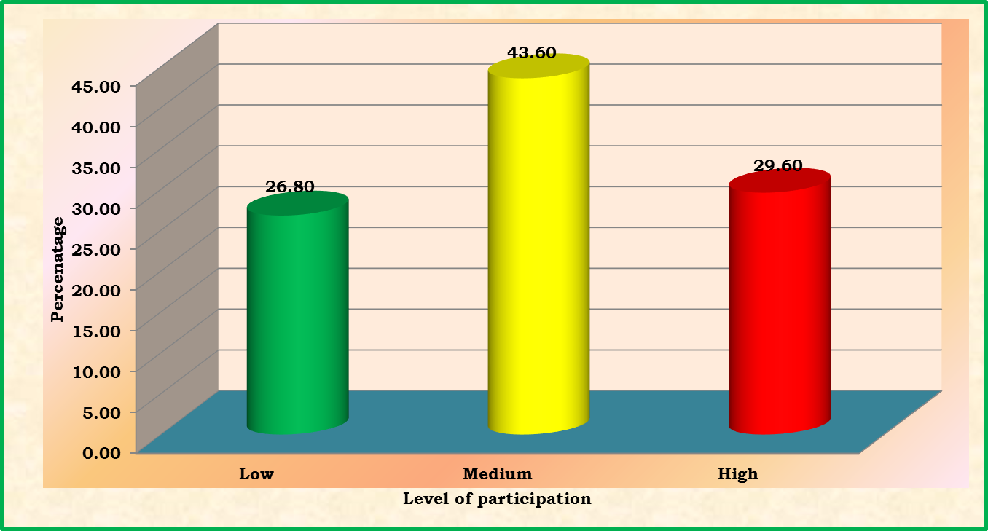

Impact of CBAs on annual income, employment generation and social status
Sl. No. | Impact | Mean values |  | Mean  enhancement | Percentage  of  increase | Paired  ‘t’ value
Sl. No. | Impact | Before | After | Mean  enhancement | Percentage  of  increase | Paired  ‘t’ value
1. | Annual Net income (Rs) | 55170.80 | 70377.88 | 15208.84 ±25468.31 | 27.56 | 10.49**
2. | Employment generation (Mandays) | 390.28 | 437.20 | 46.916±29.28 | 12.03 | 9.44**
3. | Social status (Score) | 7.80 | 15.08 | 7.28±5.73 | 93.23 | 19.73**
n=250)
**: Significant at 1 per cent level of probability.

Conclusion
Accumulated research and experience show that while small farmers acting alone did not benefit from higher food prices, those acting collectively in strong producer organizations and cooperatives were better able to take advantage of market opportunities and mitigate the negative effects of food and other crises. Small Farmers’ Organizations such as cooperatives and POs are expected to enhance incomes, reduce costs of input purchases along with transaction costs, create opportunities for involvement in value-addition including processing, distribution and marketing, enhance bargaining power, provide access to formal credit, reducing poverty, improving food security and generating employment opportunities. Thus, cooperatives and POs play a crucial role in contribution to global socio-economic development. Hence awareness on cooperatives and PO’s must be raised for overall development of small and marginal farmers.

References:
ANONYMOUS, 2004, Improving Agricultural Extension. A Reference Manual. Published by Natural Resources Management and Environment Department. FAO, Rome.
CHAMALA, S., 1990, Establishing a group: A participative action model. Brisbane: Australian Academic Press : 13-38.
DEV, S. M. 2005, 'Agriculture and rural employment in the budget', Economic and Political Weekly, 40(14): 1410-1418.
GOPALA.Y.M, 2014, Impact analysis of commodity based associations, Ph.D.(Agri.)Thesis, UAS, Bangalore.
HELLIN, J., LUNDY, M. and MEIJER, M. 2009, 'Farmer organization, collective action and market access in Meso-America', Food Policy, 34(1): 16-22.
NALINI BIKKINA, RAMA MOHANA TURAGA AND VAIBHAV BHAMORIYA, 2015, IIMA Working Papers from Indian Institute of Management Ahmedabad, Research and Publication Department, No WP2015-01-05.
RESERVE BANK of INDIA. 2006, 'Report of the Working Group to Suggest Measures to Assist Distressed Farmers', Accessed on 2 June 2014.
SATISH, P. 2007 'Agricultural credit in the post-reform era: A target of systematic policy coarctation', Economic and Political Weekly: 2567-2575.
SINGH, S. 2012, 'New markets for smallholders in India–Exclusion, policy and mechanisms', Economic and Political Weekly, 47: 95-105.

**********THANK YOU**********

Some of questions asked during the seminar
- According to speaker which is the best producer’s organisation for small and marginal farmer.
Answer: Farmers producer organisation will be the best and suitable producer organisation in nearforth has it will be registered in producers company act than in cooperatives act which is more liberty to implement the things.
- Why this PO’s are not performing well
Answer: This PO’s are formed based on the commodity or crop which leads to seasonality in production and market this makes the performance of the PO’s in a deteriorating manner.
- Whether banana growing association established at Mudigere in 1985 is working
Answer: No, it is not working has banana growing area as drastically came down.
- Is the coffee growers association members are also the members of the coffee board.
Answer: Yes
- Is TIN and PAN number is required for all the members of FPO’s
Answer: No, TIN and PAN is not required for each persons of the FPO’s, it is required only for the organisation or association.
- How do you compare contract farming with FPO’s
Answer: One of the major difference in between this two is, contract farming is company oriented where has FPO’s are producers oriented.

**********THANK YOU**********

