Geographic Information System (GIS) and Geographical Positioning System (GPS): its application in Agriculture

INTRODUCTION
Agriculture is an inherently geographical practice and it is not surprising that this, together with the extremely large sums of money involved make it a natural application for GIS. Many site-specific farming systems utilize Geographic Information System and Geographic Positioning System to collect spatially referenced data, perform spatial analysis and decision- making, and apply variable rate treatment The development and implementation of precision agriculture or site-specific farming has been made possible by combining the GPS and GIS. These technologies enable the coupling of real-time data collection with accurate position information, leading to the efficient manipulation and analysis of large amounts of geospatial data. GPS-based applications in precision farming are being used for farm planning, field mapping, soil sampling, tractor guidance, crop scouting, variable rate applications, and yield mapping. GPS allows farmers to work even during low visibility field conditions such as rain, dust, fog, and darkness.
Objectives
- To understand the concept of GIS and GPS
- To know the functioning and application of GIS and GPS in Agriculture.
- To review the case studies related to GIS and GPS in Agriculture.

Think about all the activity occurring through out a landscape.
How can we map, manage and analyse all that is going on???

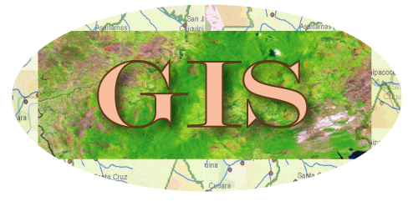
What is GIS?
G: GEOGRAPHIC
I: INFORMATION
S: SYSTEM
Meaning of GIS?
“GIS is a computer system capable of assembling, storing, manipulating, and displaying geographically referenced information, i.e. data identified according to their locations.”
- Makes it possible to link, or integrate, information that is difficult to associate through any other means.
- Use combinations of mapped variables to build and analyze new variables.
- Is most useful when used to perform data analysis
- It is a tool for planning and decision making processes.

- It is used in a wide range of applications like urban and regional planning, agriculture, emergency response systems and natural resource management.

- It is an emerging field and grows at very rapid pace.

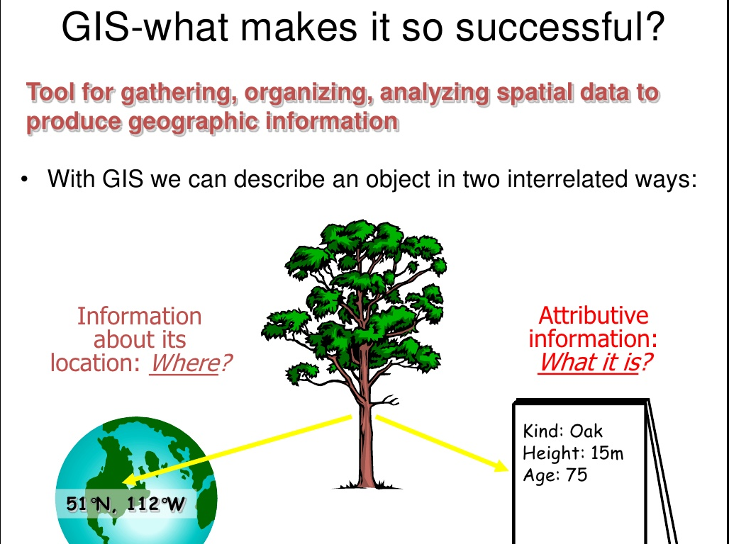

History of GIS
- Started in 1960 in Ottawa Ontario, Canada by The federal Department of Forestry and Rural Development.
- Developed by Dr. Roger Tomlinson
- The first known use of the term "geographic information system"
- "A Geographic Information System for Regional Planning".
"Father of GIS".
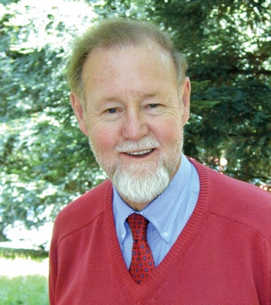
GIS: OLD AND NEW
Traditional GIS
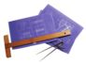
Maps Typewriter Manual Drafting Tools
New GIS
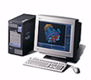 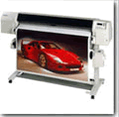  Computer Plotter CD-Rom

Components
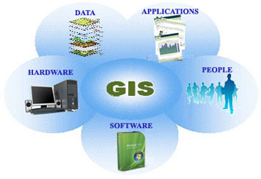
Functioning of GIS
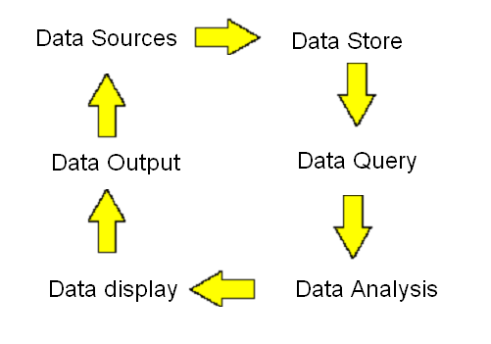

Data Sources for GIS
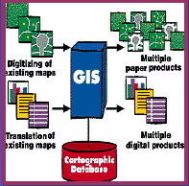
- Digitized and Scanned Maps
  - – purchased, donated, free (Internet)
  - – created by user
- DataBases –Tables of data
- GPS – Global Positioning System
– accurate locations
- Remote Sensing & Aerial Photography

Formats
Raster and vector are the two basic data structures for storing and manipulating images and graphics data on a computer. Major GIS and CAD (Computer Aided Design) software packages available today are primarily based on one of the two structures, either raster based or vector based, while they have some extended functions to support other data structures.
Raster images come in the form of individual pixels, and each spatial location or resolution element has a pixel associated where the pixel value indicates the attribute, such as color, elevation, or an ID number. Raster images are normally acquired by optical scanner, digital CCD camera and other raster imaging devices. Its spatial resolution is determined by the resolution of the acquisition device and the quality of the original data source. Because a raster image has to have pixels for all spatial locations, it is strictly limited by how big a spatial area it can represent. When increasing the spatial resolution by 2 times, the total size of a two-dimensional raster image will increase by 4 times because the number of pixels is doubled in both X and Y dimensions. The same is true when a larger area is to be covered when using same spatial resolution.
Vector data comes in the form of points and lines that are geometrically and mathematically associated. Points are stored using the coordinates, for example, a two-dimensional point is stored as (x, y). Lines are stored as a series of point pairs, where each pair represents a straight line segment, for example, (x1, y1) and (x2, y2) indicating a line from (x1, y1) to (x2, y2).
In general, vector data structure produces smaller file size than raster image because a raster image needs space for all pixels while only point coordinates are stored in vector representation. This is particularly true in the case when the graphics or images have large homogenous regions and the boundaries and shapes are the primary interest. Besides the size issue, vector data is easier than raster data to handle on a computer because it has fewer data items and it is more flexible to be adjusted for different scale, for example, a projection system in mapping application. This makes vector data structure the apparent choice for most mapping, GIS and CAD software packages. Also, topology among graphical objects or items are much easier to be represented using vector form, since a commonly shared edge can be easily defined according to its left and right side polygons. On the other hand, this is almost impossible or very difficult to do with pixels.
- Vector Formats –Discrete representations of Reality
- Raster Formats – use square cells to model reality

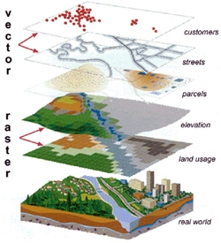
Data Query
- 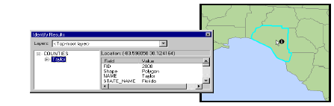Identifying specific features

- 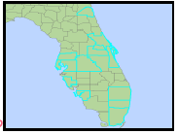Identifying features based on conditions

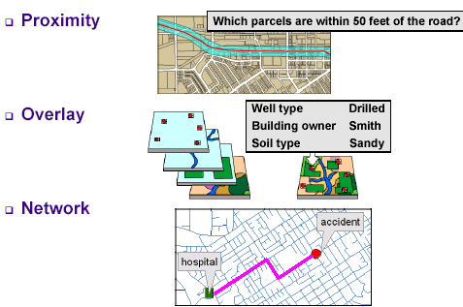Data Analysis

Data Display
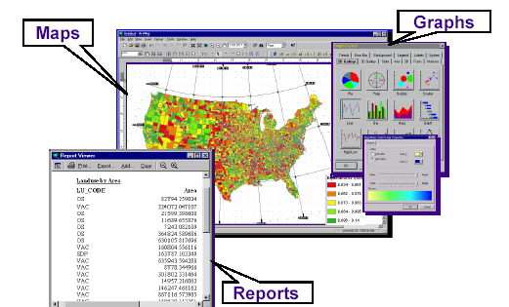

Data Output
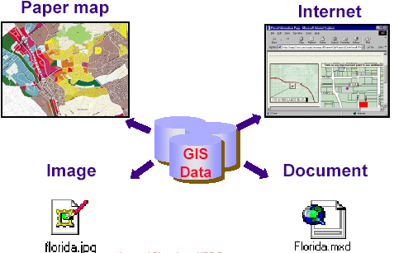

Functions of GIS

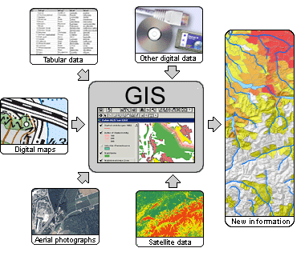

GIS APPLICATION

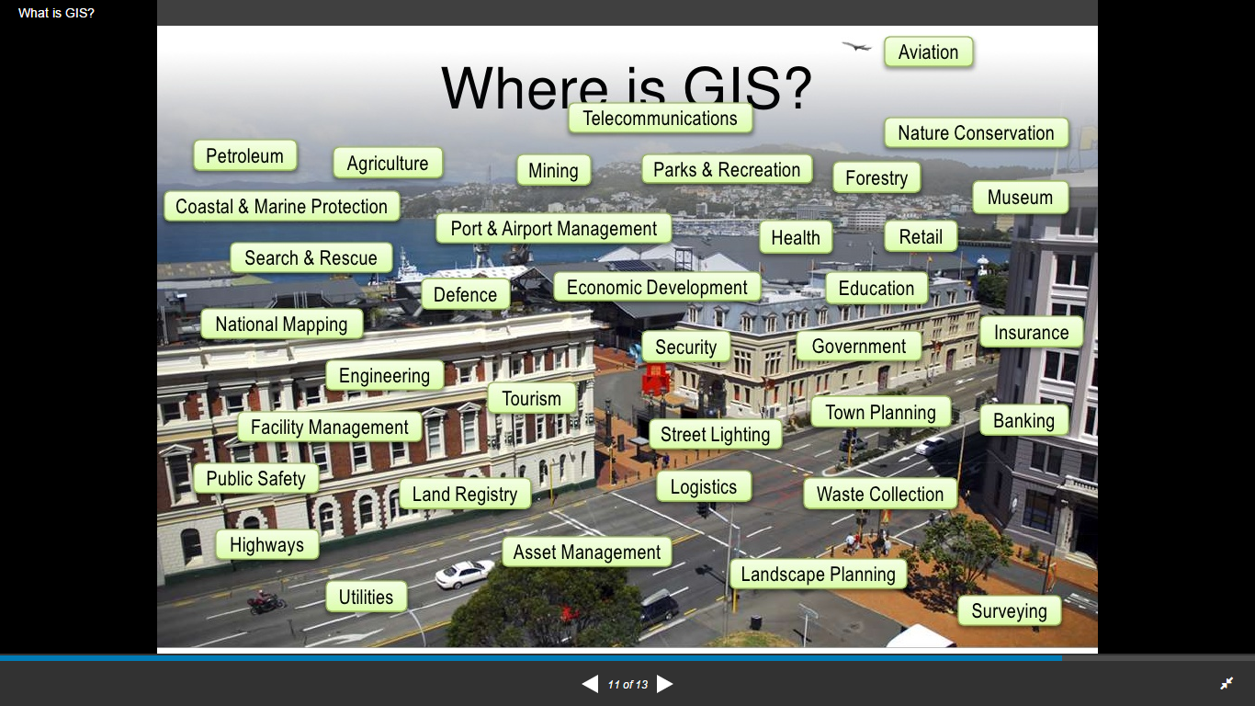

- Agriculture
- Civil engineering
- Environment
- Emergency planning
- Geology
- Utility management
- Business
- Military

GIS in Agriculture
- Agro-climatic mapping.
- Soil mapping.
- Watershed development.
- Agricultural drought assessment.
- Pest assessment and control.
- Land use/Land cover mapping
- Crop production forecasting.
Comprises of three things:
1. Identification of crops.
2. Acreage estimation.
3. Forecasting the yield.
- Tracing urban/ rural conflicts.
- Farming
- Insurance and animal health.

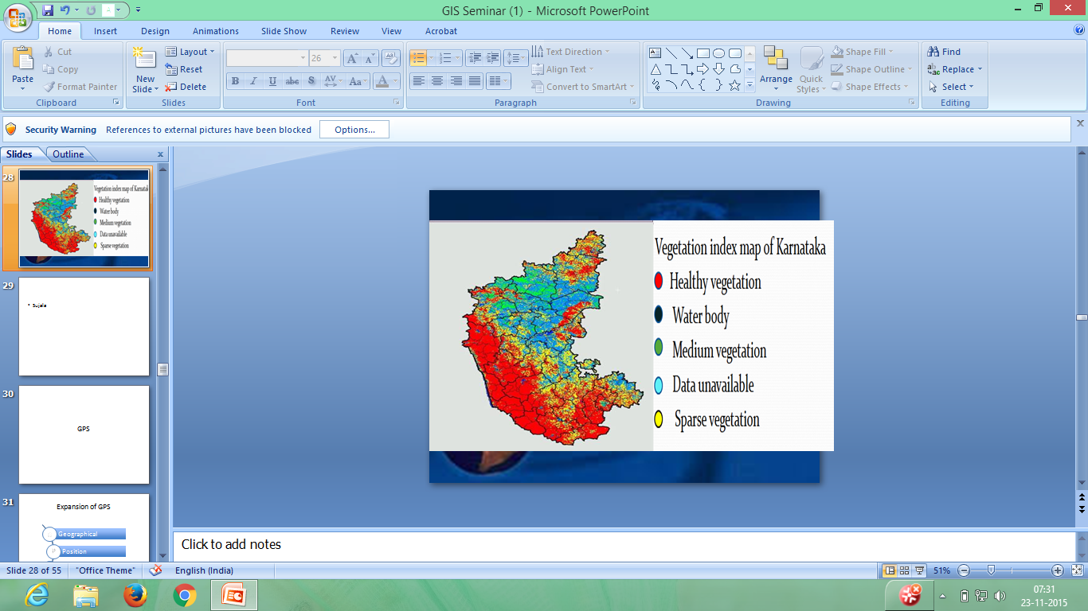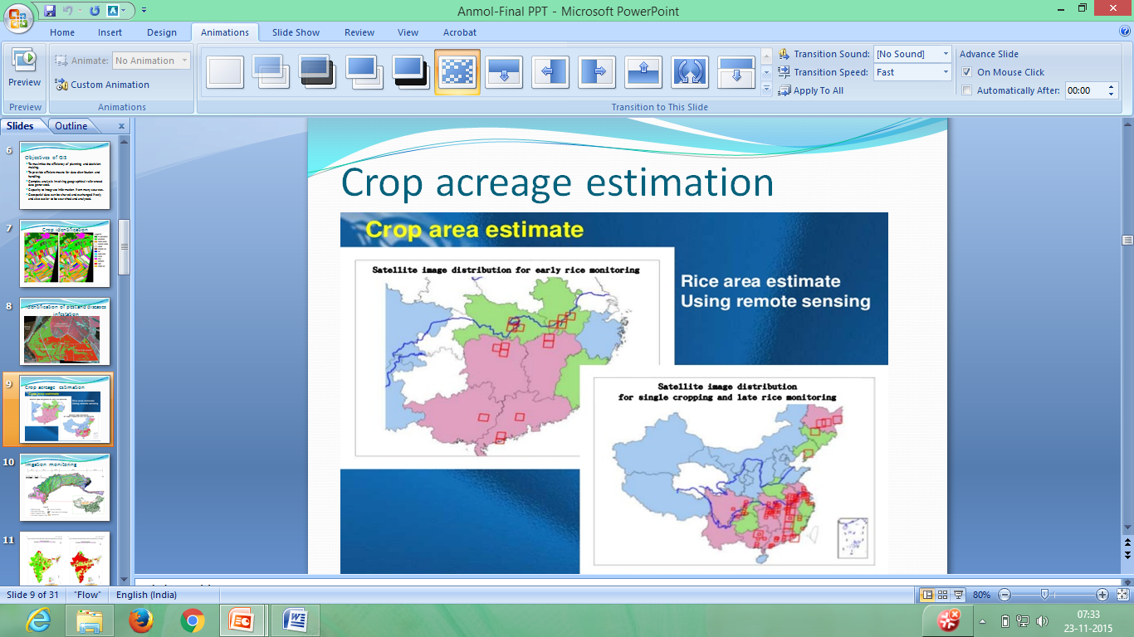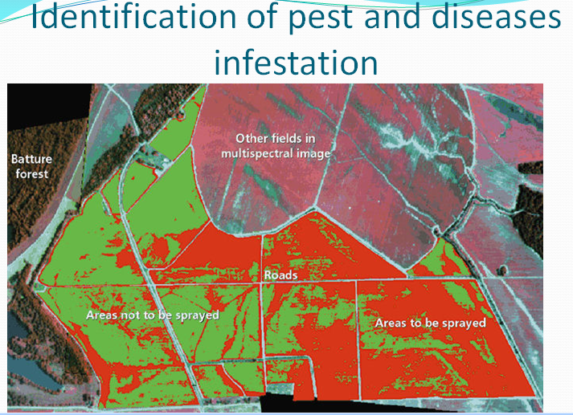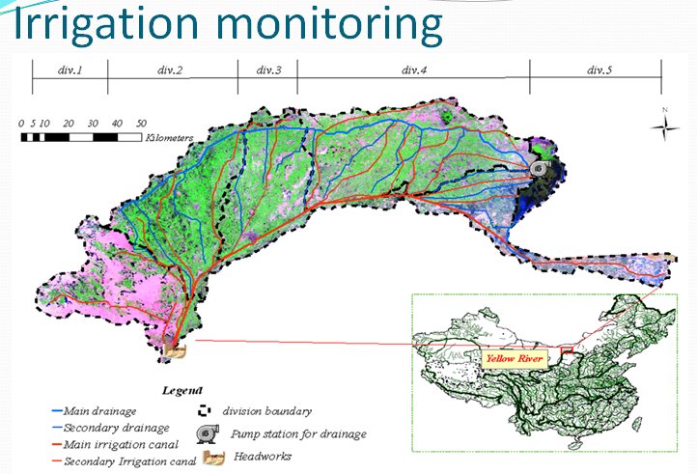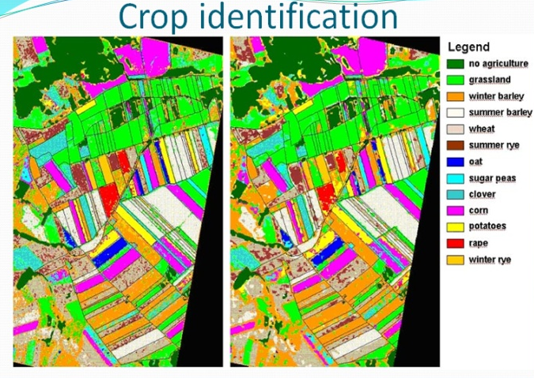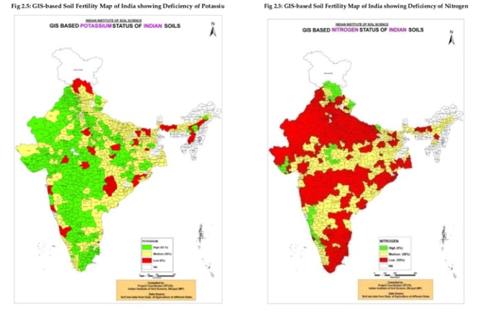

GIS IN SUJALA
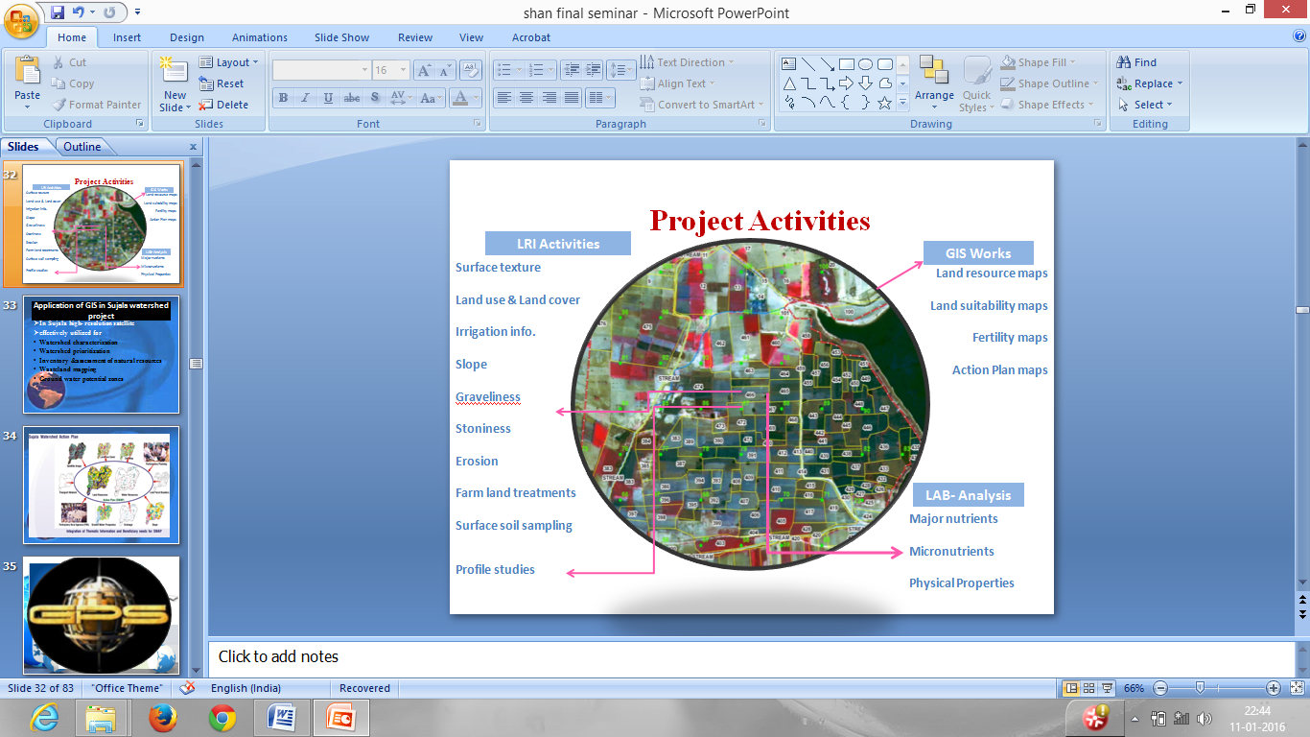

Application of GIS in Sujala watershed project
- In Sujala high- resolution satellite
- effectively utilized for
- Watershed characterization
- Watershed prioritization
- Inventory &assessment of natural resources
- Wasteland mapping
- Ground water potential zones
- Run off estimation
- Water resource action plan
- Land resource action plan
- Site selection for implementation
- Monitoring and evaluation
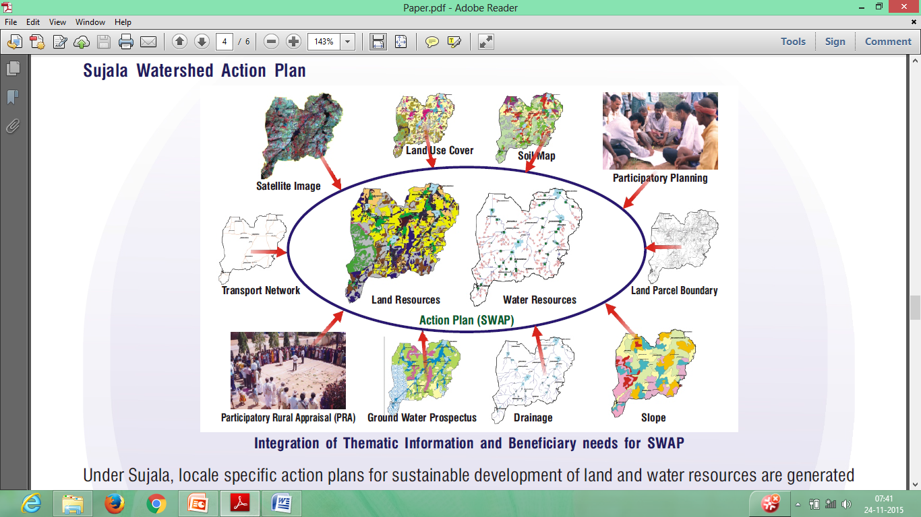
GEOGRAPHIC POSITIONING SYSTEM

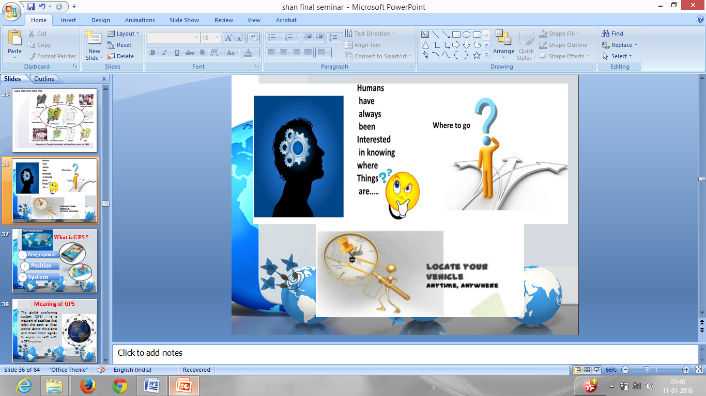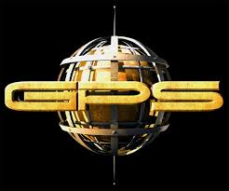

What is GPS ?
G: Geographic
P: Position
S: System

Meaning of GPS
The global positioning system (GPS) - is a network of satellites that orbit the earth at fixed points above the planet and beam down signals to anyone on earth with a GPS receiver.
The global positioning system (GPS) makes it possible to record the in-field variability as geographically encoded data. It is possible to determine and record the correct position continuously. This technology considers the agricultural areas, fields more detailed than previously; therefore, a larger database is available for the user. The accurate yield data can be reported only in the points where GPS position recording has happened.

History of the GPS
• Developed by US Department of Defense
• 1969—Defense Navigation Satellite System (DNSS) formed
• 1973—NAVSTAR Global Positioning System developed
- 1978—first 4 satellites launched
- 1993—24th satellite launched; initial operational capability
• 1995—full operational capability
• May 2000—Military accuracy available to all users

WHAT IS GPS?
- A space-based satellite navigation system
- Provides location and time information in all weather
- Maintained by United States
BUT!
Although it is a very precise geographic positioning system
It is very easy to get yourself into trouble
Why?
Because you (probably) don’t understand how it works
And that leads to garbage

OVERVEIW
- Official name : “Navigational Satellite Timing And Ranging Global Positioning System” (NAVSTAR GPS)
- Consists of 30+ GPS satellites in medium Earth orbit (2000km - 35,000 km).
- Made up of two dozen satellites working in harmony are known as a satellite constellation
- Mainly used for navigation, map-making and surveying
Characteristics of GPS
- Free
- Precise
- Reliable
- All weather
- Anytime & anywhere
- Unlimited user capacity

Segments of GPS
- Space Segment
A constellation of 24 satellites.
GPS satellites fly in circular orbits at an altitude of 20,200 km and with a period of 12 hours. Powered by solar cells. The satellites continuously orient themselves to point their solar panels toward the sun and their antenna toward the earth. Orbital planes are centered on the Earth.Orbits are designed so that, at least, six satellites are always within line of sight from any location on the planet.

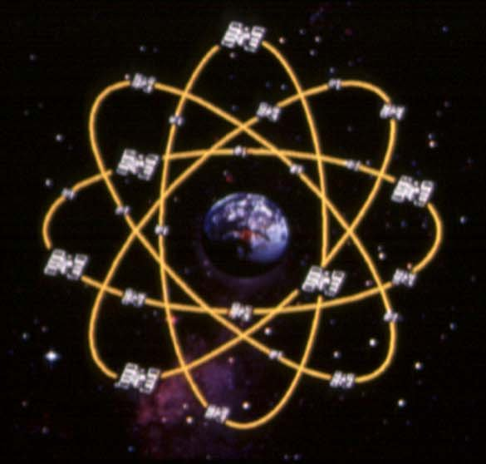

- Control segment
A network of earth-based facilities
- The CS consists of 3 entities:
  - Master Control System
  - Monitor Stations
  - Ground Antennas
MASTER CONTROL STATION
Located at Falcon Air Force Base in Colorado Springs, Responsible for overall management of the remote monitoring and transmission sites. Check-up is performed twice a day, by each of 6 stations, as the satellites complete their journeys around the earth. Can reposition satellites to maintain an optimal GPS constellation.

MONITOR STATIONS
Checks the exact altitude, position, speed, and overall health of the orbiting satellites. The control segment ensures that the GPS satellite orbits and clocks remain within acceptable limits. A station can track up to 11 satellites at a time. This "check-up" is performed twice a day, by each station.

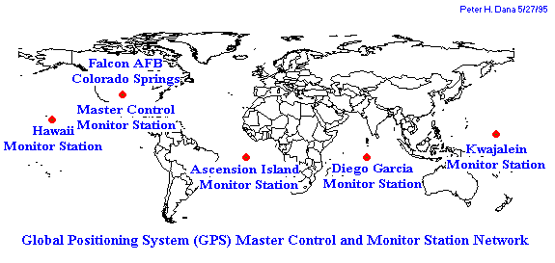
GROUND ANTENNAS
Ground antennas monitor and track the satellites from horizon to horizon. They also transmit correction information to individual satellites. Communicate with the GPS satellites for command and control purposes.
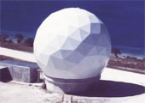
- Users & Equipment segment
GPS receivers are generally composed of
1. An antenna
2. receiver-processors, and
3. highly-stable clock
They can also include a display for showing location and speed information to the user.
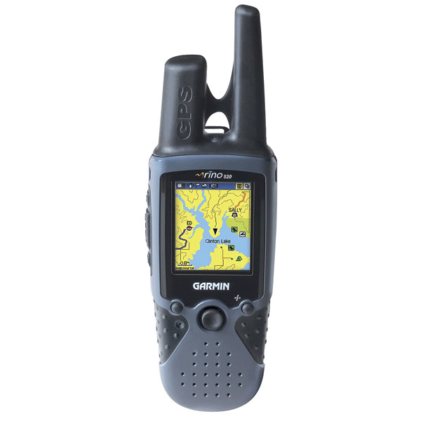

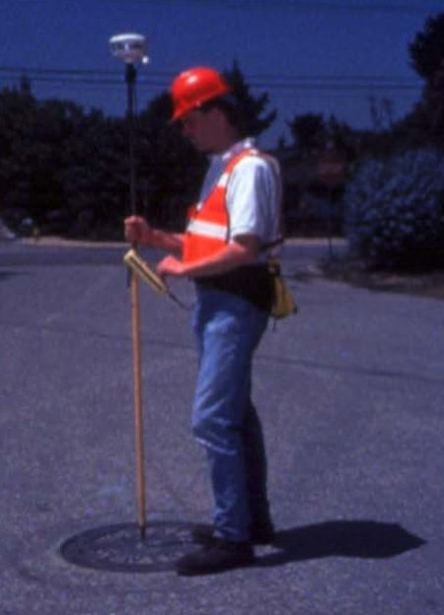

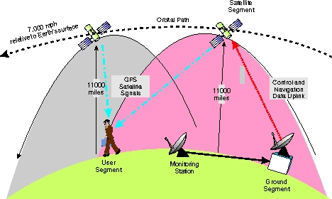
WORKING PRINCIPLE
Geometric Principle:
You can find one’s location if you know its distance from other, already-known locations.
- Things which need to be determined:
  - Current Locations of GPS Satellites.
  - The Distance between Receivers’s Position and the GPS Satellites.

CURRENT LOCATIONS OF GPS SATELLITES
GPS satellites are orbiting the earth at an altitude of 11,000 miles.
The orbits, and the locations of the satellites, are known in advance.
GPS receivers store this orbit information for all of the GPS satellites in an ALMANAC*.

How GPS Works
Uses measurements from 4+ satellites
Distance = travel time x speed of light
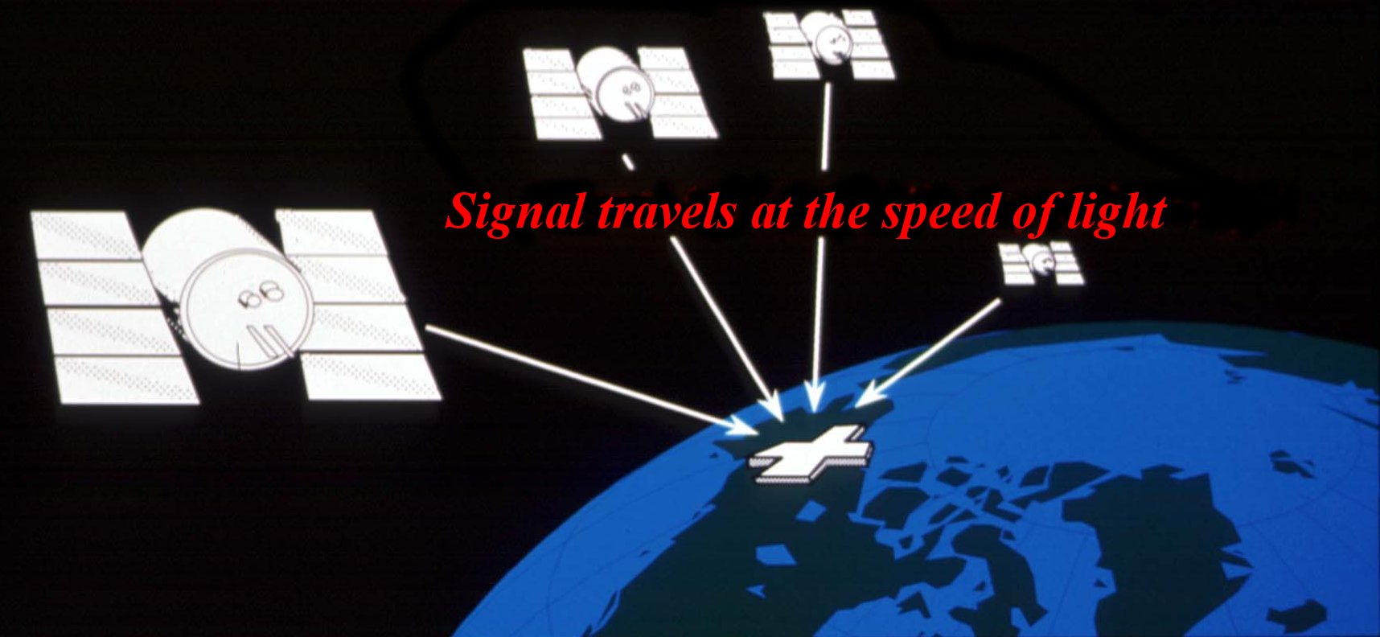

Determining GPS Position
- Suppose the distance from Satellite A to our position is 11,000 miles
- At this point we could be located anywhere on the specified sphere
- Next, let us take another measurement from a second satellite, Satellite B
- Now our position is narrowed down to the intersection of these two sphere
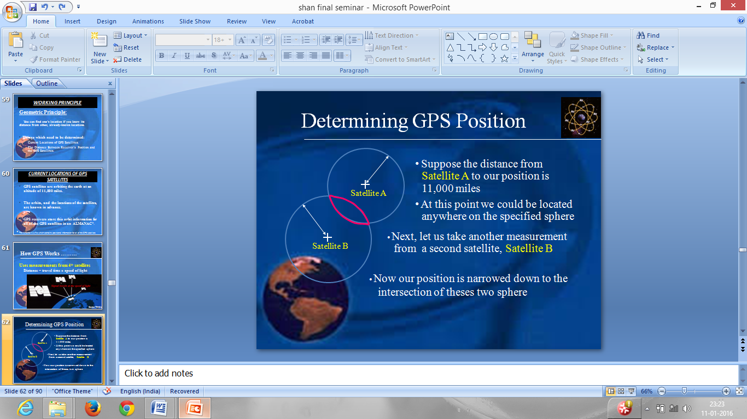

- Taking another measurement from a 3rd satellite narrows our position down even further, to the two points
- These points are located where the 3rd sphere cuts through the intersection of first two spheres
- So by ranging from 3 satellites we can narrow our position to just two points in space
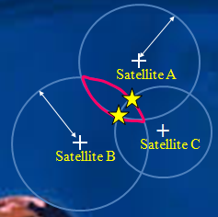
How do we decide which one is our true location?
- We could make a 4th measurement from another satellite to determine the true point
OR
- We can eliminate one of the two points that gives a ridiculous answer
- The ridiculous point may be too far from the earth
- However, GPS receivers use a 4th satellite to precisely locate our position
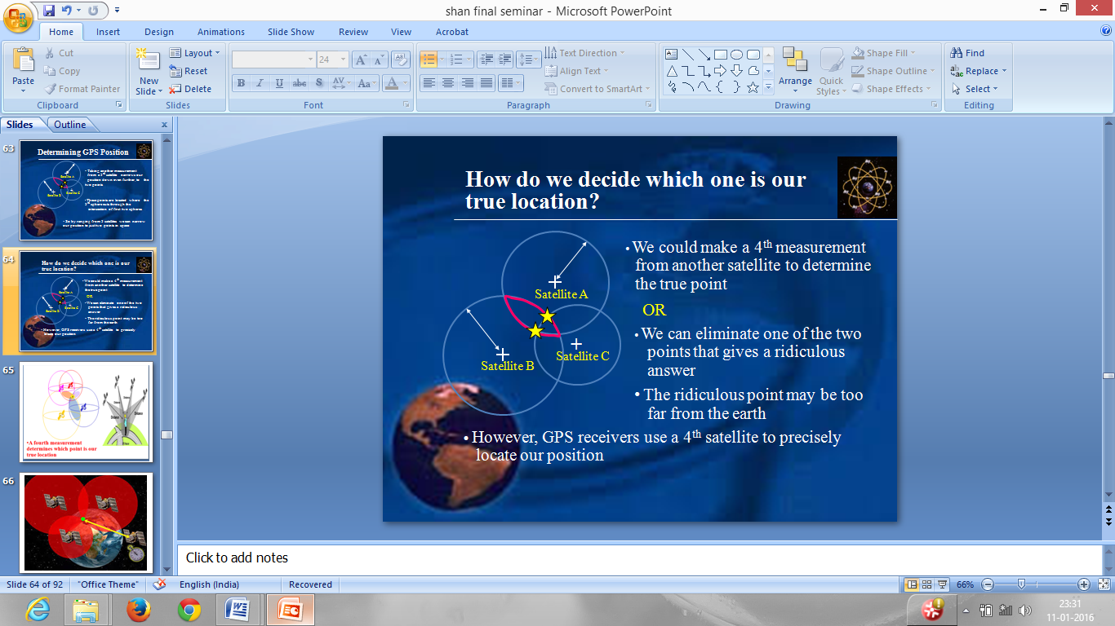

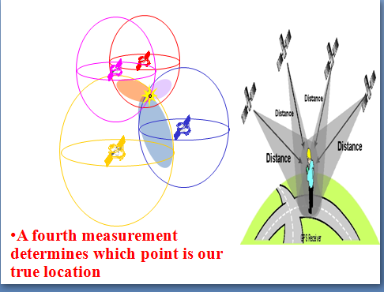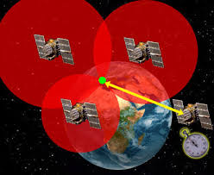

APPLICATIONS OF GPS
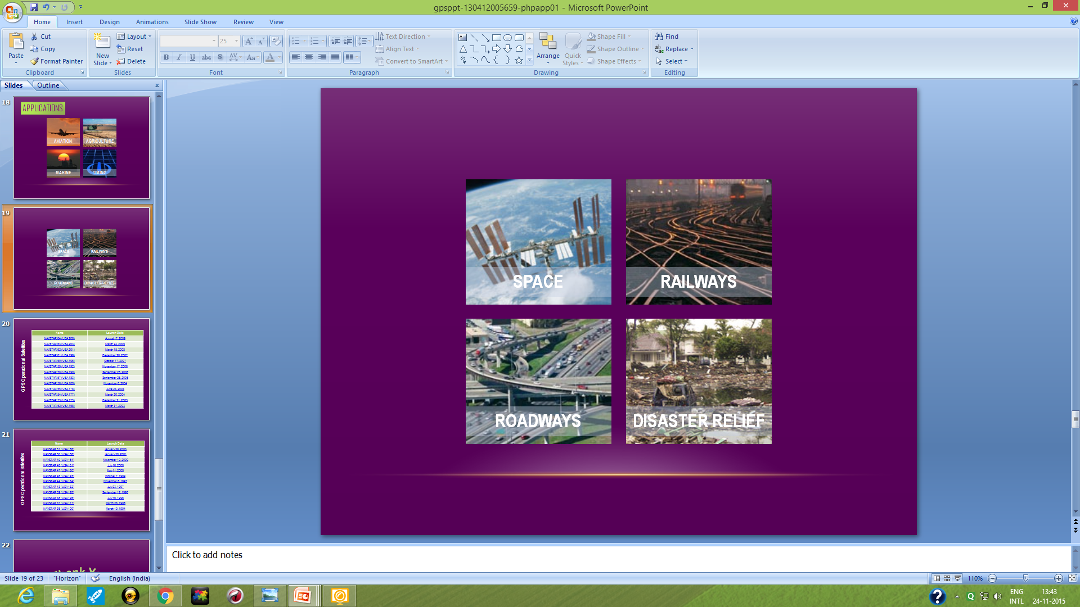

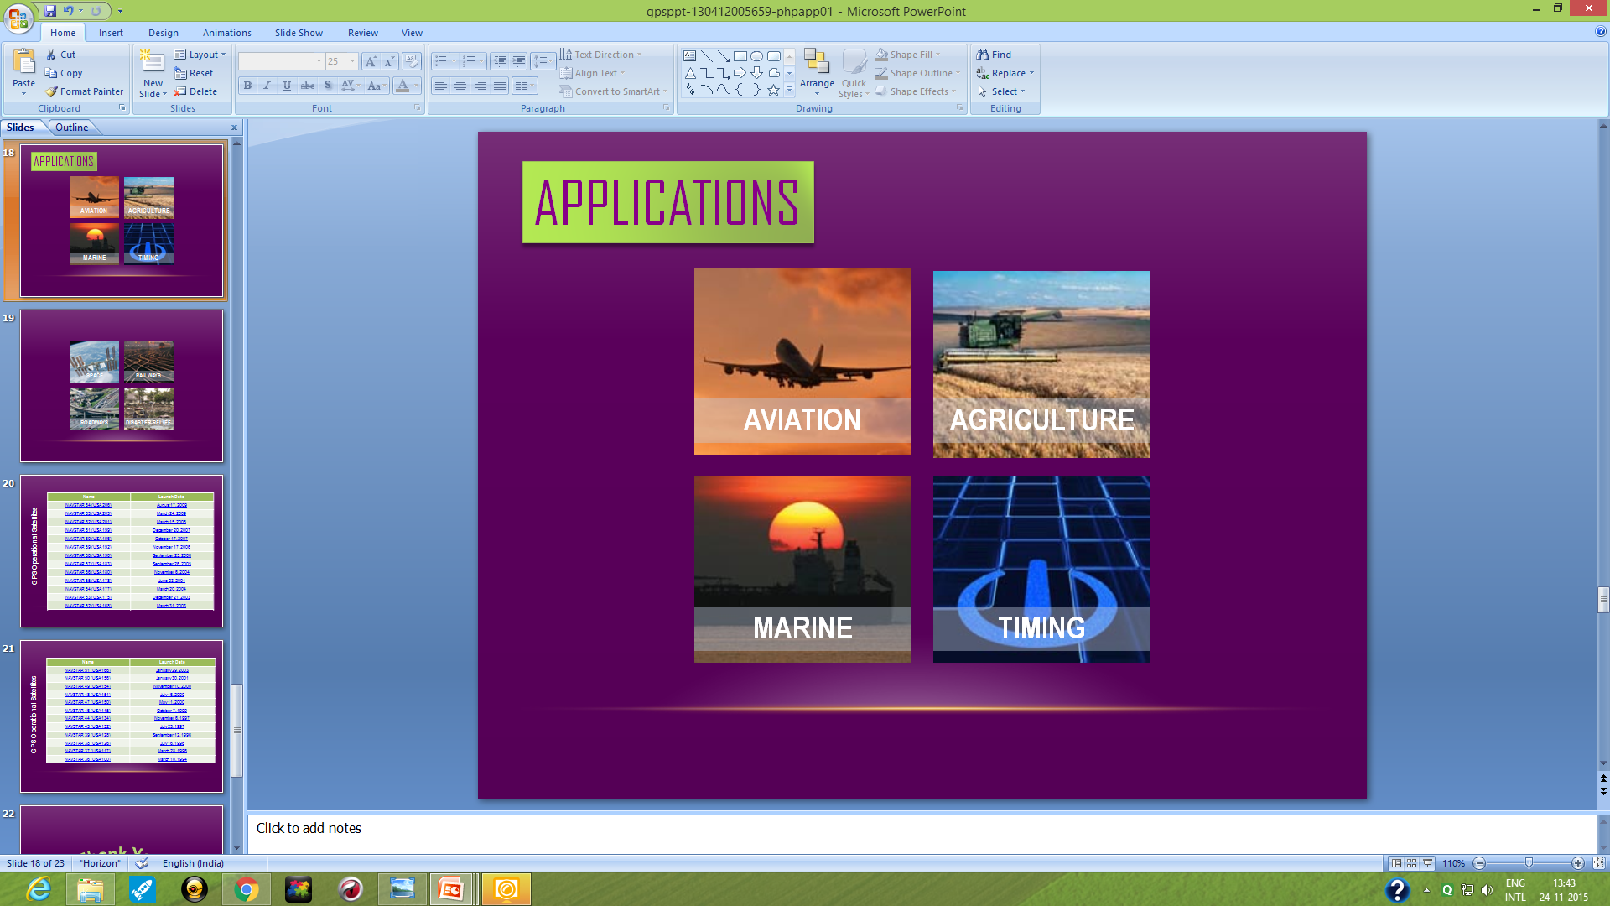

GPS Application In Agriculture
- Mapping
- Soil Properties
- Chemical application
- Chemical Prescription
- Tillage maps
- Yield mapping
- Pest mapping
- Planting maps
- Topographic Maps
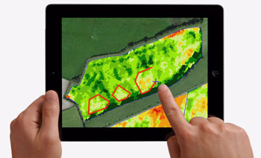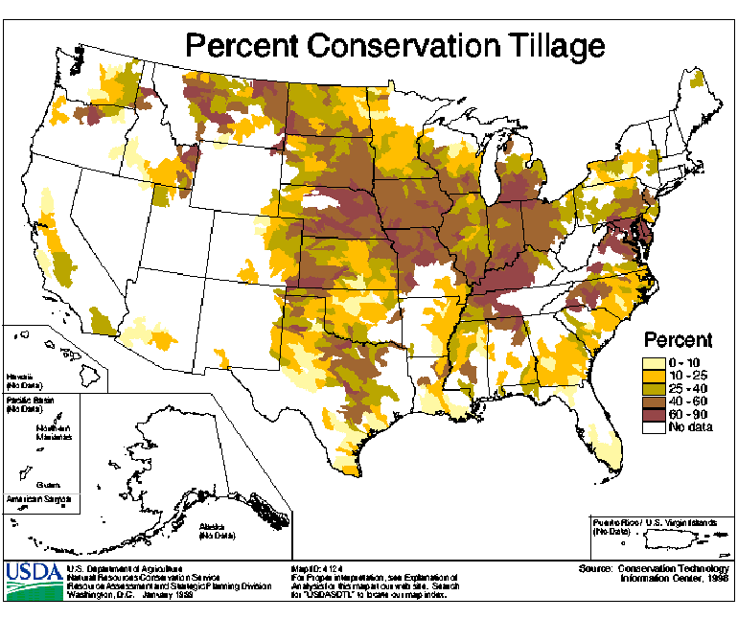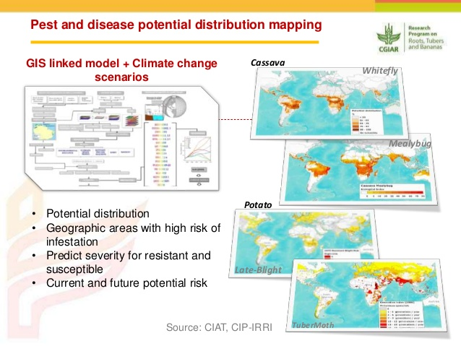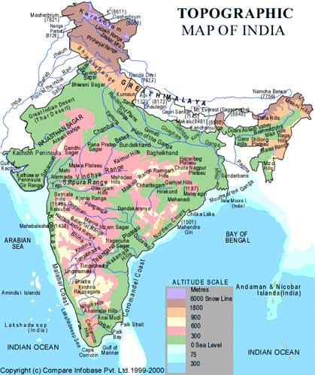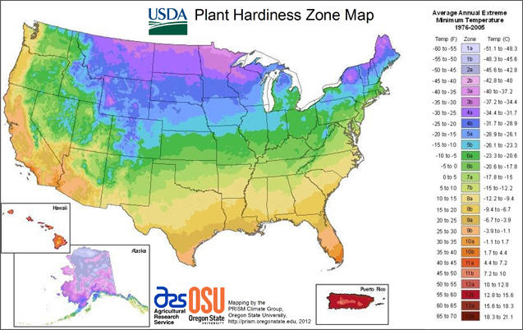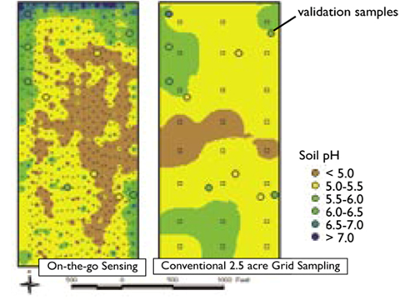

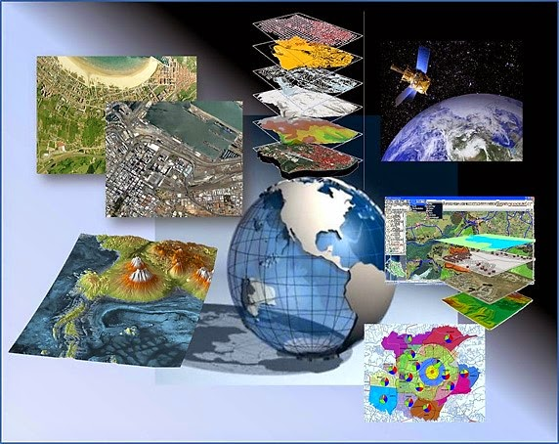
Functioning and Applications of GIS and GPS in Agriculture
GIS functions as a data capture, data storage, manipulation of data, query and analysis, visualization of results etc. The GPS concept is based on time. GPS satellites continuously transmit their current time and position. A GPS receiver monitors multiple satellites and solves equations to determine the exact position of the receiver and its deviation from true time. At a minimum, four satellites must be in view of the receiver for it to compute four unknown quantities.
Further, the GIS and GPS are applied in agriculture for crop acreage, production estimation, crop protection, drought monitoring, land use/land cover mapping wasteland mapping, groundwater development, site selection, socio-economic studies, weather forecasting, agro-climatic planning and information bank, planning for sustainable development of dry land, future scenario, ocean application, natural resource management, crisis management etc.,
Case studies
Groundwater quality mapping using geographic information system (GIS): A case study of Gulbarga City, Karnataka, India
Balakrishna et al. (2011)
- For this study, water samples were collected from 76 of the bore wells and open wells representing the entire corporation area. The water samples were analyzed for physico-chemical parameters like TDS, TH, Cl- and NO3-, using standard techniques in the laboratory and compared with the standards.
- The ground water quality information maps of the entire study area have been prepared using GIS spatial interpolation technique for all the above parameters.

STUDY AREA
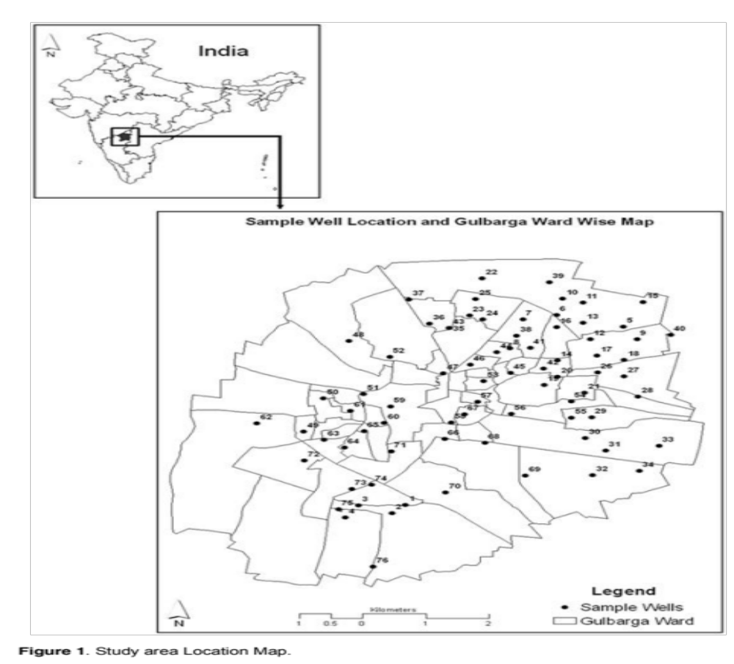

METHODOLOGY
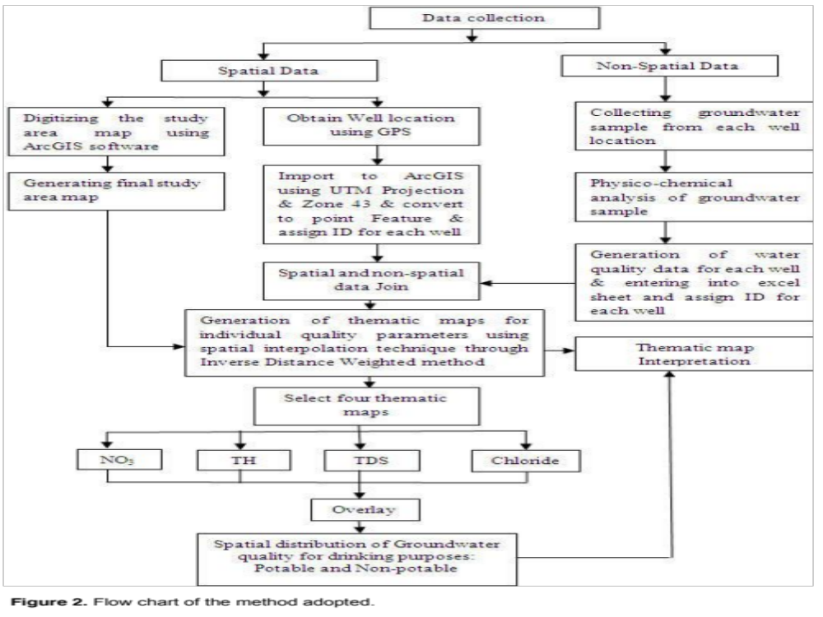
Criteria for acceptability and rejection in water quality
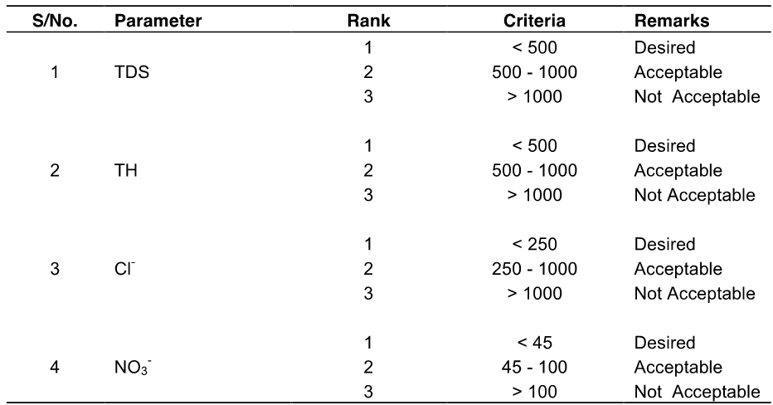

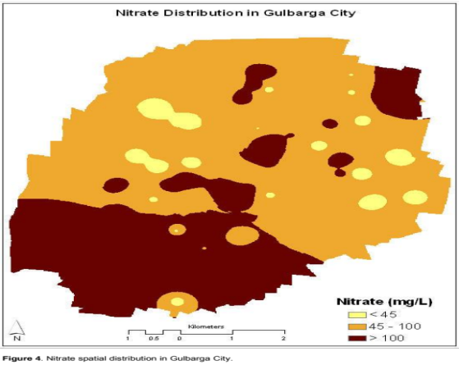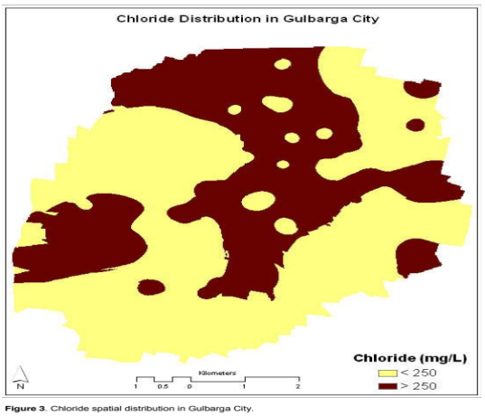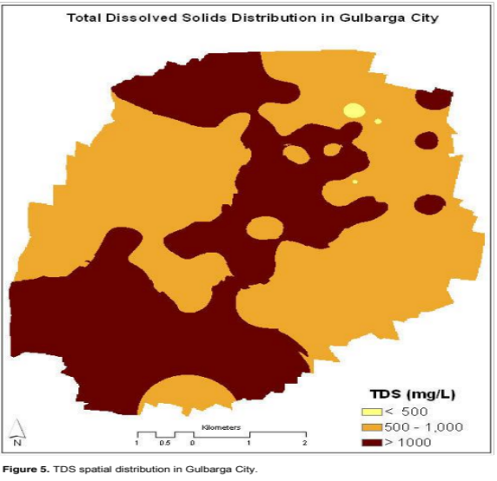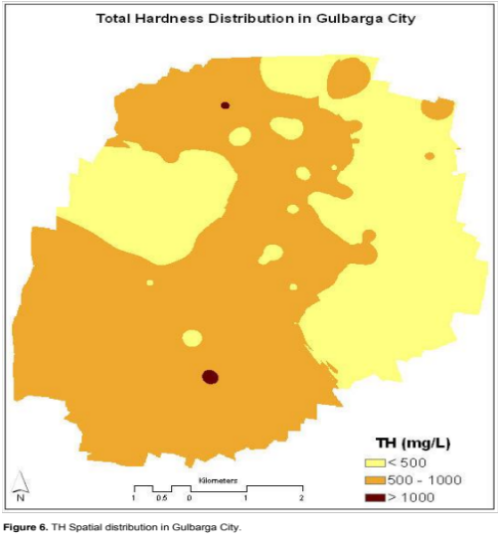

Result
- The spatial distribution analysis of groundwater quality in the study area using GIS indicated that many of the samples collected are not satisfying the drinking water quality standards prescribed by the WHO and ISI.
- Almost half of the city having non-potable ground water.

Remote Sensing and GIS for Integrated Resource Management Policy-A Case Study in Medak Nala Watershed, Karnataka, India
Shanwad et al. (2012)
The Medak Nala watershed selected for resources planning under Integrated Watershed Development Programme (IWDP) is in Sedam taluk of Gulbarga district that falls in Northern Dry Agro-climatic Zone of Karnataka. Action plan preparation for Medak Nala watershed using Indian Remote Sensing Satellite Imageries of Indian Remote Sensing Satellite (IRS 1D) and GIS.

STUDY AREA
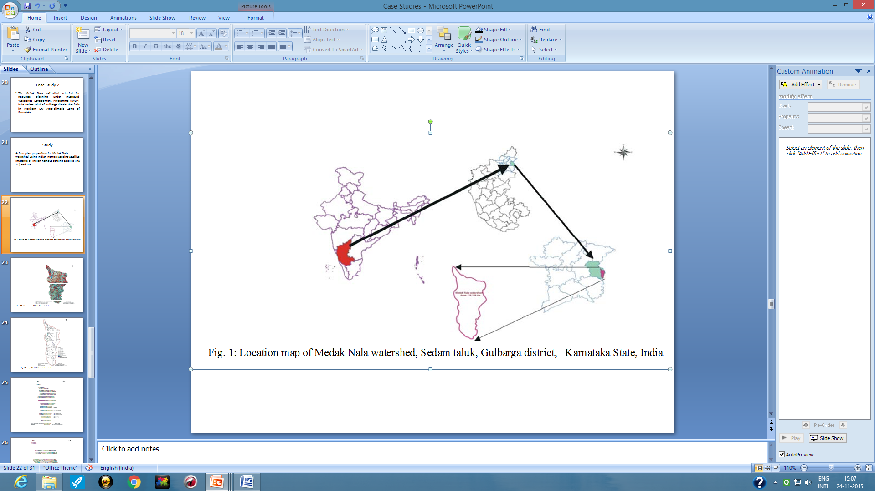
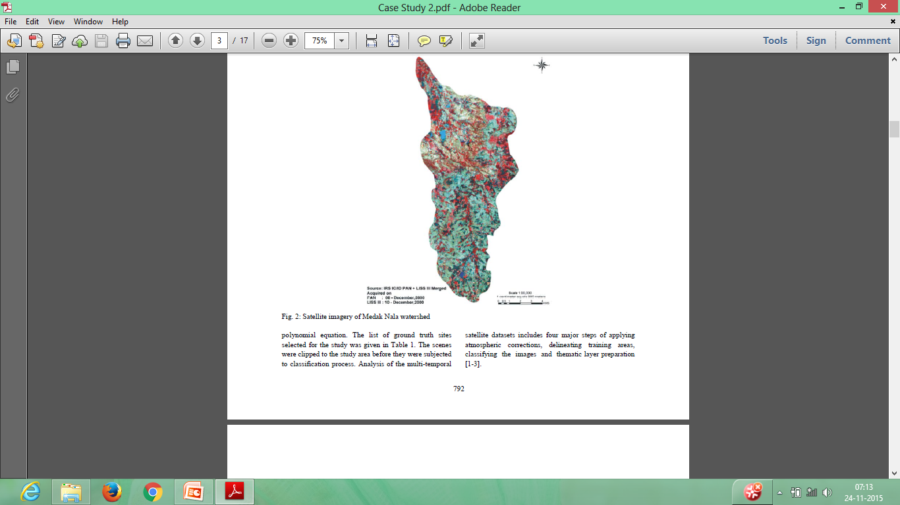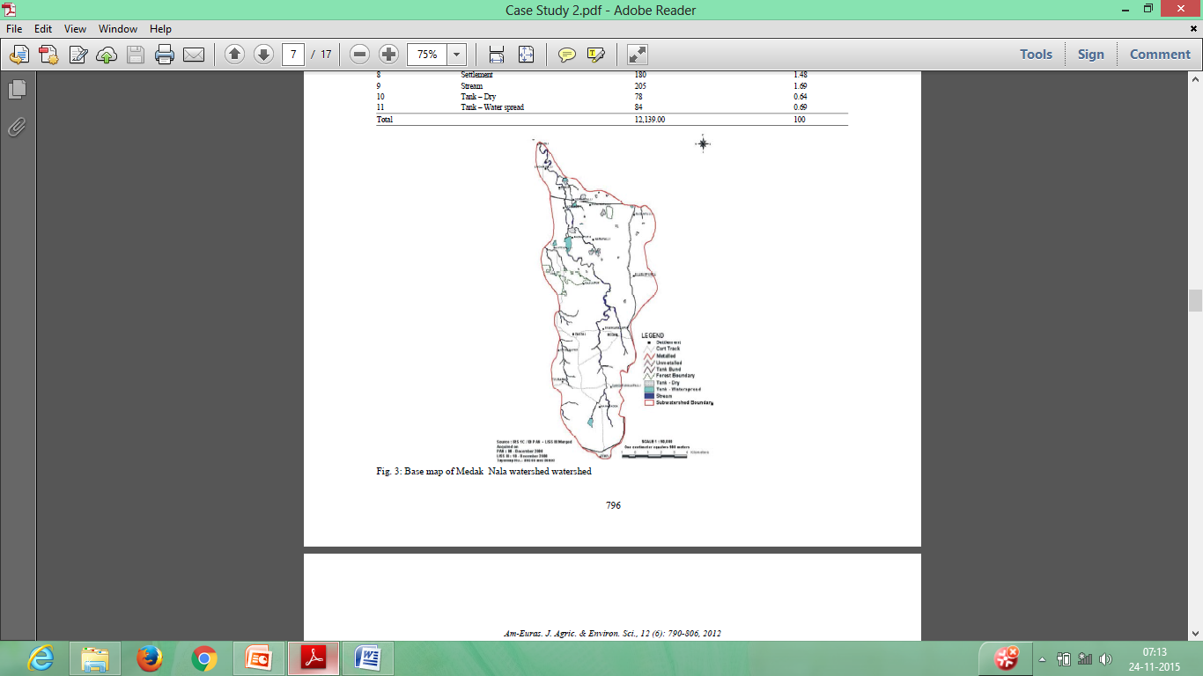
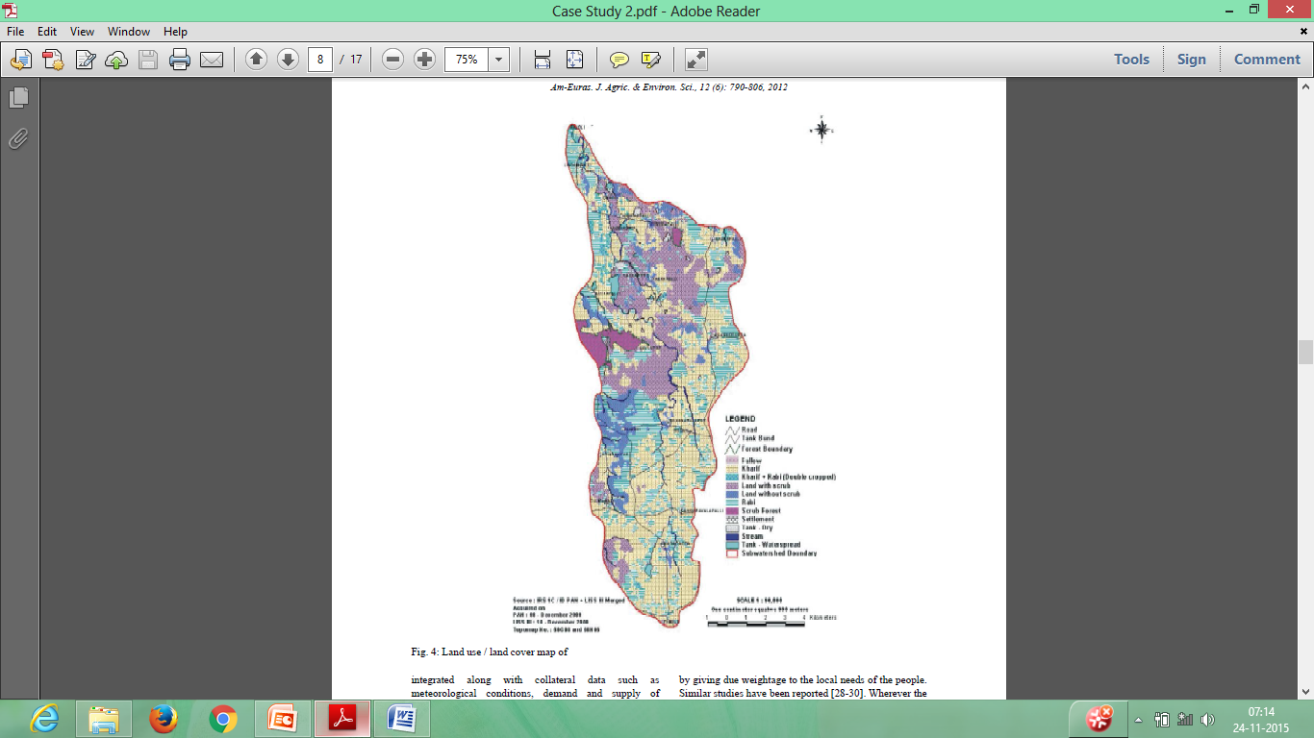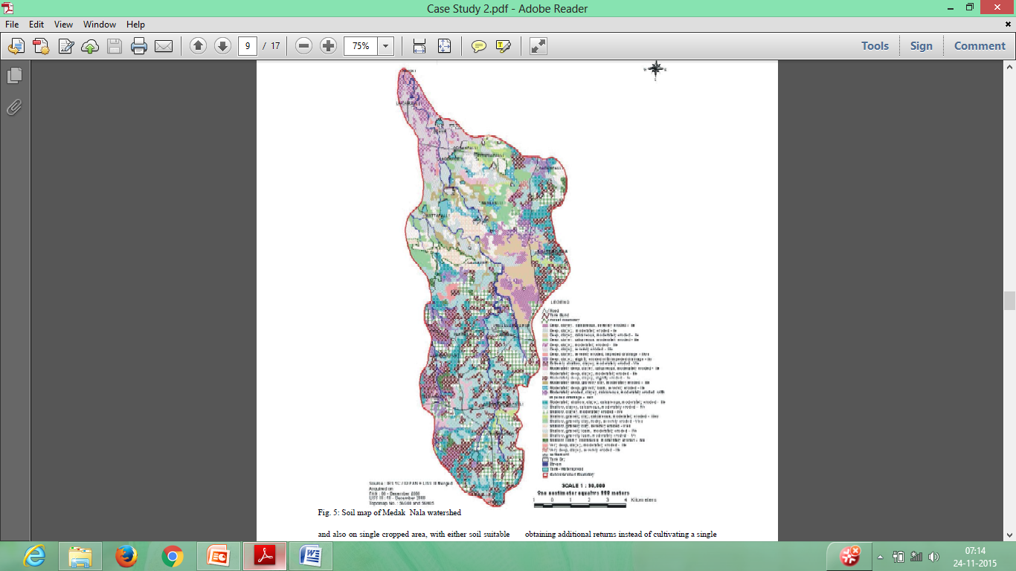
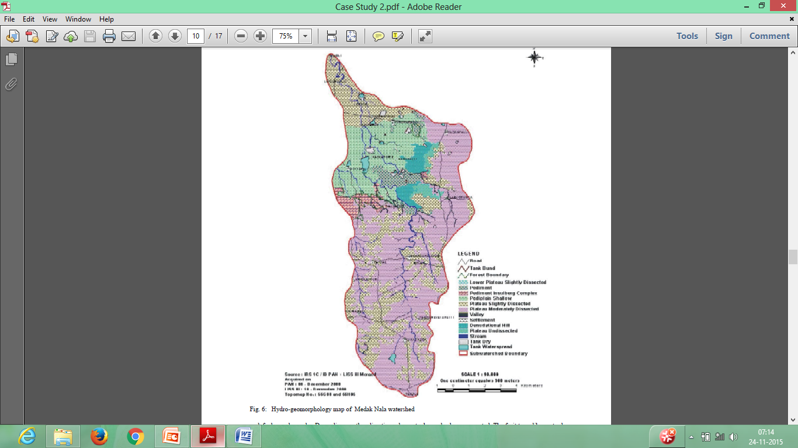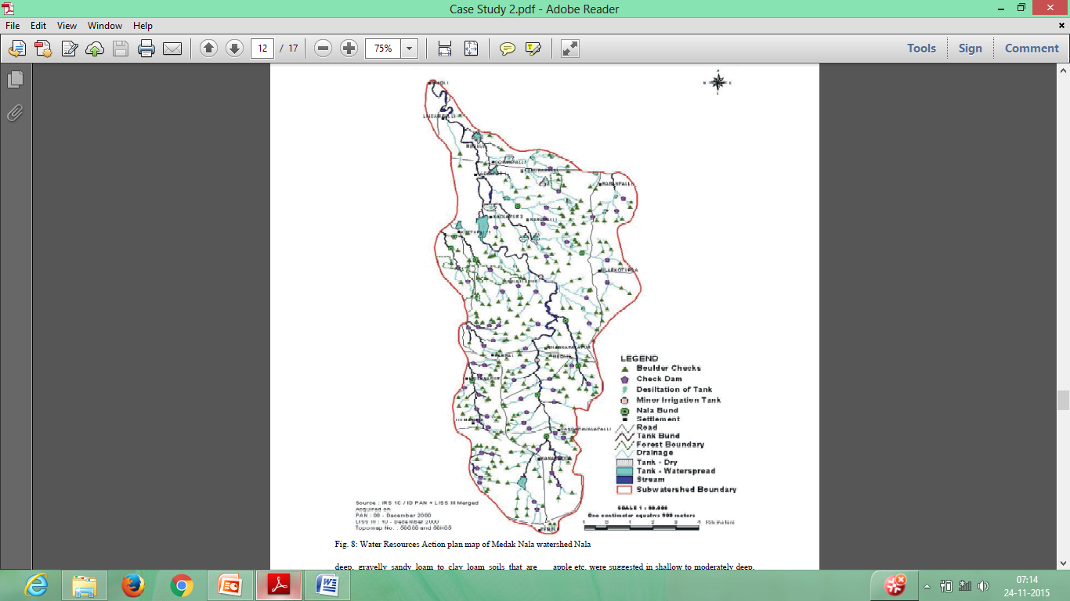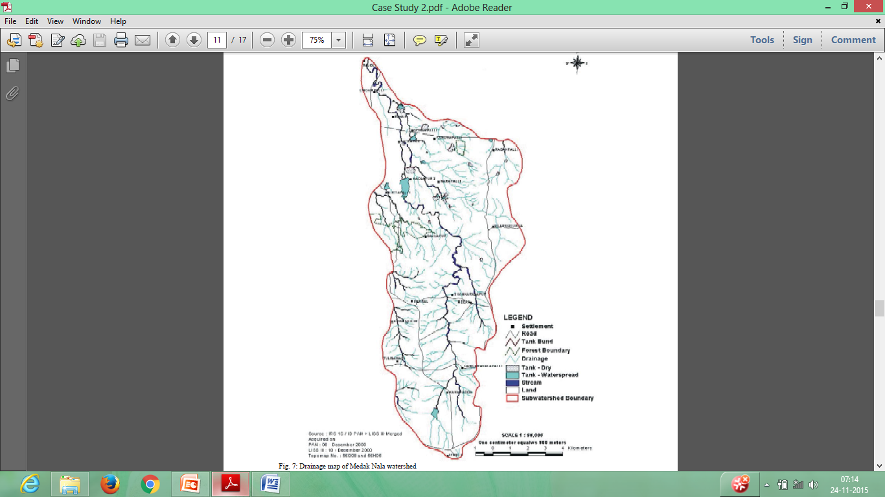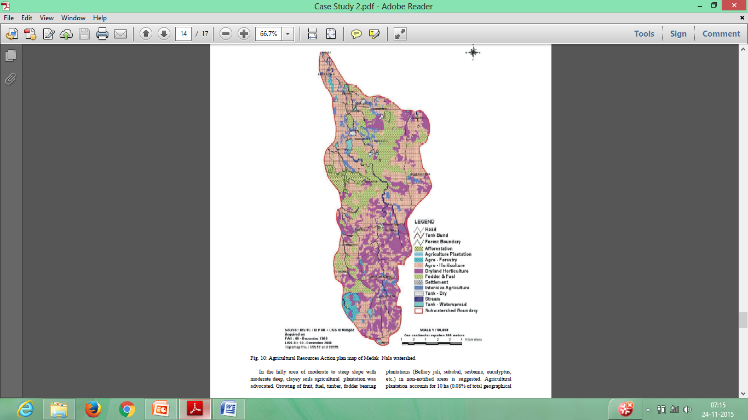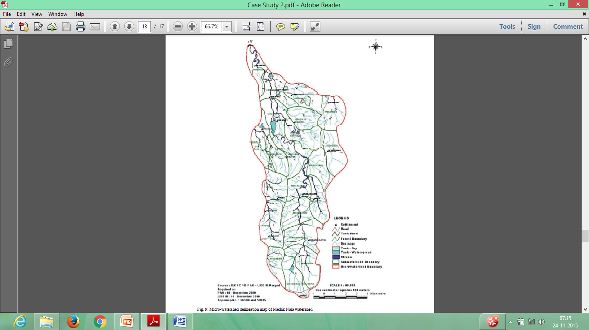

Result
- Remote sensing and GIS technologies can be used for scientific planning and management of natural resources. The generation of alternative land use / land cover practices for natural resources management involves careful study of thematic maps.
- Action plans are generated in an integrated way for different land use system based on systematic assessment of physical capability, economic viability and technical feasibility.

An integrated approach of Satellite Remote Sensing technology and Geographical Information system for the land use land cover change detection studies for urban planning of Mangalore taluk of Karnataka State, India
Usha et al. (2014)

Identification and analysis of land-use/land-cover and the pattern of urban growth in advance would help in effective infrastructure planning and resource management.
Keeping the above in view, the present work has been undertaken to prepare the multi-date land use/ land cover maps of Mangalore city from multi-sensor satellite data and monitor the changes in various land-use/land-cover classes using digital image processing techniques.

STUDY AREA
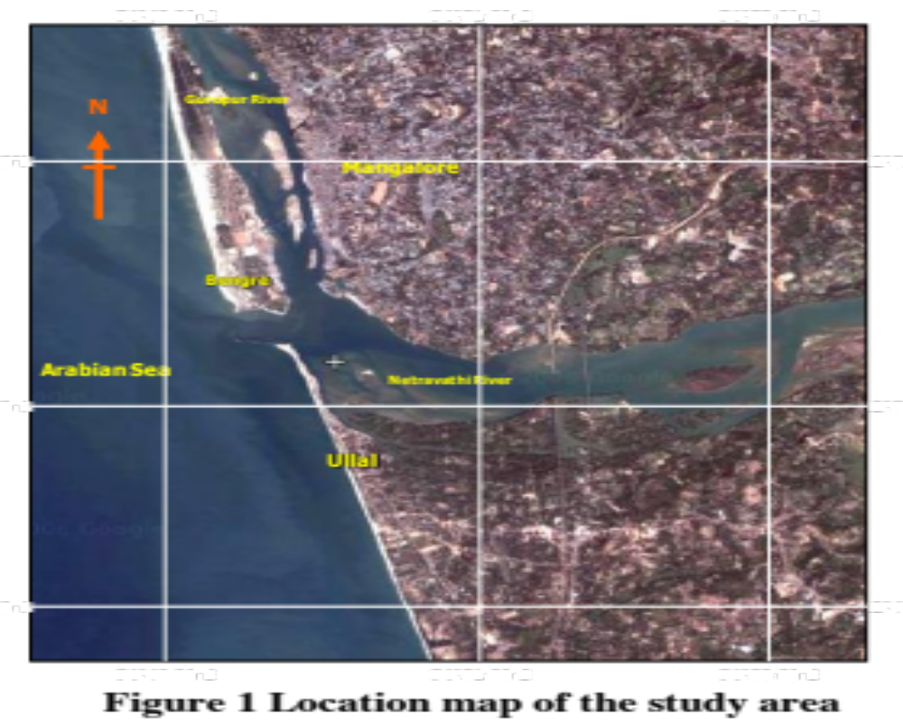

METHODOLOGY
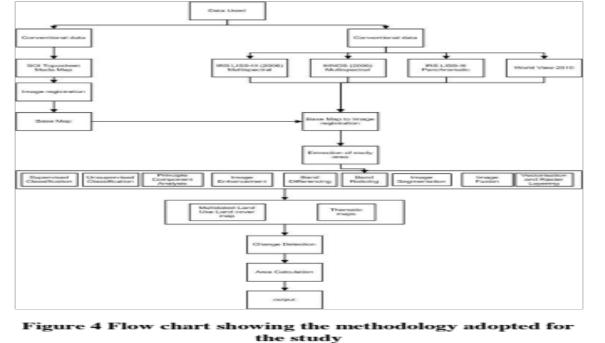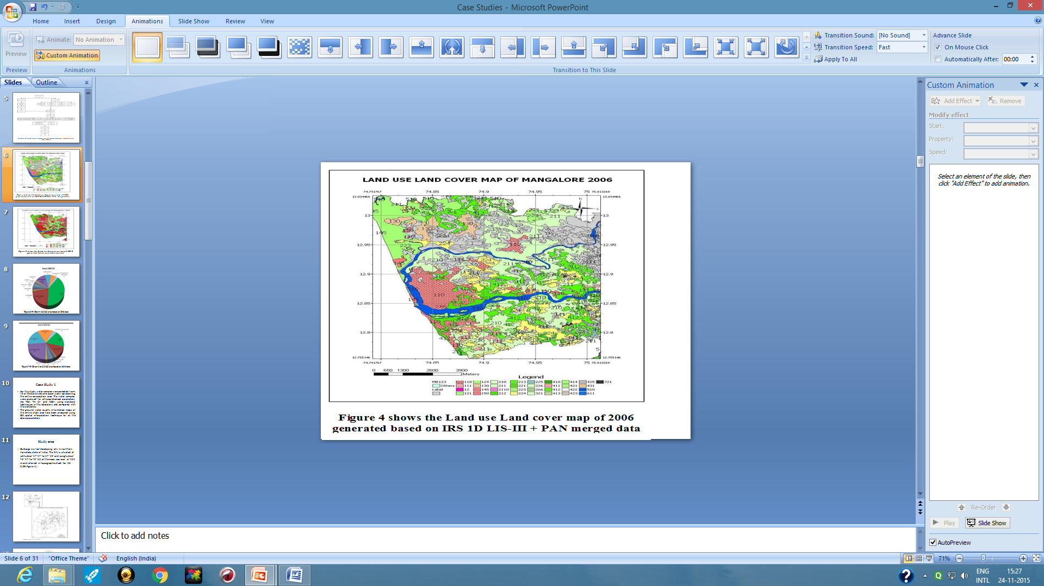
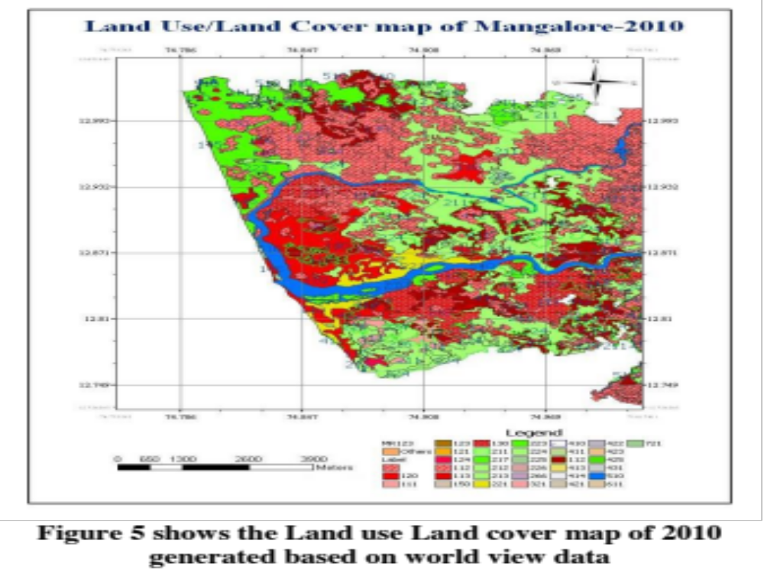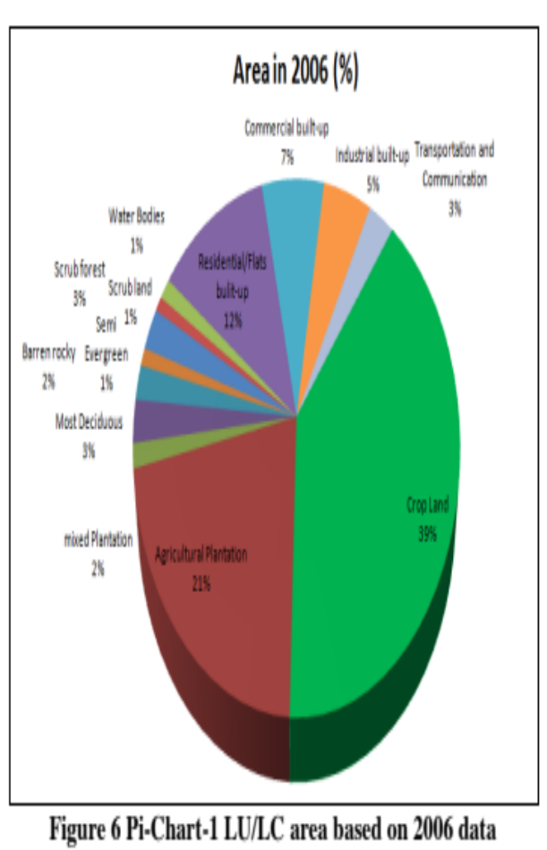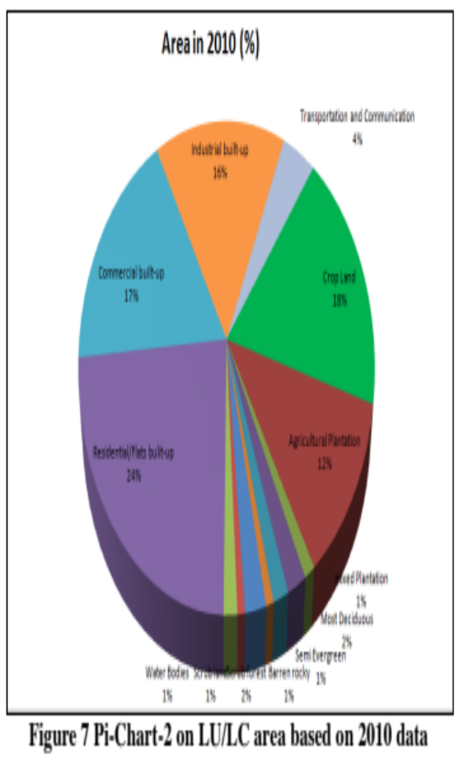
Result
- Remote sensing data along with GPS help in effective land cover analysis.
- Successful utilization of remotely sensed data for land cover and land use change detection requires careful selection of appropriate data set.
- Good quality of RS data, strict geometric registration and radiometric normalization, and suitable training data selection are important for successful implementation of the Land Use Land Cover change detection.

Conclusion
The futuristic application of GIS and GPS gives tremendous promise towards meeting information needs on a continual basis, on larger scale a variety of resources which could then be deployed for still better planning to face the challenge and for sustainable development of agriculture.

References
BALAKRISHNAN, P., ABDUL SALEEM AND MALLIKARJUN, N.D., 2011, Groundwater Quality Mapping using Geographic Information System (GIS): A Case Study of Gulbarga City, Karnataka, India, African Journal of Environmental Science and Technology, 5(12): 1069-1084.
SHANWAD, U. K., PATIL, V.C., HONNE GOWDA, H. AND SHASHIDHAR, K.C., 2012, Remote Sensing and GIS for Integrated Resource Management Policy-A Case Study in Medak Nala Watershed, Karnataka, India American-Eurasian J. Agric. & Environ. Sci.,12 (6): 790-806.
USHA, THUKARAM, M., MOHANDAS CHADAGA AND NAVEENCHANDRA, B., 2014, An integrated approach of Satellite Remote Sensing technology and Geographical Information system for the land use land cover change detection studies for urban planning of Mangalore taluk of Karnataka State, India, International Journal of Scientific and Research Publications, 4(5):1-7.


UNIVERSITY OF AGRICULTURAL SCIENCES
DEPARTMENT OF AGRICULTURAL EXTENSION
GKVK, BANGALORE-560065
Name: Shanabhoga M B Date: 27-11-2015
ID. No.: PALB 4120 Time: 02:00 PM
Class: Sr. M.Sc (Ag. Extn) Venue: Dwarakinath Hall
I Seminar
Geographic Information System (GIS) and Geographical Positioning System (GPS): its application in Agriculture
Synopsis

Agriculture is an inherently geographical practice and it is not surprising that this, together with the extremely large sums of money involved make it a natural application for GIS. Many site-specific farming systems utilize Geographic Information System and Geographic Positioning System to collect spatially referenced data, perform spatial analysis and decision- making, and apply variable rate treatment the development and implementation of precision agriculture or site-specific farming has been made possible by combining the GPS and GIS. These technologies enable the coupling of real-time data collection with accurate position information, leading to the efficient manipulation and analysis of large amounts of geospatial data. GPS-based applications in precision farming are being used for farm planning, field mapping, soil sampling, tractor guidance, crop scouting, variable rate applications, and yield mapping. GPS allows farmers to work even during low visibility field conditions such as rain, dust, fog, and darkness. With this background, the present seminar has been conceptualized with the following objectives.
- To understand the concept of GIS and GPS
- To know the functioning and application of GIS and GPS in Agriculture
- To review the case studies related to GIS and GPS in Agriculture
The concept of GIS and GPS
GIS: Geographical information system (GIS) is computer system capable of capturing, storing, manipulating and displaying spatially referenced information. It is a tool for planning and decision making processes. It is used in a wide range of applications like urban and regional planning, agriculture, emergency response systems and natural resource management. It is an emerging field and grows at very rapid pace
GPS: The global positioning system (GPS) makes it possible to record the in-field variability as geographically encoded data. It is possible to determine and record the correct position continuously. This technology considers the agricultural areas, fields more detailed than previously; therefore, a larger database is available for the user. The accurate yield data can be reported only in the points where GPS position recording has happened.
Functioning and Applications of GIS and GPS in Agriculture
GIS functions as a data capture, data storage, manipulation of data, query and analysis, visualization of results etc. The GPS concept is based on time. GPS satellites continuously transmit their current time and position. A GPS receiver monitors multiple satellites and solves equations to determine the exact position of the receiver and its deviation from true time. At a minimum, four satellites must be in view of the receiver for it to compute four unknown quantities.
Further, the GIS and GPS are applied in agriculture for crop acreage, production estimation, crop protection, drought monitoring, land use/land cover mapping wasteland mapping, groundwater development, site selection, socio-economic studies, weather forecasting, agro-climatic planning and information bank, planning for sustainable development of dry land, future scenario, ocean application, natural resource management, crisis management etc.,
Case studies
Balakrishna et al. (2011) concluded that the spatial distribution analysis of groundwater quality in the study area using GIS indicated that many of the samples collected are not satisfying the drinking water quality standards prescribed by the WHO and ISI with almost half of the city is having non-potable ground water.
Shanwad et al. (2012) concluded that remote sensing and GIS technologies can be used for scientific planning and management of natural resources. The generation of alternative land use / land cover practices for natural resources management involves careful study of thematic maps. Action plans are generated in an integrated way for different land use system based on systematic assessment of physical capability, economic viability and technical feasibility.
Usha et al. (2014) concluded that remote sensing data along with GPS help in effective land cover analysis. Successful utilization of remotely sensed data for land cover and land use change detection requires careful selection of appropriate data set. Good quality of RS data, strict geometric registration and radiometric normalization, and suitable training data selection are important for successful implementation of the Land Use Land Cover change detection.
Conclusion
The futuristic application of GIS and GPS gives tremendous promise towards meeting information needs on a continual basis, on larger scale a variety of resources which could then be deployed for still better planning to face the challenge and for sustainable development of agriculture.
References
BALAKRISHNAN, P., ABDUL SALEEM AND MALLIKARJUN, N.D., 2011, Groundwater Quality Mapping using Geographic Information System (GIS): A Case Study of Gulbarga City, Karnataka, India, African Journal of Environmental Science and Technology, 5(12): 1069-1084.
SHANWAD, U. K., PATIL, V.C., HONNE GOWDA, H. AND SHASHIDHAR, K.C., 2012, Remote Sensing and GIS for Integrated Resource Management Policy-A Case Study in Medak Nala Watershed, Karnataka, India American-Eurasian J. Agric. & Environ. Sci.,12 (6): 790-806.
USHA, THUKARAM, M., MOHANDAS CHADAGA AND NAVEENCHANDRA, B., 2014, An integrated approach of Satellite Remote Sensing technology and Geographical Information system for the land use land cover change detection studies for urban planning of Mangalore taluk of Karnataka State, India, International Journal of Scientific and Research Publications, 4(5):1-7.

Question asked in the seminar

- How GIS and GPS are useful in agricultural extension?
Agricultural extension is a location based activity; in this activity extension personnel should give the solutions for the problem at the field level. For this GIS is helpful in providing location based data like soil texture, fertility, land mapping etc. and GPS will provide the information about the location.

- What are the problems existed in the application of these technologies in the Indian Agriculture context?
We all know that Indian farmers are having small land holding. So using these technologies for the small farmers is difficult because Indian Agriculture is diversified with various crops and environment conditions.

