Application of Descriptive and Inferential Statistics in Social Science Research
Introduction
The goal of social science research is to make conclusions that go beyond our intuitive understanding. With large number of studies it is possible to make generalizations about the causal effects of different phenomena. As a tool of the positivist tradition, the statistical method is a way of identifying patterns and regularities in the observable world. Statistics involve the systematic collection of data with the aim of achieving knowledge by induction, that is, making inferences from observed regularities to general theories. Using the statistical methods, social scientists are able to make generalizations about the empirical world, whether operating with samples of a population, or the population as a whole. Keeping these aspects in view, the present seminar is conceptualized with following objectives:
- To know the Measures under Descriptive Statistics and its applications.
- To know the Techniques under Inferential Statistics and its applications.
- To review the related Research Studies.
Statistics
Statistics is a branch of science which deals with collection, classification, tabulation, analysis and interpretation of data.
Statistics is the branch of science which deals with the collection, classification and tabulation of numerical facts as the basis for explanations, description and comparison of phenomenon . - Lovitt
Statistics may be called the science of counting or science of averages or statistics is the science of the measurement of social organism, regarded as whole in all its manifestation - Bowley
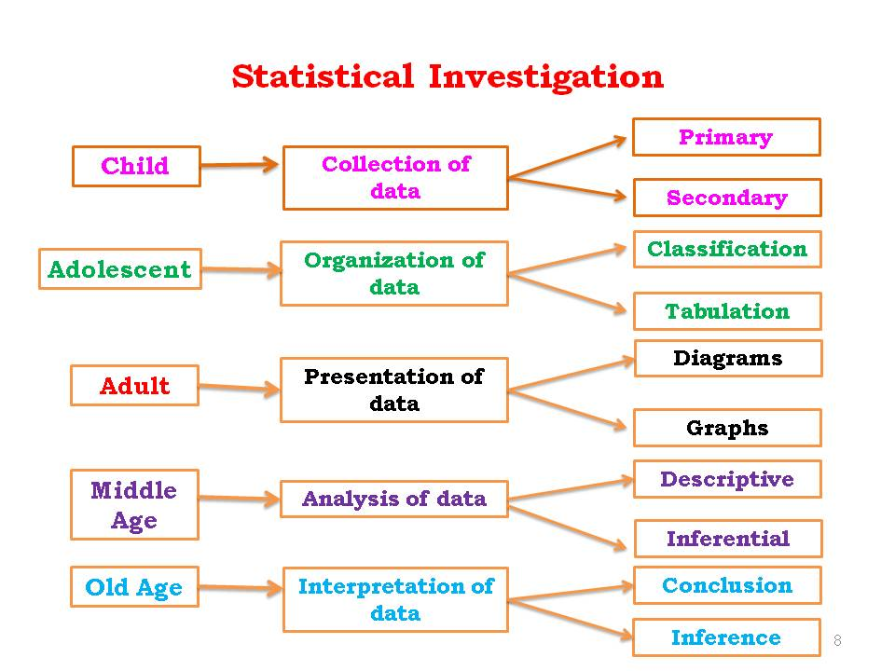
Importance
Statistics plays an important role in our daily walks of life. It is useful in almost all sciences such as social, physical, biology, psychology, education, economics, business management, administration, animal science, lab science and agricultural sciences etc. In agricultural research, Statistical tools have played an effective and significant role in the analysis and interpretation of data more effectively.

Descriptive Statistics
It means summarization of a collection of data in a clear and understandable way and it is the most basic functions of statistics and it lays the foundation for all statistical techniques.

Measures under descriptive statistics (Guptha and Kapoor, 2003)
- Measures of Central Tendency
- Measures of Dispersion
- Measures of Relative Dispersion
- Coefficient of Variation
- Skewness and
- Kurtosis

Measures of Central Tendency
One of the most important aspects of describing a frequency distribution is the central value around which the observations are distributed.
Types:
- Arithmetic Mean: It is defined as the sum of the given observations divided by the number of observations. A.M. is measured with the same units as that of the observations.
- Median : The median is the middle most item that divides the distribution into two equal parts when the items are arranged in ascending order.
- Mode : Mode is the value which occurs most frequently in a set of observations or mode is the value of the variable which is predominant in the series.
Properties
Sl. No. | Properties | AM | Me | Mo
1 | Rigidly defined | Yes | Yes | Yes
2 | Easy to understand and easy to calculate | Yes | Yes | Yes
3 | Based on all the observations | Yes | No | No
4 | Capable of further algebraic treatment | Yes | No | No
5 | Not affected much by the extreme values | No | Yes | Yes
6 | Located easily | Yes | Yes | Yes

Measures of Dispersion
Dispersion means scattering or variability of the observations among themselves or from a central value of data or series.
Types: Range (R)
Quartile Deviation (QD)
Mean Deviation (MD)
Standard Deviation (SD)
Coefficient of Variation (CV)
Standard Error (SE)

- Range: It is the difference between highest and lowest value.

- Quartile Deviation: It is the average difference between the extreme quartiles.

- Mean Deviation: It is the absolute deviation of observation from the mean.

- Standard Deviation: It is the average square root of observation from the mean.

- Coefficient of Variation: It is the ratio between SD to the corresponding mean, expressed in percentage.

- Standard Error: It is the experiment error, worked out for the variation with respect to sample size.

Properties:
Sl. No. | Properties | R | QD | MD | SD
1 | Rigidly defined | Yes | Yes | Yes | Yes
2 | Easy to understand and easy to calculate | Yes | Yes | Yes | Yes
3 | Based on all the observations | No | No | Yes | Yes
4 | Capable of further algebraic treatment | No | No | No | Yes
5 | Not affected much by the extreme values | No | No | Yes | Yes
6 | Consider algebraic sign | No | No | No | Yes

Measures of Relative Dispersion
These measures are calculated for the comparison of dispersion in two or more than two sets or group of observations.

Quartiles: Describes the characteristics and divide into 4 equal parts or halves (Q1, Q2 &
Q3).
Deciles: Describes the characteristics and divide into 10 equal parts or halves (D1,
D2…… .D9).
Percentiles: Describes the characteristics and divide into 100 equal parts or halves (P1,
P2……P99).

SKEWNESS OF DISTRIBUTION
It is a measure describes the deviation of frequency data or series from the symmetrical distribution.
Types: 1. Positive Skewness
2. Negative Skewness

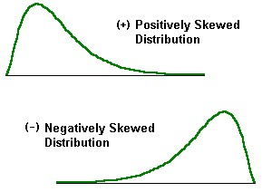
Kurtosis
It is a statistical measure explains the variation in terms of peakedness or flatness from the frequency data or series.
Types:
- Leptokurtic (β2<3)
- Mesokurtic (β2=3)
- Platykurtic (β2>3)
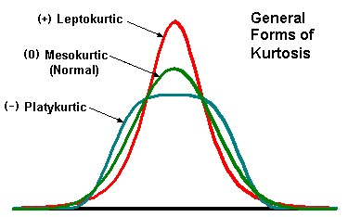

INFERENTIAL STATISTICS
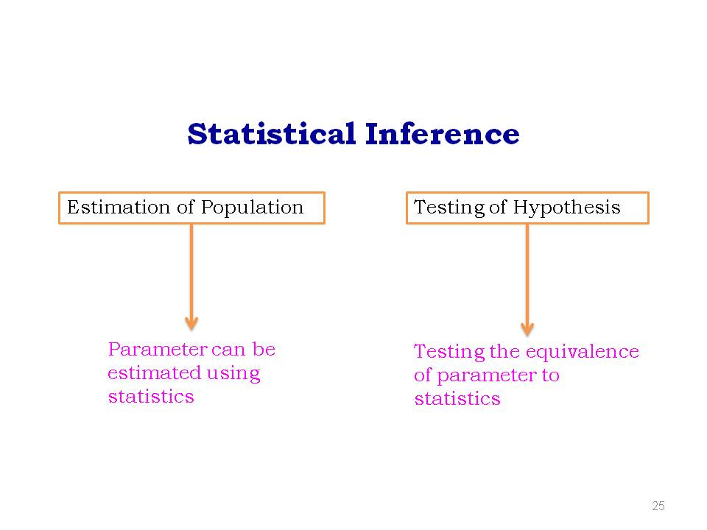
Estimation of Population
Parameter: Describes the population characteristics(µ, σ^{2,} ρ,….)
Statistic: Describes the sample characteristics (X, S² , r,….)
Estimators: Selecting the sample of size(n) from the population of size(N). We equate the
sample measure to the population measure

Characteristics of Estimator
- Unbiasedness: Sample mean is exactly equal to population mean
- Consistency: Not much difference between mean and population using confidence
interval
- Efficiency: Method selected for n of N to arrive to the nearest values
- Sufficiency: It select the desired sample size required

Testing of Hypothesis
Hypothesis: The assumption made about any unknown characteristics.
Null hypothesis: (H₀): Any statistical hypothesis under test called null hypothesis and it constructing when the results are specifically not known.
Alternative hypothesis: (H₁): Any hypothesis, which is complementary to the null hypothesis is called an alternative hypothesis and it constructing when the results are specifically known.

Types of Errors
Result | H₀ is true | H₀ is false
Rejecting H₀ | Type-I error (α) | Correct
Accepting H₀ | Correct | Type-II error (β)

Type-I error: Rejecting null hypothesis when it is true.
Type-II error: Accepting null hypothesis when it is false.

Level of significance(LOS): It is the probability that the null hypothesis is rejected when in fact is true.
Measured at 5% & 1% level

Steps in Hypothesis Testing
- Problem statement
- Formulate the statistical hypothesis (null/alternative)
- Determine the appropriate test (based on the data)
- Establish the level of significance (5% & 1%)
- Calculate the test statistic (using formula)
- Compare computed test statistic against a table value
- Conclusion: If calculated value greater than table value reject the null hypothesis. If calculated value less than table value accept the null hypothesis.

Parametric statistical methods
- Parametric statistical test is one that makes assumptions about the parameters (defining properties) of the population distribution(s) from which one's data is drawn.
- Most well-known elementary statistical methods.
Assumptions of Parametric statistical methods
- Dependent variables are interval or ratio.
- The population from which samples are drawn is normally distributed.
- Samples are randomly selected.
- The groups have equal variance (Homogeneity of variance) “t-test”
Non-Parametric statistical methods
- Non-parametric test is one that makes no such assumptions about the parameters (defining properties) of the population distribution(s) from which one's data is drawn.
- In this strict sense, "non-parametric" is essentially a null category, since virtually all statistical tests assume one thing or another about the properties of the source population(s).
Difference between parametric and non parametric methods
 | Parametric | Non-parametric
Assumed distribution | Normal | No distribution
Assumed variance | Homogeneous | -
Typical data type | Ratio or Interval | Nominal or Ordinal
Data set relationships | Independent | Any
Usual central measure | Mean | Median, Mode
Benefits | Can draw more conclusions | Simplicity; Less affected by outliers
Tests
Correlation test | Pearson | Spearman
Independent measures, 2 groups | Independent-measures t-test | Mann-Whitney “U” test
Independent measures, >2 groups | One-way, independent-measures ANOVA | Kruskal-Wallis test
Dependent measures, 2 conditions | Matched-pair t-test | Wilcoxon test
Dependent measures,>2 conditions | One-way, repeated measures ANOVA | Friedman's test

Parametric statistical methods
1. t-test
2. Z-test
3. Correlation coefficient
4. Regression analysis
1. Students ’t’ test
Introduced by W. S. Gossett but preferred to keep anonymous so wrote under the pen name “Student”.
Data types that can be analyzed with t-tests
- Data sets should be independent from each other except in the case of the paired-sample t-test
- Where n<30 the t-test should be used
- Sample units are selected at random from a normally distributed population
- Sample sizes should be as equal as possible but some differences are allowed
Student‘s t-test will be used:
When Sample size is small (n<30) and for the following situations:
- To compare the single sample mean with the population mean
- To compare the sample means of two independent samples
- To compare the sample means of paired samples

t-Statistic
$$t=\frac{\overline{x}-μ}{s/\sqrt{n}}$$
When the sampled population is normally distributed, the t statistic is Student t distributed with n-1 degrees of freedom.
where
- $\overline{x}$ is the sample mean of the data
- n is the sample size
- s is the sample standard deviation and
- $μ$ is population mean

2. Z test (Normal test)
Data types that can be analyzed with z-tests
- data points should be independent from each other
- z-test is used when the sample size is large (n>30)
- The distributions should be normal if n is low, if however n>30 the distribution of the data does not have to be normal
- Sample unit should be selected at random from the population
- Sample sizes should be as equal as possible but some differences are allowed
When the given means are sample means
Z$=\frac{\overline{x}-μ }{σ}$
where
- $\overline{x}$ is the sample mean of the data
- μ is the population mean
- $σ$ is the population standard deviation.

When do we use Z Test (Two Sample Means)
- When two separate samples are drawn at random.
- When testing whether the two samples are taken from a single population.
- It is necessary that the sample must be independent
Comparing two population
$$Z=\frac{\overline{μ_{1}}-{\overline{μ}}_{2}}{\sqrt{\frac{{σ_{1}}^{2}}{n_{1}}+\frac{{σ_{2}}^{2}}{n_{2}}}}$$
where
$\overline{μ_{1}}$= mean of the first population
$\overline{μ_{2}}$= mean of the second population
${σ_{1}}^{2}$= standard deviation of the first population
${σ_{2}}^{2}$= standard deviation of the second population
$n_{1}$= size of the first population
$n_{2}$= size of the second population
Correlation coefficient
- Francis Galton
- The prime tool of modern social-science statistics.
- Karl Pearson carried on Galton’s work
Correlation
- Correlation analysis deals with the association between two or more variables
- Correlation is a statistical tool that helps to know the degree of relationship between two or more variables
- The measure of correlation is called as correlation coefficient

- The degree of relationship is expressed by coefficient which ranges between -1 to +1
- The direction of change is indicated by a sign
Types of Correlation
Type I
- Positive Correlation
- Negative Correlation
Type II
- Simple correlation (only 2 Variable)
- Multiple correlation (>2 Variables)
- Partial Multiple correlation
- Total Multiple correlation
Type III
- Linear Correlation
- Non Linear Correlation
Methods of Studying Correlation
- Scatter Diagram Method
- Graphic Method
- Karl Pearson’s Coefficient of Correlation
- Method of Least Squares
- Spearmen rank correlation coefficient
Karl Pearson's Coefficient of Correlation
- Pearson’s ‘r’ is the most common correlation coefficient.
- Karl Pearson’s Coefficient of Correlation denoted by- ‘r’
- The coefficient of correlation ‘r’ measure the degree of linear relationship between two variables say x & y

Karl Pearson's Coefficient of Correlation
- 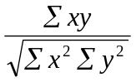When deviation taken from actual mean:
r(x,y)=
- 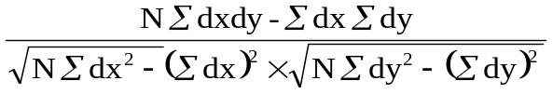When deviation taken from an assumed mean:
r=

Properties of Correlation coefficient
- The correlation coefficient lies between -1 & +1 symbolically ( - 1≤ r ≥ 1 )
- 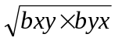The coefficient of correlation is the geometric mean of two regression coefficient.
r =
The one regression coefficient is (+ve) other regression coefficient is also (+ve) correlation coefficient is (+ve)
Assumptions of Pearson’s Correlation Coefficient
- There is linear relationship between two variables, i.e. when the two variables are plotted on a scatter diagram a straight line will be formed by the points.
- Cause and effect relation exists between different forces operating on the item of the two variable series.
Advantages of Pearson’s Coefficient
- It summarizes in one value, the degree of correlation & direction of correlation also
Limitation of Pearson’s Coefficient
- Always assume linear relationship
- Interpreting the value of r is difficult
- Value of Correlation Coefficient is affected by the extreme values
Coefficient of Determination
- The convenient way of interpreting the value of correlation coefficient is Coefficient of Determination.
- The Coefficient of Determination = r².
- Suppose: r = 0.9, r² = 0.81
- The maximum value of r² is 1 because it is possible to explain all of the variation in y but it is not possible to explain more than all of it
- Coefficient of Determination = Explained variation / Total variation
Regression Analysis
- Regression Analysis is mathematical measure of average relationship between two or more variables.
- Regression analysis is a statistical tool used in prediction of value of unknown variable from known variable.
- Simple Regression - uses just 2 variables (X and Y)
- Multiple Regression (one Y and many X’s)
- Linear Regression - fits data to a straight line
- Curvilinear Regression (curved line)
Regression Equation / Line & Method of Least Squares
- Regression Equation of y on x
Y = a + bx
In order to obtain the values of ‘a’ & ‘b’
- Regression Equation of x on y
X = c + dy
In order to obtain the values of ‘c’ & ‘d’
Properties of the Regression Coefficients
- If b_{yx} is positive than b_{xy} should also be positive & vice versa.
- If one regression coefficient is greater than one, the other must be less than one.
- The coefficient of correlation will have the same sign as that our regression coefficient.
- Regression coefficient are independent of origin but not of scale.
Non-Parametric statistical methods
- Kruskal-Walis test
- Chi square test
- The Mann - Whitney U test

The Kruskal–Wallis one-way analysis of variance by ranks (named after William Kruskal and W. Allen Wallis)
- A Non-parametric “analogue” of ANOVA in testing for variation.
- Used to compare the medians of 3 or more independent groups.
- Like most non-parametric tests, it is performed on the ranks of the measurement observations.
- The null hypothesis of the Kruskal-Wallis test states that the samples are from identical populations.
- When rejecting the null hypothesis of the Kruskal-Wallis test, then at least one of sample dominates at least one other sample.
Test statistics
$$K=\frac{12}{N(N+1)}\sum_{j=1}^{k}{\frac{R_{j^{2}}}{n_{j}}-3(N+1)}$$

Where
- $n_{j}$ is the number of observations in group
- Rj is the rank (among all observations) of observation from group
- N is the total number of observations across all groups

Chi square test
Milestone in Statistics
"Karl Pearson's famous chi-square paper appeared in the spring of 1900, an auspicious beginning to a wonderful century for the field of statistics."
(published in the Philosophical magazine )
Chi square test
- The chi-square test is an important test amongst the several tests of significance developed by statisticians.
- Is was developed by Karl Pearson in1900.
- This statistical test follows a specific distribution known as chi square distribution.
- In general we use to measure the differences between what is observed and what is expected according to an assumed hypothesis is called the chi-square test.
Applications of a Chi Square test.
- Goodness of fit of distributions
- Test of independence of attributes
- Test of homogeneity
Test statistics
$$X^{2}=\sum{\frac{{(O-E)}^{2}}{E}}$$
Where,
O = observed frequency
E = expected frequency
If two distributions (observed and theoretical) are exactly alike, $X^{2}$ = 0; (but generally due to sampling errors, $X^{2}$ is not equal to zero)

The Mann - Whitney U test
The Mann-Whitney U test may be used to test whether two independent groups have been drawn from the same population. It is a most useful alternative to the parametric ‘t’ test when the researcher wishes to avoid the ‘t’ test assumptions.
Limitations of Statistics
- More of Quantitative and less of Qualitative phenomena.
- Does not study individuals
- Does not reveal the entire information
- It is liable to be misused
- Conclusions are valid only on average base

RESARCH STUDIES
1. Review of Adoption Research studies Published in Maharashtra Journal of Extension Education since 1982 to 1997
- Ranjay et al. (1992)
They have reviewed 213 adoption research studies published in Maharashtra Journal of Extension Education and they reported that the most commonly used analysis techniques from the method of estimation of group were percentage (43.5%), coefficient of correlation (15%), multiple regression (12%), mean and SD (55%). Among the method of testing group ‘t’ test was applied in 3.76 per cent studies. ‘F’ test and ‘Z’ test were used in 3.5 per cent studies, respectively. In non-parametric statistical group, chi-square was used in about 15.00 per cent of the research studies. It can be concluded that in most of the studies, method of estimation statistical tools of data analysis were used followed by non-parametric techniques.
2. Review of Agricultural communication Research studies Published in Maharashtra Journal of Extension Education
- Tripathi et al., (2000)
They reviewed 89 communication research studies and found that Majority (76.47%) of the researchers analysed the data on the basis of percentage, coefficient correlation, mean, SD and multiple regression. Among the method of testing group, chi-square test was applied in 12.03 per cent research studies, “t” test and “z” test were used in 8.99 and 2.25 per cent studies respectively. It is concluded that most of the studies method of estimated statistical tools of data analysis were used, followed by non-parametric techniques.

3. Content Analysis of Post Graduate Research in Extension at UAS, Bangalore
- B.S. Lakshman Reddy (2002)
For his masters research he has done content analysis of Post Graduate Research (M.Sc) studies conducted in Extension till 2000. Totally he has reviewed 266 extension research studies conducted in UAS, GKVK, Bangalore. The Results found were All the Reaserchers (100%) have used Percentage, Frequency, 90 per cent of them have used Mean parametric tools. Among Non-Parametric tools most used test is chi-square.
Table 5: Statistical tools used in extension research studies
(N = 266)
Parametric Tools | No | % | Parametric Tools | No | %
- 1. Percentage | 266 | 100.00 | 13. Yates correction | 7 | 2.63
2. Frequency | 266 | 100.00 | 14. Normality test | 5 | 1.88
3. Mean | 241 | 90.60 | 15. Path Analysis | 4 | 1.50
4. SD | 183 | 68.79 | 16. Binomial Analysis | 4 | 1.50
5. Correlation co-efficient | 103 | 38.72 | 17. Median | 3 | 1.13
6. t-test | 83 | 31.20 | 18. Mode | 3 | 1.13
7. Multiple Regression | 55 | 20.68 | 19. Critical Difference | 2 | 0.75
8. ANOVA | 43 | 16.16 | 20. Bartletts Test | 1 | 0.37
9. F-test | 16 | 6.02 | 21. Cluster Analysis | 1 | 0.37
10. Rank Order | 15 | 5.64 | 22. Paired comparison | 1 | 0.37
11. Spearman Rank correlation | 9 | 3.38 | 23. F-Matrix | 1 | 0.37
12. PPMC | 9 | 3.38 | 24. Z-Matrix | 1 | 0.37
Non-Parametric Tools | No | % | Non-Parametric Tools | No | %
- Chi-square | 13 | 52.25 | 8. Sign test | 2 | 0.75
2. Kruskal wallis one way analysis | 5 | 1.88 | 9. Omega test | 1 | 0.37
3. Kendall co-efficient of concordance | 5 | 1.88 | 10. Contingency co-efficient | 1 | 0.37
4. Kolmogrov Smirnov test | 4 | 1.50 | 11. Relevancy Co-efficient | 1 | 0.37
5. Wilcoxon test | 3 | 1.13 | 12. Cochran Q test | 1 | 0.37
6. Mann Whitney U test | 2 | 0.75 | 13. Linert Contrast analysis | 1 | 0.37
7. Principal component Analysis | 2 | 0.75 | 13. Linert Contrast analysis | 1 | 0.37

CONCLUSION
Social science researchers use statistical tool (parametric and non-parametric) as an aid in testing hypotheses about the nature of social reality. However, researchers seek to collect systematic evidence in support of their ideas. Depending on the particular level of measurement, series of numbers are often employed by social science researchers to categorize (nominal level), rank (ordinal level), or score (interval/ratio level) their data. Finally, social science researchers are able to take advantage of two major functions of statistics in data-analysis stage of research, that is description ( reducing quantitative data to a smaller number of more convenient descriptive terms) and decision making ( drawing inferences from samples to populations).

REFERENCES
GUPTA, S. C. AND KAPOOR, V. K., 2003, Fundamentals of Applied Statistics, Sultan Chand & Sons, New Delhi.

LAKSHMAN REDDY, B. S., 2002, Content analysis of Post Graduate Research in Extension at UAS, Bangalore. M.Sc. (Agri.) Thesis (Unpub.), Univ. Agric. Sci., Bangalore.

SARAVANAN, B., 1999, A study on privatization of agricultural extension service. M.Sc. (Agri.) Thesis (Unpub.), Univ. Agric. Sci., Bangalore.

TRIPATHI, S, SINGH, R. K AND SHARMA, T. N., 2000, Review of agricultural communication research studies published in Maharashtra Journal of Extension Education. Maharashtra J. Extn. Educ., 19: 272-276.


UNIVERSITY OF AGRICULTURAL SCIENCES,
DEPARTMENT OF AGRICULTURAL EXTENSION
GKVK, BANGALORE-560065
Name : Kowsalya, K. S. Date: 19/12/2015 I.D No: PALB 4019 Time: 9.00 AM
Class: II Ph.D Venue: Dwarakinath Hall
Seminar – I
Synopsis

Application of Descriptive and Inferential Statistics in Social Science Research

The goal of social science research is to make conclusions that go beyond our intuitive understanding. With large number of studies, it is possible to make generalizations about the causal effects of different phenomena. As a tool of the positivist tradition, the statistical method is a way of identifying patterns and regularities in the observable world. Statistics involve the systematic collection of data with the aim of achieving knowledge by induction, that is, making inferences from observed regularities to general theories. Using the statistical methods, social scientists are able to make generalizations about the empirical world, whether operating with samples of a population, or the population as a whole. Keeping these aspects in view, the present seminar is conceptualized with following objectives:
- To know the Measures under Descriptive Statistics and its applications.
- To know the Techniques under Inferential Statistics and its applications.
- To review the related Research Studies.
Statistics
Statistics is a branch of science which deals with collection, classification, tabulation, analysis and interpretation of data.
Importance
Statistics plays an important role in our daily walks of life. It is useful in almost all sciences such as social, physical, biology, psychology, education, economics, business management, administration, animal science, lab science and agricultural sciences etc. In agricultural research, Statistical tools have played an effective and significant role in the analysis and interpretation of data more effectively.

Descriptive Statistics
It means summarization of a collection of data in a clear and understandable way and it is the most basic functions of statistics and it lays the foundation for all statistical techniques.
Measures under descriptive statistics
Measures of Central Tendency, Measures of Dispersion, Measures of Relative Dispersion, Coefficient of Variation, Skewness and Kurtosis (Guptha and Kapoor, 2003)

Inferential Statistics
One of the main objectives of statistics is to draw inference about a population from the analysis of a sample from that population. Two important problems in statistical inference are estimation of population and testing of hypothesis.

Estimation of Population Parameter
The best estimate would be one that falls nearest to the true value of the parameter to be estimated. The statistic whose distribution concentrates as closely as possible near the true value of the parameter regarded as the best estimate.

Testing of Hypothesis
Assumption made about any unknown characteristics is called as hypothesis. It may or may not be true.

Parametric statistical methods
- Students ’t’ test 2. Z-test 3. Correlation coefficient 4. Regression Analysis

Non-Parametric statistical methods
1. Chi-square test 2. Kruskal-Walis test 3. The Mann-Whitney U test

Research studies
Tripathi et al. (2000) reported that majority (76.47%) of the researchers analyzed the data on the basis of Percentage, Coefficient Correlation, Mean, Standard Deviation and Multiple regression. Among the methods of testing group, chi-square test was applied in 12.03 per cent research studies, t-test and z-test were used in 8.99 and 2.25 per cent studies, respectively.
Lakshman Reddy (2002) found that among parametric statistical tools, all the researchers analyzed the data using frequency and percentage, while 90.60 per cent and 68.79 per cent used mean and standard deviation respectively. Among non-parametric statistical tools, more than fifty per cent of the researchers (52.25%) analyzed data using chi-square test.

Conclusion
Social science researchers use statistical tool as an aid in testing hypotheses about the nature of social reality. However, researchers seek to collect systematic evidence in support of their ideas. Depending on the particular level of measurement, series of numbers are often employed by social science researchers to categorize (nominal level), rank (ordinal level), or score (interval/ratio level) their data. Finally, social science researchers are able to take advantage of two major functions of statistics in data-analysis stage of research, that is description (reducing quantitative data to a smaller number of more convenient descriptive terms) and decision making (drawing inferences from samples to populations).

References

GUPTA, S. C. AND KAPOOR, V. K., 2003, Fundamentals of Applied Statistics, Sultan Chand & Sons, New Delhi.

LAKSHMAN REDDY. B. S., 2002, Content Analysis of Post Graduate Research in Extension at UAS, Bangalore. M.Sc.(Agri.) Thesis (Unpub.), Univ. Agric. Sci., Bangalore.

TRIPATHI. S, SINGH. R. K. AND SHARMA. T. N., 2000, Review of Agricultural Communication Research Studies Published in Maharashtra Journal of Extension Education. Maharashtra J. Extn.Educ., 19: 272-276.

