Entrepreneurship as an Economic Force in Rural Development
Introduction
Now a day’s entrepreneurship is getting a great deal of attention, as it contributes positively to nation building in number of ways by generating employment and wealth. Entrepreneurship plays an important role in increasing national productivity, distribution of economic power, balancing regional development, providing avenues for creativity and idea generation. Entrepreneurship is considered as an important part of the national economy for creating and increasing employment opportunities and fuelling economic growth. For many years, policymakers have identified entrepreneurs as important drivers for employment, innovation and economic growth. Therefore there is great need of entrepreneurship development particularly among having limited employment opportunity. In this context, the present seminar has been conceptualized with the following objectives.
- To know the concept of entrepreneurship and problems faced by rural entrepreneurs.
- To analyze the promotion of entrepreneurship for rural development.
- To visualize a training approach for economic development of rural entrepreneurs.
- To review the case studies and research studies related to entrepreneurs.
Growth rate of population (%)
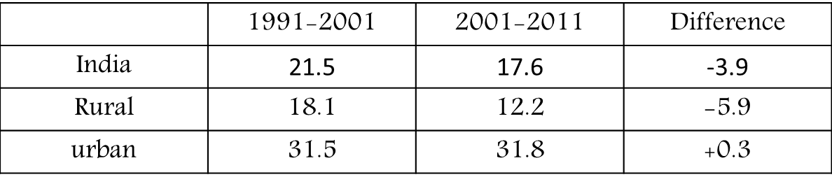

Literacy rate (%)
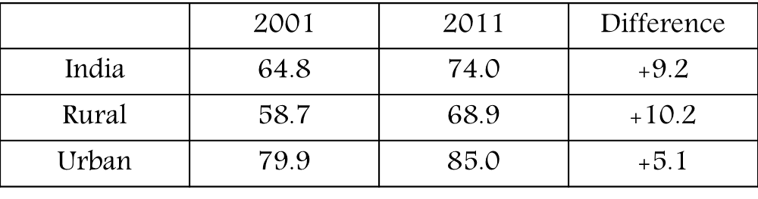
Unemployment
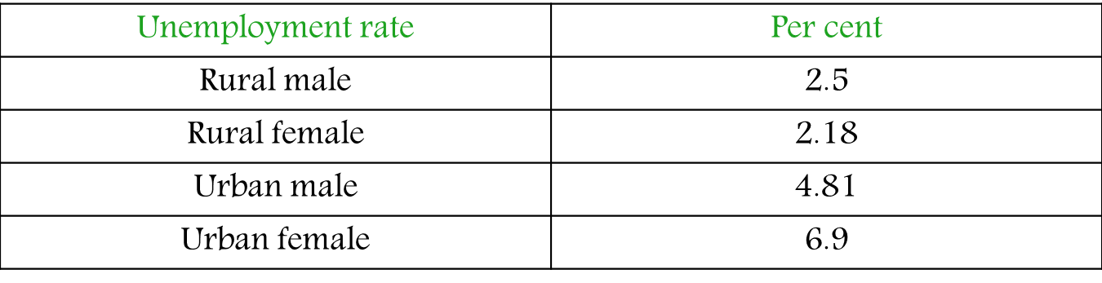

Entrepreneurship
The term entrepreneurship is derived from the 17th century French verb ‘Entrependre’, referring to individuals who are ‘undertakers’, i.e., those who undertake the risk of new enterprise.
Entrepreneurship is a process through which entrepreneurs create and grow enterprises to provide new services or products, or add value to services or products.
According to Schumpeter “the entrepreneurship is essentially a creative activity or it is an innovative function”.
The entrepreneurship is a risk taking factor, which is responsible for the end result in the form of profit or loss
Entrepreneurship is the study of taking calculative risks in both creating new enterprise and managing as enterprise when already created requiring effective operation.
Entrepreneurship is the practice of starting new organizations or revitalizing mature organizations, particularly new business generally in response to identified opportunities.
"A force that mobilizes other resources to meet unmet market demand", "the ability to create and build something from practically nothing", "the process of creating value by pulling together a unique package of resources to exploit an opportunity”.

"Entrepreneurship can be described as a creative and innovative response to an environment. Such responses can take place in any field of social Endeavour – business, agriculture, education, social work and the like. Doing new things or doing things that are already being done in a new way is, therefore, a simple definition of entrepreneurship.
In conceptualizing entrepreneurship we could differentiate between concepts.
- Entrepreneur= individual actor in the market.
- Entrepreneurial= behavior in the market , and
- Entrepreneurship = combines the actor and the behavior in the market
Entrepreneur
One who undertake an enterprise, one who owns and manages a business, person who takes the risk of profit or loss
- Oxford English Dictionary
An Entrepreneur is a person who organizes, operates and assumes the risk for a business venture.

Successful entrepreneur possesses the following important characteristics:

- Initiative: An entrepreneur takes actions that go beyond job requirements or the demand of the situation.
- Opportunity seeking: An entrepreneur is quick to see and seize opportunities. He/she does things before he/she is asked to work by people or forced by situation.
- Persistence: An entrepreneur is not discouraged by difficulties and problems that come up in the business or his/her personal life. Once she sets a goal she is committed to the goal and will become completely absorbed in it.
- Information seeking: An entrepreneur undertakes personal research on how to satisfy customers and solve problems. He/she knows that different people have different capabilities that can be of help to them. He/she seeks relevant information from his/her clients, suppliers, competitors and others. He/she always wants to learn things which will help the business to grow.
- Demand for quality and efficiency: An entrepreneur is always competing with others to do things better, faster, and at less cost he/she strives to achieve excellence.
- Risk taking: Are you afraid of uncertainties? Then you cannot be an entrepreneur. Entrepreneurs are not high risk takers. They are also not gamblers; they calculate their risks before taking action. They place themselves in situations involving moderate risk so they are moderate risk takers.
- Goal setting: An entrepreneur sets meaningful and challenging goals for him/herself. An entrepreneur does not just dream. Him/she thinks and plans what he/she does. He/she is certain or has hope about the future.
- Commitment to work: An entrepreneur will work long hours after into the night just to be able to keep his/her promise to his/her client. He/she does the work together with his/her workers to get a job done. He/she knows how to make people happy to work for him/her due his/her dynamic leadership.
- Systematic planning and monitoring: An entrepreneur plans for whatever he/she expects in the business. He/she does not leave things to luck. He/she plans by breaking large tasks down into small once and puts time limits against them. Since and entrepreneur knows what to expect at anytime he/she is able to change plans and strategies to achieve what he/she aims at.
- Persuasion and networking: An entrepreneur acts to develop and maintain business contacts by establishing good working relationship. Uses deliberate strategies to influence others.
- Independence and self confidence: Most entrepreneurs start business because they like to be their own boss. They are responsible for their own decisions.

Rural Entrepreneurship
Entrepreneurship which ensures value addition to rural resources in rural areas engaging largely rural human resources.
Types of Rural Entrepreneurship
- Individual Entrepreneurship: It is the entrepreneur who is the only (100%) owner. The entrepreneur bears full responsibility for each and every activity and is alone strategic thinker and decision maker to make the unit viable as well as profitable. There is hardly any difference between personal assets and business assets. The entrepreneur “unlimited liability under the law”. This type of entrepreneurship is quite prevalent in rural areas where an entrepreneur has limited resources.

- Group Entrepreneurship: It is classified into mainly 3 types such as

- Partnership: In this case there is no individual ownership of the unit. There is another partner with you who works with you and also bears the responsibility and shares profit. Like proprietorship, the liability is “Joint and Several”. The characteristics of partnership are, i) association of two or more persons, ii)contractualrelation, iii) lawful business, iv) sharing of profit, v) agency relationship.
- Private Limited Company: In this case shareholders are the owners. There must be a minimum of 2 shareholders. The Indian law allows maximum of 50 shareholders. The liability is limited in this case. Being a private limited company, one can raise far less money than a public limited company.
- Public Limited Company: In this case also shareholders are the owners. There must be minimum 7 shareholders. There might be millions of shareholders as there is no such upper limit. Being a public limited company it can raise more money from the public by issuing equity shares, debentures, etc. to meet various expenses of the company.

- Cluster Formation: It is primarily a formal and non-formal group of people to achieve a common objective. It basically covers Non-Governmental Organization, Voluntary Organization, Self-Help Groups and Community Based Orgnizations.
Need for Rural Entrepreneurship
- Employment generation
- Income generation
- Rural development
- Build up village republics
- Curbs rural-urban migration
Theories of Entrepreneurship
Researchers use the theories to explain phenomena. These theories consist of concepts and constructs related to entrepreneurship development.
- Psychological theories such as those developed by McLelland pay attention to personal traits, motives and incentives of an individual and conclude that entrepreneurs have a strong need for achievement.
Entrepreneurship gets a boost when society has sufficient supply of individuals with necessary psychological characteristics. The psychological characteristics include need for high achievement, a vision or foresight, ability to face opposition
- Motivation theory by McClelland (Acquired Needs theory) According to McClelland, a person has three types of needs at anygiven time, which are:–Need for achievement (get success with one’s own efforts)–Need for power (to dominate, influence others)–Need for affiliation (maintain friendly relations with others). The need for achievement is the highest for entrepreneurs.
- Sociological theories that start from ethnic identification try to explain entrepreneurship as a process where the individual’s sociological (disadvantageous) background is one of the decisive “push” factors to become an entrepreneur.
- Economic Theory profound that, Entrepreneurship and economic growth take place when the economic conditions are favorable. Economic incentives are the main motivators for entrepreneurial activities. Economic incentives include taxation policy, industrial policy, sources of finance and raw material, infrastructure availability, investment and marketing opportunities, access to information about market conditions, technology etc

Agripreneurship
An agripreneurship is any business in the agricultural industry which includes production agriculture, food, fiber, the environment and natural resources. Agri entrepreneurs avoid low- risk situations because there is a lack of challenge. They avoid high risk situations because they want to succeed. They like achievable challenges. A risk situation occurs when Agri-entrepreneur is required to make a choice between two or more alternatives whose potential outcomes are not known and must be evaluated in advance, with limited information. A risk situation involves potential gain and potential loss.

Agripreneurship: It is defined as generally sustainable, community oriented, directly marketed agriculture. Sustainable agriculture denotes a holistic, systems oriented approach to farming that focuses on the interrelationships of social, economic and environmental process.

Need for Agripreneurship:
• Increasing demand of organic and quality food both in India and abroad
• Competitive advantages for many primary production activities in agriculture. Ex:
Rainfed farming, livestock and wild craft production is through low cost production technologies only.
• Private sector is willing to enter in to agribusiness at all levels of operation.
• To reduce mall nutrition as majority of women and children in the country are mall- nourished.

Scope for entrepreneurship development in Agriculture:
There is a vast scope for entrepreneurial activities in the agricultural sector. By establishing a link between agriculture and allied industries, the rural entrepreneur can exploit opportunities in areas of farming, agricultural processing and marketing. The government has given priority to agriculture related program and ensured adequate flow of credit to small and marginal farmers
• Technologies those reduce the cost of production and increase the benefit of the
farmers will open new opportunities for Agri-entrepreneurship.

• New technologies that are simple and time saving and keep away farmers from
drudgery of labour will also provide opportunity for entrepreneurship in agriculture.

• Technologies that provide social and psychological benefits to farmers will also
provide opportunity for entrepreneurship in agriculture.

Areas of Entrepreneurship in Agriculture
(1) Agro produce processing units: These units do not manufacture any new product. They merely process the agriculture produce. e.g., Rice mills, Dal mills, Decorticating mills etc.
(2) Agro produce manufacturing units: These units produce entirely new products based on the agricultural produce as the main raw material. e.g., Sugar factories, Bakery, Strawboard units etc.
(3) Agro-inputs manufacturing units: These units produce goods either for mechanization of agriculture or for increasing productivity. E.g., Fertilizer manufacturing plants, insecticides production units, food processing units, agricultural implements etc.
(4) Agro-service centers: These include the workshops and service centers for repairing and serving the agricultural implements used in agriculture.

Domines
- Food processing
- Dehydrated Fruits and Vegetables
- Fruit Based Beverages
- Mushrooms
- Poultry Industry
- Cottage industries
- Oil Industry
- Pottery
- Repair of Phone/Mobile Phone, Electronic and Electrical goods
- Rural Tourism
- Entertainment
Problems faced by rural entrepreneurship
Lack of infrastructural facilities:
Rural areas are characterized by poor infrastructural farcicalities in the field of roads, electricity, street lighting, road transport etc. which hampers the smooth movement of various industrial activities. This is a major problem faced by rural entrepreneurs.
Financial constraints:
Most of the rural entrepreneurs face financial crunch in setting up rural industries because of the non-supportive attitude of financial institutions and banks which work more on papers. The procedures and conditions to avail a loan is so time consuming that its delay often disappoints the entrepreneur. Due to this, the entrepreneurs are forced to take credit from village money lenders who charges exorbitant rate of interest.
Lack of technical know-how:
As rural industries are labour intensive, they cannot afford to introduce sophisticated techniques and methods of production which is very expensive. Lack of technical know-how, appropriate technology and training create immense problem in the growth of rural industries. Without this, productivity and increased profit is a distant dream.
Marketing problems:
Marketing of rural products has not been well developed. Promotion, distribution and implementation of customer feed-back is lacking. Rural industries cannot compete with their urban counterparts. Dealers exploit the rural industries in the traditional sector. Lack of proper communication facilities and marketing information adds to the problem to large extent.
Lack of adequate knowledge and information:
Though information technology has substantially developed in the modern world and has penetrated into the rural areas through internet, rural people hardly availed its benefits. Because, rural people do not have adequate information avenues. They are not knowledgeable, trained and motivated to achieve more and more in their own sphere.
Raw materials:
Rural industries face a tough task in procuring and storing raw materials. Since rural industries are small they procure raw materials from middlemen at higher prices. Lack of warehousing facilities in the rural sector also costs more towards storing of raw materials.
Legal problems:
Rural industries need compliance of various legal formalities in obtaining the government's approval and license for carrying out industrial activities. But rural entrepreneurs find it extremely difficult to comply with various legal formalities due to sometimes complex legal provisions or illiteracy and ignorance.
Besides the above problems, lack of awareness and knowledge about the importance of rural industries stand as a major problem before rural entrepreneurs. Added to this another problem crops up relates to the disinterest shown by rural people to assume rural entrepreneurship as career. The ninth plan has also sorted out the problems of rural industries as follows:
- Inadequate flow of credit
- Use of obsolete technology, machinery and equipment
- Poor quality standards
- Inadequate infrastructural facilities.
Solutions:
Creation of finance cells
The financial institutions and banks which provide finances to entrepreneurs must create special cells for providing easy finance to rural entrepreneurs.
Concessional rates if interest
The rural entrepreneurs should be provided finance at concessional rates of interest and on easy repayment basils. The cumbersome formalities should be avoided in sanctioning the loans to rural entrepreneurs.
Proper supply of raw materials
Rural entrepreneurs should be ensured of proper supply of scarce raw materials on priority basis. A subsidy may also be offered to make the products manufactured by rural entrepreneurs cost competitive and reasonable.
Offering training facilities
Training is essential for the development of entrepreneurships. It enables the rural entrepreneurs to undertake the venture successfully as it imparts required skills to run the enterprise.
Presently the economically weaker entrepreneurs of the society are offered such training facility under Prime Minister’s RozgarYojna. (PMRY) Programmed FICCI, (NGOs) Lions Clubs, Rotary Clubs and voluntary organizations can also arrange such training programmers for rural entrepreneurs to provide them stimulation counseling and assistance .For rural entrepreneurs, individual based EDI’ approach is highly relevant where the motivation and familiarization processes coupled with promise of bank credit and support by way of escort services could persuade rural youth with certain basic skills of- hands on technology to start small enterprises.

Setting up marketing co-operatives
Proper encouragement and assistance should be provided to rural entrepreneurs for setting up marketing co-operatives. These co-operatives shall help in getting the inputs at reasonable rate and they are helpful in selling their products at remuneration prices.
Hence, middlemen can be avoided and rural entrepreneurs derive the benefits of enterprise. Common production-cum-marketing centers should be set up with modern infrastructural facilities.
Thus, proper education, comprehensive training, setting up of separate financial institutions, development of marketing co-operatives to a large extent help to flourish the rural entrepreneurs in India. Further, both government and non-government agencies should play an important role.
Constraints of Potential Rural Entrepreneurs
- Low self image
- No faith on others includes friends
- No exposure to industry/business
- What formalities and procedures are to be followed?
- How to know whether the identified business is a viable and sound proposition?
- How does one carry out bank operations?
- How to manage the business?
- Almost no technical skills

Promotion of Entrepreneurship
Two approaches: 1. Promotional programme
2. Institutional approach
Promotional programmes
- Entrepreneurship Development Programme (EDP)
- Rural Entrepreneurship Development Programme (REDP)
- Technology Based Entrepreneurship Development Programme (TEDP)
- Prime Minister Employment Generation Programme (PMEGP)
- SwarnJayanti Gram SwarozgarYojana (SGSY)
Entrepreneurship Development Programme (EDP)
- Development of entrepreneurs through systematic training.
- Important strategy for development of human resources for promoting small business enterprises in rural areas.
Rural Entrepreneurship Development Programme (REDP)
- Supported by NABARD
- Objective: to create sustainable employment and income opportunities in a cost effective manner.
- To set up small/ micro-enterprises.
- It comprises 3 phases: Pre-training
Training
Post-training
Technology Based Entrepreneurship Development Programme (TEDP)
- Focus of training is on specific products/ technologies, having commercial viability.
- Motivational & managerial inputs.
Objectives:
- The entrepreneurs are exposed to technical knowledge
- The R & D lab having commercially viable technologies

Prime Minister Employment Generation Programme (PMEGP)
- To generate employment opportunities in rural areas of the country through setting up of new self employment ventures
- To provide continuous and sustainable employment to a large segment of traditional and prospective artisans and rural and urban unemployed youth in the country
SwarnJayanti Gram SwarozgarYojana (SGSY)
- To bring the assisted families above poverty line in rural area
- To establish a large number of micro-enterprises in the rural area and building upon the potential of the rural people
- It is a holistic programme
- Credit cum subsidy programme
Institutional approach
- Educational institutions
- Financial institutions
Educational institutions
- RUDSETI
- Entrepreneurship Development Institute of India (EDI)
- National Institute for Entrepreneurship and Small Business Development (NIESBUD)
- Indian Institute of Entrepreneurship (IIE)
- Association of Women Entrepreneurs of Karnataka (AWAKE)
Rural Development and Self Employment Institute
Objectives
- To identify, orient, motivate, train and assist the rural youth to take up self-employment as an alternative career.
- To promote rural entrepreneurship.
- To train village level workers.
- Counseling and project consultancy.
- 68% of the trained candidates have successfully established self-employment ventures.
- RUDSET Institutes have contributed to the national wealth to the tune of Rs. 315Crores per annum
Entrepreneurship Development Institute of India (EDI)
It is a Centre for Micro Enterprises, Micro Finance and Sustainable Livelihood
Mission
- Enterprises building of NGOs in micro enterprise development
- Training of rural poor as entrepreneurs
- Strengthening of rural industries
National Institute for Entrepreneurship and Small Business Development (NIESBUD)
- To evolve standardized materials and process for selection and conducting of entrepreneurship development training
- Serve as an apex national level resource institute for accelerating the process of entrepreneurship development
- Conducting training for trainers and providing consultancy services
- Coordinating the activities of various institutions engaged in entrepreneurship development
Indian Institute of Entrepreneurship (IIE)
- Established in the year 1993 in Guwahati.
OBJECTIVES
- To organize and conduct training for entrepreneurship development.
- To evolve strategies & methodologies for different target groups & locations & conduct field tests.
- To document and disseminate information need for policy formulations.

Association of Women Entrepreneurs of Karnataka (AWAKE)
- 1984. AWAKE started with Business Counselling
Purpose:
provides support and guidance to aspiring women from rural, urban, national and international arenas to be successful entrepreneurs
Financial Institutions
Micro, Small and Medium Enterprises Development Institute (MSMEDI)
- Established in the year 1954 by GOI
- Small Industries Service Institute
- In Karnataka, it has 4 branch offices located at Bangalore, Mangalore, Hubli and Gulbarga.
Objectives
- To impart greater vitality and growth impetus.
- To popularize entrepreneurship among our youth.
- To impart confidence to individuals.
Activities
- Promote and encourage quality control and technology upgradation
- Promote and encourage expert promotion
- Providing intensive technical assistance
- Organizing skill development programmes
- Organizing entrepreneurship development programme
- Organizing industrial awareness cum motivational campaign
Classification
According to Micro, Small and Medium Enterprises Development Act 2006:
- Manufacture enterprise:This enterprise manufacture or produce goods pertaining to any industry. The manufacture enterprise defined investment in terms plants and machineries.
Ex: Fertilizer manufacturing plants, food processing units
- Service enterprise: Thisenterprise providing or rendering services. The service enterprise defined investment in terms equipments.

Manufacturing enterprise
Enterprises | Investment in plant and machinery
Micro Enterprises | < 25 lakh
Small Enterprises | 25 lakh to 5 crores
Medium Enterprises | > 5 crores but does not exceed  Rs. 10 crores

Service enterprise
Enterprises | Investment in Equipments
Micro Enterprises | < 10 lakh
Small Enterprises | 25 lakh to 2 crores
Medium Enterprises | > 2 crores but does not exceed  Rs. 5 crores

Direct and Indirect Financial Support
- Nationalized banks
- State finance corporation
- State industrial development corporation
- District industries centres
- Differential rate schemes
- Mahila Udyug Needhi Scheme
- Small Industries development Bank of India (SIDBI)
- State Small Industrial Development Corporations (SSIDCs)
- District Co-operative Central Bank (DCCB)
- Grameen Banks
Planning a Rural Enterprise
- Project identification
- Information accessibility
- Market assessment
- Feasibility report
Basic infrastructure for rural entrepreneurship
- Transport
- Railways
- Roads
- Power
- Communication & telecommunication services
- Additional infrastructure facilities that are also required are drinking water, housing, healthcare etc.

Training approach
Development of entrepreneurial culture:
Training inputs include themes to enhance participants' understanding of:
· what is entrepreneurship?
· who are entrepreneurs'? and
· mechanisms crucial for the development of positive attitudes towards entrepreneurship on national, regional and local levels.
Encouraging start-ups
Training inputs are geared at helping potential entrepreneurs to overcome the constraints that prevent them from taking action, such as the lack of self-confidence due to the lack of entrepreneurial critical mass in the rural environment and the inability to evaluate whether a business idea is also a business opportunity.. It also helps individuals who would like to be entrepreneurs but who lack the necessary skills to recognise this before they go into business. These include:
· Identification of constraints and the design of training inputs to overcome these constraints
· Process of identification of business ideas, where to look and how to develop business ideas
· Business ideas vs. business opportunities and
· Estimating entrepreneurial potential of would be entrepreneurs, self-determination, understanding of who are the customers, where are the markets and how to reach them.
Setting up the new venture
Potential entrepreneurs need a comprehensive plan to transform their business ideas into a working operation. A business plan is an instrument for screening the profitability of business alternatives, identifying constraints and opportunities and one's weaknesses and strengths. Therefore, a business plan lowers the risk of going into business. Since the development of a comprehensive business plan is a demanding task, it is advisable to first prepare the feasibility study, which is a less comprehensive version of a complete business plan.
Training inputs concentrate on the techniques for evaluating the feasibility of a business idea and the development of a comprehensive business plan and its evaluation:
· the feasibility study
· the business plan and
· guidelines for evaluating the persuasiveness of the business plan.
Development of a new venture and growth
The operating and managing of a business demand certain skills in finance, organization, production, marketing and distribution of products. The entrepreneurs should acquire these skills and should continuously up-date them in order to ensure/maintain their competitive position based on a well-defined long-term business strategy. Too often small firms suffer from managing their businesses on a day to day basis and not realising their potential for growth. Training inputs therefore concentrate on all aspects of managing the business and on the strategies for future growth:
· managerial skills
· recording, measuring and controlling business performance and
· strategies for future growth.

Institution building
For entrepreneurship to flourish, a supportive environment is needed. Therefore, those who are involved in fostering rural entrepreneurship should not only influence national/regional development policies, but also facilitate the development of national and regional supporting institutions. Training inputs focus on:
· the role of national and local governments and non-governmental institutions in promoting entrepreneurial restructuring of rural areas
· financial institutions: commercial banks, special funds (Consortia) and venture capital companies
· networking: understanding the concept, goal, purpose, benefits of networking and developing a strategy to set up the network
· economic development alliances between potential entrepreneurs, new firm formation, community/regional infrastructure and the existing private sector.

Benefits of Rural Entrepreneurship
Provide employment opportunities
Rural entrepreneurship is labor intensive and provides a clear solution to the growing problem of unemployment. Development of industrial units in rural areas through rural entrepreneurship has high potential for employment generation and income creation.
Check on migration of rural population
Rural entrepreneurship can fill the big gap and disparities in income rural and urban people. Rural entrepreneurship will bring in or develop infrastructural facilities like power, roads, bridges etc. It can help to check the migration of people from rural to urban areas in search of jobs.

Balanced regional growth
Rural entrepreneurship can dispel the concentration of industrial units in urban areas and promote regional development in a balanced way.
Promotion of artistic activities
The age-old rich heritage of rural India is preserved by protecting and promoting art and handicrafts through rural entrepreneurship.
Check on social evils
The growth of rural entrepreneurship can reduce the social evils like poverty, growth of slums, pollution in cities etc.
Awaken the rural youth
Rural entrepreneurship can awaken the rural youth and expose them to various avenues to adopt entrepreneurship and promote it as a career.
Improved standard of living
Rural entrepreneurship will also increase the literacy rate of rural population. Their education and self-employment will prosper the community, thus increasing their standard of living.

Case Studies
Srushti Media Services
Agricultural Extension through Audio-Visual films
- B. N. Ambarish
- Producer
- Srushti Media Services, Bangalore
- Education ; B. Sc. Agril. Marketing, UAS, Bangalore
- Under AC&ABC scheme established his own venture (2005)
List of video cd’s available in srusthi media service
Sl. No | Subject | Language | Price(RS)
1 | Profitable dairying | Kannada | 100
2 | Rabbit farming | Kannada | 100
3 | Murra buffalo rearing | Kannada | 100
4 | Azolla as animal feed | Kannada | 100
5 | Drip irrigation | Kannada, English | 100
6 | Floriculture prospects | Kannada | 100
7 | Organic village scheme | Kannada | 100
8 | Poultry contract farming | Kannada | 100
9 | Aerobic rice cultivation | Kannada | 100
10 | Bore well recharging | Kannada | 100

Supplied these Cd’s to…
- Farmers
- Training centres
- KVK’s
- Veterinary hospitals
- NGO’s, SHG’s
- Banks
- Agriculture departments
Mr. Mariraj – A successful IFS farmer
- Guttahalli village, BangarepateTaluk
- Land – 3.5 ha
- Crops; Tomato & Capsicum
- Yield; Tomato – 225 q/ac & Capsicum – 108 q/ac
- Income – Rs. 1,35,000 &Rs. 2,16,000 / ac in two crop
- Adopted Integrated Crop Mangement
- 5 guntas – grown fodder
- Also maintains cross-bead cow and sheep rearing
- From which he getting income Rs. 70,000 per year
- Annual income from both crop & animal husbandry was Rs. 4,21,000 per year
Mrs. Latha– A successful women entrepreneur
Place; Laggere, Penya industrial area, Bengaluru
Education; B.Sc
Field of enterprise; Processedragi& multigrain products
Name of unit; Shree Agro Foods
Brand name; NAVAVITA
Initial investment; 5.5 lakhs
Annual turn over; 25 lakhs (2014-15)

Training undergone:
Training | Type of training
Training | EDP | Bakery products
Duration of the training | 12 days  2009 | 3 months  2012
Name of the Institution | AWAKE | BTU, UAS, Hebbal

Impact of Training:
- Helped to improve the quality of life
- Improvement in communication skills
- Motivated to take up this enterprise

Research studies
- A study on group dynamics and entrepreneurialbehaviour of women in self help groups
- (Prasanna Kumar, 2009)
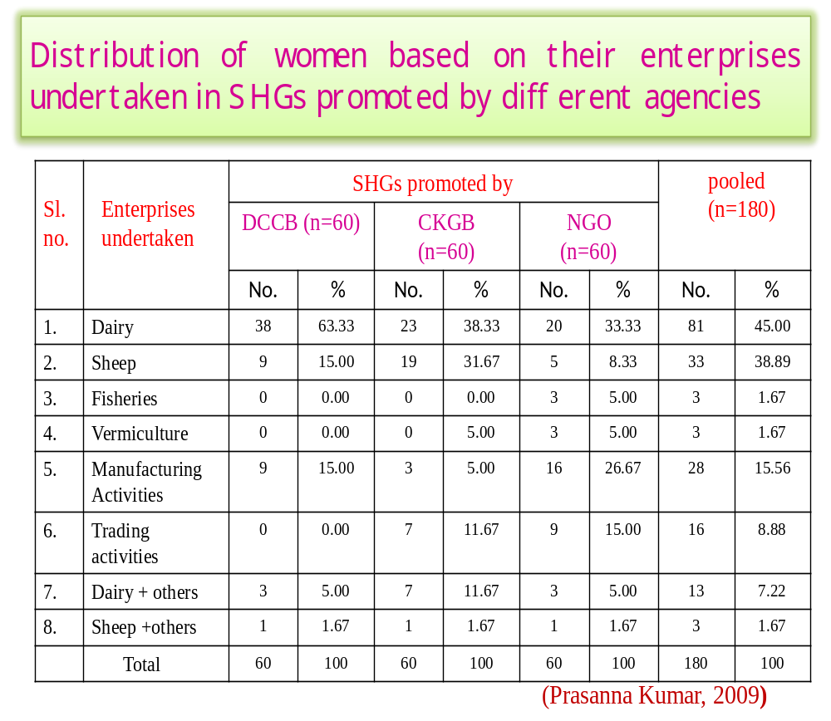This table shows that among all enterprises most of the women are engaged in dairy activities fallowed by sheep rearing and least in fishery, vermiculture.

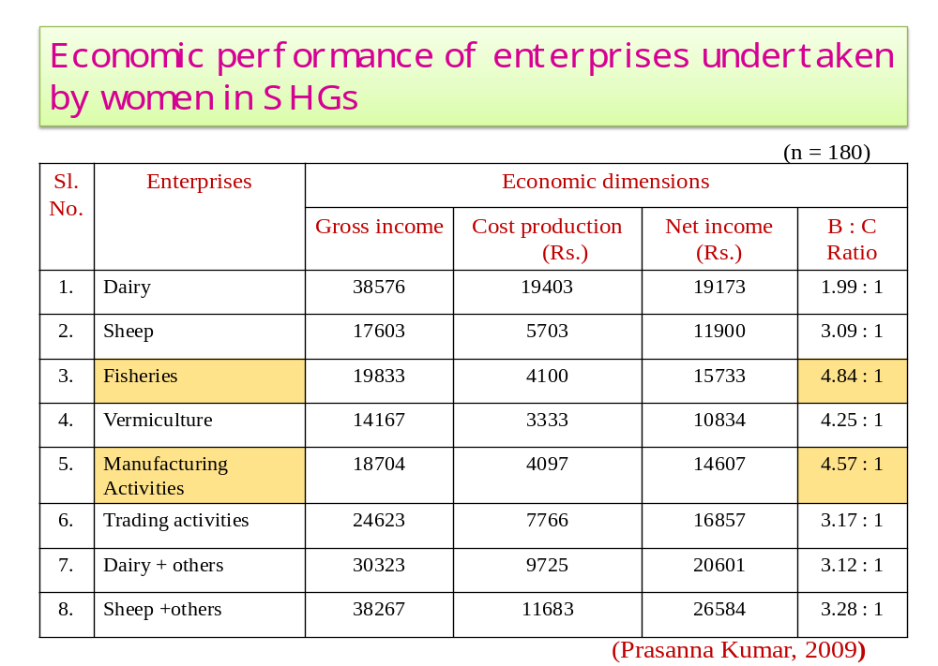
This table shows that among all enterprises the economic performance of fisheris B:C ratio contribute highest fallowed by manufacturing activities and dairy contribute less.

- A study on entrepreneurial behavior of rural women in Mandya district of karnataka
- (Sowmya, 2009)
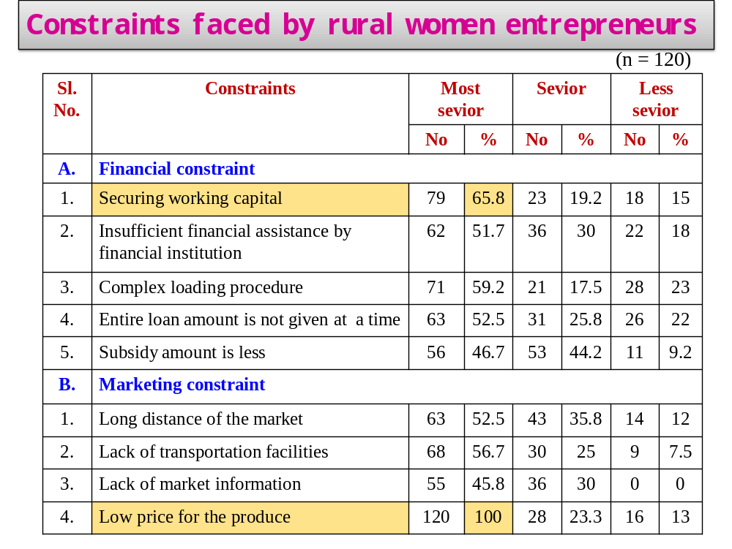

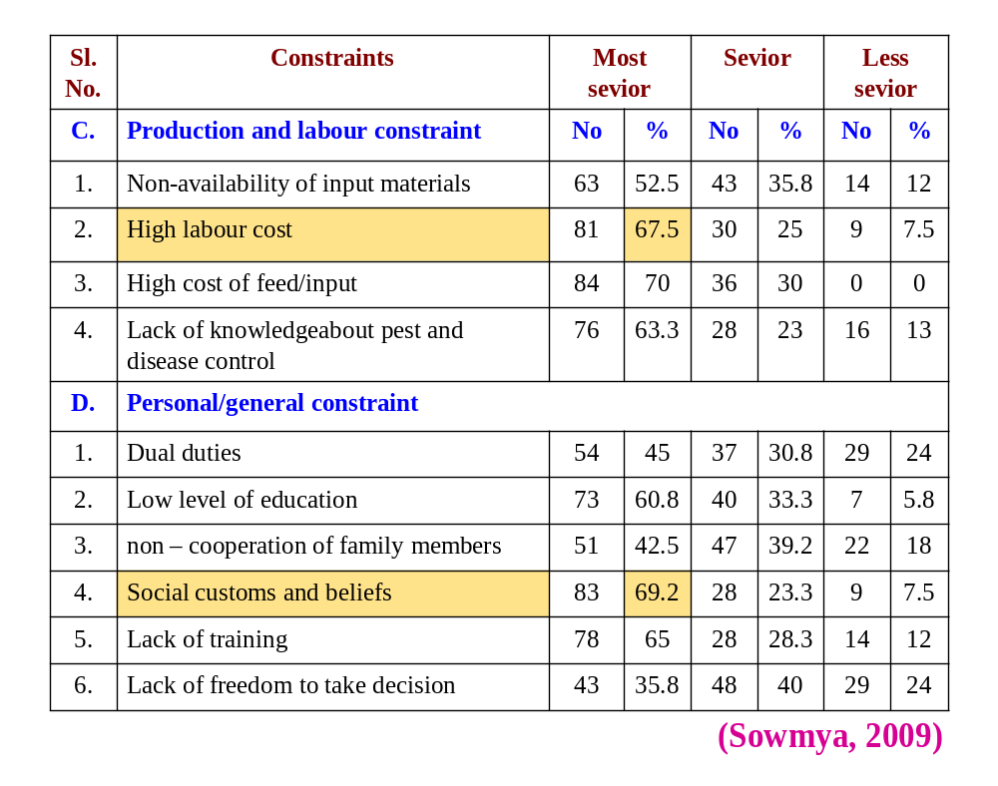This table shows that constraints faced by rural women entrepreneurs in their farming and allied enterprises from different areas among that low price for the produce (100%), followed by high cost of inputs/feeds (70.00%), social customs and beliefs (69.17%), securing working capita (65.83%) were the most serious constraints.

Conclusion
Although opportunities exist most people are not taking advantage of these opportunities. The educated people prefer government job in a public sector, but it is not possible to accommodate all of them in government service. The only solution to the problem lies in wide scale self-employment by educated young people. A person can raise his income by diversifying the farm and allied activities by lowering the risk and generating the self employment.

Reference
AMBARISH, B. N., 2008, Srushti Media Services – Agricultural Extension through audio-visual films. www.srushtimedia.com
ESWARAPPA, G., YELLAPPA, E. AND ASHOKA DODDAMANI., 2011, Integrated Farming System Demonstration Model for Attracting Rural Youth for Agriculture, National Seminar on Attracting Farm Youth to sustainable Agriculture, pp. 102-103, Bangalore, India.
PRASANNA KUMAR, R., 2009, A study on Group Dynamics and Entrepreneurial Behavior of Women in Self Help Groups, Ph.D. Thesis (Unpub.), Univ. Agric. Sci., Bangalore.
www.wikipedia.org.com

Discussion
- What is the difference between businessmen and entrepreneur?
Basis for comparison | Businessmen | Entrepreneur
Meaning | A businessman is someone who sets up a business with an existing idea offering products and services to the customers. | An entrepreneur is a person who starts an enterprise with a new idea or concept, undertaking commercial activities.
Market Position | Market Player | Market Leader
Market | Creates place in existing markets | Creates new market
Risk factor | Less | Comparatively high
Methods applied for doing things | Conventional | Unconventional
Orientation | Profit | People
Competition | Very high | Low

- What is market survey?
Entrepreneurs specialize at creating innovative ideas for new products and services, but ideas that sound good on paper are not always good in practice. Determining what consumers want and designing products and services that fulfill those wants is essential to the success of a business. Businesses use market surveys to gather information that aids in market research.


UNIVERSITY OF AGRICULTURAL SCIENCES,
DEPARTMENT OF AGRICULTURAL EXTENSION
GKVK, BANGALORE-560065
Name: Kowsalya, K. S. Date:26/03/2016 I.D No: PALB 4019 Time:9.00 AM
Class: II Ph.DVenue: Dwarakinath Hall
Seminar – II
Synopsis

Entrepreneurship as an Economic Force in Rural Development

Now a day’s entrepreneurship is getting a great deal of attention, as it contributes positively to nation building in number of ways by generating employment and wealth. Entrepreneurship plays an important role in increasing national productivity, distribution of economic power, balancing regional development, providing avenues for creativity and idea generation. Entrepreneurship is considered as an important part of the national economy for creating and increasing employment opportunities and fuelling economic growth. For many years, policymakers have identified entrepreneurs as important drivers for employment, innovation and economic growth. Therefore there is great need of entrepreneurship development particularly among having limited employment opportunity. In this context, the present seminar has been conceptualized with the following objectives.
- To know the concept of entrepreneurship and problems faced by rural entrepreneurs.
- To analyze the promotion of entrepreneurship for rural development.
- To visualize a training approach for economic development of rural entrepreneurs.
- To review the case studies and research studies related to entrepreneurs.
Entrepreneurship
Entrepreneurship is aprocess through which entrepreneurs create and grow enterprises to provide new services or products, or add value to services or products.
Problems faced by Rural Entrepreneurship
- Lack of infrastructural facilities
- Financial constraints
- Lack of technical know-how
- Marketing problems
- Lack of adequate knowledge and information
- Raw materials
- Legal problems

Promotion of Entrepreneurship
- Promotional programmes
- Institutional approach

Training approach
Entrepreneurship development process:
- Development of entrepreneurial culture
- Encouraging start-ups
- Setting up the new venture
- Development of a new venture and growth
- Institution building
Case studies
Ambarish (2008) reported that before undertaking entrepreneurship his earning was Rs. 10,000 per month. But, after taking up entrepreneurship his earnings increased to more than one lakh rupees per month. As entrepreneur he became employer, decision maker, self dependent, enjoying the work satisfaction and he has freedom to expand the area of work.
Eswarappaet al (2011) documented that, a farm youth Mr. Mariraj, having 3.5 acres of land and grows crops like tomato with an average yield of 225 q/ac, capsicum yielding 108 q/ac and earning Rs. 1,35,000 and Rs. 2,16,000 respectively in these two crops. He is maintaining cross-bred cow, five ewes and one ram from which he is earning an income of Rs. 78,064 per year. With the adoption of IFS he is getting a net income of Rs. 4,70,814 per year.
Research study
Prasanna Kumar (2009) reported that around one-third of the women in SHGs promoted by CKGB and NGO undertaken dairy followed by sheep rearing (32%) in case of SHGs promoted by CKGB and manufacturing activities (27%) in case of SHGs promoted by NGO. Further, study reported the economic performance of enterprises undertaken by women in SHGs. The highest B:C ratio was obtained in fisheries (4.84:1) followed by manufacturing activities (4.57:1) and vermiculture (4.25:1).

Conclusion
Although opportunities exist most people are not taking advantage of these opportunities. The educated people prefer government job in a public sector, but it is not possible to accommodate all of them in government service. The only solution to the problem lies in wide scale self-employment by educated young people. A person can raise his income by diversifying the farm and allied activities by lowering the risk and generating the self employment.

Reference
AMBARISH, B. N., 2008, Srushti Media Services – Agricultural Extension through audio-visual films. www.srushtimedia.com
ESWARAPPA, G., YELLAPPA, E. AND ASHOKA DODDAMANI., 2011, Integrated Farming System Demonstration Model for Attracting Rural Youth for Agriculture, National Seminar on Attracting Farm Youth to sustainable Agriculture, pp. 102-103, Bangalore, India.
PRASANNA KUMAR, R., 2009, A study on Group Dynamics and Entrepreneurial Behavior of Women in Self Help Groups, Ph.D. Thesis (Unpub.), Univ. Agric. Sci., Bangalore.

