DETAILED REPORT ON WORLD SOIL DAY CELEBRATION

- Name of the Village: Reddydyavarahalli

- Date & Time of the World Soil Day celebration – December 5th , 2023, 5:30 PM onwards

- Programme & Invitation : World Soil day, soil and water – a source of life

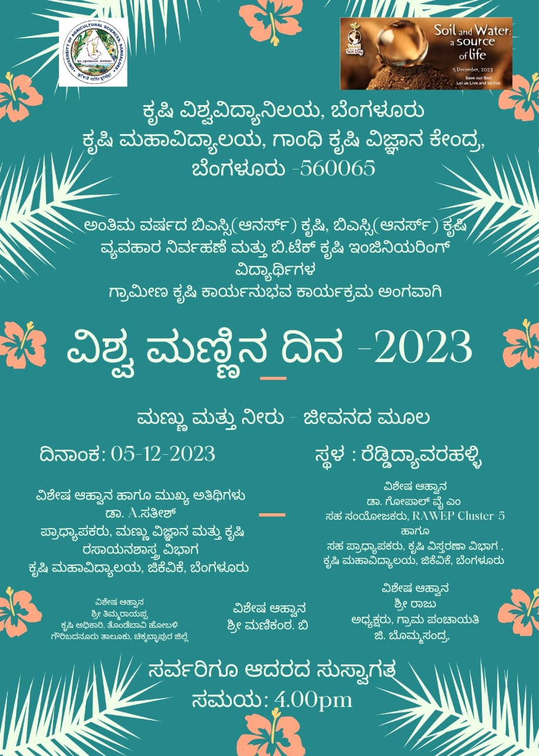

- Details of Competitions conducted:
Drawing competition
Quiz competition -
Memory game -

- Details of Winners & Prizes Distributed :
Drawing competition – Prizes – Lunch boxes
1st Dinesh D.A 5th standard ,
2nd Madan R 4th standard ,
3rd Rakshitha 4th standard

Quiz competition –
1st Jagan ,Madan, Shravani ,Prize Notebooks
2nd – Dinesh , Shreyas , Gowtham, Prize Penpencil
3rd – Mallika, Pavan, Manoj, Prize Pencil

Memory game –
1st Ramya B 5th standard
2nd Dinesh 5th standard
3rd Shreyas 4th standard

- Details of Scientists Participated:
Dr. A Satish , Professor, Dept. of Soil science and agricultural chemistry, College of agriculture, UASB

- Details of Topics and Salient Points covered in the programme
World Soil day – 1.History in World Soil day
2.Theme of the year – Soil and water is a source of life.
3.Soil sampling, Importance of soil testing,
4. Discussion on soil health card,
5.Integrated nutrient management,
6. Explanation of soil profile

- Queries raised by the farmers in the programme
Questions related to soil testing – depth, location, frequency of soil sampling
And related to Organic source of nutrients

- Details of participants (Give Numbers and Description):
- Farmers - 32
- Farm Women 18
- Youth (Men & Women) 15
- School Children 17
- Progressive Farmers 5
- Officials 1
- Total 88
- Feedback of participants: They expressed their gratitude about the programme , They came to know about how to improve the soil health in a sustainable manner.

- Details of Soil Samples Tested and Soil Health Cards Distributed
Farmer - Shri. Ramegowda , 83.5 Gunta, Survey No. 15/2B , Place Reddydyavarahalli

- Details of Models and Charts Prepared
Charts –
Integrated Nutrient management
Soil testing – Interpretation of different soil chemical properties .

Model – Soil Profile,
Compost pits

- Details of Demonstrations Made
Method demonstration on soil sampling

- Photos of the Event: Give Webpage Link

- Press Coverages of the Programme: Give Webpage LinkReddydyavarahalli, World Soil day

- Detail the list of Agencies collaborated and supported for the event

GIVE THE NUMERICAL ABSTRACT OF THE WORLD SOIL DAY 2023 PROGRAMME

Sl. No. | Particulars | No.
 | No. of Charts Prepared | 3
 | No. of Models Prepared | 3
 | No. of Exhibition Stalls Put | 0
 | No. of Videos Prepared | 1
 | No. of Demonstrations conducted | 1
 | No. of Competitions Conducted | 3
 | No. of Prizes Distributed | 15
 | No. of Scientists Participated | 1
 | No. of Farmers Participated | 58
 | No. of Soil Related Agencies Participated | 0
 | No. of soil samples tested and Health card issued | 1
 | No. of Webpages created | 1
 | No. of Videos Uploaded / Live Streamed | 2
 | No. of Invitations made | 20
 | No. of soil related Topics Covered in the programme | 6
 | No. of Queries made by the farmers in the event | 5
 | No. of Progressive Farmers participated | 5
 | No. of topics covered in the event by invitees | 3
 | No. of students Participated  RAWE  PG  Others | 19  0
 | No. of school Children Participated | 17
 | No. of Officials Participated | 1
 | No. of Press Coverages Made on the programme | 1
 | Any other information

