

PRACTICAL WORK MANUAL
RURAL AGRICULTURAL
WORK EXPERIENCE PROGRAMME
Under
STUDENT READY PROGRAMME
B.Sc. (Hons.) in Agriculture

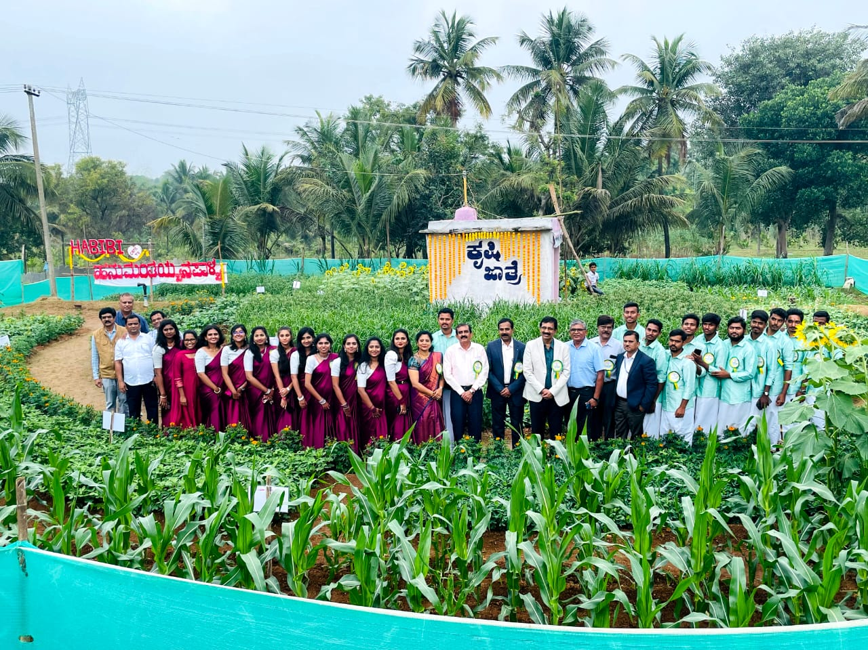
I Semester of 2023-24

DEPARTMENT OF AGRICULTURAL EXTENSION
COLLEGE OF AGRICULTURE, GKVK, BENGALURU – 560065
UNIVERSITY OF AGRICULTURAL SCIENCES, GKVK, BENGALURU – 560065
OCTOBER 2023
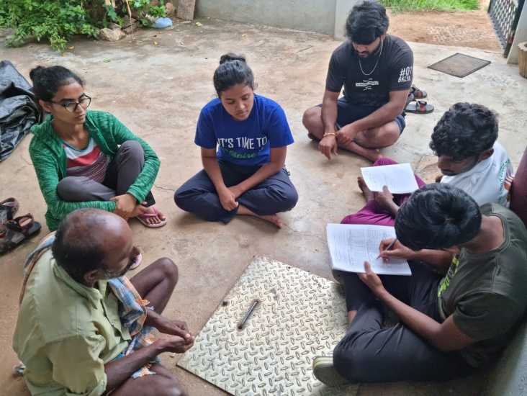 | 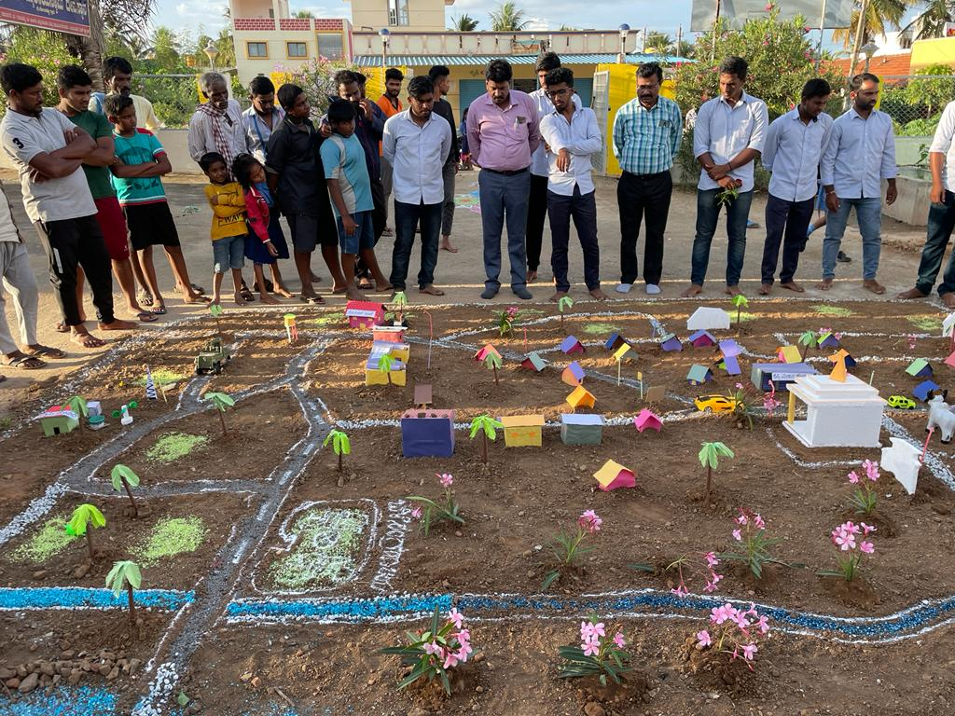
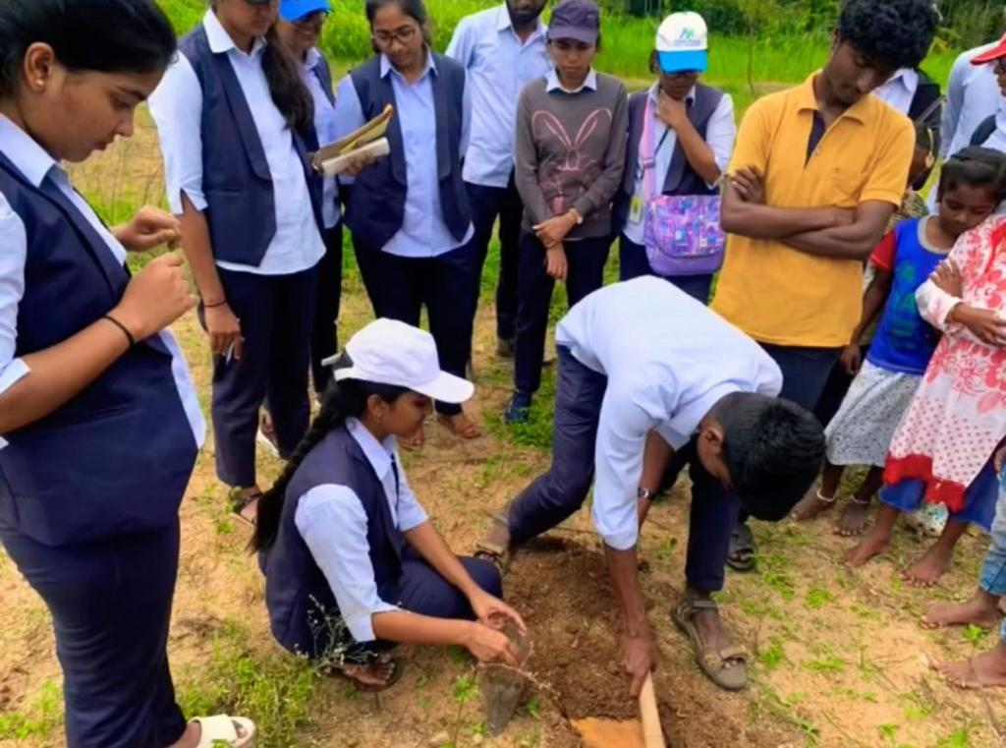 | 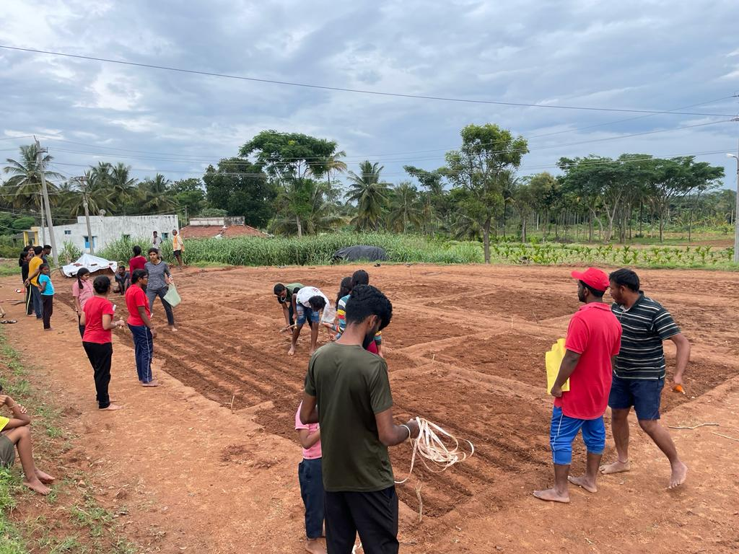
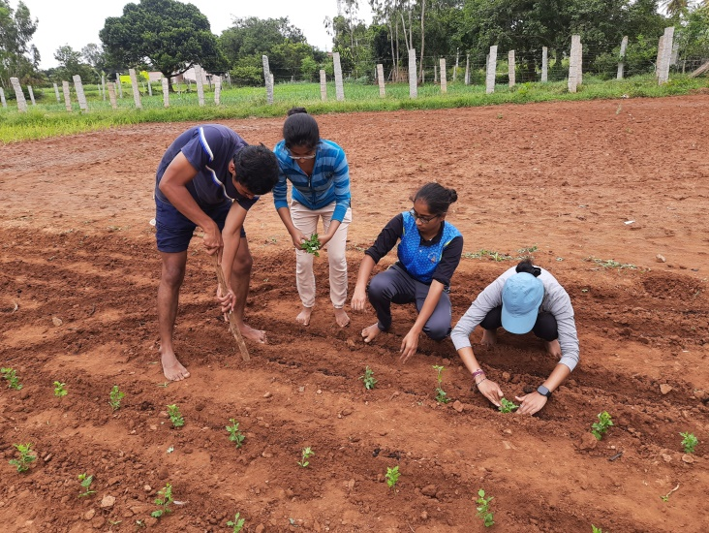 | 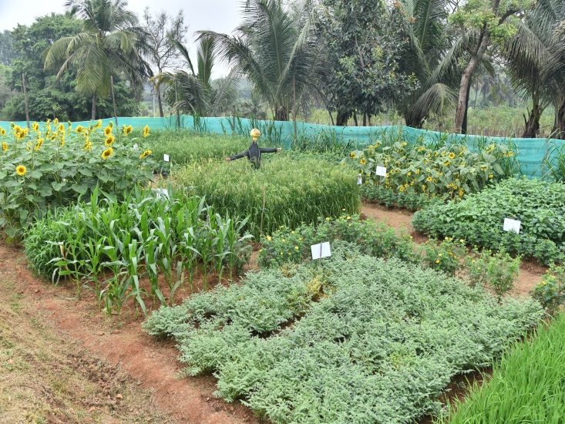
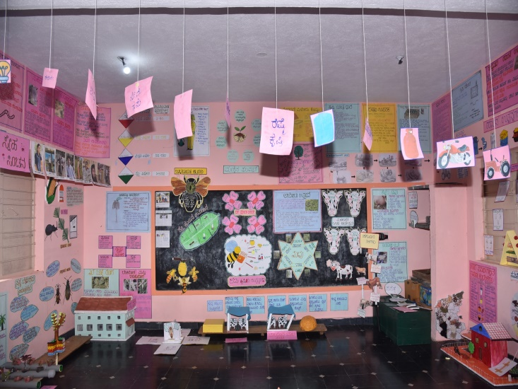 | 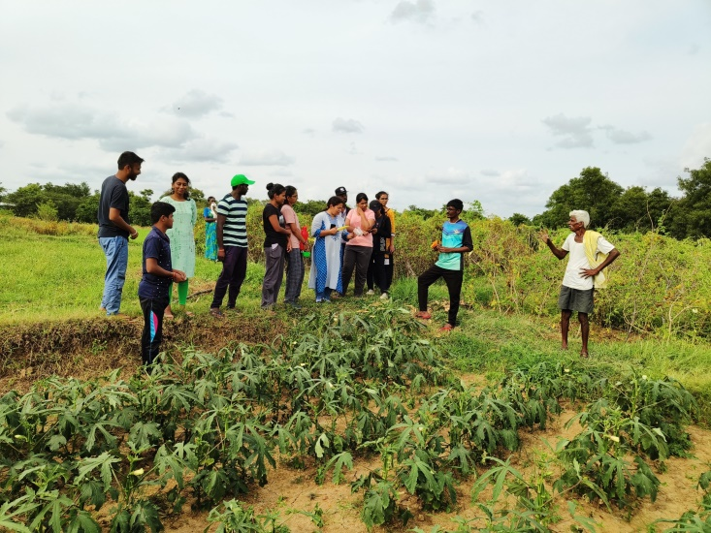

UNIVERSITY OF AGRICULTURAL SCIENCES, BANGALORE

Manual oF Rural AGRICULTURAL
Work Experience Programme (RAWEP)
Under
STUDENT READY PROGRAMME

B.Sc. (Hons.) in Agriculture

I Semester of 2023-24

Name : ......................................................

Fix your Passport Size Photograph Here
I.D. No. : .....................................................
Cluster No. : ………………………………………………….
RSK : ………………………………………………….
Village : ………………………………………………….
Manual Prepared By

Professor and Head  Dr. Y.N. Shivalingaiah, | RAWEP Co-ordinator  Dr. S.Ganesamoorthi
Associate Co-ordinators  Dr.M.T. Lakshminarayan, Dr. C.M.Savitha & Dr. H.K. Pankaja | RAWEP Teachers  Dr. Yashashwini M.A. & Dr.Y.M.Gopala
DEPARTMENT OF AGRICULTURAL EXTENSION
COLLEGE OF AGRICULTURE, GKVK, BENGALURU – 560065
October 2023

UNIVERSITY OF AGRICULTURAL SCIENCES, BANGALORE
COLLEGE OF AGRICULTURE, GKVK, BENGALURU – 560065
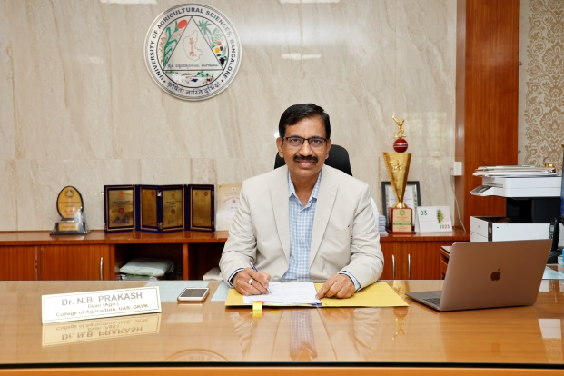
FOREWORD
Student Rural Entrepreneurship Awareness Development Yojana (Student READY) Programme aims to provide rural entrepreneurship awareness besides practical experience in real-life situation to students. The programme will help the students in building confidence, developing communication skills and acquiring Indigenous Technical Knowledge (ITK) of the region and thereby preparing the passing out graduates for future. It also aims to provide opportunities to acquire work experience and diagnostic skills apart from acquaint with on-going programmes in developmental departments. Further, this programme provides an opportunity for students to understand rural community life, familiarize with the socio-economic status of farmers and their problems, provides practical training in crop production, facilitates the understanding of agricultural technologies, their implementation, identifying gaps in adoption and preparing alternate plans to suit to local conditions.
Rural Agricultural Work Experience Programme is an innovative programme under Student READY, implemented by the University of Agricultural Sciences, Bangalore. It is a learner centred approach wherein undergraduate students learn by using the principles of ‘Learning by Doing’ and ‘Seeing is Believing’.
I am confident that RAWE manual developed for the academic year 2023-24, based on the course curriculum, would serve as a guide and facilitate students to achieve the objectives set under the Student READY programme. I wish the students all the success in completing this practical exercise in a befitting manner and also hope that they would be the true ambassadors of UAS, Bangalore in their future endeavours.
(N.B. Prakash)
Dean (Agri.)
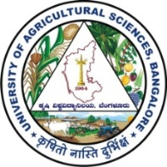
UNIVERSITY OF AGRICULTURAL SCIENCES, BANGALORE
DEPARTMENT OF AGRICULTURAL EXTENSION
COLLEGE OF AGRICULTURE, GKVK, BENGALURU– 560065
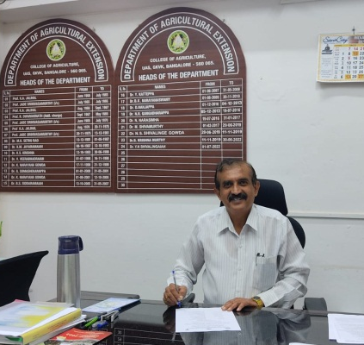
PREFACE
The University of Agricultural Sciences, Bangalore introduced the Student Rural Entrepreneurship Awareness Development Yojana (READY) refined from the earlier programme called Rural Agricultural Work Experience Programme (RAWEP) for the students of the undergraduate degree programmes. The Student READY / RAWEP is organized during the VII semester coinciding with the monsoon where teachers of all the disciplines are involved for improving the technical capacity and field competency of the students on the social and communication skills. Student READY / RAWEP aim at providing practical training opportunity for the final year B.Sc. (Hons.) Agriculture students which enables the students to develop the competency in crop production interventions, crop protection interventions, social and allied Science interventions, extension and transfer of technologies, plant clinic / information centre/ crop museum establishment, attachment to KVKs/Research stations and other units, and Agro-Industrial Attachment. It also provides first-hand experience for students to understand rural life and gain experience in promoting technologies among farming community. The students will be sound in theory in the first three years of undergraduate programme and in the final year the students will be exposed to Student READY / RAWE programme which provides them an opportunity to have practical training in the real rural life situations.
In order to understand and effectively implement Student READY / RAWE program, the practical manual is essential and will serve as a guide for the students and faculty and also to bring uniformity in activities. The RAWEP manual prepared for the year 2023-24 is developed based on the revised curriculum in accordance with the V Deans Committee recommendations. The final year B.Sc. (Hons.) Agriculture, B.Sc. (Hons.) Agribusiness Management and B.Tech. (Ag. Engg.) students and faculty can make best use of this manual for effective implementation of the Rural Agricultural Works Experience Programme. The narration of benefits from participation in RAWEP by past batches of graduated students reflects their positive and productive experience gained, which has been helping them not only in their academic pursuits, but also in achieving their professional goals in perspective. I wish all the students an excellent and outstanding participation in RAWEP under Student (READY) Programme with a sense of belongingness for the benefit of farmers of Karnataka in the process of learning through participatory process.
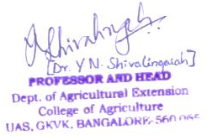
(Y.N. Shivalingaiah)
Professor and Head
HEAD OF THE DEPARTMENT, RAWEP COORDINATOR, ASSOCIATE COORDINATOR AND RAWEP TEACHERS OF DEPT. OF AGRICULTURAL EXTENSION, CoA, GKVK
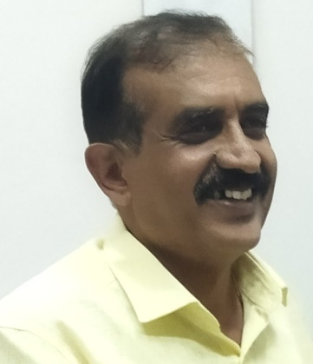  Dr. Y.N. Shivalingaiah  PROFESSOR AND HEAD |  | 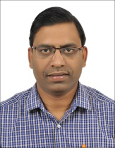  Dr. Ganesamoorthi, S.  RAWEP COORDINATOR
ASSOCIATE COORDINATORS & RAWEP TEACHERS
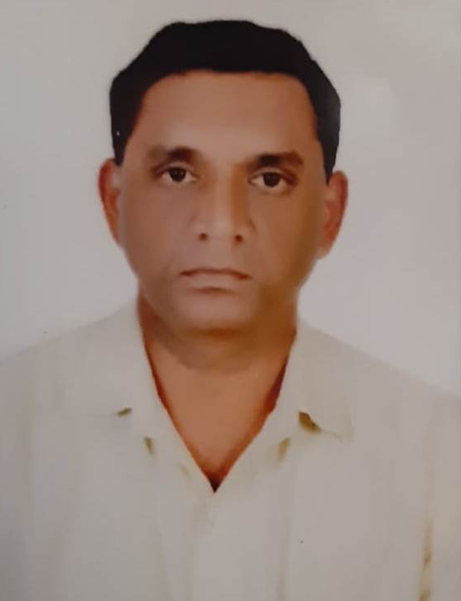  Dr. M.T. Lakshminarayan,  Prof. of Agricultural Extension | 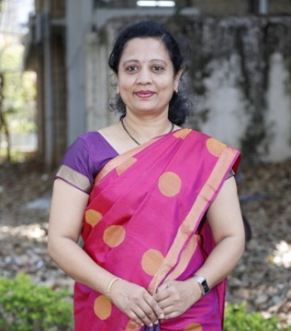  Dr. C.M. Savitha,  Assoc. Prof. of Agricultural Extension |  | 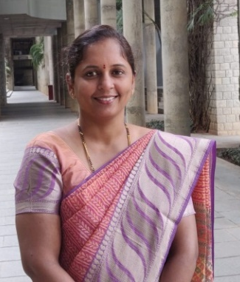  Dr. H.K. Pankaja Asst. Prof. of Agricultural Extension
RAWEP TEACHERS
  Dr. Yashashwini, M.A.  Asst. Prof. of Agricultural Extension (C) |  | 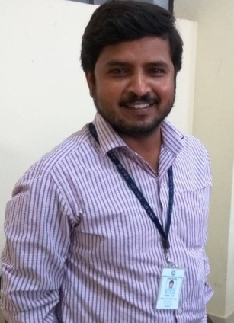  Dr. Y.M. Gopala  Asst. Prof. of Agricultural Extension (C)

UNIVERSITY OF AGRICULTURAL SCIENCES, BANGALORE
COLLEGE OF AGRICULTURE, GKVK, BENGALURU – 560 065
STUDENT READY PROGRAMME - RURAL AGRICULTURALWORK EXPERIENCE (RAWE) 2023-24

INSTRUCTIONS TO STUDENTS
- Students should stay only in the assigned ARS/KVK/AIA institution / Camp villages during the specified period of stays.
- Students should not leave the camp even during holidays without official permission of the university.
- During the village placements, the students should involve in organizing number of meetings, discussions, method demonstrations, campaign, field visits, etc., as specified in the plan of work.
- Each student should have observation cum work diary where list of activities carried out throughout the placements should be recorded separately and submit to in-charge teacher / multidisciplinary teachers for evaluation.
- Students should behave in an exemplary manner during their stay in the villages / KVK/ARS/AIs as worthy representatives of the UAS, Bangalore. Any misconduct or misbehaviour or indiscipline would be severely dealt with.
- In the RAWE placements, students are forbidden from swimming in village and using own motor vehicles.
- Students should report immediately their illness to the camp leader and teacher in-charge who in turn will take necessary action.
- Students should maintain cleanliness and ideal atmosphere in their places of stay and surroundings.
- Students should not give room for any untoward incident to happen during RAWE placements.
- During the KVK/ARS/AIA placements, the students should involve themselves in observation, discussions and associate in organising method demonstrations, campaign, field visits, etc., as decided by the KVK / ARS.
- All the students & their parents should mandatorily give the below undertaking and no objection certificate
- All the activities of the RAWE should be documented and submitted to the concerned teachers and the highlights should be published in the print, mass and electronic media including RAWE website.

STUDENT DECLARATION AND PARENT’S CONSENT TO UNDERGO STUDENT READY PROGRAMME

I ……………………………….I.D. No. ……………… S/o / D/o……………………………… studying in final year B.Sc. (Hons.) Agri. / B.Sc. (Hons.) ABM / B.Tech. (Ag.Engg.) undertake the RAWEP as part of the course curriculum and shall abide to the following conditions.
- I will adhere to schedule of RAWEP activities and in case if I miss/deviate from the scheduled programme I will be liable for any penalties/punishment as decided by the college/university.
- I will not create any unpleasant or unhealthy situations during the Stay/Visit at KVK / ARS / Research Schemes / RSKs/villages and extend full co-operation for successful completion of RAWEP.
- I or my parents/guardians will have no claim with University if I lose my personal belongings of any kind/cash or fall ill/drive bike/scooter/car and met with an accident/indulge in swimming.
- I have informed my parents/guardians about my participation in the RAWE Programme and they are not permitted to visit the students in the placement areas.

Place :_____________________ | Date :_____________________
Student’s Mob. No. :_____________________ | Father/Mother Mob. No :_____________________
I have no objection for my ward for attending RAWE programme and he/she will be taking care of his/her health and safety.

Signature of the Student’s Parent / Guardian  Name, Address and Contact Number of Parents | Signature of the Student

RAWEP TEACHERS FOR 2023-24
Dept. | Name of the RAWEP Teacher | Designation | Mobile No. | Inter com | e-mail ID
College of Agriculture | Dr. N.B. Prakash | Dean (Agri.) | 9449866910 | 285 | deanagben@uasbangalore.edu.in
College of Agriculture | Dr. C. Narayanaswamy | Scientific Officer | 9448308678 | 285 | cnswamyextn@gmail.com
Agril. Extension | Dr. Y.N. Shivalingaiah | Professor & Head | 9611457341 | 368 | agextngkvk@gmail.com  ynshivalingaiah@gmail.com
Agril. Extension | Dr. S. Ganesamoorthi | Prof. & RAWEP Coordinator | 9731876687 | 368 | aex201@gmail.com
Agril. Extension | Dr. M.T. Lakshminarayan | Prof. & Assoc. RAWEP Coordinator | 9620572173 | 368 | mtlnextn@gmail.com
Agril. Extension | Dr. C.M. Savitha | Assoc. Professor & Assoc. RAWEP Coordinator | 9986635272 | 368 | savithacm18@gmail.com
Agril. Extension | Dr. H.K. Pankaja | Asst. Professor & Assoc. RAWEP Coordinator | 9449429217 | 368 | pankaja4012@gmail.com
Agril. Extension | Dr. Yashashwini, M.A. | Asst. Professor | 9036506569 | 368 | yashu19gowda@gmail.com
Agril. Extension | Dr. Y.M. Gopala | Asst. Professor | 9449142738 | 368 | gopalym@gmail.com
Agricultural Entomology | Dr. D. Jemla Naik | Professor and Head | 9449759019 | 288 | djn97@rediffmail.com
Agricultural Entomology | Dr. M. Thippaiah | Professor | 9900528603 | 288 | mthippaiah_ent@rediffmail.com
Agricultural Entomology | Dr. Murali Mohan, K. | Professor | 9900721071 | 288 | entomurali@gmail.com
Agricultural Entomology | Dr. Rajanna, D. | Professor | 9108562289 | 288
Agronomy | Dr. K. Murali | Professor & Head | 9980520498 | 283 | muralikariyappa69@gmail.com
Agronomy | Dr. Pushpa, K. | Asst. Professor | 9880177338 | 283 | drpushpakrishna@gmail.com
Agronomy | Dr. Pavan, A.S. | Asst. Professor | 9036399347 | 283 | pavanagaradahalli@gmail.com
Agronomy | Dr. Basavaraj Biradar | Asst. Professor | 8105281297 | 283
IABM | Dr. Siddayya | Professor & Head | 9640689311  9449866937 | 380 | ssiddayya@gmail.com
IABM | Dr. M.S. Ganapathy | Prof. & Uni. Head & Assoc. Coordinator | 9448975304 | 380 | ganapathy.agmo@gmail.com
IABM | Dr. Syed Rizwan Ahmed | Asst. Professor | 9591113182 | 380 | rizwan.pau@gmail.com
IABM | Dr. Manohar, B.H. | Asst. Professor | 9916443277 | 380
Food Science & Nutrition | Dr. K.G. Vijayalaxmi | Professor & Head | 9880372159 | 377 | vijayalaxmivinod@gmail.com
Food Science & Nutrition | Dr. M.L. Revanna | Professor | 7975948592 | 317 | revannaml@yahoo.com
Food Science & Nutrition | Dr. Mamatha, H.S. | Assoc. Professor | 8277221683  8861304383 | 317 | mamathabtu@gmail.com
Agril. Microbiology | Dr. K. Nagaraju | Professor & Head | 8123613956 | 372 | knagaraju@uasbangalore.edu.in nagaraj.ksamandur@gmail.com
Agril. Microbiology | Dr. N. Umashankar | Professor | 9845637672 | 372 | umashankarnagaraju@gmail.com
Agril. Microbiology | Dr. Lakshmipathi, R.N. | Asst. Professor | 9481906634 | 372 | lakshmipathirnl@gmail.com
Crop Physiology | Dr. M.S. Sheshashayee | Professor & Head | 9972308219 | 376 | msheshshayee@hotmail.com
Crop Physiology | Dr. Praveen, H.G. | Asst. Professor | 9886340507 | 376 | praveenhg.agri1@gmail.com
Forestry & Environ. Science | Dr. M. Mahadeva Murthy | Professor & Head | 9845588203 | 354 | mmmurthy@rediffmail.com
Forestry & Environ. Science | Dr. Rinku Verma | Asst. Professor | 9880101975 | 253 | rinkuv@yahoo.com
Forestry & Environ. Science | Dr. H.B. Raghu | Asst. Professor | 9980516465 | 253 | raguhbforestry@gmail.com
Agril. Economics | Dr. H. Lokesha | Professor and Head | 9880439450 | 298 | ag.econ67@gmail.com
Agril. Economics | Dr. M.N. Venkataramana | Professor | 9448856306 | 298 | venkataramanamn@rediffmail.com
Agril. Economics | Dr. Mahin Sharif | Asst. Professor | 9449318177 | 298 | sharif.mahin@gmail.com
Agril. Economics | Dr. Anitha, S. | Asst. Professor | 9035718826 | 298 | anu.s.naik@gmail.com
Agril. Engineering | Dr. H.C. Prakasha | Special Officer, CoAE, GKVK | 9449866907 | 332 | specialofficercoae@gmail.com  hodaenben@uasbangalore.edu.in
Agril. Engineering | Dr. Mohit Kumar G.V. | Assoc. Professor & Assoc. Coordinator | 9448886419 | 333 | gvmohith.471@gmail.com
Agril. Engineering | Dr. Veeresh Kumar Gouda | Asst. Professor & Assoc. Coordinator | 9901069131 | 333 | vkgouda@gmail.com  vkgbiogas@gmail.com
Apiculture | Dr. Mohan I. Naik | Professor & Head | 9448856892 | 289 | mohanishwarnaik@yahoo.co.in
Apiculture | Dr. B.V. Shwetha | Asst. Professor | 9916289422 | 289 | shwethabv@gmail.com
Plant Pathology | Dr. N. Nagaraju | Professor & Head | 9731559754 | 294 | nagaraju63kgere@yahoo.co.in
Plant Pathology | Dr. C.R. Jahir Basha | Assoc. Professor | 9964512618 | 294 | jahir_basha@rediffmail.com
Plant Pathology | Dr. Manjunath, B. | Asst. Professor | 9986032259 | 294 | manjunathkrishi@gmail.com
Seed Science and Technology | Dr. R. Siddaraju | Professor & Head | 9880047284 | 290 | hodsstben@uasbangalore.edu.in  siddarajur1968@gmail.com
Seed Science and Technology | Dr. B.N. Radha | Asst. Professor | 9113819286 | 290 | radhabn29@gmail.com
Seed Science and Technology | Dr. K.J. Sowmya | Technical Assistant | 9964444612 | 290 | sowmyaseed@gmail.com
Animal Science | Dr. O.R. Nataraj | Professor & Head | 9449866936  9448443279 | 327 | ornataraju@gmail.com
Animal Science | Dr. G. Ananda Manegar | Assoc. Professor | 9972201347 | 327 | dranandamanegar@gmail.com
Plant Biotechnology | Dr. S. Shyamalamma | Professor & Head | 9448856958 | 276 /275 | shyamala_reddyrs@yahoo.co.in  shyamalamma@uasbangalore.edu.in
Plant Biotechnology | Dr. Poornima, R. | Asst. Professor | 9964431191 | 235 | poornima.r@uasbangalore.edu.in  poornima.r.naik@gmail.com
Plant Biotechnology | Dr. P. Bhavani | Asst. Professor | 9739793777 | 235 | bhavanip@uasbangalore.edu.in  bhavanigirish259@gmail.com
Horticulture | Dr. P. Venkatesha Murthy | Professor & Head | 9448657775 | 338 | pvenkateshamurthy@gmail.com
Horticulture | Dr. R. Vasantha Kumari | Professor | 9900103338 | 338 | kvasantha.08@gmail.com
Horticulture | Dr. A. Vidya | Assoc. Professor | 9844639445 | 338 | pomology2016@gmail.com
Horticulture | Dr. Sharanya, B.R. | Asst. Professor | 8277305469 | 338
Genetics & Plant Breeding | Dr. Shanthala | Professor & Head | 8861253188 | 286/ 390 | shanthala16@gmail.com  hodgpb5@gmail.com
Genetics & Plant Breeding | Dr. N. Marappa | Assoc. Professor | 9448181072  8618788107 | 286 | marsgpb@uasbangalore.edu.in  nmaars@gmail.com
Genetics & Plant Breeding | Dr. H.B. Mahesh | Asst. Professor | 9945683751 | 286 | maheshhbg@gmail.com
Soil Science & Agril. Chemistry | Dr. J. Saralakumari | Professor & Head | 9611567094 | 293 | saralaramanand@gmail.com
Soil Science & Agril. Chemistry | Dr. S. Channakeshava | Professor | 9449302297 | 293 | channa_2005@rediffmail.com
Soil Science & Agril. Chemistry | Dr. B. Mamatha | Asst. Professor | 9481249881 | 293 | mamatha.bhavya@gmail.com
Soil Science & Agril. Chemistry | Dr. T. Jayanthi | Asst. Professor | 9448056893 | 293 | jayanthiuasb@gmil.com
Sericulture | Dr. Manjunath Gowda | Professor & Head | 9743533047 | 292 | mgowda_uas@rediffmail.com
Sericulture | Dr. Chikkalingaiah | Professor | 9449721475 | 292 | chikkalingaiah@rediffmail.com
Sericulture | Dr. Vinoda, K.S. | Asst. Professor | 9481243080 | 292 | vinoda.shankarappa@gmail.com

CONTENTS
Sl. No. | Particulars | Page No.
 | Introduction | 01
 | Registration and Guidance | 03
 | Group Leaders and Associates | 05
 | Schedule of Events | 05
 | Course Syllabus for Group of Subjects | 06
 | Procedure for Evaluation of the Performance of Students | 10
 | Details of Agro-Industrial Attachment (AIA) | 10
 | Details of Course Syllabus | 12
 | Extension Teaching Methods | 16
 | Discipline wise RAWE Assignments | 24
 | Weekly schedule of activities | 33
 | List of registered students for RAWE programme 2023-24 | 37

Introduction
About Student READY
The Student READY (Rural Entrepreneurship Awareness Development Yojana) programme aims to provide rural entrepreneurship awareness, practical experience in real-life situation in rural agriculture and creating awareness to undergraduate students about practical agriculture and allied sciences. The programme will help in building confidence, skill and acquire Indigenous Technical Knowledge (ITK) of the locality and thereby, preparing the pass-out for self-employment. It also aims to provide opportunities to acquire hands-on-experience and entrepreneurial skills. To reorient graduates of agriculture and allied subjects for ensuring and assuring employability and develop entrepreneurs for emerging knowledge intensive agriculture, it was felt necessary to introduce this program in all the AU’s as an essential prerequisite for the award of degree to ensure hands on experience and practical training.
The Fifth Deans committee has given detailed curriculum of student READY programme for all the disciplines in agriculture and allied sciences. The course curricula have been restructures to develop much needed skills and entrepreneurial mind-set among the graduates to take up self-employment, contribute to enhanced rural livelihood and food security, sustainability of agriculture and be propeller for agricultural transformation. The following components are proposed for carrying out one year Student READY programme in all the Under graduate (UG) disciplines:
1. Experiential Learning on Business model / Hands on Training.
2. Experiential Learning on Skill Development.
3. Rural Agricultural Work Experience (RAWE).
4. Internship / In-Plant Training / Industrial attachment.
5. Students Projects.
The students required to have any three of the five components listed above depending on the requirement of their graduate education and implemented for one complete year. All the above mentioned components are interactive and are conceptualized for building skills in project development and execution, decision-making, individual and team coordination, approach to problem solving, accounting, quality control, marketing and resolving conflicts, etc. with end to end approach.
Experiential Learning is an opportunity for the students to develop high quality professional competence, skill development and confidence to step towards “Earn while learn”. Experiential Learning aims towards Practical Work Experience in Real Life Situation among the undergraduate students and therefore it helps student become “Job Providers rather than Job Seekers”.
Rural Agricultural Works Experiential enable the students to gain rural experience, give them confidence and enhance on farm problem solving abilities in real life situations, especially in contact with farmers, growers, etc.
Student Project is essential for students who are interested in higher education. Through this they will gain expertise for identification of research problem, planning and setting up experiments and writing of reports, etc.
EL provides the students an excellent opportunity to develop analytical and entrepreneurial skills and knowledge through meaningful hands on experience, confidence in their ability to design and execute project work. The main objectives of EL are:
- To promote professional skills and knowledge through hands on experience.
- To build confidence and ability to work in project mode.
- To acquire enterprise management capabilities.

Rural Agricultural Work Experience
The Rural Agricultural Work Experience (RAWE) helps the students primarily to understand the rural situations, status of agricultural technologies adopted by farmers, prioritize the farmer’s problems and to develop skills and attitude of working with farm families for overall development in rural area. The timings for RAWE can be flexible for specific regions to coincide with the main cropping season.
The main objectives of RAWE are:
- To provide opportunity to the students to understand the rural situation in relation to agriculture and allied activities.
- To make the students familiar with socio-economic conditions of the farmers and their problems.
- To impart diagnostic and remedial knowledge to the students relevant to real field situations through practical training.
- To develop effective communication skills of students with farmers using latest extension methodologies in transfer of technology.
- To develop confidence and competence among students to solve complex agricultural problems.
- To acquaint students with on-going extension and rural development programmes.
Semester VII: Rural Agricultural Work Experience (RAWE) and Agro-Industrial Attachment (AIA)
This programme will be undertaken by the students during the VII semester for a total duration of 21 weeks with a weightage of 0+20 credit hours in two parts viz., RAWE and AIA. It will consist of general orientation and on campus training by different faculties followed by village attachment/unit attachment in University/College/KVK or a Research station. The students will be attached with the agro-industries to get an experience of the industrial environment and working. Weightage in terms of credits hours will be given depending upon the duration of stay of students in villages/agro-industries. At the end of RAWE/AIA, the students will be given one week for project report preparation, presentation and evaluation. The students would be required to record their observations in field and agro-industries on daily basis and will prepare their project report based on these observations.

REGISTRATION AND GUIDANCE

Registration
Students who have successfully completed all the scheduled courses till the end of the 6th Semester are eligible to register for Rural Agricultural Work Experience Programme (RAWEP). They should not register for any other courses on the campus during the 8th semester. The students shall register for the following 20 credits of RAWEP during the 8th semester. The details of credit hours for each group of subjects are as follows.
Sl. No. | Course No. & Credit Hrs. | Title | Weeks | Concerned Departments for monitoring and evaluation
A |  | RAWE / Subject Orientation | 1 Week
B |  | Village Attachment | 12
1 | SRA 411 (0+4) | Crop production and crop improvement interventions |  | Agronomy, Horticulture, Soil Science & Agril. Chemistry, Seed Science& Technology, Genetics and Plant Breeding, Agril. Microbiology, Crop Physiology, Plant Biotechnology
2 | SRA 412 (0+3) | Crop protection interventions |  | Plant Pathology, Agril. Entomology, Sericulture and Apiculture
3 | SRA 413 (0+3) | Social and allied science interventions |  | Agril. Economics, Agril. Marketing, Cooperation & BM, Agril. Engineering, Food Science & Nutrition, Animal Science, Forestry & Environmental Science
4 | SRA 414 (0+4) | Extension and Transfer of Technologies |  | Agril. Extension
5 | SRA 415 (0+2) | Plant clinic / Information Centre/ Crop Museum |  | Coordinator/Associate Coordinator along with agronomist, horticulturist and plant protection Specialists
C | SRA 416 (0+2) | Attachment to KVKs/Research stations and other units | 2 | RAWEP Coordinator & Assoc. Coordinators
D | SRA 417 (0+2) | Agro-Industrial Attachment | 3 | Concerned teacher of the respective departments
E |  | Project report preparation, presentation and evaluation | 2 | Coordinators / Concerned Teachers
 | Total No. of Credits : 20 credits |  | 20

Advisory Committee
There shall be an Advisory Committee headed by the Dean (Agri.), College of Agriculture as the Chairman and all the Heads of the Departments of the College, the Co-ordinator and Associate Co-ordinator of RAWEP as the members. The Committee is responsible to guide the teachers in-charge of RAWEP and students for effective implementation. The Committee shall meet periodically to review and monitor the programme.
Co-ordinator
The teachers from the Department of Agricultural Extension will be designated as Co-ordinator and Associate Co-ordinators to co-ordinate the entire RAWEP.

Supervision and Guidance
The designated RAWEP teachers from all the departments of the college are responsible to monitor, supervise and guide the students to attend to their allotted work by different departments. The students will be evaluated on their performance in different courses throughout the RAWEP.
Attendance and Discipline
All the components of RAWEP are compulsory for all the students who have registered for RAWEP. They should get a minimum of 80 per cent attendance in all disciplines of RAWEP courses as in the case of other courses. The students shall maintain good discipline during the placement in villages and Agro-Industrial Attachment and prove themselves to be worthy students of the University of Agricultural Sciences, Bangalore. The behaviour in the villages should be exemplary. Any student who wants to leave the placement on official work of the university like participation in sports and other co-curricular activities or in the event of illness or unforeseen circumstances should obtain prior written permission from the Dean (Agri.). Further, a student may be permitted to leave the placement with the written permission of the designated teachers of the camp. However, the student should make up the curricular requirement for the period of their absence and to make up the days lost by doing extra work. Any misconduct of the student in the village will be viewed very seriously and such students shall be expelled from the RAWEP/ liable for the disciplinary action as decided by the university.
Work Diary
The students should write the individual daily work in diary during the placement in villages and agro industries and KVKs. The diary will be checked by the designated RAWEP teachers of different departments periodically and during their visit to the villages.
Reports
The students should write the detailed report on completion of each assignment and it will be evaluated by the concerned RAWEP teachers of different departments.
Evaluation
The performance of the students will be evaluated as specified separately for each of the RAWEP course by the identified group leaders with the support of designated RAWEP teachers.

Group Leaders and Associates for the courses approved under each group

Group | Course No. | Group Leaders | Associate Leaders
IV B.Sc. (Hons.) Agriculture | Course No. | Group Leaders | Associate Leaders
Village Attachment | Course No. | Group Leaders | Associate Leaders
- Crop Production/ Improvement Interventions | SRA-411 (0+4) | Professor & Head  (Agril. Microbiology) | Dr. Ganesamoorthi, S.
- Crop Protection Interventions | SRA-412 (0+3) | Professor & Head  (Sericulture) | Dr. C.M. Savitha
- Social and Allied Science Interventions | SRA-413 (0+3) | Professor & Head  (Food Science & Nutrition) | Dr. H.K. Pankaja
- Extension and Transfer of Technologies | SRA-414 (0+4) | Professor & Head  (Agril. Extension) | Dr. Ganesamoorthi,  Dr. Yashashwini, M.A.
- Plant Clinic / Information Centre / Crop Museum | SRA-415 (0+2) | Professor & Head  (Agril. Extension) | Dr. M.T. Lakshminarayan  Dr. Y.M. Gopala
- Attachment to KVKs/Research stations and other units | SRA-416 (0+2) | Professor & Head  (Agril. Extension) | Dr. C.M. Savitha
- Agro-Industrial Attachment | SRA-417 (0+2) | Professor & Head  (Agril. Extension) | Dr. H.K. Pankaja
IV B.Sc. (Hons.) ABM  - Attachment to KVK / Research Station | SRG-412 (0+3) | Professor & Head  (Agril. Extension) | Dr. M.S. Ganapathy  Dr. C.M. Savitha
- Practical Extension Work in Villages | SRG-413 (0+4) | Professor & Head  (Agril. Extension) | Dr. M.S. Ganapathy  Dr. H.K. Pankaja
IV B.Tech. (Ag. Engg.)  - Practical Extension Work in Villages | SRE-414 (0+2) | Professor & Head  (Agril. Extension) | Dr. Ganesamoorthi, S.  Dr. Mohith Kumar

SCHEDULE OF EVENTS
The RAWEP will be for a period of one full semester (21 weeks) during 2023-24. The break-up of 21 weeks for various components of RAWEP is as follows:
Period | Item of work | Duration
04.10.2023 to  12.10.2023 | Student READY Programme orientation | 1 week
13.10.2023 to 10.01.2024 | Placement in RSKs and Villages for practical experience | 13 weeks
11.01.2024 to 01.02.2024 | Agro-Industrial Placement/Attachment | 3 weeks
02.02.2024 to 16.02.2024 | Placement in Krishi Vignana Kendras (KVK)/ Agricultural Research Station (ARS) and Other Units | 2 weeks
17.02.2024 to  28.02.2024 | Project report preparation, Group Discussion, Presentation, Exam and submission | 2 weeks
Total |  | (21 weeks)

On Campus Orientation
The students registered for the RAWEP will be oriented on back ground, importance and objectives of RAWEP, different activities to be conducted in villages, Programme planning, method of data collection, types of leaders and their identification in villages, maintenance of work diary, using different extension teaching methods and use of different teaching aids etc. Further, orientation will be given to the students on various subject matter areas related to important crops and enterprises of the RAWEP villages.
Village and RSK attachment
- Data Collection from Villages and Analysis
The students will collect the data, analyse the situation and identify the problems. Based on the problems identified they will prepare plan of work and calendar of operation and accordingly execute the extension programmes for the allotted villages.
- Placement in villages/RSKs
The placement in villages is intended to facilitate the students to work with the farmers under village situation. Students will identify the local leaders and work with the contact farmers. Students will use various communication skills using different extension teaching methods like general meeting, farm and home visit, group discussion meeting, method demonstration, result demonstration, farmers training programmes, campaigns, exhibition, field visits, field days and other community work. It is mandatory for all the teachers offering RAWEP courses to visit in the identified Rawep villages. Further, students have to work in concerned RSKs and should provide advisory services to the farmers by establishing crop museum, plant clinic, information centres in villages and RSKs.

COURSE SYLLABUS FOR GROUP OF SUBJECTS
Group I: SRA 411 (0+4): Crop Production Interventions
Agronomy
Collection of meteorological data, production of organic manures- selection of site for FYM/ compost pit, FYM, different methods of compost production, vermi-compost, liquid manures, oil cakes, green manuring in dry land agriculture, fertilizer management including secondary and micronutrients, integrated nutrient management, site specific nutrient management, integrated weed management, Watershed management, soil and water conservation, integrated farming system, water management including micro irrigation, aerobic rice production, non-cash and low-cost inputs for crop production.
Soil Science and Agril. Chemistry
Collection and preparation of soil and water samples for analysis and recommendation based on results of analysis; STCR based methods of fertilizer application; Identification and amelioration of saline, sodic and acidic soils; Identification of nutrient deficiency/toxicity symptoms in crops and recommendations to rectify the problems, Utilization of organic wastes; Integrated nutrient management; Enhancement of fertilizer use efficiency, preparation of slow release fertilizers by using neem cake coated and gypsum blended urea; Scientific methods of enrichment of FYM by using weeds, rock phosphate and micronutrients.
Agril. Microbiology
Biofertilizers usage in different crops: a) Rhizobium inoculation in leguminous crops b) Azotobacter inoculation in cereals c) Azospirillum inoculation in paddy and ragi d) Gluconobacter inoculation in sugarcane e) Use of phosphorus solubilizing microorganisms in crop production f) Azolla and its cultivation, its importance in agriculture and animal husbandry g) PGPR microorganisms, AM fungi and their importance in agriculture. Use of biofertilizers in horticulture and sericulture crops. Mushroom cultivation, fast decomposers and compost enriching microbes. Microbial bio-control agents like Trichoderma spp, Pseudomonas spp. and Bacillus spp.

Horticulture
Preparation of seed beds, sowing, planting/transplanting of vegetables and flower crops. Use of growth regulators, weedicides, harvesting, packing, storage and transportation of vegetables and flowers. Pinching, pruning and training in flower crops. Planting operation - opening of pits, filling the pits and planting; Propagation of plants by budding, grafting, air layering, cutting with the use of growth regulators. Top working and pruning in mango; Nutrition management, Post-harvest handling including picking, packing and use of ripening treatments in fruits; Selection of coconut mother palms and nuts. Sowing of nuts in the nursery. Selection and storage seed rhizomes of ginger and turmeric with seed treatment and planting; recommended cultivation practices of major dry land horticultural crops; Preparation of jam, jelly, squash, nectar, pickle etc.
Seed Science and Technology
Different sources of seed and their characteristics (BS, FS, CS and TL seeds).Status of Seed replacement in RAWE villages (cereals, pulses, millets and oil seed crops).Involvement of seed producing organization in seed production: Government sector, Private sector, Co-operative sector. Techniques followed in seed production: Hybrids, High yielding varieties and vegetable crops. Post-harvest technology followed in seed crops: Method of harvest, Method of threshing. Method of pre-cleaning, Method of drying and packing, Analysis of post-harvest losses at various levels. Analysis of seed quality of farmers saved seed: Collection of seed from farmer, Subjecting for seed quality parameters like G, P, M, Result communication. Demonstration of different class of seed and their identification: Breeder seed, Foundation seed, certified seed, Truth fully labelled seed. Visit to seed processing unit: Study various activities, involving in processing operations like grading, cleaning, storage, treating, packaging etc. Seed treatment techniques. Seed marketing and seed distribution system
Genetics and Plant Breeding
Plant selection techniques. Creating awareness about techniques of saving seed for raising subsequent crops considering mode of pollination and type of cultivar (pure-line variety/open pollinated cross pollinated variety/hybrid).Creating awareness about Farmers’ rights under PPV & FR 2001 Act. Creating awareness about released crop varieties/hybrids relevant to particular region, their adoption levels and eliciting feedback on the adopted varieties/hybrids
Crop Physiology
Nutrient elements and their importance in growth and development of crops. Deficiency and toxicity symptoms and their identification in the field and corrective measures. Foliar nutrition. Plant growth regulators and their role in plant growth and development. Use of plant growth regulators in agriculture, horticulture, forestry and industry. Demonstration of use of plant growth regulators to induce rooting of cuttings, induction of regular flowering prevent/ reduce flower and fruit drops, increase in fruit size breaking seed, dormancy, fruit ripening. Importance of seed hardening and demonstration.
Plant Biotechnology
Tissue culture technologies to farmers and Nano-technologies.

Group II: SRA 412 (0+3): Crop Protection Interventions
Agril. Entomology
Identification of local pest situations and pest management practices; Different types of non-chemical inputs used in pest management, Seed treatment with pesticides ; Storage practices of farm produces to prevent insect damage ; Local and traditional practices of pest management ; Assessment of pest and natural enemy densities; Surveillance of pest and natural enemies, Importance of keeping record of purchases of the insecticides; Sources of information available for plant protection practices; Preparation of spray solutions : Calculation of spray volume; Harvesting and processing local plants and their products for Pest management practices; Preparation of NSKE, vegetable oils and other plant sources and NPV; Use of pheromone traps for pest monitoring; Safe handling and field release of parasites and predators; Use of nylon nets in nurseries; Root feeding and / or stem Injection of pesticides; fumigants; rodent management.
Plant Pathology
Plant disease details for major crops – a) Important diseases and their severity, b) Collection of diseased plants and plant parts; Disease management practices and their frequency; Use of fungicides, bactericides, antibiotics; Different types of non-chemical inputs used; Sources of information on plant protection practices. Information regarding storage practices; Information on conventional or local practices of disease management; storage practices; Types of sprayers/ dusters and their availability; Preparation of Bordeaux mixture; Cultural and biological management of soil borne disease; Seed treatment with fungicides/ antibiotics; Preparation of spray solutions, proprietary fungicides and their applications; Calculations of spray volume requirement – Preparation of NSKE and vegetable oils for spraying; Use of nylon nets in nurseries; Use of biological agents; Root feeding of fungicides; Hot water treatment and furadon or thimet application against nematodes.
Sericulture
Improved cultivation practices of mulberry; Improved silkworm rearing practices; Advantages of V-I mulberry variety; Preservation of mulberry leaves for chawki rearing: Egg incubation; Chawki silkworm rearing: Silkworm rearing on mulberry shoots; Application of bed disinfectants against silkworm diseases; Cocoon harvesting and grading.
Apiculture
Identification of bees; floral calendar by including major and minor sources of nectar and pollen for the year; Hiving of bee colonies: Bee-hive products.
Group III: SRA 413 (0+3): Social and Allied Science Interventions

Agril. Economics
Introductory economic principles of practical application in micro level problems faced by farmers in agriculture; Introductory economic principles of practical application in macro level issues of the village economy; Cost effectiveness of different agricultural technologies; Costing / Valuing inputs including natural resources used in agriculture; Relative profitability of crops, livestock, horticulture, fishery enterprises; Risks and uncertainties involved in cultivation and marketing and mitigation strategies; Economic efficiency; Gaps in efficiency, productivity and how to address them.
Problem statement in lay person’s terms. Problem restated in Economic terminology or economic parlance. The broad subject matter area which best describes the economic problem (classification of the problem) Gaps between targets and achievement and factors facilitating (Ex. Access to quality inputs and markets) Solutions at farm Solutions at program / policy levels. Appraising the selected farmers regarding the economic solutions to the problems identified covering economic efficiency, pricing, marketing, group marketing, backward and forward linkages, new enterprises, synergies, diversification, and risk aversion strategies.

Agril. Marketing and Cooperation
Concept of Agricultural Marketing, Significance of Marketing, Marketing functions, -Physical, Exchange and facilitative, Different types of Agricultural Markets, Methods of Sales of Agricultural Commodities, APMC & their objectives, Different Government Schemes in Agricultural Marketing, Marketing Institutions. Grading of Agricultural Commodities, Importance, Types, Scientific Marketing of Agricultural Commodities, Standards for Manufacture Products, and Recent Advances in Agricultural Marketing.
Food Science & Nutrition
Balanced diets for different age groups; Supplementary foods for children; Micronutrient rich food preparation; Establishment of nutritional / kitchen garden; Preparation of beverages from cereals and pulses; Processing of fruits and vegetables; Value addition in local staples; Sanitation and hygiene.
Forestry and Environmental Science
Biofuel crops. Nursery techniques of tree species. Bio-degradable waste. Renewable / Non-conventional energy sources. Solid waste Management.
Agril. Engineering
Study on improved primary and secondary tillage implements, improved seed drill, seed-cum-fertilizer drill, planters and transplanters, improved intercultural implements like hoes, hand weeder and ridger, high-tech plant protection equipment like sprayers and dusters, improved sickles, harvester and reapers; power operated winnowers, threshers, dryers, cleaners, graders and improved storage bins, coconut climbers, coconut de-husker, groundnut decorticators, arecanut decorticators and maize shelter, soil and water conservation structures. Renewable / Non-conventional energy sources.
Animal Science
Enrichment of dry fodder, Preparation of balanced cattle feed, Management of animals, Fodder production and selection of animals, Preparation of balanced Cattle feed, Backyard poultry, Importance of Goat and Sheep farming.
Group IV: SRA 414 (0+4): Extension and Transfer of Technologies

Agril. Extension
Extension programme planning and Execution, Leadership in rural areas and identification of leaders to use in Extension work, Participatory Rural Appraisal (PRA) techniques for efficient extension work, Extension teaching methods like General meeting, Farm and Home Visit, Group discussion meeting, Method Demonstration, Result Demonstration, Campaign, Farmers Training, Exhibition, Field Visits, Field days, Community work etc.
Group V: SRA 415 (0+2): Plant Clinic / Information Centre / Crop Museum Establishment
The students shall be given an opportunity to establish plant clinic at RSK and Plant Clinic cum Information Centre along with Crop Museum at allotted villages as part of village stay practical. Activities of Plant Clinic include Soil and Water sample collection and analysis. Display of specimens or objects related to nutrient deficiency, pest and disease problems, weeds etc., at RSK and in the information centre in the village. Further, they have to establish Information Centre depicting village information, farming system, major crops/enterprises, problems identified and plan of work in the centre. In addition to this, they are supposed to establish crop museum using latest varieties of local important crops, some skill teaching activities like seed germination test, vermi compost preparation, detection of fertilizer adulteration etc., apart from providing advisory service to farmers.
Group VI: SRA 416 (0+2): Attachment to KVKs/Research stations and other units.
Under this Group, the students shall be given an opportunity to work in KVKs, Research Stations and other Units to study the objectives, activities, staffing pattern, plan of work of institute funding, challenges and constraints etc.
Group VII: SRA 417 (0+2): Agro-Industrial Attachment
The placement in Agro Industrial Attachment is intended to provide an opportunity to the students to get acquainted with the day to day activities of the Agro Industrial Attachment related to agriculture. The 16 departments of the college shall arrange for the placement in identified Agro Industrial Attachment related to their subject matter areas. The students shall be placed in these Agro Industrial Attachments.
PROCEDURE FOR EVALUATION OF THE PERFORMANCE OF STUDENTS

For Group-I, II, III, IV, V, VI & VII
The performance of the students in each Group will be evaluated by the multidisciplinary team during their scheduled visit to the villages as per the weekly evaluation format. The students should submit the practical record, project report / assignments and work diary to the concerned teacher of the identified Departments. The identified group leader along with other RAWEP teachers of identified Departments will conduct the group discussion, presentation and final examination and finalise the grades. The performance of the students will be evaluated as follows:
Sl. No. | Criteria | Marks
1. | Attendance & Diligence | 05
2. | Initiation & Creativity | 10
3. | General conduct & Discipline | 10
4. | Work experience  - Performance in Village Placements / Plant Clinic / KVK/AIA Attachments  - Final Examination | 55  35  20
5. | Presentation, Group discussion and evaluation of detailed reports | 20
 | Total | 100
- Multi-Disciplinary team would evaluate the weekly performance of individual student for 60 marks (Attendance and Diligence – 5 Marks, Initiation and creativity – 10 marks, General conduct and Discipline – 10 marks and performance in village – 35 marks). Proforma will be provided to the multi-disciplinary team for evaluation.
- Multi-Disciplinary team would submit the weekly performance evaluation to the Coordinator/Assoc. Coordinator, RAWEP for Compilation and forwarded to the group leaders for finalization of grades.

Details of Agro-Industrial Attachment (AIA) - 3 Weeks
The placement in Agro Industrial Attachment is intended to provide an opportunity to the students to get acquaint with the day to day activities of the Agro Industries related to agriculture. The 16 departments of the college namely Plant Pathology, Agricultural Entomology, Seed Science and Technology, Horticulture, Sericulture, Agricultural Engineering, Apiculture, Agricultural Marketing, Co-operation and Business Management, Agricultural Microbiology, Soil Science and Agricultural Chemistry, Agronomy, Plant Bio-technology, Forestry and Environmental Sciences, Agricultural Economics, Food Science and Nutrition and Agricultural Extension will arrange for the placement in identified Agro Industrial Attachment related to their subject matter areas including the animal science.

Placement in Agro-Industries
The following are the tentative subject matter areas identified by different departments for placement in concerned Agro Industrial Attachment.
S. No. | Departments | Subject Matter Areas
1 | Agricultural Microbiology | - Bio-technology Centre, Dept. of Horticulture Hulimavu (for mushroom cultivation & Bio-fertilizers)  - KCDC, Haralakunte, Singasandra Post (Compost making Bio-fertilizers production)  - Rhizobium Laboratory, KSDH, Hebbal, Bengaluru.
2 | Seed Science and Technology | - NSC and KSSC, Hebbal.  - KSSCA, Hebbal.  - STR / NSP, GKVK.
3 | Agronomy | - Cattle Feed Plant, Rajanukunte, Bengaluru.  - Tropical Agro Industries, Gouribidanur.
4 | Plant Pathology | - Cryogen
5 | Agril. Entomology | - Pest Control of India, Sriramanahalli, Rajanukunte  - National Bureau of Agricultural Important Insects (NBAII), Hebbal, Bangalore
6 | Horticulture | - Horticulture Garden - BEL Factory, Bengaluru  - Hitakari Nursery, Attur Layout, Yelahanka New Town, Bangalore
7 | Sericulture | - Chawki Rearing Centre and Silkworm  - Grainage Techniques, Chikkaballapur
8 | Agricultural Engineering | - Kissan Craft Mission Tools Pvt. Ltd., No. 32/5, Dasarahalli Village, HA Farm Post, Hebbal, Bangalore-24  - Sujay Irrigation Pvt. Ltd., No. 86, Main Road, Petechannappa Industrial  Estate, Kamakshipalya, Bangalore-79  - Mahendra Tractor Training Centre, Dept. of Agril. Engineering, UAS, GKVK Bangalore
9 | Institute of Agri-Business Management | - Placement in Marketing Institutions, Cooperative Institution and Financial Institutions
10 | Soil Science & Agricultural Chemistry | - Placement in STL Dept. of Agricultural Zuari Agro Research Centre and KCDC
11 | Apiculture | - Karnataka Apiaries, Hiriyur  - KVIC, Bangalore
12 | Forestry and Environment Sciences | - Karnataka Remote Sensing Application Centre (KSRSAC)
13 | Agricultural Economics | - Agricultural Finance Institutions  - Agricultural Input Supply Institutions  - Agricultural Marketing Institutions (APMC)  - Agricultural Machineries Implements Enterprises  - Dairy Enterprise  - HOPCOMS, Lalbaugh, Bengaluru  - Processing Enterprise
14 | Food Science and Nutrition | - Bakery Training Unit, Hebbal
15 | Animal Science | - Inland Fisheries Unit, MRS, Hebbal  - Dairy Unit, GKVK, Bengaluru
16 | Agricultural Extension | 1. Training Institutes – RUDSETI, DATC  2. Multimedia Development Institutes  3. Event Management Institutes  4. Mass Media Agencies– Print & Electronic media  5. NGOs
DETAILS OF COURSE SYLLABUS
Agricultural Extension
PROGRAMME PLANNING
Programme is a broad outlay of things to be done and planning is designing in advance what is to be done in future. Planning is essential for any systematic attempt to achieve desired goals. Planning helps to identify the educational objectives, facilitates the selection of learning experience to attain these objectives and evaluation of the results in relation to objectives. Programme planning involves the series of actions / steps which culminate in the accomplishment of a goal. In the process, the students will get the first-hand knowledge and experience of developing and implementation of useful programmes for the benefit of farmers. Also they will be exposed practically on how to collect data, how to identify the needs / problems of farmers and how to develop objectives and selection of technology to solve the problems. Further, Extension programme is a statement of situation, objectives, problems and solutions which are relatively permanent but requires constant revision. However, the steps in programme planning are: (1) Collection of facts, (2) Analysis of situation, (3) Identification of problems, (4) Decide on objectives, (5) Develop plan of work, (6) Execute plan, (7) Evaluation and (8) Reconsideration.
LEADERSHIP
Leadership is defined as the role and status of one or more individuals in the structure and functioning of group organisations which enable these groups to meet a need or purpose that can be achieved only through the co-operation of the members of the group.
Types of leadership in rural areas
- Operational leader: The person who actually initiate action within the group, regardless of whether or not he holds an effective office.
- Popularity leader: The popular person is elected to a position of leadership because he is well-liked by the members.
- Assumed leader: The person selected to work with a committee or other leaders because the latter have assumed that he represents another group they desire to work with. He may or may not be a leader of the group.
- Prominent talent leader: The person who exhibits an outstanding ability and accomplishment in respective fields. It may include experts and intellectual leaders. Example: Artists, Musicians etc.
- Professional leader: The professional leader is one who has received specific specialized training in the field in which he works full time as an occupation and is paid for his work. Example: Extension worker.
- Lay leader: The lay leader may or may not have received special training and is not paid for his work and generally works part time with local group organisations. Lay leaders also called as volunteer leaders or local leaders or natural leaders. Example: Youth club President.
- Autocratic leader: The autocratic leader operates as if he cannot trust people. He thinks his sub-ordinates are never doing what they should do, that the employee is paid to work and therefore, must work.
- Democratic leader: The democratic leader shares with the group members about the decision making and planning of activities. The participation of all is encouraged. He works to develop a feeling of responsibility on the part of every member of the group. He attempts to understand the position and feelings of the employee.
- Laissez-faire leader: The laissez-faire leader believes that if workers left alone the work will be done. He seems to have no confidence in himself. If at all possible, he puts off decision making.
Roles of leadership and qualities of leaders
(1) Group spokesman, (2) Group harmonizer, (3) Group planner, (4) Group executive, (5) Group educator or teacher, (6) Symbol of group ideals, (7) Group discussion chairman, (8) Group supervisor. However, the leaders should have qualities like (1) Physical fitness, (2) Mental ability (intelligence), (3) Sense of purpose (having definite ideas regarding the aims of the group), (4) Social insight (sensitivity to other person’s position, problems or points of view), (5) Communication (including good listening and speaking), (6) Love for people (friendliness without favouritism or without giving scope for indiscipline), (7) Democracy (giving members equal opportunities for participation etc.), (8) Initiative, (9) Enthusiasm, (10) Authority (based upon mastery of knowledge and skills in a particular field), (11) Decisiveness (ability to make good and prompt decisions or judgment), (12) Integrity or character, (13) Teaching ability, (14) Convictions and faith.
Opinion leadership
Opinion leadership is the degree to which an individual is able to influence informally other individual’s attitudes or overt behaviour in a desired way with relative frequency. Further, opinion leader is a person / individual who lead in influencing others opinions in informal ways. They are also known as fashion leaders, information leaders, influencers etc. However, the characteristics of opinion leaders are like (1) External communication: Opinion leaders have greater exposure to mass media than followers because they attend to mass media channels more compared to others. They are more cosmopolite than their followers. They have greater change agent contact than followers. (2) Accessibility: Opinion leaders to relay their personal messages about innovations; they must have direct dialogue with their followers. Therefore, the opinion leaders must be accessible one such indicant is social participation. Opinion leaders have greater social participation than their followers. (3) Social status: Opinion leaders have better social status than their followers. (4) Innovativeness: Opinion leaders are more innovative than their followers because they adopt new ideas earlier than their peers.
Identification of opinion leaders
(1) Socio-metric method: It involves asking questions to the members as to whom they sought for information or advice about a given topic, issue etc. So, opinion leaders are those members of a system who receive the greatest number of socio-metric choices. Further, it is the most valid method of identifying the opinion leaders as it is measured through the eyes of the followers. But, it necessitates interrogating a large number of respondents in order to locate a small number of leaders. And this is most applicable if all the members of a social system are interviewed rather than few in the social system. However, the advantages are like questions are easy to administer and adoptable to different types of settings and issues and the disadvantages are analysis of socio-metric method data is often complex, requires large number of respondents to locate a small number of opinion leaders. Not applicable to sample designs where only a portion of the social system is interviewed.
(2) Key informants rating: Here the judges or key informants are asked to identify the opinion leaders for a given topic(s). Key informants are especially knowledgeable about the patterns of influence in a system. However, the advantages are like advantages: A cost and time saving method as compared to socio-metric method and disadvantages are each informant must be thoroughly familiar with the system.
(3) Self designating technique: This technique asks the members to indicate the tendency to regard them as influential. The questions like, do you think people come to you for information or advice more often than to others? will be asked to the members to identify the opinion leaders. This technique depends upon the accuracy with which respondents can identify and report their self-images. However, the advantages are measures the individual perceptions of his opinion leadership, which influence his behaviour and disadvantages are dependent upon the accuracy with which respondents can identify and report their self-images.
Types of opinion leaders and their role in agriculture
(1) Polymorphic opinion leaders: Here opinion leaders act as a leader for a variety of topics. (2) Monomorphic opinion leaders: The tendency of an individual to act as an opinion leader for only one topic. Further, opinion leaders play important role in agricultural development process like (1) in diffusion of innovations, (2) build the confidence among the followers about any practice, and (3) Stimulation of the co-ordinated action, which is beneficial for the society or the system.
participatory rural appraisal (PRA)
Participatory Rural Appraisal, on the other hand, is a family of approaches and methods, which enable the local people to analyze their situation to plan and act. It is a methodology for interacting with rural people, understanding and learning from them. Thus, PRA can be defined as an intensive and systematic learning experience carried out in a community by a multi-disciplinary team of researchers and / or, development personnel including local people. The method nets, in a relatively short time, people’s views about their world, along with their felt needs in addition to providing valuable insights in to the dynamics of rural life. PRA as a research development methodology has primarily been evolved to appraise the rural resources, problems and requirements by the rural people themselves under the facilitation of research and development workers.
PRA Techniques: PRA methodology offers a basketful of tools and techniques for one to choose a best combination depending on the purpose, objectives and resource availability for conducting development research. There are many PRA techniques, which can be employed for understanding and analyzing various facets of rural life. Further, before embarking on doing the PRA proper, it has to be ensured that an appointment for the purpose with the village key stakeholders such as village headman (Sarpanch / Pradhan), village accountant, village development officer, officials of other development departments posted in the village, a cross section of farmers, etc. is fixed and accordingly carried out. Freely and frankly share the objectives of the exercise to gain the confidence and willing cooperation of the stakeholders. Use these contacts to quickly build the rapport with the villagers at large. Then start the PRA using the following techniques in the same sequence as below.
- Collection of basic information of the village: This technique enables to document in a relatively short time the basic data of a village such as demographic, socio-economic, agriculture and animal husbandry, pollution problems etc. In doing a PRA within a reasonable time frame, the PRA team has to collect the basic information of the village by referring to the records available in the village panchayat office and also by interacting with the Key Informants (Kls). For this, ideally select official members of panchayat / school and such organizations of the village as Key Informants.
- Village transect: It is also known as general transect. Transect is making a long walk inside the village and locating the various items that are found therein like soil, crops, animals, problems, etc. To start with a transect walk, decide the route with varied features, take at least three routes, two along both the sides of village and one passing through the village. Ensure participation of villagers. Discuss while conducting transect walk. Identify topography (agro ecological niches) like upland, medium land, low land, road, residential area, field bunds, ponds, stream, hillock marshy land, common land, forest land, orchards, arable land, non-arable land, etc. Write down above transect lines in local language along with translation in English. Mention one niche once only, no matter how often it occurs. Transect is not an imaginary line passing through the village. General convention is to put uplands on left and lowlands on right. Put pictorials of niches on top. Now fill up the transect matrix with reference to following variables in each of the agro-ecological niches: soil type, water resources, crops, vegetables, trees, forests, agro forestry, forages, animals, interventions, problems and opportunities. While listing the species, also list species not available at present, but grown in other seasons.
- Agro-ecology map: Agro -ecology map depicts the relation between agriculture and environment which includes average temperature, average rainfall, fragmentation of holdings, natural vegetation, drainage system, weeds, etc. Encourage farmers to draw this map. Identify major land marks. Identify systems (village) and sub systems (crop land, orchards, common land etc.) boundaries, show the neighbouring villages or other features like river, hillocks, government land, forests etc., where the boundary of village ends. Depict crops, animals, natural resources like soil type, water resources (wells, river, channel, ponds etc.), forest, common property resources (CPRs), use of locally available resources or whatever stake holders observe during the walk. Write in local language along with English translation. It differs from village map.
- Resource map: This indicates both the natural resources and manmade resources needed for development of agriculture. Ensure the participation of all stakeholders (male, female, old, young and children). Depict main crops, trees, animals, houses, schools, farm implements, luxury items, communication means, social resources like women groups, self-help groups (SHG), local self-government, etc.
- Social map: This is a simple drawing or map drawn without scale to understand and simplify location and structure of houses and other social facilities. It depicts the various social issues of the village such as social structure, stratification, social facilities, conflicts, cooperation, value systems, leadership pattern, housing pattern, social evils, etc.
- Mobility map: This indicates the mobility pattern of rural people in terms of the places visited, purpose, mode of transport, cost and time involved, etc. In a way, this technique helps us to analyze the cosmopolite behaviour of people.
- Time line and time trend: Time line indicates the major remembered events in the history of a village life that have direct or indirect bearing on the rural life. Time trend, on the other hand, reveals the changes / fluctuations that have occurred over a period of time in the variables influencing village life. Time trend also hints at the coping behaviour of villagers during adversities.
- Seasonal analysis: This indicates the month-wise abnormalities with regard to agriculture and animal husbandry.
- Impact / consequence diagram: This indicates the changes that have occurred either for individual or for the society due to adoption of technology.
- Wealth ranking: It refers to placing villagers along a wealth continuum described in terms of a set of criteria identified by the villagers themselves.
- Livelihood analysis: It indicates the way in which villagers belonging to different wealth categories manage their livelihood in terms of income-expenditure dynamics including crisis management.
- Farm household map: This map depicts the way in which the surroundings of a typical household appear without going in to the details of its inside structure.
- Bio-resource flow diagram: This indicates the degree to which village household members utilize and recycle the various resources in and around their settings to suggest remedial measures.
- Venn diagram: This is also known as chapatti diagram. It indicates the importance of various individuals and institutions in and outside the village with regard to a phenomenon related to rural life, e.g., getting loan for agricultural purposes. It reflects on the linkages and the stakeholders of the village with respect to the phenomenon studied.
- Daily routine diagram: This diagram depicts the way in which rural people manage their daily time.
- Indigenous technical know-how (ITK) map: This map depicts the pictorial instructions on the indigenous technologies found in village with reference to agriculture.
- Technology map: The technology map indicates the technology decision behaviour of the farmers in terms of adoption, rejection and discontinuance with reference to the agricultural technologies.
- Matrix ranking: Matrix ranking indicates the reasons for technology decision behaviour of the farmers.
- Preference ranking: This technique helps to identify and prioritize various agricultural problems in a village.
- Problem tree: The problem tree indicates various causes responsible for the specific problem related to agriculture. This also hints at possible intervention for the various causes which will help in problem identification related to a discipline.
- Solution tree: It is a modification of the problem tree, wherein for each level of problem cause, solutions are indicated to solve that particular problem.
- Action plan: It refers to the plan of action prepared in a participatory way taking the viewpoints of all the concerned stakeholders to solve the top most researchable problem. It tries to answer a few basic questions like what, how, when, where and by whom relating to course of action to solve the identified and prioritized problem.
Assignment: Use PRA Techniques for data collection in villages & finalise the problems, thrust areas and extension activities in a week time of placement and present them to the farmers through information centres.

EXTENSION teaching METHODS
GENERAL MEETING
General meeting is a mass contact method wherein a large number of heterogeneous people meet together with some purpose to share their knowledge and experience to satisfy a natural desire for social contact. Generally meeting includes such of the meetings, which are conducted to inform and to create personal contact with large number of people.
Purpose: General meeting is employed to introduce students to the villagers and to inform them about the future educational activities in the villages.
Procedure: There are three phases viz., planning, conducting and follow up.
a) Planning :(1) Selection of topic / theme. (2) Identification of suitable time. (3) Selection of place. (4) Selection of speakers, chairman, etc. (5) Give adequate publicity. (6) Physical arrangement.
b) Conducting: Conducting a meeting is the actual running of a meeting. The two aspects to be considered are programme procedure and audience participation. Programme procedure like (1) Start the meeting on time. (2) State the purpose and programme of the meeting. (3) Make brief introduction at the beginning of the meeting. (4) Focus attention on central theme. (5) Keep meeting moving on schedule. (6) Use appropriate audio-visual aids. Audience participation like (1) Watch reactions of audience, encourage audience participation. (2) Close meeting on time with brief summary by the Chairman. (3) Give recognition to the individuals who have actively participated. (4) Handover relevant folders or pamphlets at the time of break-off. (5) Take names of those interested for further information or follow up.
c) Follow up: A meeting should never be regarded as an end in itself. The process of meeting should be an integral part of the whole educational activities i.e., your extension activities in the villages. A printed summary of the talks should be given at the end of the meeting.
Assignment :(a) Follow the above procedure and conduct the general meeting in your allotted village and a check list of the questions for the students to evaluate are given below.
- Whether the time and place was most suitable? Yes / No
- Whether the physical arrangements comfortable? Yes / No
- Did the meeting begin on time? Yes / No
- If the meeting was a long one, were there suitable intervals in between? Yes / No
- Did the audience show interest in the meeting? Yes / No
- Was the agenda over-crowded? Yes / No
- Was the business of the meeting well conducted? Yes / No
- Did the speaker make a good impression on the audience? Yes / No
- Could every one hear all that was said? Yes / No
- Was the subject matter made easily understandable? Yes / No
- Whether the teaching aids used were adequate? Yes / No
- Was the discussion stimulating? Yes / No
- Was it constructive and to the point? Yes / No
- Did the audience participate fully? Yes / No
- Was the discussion summarized adequately? Yes / No
- Were any useful conclusions reached? Yes / No
- Did the meeting lead to positive results ? Yes / No
- Whether improvements could be made for the next meeting Yes / No
- If yes, what improvements?
(a)............................................................................................
(b)............................................................................................
(c)............................................................................................

FARM AND HOME VISIT
Farm and home visit is a direct contact by the extension worker with the farmer or the members of the family at his / her home or on his / her farm for a specific purpose.
Purpose: (1) To get acquaintance and get confidence of the farmer and to give a courtesy call. (2) To discuss individual problems. (3) To find out problems. (4) To obtain or give information. (5) To teach skills.
Procedure: (1) It should be made with a definite purpose. (2) Punctuality and consideration of the time of the farmer should always be borne in mind. (3) Schedule of visits should be worked out to save time. (4) Remote and unfrequented farms and homes should always be kept in view. (5) Use this method to reinforce other methods.
During the farm and home visit the following points are to be followed
(1) Develop conversation on interested topics. (2) Let the farmer do most of the talking and do not interrupt him / her. (3) Speak only when he / she is willing to hear. (4) Talk in terms of he / she has interest. (5) Use natural and easy language, speak slowly and cheerfully. (6) Be accurate in your statement. (7) Don’t prolong arguments. (8) Let the farmer take the credit for good things. (9) Be sincere in learning as well as teaching. (10) Record the visit - date, purpose, accomplishments and commitments. (11) Handover a folder or leaflet etc. pertaining to the topic discussed, if necessary. (12) Follow up the visit.
Assignment: Follow the above procedure in employing the farm and home visits during your RAWEP. Document all the farm and home visits of RAWEP.
GROUP DISCUSSION MEETING
Group discussion meeting is a method of democratically arriving at certain decisions by group of people by taking into consideration the views of members.
Purpose: (1) To prepare a favourable climate for discussion and help in better understanding of the problem by pooling. (2) To facilitate in-depth discussion by involving a number of participants. (3) To generate new ideas and methods and select the rational ones through group interaction. (4) To develop a favourable attitude and commitment for action through group involvement. (5) To act as a safety valve for reducing tension.
Procedure
a) Planning : (1) Select the topic based on the needs of the people. (2) Collect enough technical information on the topic. (3) List out and collect objects, specimens, models and other materials required. (4) Prepare the teaching materials (slides, charts, flannel graphs etc.). (5) Decide the effective speakers for the meeting. (6) Decide the place, time and venue of the meeting in consultation with the villagers. (7) Give wide publicity for the meeting. (8) Make physical arrangements for the meeting.
b) Conducting: (1) Start the meeting on time. (2) Physical arrangements should be proper. (3) Logical way of presentation of the topic and initiation of discussion, involvement of the farmers at each and every stage. (4) Use effective teaching aids to support teaching. (5) Employ models, specimens and samples during presentation. (6) Encourage farmers to participate in discussions. (7) Identify the shy farmers and encourage them to participate in meeting actively. (8) Avoid arguments with the farmers. (9) Present the cost of the new practice discussed. (10) Use local language during the presentation. (11) Distribute relevant literature at the end of the meeting. (12) Thank the audience.
c) Evaluation: (1) Counting the farmers present in the meeting. (2) Active participation of the audience. (3) Counting the number of persons who accepted the matter / technical know-how discussed.

Assignment: (1) Follow the procedure given for conducting group discussion meeting. (2) Conduct the group discussion meetings based on needs and interests of the farmers. (3) Record the following information after completion of every group discussion meeting.
- Topic title .............................................................
- Date, place and time. .............................................................
- Number of audience participated .............................................................
- Speakers. .............................................................
- Specialists (if any). .............................................................
- Questions asked by the farmers. .............................................................
- Answers to questions by students. .............................................................
- Suggestions of farmers. .............................................................
- Teaching aids used. .............................................................

METHOD DEMONSTRATION
Method Demonstration is a short time demonstration before a group to teach as how to carry out an entirely new practice or an old practice in a better way. This is a skill teaching method.
Purpose: (1) To teach skill and to stimulate people for action. (2) To build up learner’s confidence and satisfaction on the practice.
Points to be considered while conducting method demonstration
(1) Method demonstration should be timely. (2) Give advance publicity to build up the interest and secure wide participation. (3) Use materials that are easily available to the rural people. (4) Clarify doubts, but avoid arguments. (5) Appreciate the methods already in use by the group.
Procedure
a) Planning : (1) Analyse the skills required. (2) Inform well in advance about the time, place and date of conducting method demonstration. (3) Ensure the materials required for conducting method demonstration well in advance. (4) Select the place where all the farmers could be able to see the method demonstration.
b) Conducting: (1) Be at the spot early to check up equipment and materials required for conducting method demonstration. (2) Extension worker has to practice by himself before carrying out method demonstration. (3) Make proper arrangements to facilitate all the participants to have a clear look at demonstration and to take part in the discussion. (4) Conduct demonstration step by step. (5) Give opportunity to individuals to practice the skill. (6) Distribute leaflets or any other literature related to the demonstration.
c) Evaluation : (1) List out the number of participants with names. (2) Get the names of the participants who come forward to take up a particular skill shown in the method demonstration. (3) Publish the news story on the demonstration. (4) Follow up the participants who have practiced skills. (5) Entrust the leaders with the task of watching the adoption of new practice.
Assignment: (1) Follow the above procedure in conducting any method demonstration. (2) In each village, conduct 5 - 6 method demonstrations based on the important skills that farmers should learn. (3) Record the following information at the end of each method demonstration.
  - Topic ...............................................
  - Date, place and time. ...............................................
  - Name of the student(s) conducted the demonstration ................................................
  - Specialists participated ................................................
  - Number of audience participated. ...............................................
  - Questions asked by the farmers. ...............................................
  - Answers to questions by students. ...............................................
  - Teaching aids used. ...............................................

RESULT DEMONSTRATION
Result demonstration is a demonstration conducted to show the worth of the new practice over the existing one at a particular point of time in a given place and this will be conducted by the farmer himself / herself under the direct supervision of extension worker. It needs careful planning, substantial time and record keeping. Further, the result demonstration can be used when (a) the technology is new to the area and (b) the extension worker fails to convince the farmers about the technology by using other methods.
Purpose: (1) To show the worth of new technology over the existing one. (2) To create confidence about the technology in the farmer as well as extension worker. (3) To educate the other farmers about the technology.
Procedure: (1) Analyse situation and determine the need for demonstration. (2) Decide upon specific purpose and write down the statement of objectives. (3) Workout the design of the demonstration i.e., plan the result demonstration.
(a) Select the demonstrator: (a) Consult with local leaders and select a demonstrator who commands the confidence and respect of his/her neighbours and who is interested in improving his /her practices (He / She should be typical farmer of the area). Select the demonstrator in a meeting. (b) Visit the prospective demonstrator to make sure that all conditions for success of demonstration are available. (c) The demonstrator should be convinced of his/her responsibility for the successful completion of the demonstration and its effect upon the community. (d) The demonstrator should be willing for the use of demonstration for teaching purpose through publicity, pictures, meetings, tours etc. (e) The demonstrator should secure the necessary physical equipment, supplies and materials to carry out the demonstration in successful way. (f) Explain and agree upon procedure with the demonstrator and leave written instructions preferably.
(b) Select the plot: (1) The plot should be located preferably in a road side for easy accessibility and publicity. (2) The field should be representative of the farmers in the village (neither too rich nor too poor).
(c) Start the demonstration: (1) Give wide publicity before starting the demonstration. (2) Get all the materials ready. (3) Have written plan of work indicating specific tasks. (4) Start the demonstration in the presence of the villagers. (5) Arrange for a method demonstration where a skill may be involved in the beginning of the demonstration. (6) Mark the demonstration plots with large signs, so that all can see.
(d) Use of demonstration: (1) Farmers should be taken to field during the growth of the crop to explain the difference. (2) Conducting result demonstration meeting at the time of the harvest and yields should be compared with reference to cost. (3) Photographs and slides should be taken for further use (educational use).
Assignment: Initiate the result demonstration on the following technologies. (1) Improved varieties of crops. (2) Mushroom cultivation. (3) Any other new technology. Further, record the following information after initiation of each result demonstration.
- Name of the village .....................................
- Name of the technology introduced. .....................................
- Name of the farmer with his / her particulars. .....................................
- Teaching aids / methods used to convince the farmers to take up the technology. ........................
- When the results of the new technology can be seen by the farmers. .....................................
- Agencies / persons involved in introduction of the technology. .....................................
- Follow-up arrangements made. .....................................

CAMPAIGN
Campaign is a well organised plan for bringing about widespread adoption of a particular practice. It is a concerted teaching effort for a set period of time. People are repeatedly motivated to adopt a solution to a problem.
Hints for successful campaign
(1) Give an appropriate solution to problems recognized by people. (2) Deal with a problem that affects large number of people. (3) Offer solution that the people can and will accept. (4) Emphasize one idea at a time.
(a) Procedure Planning (local people be involved in planning) (1) Analyse the situation. (2) Select the practice to promote. (3) Set objectives. (4) Plan for evaluation. (5) Decide how to involve people. (6) Prepare the schedule of events. (7) Arrange for equipment and supplies.
(b) Conducting: (1) Give publicity. (2) Conduct meetings. (3) Make farm and home visits. (4) Launch your campaign. (5) Give opportunity to individuals to practice the skill. (6) Demonstrate recommended practice through exhibits, contests, slogans, signs, posters, wall newspaper, radio and television.
(c) Ending campaign dramatically :(1) Set a definite time to end the campaign. (2) Feature the final day so that the people can share the satisfaction of completing the project. (3) Encourage all the people who took part in the campaign to come and rejoice its success. (4) Invite important persons. (5) Recognize community leaders for their work. (6) Report results to the people.
(d) Evaluation: (1) Counting the people who have participated. (2) Measure what changes were expected either in the knowledge or in skills or in attitudes or in the adoption after the campaign. (3) What evidences can be noticed with respect to changes. (4) Who is adopting recommended practice after the campaign? However, Evaluation is a continuous process, but the final evaluation is necessary to provide adequate guide lines for future programmes.
Assignment: (1) Organise a campaign in your allotted villages by following the above procedure and (2) Record the following information after conducting the campaign.
  - What is a problem? ....................................................
  - Solution suggested ....................................................
  - Specialist participated ....................................................
  - Practice promoted. ....................................................
  - Date, time and place. ....................................................
  - Number of people participated. ....................................................
  - Results of the campaign. ....................................................
FARMERS TRAINING
Farmers’ training is an intensive educational activity with a focus on the development of selected manual or managerial skills based on adequate background understanding and facilitating systematic preparation and application of new technology.
Purpose: (1) To build upon the interest of farmers to lead them to action. (2) To enable farmers to learn the new technology unhurriedly, its background, its application and its consequences. (3) To enable farmers to learn and practice the technology under comparable or stimulated conditions. (4) To make use of group dynamics for reinforcing learning and facilitate horizontal learning. (5) To make use of progressive farmers and facilitators in future extension work.
Procedure (training consists of three phases)
(a) Pre-training: (1) Understand the situation. (2) Delineate the task of people who perform it i.e., task group. (3) Efforts to motivate the participants and giving more publicity.
(b) Training: (1) Put it in a way more convincing to the participants. (2) Incorporate demonstrations to improve the skills. (3) Trainers should visualise the actual work situations of farmers and should tailor it accordingly. (4) Provide an opportunity to the participants to clear their doubts regarding the subject.
(c) Post-training: (1) Assess the effectiveness of training. (2) Ensure conditions for improved performance by participants in their fields. (3) Plan follow-up action.
Assignment: (1) Follow the above procedure in conducting farmers training programme. (2) Conduct the farmers training programmes in your allotted villages by involving the scientists of different subject matter areas from the university. (3) Record the following information after conducting the farmers training programme.
- Subject ........................................................
- Date, place and time. ........................................................
- Name of the scientists participated. ........................................................
- Number of audience participated. ........................................................
- Questions asked by the farmers. ........................................................
- Answers to questions by scientists. ........................................................
- Teaching aids used. ........................................................
- Feedback of scientists ........................................................
- Farmers’ opinion (feedback) ........................................................

EXHIBITION
Exhibition is a systematic display of models, charts, photographs, maps, specimen or any other materials in a pre-decided place and time.
Points to organise an exhibition

- The objectives of the exhibition must be clear and specific.
- Decide the theme of exhibition based on situations and problem.
- As far as possible local materials need to be used for exhibition.
- The place, date and time of exhibition should be announced well in advance.
- All the items should be labelled in the local language.
- Arrange the exhibition in logical sequence.
- Use three dimensional materials.
- At the end of the exhibition furnish participants with relevant literature.
- Ascertain the opinion of the visitors to exhibition to know the effectiveness of exhibition.

Assignment
(1) Follow the above procedure, plan and organise one exhibition in each batch of the RAWEP at main village based on the local situation and problems and (2) Record the following information after the exhibition.
- Date and place of exhibition conducted. ...............................................
- Number of stalls in the exhibition. ...............................................
- Type of stall exhibited ...............................................
- Important guests participated in the exhibition. ...............................................
- Number of specialists participated ...............................................
- Number of audience visited. ...............................................
- Exhibitors opinion (feedback) ...............................................
- Farmers opinion (feedback) ...............................................
- Camp teacher’s opinion (feedback) ...............................................

FIELD VISITS
It is a small group of interested farmers led by the extension person who visits the plots / sites to study some current problems, differences in local production practices etc. It is a powerful teaching device, which provides scope to observe, analyse and infer under the guidance of the extension person, specialists or experienced farmers.

Purpose
(1) To elicit the information from the farmers. (2) To inform and convince the farmers about the problems existing in the field. (3) To educate the other farmers about the demonstrated technology. (4) To diagnose the technical problems.
Procedure (the procedure varies according to the purpose)
(1) If it is for the identification of field problem, the field visit may be either pre-planned or spontaneous. (2) If it is to observe the difference between farmers, an element of surprise and impartiality can be achieved by a visit without pre-planning. (3) If it is to study the impact of new technology, proper preparatory work is helpful. (4) In all these cases, (a) Protracted deliberations must be ensured on the points observed, lessons to be drawn and utilisation of these lessons. (b) Preparedness and advance thinking on these points are necessary. (c) Follow-up action is an integral part of the method.

Assignment: (1) Organise field visits of interested farmers to nearby demonstration units and (2) Record the following information at the end.

- Purpose of field visit .............................................................
- Name of the farmers visited .............................................................
- Date, place and time. .............................................................
- Specialist participated .............................................................
- Solution given to solve problem .............................................................
- Number of farmers participated. .............................................................
- Feedback of participants (Specialists) .............................................................
- Farmers Opinion (feedback) .............................................................
FIELD DAY
Field day is an educational opportunity, planned and organised to involve interested farmers, farm leaders and organisational representatives. Focus of attention is on the recommended new technology to highlight its impact, as well as to facilitate an exchange of views and opinions among the participants, leading to the formation of firm attitudes and opinions regarding adoption of the new technology.
Purpose
(1) To observe the new technology in its application and to evaluate its suitability and benefits. (2) To facilitate discussion among groups of participants resulting in firm views on the recommended technology. (3) To create a favourable atmosphere for a rapid diffusion of the technology. (4) To build up opinion leaders and facilitators.
Procedure: A field day is usually organised around a result demonstration
(a) Planning: (1) Select an impressive result demonstration and schedule the field day at an appropriate stage. (2) Select the participants of the field day including farmers, farm leaders, organisations and extension specialists and give the advance intimation to them. (3) Decide and plan the events of the day. (4) Arrange the necessary banners, posters, support literature and teaching aids. (5) The concerned demonstrator-farmer should be briefed and guided to conduct the activity. (6) Ensure the local support for the field day.
(b) Conducting: (1) Start the activity on time. (2) The objectives of the demonstration should be explained by the extension worker. (3) The demonstrator-farmer should explain the procedure followed in the demonstration step by step. (4) The participants in small groups should be taken around the demonstration plot. (5) If possible, arrange for sample harvest. (6) Arrange the systematic discussion on all relevant aspects including the economics with the demonstrator-farmer and the extension specialists. (7) The main conclusions should be summarised for all to know.
(c) Follow-up: (1) Identify the farmers interested in the new technology for follow-up. (2) Encourage the demonstrator-farmer and others to help other interested farmers. (3) Initiate further educational work using the evidence built up. However, record the following information.
- Name of the technology .............................................................
- Name of the farmers field .............................................................
- Date, place and time. .............................................................
- Important guests participated .............................................................
- Number of audience participated .............................................................
- Opinion of the farmers participated. .............................................................
- Opinion of the quests participated. .............................................................
COMMUNITY WORK
Community work is an intensive activity involving the people of a community with a common goal for overall development.
Examples of community work:
(1) Tree planting. (2) Construction / repair of roads (3) Village sanitation with special focus on parthenium and plastics. (4) Desilting of tank / pond (5) Educating the School Children on agriculture
Steps to be followed while conducting community work:
(1) Conduct group meeting to identify the topic / need. (2) Identify the local leaders who are interested in community work. (3) Give wide publicity about the programme to involve the people as much as possible. (4) Mobilise the resources needed for the community work. (5) Fix the responsibilities to the individuals to complete work in time. (6) Start the programme in time on scheduled date as published earlier.
Assignment :(1) Plan the community work depending upon the need and execute it properly in the allotted villages. (2) Record the following information at the end of community work.
- Name of the community work conducted. ......................................................
- Date, place and time. .............................................................
- Collaborated Departments. .............................................................
- Number of audience participated. .............................................................
- Amount spent (Rupees) .............................................................
- Feedback of village leaders .............................................................
- Farmers opinion (feedback) .............................................................
- Camp teacher’s opinion (feedback) .............................................................

Discipline wise RAWE assignments
AGRONOMY
1. Collection of meteorological observations of the placement site: The students should collect the rainfall, temperature, relative humidity and other available weather data. Analyse data with respect to rainfall distribution pattern, temperature fluctuations and relative humidity. Suggest the crops based on the length of the growing period. Prepare cropping plan and cropping scheme for the area.
2. Study of the cropping pattern and agro-techniques followed by farmers: The students should study the sowing time, seed rate, seed treatment, method of sowing, fertilization, irrigation practices, weeding and post-harvest practice and also have to identify the extent of adoption of technologies. Student should study agricultural, horticultural, mulberry and forest trees also in the study area.
3. a) Preparation of farm yard manure / compost: The students should involve in collection of biomass / residue available in farmer’s field. Demonstration of Pit / Vat method of composting - steps like filling the pit, addition of microbial cultures, enrichment materials and measures to prevent nutrient losses during composting. Students should also demonstrate vermi-composting and use of locally available crop residues. b) Green manuring practices - in situ and green leaf manuring: The students should identify the sources of green manure crops / plants and demonstrate the practice. Student should identify locally available green manuring crops and try to impress the farmers with respect to use of green manure crops. c) Recycling of wastes in agriculture, tank silt application etc.: The students should collect the data on amount of agricultural wastes on farm and educate its usefulness. The benefits of usage of tank silt should be highlighted in terms of improving soil fertility.
4. Preparation of detailed contingency crop plan: The students should prepare the detailed contingency plan for the selected farmers for efficient utilization of available resources and market facilities. Student should also give stress on dry land and rain fed agriculture and mid-season correction for aberrant weather.
5. Soil and moisture conservation: Demonstrate contour ploughing, ploughing across the slope, formation of dead furrows, small section bunds, live bunds using khus grass etc. The Students should also impress the farmers with respect to construction of farm ponds and water harvesting structures.
6. Seed treatment: Seed hardening in ragi, overnight soaking of sunflower seeds and preparing of seeds for aerobic rice should be done.
7. Preparation of raised nursery beds: Demonstrate the technique of preparation of raised nursery beds for ragi and paddy, nursery techniques for raising seedlings for mechanized transplanting (paddy transplanter), drum seeding of paddy, aerobic rice and SRI method can be demonstrated, if water facility is available.
8. Fertilizer management: Educate the farmers about time and method of fertilizer application with respect to various crops, selection of fertilizer material, methods for improving fertilizer use efficiency, balanced fertilization, etc. The farmers can also be guided with fertigation technology for high value crops.
9. Weed management: Demonstrate herbicide application for the major crop (preparation of herbicide spray solution, method and time of application, precautions to be taken). Bad effects of parthenium and control of parthenium and other noxious weeds can be demonstrated.
10. Management practices under aberrant weather conditions: Thinning excess plant population, mulching and inter-cultivation in dry land ragi. Selection of short duration varieties etc.
11. Water management: Scheduling of irrigation based on critical stage approach for the major irrigated crops-emphasize the ill effects of over irrigation, suggest practices to improve water use efficiency (lining channels with polyethylene sheet etc.). Drip irrigation system and recharging bore wells should be highlighted.
12. Alternate land use systems for class IV and above: Students should identify the land falling in class IV and above and demonstrate alternate land use for such lands.
13. Integrated farming systems (IFS): Students should collect information on existing Integrated Farming Systems with contact farmers and include its sustainability in the report. Combining of different enterprises which are locally suitable and viable should be highlighted to farmers to improve the financial conditions.
14. Watershed Management: Scope of watershed in improving overall development of farmer should be highlighted. Conduct demonstration on different components of watershed to the farmers.
SOIL SCIENCE AND AGRICULTURAL CHEMISTRY
- Conduct method demonstrations on collection and preparation of soil and irrigation water samples for analysis.
- Collect the soil and water samples from the fields of the contact farmers.
- Arrange for analysis of soil and water samples from the nearest soil testing laboratories / other laboratories.
- Collect the results from the STL and make necessary interpretations of the results.
- Based on the results, educate the farmers regarding application of fertilizers / adoption of reclamation measures, suitability of water for irrigation etc. as and when necessary.
- Educate the farmers on the adoption of STCR based method of fertilizer application.
- Educate the farmers about amelioration of saline soils with suitable drainage and irrigation with good quality water; sodic soils with gypsum application; and acid soils with lime application.
- Identify the nutrient deficiency / toxicity symptoms in crops and suggest suitable corrective measures.
- Educate the farmers regarding importance and use of micronutrients in different crops.
- Educate the farmers regarding utilization of farm, city and industrial organic wastes as such or by composting for nutrient recycling and improvement of organic matter status of the soil, suitability of wastes for use and possible adverse effects.
- Conduct the following demonstrations on Integrated Nutrient Management and enhancement of Fertiliser Use Efficiency strategies:
  - Benefits of slow release of nutrients from fertilizers by using tar coated, neem cake coated, gypsum blended urea.
  - Scientific methods of enrichment of FYM by using microbial cultures, rock phosphate, glaucomite, weeds etc.
AGRICULTURAL ENGINEERING
- Conduct demonstrations on use of improved implements for primary and secondary tillage.
- Conduct demonstrations on use of improved seed-cum-fertilizer drills, multi-furrow openers, improved soil crust breakers and improved equipment for inter-cultural operations.
- Conduct demonstrations on use of improved sickles, hand weeders, harvesters, threshers, power operated winnowers and improved storage bins.
- Conduct demonstrations on maintenance of equipment used for application of plant protection chemicals.
- Conduct demonstrations on simple methods of contouring for soil and water conservation and construction of farm ponds.
AGRICULTURAL MICROBIOLOGY
- Collect the information on use of bio-fertilisers in different crops of the selected villages.
- Educate the farmers on use of microbial inoculants for efficient degradation of complex polymers in compost preparation.
- Conduct demonstrations on :
      - Use of Rhizobium inoculant to legume seeds.
      - Root dipping treatment of seedlings with suitable biofertilizer.
      - Soil application of biofertilizers.
      - Azotobacter for sugarcane.
      - Azospirillum for paddy.
      - Application of Phosphorus Solubilising Bacteria (PSB).
      - Cultivation of Azolla.
- Initiate result demonstrations on mushroom cultivation.
- Conduct demonstrations on use of Trichoderma - Bio control agent.

HORTICULTURE
1. Identify the important horticultural crops grown in the selected villages.
2. Conduct demonstrations on planting operation - opening of pits, filling the pits and planting.
3. Conduct demonstrations on propagation of plants by budding, grafting, air layering, cuttings with the use of growth regulators. Preparation of growth regulators viz., Indole Butyric Acid and Naphthalene Acetic Acid at different concentrations and use in propagation of plants.
4. Conduct demonstrations on top working and pruning in mango.
5. Conduct demonstrations on nutrition management including fertilizer mixture preparation and application in fruit crops.
6. Educate the farmers on use of growth regulators for fruit set and development in grapes, mango and other horticulture crops.
7. Conduct demonstrations on post-harvest handling including picking, packing and use of ripening treatments.
8. Selection of coconut mother palms and nuts. Sowing of nuts in the nursery and method of planting coconut in the pits.
9. Selection and storage of seed rhizomes of ginger and turmeric with seed treatment and planting.
10. Educate the farmers regarding recommended cultivation practices including selection of seeds, seed treatment, nursery practices, fertiliser application, plant protection etc. of major horticultural crops of the selected villages.
11. Conduct demonstrations on use of growth regulators, training, pruning, plant protection, seed extraction, drying and storage in vegetable crops of the selected villages.
12. Harvesting and storage of tomato, cauliflower, potato, cabbage etc.
13. Conduct demonstrations on preparation of seed beds, sowing, planting, pinching, pruning, use of growth regulators, harvesting, packaging, storage and transportation in flower crops of the selected villages.
14. Conduct demonstrations on preparation of jam, jelly, squash, nectar, pickle etc. using locally available fruits and vegetables.
15. Educate the farmers regarding Hi-tech horticulture - Cultivation of commercial cut flowers (rose, anthurium, carnations, gerbera, etc.) and vegetables (capsicum, pole beans, tomato, etc.).
SEED SCIENCE AND TECHNOLOGY
1. Collect the information regarding variety-wise yield of different crops of selected villages.
2. Collect the information on source of seeds (self-saved, certified and non-certified).
3. Identify the seed organizations (public and private) involved in production of seeds in the area of selected villages.
4. Collect the information on seed production of different crops undertaken in the area, seed production practices followed (crop variety wise).
5. Collect the information on harvest and post-harvest handling of seeds (method of harvesting, threshing, drying, cleaning, grading, storage, treatment, marketing etc.).
6. Conduct demonstrations on seed quality testing, germination testing, enhancement technique like seed hardening etc.
7. Collect the specific problems related to seeds, if any.
GENETICS AND PLANT BREEDING
1. Germplasm collection with passport data of given crops (10 samples) (use passport Proforma given).
2. Study of Bio-diversity in the area (use the Proforma given).
3. Display of HYVs and hybrids.
PLANT BIOTECHNOLOGY
1. Assess the potentials and risks of biotechnology.
2. Impart the knowledge to the farmers on bio-safety regulations for testing and release of genetically modified organisms.
3. Collect the feedback of farmers towards biotechnological inputs and products
CROP PHYSIOLOGY
I. Collect the information on use of growth regulators / micro-nutrient formulations by the farmers.
2. Collect the information on availability of different growth regulators and micro-nutrient formulations and their trade names with local input agencies.
3. Conduct the demonstrations on application of different growth hormones for
a) Rooting of stem cuttings/seedlings.
b) Preventing dropping of nuts, flowers / flower buds.
c) Increasing size of fruits.
d) Increasing tuberisation in tuber crops.
e) Regular bearing in of fruit crops.
AGRICULTURAL ENTOMOLOGY
The course involves two major components of activities.
a) Learning local conditions and practices and
b) Demonstration of pest management activities.

A) Learning Exercises:
1. Recording local pest situations: The students should record the details of crops grown; local agronomic practices and their variation; densities of different pests encountered on different crops and nature and extent of damage by different pests; develop the pest damage herbaria to demonstrate the damage pattern of different pests; classify different pests encountered according to their taxonomic affiliations and according to the nature of damage.
2. Recording local pest management practices: The students should record in detail the various existing local practices of pest management according to crop; according to pests; according to type of practices such as mechanical, physical, chemical, agronomic (cultural), biological etc.
3. Comparison of local practices with recommended practices of pest management: To identify the lacunae in practices and adoption rates of recommended practices of pest management, students should develop comparative tables of local and recommended practices to evaluate this aspect.
4. Recording the local pesticide consumption: The students should visit the nearby pesticide shops and collect the availability and sale of different pesticides in the nearby market. Using this information, they should make a comparison with the farmers’ practices to see whether there is any discrepancy and make efforts to understand the reasons for the discrepancy. This exercise is expected to provide insights into the input market for plant protection practices.
5. Recording different types of non-chemical inputs used in pest management: The students should prepare an inventory of non-chemical inputs used in pest management such as use of resistant varieties, adjustment of sowing dates, cultural practices, etc. in different crops grown in the area and integration of these practices under different cropping systems to evaluate effective IPM module for sustainability.
6. Recording sources of information for plant protection practices: The students should collect the information from the farmers to understand the most important source of information for plant protection practices.
7. Recording storage practices of farm produces to prevent insect damage: The students should record the various practices followed for storing agricultural produces and assess the extent of damage due to different pests under farmer storage practices with a clear documentation on the nature of storage practice.
8. Recording information on local and traditional practices of pest management: The students should explore the prevalence of local and traditional practices exist among the farming community to prevent pest damage to crops.
9. Recording pest management tools prevalent in the area: The students should record the details of difficulties or the ease with which the farmers are able to access pest management tools such as sprayers, dusters etc., for pest management practices.
B) Demonstration Exercises:
The students should demonstrate various basic methods of pest management, with a view to educate farmers on methods of pest management.
1. Assessment of pest and natural enemy densities: The students should record the pest population and their natural enemies on different crops along with a thorough record of pest management practices and educate the farmers on these aspects of differentiating the pest insects and their natural enemies.
2. Training farmers on the need for surveillance of pest and natural enemies: The students should make regular farm visits and record the population of pests and their natural enemies so that during successive phases of visits the changing pattern of pest and natural enemy densities can be documented and the farmers’ be demonstrated about the importance of natural enemies. The relevance of these data to pest management decisions need to be conveyed to the farmers.
3. Educating farmers on the importance of keeping record of purchases of the insecticides: The students should accompany the farmers during the purchases of insecticides and other pest management inputs. Basic requirements of obtaining the bills checking on the dates of manufacture, expiry dates, costs, packaging sizes and decisions on the quantity to be purchased etc. are to be conveyed to the farmers about handling purchases of pest management inputs. The exercise also includes educating farmers on the sources of pest management inputs.
4. Seed treatment with pesticides: Conduct demonstrations on treatment of seeds for protecting the seedlings from pests and diseases in selected crops.
5. Preparation of spray solutions: Conduct demonstrations on preparation of spray solutions / dusts.
6. Calculation of spray volume requirement: Demonstrate simple methods of calculating the spray volume required for proper coverage at different stages of the crop.
7. Harvesting and processing local plants & their products for pest management practices: Many local plants such as neem, annona, pongamia, heddumbe, mukkadaka, etc. are excellent sources of insecticides. Crude preparations of these can be effectively used to replace synthetic insecticidal input. However, these inputs have the inherent dangers of variable performances. To overcome such variability, the plant or their products have to be properly handled. The students should train the farmers in their proper handling to reduce the synthetic insecticidal inputs.
8. Preparation of NSKE, vegetable oils and other plant sources for spraying: Conduct demonstrations on preparation of neem seed kernel extract (NSKE) and vegetable oil spray solution and precautions to be taken for high efficacy.
9. Preparation of NPV for spraying: Conduct demonstration on preparation of NPV along with the necessary adjuvants for spraying.
10. Use of pheromone traps for pest monitoring: Conduct demonstration on procurement, handling and interpretation of pheromone trap catches for monitoring pests like Helicoverpa armigera, Spodoptera plutella, etc.
11. Safe handling and field release of parasites and predators: Conduct demonstration on safe handling and field release of natural enemies in selected crops.
12. Use of nylon nets in nurseries: Conduct demonstration on the type of net and the method of using them to exclude disease vectors and other pests to reduce the insecticidal input.
13. Root feeding and / or stem injection of pesticides for the control of pests and diseases: Conduct demonstration on the correct procedure to be adopted for root feeding / stem injection for the management of pests and diseases in palms like coconut.
14. Use of fumigants for the control of storage pests: Conduct demonstration on safe and effective utilization of fumigants against storage pests.
15. Techniques in rodent management: Conduct demonstration on physical and chemical methods of rodent managements.
PLANT PATHOLOGY
The details of the activities under the component of Plant Pathology are as follows:
Learning Exercises
1. Recording the plant disease details for major crops of the village: Assessment of the disease situation on crops grown in the village by recording the information on all major crops. This exercise will have the following two components:
a) Recording important diseases and their severity: Record the incidence / severity of diseases on major crops, the crop stages attacked and note the severity of the disease either by qualitative or quantitative estimation.
b) Collection of diseased plants and plant parts: Collect the soil samples of diseased plants or plant parts and diagnose the prevailing diseases on major crops of the village and classify or group them based on group of pathogen, symptoms / damage and nature of transmission.
2. Recording disease management practices and their frequency: Collect information on the prevailing disease management practices being followed by the farmers in the village. Collect the information according to crop, disease and nature of management practice (cultural, biological, chemical etc.).
3. Recording the fungicides, bactericides and antibiotics used: Collect the information regarding use of fungicides, bactericides, antibiotics etc. with chemical names, trade names and manufacturers, formulation (EC, WP, Dust), concentration or quantity used, method of application, stage of application etc., to learn about the range of chemicals available for plant protection and the level of awareness among farmers about plant protection chemicals.
4. Recording different types of non-chemical inputs used: Collect the information regarding the use of non-chemical inputs like use of resistant varieties, adjustment of sowing date, cultural practices, etc. for disease management.
5. Recording sources of information on plant protection practices: Collect the information to learn about the channels of information used by the farmers to obtain and seek advice on plant protection and thereby understand the working of the extension agencies.
6. Recording information regarding storage practices: Collect the information on storage practices of agricultural produce like grains, seeds, fruits and vegetables including fodder and the associated diseases of such produce to identify problems of diseases encountered by the farmers in the post-harvest stages of all major crops.
7. Recording information on conventional or local practices of disease management: Collect the information about traditional / local practices of disease management, if any, followed by the farmers.
8. Recording types of sprayers / dusters and their availability: Collect the information on availability of various types of plant protection equipment in the village and plant protection equipment used by the farmers.
9. Preparation of Bordeaux mixture: Use of good quality copper sulphate and lime in preparation of Bordeaux Mixture for management of important crop diseases.
10. Cultural and biological management of soil borne disease: Collect the information on practicing deep ploughing, soil solarisation, application of organic amendments, mixed cropping etc. in the management of soil borne diseases.
Demonstrations to be conducted
1. Seed treatment with fungicides / antibiotics: Conduct demonstration on treatment of seeds or propagating material for protecting the seedling from diseases in selected crops.
2. Preparation of spray solutions, proprietary fungicides and their applications: Conduct demonstration on correct way of preparation of spray solution / dusting and other methods of application.
3. Calculation of spray volume requirement: Conduct demonstration on simple methods of calculating the spray volume required for proper coverage at different stages of the crop.
4. Preparation of NSKE and vegetable oils for spraying: Conduct demonstrations on the correct way to prepare neem seed kernel extract and vegetable oil spray solution for vector management and precautions to be taken for high efficacy.
5. Use of nylon nets in nurseries: Conduct demonstrations on the type of nylon net and the method of using them to exclude pathogen vectors to prevent virus infection.
6. Use of biological agents: Conduct demonstrations on multiplication and use of biological agents such as Trichoderma spp. for disease management.
7. Root feeding of fungicides for the control of diseases: Conduct demonstration on the correct procedure to be adopted for root feeding for the management of soil borne diseases in coconut, banana etc.
8. Hot water treatment and furadon or thimet application against nematodes: Conduct demonstration on rhizome treatment in banana.
SERICULTURE
- Collect the information on details of mulberry cultivation and silkworm rearing practices.
- Educate the farmers about the improved cultivation practices of mulberry.
- Educate the farmers about the improved silkworm rearing practices.
- Educate the farmers regarding the advantages of V-I mulberry variety.
- Conduct the demonstrations on preservation of mulberry leaves for chawki rearing.
- Conduct the demonstrations on egg incubation.
- Conduct the demonstrations on chawki silkworm rearing.
- Conduct discussion meetings / demonstrations on silkworm rearing on mulberry shoots.
- Conduct the demonstrations on application of bed disinfectants against silkworm diseases.
- Conduct the demonstrations on cocoon harvesting and grading.

AGRICUTURAL ECONOMICS
1. Appraisal of situation and identification of needs and problems: Collection of information through the interview and observation method on land use pattern, land holdings, source and extent of irrigation, season-wise crop production, socio-economic information, demographic features, livestock population, infrastructure and institutional facility of the village.
2. Resource appraisal and farm inventory: The inventory of the resources on the farm viz., land, well, trees on the farm, farm machinery and equipment, farm animals, family labour, distance to the nearest market, credit institutions, availability of public transport etc. need to be ascertained to facilitate in planning for various production activities on the farm.
3. Economics of farm enterprises: The cost-return structure of economically important crop and other enterprises on the farm needs to be ascertained for preparation of alternate farm plans considering the resource inventory and the institutional support available.
4. Procurement of farm inputs: The availability of requisite farm inputs such as seed and plant, production and protection inputs, farm machinery and equipment, sources, distance from the farm, quantity and quality of input availability, prices of inputs need to be recorded to facilitate planning for different production activities.
5. Agricultural credit: The information on the sources of credit, terms and conditions of borrowing, quantum and method of repayment, the nature and magnitude of overdue and the causes for the same should be sought from the contact farmers to judge the performance of institutional credit.
AGRICULTURAL MARKETIING, CO-OPERATION AND BUSINESS MANAGAMENT
1. Grading of farm produce: Collection of information on the grading aspects of the farm produce.
2. Marketing of farm produce: Collection of information on the marketing aspects from the household in respect of the marketable and marketed surplus, the market where the output is sold, the prices received, the cost of marketing etc.
FOOD SCIENCE AND NUTRITION
1. Demonstration of supplementary foods for children: Conduct demonstrations on the preparation of weaning foods like kichidi, malted ragi porridge, wheat payasam, kheer etc. from locally grown ingredients with the combination of cereals (wheat, ragi, rice), pulses (grams / dais), nuts and oilseeds (groundnut, sesame), oils, sugar, jaggery etc.
2. Demonstration of vitamin A and iron rich food preparation for pre-schoolers: Conduct demonstrations on the preparation of low cost nutritious snacks like poustikrotis, poustikladoo to overcome the problem of vitamin A and iron deficiency in the diets of pre-school children.
3. Group discussion meetings on balanced diets for adult women: Conduct group discussion meetings on balanced diets for adult women.
4. Demonstration on preparation of beverages from cereals and pulses: Conduct demonstrations on the preparation of beverages from cereals and pulses like ragi malt, malt beverages, amaranth milk etc. to provide energy, protein, vitamin and minerals.
5. Establishment of nutritional / kitchen garden: Initiate result demonstrations on the establishment of kitchen garden in the backyard of contact farmers by giving preference to the perennial plants followed by seasonal crops.
6. Processing of fruits and vegetables: Conduct demonstrations on the preparation of processed produces like tomato chutney, grated mango chutney, tomato rice, mango juice etc.
7. Value addition in ragi and soybean: Conduct demonstrations on value addition in ragi and soybean.
8. Promotion of sanitation and hygiene: Educate the farmers regarding sanitation and hygiene in villages.
FORESTRY AND ENVIRONMENTAL SCIENCES
- Conduct the survey of the major forest tree crops grown by farmers.
- Elicit the information on the purpose for which forest trees are grown from the contact farmers.
- Collect the information on the use of renewable (Bio-gas, solar, bio-fuel etc.) and non-renewable (kerosene, LPG gas, electricity, fuel wood, agricultural residues, cow dung etc.) sources of energy by the farmers.
- Measure the volume of merchantable wood of different species and estimate their approximate value at a known age of the trees.
- Recommend the suitable tree species for community area, roadside and other areas in the village.
- Document the bio-diversity wealth and rare species in the village.
- Conduct demonstrations on nursery practices and planting practices to improve survival of seedlings under unfavourable conditions.
- Workout the income and expenditure of farm forestry of the farmers and compare with the income of agricultural crops.
- Collect the information on beneficial and harmful effects of trees in agro-forestry.
- Organise tree planting in community area.
- Create awareness on environmental pollution.
APICULTURE
- Conduct group discussion meeting on apiculture.
- Help the farmers to identify bees.
- Prepare a floral calendar by including major and minor sources of nectar and pollen for the year through interaction with farmers.
- Locate bee colonies and demonstrate to the farmers about the hiving of such colonies with the help of apiary.
- Organise meetings of motivated farmers to educate them more about bee-keeping.
- Conduct demonstrations on hive products.

PÀÈ¶ «±Àé«zÁå¤®AiÀÄ, ¨ÉAUÀ¼ÀÆgÀÄ
PÀÈ¶ ªÀÄºÁ«zÁå®AiÀÄ, UÁ.PÀÈ.«.PÉÃ., ¨ÉAUÀ¼ÀÆgÀÄ – 65
¸ÀÆÖqÉAmï – gÉr PÁAiÀÄðPÀæªÀÄzÀr – 2023-24
CAwªÀÄ ªÀµÀðzÀ ©.J¹ì. (D£À¸ïð) PÀÈ¶, ©.J¹ì. (D£À¸ïð) PÀÈ¶ ªÀiÁgÁl ªÀÄvÀÄÛ ¸ÀºÀPÁgÀ ªÀÄvÀÄÛ
©.mÉPï. (PÀÈ¶ EAf¤AiÀÄjAUï) «zÁåyðUÀ¼À UÁæ«ÄÃt PÀÈ¶ PÁAiÀiÁð£ÀÄ¨sÀªÀ PÁAiÀÄðPÀæªÀÄ – 2023-24
PÀ£ÁðlPÀ ¸ÀPÁðgÀzÀ PÀÈ¶ DAiÀÄªÀåAiÀÄ ¥ÀvÀæ 2023-24 gÀ°è ¤UÀ¢¥Àr¹gÀÄªÀAvÉ PÀÈ¶ ªÀÄºÁ«zÁå®AiÀÄzÀ CAwªÀÄ ªÀµÀðzÀ «zÁåyðUÀ¼ÀÄ vÀªÀÄä UÁæ«ÄÃt PÀÈ¶ PÁAiÀiÁð£ÀÄ¨sÀªÀ ¥ÀqÉAiÀÄÄªÀ PÁAiÀÄðPÀæªÀÄzÀrAiÀÄ°è 13 ªÁgÀUÀ¼À PÁ® ªÀÄÄAUÁgÀÄ ºÀAUÁ«ÄUÉ ¸ÀjºÉÆAzÀÄªÀAvÉ gÉÊvÀ ¸ÀA¥ÀPÀð PÉÃAzÀæ ªÀÄvÀÄÛ CzÀgÀ ªÁå¦ÛAiÀÄ°è §gÀÄªÀ ºÀ½îUÀ¼À°è gÉÊvÀgÉÆA¢UÉ PÀÈ¶ «¸ÀÛgÀuÁ PÁAiÀÄðPÀæªÀÄUÀ¼À£ÀÄß £ÀqÉ¸À®Ä ¤AiÉÆÃf¸À¯ÁVzÉ. F ªÀµÀðzÀ ªÉÆzÀ®£ÉAiÀÄ ¸É«Ä¸ÀÖgï 04.10.2023PÉÌ ¥ÁægÀA¨sÀUÉÆAqÀÄ 28.02.2024PÉÌ ªÀÄÄVAiÀÄÄvÀÛzÉ. ¥Àæw UÁæªÀÄzÀ°è ¸ÀÄªÀiÁgÀÄ 18 jAzÀ 22 «zÁåyðUÀ¼ÀÄ ¢£ÁAPÀ 13.10.2023 jAzÀ 28.02.2023 gÀªÀgÉUÉ DAiÀÄÝ 17 UÁæªÀÄUÀ¼À°è ªÁ¸ÀÛªÀå ºÀÆr gÉÊvÀjAzÀ ªÀiÁ»w ¸ÀAUÀæ»¹ ¸ÀªÀÄ¸ÉåUÀ½UÉ C£ÀÄUÀÄtªÁV ««zsÀ «¸ÀÛgÀuÁ ZÀlÄªÀnPÉ UÀ¼À£ÀÄß PÉÊUÉÆ¼ÀÄîªÀÅzÀ®èzÉÃ, gÉÊvÀ ¸ÀA¥ÀPÀð PÉÃAzÀæPÉÌ ¨sÉÃn ¤ÃqÀÄªÀÅzÀPÉÌ ¤AiÉÆÃf¸À¯ÁVzÉ.
¨sÁUÀ: 1 | gÉÊvÀ ¸ÀA¥ÀPÀð PÉÃAzÀæzÀ°è 13.10.2023 jAzÀ 28.02.2023 gÀªÀgÉUÉ ¤ªÀð»¸ÀÄªÀ PÉ®¸ÀUÀ¼ÀÄ
E§âgÀÄ «zÁåyðUÀ¼ÀÄ ¥Àæw¢£À ¸ÀgÀ¢AiÀÄ ªÉÄÃgÉUÉ gÉÊvÀ ¸ÀA¥ÀPÀð PÉÃAzÀæzÀ ¹§âA¢ ¸ÀÆa¸ÀÄªÀ PÉ®¸ÀUÀ¼À£ÀÄß ¤ªÀð»¸ÀÄªÀÅzÀgÀ eÉÆvÉUÉ C°èUÉ §gÀÄªÀ gÉÊvÀjUÉ vÁAwæPÀ ªÀiÁ»wAiÀÄ£ÀÄß MzÀV¸ÀÄvÁÛgÉ.

¨sÁUÀ: 2 | gÉÊvÀ ¸ÀA¥ÀPÀð PÉÃAzÀæ CxÀªÁ ªÁ¸À«gÀÄªÀ ºÀ½îAiÀÄ°è ªÀÄvÀÄÛ ¸ÀÄvÀÛªÀÄÄvÀÛ°£À ºÀ½îUÀ¼À°è ¥ÀæwªÁgÀ vÉUÉzÀÄPÉÆ¼ÀÄîªÀ PÉ®¸ÀUÀ¼ÀÄ (18-22 «zÁåyðUÀ¼ÀÄ)

PÀæ. ¸ÀA. | ZÀlÄªÀnPÉ |  |  | §¼À¸ÀÄªÀ «¸ÀÛgÀuÁ ¥ÀzÀÞw
1£ÉÃ ªÁgÀ (13.10.23-19.10.23)
 | DAiÀÄÝ UÁæªÀÄUÀ¼À°è PÀÈ¶ ¹ÜwUÀwUÀ¼À£ÀÄß w½AiÀÄ®Ä ªÀiÁ»w ¸ÀAUÀæºÀuÉ, «±ÉèÃµÀuÉ ºÁUÀÆ PÀÈ¶ ¸ÀªÀÄ¸ÉåUÀ¼À£ÀÄß UÀÄgÀÄw¸ÀÄªÀÅzÀÄ.  ¥Àæw «zÁåyð LzÀÄ d£À gÉÊvÀgÀ£ÀÄß DAiÉÄÌ ªÀiÁr (CªÀgÀ°è vÀ¯Á E§âgÀÄ zÉÆqÀØ, ¸ÀtÚ ºÁUÀÆ M§â Cw ¸ÀtÚ gÉÊvÀgÀÄ EgÀ¨ÉÃPÀÄ) CªÀjAzÀ PÀÈ¶UÉ ¸ÀA§A¢ü¹zÀ «ªÀgÀªÁzÀ ªÀiÁ»wAiÀÄ£ÀÄß ¸ÀAUÀæ»¹, «±ÉèÃ¶¹ CªÀjUÉ ¸ÀjºÉÆAzÀÄªÀAvÀºÀ ¥ÀAiÀiÁðAiÀÄ ¨É¼É AiÉÆÃd£ÉUÀ¼À£ÀÄß gÀÆ¦¸À¨ÉÃPÀÄ |  |  | ¸ÀºÀ¨sÁVvÀézÀ ªÀÄÄSÉÃ£À UÁæ«ÄÃt ¸À«ÄÃPÉë (¦.Dgï.J.)
 | «zÁåyðUÀ¼ÀÄ gÉÊvÀ ¸ÀA¥ÀPÀð PÉÃAzÀæzÀ ¹§âA¢ eÉÆvÉ ¨ÉgÉvÀÄ PÉÊUÉÆ¼Àî¨ÉÃPÁVgÀÄªÀ ZÀlÄªÀnPÉUÀ¼À §UÉÎ ZÀað¹ CAwªÀÄUÉÆ½¸ÀÄªÀÅzÀÄ ºÁUÀÆ gÉÊvÀjUÉ DzsÀÄ¤PÀ vÁAwæPÀvÉUÀ¼À ¸ÁªÀÄxÀåð ºÉaÑ¸À®Ä ««zsÀ «¸ÀÛgÀt ¥ÀzÀÞwUÀ¼À §¼ÀPÉ ªÀiÁqÀ®Ä ºÁUÀÆ ªÀ¸ÀÄÛ ¹ÜwAiÀÄ£ÀÄß w½AiÀÄ®Ä AiÉÆÃd£ÉAiÀÄ£ÀÄß gÀÆ¦¸À¯ÁUÀÄªÀÅzÀÄ |  |  | ¸ÁªÀiÁ£Àå ¸À¨sÉ, ZÀZÉð, ¨sÉÃn
2£ÉÃ ªÁgÀ (20.10.13-26.10.23)
 | DAiÀiÁ ¨sÁUÀzÀ ¥ÀæªÀÄÄR ¨É¼ÉUÀ¼À°è UÀÄgÀÄw¹zÀ vÁAwæPÀ ¸ÀªÀÄ¸ÉåUÀ¼ÀÄ ºÁUÀÆ CªÀÅUÀ¼À ¸ÀÄzsÁgÀuÉUÉ EgÀÄªÀ CªÀPÁ±ÀUÀ¼ÀÄ ªÀÄvÀÄÛ «zsÁ£ÀUÀ¼ÀÄ |  |  | ¸ÁªÀiÁ£Àå ¸À¨sÉ  UÀÄA¥ÀÄ ZÀZÁð¸À¨sÉ
 | ªÀÄtÂÚ£À ºÁUÀÆ ¤Ãj£À ªÀiÁzÀjUÀ¼À£ÀÄß vÉUÉzÀÄ ¥ÀjÃPÉëUÉ PÀ¼ÀÄ»¸ÀÄªÀÅzÀÄ |  |  | ªÀiÁzÀj ¸ÀAUÀæºÀuÉ/¥ÀzÀÞw ¥ÁævÀåQëPÉ
 | ¨É¼ÉAiÀÄÄ½PÉ/ vÁådå ªÀ¸ÀÄÛUÀ¼À£ÀÄß §¼À¹ GvÀÛªÀÄ ¸ÁªÀAiÀÄªÀ UÉÆ§âgÀ (J¥sïªÉÊJA/PÁA¥ÉÆÃ¸ïÖ) vÀAiÀiÁj¸ÀÄªÀÅzÀÄ |  |  | UÀÄA¥ÀÄ ZÀZÁð¸À¨sÉ ªÀÄvÀÄÛ ¥ÀzÀÞw ¥ÁævÀåQëPÉ
 | DAiÀiÁ ¨sÁUÀzÀ ¥ÀæzÉÃ±ÀzÀ°è ¨É¼ÉAiÀÄÄªÀ ¨É¼ÉUÀ½UÉ ¨ÉÃPÁVgÀÄªÀ ¥ÀjPÀgÀUÀ¼ÀÄ, CªÀÅUÀ¼À ¥ÀæªÀiÁt, zÉÆgÉAiÀÄÄªÀ ¸ÀÜ¼À, ¨É¯É, EvÁå¢UÀ¼À ¤zsÁðgÀ |  |  | UÀÄA¥ÀÄ ZÀZÁð¸À¨sÉ
 | ®¨sÀå«gÀÄªÀ DzsÀÄ¤PÀ ºÁUÀÆ ¸ÀÆPÀÛ PÀÈ¶ ¸À®PÀgÀuÉUÀ¼ÀÄ/AiÀÄAvÉÆæÃ¥ÀPÀgÀtUÀ¼ÀÄ, G¥ÀAiÉÆÃUÀUÀ¼ÀÄ. |  |  | UÀÄA¥ÀÄ ZÀZÉð
 | ««zsÀ ¨É¼ÉUÀ¼À ¨ÉÃ¸ÁAiÀÄPÉÌ vÀUÀ®ÄªÀ Rað£À CAzÁdÄ ºÁUÀÆ ºÀt PÉÆæÃrüÃPÀj¸ÀÄ«PÉUÉ EgÀÄªÀ CªÀPÁ±ÀUÀ¼ÀÄ |  |  | UÀÄA¥ÀÄ ZÀZÉð
 | ªÀiÁ»w PÉÃAzÀæ ªÀÄvÀÄÛ ¨É¼É ¥ÁævÀåQëPÉ DAiÉÆÃd£É
3£ÉÃ ªÁgÀ (27.10.23-2.11.23)
 | ««zsÀ E¯ÁSÉUÀ½AzÀ zÉÆgÉAiÀÄÄªÀ ¸Ë®¨sÀåUÀ¼À §UÉÎ ¥ÀjZÀAiÀÄ |  |  | UÀÄA¥ÀÄ ZÀZÁð¸À¨sÉ
 | ©vÀÛ£ÉUÉ §¼À¸ÀÄªÀ ©ÃdUÀ¼À UÀÄtªÀÄlÖ ¤zsÀðj¸À®Ä PÉÊUÉÆ¼Àî§ºÀÄzÁzÀ «zsÁ£ÀUÀ¼ÀÄ (GzÁ. ªÉÆ¼ÀPÉAiÉÆqÉAiÀÄÄ«PÉAiÀÄ ªÀÄlÖ/PÀ®¨ÉgÀPÉ) |  |  | ¥ÀzÀÞw ¥ÁævÀåQëPÉ
 | ªÀÄÄAUÁgÀÄ ºÀAUÁ«Ä£À ¨ÉÃ¸ÁAiÀÄPÉÌ ¨ÉÃPÁVgÀÄªÀ ¥ÀjPÀgÀUÀ¼ÀÄ, ¥ÀæªÀiÁt ªÀÄvÀÄÛ CªÀÅUÀ¼À£ÀÄß ¥ÀqÉAiÀÄÄªÀ ¸ÀªÀÄAiÀÄ ºÁUÀÆ EgÀÄªÀ CªÀPÁ±ÀUÀ¼ÀÄ |  |  | UÀÄA¥ÀÄ ZÀZÁð¸À¨sÉ
 | ¸ÀÜ½ÃAiÀÄªÁV zÉÆgÉAiÀÄÄªÀ CgÀtå/ vÉÆÃlUÁjPÉ/ vÀgÀPÁj ¨É¼ÉUÀ¼À ©Ãd ¸ÀAUÀæºÀuÉ ªÀiÁr ¸À¹UÀ¼À£ÀÄß ¨É¼É¸ÀÄªÀÅzÀÄ (£À¸Àðj) |  |  | UÀÄA¥ÀÄ ZÀZÁð¸À¨sÉ
 | ¨É¼ÉUÀ½UÉ ¨ÉÃPÁVgÀÄªÀ ¥ÉÆÃµÀPÁA±ÀUÀ¼ÀÄ, CªÀÅUÀ¼À ¥ÁæªÀÄÄRåvÉ ºÁUÀÆ CªÀÅ zÉÆgÉAiÀÄÄªÀ ªÀÄÆ® |  |  | UÀÄA¥ÀÄ ZÀZÁð¸À¨sÉ
 | JgÉºÀÄ¼ÀÄ«£À UÉÆ§âgÀzÀ ªÀÄºÀvÀé ºÁUÀÆ vÀAiÀiÁjPÉ |  |  | UÀÄA¥ÀÄ ZÀZÉð, ¥ÁævÀåQëPÉ
 | ªÀÄtÄÚ ¥ÀjÃPÉë DzsÁgÀzÀ ªÉÄÃ¯É ««zsÀ ¨É¼ÉUÀ½UÉ MzÀV¸À¨ÉÃPÁVgÀÄªÀ ¸ÁªÀAiÀÄªÀ, gÁ¸ÁAiÀÄ¤PÀ ºÁUÀÆ EvÀgÉ ªÀ¸ÀÄÛUÀ¼À ¥ÀæªÀiÁtzÀ ¤zsÁðgÀ |  |  | UÀÄA¥ÀÄ ZÀZÁð¸À¨sÉ
 | ¸ÁªÀAiÀÄªÀ, gÁ¸ÁAiÀÄ¤PÀ ºÁUÀÆ eÉÊ«PÀ UÉÆ§âgÀUÀ¼À ¸ÀªÀÄ¥ÀðPÀ §¼ÀPÉUÁV C¼ÀªÀr¸À¨ÉÃPÁzÀ PÁAiÀÄðvÀAvÀæUÀ¼ÀÄ |  |  | UÀÄA¥ÀÄ ZÀZÁð¸À¨sÉ  ¥ÀzÀÞw ¥ÁævÀåQëPÉ
 | gÀ¸ÀUÉÆ§âgÀUÀ¼À PÀ®¨ÉgÀPÉ w½AiÀÄÄªÀ ¸ÀgÀ¼À «zsÁ£ÀUÀ¼ÀÄ |  |  | ¥ÀzÀÞw ¥ÁævÀåQëPÉ
4£ÉÃ ªÁgÀ (03.11.23-09.11.23)
 | ©ÃeÉÆÃ¥ÀZÁgÀ ªÀiÁqÀÄªÀ «zsÁ£À-eÉÊ«PÀ UÉÆ§âgÀUÀ¼ÀÄ/gÉÆÃUÀ vÀqÉAiÀÄÄªÀ gÁ¸ÁAiÀÄ¤PÀUÀ¼ÀÄ |  |  | ¥ÀzÀÞw ¥ÁævÀåQëPÉ
 | ©vÀÛ£É ©Ãd ¨É¼ÉAiÀÄ®Ä EgÀÄªÀ CªÀPÁ±ÀUÀ¼ÀÄ ºÁUÀÆ D¸ÀQÛ¬ÄgÀÄªÀ gÉÊvÀgÀ£ÀÄß UÀÄgÀÄw¸ÀÄ«PÉ |  |  | UÀÄA¥ÀÄ ZÀZÁð¸À¨sÉ
 | ¸ÀªÀÄUÀæ ¨É¼É ¤ªÀðºÀuÉ ªÀÄºÀvÀé ºÁUÀÆ C£ÀÄ¸Àj¸À¨ÉÃPÁzÀ «zsÁ£ÀUÀ¼À ¥ÀjZÀAiÀÄ |  |  | UÀÄA¥ÀÄ ZÀZÁð¸À¨sÉ
 | ®¨sÀå«gÀÄªÀ DzsÀÄ¤PÀ AiÀÄAvÉÆæÃ¥ÀPÀgÀtUÀ¼ÀÄ/¸À®PÀgÀuÉUÀ¼À §¼ÀPÉ «zsÁ£À |  |  | ¥ÀzÀÞw ¥ÁævÀåQëPÉ
 | DAiÀiÁ ¨sÁUÀzÀ ¨É¼ÉUÀ½UÉ vÀUÀ®ÄªÀ gÉÆÃUÀUÀ¼ÀÄ ºÁUÀÆ QÃlUÀ¼À ¥ÀjZÀAiÀÄ ºÁUÀÆ PÉÊUÉÆ¼Àî¨ÉÃPÁVgÀÄªÀ ªÀÄÄ£ÀßZÀÑjPÉ PÀæªÀÄUÀ¼ÀÄ |  |  | UÀÄA¥ÀÄ ZÀZÁð¸À¨sÉ
 | DAiÀÄÝ ¨É¼ÉUÀ¼À°è ©vÀÛ£É ©Ãd ¨É¼ÉAiÀÄÄªÀ vÁAwæPÀvÉUÀ¼À «ªÀgÀ |  |  | UÀÄA¥ÀÄ ZÀZÁð¸À¨sÉ, ¥ÁævÀåQëPÉ
 | ¥Àæw «zÁåyð vÁ£ÀÄ DAiÀÄÝ LzÀÄ d£À gÉÊvÀgÀÄ ªÀÄÄAUÁgÀÄ ºÀAUÁ«Ä£À°è PÉÊUÉÆ¼ÀÄîªÀ PÀÈ¶ ZÀlÄªÀnPÉUÀ¼À C£ÀÄµÁ×£À ¥ÀæQæAiÉÄAiÀÄ°è ¸ÀQæAiÀÄªÁV ¨sÁUÀªÀ»¹ CªÀjUÉ ¸ÀjºÉÆAzÀÄªÀ ¥ÀAiÀiÁðAiÀÄ ¨É¼É AiÉÆÃd£É C¼ÀªÀr¸À®Ä ¥ÉæÃgÀuÉ ªÀiÁqÀÄªÀÅzÀÄ |  |  | ªÉÊAiÀÄQÛPÀ ¨sÉÃn, UÀÄA¥ÀÄ ZÀZÉð, ¥ÀzÀÞw ¥ÁævÀåQëPÉ
5£ÉÃ ªÁgÀ (10.11.23-16.11.23)
 | ¸ÀªÀÄ¸ÁåvÀäPÀ ªÀÄtÄÚ-PÁgÀtUÀ¼ÀÄ ºÁUÀÆ ¸ÀÄzsÁgÀuÉ «zsÁ£ÀUÀ¼ÀÄ |  |  | ¨sÉÃn, UÀÄA¥ÀÄZÀZÉð, ¥ÁævÀåQëPÉ
 | gÉÃµÉäºÀÄ¼ÀÄ ¸ÁPÀÄªÀ ªÀÄ£ÉAiÀÄ ªÀÄÆgÀÄ ºÀAvÀUÀ¼À ¸ÉÆÃAPÀÄ ¤ªÁgÀuÉ PÀæªÀÄUÀ¼ÀÄ ªÀÄvÀÄÛ ZÁQºÀÄ¼ÀÄ ¤ªÀðºÀuÉ PÀæªÀÄUÀ¼ÀÄ |  |  | UÀÄA¥ÀÄ ZÀZÁð¸À¨sÉ, ¥ÁævÀåQëPÉ
 | ¨ÉÃPÀj vÀgÀ¨ÉÃw |  |  | vÀgÀ¨ÉÃw
 | ««zsÀ ¨É¼ÉUÀ¼À C£Àé»¸ÀÄªÀAvÀºÀ ¸ÀªÀÄUÀæ ¤ÃgÀÄ ¤ªÀðºÀuÉ ¥ÀzÀÞwUÀ¼À C¼ÀªÀrPÉ (¤ÃgÁªÀj «£Áå¸À, ¤ÃgÁªÀj ¥ÀzÀÞw, ¤Ãj£À ¥ÀæªÀiÁt) |  |  | UÀÄA¥ÀÄ ZÀZÁð¸À¨sÉ, ¥ÁævÀåQëPÉ
 | ««zsÀ ¨É¼ÉUÀ½UÉ C£Àé»¸ÀÄªÀAvÀºÀ ¸ÀªÀÄUÀæ ¥ÉÆÃµÀPÁA±ÀUÀ¼À ¤ªÀðºÀuÉ ¥ÀzÀÞwUÀ¼À C¼ÀªÀrPÉ (¸ÁªÀAiÀÄªÀ, eÉÊ«PÀ ºÁUÀÆ gÁ¸ÁAiÀÄ¤PÀ ªÀÄÆ®) |  |  | UÀÄA¥ÀÄ ZÀZÁð¸À¨sÉ, ¥ÁævÀåQëPÉ
 | ©vÀÛ£É ©Ãd, vÀgÀPÁj, ºÀÆ ºÁUÀÆ EvÀgÉ ¨É¼ÉUÀ¼À vÁPÀÄUÀ½UÉ ¨sÉÃn ¤Ãr ¨É¼ÀªÀtÂUÉ, gÉÆÃUÀ, QÃl¨ÁzsÉ EvÁå¢ UÀªÀÄ¤¸ÀÄªÀÅzÀÄ ºÁUÀÆ ¸À®ºÉUÀ¼À£ÀÄß ¤ÃqÀÄªÀÅzÀÄ |  |  | ¨sÉÃn, UÀÄA¥ÀÄ ZÀZÉð, ¥ÁævÀåQëPÉ
 | ºÀªÁªÀiÁ£ÀzÀ°è£À KgÀÄ¥ÉÃgÀÄ/ ªÀÄ¼É ªÉÊ¥sÀ®å¢AzÁUÀÄªÀ ¥ÀjuÁªÀÄUÀ½UÉ ¸ÀjºÉÆAzÀÄªÀAvÀºÀ ¨É¼ÉAiÉÆÃd£ÉUÀ¼À£ÀÄß gÀÆ¦¸ÀÄªÀÅzÀÄ |  |  | UÀÄA¥ÀÄ ZÀZÉð, AiÉÆÃd£É vÀAiÀiÁj
 | PÀ¼ÉUÀ¼ÀÄ, ¥ÉÆÃµÀPÁA±ÀUÀ¼ÀÄ ºÁUÀÆ ¤ÃgÀÄ ¸ÀªÀÄUÀæ ¤ªÀðºÀuÉ PÀæªÀÄUÀ¼ÀÄ |  |  | UÀÄA¥ÀÄ ZÀZÁð¸À¨sÉ, ¥ÁævÀåQëPÉ
 | gÀ¸ÀUÉÆ§âgÀUÀ¼À §¼ÀPÉAiÀÄ ¸ÁªÀÄxÀåð ºÉaÑ¸ÀÄªÀ «zsÁ£ÀUÀ¼ÀÄ |  |  | UÀÄA¥ÀÄ ZÀZÉð, ¥ÁævÀåQëPÉ
6£ÉÃ ªÁgÀ (17.11.23-23.11.23)
 | PÀÈ¶AiÀÄ°è ¸ÀªÀÄ¥ÀðPÀ ¤ÃgÀÄ ¤ªÀðºÀuÉ |  |  | UÀÄA¥ÀÄ ZÀZÁð¸À¨sÉ, ¥ÁævÀåQëPÉ
 | vÉÆÃlUÁjPÁ ¸À¹UÀ¼À ¥Á®£É, PÀ¹ ªÀiÁqÀÄªÀ «zsÁ£À ºÁUÀÆ ¸À¸Àå ¥Á®£Á WÀlPÀUÀ¼À ¤ªÀðºÀuÉ |  |  | UÀÄA¥ÀÄ ZÀZÁð¸À¨sÉ, ¥ÁævÀåQëPÉ
 | PÉÊvÉÆÃl/ªÀÄ£ÉAiÀÄAUÀ¼ÀzÀ°è£À vÉÆÃlzÀ ªÀÄºÀvÀé ºÁUÀÆ ¤ªÀðºÀuÉ |  |  | UÀÄA¥ÀÄ ZÀZÁð¸À¨sÉ, ¥ÁævÀåQëPÉ
 | «ªÀzsÀ ¨É¼ÉUÀ¼À°è gÉÆÃUÀ/QÃl ¨sÁzÉAiÀÄ£ÀÄß UÀªÀÄ¤¸ÀÄªÀÅzÀÄ, CªÀÅUÀ¼À wÃªÀævÉAiÀÄ£ÀÄß CAzÁdÄ ªÀiÁqÀÄªÀÅzÀÄ, ¥ÀgÀ¨sÀPÀëPÀUÀ¼À ®¨sÀåvÉÉAiÀÄ£ÀÄß w½zÀÄ ¸ÀªÀÄUÀæ ¤ªÀðºÀuÉ ¥ÀzÀÞwUÀ¼À C¼ÀªÀrPÉUÉ ªÀiÁUÀðzÀ±Àð£À |  |  | ¨sÉÃn, «±ÉèÃµÀuÉ
 | ¸À¸ÀågÀAPÀëuÁ ¹A¥ÀgÀuÁ zÁæªÀt §¼À¸ÀÄªÁUÀ ¸ÀÄgÀQëvÀ ¥ÀzÀÞwUÀ¼À C¼ÀªÀrPÉ |  |  | UÀÄA¥ÀÄ ZÀZÉð, ¥ÁævÀåQëPÉ
 | ¸ÁªÀiÁfPÀ/PÀÈ¶ CgÀtåPÉÌ ¸ÀÆPÀÛ VqÀUÀ¼À DAiÉÄÌ ºÁUÀÆ £ÉqÀÄªÀÅzÀÄ |  |  | UÀÄA¥ÀÄ ZÀZÁð¸À¨sÉ, ¥ÁævÀåQëPÉ
 | gÉÊvÀ ¸ÀA¥ÀPÀð PÉÃAzÀæ DªÀgÀt CxÀªÁ ºÀwÛgÀzÀ ºÀ½îAiÀÄ°è J¯Áè «zÁåyðUÀ¼ÀÄ ¸ÉÃj DAiÀiÁ ¥ÀæzÉÃ±ÀPÉÌ ¸ÀjºÉÆAzÀÄªÀAvÀºÀ PÀÈ¶ DAzÉÆÃ®£ÀªÀ£ÀÄß (PÁåA¥ÉÊ£ï) K¥Àðr¸ÀÄªÀÅzÀÄ (GzÁ: ¥À±ÀÄ DgÉÆÃUÀå vÀ¥Á¸ÀuÉ/ VqÀ £ÉqÀÄ«PÉ/ ªÀÄtÄÚ DgÉÆÃUÀå ¸ÀÄzsÁgÀuÉ, EvÁå¢) |  |  | ¸ÀÆPÀÛ «¸ÀÛgÀuÁ ¸ÁzsÀ£ÀUÀ¼À£ÀÄß §¼À¸ÀÄªÀÅzÀÄ ºÁUÀÆ ¸ÀA§AzsÀ¥ÀlÖ E¯ÁSÉUÀ¼À ¸ÀºÀAiÉÆÃUÀzÀ°è DAzÉÆÃ®£À
 | ªÀÄ¼É ¤ÃgÀÄ ¨sÀÆ«ÄAiÀÄ°è »AUÀÄªÀ PÁAiÀÄðvÀAvÀæUÀ¼ÀÄ ºÁUÀÆ ¨sÀÆ«ÄAiÀÄ°è vÉÃªÁA±À »r¢lÄÖPÉÆ¼Àî®Ä C£ÀÄ¸Àj¸À¨ÉÃPÁzÀ «zsÁ£ÀUÀ¼ÀÄ |  |  | UÀÄA¥ÀÄ ZÀZÁð¸À¨sÉ, ¥ÁævÀåQëPÉ
 | ¸ÀªÀÄUÀæ d¯Á£ÀAiÀÄ£À C©üªÀÈ¢ÞAiÀÄ°è ««zsÀ vÁAwæPÀvÉUÀ¼ÀÄ CxÀªÁ ªÀÄ¼É ¤ÃgÀÄ ¤ªÀðºÀuÉ |  |  | UÀÄA¥ÀÄ ZÀZÁð¸À¨sÉ, ¥ÁævÀåQëPÉ  «rAiÉÆÃ ¥ÀæzÀ±Àð£À
7£ÉÃ ªÁgÀ (24.11.23-30.11.23)
 | ©vÀÛ£É ©Ãd, vÀgÀPÁj, ºÀÆ ºÁUÀÆ EvÀgÉ ¨É¼ÉUÀ¼À vÁPÀÄUÀ½UÉ ¨sÉÃn ¤Ãr ¨É¼ÀªÀtÂUÉ, gÉÆÃUÀ, QÃl¨ÁzsÉ EvÁå¢ UÀªÀÄ¤¸ÀÄªÀÅzÀÄ ºÁUÀÆ ¸ÁzsÀåªÁzÀgÉ ¸À®ºÉUÀ¼À£ÀÄß ¤ÃqÀÄªÀÅzÀÄ CxÀªÁ vÀdÕgÀ ¸ÀºÁAiÀÄ ¥ÀqÉAiÀÄÄªÀÅzÀÄ |  |  | ¨sÉÃn, UÀÄA¥ÀÄ ZÀZÉð, ¥ÁævÀåQëPÉ
 | CªÀ±ÀåPÀvÉUÀ½UÉ C£ÀÄUÀÄtªÁV ¸À¸Àå ZÉÆÃzÀPÀUÀ¼À£ÀÄß §¼À¸ÀÄªÀÅzÀÄ |  |  | UÀÄA¥ÀÄ ZÀZÉð, ¥ÁævÀåQëPÉ
 | ¸À¸Àå ¸ÀAgÀPÀët gÁ¸ÁAiÀÄ¤PÀUÀ¼À£ÀÄß RjÃ¢ ªÀiÁqÀÄªÁUÀ UÀªÀÄ¤¸À¨ÉÃPÁzÀ CA±ÀUÀ¼ÀÄ, CªÀÅUÀ¼À£ÀÄß §¼À¹zÀ ««gÀUÀ¼ÀÄ EvÁå¢UÀ¼À zÁR¯Áw EqÀÄªÀ CªÀ±ÀåPÀvÉ ªÀÄvÀÄÛ zÁR°¸ÀÄªÀ jÃw |  |  | UÀÄA¥ÀÄ ZÀZÉð, ¥ÁævÀåQëPÉ
 | ªÀÄtÄÚ ªÀÄvÀÄÛ ¤Ãj£À ¸ÀAgÀPÀëuÉ, ¨É¼É¥ÀzÀÞw ºÁUÀÆ EvÀgÉ PÀÈ¶ ZÀlÄªÀnPÉUÀ¼À zÉÃ²AiÀÄ ¥ÀzÀÞwUÀ¼À£ÀÄß (EArf£À¸ï) ¥ÀnÖ ªÀiÁqÀÄªÀÅzÀÄ |  |  | ¨sÉÃn, UÀÄA¥ÀÄ ZÀZÉð ºÁUÀÆ zÁR¯Áw
 | gÀ¸ÀUÉÆ§âgÀUÀ¼À §¼ÀPÉAiÀÄ ¸ÁªÀÄxÀåð ºÉaÑ¸ÀÄªÀ PÁAiÀÄðvÀAvÀæUÀ¼ÀÄ |  |  | UÀÄA¥ÀÄ ZÀZÉð, ¥ÁævÀåQëPÉ
 | JgÉ ºÀÄ¼ÀÄUÀ¼À ¸ÀªÀÄxÀð ¥Á®£É G¸ÀÄÛªÁj |  |  | ¨sÉÃn, UÀÄA¥ÀÄ ZÀZÉð, ¥ÁævÀåQëPÉ
 | Ct¨É ¨ÉÃ¸ÁAiÀÄ PÀæªÀÄUÀ¼ÀÄ |  |  | UÀÄA¥ÀÄ ZÀZÉð, ¥ÁævÀåQëPÉ
 | DºÁgÀ ¥ÀzÁxÀðUÀ¼À°è PÀ®¨ÉgÀPÉAiÀiÁVgÀÄªÀÅzÀ£ÀÄß UÀÄgÀÄw¸ÀÄªÀ «zsÁ£ÀUÀ¼ÀÄ |  |  | UÀÄA¥ÀÄ ZÀZÉð, ¥ÁævÀåQëPÉ
 | ºÁ° vÉÆÃlzÀ ¨É¼ÉUÀ¼À (DgÀÑgïØ÷ì/¥ÁèAmÉÃµÀ£ï) ¸ÀªÀÄxÀð ¤ªÀðºÀuÉ |  |  | UÀÄA¥ÀÄ ZÀZÉð, ¥ÁævÀåQëPÉ
 | ««zsÀ ¨É¼ÉUÀ¼À°è gÉÆÃUÀ/QÃl ¨sÁzÉAiÀÄ£ÀÄß UÀªÀÄ¤¸ÀÄªÀÅzÀÄ, CªÀÅUÀ¼À wÃªÀævÉAiÀÄ£ÀÄß CAzÁdÄ ªÀiÁqÀÄªÀÅzÀÄ, ¥ÀgÀ¨sÀPÀëPÀUÀ¼À ®¨sÀåvÉ/wÃªÀævÉAiÀÄ£ÀÄß w½zÀÄ ¸ÀªÀÄUÀæ ¤ªÀðºÀuÉ ¥ÀzÀÞwUÀ¼À C¼ÀªÀrPÉUÉ ªÀiÁUÀðzÀ±Àð£À |  |  | ¨sÉÃn, UÀÄA¥ÀÄ ZÀZÉð, ¥ÁævÀåQëPÉ
 | ¸À¸Àå¸ÀAgÀPÀëuÁ ¹A¥ÀgÀuÁ zÁæªÀt §¼À¸ÀÄªÁUÀ C£ÀÄ¸Àj¸À¨ÉÃPÁzÀ ¸ÀÄgÀPÀëvÀ ¥ÀzÀÞwUÀ¼ÀÄ ºÁUÀÆ ¥ÀæxÀªÀÄ aQvÉì §UÉÎ ªÀiÁ»w |  |  | UÀÄA¥ÀÄ ZÀZÉð, ¥ÁævÀåQëPÉ
8£ÉÃ ªÁgÀ (01.12.23-07.12.23)
 | ©vÀÛ£É ©Ãd, vÀgÀPÁj, ºÀÆ ºÁUÀÆ EvÀgÉ ¨É¼ÉUÀ¼À vÁPÀÄUÀ½UÉ ¨sÉÃn ¤Ãr ¨É¼ÀªÀuÉUÉ, gÉÆÃUÀ, QÃl¨ÁzsÉ EvÁå¢ UÀªÀÄ¤¸ÀÄªÀÅzÀÄ ºÁUÀÆ ¸ÁzsÀåªÁzÀgÉ ¸À®ºÉUÀ¼À£ÀÄß ¤ÃqÀÄªÀÅzÀÄ CxÀªÁ vÀdÕgÀ ¸ÀºÁAiÀÄ ¥ÀqÉAiÀÄÄªÀÅzÀÄ |  |  | ¨sÉÃn, UÀÄA¥ÀÄ ZÀZÉð, ¥ÁævÀåQëPÉ
 | eÉÃ£ÀÄPÀÈ¶ ªÀÄºÀvÀé, eÉÃ£ÀÄ ¸ÁPÀuÉ |  |  | UÀÄA¥ÀÄ ZÀZÉð, ¥ÁævÀåQëPÉ, ¨sÉÃn
 | ¸ÀªÀÄUÀæ PÀÈ¶ ¤ªÀðºÀuÉ ªÀiÁqÀÄªÀÅzÀÄ |  |  | ¨sÉÃn, UÀÄA¥ÀÄ ZÀZÉð, ¥ÁævÀåQëPÉ
 | ««zsÀ ¨É¼ÉUÀ¼À°è gÉÆÃUÀ/QÃl ¨sÁzÉAiÀÄ£ÀÄß UÀªÀÄ¤¹, CªÀÅUÀ¼À wÃªÀævÉAiÀÄ£ÀÄß CAzÁdÄ ªÀiÁr, ¥ÀgÀ¨sÀPÀëPÀUÀ¼À ®¨sÀåvÉ/wÃªÀævÉAiÀÄ£ÀÄß w½zÀÄ ¸ÀªÀÄUÀæ ¤ªÀðºÀuÉ ¥ÀzÀÞwUÀ¼À C¼ÀªÀrPÉUÉ ªÀiÁUÀðzÀ±Àð£À ¤ÃqÀÄªÀÅzÀÄ |  |  | ¨sÉÃn, UÀÄA¥ÀÄ ZÀZÉð, ¥ÁævÀåQëPÉ
 | ¨ÉÆÃqÉÆÃðzÁæªÀt vÀAiÀiÁjPÉ ºÁUÀÆ §¼ÀPÉ |  |  | UÀÄA¥ÀÄ ZÀZÉð, ¥ÁævÀåQëPÉ
 | ¸ÀÜ½ÃAiÀÄªÁV vÀAiÀiÁj¸À§ºÀÄzÁzÀ ¸À¸Àå¸ÀAgÀPÀëPÀUÀ¼À vÀAiÀiÁj ºÁUÀÆ §¼ÀPÉ (GzÁ: ¨ÉÃ«£À ©ÃdzÀ PÀµÁAiÀÄ, ¥ÀAZÀUÀªÀå, ©ÃeÁªÀÄÈvÀ) |  |  | UÀÄA¥ÀÄ ZÀZÉð, ¥ÁævÀåQëPÉ
 | ºÉÊmÉPï vÉÆÃlUÁjPÉ-ªÀÄºÀvÀé, ¨ÉÃPÁVgÀÄªÀ ¥ÀjPÀgÀUÀ¼ÀÄ, ºÀtPÁ¸ÀÄ ¤ªÀðºÀuÉ ºÁUÀÆ EvÀgÉ ¸ÁzÀPÀ ¨ÁzÀPÀUÀ¼ÀÄ ºÁUÀÆ vÁAwæPÀvÉUÀ¼ÀÄ |  |  | UÀÄA¥ÀÄ ZÀZÉð, ¥ÁævÀåQëPÉ, ¨sÉÃn
 | gÀ¸ÀUÉÆ§âgÀUÀ¼À §¼ÀPÉAiÀÄ ¸ÁªÀÄxÀåð ºÉaÑ¸ÀÄªÀÅzÀÄ |  |  | UÀÄA¥ÀÄ ZÀZÉð, ¥ÁævÀåQëPÉ
 | ¸À¸Àå¸ÀAgÀPÀëuÁ ¹A¥ÀgÀuÁ zÁæªÀt §¼À¸ÀÄªÁUÀ C£ÀÄ¸Àj¸À¨ÉÃPÁzÀ ¸ÀÄgÀQëvÀ ¥ÀzÀÞwUÀ¼ÀÄ |  |  | UÀÄA¥ÀÄ ZÀZÉð, ¥ÁævÀåQëPÉ
 | ©vÀÛ£É ©ÃdPÁÌV ¨É¼ÉAiÀÄÄªÀ ¨É¼ÉUÀ¼À°è C£ÀÄ¸Àj¸À¨ÉÃPÁzÀ vÁAwæPÀvÉUÀ¼ÀÄ – C¢üPÀ E¼ÀÄªÀj/ºÉÊ©æqï/vÀgÀPÁj ¨É¼ÉUÀ¼ÀÄ |  |  | UÀÄA¥ÀÄ ZÀZÉð, ¥ÁævÀåQëPÉ
9£ÉÃ ªÁgÀ (08.12.23-14.12.23)
 | ©vÀÛ£É ©Ãd, vÀgÀPÁj, ºÀÆ ºÁUÀÆ EvÀgÉ ¨É¼ÉUÀ¼À vÁPÀÄUÀ½UÉ ¨sÉÃn ¤Ãr ¨É¼ÀªÀtÂUÉ, gÉÆÃUÀ, QÃl¨ÁzsÉ EvÁå¢ UÀªÀÄ¤¸ÀÄªÀÅzÀÄ ºÁUÀÆ ¸ÁzsÀåªÁzÀgÉ ¸À®ºÉUÀ¼À£ÀÄß ¤ÃqÀÄªÀÅzÀÄ CxÀªÁ vÀdÕgÀ ¸ÀºÁAiÀÄ ¥ÀqÉAiÀÄÄªÀÅzÀÄ |  |  | ¨sÉÃn, UÀÄA¥ÀÄ ZÀZÉð, ¥ÁævÀåQëPÉ
 | ©vÀÛ£É ©ÃdPÉÌ ¸ÀA§A¢ü¹zÀ ¦¦« ºÁUÀÆ J¥sïDgï 2001 PÁAiÉÄÝUÀ¼À£ÀÄß gÉÊvÀjUÉ ªÀÄ£ÀªÀjPÉ ªÀiÁqÀÄªÀÅzÀÄ |  |  | UÀÄA¥ÀÄZÀZÉð
 | ¸ÀAUÀæºÀuÉ ªÀiÁrzÀ zÀªÀ¸À zsÁ£ÀåUÀ¼À°è ¦ÃqÉ ¤ªÀðºÀuÉ |  |  | UÀÄA¥ÀÄ ZÀZÉð, ¥ÁævÀåQëPÉ
 | ©vÀÛ£É ©ÃdUÀ¼À£ÀÄß §zÀ°ªÀiÁqÀÄªÀ (j¥ÉèÃ¸ïªÉÄAmï) ¸ÀªÀÄAiÀÄ/CAvÀgÀ |  |  | UÀÄA¥ÀÄZÀZÉð
 | ªÀiË®åªÀ¢üðvÀ GvÀà£ÀßUÀ¼À vÀAiÀiÁj ºÁUÀÆ ªÀiÁgÁl |  |  | UÀÄA¥ÀÄ ZÀZÉð, ¥ÁævÀåQëPÉ
 | ««zsÀ ¨É¼ÉUÀ¼À°è gÉÆÃUÀ/QÃl ¨sÁzÉAiÀÄ£ÀÄß UÀªÀÄ¤¹, CªÀÅUÀ¼À wÃªÀævÉAiÀÄ£ÀÄß CAzÁdÄ ªÀiÁr, ¥ÀgÀ¨sÀPÀëPÀUÀ¼À ®¨sÀåvÉ/wÃªÀævÉAiÀÄ£ÀÄß w½zÀÄ ¸ÀªÀÄUÀæ ¤ªÀðºÀuÉ ¥ÀzÀÞwUÀ¼À C¼ÀªÀrPÉUÉ ªÀiÁUÀðzÀ±Àð£À ¤ÃqÀÄªÀÅzÀÄ |  |  | ¨sÉÃn, UÀÄA¥ÀÄ ZÀZÉð, ¥ÁævÀåQëPÉ
 | ¸Àé¸ÀºÁAiÀÄ UÀÄA¥ÀÄUÀ¼ÀÄ GzÁ: ¹ÛçÃ±ÀQÛ, ¸Àé¸ÀºÁAiÀÄ UÀÄA¥ÀÄ EvÁå¢ PÀªÀiÁrn EAmÉæ¸ïÖ UÀÄA¥ÀÄUÀ¼À (GzÁ: ¨ÉÊªÉÇÃ¯ÉÖÃ£ï gÉÃµÉä ¨É¼ÉUÁgÀgÀ ¸ÀAWÀ) ªÀÄºÀvÀé ºÁUÀÆ gÀa¸ÀÄªÀ «zsÁ£À |  |  | UÀÄA¥ÀÄ ZÀZÁð¸À¨sÉ, C£ÀÄªÀÅUÁgÀgÀ §¼ÀPÉ
10£ÉÃ ªÁgÀ (15.12.23-21.12.23)
 | gÉÊvÀ ¸ÀA¥ÀPÀð PÉÃAzÀæ DªÀgÀt CxÀªÁ ºÀ½îAiÀÄ°è J¯Áè «zÁåyðUÀ¼ÀÄ ¸ÉÃj PÀÈ¶ «µÀAiÀÄUÀ½UÉ ¸ÀA§A¢ü¹zÀ gÉÊvÀjUÉ vÀgÀ¨ÉÃw PÁAiÀÄðPÀæªÀÄ K¥Àðr¸ÀÄªÀÅzÀÄ |  |  | vÀdÕgÀÄ, C£ÀÄ¨sÀªÀ¸ÀÜ gÉÊvÀgÀÄ, C£ÀÄªÀÅUÁgÀgÀÄ EAvÀºÀªÀgÀ£ÀÄß §¼À¹ vÀgÀ¨ÉÃw PÉÆqÀÄªÀÅzÀÄ
 | CeÉÆÃ® GvÁàzÀ£É ¥ÁævÀåQëPÉ K¥Àðr¸ÀÄªÀÅzÀÄ |  |  | ¥ÀzÀÞw/¥ÀjuÁªÀÄ ¥ÁævÀåQëPÉ
 | ««zsÀ ¨É¼ÉUÀ¼À°è gÉÆÃUÀ/QÃl ¨sÁzÉAiÀÄ£ÀÄß UÀªÀÄ¤¹, CªÀÅUÀ¼À wÃªÀævÉAiÀÄ£ÀÄß CAzÁdÄ ªÀiÁr, ¥ÀgÀ¨sÀPÀëPÀUÀ¼À ®¨sÀåvÉ/wÃªÀævÉAiÀÄ£ÀÄß w½zÀÄ ¸ÀªÀÄUÀæ ¤ªÀðºÀuÉ ¥ÀzÀÞwUÀ¼À C¼ÀªÀrPÉUÉ GvÉÛÃf¸ÀÄªÀÅzÀÄ |  |  | ¨ÉÃn, UÀÄA¥ÀÄZÀZÉð, ¥ÁævÀåQëPÉ, ¥À±ÀÄ aQvÁì ²©gÀ/DAzÉÆÃ®£À
 | ¸ÀÜ½ÃAiÀÄªÁV ®¨sÀå«gÀÄªÀ GvÀà£ÀßUÀ½AzÀ ¥Ë¶ÖPÀ DºÁgÀ vÀAiÀiÁj ºÁUÀÆ ««zsÀ ªÀAiÀÄ¹ì£ÀªÀjUÉ ¸ÀªÀÄvÉÆÃ®£À DºÁgÀ vÀAiÀiÁj «zsÁ£ÀUÀ¼ÀÄ |  |  | UÀÄA¥ÀÄZÀZÁð¸À¨sÉ, ¥ÁævÀåQëPÉ
11£ÉÃ ªÁgÀ (22.12.23-28.12.13)
 | gÉÊvÀ ¸ÀA¥ÀPÀð PÉÃAzÀæzÀ DªÀgÀt CxÀªÁ ºÀ½îAiÀÄ°è J¯Áè «zÁåyðUÀ¼ÀÄ ¸ÉÃj DAiÀiÁ ¥ÀæzÉÃ±ÀUÀ½UÉ ¸ÀjºÉÆAzÀÄªÀ «µÀAiÀÄzÀ §UÉÎ «ZÁgÀ «¤ªÀÄAiÀÄ PÁAiÀÄðPÀæªÀÄ (EAlgÁåPÀë£ï ¸ÉµÀ£ï) K¥Àðr¸ÀÄªÀÅzÀÄ |  | vÀdÕgÀÄ, C£ÀÄ¨sÀªÀ¸ÀÜ gÉÊvÀgÀÄ, C£ÀÄªÀÅUÁgÀgÀÄ EAvÀºÀªÀgÀ£ÀÄß §¼À¹PÉÆ¼ÀÄîªÀÅzÀÄ
 | GvÀà£ÀßUÀ¼À£ÀÄß ªÀVðÃPÀgÀt ºÁUÀÆ ¥ÁåQAUï ªÀiÁqÀÄªÀ «zsÁ£ÀUÀ¼ÀÄ |  | UÀÄA¥ÀÄZÀZÉð, ¥ÁævÀåQëPÉ, gÉÊvÀ vÀgÀ¨ÉÃw
 | ««zsÀ ¨É¼ÉUÀ¼À°è gÉÆÃUÀ/QÃl ¨sÁzÉAiÀÄ£ÀÄß UÀªÀÄ¤¹, CªÀÅUÀ¼À wÃªÀævÉAiÀÄ£ÀÄß CAzÁdÄ ªÀiÁr, ¥ÀgÀ¨sÀPÀëPÀUÀ¼À ®¨sÀåvÉ/wÃªÀævÉAiÀÄ£ÀÄß w½zÀÄ ¸ÀªÀÄUÀæ ¤ªÀðºÀuÉ ¥ÀzÀÞwUÀ¼À C¼ÀªÀrPÉUÉ GvÉÛÃf¸ÀÄªÀÅzÀÄ |  | ¨sÉÃn, UÀÄA¥ÀÄZÀZÉð, ¥ÁævÀåQëPÉ, PÀÈ¶ ªÀ¸ÀÄÛ ¥ÀæzÀ±Àð£À
 | PÉÃAzÀæ CxÀªÁ «zÁåyðUÀ½UÉ ««zsÀ E¯ÁSÉUÀ¼À ¸ÀºÀAiÉÆÃUÀzÉÆA¢UÉ gÉÊvÀ ¸ÀA¥ÀPÀð PÉÃAzÀæ EgÀÄªÀ ºÀ½îAiÀÄ°è PÀÈ¶ ªÀ¸ÀÄÛ ¥ÀæzÀ±Àð£À K¥Àðr¸ÀÄªÀÅzÀÄ
12£ÉÃ ºÁUÀÆ 13£ÉÃ ªÁgÀ (29.12.23-10.1.2024)
 |  | ¸ÀÜ½ÃAiÀÄ GvÀà£ÀßUÀ½AzÀ ªÀiË®åªÀ¢ðvÀ DºÁgÀ vÀAiÀiÁj, §¼ÀPÉ ºÁUÀÆ ªÀiÁgÁl ªÀiÁqÀÄ«PÉ
 |  | ««zsÀ ¨É¼ÉUÀ¼À PÉÆAiÀÄÄè ºÁUÀÆ PÉÆ¬Äè£ÉÆÃvÀÛgÀ vÁAwæPÀvÉUÀ¼ÀÄ
 |  | PÀÈ¶ ªÀ¸ÀÄÛ ¥ÀæzÀ±Àð£À ªÀÄvÀÄÛ «ZÁgÀ ¸ÀAQÃtð PÁAiÀÄðPÀæªÀÄUÀ¼À£ÀÄß DAiÉÆÃf¸ÀÄªÀÅzÀÄ
 |  | ¨É¼ÉzÀ GvÀà£ÀßUÀ¼À ªÀiÁgÁl ªÀiÁqÀ§ºÀÄzÁzÀ ¥ÀæªÀiÁtzÀ ¤zsÁðgÀ, ªÀiÁgÁl ªÀiÁqÀ§ºÀÄzÁzÀ ¸ÀÜ¼ÀUÀ¼ÀÄ ºÁUÀÆ ¸ÀA§A¢ü¹zÀ «µÀAiÀÄUÀ¼ÀÄ
 |  | PÉÃAzÀæ CxÀªÁ «zÁåyðUÀ½UÉ ««zsÀ E¯ÁSÉUÀ¼À ¸ÀºÀAiÉÆÃUÀzÉÆA¢UÉ gÉÊvÀ ¸ÀA¥ÀPÀð EgÀÄªÀ ºÀ½îAiÀÄ°è PÀÈ¶ ªÀ¸ÀÄÛ ¥ÀæzÀ±Àð£À K¥Àðr¸ÀÄªÀÅzÀÄ
ªÉÄÃ°£À ¥ÀnÖAiÀÄ°è £ÀªÀÄÆ¢¹gÀÄªÀ ZÀlÄªÀnPÉUÀ¼À£ÀÄß ¥Àæw gÉÊvÀ ¸ÀA¥ÀPÀð PÉÃAzÀæUÀ¼À°è ¤AiÉÆÃf¹gÀÄªÀ «zÁåyðUÀ¼ÀÄ ¸ÀAzÀ¨sÀðPÉÌ vÀPÀÌAvÉ CUÀvÀåPÀÌ£ÀÄUÀÄtªÁV §zÀ¯ÁªÀuÉ ªÀiÁrPÉÆAqÀÄ PÀÈ¶ «±Àé«zÁå¤®AiÀÄzÀ «µÀAiÀÄ vÀdÕgÀ ªÀÄvÀÄÛ gÉÊvÀ ¸ÀA¥ÀPÀð PÉÃAzÀæzÀ C¢üPÁjUÀ¼À ¸ÀºÀPÁgÀ¢AzÀ PÁAiÀÄðgÀÆ¥ÀPÉÌ vÀgÀvÀPÀÌzÀÄÝ.
* ©.mÉPï. (PÀÈ¶ EAf¤AiÀÄjAUï) «zÁåyðUÀ¼ÀÄ ¢£ÁAPÀ 31.10.2023 jAzÀ 30.11.2023 gÀªÀgÉUÉÉ UÁæªÀÄUÀ¼À°è ¥ÁæAiÉÆÃVPÀ «¸ÀÛgÀuÁ PÁAiÀÄðPÀæªÀÄzÀ°è ¨sÁUÀªÀ»¸ÀÄvÁÛgÉ. ©.J¹ì. (D£À¸ïð) PÀÈ¶ ªÀåªÀºÁgÀ ¤ªÀðºÀuÉ «zÁåyðUÀ¼ÀÄ ¢£ÁAPÀ 13.10.2023 jAzÀ 10.01.2024 gÀªÀgÉUÉ UÁæªÀÄUÀ¼À°è ¸ÀºÀPÁgÀ, ºÀtPÁ¸ÀÄ ªÀÄvÀÄÛ ªÀiÁgÁl ¸ÀA¸ÉÜUÀ¼À°è Ej¸ÀÄªÀ eÉÆvÉUÉ ¥ÁæAiÉÆÃVPÀ «¸ÀÛgÀuÁ PÁAiÀÄðPÀæªÀÄzÀ°è ¨sÁUÀªÀ»¸ÀÄvÁÛgÉ.

LIST OF STUDENTS REGISTERED FOR RAWE PROGRAMME

S. No. | ID No. | Name | M/F
 |  | B.Sc.(Hons.) Agri.
1 | AMB 0001 | AASHIK KHANAL | M
2 | AMB 0002 | ABHIJNA V | F
3 | AMB 0003 | ABHISHEK TARANATH NAIK | M
4 | AMB 0004 | ADARSH | M
5 | AMB 0005 | ADARSH R MUDNAL | M
6 | AMB 0007 | AHDAL NIYAS | M
7 | AMB 0008 | AISHWARYA | F
8 | AMB 0009 | AISHWARYA S | F
9 | AMB 0010 | AKSHAT PATEL | M
10 | AMB 0011 | AKSHATHA J | F
11 | AMB 0012 | AKUL GOWDA S R | M
12 | AMB 0013 | AMOOL | M
13 | AMB 0014 | AMRUTHA C S | F
14 | AMB 0015 | AMRUTHA G | F
15 | AMB 0016 | ANAGHA M G | F
16 | AMB 0017 | ANANYA K P | F
17 | AMB 0018 | ANIKA PRAKASH | F
18 | AMB 0019 | ANKITA VERMA | F
19 | AMB 0020 | ANUSHA L S | F
20 | AMB 0021 | ARJUN G L | M
21 | AMB 0022 | ARUN BALAPPA BIJJARAGI | M
22 | AMB 0023 | ARUNKUMAR H | M
23 | AMB 0024 | ASHOKA | M
24 | AMB 0025 | AYAZ S SHAJIL | M
25 | AMB 0026 | BADAVATH KEEN VICTOR NAIK | M
26 | AMB 0027 | M V BAHUL REDDY | M
27 | AMB 0028 | BASAVARAJ | M
28 | AMB 0029 | BASAVARAJ SHRISHAIL BABALAD | M
29 | AMB 0030 | BAVANI U | F
30 | AMB 0031 | BEERESH M | M
31 | AMB 0032 | BHANU KUMAR S | M
32 | AMB 0033 | G BHARGAV REDDY | M
33 | AMB 0034 | BHASKAR GOWDA T N | M
34 | AMB 0035 | BHAVANA H S | F
35 | AMB 0036 | BHUMIKA P | F
36 | AMB 0037 | BHUVANARADHYA C | M
37 | AMB 0038 | BHUVANESHWARI SIDARAYA KHASAGI | F
38 | AMB 0039 | CHANDAN M N | M
39 | AMB 0040 | CHANDANA G T | F
40 | AMB 0041 | CHANDANA H R | F
41 | AMB 0042 | CHANDRASHEKHAR B A | M
42 | AMB 0043 | CHANDUSHREE R | F
43 | AMB 0044 | CHETHAN A M | M
44 | AMB 0045 | CHETHAN R | M
45 | AMB 0046 | CHINMAYISRI A S | F
46 | AMB 0047 | CHIRANTHANA KISHORE | F
47 | AMB 0048 | DARSHAN PRASHANT HEGDE | M
48 | AMB 0049 | DEEKSHITH GOWDA S | M
49 | AMB 0050 | DEEKSHITHA M P | F
50 | AMB 0051 | DEEPTHI T L | F
51 | AMB 0052 | DEERAJ R | M
52 | AMB 0053 | DEVENDRA DANSENA | M
53 | AMB 0054 | DHANUSH A R | M
54 | AMB 0055 | DILEEP KUMAR C | M
55 | AMB 0056 | DIVAKARA B P | M
56 | AMB 0057 | K C DIVYA | F
57 | AMB 0058 | DIVYASHREE S N | F
58 | AMB 0059 | DIVYASHREE V M | F
59 | AMB 0060 | GAGAN S M | M
60 | AMB 0061 | GAGANA S | F
61 | AMB 0062 | GANESH GENAKIHAL | M
S. No. | ID No. | Name | M/F
62 | AMB 0063 | GANESHA H | M
63 | AMB 0064 | GAVISIDDESH PRABHURAJ PATIL | M
64 | AMB 0065 | GAYAN M Y | M
65 | AMB 0066 | GOPAL LAL DHAKER | M
66 | AMB 0067 | GOVARDHAN GOWDA M R | M
67 | AMB 0068 | GOVIND S | M
68 | AMB 0069 | GOWTHAMI M | F
69 | AMB 0070 | GOWTHAMI N (NARAYANASWAMY T G) | F
70 | AMB 0071 | GOWTHAMI N (NIRANJANA MURTHY T) | F
71 | AMB 0072 | HARSHA S | M
72 | AMB 0073 | HARSHITHA N | F
73 | AMB 0074 | HEMANTH ARADHYA K N | M
74 | AMB 0075 | HEMANTH M J | M
75 | AMB 0076 | HEMANTHARAJU K | M
76 | AMB 0077 | HEMANTHKUMAR H K | M
77 | AMB 0078 | IMRAN | M
78 | AMB 0079 | B INDRANEEL REDDY | M
79 | AMB 0080 | BASALINGAPPA | M
80 | AMB 0081 | BASAVANNEPPA KARAVAJJANAVARA | M
81 | AMB 0082 | CHAITHRA R | F
82 | AMB 0083 | CHANDAN C | M
83 | AMB 0084 | CHANDRIKA MAHALING MADAWAL | F
84 | AMB 0085 | CHETHAN M | M
85 | AMB 0086 | LIKHITHA NADIGA M | F
86 | AMB 0087 | NAGARAJA NAIK R | M
87 | AMB 0088 | PANUSHA S T | F
88 | AMB 0089 | PREETHAN B | M
89 | AMB 0090 | RUDRESH S | M
90 | AMB 0091 | SAHADEV DAVARGAVE | M
91 | AMB 0092 | VIRESH | M
92 | AMB 0093 | IRFAN M | M
93 | AMB 0094 | JAGANNATH GOWDA N G | M
94 | AMB 0095 | JAHNAVI A | F
95 | AMB 0096 | JAHNAVI B GOWDA | F
96 | AMB 0097 | G JANANI | F
97 | AMB 0098 | JEEVA V G | F
98 | AMB 0099 | KANINIKA V | F
99 | AMB 0100 | KANYAKUMARI | F
100 | AMB 0101 | KATTEPOGU VAMSI | M
101 | AMB 0102 | KAVANA B M | F
102 | AMB 0103 | KAVYA K A | F
103 | AMB 0104 | KEERTHANA G R | F
104 | AMB 0105 | KEERTHANA M | F
105 | AMB 0106 | KEERTHANA R | F
106 | AMB 0107 | KEERTHANA NAYAK N | F
107 | AMB 0108 | KRISHNAVENI B K | F
108 | AMB 0109 | KUSHAL B KRISHNA | M
109 | AMB 0110 | KUSHAN KUMAR A | M
110 | AMB 0111 | KUSUMA H | F
111 | AMB 0112 | LAKSHMI CHANDANA R | F
112 | AMB 0113 | LAKSHMI PRIYA M G | F
113 | AMB 0114 | LIKHITH B M | M
114 | AMB 0115 | LIKHITHA G | F
115 | AMB 0116 | LISA D SA | F
116 | AMB 0117 | LUBNA GHAJAL | F
117 | AMB 0118 | MADHU | F
118 | AMB 0119 | MAHANTHESHA | M
119 | AMB 0120 | MAHANTHESHA K | M
120 | AMB 0121 | MAHARSHI SARKAR | M
S. No. | ID No. | Name | M/F
121 | AMB 0122 | MAHESH | M
122 | AMB 0123 | MAHMAD ZAKEER HUSSAIN | M
123 | AMB 0124 | MANASA B N | F
124 | AMB 0125 | MANASA H | F
125 | AMB 0126 | MANASA M A | F
126 | AMB 0127 | N M MANASA GANGOTHRI | F
127 | AMB 0128 | MANISHA R | F
128 | AMB 0129 | MANJUNATH R | M
129 | AMB 0130 | MANOJ N | M
130 | AMB 0131 | MANU R | F
131 | AMB 0132 | MANVANTH P | M
132 | AMB 0133 | MEDHA | F
133 | AMB 0134 | MEGHA H S | F
134 | AMB 0135 | MITHUN C | M
135 | AMB 0136 | MOHAN | M
136 | AMB 0137 | MONISHA S | F
137 | AMB 0138 | MRUTYUNJAYA MUNDAS | M
138 | AMB 0139 | NAMRATHA H | F
139 | AMB 0140 | NANDINI A R | F
140 | AMB 0141 | NARESH KUMAR | M
141 | AMB 0142 | NAVEEN N | M
142 | AMB 0143 | NAVYA G M | F
143 | AMB 0144 | NEHA C N | F
144 | AMB 0145 | NETHRAVATHI D | F
145 | AMB 0146 | NISARGA M | F
146 | AMB 0147 | NISARGA V GANGAVATI | F
147 | AMB 0148 | NISHMITHA | F
148 | AMB 0149 | NITHIN A | M
149 | AMB 0150 | NITHYASHREE U | F
150 | AMB 0151 | NITIN KUMAR C K | M
151 | AMB 0152 | NIVEDITA G PUJAR | F
152 | AMB 0153 | NIVYA V | F
153 | AMB 0154 | D V PAHIMA | F
154 | AMB 0155 | PALLAVI M S | F
155 | AMB 0156 | PALLAVI CHILAGODU | F
156 | AMB 0157 | PAVAN GOWDA P | M
157 | AMB 0158 | PAVAN K SHETTY | M
158 | AMB 0160 | PAWAN KALYAN K | M
159 | AMB 0161 | PONNAMMA D T | F
160 | AMB 0162 | POORVAJ K C | M
161 | AMB 0163 | PRABHUDEVA PATTAR | M
162 | AMB 0165 | PRADEEP TADALAGI | M
163 | AMB 0166 | PRADIPTA KUNDU | M
164 | AMB 0167 | PRAGNA P | F
165 | AMB 0168 | PRAJWAL N H | M
166 | AMB 0170 | PRAJWAL KUMAR S K | M
167 | AMB 0171 | PRAKRUTHI R | F
168 | AMB 0172 | PRAKRUTHI S S | F
169 | AMB 0173 | PRAPUL M P | M
170 | AMB 0174 | PRATAP | M
171 | AMB 0175 | K PRAVALLIKA | F
172 | AMB 0176 | PREETHI R | F
173 | AMB 0177 | PRITAM LAYEK | M
174 | AMB 0178 | PRIYANKA SHEELA | F
175 | AMB 0179 | PRIYANKA TAREI | F
176 | AMB 0180 | B N PRUTHVI | F
177 | AMB 0181 | PUNYASHREE C | F
178 | AMB 0182 | RACHANA T K | F
179 | AMB 0183 | RAGHAVENDRA N | M
180 | AMB 0184 | RAKESH N H | M
181 | AMB 0185 | RAKESH BIRADAR | M
182 | AMB 0186 | RANJANA M V | F
183 | AMB 0187 | RINCHEN ANGMO | F
184 | AMB 0188 | RIYA K D | F
S. No. | ID No. | Name | M/F
185 | AMB 0189 | ROHINI S | F
186 | AMB 0190 | ROHITH S | M
187 | AMB 0191 | SACHIN KUMAR | M
188 | AMB 0192 | SAFIYA NISHATH | F
189 | AMB 0193 | SAHANA | F
190 | AMB 0194 | SAHANA K H | F
191 | AMB 0195 | SAHANA K R | F
192 | AMB 0196 | SAHIL S KHAZI | M
193 | AMB 0197 | SAI DINESH T | M
194 | AMB 0198 | SAKINA ALI | F
195 | AMB 0199 | SALMA | F
196 | AMB 0200 | SAMEEKSHA SHETTY | F
197 | AMB 0201 | SAMEER SURESH KAGALE | M
198 | AMB 0202 | SANDEEP D | M
199 | AMB 0203 | SANDHYA A | F
200 | AMB 0204 | SANDRA MARIA TOM | F
201 | AMB 0205 | SANGEETHA L | F
202 | AMB 0207 | SANKET SHANTAPPA KHYADI | M
203 | AMB 0208 | SANTOSH G SHIVAMURTHIMATH | M
204 | AMB 0209 | SANTOSH M RAICHUR | M
205 | AMB 0210 | SARASWATHI | F
206 | AMB 0212 | SHALINI T | F
207 | AMB 0213 | SHARVARI K N | F
208 | AMB 0214 | SHASHANK M | M
209 | AMB 0215 | SHASHANK GOWDA B V | M
210 | AMB 0216 | SHIVARAJKUMAR BHIMASHANKAR BHAIRAGOND | M
211 | AMB 0217 | SHRADDHA H SUGANNAVAR | F
212 | AMB 0218 | SHRAVAN A PATIL | M
213 | AMB 0219 | SHREYA K R | F
214 | AMB 0220 | SHWETHA S M | F
215 | AMB 0221 | SINCHANA M R | F
216 | AMB 0222 | SINCHANA S | F
217 | AMB 0223 | SINDHU N | F
218 | AMB 0225 | SNEHA KANAKARADDI | F
219 | AMB 0226 | SOUMYA MALLIKARJUNA NAGARAL | F
220 | AMB 0227 | SOWJANYA N J | F
221 | AMB 0228 | SPANDANA P | F
222 | AMB 0229 | SPOORTHI G S | F
223 | AMB 0230 | SPOORTHY S G | F
224 | AMB 0231 | SPOORTI | F
225 | AMB 0233 | SRINIVASA | M
226 | AMB 0234 | SRUSHTI T S | F
227 | AMB 0235 | SUBRAMANYA B GORABAL | M
228 | AMB 0236 | SUDEEP M | M
229 | AMB 0237 | SUMITHRA M V | F
230 | AMB 0238 | SUMUKH SHRIDHAR BHAT | M
231 | AMB 0239 | SURESH | M
232 | AMB 0240 | SWATHI K | F
233 | AMB 0241 | SYED SHARAAN AHMED | M
234 | AMB 0242 | SYEDA IFTHAQUAR BANU | F
235 | AMB 0243 | TANU SHREE P | F
236 | AMB 0244 | TANUJA RAMESH AIHOLE | F
237 | AMB 0245 | TANZIYA BANU K | F
238 | AMB 0246 | TEJESHWINI WANJRE | F
239 | AMB 0247 | THIPPESWAMY K | M
240 | AMB 0248 | THRILOK M S | M
241 | AMB 0249 | THRUPTHI A P | F
242 | AMB 0250 | THYAGARAJ D K | M
243 | AMB 0251 | TRUPTHI N | F
244 | AMB 0252 | UDHAM SINGH | M
245 | AMB 0253 | VARSHA P | F
246 | AMB 0254 | VARSHA T R | F
S. No. | ID No. | Name | M/F
247 | AMB 0255 | VARUN C C | M
248 | AMB 0256 | VARUN PATIL | M
249 | AMB 0257 | VASHISTA K | M
250 | AMB 0258 | VEDA N | F
251 | AMB 0259 | VEERESH | M
252 | AMB 0260 | A VENKATESHA | M
253 | AMB 0261 | VENUGOPAL M P | M
254 | AMB 0262 | VIBHA C K | F
255 | AMB 0263 | VIDHUNYA ANIYERI | F
256 | AMB 0264 | VIDYASHREE K J | F
257 | AMB 0265 | VIJAYAKUMARA GADDI | M
258 | AMB 0267 | VIKASH KUMAR | M
259 | AMB 0268 | VINAYAK KALLAPPA ITNAL | M
260 | AMB 0270 | VINUTHA T S | F
261 | AMB 0271 | VISHAL | M
262 | AMB 0272 | VISHAL S | M
263 | AMB 0273 | VISHNURAM | M
264 | AMB 0274 | VISHWANATHA C N | M
265 | AMB 0275 | VISHWAS B M | M
266 | AMB 0276 | VISMAYA M | F
267 | AMB 0277 | G VYSHNAVI | F
268 | AMB 0278 | YASHASWINI P | F
269 | AMB 0279 | YOGEESH E | M
270 | AMB 0280 | YOGESH R V | M
271 | AMB 0281 | ZOYA KOWNAIN S | F
272 | AMH 0056 | NISHA J HOSMANI | F
273 | AMH 0085 | SHREYAS H V | M
 |  | B.Sc. (Hons.) ABM
1 | BMB 0001 | ABHISHEK | M
2 | BMB 0002 | ABHISHEK G C | M
3 | BMB 0003 | AFREEN TABASSUM | F
4 | BMB 0004 | AISHWARYA | F
5 | BMB 0005 | AISHWARYA D N | F
6 | BMB 0006 | AISHWARYA GANAPATI GOUDA | F
7 | BMB 0007 | ANUSHA A R | F
8 | BMB 0008 | APOORVA M | F
9 | BMB 0009 | ASHWINI | F
10 | BMB 0010 | BASAVARAJ HANAMANT GUDLI | M
11 | BMB 0011 | BHAGYASHREE MATHAD | F
12 | BMB 0012 | BHANUSHREE T S | F
13 | BMB 0013 | BHARATH K N | M
14 | BMB 0014 | BHAVANA K S | F
15 | BMB 0015 | BINDU SHREE M | F
16 | BMB 0016 | CHAITHANYA D | F
17 | BMB 0017 | CHARUMATHI M K | F
18 | BMB 0018 | M S CHIRANTH | M
19 | BMB 0019 | DATTUKUMAR | M
20 | BMB 0020 | DEEPASHREE U | F
21 | BMB 0021 | DHYAAN C | M
22 | BMB 0022 | DIVYA T | F
23 | BMB 0023 | DIVYA U | F
24 | BMB 0024 | HARSHA V | M
25 | BMB 0025 | HEMAVATHI G | F
26 | BMB 0026 | INDU A | F
27 | BMB 0027 | JAYANTH N | M
28 | BMB 0028 | K JYOTI | F
29 | BMB 0029 | KAVANA A G | F
30 | BMB 0030 | KAVANA S | F
31 | BMB 0031 | KRATIKA | F
32 | BMB 0032 | LAKSHMANA | M
33 | BMB 0033 | K LINGAMURTHY | M
34 | BMB 0034 | NAVYA A | F
35 | BMB 0035 | NISARGA N S | F
36 | BMB 0036 | NISHCHITHA C A | F
S. No. | ID No. | Name | M/F
37 | BMB 0037 | NIVEDITASHIVAPRASAD HIREMATH | F
38 | BMB 0038 | PRASANNA | M
39 | BMB 0039 | PREETHI D | F
40 | BMB 0040 | PRERANA V | F
41 | BMB 0041 | RENUKA N | F
42 | BMB 0042 | ROHITH J | M
43 | BMB 0043 | SACHIN | M
44 | BMB 0044 | SAHANA | F
45 | BMB 0045 | SAHANA J K | F
46 | BMB 0046 | SANGEETHA PATIL | F
47 | BMB 0047 | SANJAY S J | M
48 | BMB 0048 | SHAEEN GOUSUSAB PENDARI | F
49 | BMB 0050 | SHREELAKSHMI S | F
50 | BMB 0051 | SHREEPRIYA K L | F
51 | BMB 0052 | SINDHU S | F
52 | BMB 0053 | SUHAS GOWDA B M | M
53 | BMB 0054 | VARSHA N | F
54 | BMB 0055 | VARSHINI KRISHNA H K | F
55 | BMB 0056 | VEERAGANTESH | M
56 | BMB 0057 | VENKATESHA B K | M
57 | BMB 0058 | VIDYASHREE N | F
58 | BMB 0059 | VIDYASHREE T S | F
59 | BMB 0060 | VINUTA BHIMAGOND PUJARI | F
 |  | B.Tech. Agril. Engineering
1 | EMB 0001 | AFREEN | F
2 | EMB 0002 | AMAR ANNASAHEB NANDAGANVE | M
3 | EMB 0003 | ANUPAM SHETTY | M
4 | EMB 0004 | BHARATH T S | M
5 | EMB 0005 | BHAVANA G S | F
6 | EMB 0007 | CHINMOY KALITA | M
7 | EMB 0008 | CHITHRASHREE C | F
8 | EMB 0009 | CHYTRA C S | F
9 | EMB 0010 | DARSHAN B L | M
10 | EMB 0011 | DASHARATH APPAYYA VANNUR | M
11 | EMB 0012 | DAWALABHASHA KACHOOR | M
12 | EMB 0013 | DEEPAK BALAPPA SANADI | M
13 | EMB 0014 | DEVI P B | F
14 | EMB 0015 | D C DHARINI | F
15 | EMB 0016 | DILIP A | M
16 | EMB 0017 | DIVYA S | F
17 | EMB 0018 | M S DIVYASHREE | F
18 | EMB 0019 | GAGAN N S | M
19 | EMB 0021 | GOUDAPPA SHIVANAGOUDA PATIL | M
20 | EMB 0022 | GOUTHAMI H L | F
21 | EMB 0023 | GURUPRASAD R TALAWAR | M
22 | EMB 0024 | HARSHA R | M
23 | EMB 0025 | HARSHITHA M | F
24 | EMB 0026 | HASANSAB | M
25 | EMB 0027 | HITESH K | M
26 | EMB 0028 | INDU PRIYA M | F
27 | EMB 0029 | JEEVITHA K B | F
28 | EMB 0030 | MAHALAKSHMI M N | F
29 | EMB 0031 | MALLIKARJUN | M
30 | EMB 0032 | MOUNIKA N | F
31 | EMB 0033 | NAGARAJ | M
32 | EMB 0034 | NANDEESH S HIREMATH | M
33 | EMB 0035 | R M NANDISH | M
34 | EMB 0036 | NAVEEN KUMAR | M
35 | EMB 0037 | NAVEEN KUMAR M | M
36 | EMB 0038 | NAVEEN KUMAR N V | M
37 | EMB 0040 | NIRAJ SINGH RATHOUR | M
38 | EMB 0041 | NISARGA | F
39 | EMB 0042 | NISCHIT MALLANAGOUD DEVARADDI | M
S. No. | ID No. | Name | M/F
40 | EMB 0043 | OMKAR | M
41 | EMB 0044 | PADMASHREE S | F
42 | EMB 0045 | POOJA S N | F
43 | EMB 0046 | PRADEEP BASALINGAPPA KUNDARANAD | M
44 | EMB 0048 | RAMKRUSHNA MURMU | M
45 | EMB 0049 | RISHA SUBBAIAH B | F
46 | EMB 0050 | SADHANA D J | F
47 | EMB 0051 | SAGAR N | M
48 | EMB 0052 | SAMEEKSHA SHETTY | F
49 | EMB 0053 | SANDEEP UPADHYAY | M
50 | EMB 0054 | SANJANA B L | F
51 | EMB 0055 | SANJAY GOUDA | M
52 | EMB 0056 | SAYANTAN MAITI | M
53 | EMB 0057 | SEJAL ARSE | F
54 | EMB 0058 | SHARANU | M
S. No. | ID No. | Name | M/F
55 | EMB 0059 | K SHIVAKUMAR | M
56 | EMB 0060 | SHIVALING | M
57 | EMB 0061 | SHIVARAJ | M
58 | EMB 0063 | SOUMYA SABADE | F
59 | EMB 0064 | SOURAV N NAIK | M
60 | EMB 0065 | SRIVIDYA R | F
61 | EMB 0066 | TANVIKA S | F
62 | EMB 0067 | TEJKUMAR VS | M
63 | EMB 0068 | P VEERESH | M
64 | EMB 0069 | VIDYA YAMANAPPA ODDODAGI | F
65 | EMB 0070 | VIKAS YADAV | M
66 | EMB 0071 | VISHWANATH K | M
67 | EMB 0072 | YASHASWINI R | F

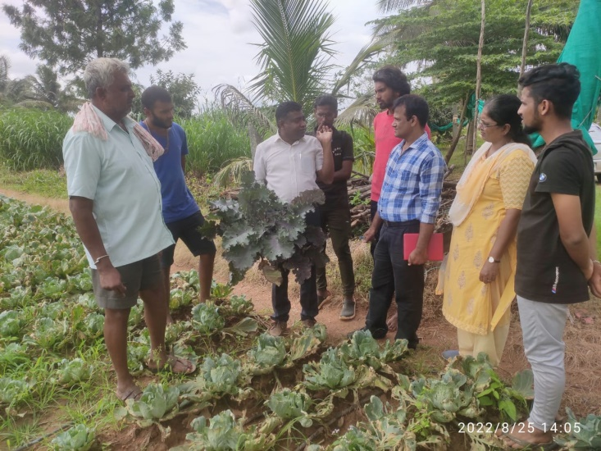 | 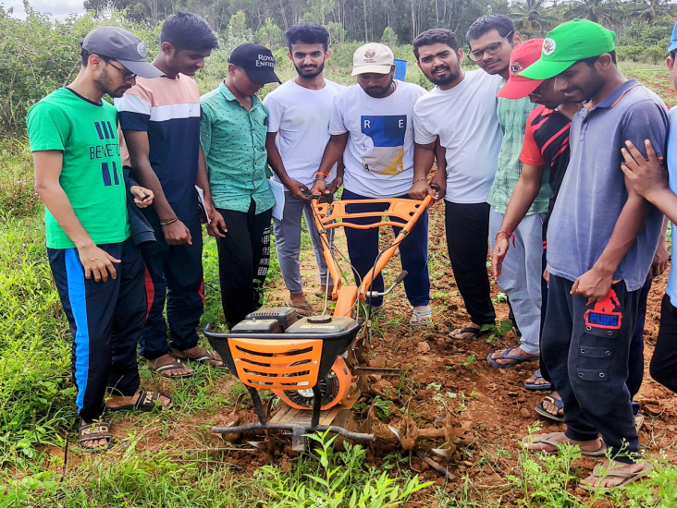
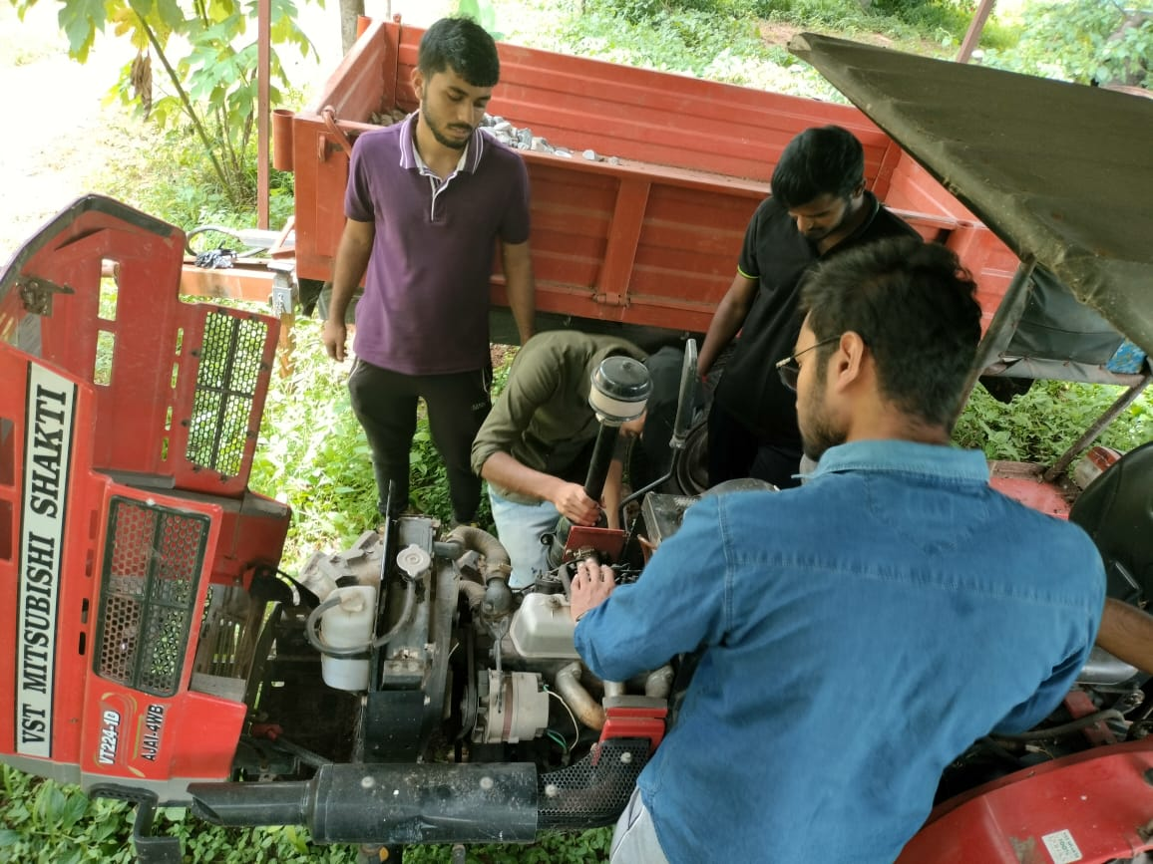 | 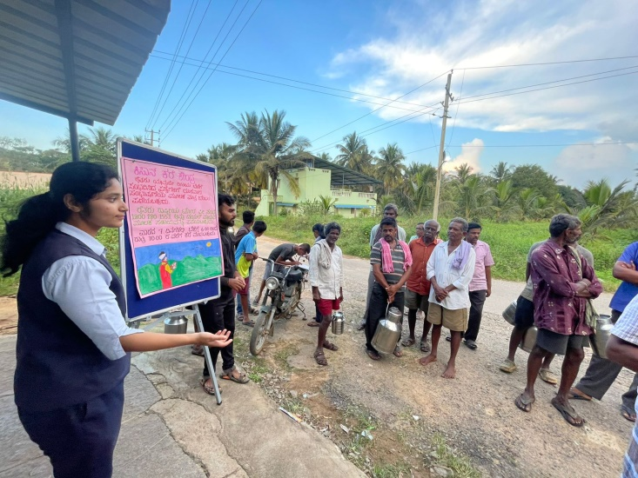
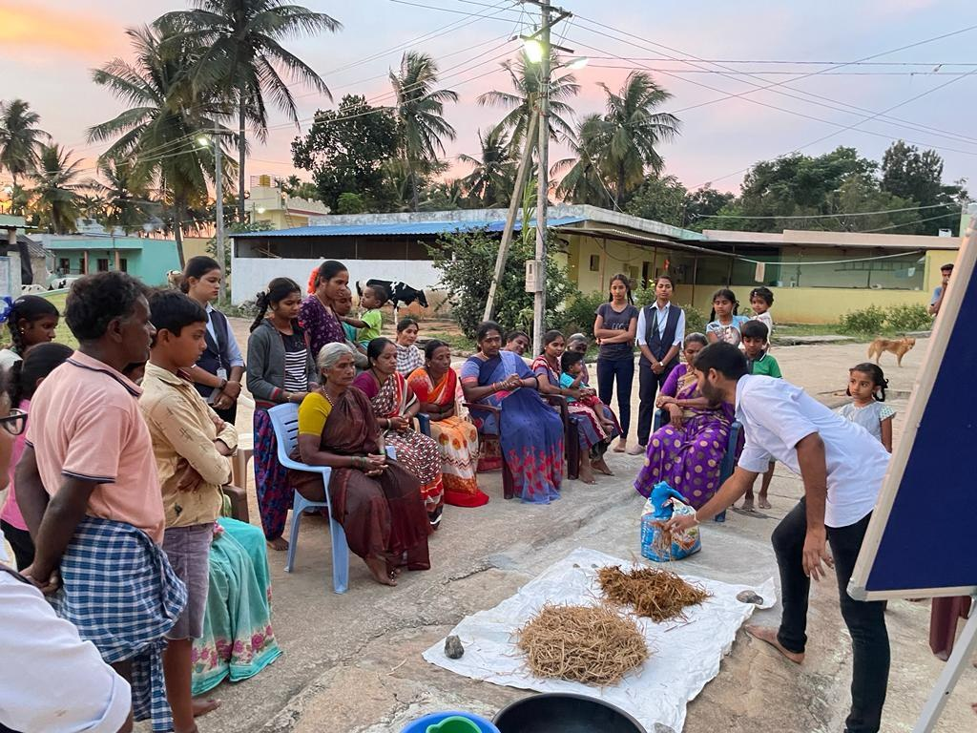 | 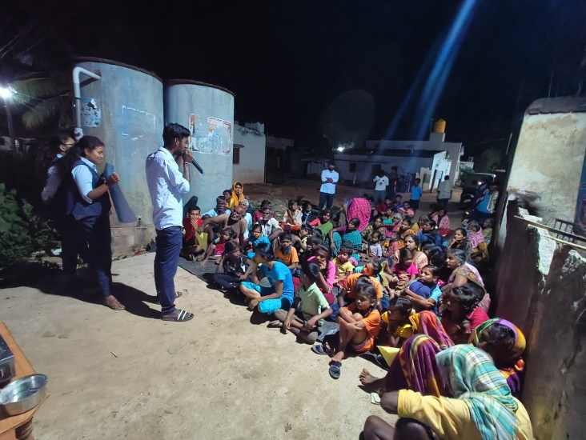
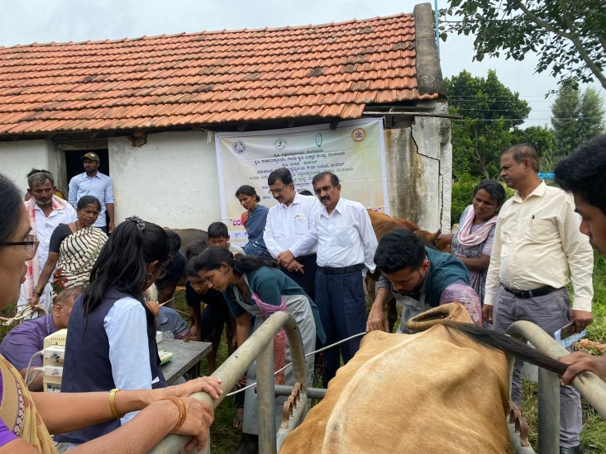 | 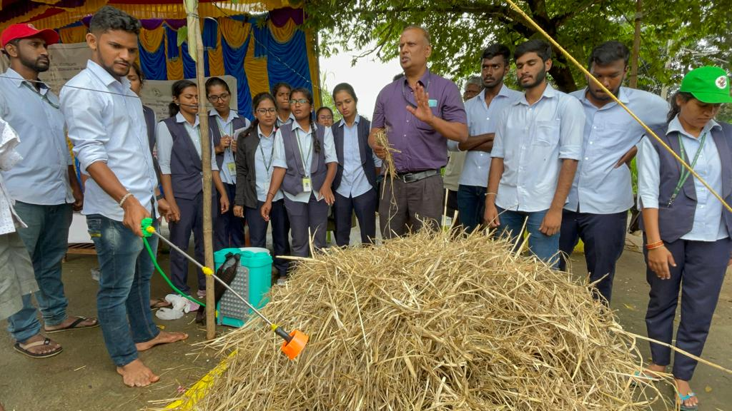
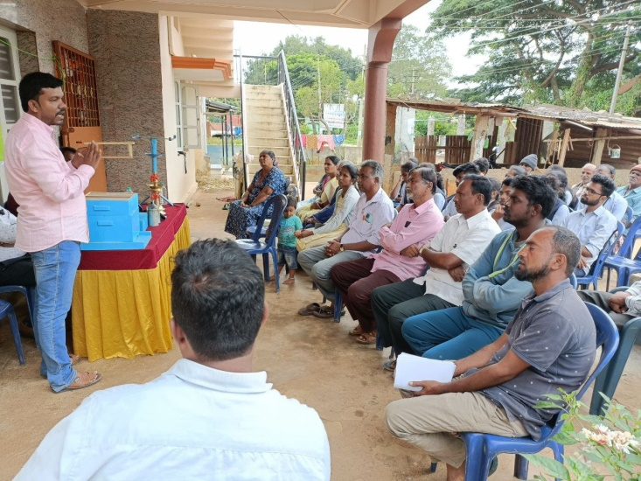 | 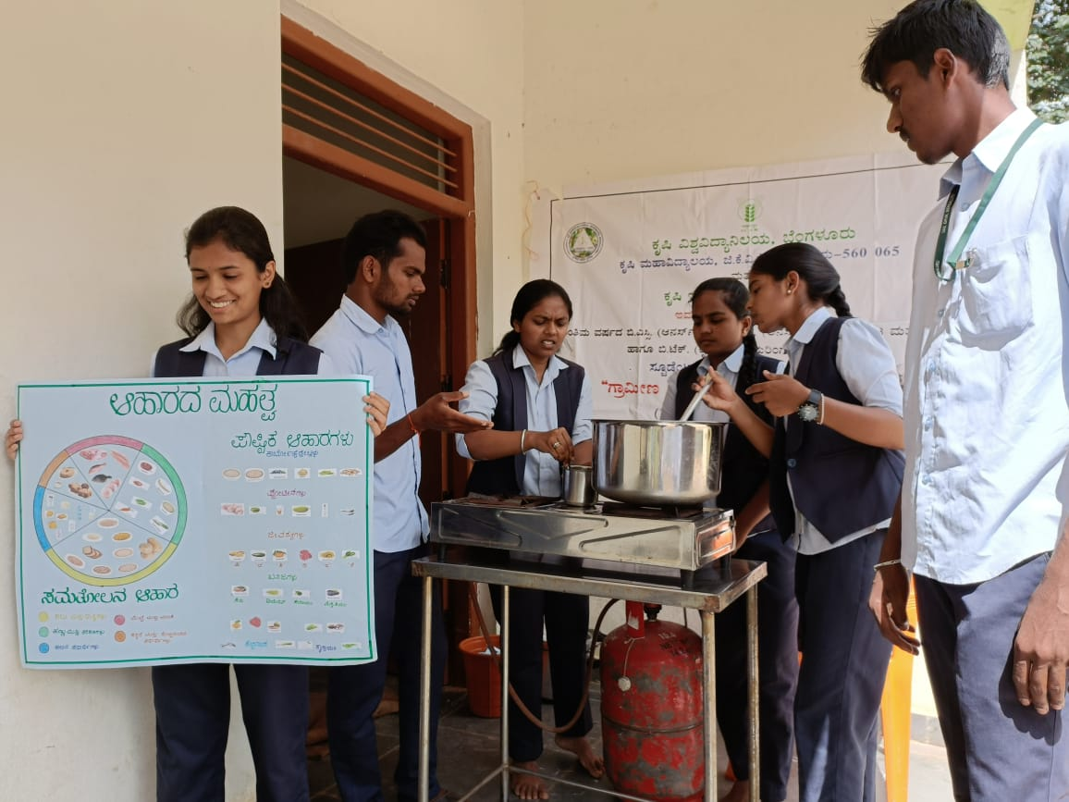
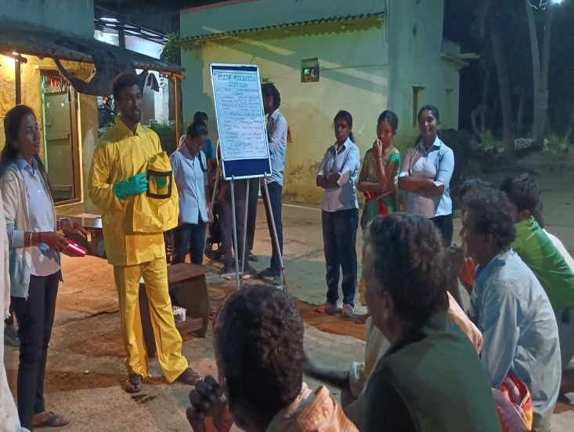 | 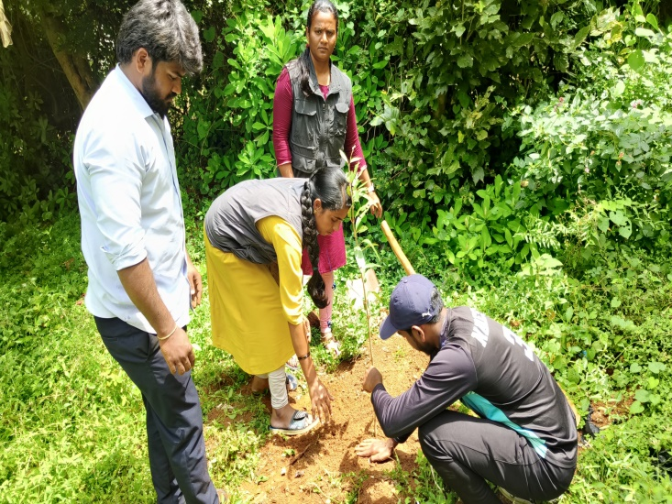
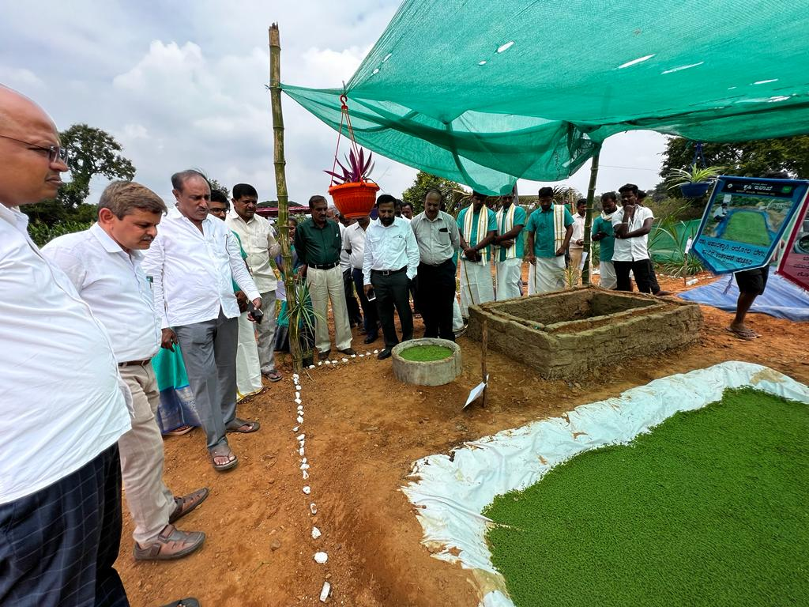 | 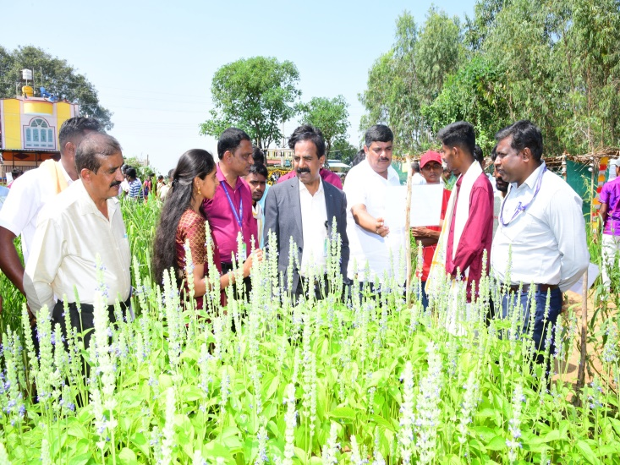
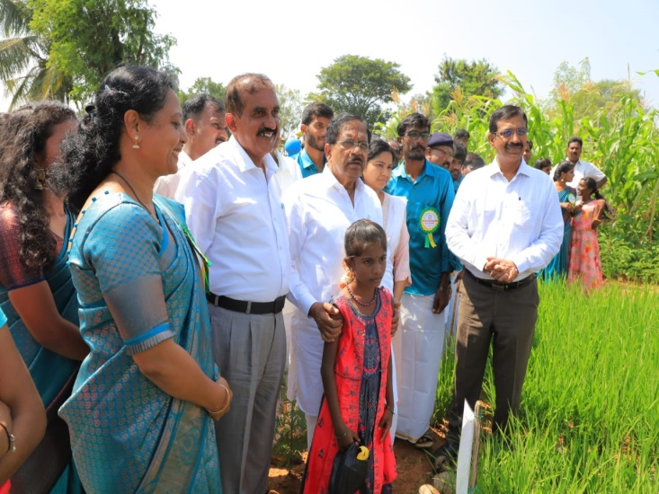 | 