INTRODUCTION

- TOURISM
Tourism is an important sector that contributes significantly to the global economy, creating employment opportunities and generating revenue for countries. There are different types of tourism that people engage in for various reasons, and understanding these types is crucial for policymakers, tourism industry players, and tourists themselves.

  - TYPES OF TOURISM

- Adventure Tourism:

Adventure tourism involves activities that are physically challenging and require a certain level of skill and experience. Some examples of adventure tourism activities include mountaineering, rock climbing, bungee jumping, white-water rafting, and skydiving. Adventure tourists seek new challenges, unique experiences, and an opportunity to test their physical limits.

The characteristics of adventure tourism include risk-taking, excitement, adrenaline rush, and exploration. Adventure tourism is also associated with environmental conservation, as it takes place in natural environments such as mountains, rivers, and forests. However, adventure tourism can also have negative impacts on the environment, such as soil erosion, water pollution, and disturbance of wildlife habitats.

Adventure tourism has a positive impact on the economy, as it attracts high-spending tourists who require specialized equipment, guides, and accommodation. Adventure tourism also contributes to the development of rural areas, as many adventure activities take place in remote areas.



- Cultural Tourism:

Cultural tourism involves the exploration of different cultures, traditions, and heritage sites. Cultural tourists visit museums, art
galleries, historical sites, and festivals to learn about the customs and beliefs of different communities. Cultural tourism is also associated with culinary tourism, as tourists seek to taste traditional foods and drinks.

The characteristics of cultural tourism include learning, appreciation of diversity, and immersion in local communities. Cultural tourism also contributes to the preservation of cultural heritage, as tourists provide revenue that can be used to maintain heritage sites and artifacts.

Cultural tourism has a positive impact on the economy, as it creates employment opportunities for local communities and generates revenue for the tourism industry. Cultural tourism also promotes intercultural understanding and social harmony, as tourists learn about different cultures and traditions.

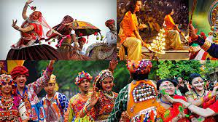

- Eco-Tourism:

Eco-tourism involves travel to natural environments with the aim of appreciating and conserving biodiversity. Eco-tourists visit national parks, wildlife reserves, and natural habitats to observe and learn about the natural world. Eco-tourism also involves activities that have a low impact on the environment, such as hiking, bird-watching, and nature photography.

The characteristics of eco-tourism include conservation, sustainability, and education. Eco-tourism is also associated with responsible travel, as eco-tourists seek to minimize their impact on the environment and support local conservation efforts.

Eco-tourism has a positive impact on the economy, as it creates employment opportunities for local communities and generates revenue for the tourism industry. Eco-tourism also contributes to the conservation of biodiversity, as tourists provide revenue that can be used to protect natural habitats and endangered species.

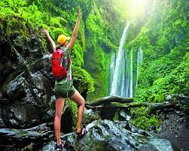

- Health and Wellness Tourism:

Health and wellness tourism involves travel to destinations with the aim of improving one's physical and mental well-being. Health and wellness tourists visit spas, retreats, and wellness centers to engage in activities such as yoga, meditation, massage, and other
therapeutic treatments. Health and wellness tourism also involves activities that promote healthy lifestyles, such as hiking, cycling, and healthy eating.

The characteristics of health and wellness tourism include relaxation, rejuvenation, and self-care. Health and wellness tourism is also associated with medical tourism, as some tourists travel to other countries for medical procedures that are not available or affordable in their home countries.

Health and wellness tourism has a positive impact on the economy, as it creates employment opportunities for local communities and generates revenue for the tourism industry. Health and wellness tourism also promotes healthy lifestyles and disease prevention.



  - TOURISM: BENEFITS AND IMPACTS

Tourism is the act of travelling to a different place for leisure, business or other purposes. It has become a significant global industry and is one of the fastest-growing sectors in the world, with an estimated 1.4 billion international tourist arrivals in 2018. Tourism provides numerous benefits to both the traveller and the host country, but it also has some negative impacts that need to be addressed.

One of the most significant benefits of tourism is economic development. It generates income and employment opportunities for the local population, which can help reduce poverty and increase the standard of living. Tourism also helps diversify the economy, reducing reliance on a single industry, and it can attract foreign investment, increasing the competitiveness of the host country. Another benefit of tourism is cultural exchange. Travellers have the opportunity to learn about different cultures, traditions, and ways of life, which can promote mutual understanding and respect. This cultural exchange can also contribute to the preservation and promotion of cultural heritage sites, which can boost tourism and provide educational opportunities.

In addition to economic and cultural benefits, tourism can also have environmental benefits. The tourism industry can support the conservation and protection of natural areas, such as national parks and wildlife reserves. By creating economic incentives for conservation, tourism can help reduce the pressure on natural resources and ecosystems. However, tourism also has negative impacts that need to be addressed. One of the most significant is the environmental impact. The tourism industry can contribute to pollution, waste, and other environmental problems, particularly in popular tourist destinations. This can result in the degradation of natural resources and ecosystems, which can negatively impact local communities and the tourism industry itself.
Another negative impact of tourism is the social impact. Tourists can put pressure on local communities and resources, leading to cultural erosion and social disruption. Tourism can also contribute to the displacement of local communities and the loss of traditional livelihoods.
To address these negative impacts, it is essential to promote sustainable tourism practices. Sustainable tourism aims to minimize the negative impacts of tourism while maximizing the benefits. This can include initiatives such as promoting responsible tourism practices, supporting local communities and economies, and protecting the environment and cultural heritage sites.
Tourism is a significant global industry that provides numerous benefits to both the traveller and the host country. However, it also has negative impacts that need to be addressed, particularly in terms of environmental and social impact. Sustainable tourism practices can help minimize these negative impacts and promote a more responsible and sustainable tourism industry. As a global community, we must work together to ensure that tourism can continue to provide economic, cultural, and environmental benefits for generations to come.

The characteristics of eco-tourism include conservation, sustainability, and education. Eco-tourism is also associated with responsible travel, as eco-tourists seek to minimize their impact on the environment and support local conservation efforts.
Eco-tourism has a positive impact on the economy, as it creates employment opportunities for local communities and generates revenue for the tourism industry. Eco-tourism also contributes to the conservation of biodiversity, as tourists provide revenue that can be used to protect natural habitats and endangered species.

  - TYPES OF TOURISM IN INDIA

India is a diverse country with a rich cultural heritage and natural beauty. It is a popular tourist destination that offers a wide range of tourism experiences to its visitors. From the majestic Himalayas to the sunny beaches of Goa, from the historic forts and palaces to the colorful festivals and traditions, India has something to offer to everyone.
A. Cultural Tourism
Cultural tourism is one of the most popular types of tourism in India. India has a rich cultural heritage and history, and tourists from around the world come to India to experience it. India is home to many ancient monuments, forts, palaces, and temples that are famous for their architectural beauty and historical significance. The most popular cultural destinations in India include the Taj Mahal, the Red Fort, Khajuraho Temples, Hampi, and the Ajanta and Ellora caves.

B. Adventure Tourism
India is also a popular destination for adventure tourism. With its vast mountain ranges, rivers, and beaches, India offers a wide range of adventure activities to its
visitors. Trekking, camping, skiing, rock climbing, river rafting, bungee jumping, and paragliding are some of the popular adventure activities in India. Some of the popular adventure destinations in India include the Himalayas, Ladakh, Goa, Rishikesh, and Darjeeling.

C. Wildlife Tourism
India is home to a diverse range of flora and fauna, and it is a popular destination for wildlife tourism. The country has many national parks, wildlife sanctuaries, and reserves that are home to some of the rarest and most endangered species of animals and birds. The most popular wildlife destinations in India include the Jim Corbett National Park, Ranthambore National Park, Bandhavgarh National Park, and Kanha
National Park.

D. Beach Tourism
India has a long coastline of over 7,000 kilometers, and it is a popular destination for beach tourism. The beaches in India are known for their beauty, serenity, and sun-soaked sands. The most popular beach destinations in India include Goa, Kerala, Andaman, and Nicobar Islands, and Puri in Odisha.

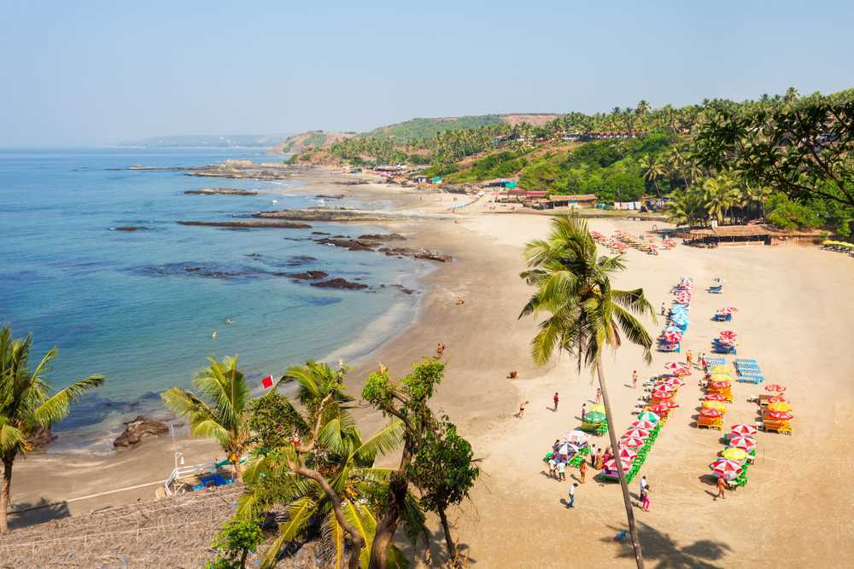

E. Medical Tourism
India is also a popular destination for medical tourism. The country has world-class medical facilities and experienced doctors who provide high-quality medical treatments at affordable prices. Some of the popular medical treatments in India include Ayurveda, yoga, and meditation, cosmetic surgery, dental
care, and cardiac surgeries.

F. Religious Tourism
India is a land of spirituality and religion, and it is a popular destination for religious tourism. The country is home to many holy shrines, temples, and pilgrimage centers that are visited by millions of devotees every year. The most popular religious destinations in India include the Char Dham Yatra, Amarnath Yatra, Vaishno Devi Yatra, and the Kumbh Mela.

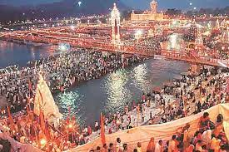
In conclusion, India is a country that offers a wide range of tourism experiences to its visitors. Whether you are looking for adventure, relaxation, culture, spirituality, or medical treatment, India has something for everyone. With its diverse natural beauty, rich cultural heritage, and warm hospitality, India is truly a traveler's paradise.

- AGRITOURISM

  - Agritourism through the ages

Agritourism, also known as agricultural tourism, is a type of tourism that involves visiting and engaging in activities on farms, ranches, and other agricultural enterprises. It has gained popularity in recent years as a way for consumers to connect with the source of their food and learn about sustainable farming practices. Agritourism has a long and varied history, dating back to ancient times, and has evolved in response to changing social, economic, and environmental conditions.

The earliest known form of agritourism dates back to ancient civilizations, such as the Greeks and Romans, who organized agricultural festivals and celebrations. These events served as an opportunity for farmers to showcase their crops and livestock and for communities to come together and celebrate their agricultural heritage. In ancient Egypt, farmers would host guests on their farms during the annual harvest season and provide food and lodging in exchange for labor.

In Europe, the tradition of agritourism continued throughout the Middle Ages and into the Renaissance. Monasteries and castles often had extensive gardens and farms that produced food for the residents and visitors. These sites also served as pilgrimage destinations, and visitors would often stay for extended periods of time, engaging in agricultural work as a form of penance or spiritual practice.

During the 19th century, agritourism began to take on a more commercial form as rail travel and tourism became more widespread. Farmers in rural areas began to offer lodging and meals to travelers, often providing an escape from the noise and bustle of urban life. This type of agritourism was particularly popular in Europe and the United States, where it offered a glimpse into the simpler, more traditional way of life that many urbanites idealized.

In the United States, the rise of agritourism in the 19th century was closely tied to the development of the national park system. Many farmers and ranchers who lived near the parks began offering lodging and recreational activities to visitors, such as horseback riding, fishing, and hunting. This type of agritourism remains popular today, particularly in Western states such as Montana and Wyoming.

The 20th century saw a decline in agritourism in many parts of the world as industrialization and urbanization made farming less central to daily life. However, in the latter half of the century, agritourism began to make a comeback as people became more interested in the origins of their food and the impact of agriculture on the environment. This renewed interest in agritourism was also driven by the growth of the organic and local food movements, which emphasized the importance of sustainable agriculture and the benefits of eating locally sourced food.

Today, agritourism is a global phenomenon, with farms and ranches offering a wide range of activities and experiences to visitors. In addition to traditional forms of agritourism such as farm stays and guided tours, many farms also offer cooking classes, wine tastings, and other culinary experiences. Some farms have even diversified into non-agricultural activities such as camping, hiking, and outdoor recreation.

The rise of agritourism has had significant economic and social impacts in many rural communities. For farmers, agritourism can provide an important source of income, especially during the off-season when traditional farming activities may be less profitable. It can also provide opportunities for diversification, allowing farmers to supplement their income with activities such as direct-to-consumer sales of value-added products or other forms of hospitality.

Agritourism can also help to promote rural development by attracting tourists to areas that may not have many other attractions. In some cases, agritourism has even helped to revitalize struggling rural communities, providing a new source of jobs and economic activity. For visitors, agritourism can provide a unique and authentic experience of rural life.

2.1. TYPES OF AGRI-TOURISM

Agricultural tourism, also known as agri-tourism, is a type of tourism that involves visiting a working farm or agricultural operation for the purpose of experiencing and learning about rural life, agriculture, and food production. Agri-tourism can take many forms, depending on the type of farm or agricultural operation, the interests of the visitors, and the local culture and customs.
- Farm Stays
Farm stays are a popular type of agri-tourism that allows visitors to stay overnight on a working farm. Visitors can participate in farm activities such as milking cows, feeding animals, collecting eggs, and harvesting crops. Farm stays can range from rustic camping experiences to luxurious farmhouses and cottages with all the modern amenities. This type of agri-tourism is ideal for families and groups who want to experience farm life up close and personal.
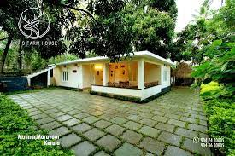
- Farm Tours
Farm tours are another common type of agri-tourism that involves guided tours of a working farm. Visitors can learn about the various crops and livestock raised on the farm, as well as the farming methods and techniques used. Some farm tours also include demonstrations of agricultural equipment, such as tractors and harvesters. This type of agri-tourism is ideal for individuals and groups who want to learn more about agriculture and food production.

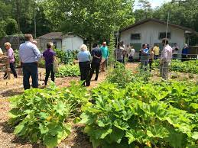

- Farmers' Markets
Farmers' markets are a type of agri-tourism that allows visitors to purchase locally grown produce, meats, and dairy products directly from the farmers who produce them. Many farmers' markets also feature live music, cooking demonstrations, and other activities that showcase local culture and traditions. This type of agri-tourism is ideal for foodies and those who are interested in sustainable agriculture and local food systems.
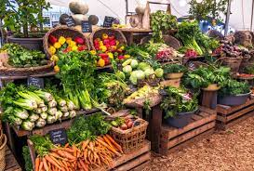

- Vineyard Tours
Vineyard tours are a type of agri-tourism that involves visiting a winery or vineyard and learning about the wine-making process. Visitors can tour the vineyard, learn about the different grape varieties, and see how wine is made and aged. Some vineyard tours also include wine tastings and food pairings. This type of agri-tourism is ideal for wine lovers and those who want to learn more about the art and science of wine-making.
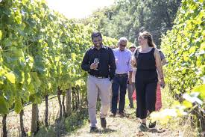
- Culinary Tourism
Culinary tourism is a type of agri-tourism that focuses on food and beverage experiences. This can include cooking classes, food and wine pairings, farm-to-table dinners, and other culinary activities that showcase local cuisine and ingredients. Culinary tourism is ideal for foodies and those who want to learn more about regional food cultures and traditions.

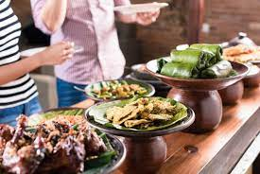
- Agritainment
Agritainment is a type of agri-tourism that combines agriculture and entertainment. This can include activities such as corn mazes, hayrides, petting zoos, and other farm-themed attractions. Agritainment is ideal for families and groups who want to have fun while learning about agriculture and farm life.

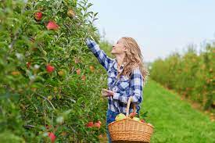
Agri-tourism is a diverse and vibrant industry that offers many different types of experiences for visitors. From farm stays and farm tours to culinary tourism and agritainment, there is something for everyone who wants to learn more about agriculture, food production, and rural life. Agri-tourism also provides an opportunity for farmers and agricultural operators to diversify their income streams and educate the public about the importance of agriculture to our society and economy.

Agritourism is a relatively new industry in India, but it is growing rapidly as more and more farmers and rural entrepreneurs recognize the potential of this sector. Agritourism in India is a unique experience that combines the beauty of rural life with the vibrant culture and traditions of the country. In this essay, we will explore the history, current state, and future prospects of agritourism in India.

  - HISTORY OF AGRITOURISM IN INDIA

The concept of agritourism in India is not new. In fact, it has been a part of the country's rural culture for centuries. India has a rich agricultural heritage, and many of the country's festivals and traditions are linked to the farming calendar. For example, the harvest festival of Pongal is celebrated in Tamil Nadu to give thanks for a bountiful crop, and the Bihu festival is celebrated in Assam to mark the onset of the agricultural season. However, it was not until the 1990s that the term "agritourism" came into use in India. The state of Maharashtra was one of
the first to recognize the potential of this sector and launched a program to promote agritourism in the state. Since then, other states such as Kerala, Karnataka, and Tamil Nadu have also developed agritourism programs to boost rural tourism and provide income opportunities for farmers.

    - Current State of Agritourism in India
Agritourism in India is still in its nascent stages, but it is growing rapidly. According to a report by the World Tourism Organization, India has the potential to become a major player in the global agritourism market. The report estimates that the agritourism sector in India could generate up to 20% of the country's tourism revenue by 2025.There are many different types of agritourism experiences available in India, ranging from farm stays and farm tours to culinary experiences and cultural activities. Some of the popular agritourism destinations in India include:

Rajasthan - Known for its royal palaces and rich cultural heritage, Rajasthan is also home to many agritourism destinations that showcase the state's rural life and agriculture. Visitors can experience traditional Rajasthani cuisine, learn about local farming practices, and participate in cultural activities such as folk music and dance.
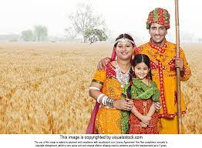

Kerala - Kerala is known for its lush greenery, backwaters, and tropical beaches, but it is also home to many agritourism destinations that showcase the state's agricultural heritage. Visitors can learn about organic farming practices, participate in cooking classes, and enjoy the local cuisine.

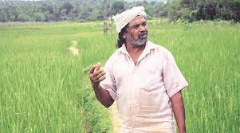
Maharashtra - Maharashtra was one of the first states to promote agritourism in India, and it remains a popular destination for visitors who want to experience rural life and agriculture. The state is known for its vineyards, orange orchards, and strawberry farms, and visitors can enjoy farm stays, farm tours, and other agritourism experiences.

  - Tourism Ministry India
The Ministry of Tourism is a government body responsible for the development and promotion of tourism in India. Tourism is a significant industry in India, contributing to the country's economic growth and creating employment opportunities for millions of people. The ministry plays a crucial role in driving tourism growth, ensuring that India remains a top destination for visitors from around the world.The ministry has been working towards the development of tourism infrastructure in India, which includes the construction of hotels, resorts, and other tourist facilities. They have also been working to improve transportation, such as building new airports and expanding the railway network. Additionally, the ministry has been promoting the development of new tourist destinations and improving existing ones. This has helped to diversify India's tourism offerings, providing visitors with a range of experiences that cater to their interests.

One of the key functions of the Ministry of Tourism is to promote India as a tourist destination. They work with various stakeholders, including tour operators, travel agents, and airlines, to showcase India's cultural, historical, and natural attractions. The ministry has launched several campaigns to attract tourists to India, such as the "Incredible India" campaign, which highlights the country's diverse cultural heritage and natural beauty. This campaign has been very successful in raising awareness of India as a tourist destination and increasing the number of visitors to the country.

Another important function of the ministry is to support the development of the tourism industry at the state level. The ministry works closely with state tourism departments to identify areas of potential growth and provide them with the necessary support to develop their tourism infrastructure. This includes providing funding for tourism projects, training for tourism professionals, and marketing support to promote tourism in the state.

The Ministry of Tourism also plays a role in promoting sustainable tourism practices. They work with industry stakeholders to promote responsible tourism, which includes minimizing the environmental impact of tourism activities and supporting local communities. The ministry has launched several initiatives to promote sustainable tourism, such as the "Clean India" campaign, which aims to improve the cleanliness and hygiene of tourist destinations.

In recent years, the Ministry of Tourism has focused on developing new tourism products and experiences. This includes promoting adventure tourism, eco-tourism, and medical tourism. Adventure tourism, which includes activities such as trekking, camping, and rafting, has become increasingly popular in India, and the ministry has been working to promote adventure tourism destinations across the country. Eco-tourism, which focuses on sustainable tourism practices and nature conservation, has also been promoted as a way to attract visitors to India's natural attractions. Medical tourism, which involves travelling to India for medical treatment, has also been a growing sector, with the country's advanced healthcare facilities and affordable medical treatments attracting patients from around the world.

The Ministry of Tourism has also been working to promote digital tourism in India. This includes developing online platforms for tourism promotion, such as the "Incredible India" website and mobile app, which provides information about tourist destinations, attractions, and travel tips. The ministry has also been promoting the use of technology in tourism, such as using virtual reality and augmented reality to enhance the tourist experience.

In conclusion, the Ministry of Tourism plays a vital role in promoting and developing tourism in India. Their efforts to develop tourism infrastructure, promote sustainable tourism practices, and support state-level tourism development have helped to create a diverse and vibrant tourism industry in India. With the growing popularity of adventure tourism, eco-tourism, and medical tourism, the ministry's focus on developing new tourism products and experiences will help to ensure that India remains a top destination for tourists from around the world.
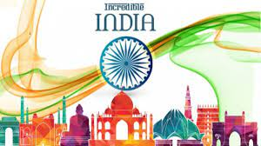

  - Agritourism Development Corporation, Pune
Agritourism is a type of tourism that combines elements of agricultural activities with the recreational experiences of visitors. It offers an opportunity to tourists to explore the local culture, cuisine, and agricultural practices of a region while also providing economic benefits to farmers and rural communities. The Agritourism Development Corporation (ATDC) in Pune, Maharashtra, India, is an excellent example of an organization that is working to promote agritourism in the region and provide a platform for farmers and tourists to come together.

The Agritourism Development Corporation was established in 2005 by the Maharashtra State Government as a part of its initiative to promote sustainable rural tourism in the state. The primary aim of the corporation is to develop and promote agritourism as an alternative source of income for farmers and rural communities. The corporation provides a platform for farmers to showcase their agricultural practices, traditions, and local culture to tourists while also generating additional income for themselves.

Pune, located in the western part of Maharashtra, is a hub for agricultural activities and is known for its rich agricultural diversity. The region produces a variety of crops, including fruits, vegetables, grains, and spices. The Agritourism Development Corporation in Pune has identified more than 200 farm-based tourism sites across the district, including organic farms, dairy farms, and vineyards. These sites offer a range of experiences, including farm stays, nature walks, bird watching, cooking classes, and local food tastings.

One of the key objectives of the Agritourism Development Corporation is to create awareness about agritourism among farmers and rural communities. The corporation conducts training programs for farmers and their families to help them understand the potential of agritourism and how to develop their farm as a tourist destination. The training programs cover topics such as farm management, hospitality, marketing, and customer service. The corporation also provides financial assistance to farmers to upgrade their infrastructure, such as building guesthouses, providing clean water, and improving sanitation facilities.

The Agritourism Development Corporation also works closely with tour operators, travel agents, and other stakeholders in the tourism industry to promote agritourism in the region. The corporation organizes fam trips (familiarization trips) for tour operators to showcase the various agritourism sites in the region. The fam trips help the tour operators to understand the experiences that are on offer and help them to promote these experiences to their clients.

The Agritourism Development Corporation also organizes various events and festivals throughout the year to promote agritourism in the region. These events include farm fairs, food festivals, and cultural events. The events provide an opportunity for farmers to showcase their products and services to tourists and create awareness about the various agritourism sites in the region.

The Agritourism Development Corporation has been successful in creating a sustainable tourism model that benefits farmers, rural communities, and tourists. Agritourism has provided an alternative source of income for farmers, which has helped to reduce their dependency on agriculture. Agritourism has also generated employment opportunities for local people and has helped to promote the local culture and traditions. For tourists, agritourism offers a unique and authentic experience that helps them to understand the local culture, cuisine, and agricultural practices of the region.

The Agritourism Development Corporation in Pune, Maharashtra, is an excellent example of an organization that is working to promote sustainable rural tourism. Agritourism has the potential to transform rural economies and create a more sustainable future for farmers and rural communities. The Agritourism Development Corporation has shown that with the right support and infrastructure, agritourism can be a viable and sustainable source of income for farmers and a unique and authentic experience for tourists.

  - Pandurang Taware and Indian Agritourism
Pandurang Taware, also known as 'Bhau' Taware, is a renowned personality in the field of agriculture and rural development. He is the founder of Agri-tourism Development Corporation, which has transformed the face of rural tourism in Maharashtra, India. Bhau Taware's vision of promoting agriculture-based tourism has not only given a boost to the rural economy but has also helped in preserving the traditional way of life in rural areas.
Agritourism is a form of tourism that involves visiting agricultural areas, farms, or ranches. It is a unique way of experiencing the rural lifestyle, culture, and traditions of a particular region. Agritourism is gaining popularity all over the world, and it has become an essential component of sustainable tourism.

Bhau Taware's journey began in 2005 when he started promoting agri-tourism in his village, Pachnai, in Maharashtra. He was a farmer by profession and had a keen interest in preserving the traditional way of life. Bhau Taware realized that agriculture could be an important source of income for rural areas, and hence, he started promoting agri-tourism in his village.

Initially, Bhau Taware faced several challenges in promoting agri-tourism. People were not aware of the concept, and there was a lack of infrastructure and facilities for tourists. However, Bhau Taware was determined to make a difference, and he started working towards developing agri-tourism in his village. Bhau Taware's efforts paid off, and soon, his village became a popular destination for tourists who wanted to experience the rural way of life. Bhau Taware's success inspired him to establish the Agri-tourism Development Corporation in 2008, with the aim of promoting agri-tourism in Maharashtra.

The Agri-tourism Development Corporation has been instrumental in developing the infrastructure and facilities for agri-tourism in Maharashtra. The corporation provides training to farmers and villagers on how to host tourists and how to provide them with a unique rural experience. The corporation also helps in marketing the agri-tourism destinations and in promoting rural tourism in Maharashtra.

Today, Maharashtra is a leading state in agri-tourism, and it has become a major source of income for rural areas. Agri-tourism has helped in preserving the traditional way of life, culture, and heritage of rural areas, and it has also helped in promoting sustainable tourism. Bhau Taware's vision of promoting agri-tourism has been a game-changer in the tourism industry, and it has opened up new avenues for rural development.

In conclusion, Bhau Taware's contribution to the development of agri-tourism in Maharashtra is commendable. His vision and determination have transformed the face of rural tourism in Maharashtra, and it has helped in preserving the traditional way of life in rural areas. Agri-tourism has become an important source of income for rural areas, and it has also helped in promoting sustainable tourism. Bhau Taware's success story is an inspiration for many, and it highlights the importance of promoting agriculture-based tourism for rural development.

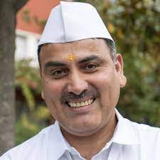

  - Farmstays in India

India is a country that boasts of a rich and diverse agricultural heritage. The agrarian lifestyle and practices in the country have been passed down for centuries, and still play a significant role in shaping the economy and culture of the country. One way to experience this lifestyle is through farmstays, which provide visitors with a chance to live and work on a farm, learning about the local agricultural practices and culture. In this essay, we will explore some
of the major farmstays in India.

- The Farm, Pune
Located just outside the city of Pune in Maharashtra, The Farm is a popular destination for those looking for a rural getaway. Spread over 45 acres, the farm offers visitors a chance to experience the joys of farm life, including milking cows, harvesting fruits and vegetables, and caring for animals. The farmstay also offers a range of activities such as yoga, pottery classes, and bird-watching. Visitors can stay in one of the farm's rustic cottages or tents, and enjoy delicious farm-to-table meals prepared using fresh ingredients grown on the property.



- Aanvis Inn, Goa
Aanvis Inn is a unique farmstay located in the small village of Camurlim in North Goa. The farmstay is spread over 5 acres and is surrounded by lush greenery and tropical fruit trees. Visitors can participate in a range of activities, including fishing, bird-watching, and kayaking. They can also learn about traditional Goan farming practices, such as rice cultivation and coconut harvesting. The farmstay has comfortable rooms and cottages, and visitors can enjoy delicious Goan cuisine prepared using fresh ingredients sourced from the farm.

- Kutch Adventures India, Gujarat
Kutch Adventures India is a farmstay located in the remote village of Hodka in the Kutch district of Gujarat. The farmstay is a part of a larger eco-tourism initiative that aims to promote
sustainable agriculture and rural development in the region. Visitors can participate in a range of activities such as milking cows, planting crops, and cooking traditional Gujarati dishes. The farmstay also offers guided tours of the surrounding villages and wildlife sanctuaries, providing visitors with a unique insight into the local culture and biodiversity.

D. Banjara Camps and Retreats, Himachal Pradesh
Banjara Camps and Retreats is a farm stay located in the picturesque village of Sangla in the Kinnaur district of Himachal Pradesh. The farmstay is spread over 20 acres and offers visitors a chance to experience the beauty and serenity of the Himalayan region. Visitors can participate in a range of activities such as trekking, mountain biking, and apple-picking. They can also learn about the local agriculture practices, such as terraced farming and traditional irrigation techniques. The farmstay has comfortable tents and cottages, and visitors can enjoy delicious Himachali cuisine prepared using fresh ingredients grown on the property.

- Spice Village, Kerala
Spice Village is a farmstay located in the village of Kumily in the Periyar National Park in Kerala. The farmstay is spread over 14 acres and is surrounded by lush forests and spice plantations. Visitors can participate in a range of activities such as nature walks, bird-watching, and spice tours. They can also learn about the local agriculture practices, such as organic farming and spice cultivation. The farmstay has comfortable cottages and villas, and visitors can enjoy delicious Kerala cuisine prepared using fresh ingredients sourced from the farm.

Farmstays provide a unique opportunity for visitors to experience the joys of rural life and learn about local agriculture practices and culture. These farmstays in India offer visitors a chance to connect with nature and the local community, and to experience the country's rich agricultural heritage.

- AGRITOURISM IN KARNATAKA

Agritourism is a form of tourism that involves visiting farms or agricultural regions to experience the agricultural way of life, learn about farming practices, and enjoy the natural beauty of the countryside. Karnataka, one of the southern states of India, is a perfect destination for agritourism. With its diverse landscapes, rich cultural heritage, and varied agricultural practices, Karnataka offers a unique and immersive agritourism experience to visitors.

Karnataka is known for its diverse topography, which ranges from lush green forests to arid plateaus. The state is also famous for its rich cultural heritage, with ancient temples, palaces, and other historical monuments that attract tourists from all over the world. However, in recent years, agritourism has emerged as a new and exciting tourism segment in Karnataka, offering visitors a chance to experience the rural way of life and learn about farming practices.

The state's agriculture sector is diverse, with a wide range of crops grown across its various regions. From the verdant paddy fields of the coastal region to the coffee plantations of the Western Ghats and the sugarcane fields of the northern plains, Karnataka's agricultural landscape is both varied and stunning. Agritourism in Karnataka offers visitors a chance to experience this diversity firsthand, with farm visits, farm stays, and other activities that showcase the region's agricultural practices.

One of the most popular agritourism activities in Karnataka is visiting coffee plantations in the Western Ghats. These plantations offer visitors a chance to learn about the coffee growing process, from planting to harvesting and processing. Visitors can also participate in coffee tasting sessions, where they can sample different varieties of coffee and learn about the different brewing methods. Many coffee plantations also offer farm stays, where visitors can experience the rural way of life and immerse themselves in the local culture.

Another popular agritourism activity in Karnataka is visiting spice plantations. These plantations, located mainly in the coastal region, offer visitors a chance to learn about the various spices grown in the region, including pepper, cardamom, cinnamon, and cloves. Visitors can also participate in spice tasting sessions, where they can sample different spices and learn about their uses in local cuisine.

Apart from coffee and spice plantations, agritourism in Karnataka also offers visitors a chance to experience rural life and traditional farming practices. Many farms in the state offer farm visits and farm stays, where visitors can learn about traditional farming practices, such as organic farming, and participate in activities like milking cows, ploughing fields, and harvesting crops.

Agritourism is a growing segment of tourism in Karnataka, offering visitors a chance to experience the region's diverse agricultural practices and rural way of life. With its varied landscapes, rich cultural heritage, and unique agricultural practices, Karnataka is a perfect destination for those looking to experience the beauty and bounty of rural India.

  - Types of agri-tourism in Karnataka

Agriculture has always been an integral part of economy, with more than 50% of the population engaged in agriculture and allied activities. Agri-tourism, a subset of rural tourism, has emerged as a viable alternative to traditional farming practices, providing additional income to farmers while preserving the rural landscape and promoting sustainable tourism. In this essay, we will explore the various types of agri-tourism in Karnataka, their significance, and the challenges faced by this sector.

A. Farm Stays:

Farm stays are becoming increasingly popular in Karnataka, particularly among urban dwellers seeking a break from the monotony of city life. They provide an opportunity for visitors to experience farm life, participate in agricultural activities such as milking cows, planting crops, and harvesting produce, and learn about local farming practices. Farm stays also offer visitors a chance to sample fresh, locally grown produce, often cooked in traditional regional styles.

Farm stays can be run by individual farmers, cooperative societies, or government organizations. These are primarily located in rural areas, providing visitors with a glimpse into the lives of the rural population. Many farm stays offer additional activities such as bird watching, hiking, or sightseeing in nearby tourist destinations. Some popular farm stay destinations in India include Mahabaleshwar, Coorg, Wayanad, and Munnar.

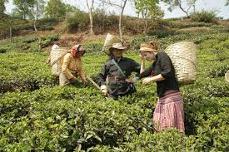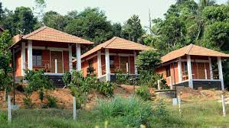

B. Agro-Tourism:

Agro-tourism, also known as agricultural tourism, involves visiting farms or agricultural estates to experience rural life and learn about agricultural practices. It provides visitors with an opportunity to learn about sustainable farming practices, organic farming, and biodiversity conservation. Agro-tourism also promotes rural economic development by creating new revenue streams for farmers and supporting local agriculture.

In India, agro-tourism has gained popularity in recent years, particularly in states such as Maharashtra, Gujarat, and Karnataka. Visitors can participate in activities such as harvesting crops, milking cows, and cooking local cuisine. Agro-tourism also offers visitors an opportunity to learn about traditional medicinal plants, forest conservation, and beekeeping. Some popular agro-tourism destinations in India include Agri-Koli Village in Maharashtra, Patanjali Yogpeeth in Uttarakhand, and the Farm Stay in Coorg.

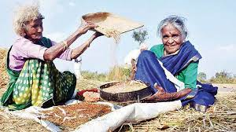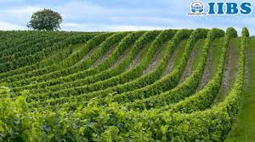

C. Rural Craft Tourism:
Rural craft tourism is a subset of agri-tourism that involves visiting rural artisans and learning about their craft. It provides visitors with an opportunity to learn about traditional handicrafts, such as pottery, weaving, and metalwork, and supports local artisans by promoting their products. Rural craft tourism also preserves traditional art forms that may be in danger of dying out due to urbanization and globalization.

In India, rural craft tourism is prevalent in states such as Rajasthan, Gujarat, and Madhya Pradesh. Visitors can learn about traditional handicrafts such as pottery in Khurja, metalwork in Moradabad, and textile weaving in Bhuj. Rural craft tourism also offers visitors an opportunity to purchase locally made handicrafts, supporting the local economy. Channapatna toys in Karnataka is an added attraction.

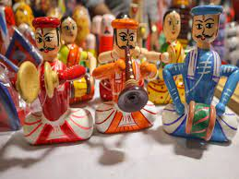
D. Agricultural Fairs:
Agricultural fairs, also known as Krishi Melas, are a popular form of agri-tourism in India. These fairs provide farmers with an opportunity to showcase their agricultural products and techniques, while also providing visitors with an opportunity to learn about new agricultural technologies and practices. Agricultural fairs are usually held at the district or state level and attract a large number of visitors from both rural and urban areas.

Agricultural fairs offer visitors an opportunity to learn about new agricultural technologies, such as irrigation systems, crop rotation, and pest control. Visitors can also participate in competitions such as best crop yield, best livestock, and best farm practices.
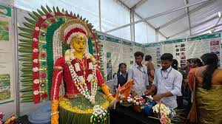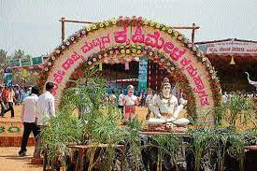

  - Farmstays in Karnataka
Farmstays in Karnataka offer a unique opportunity to experience the rural way of life in India. These farmstays provide an authentic experience of living in the countryside and learning about farming practices, local cuisine, and culture. Karnataka is a state in South India with a rich history, diverse culture, and stunning landscapes. Farmstays in Karnataka offer a chance to explore the state's rural areas, meet local people, and learn about their way of life.

The state of Karnataka has a strong agricultural sector and is known for its production of rice, coffee, spices, and sugarcane. Many farmers in the state have opened up their homes and farms to visitors, providing them with an opportunity to experience the rural way of life. These farmstays offer guests a chance to stay in traditional homes, eat local food, and participate in farming activities.

One of the popular farmstays in Karnataka is the Hasiru Homestay, located in the Coorg district. The homestay is set amidst a coffee plantation and offers guests an opportunity to learn about coffee cultivation and processing. Guests can also participate in activities like birdwatching, nature walks, and fishing. The homestay provides traditional Coorgi food made with local ingredients, giving guests a taste of the region's cuisine.
Another popular farmstay in Karnataka is the Rural Retreat in the Shimoga district. The homestay is located on a 20-acre farm and offers guests an opportunity to participate in farming activities like milking cows, planting crops, and harvesting. The homestay also offers activities like bullock cart rides, birdwatching, and fishing. Guests can also learn about the region's history and culture by visiting nearby temples and historical sites.
The Agro-based Tourism Centre in the Mandya district is another popular farmstay in Karnataka. The homestay is located on a farm that produces sugarcane, paddy, and coconut. Guests can learn about the farming practices used in the region and participate in activities like harvesting sugarcane and making jaggery. The homestay also offers activities like birdwatching and visits to nearby historical sites.
Farmstays in Karnataka offer an excellent opportunity to learn about the region's agriculture, culture, and history. The homestays provide guests with an authentic experience of living in the countryside and participating in farming activities. Guests can also enjoy traditional food made with local ingredients and explore the region's natural beauty. Farmstays in Karnataka are a great way to experience the rural way of life in India and to learn about the region's unique culture and history.

  - Krishi Melas

Krishi Melas, also known as agricultural fairs or exhibitions, are events that showcase the latest advancements in agriculture and farming practices. These events bring together farmers, researchers, and agricultural experts to share knowledge, exchange ideas and innovations, and promote the use of new technologies and techniques in agriculture. Krishi Melas are important events for the development of the agricultural sector, as they help farmers stay up-to-date with the latest practices and technologies in the field.

Krishi Melas are usually organized by state governments, agricultural universities, or agricultural research institutions. The events are held in different locations throughout the country, depending on the region's agricultural significance. Krishi Melas are typically held during the harvesting season or before the sowing season, so that farmers can learn about new techniques and technologies that they can use in the upcoming season.

The fairs typically include a range of activities, including exhibitions, seminars, workshops, and demonstrations. These events showcase the latest agricultural technologies and techniques, such as new crop varieties, soil health management practices, irrigation techniques, and post-harvest technologies. Experts from the agricultural sector, including scientists, researchers, and agricultural extension officers, share their knowledge and experiences with the farmers attending the event. Krishi Melas also provide a platform for farmers to interact with each other and share their experiences, challenges, and solutions.

One of the key benefits of Krishi Melas is that they provide farmers with access to new technologies and techniques that they may not have been aware of before. By attending the events, farmers can learn about the latest agricultural practices and technologies that can help them improve their yield, reduce their costs, and increase their profits. Krishi Melas also provide farmers with the opportunity to learn about government schemes and subsidies that can help them improve their farming practices and increase their income.

Krishi Melas are also important for the agricultural industry as a whole. They provide a platform for agricultural companies to showcase their products and services to a large audience of farmers. This helps the companies to market their products and build brand awareness. It also allows farmers to learn about the latest agricultural inputs, such as fertilizers, pesticides, and seeds, which can help them improve their crop yield.

Krishi Melas play an important role in the development of the agricultural sector in India. They provide a platform for farmers, researchers, and agricultural experts to share knowledge and promote the use of new technologies and techniques in agriculture. Krishi Melas are important for farmers as they provide them with access to new technologies and practices that can help them improve their yield, reduce their costs, and increase their profits. These events also benefit the agricultural industry as a whole, by providing a platform for companies to showcase their products and services and for farmers to learn about the latest agricultural inputs.
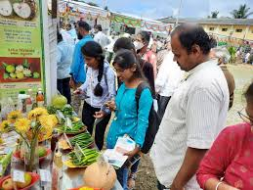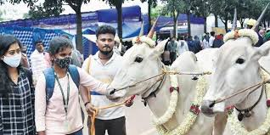

  - Rural Craft Festivals in India

India is a land of rich cultural heritage, and its rural craft festivals are a testament to the same. These festivals not only showcase the creativity of the artisans but also promote their skills, boost their income, and preserve traditional crafts that have been passed down for generations. Here are some of the major rural craft festivals in India:

- Surajkund Craft Mela: Surajkund Craft Mela is one of the most famous rural craft festivals in India. Held in Surajkund, Haryana, every year, the festival brings together artisans from all over India to showcase their crafts. The festival started in 1987 and has since grown to become a major cultural event. The festival attracts thousands of visitors every year, and it's an excellent platform for artisans to showcase their skills.
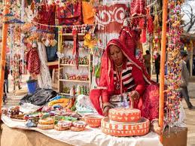
- Kala Ghoda Arts Festival: The Kala Ghoda Arts Festival is held in Mumbai every year and features a wide range of art forms, including rural crafts. The festival showcases the work of artisans from different parts of India, including pottery, embroidery, wood carving, and many more. The festival provides a platform for these artisans to showcase their work to a larger audience and interact with potential buyers.
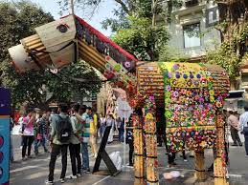
- Dastkari Haat Craft Bazaar: Dastkari Haat Craft Bazaar is an annual event held in Delhi that showcases the work of artisans from all over India. The festival has been held for over 30 years and features a wide range of crafts, including textiles, pottery, woodwork, and metalwork. The festival provides an opportunity for visitors to interact with the artisans and learn more about their craft.
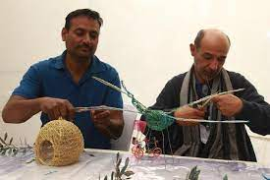

- Desert Festival: The Desert Festival is held in Jaisalmer, Rajasthan, and celebrates the culture and traditions of the Thar desert region. The festival features traditional rural crafts, including leatherwork, pottery, embroidery, and rug making. The festival also includes cultural events such as music and dance performances and a camel race.
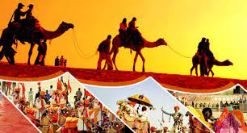
- Tansen Music Festival: The Tansen Music Festival is held in Gwalior, Madhya Pradesh, and celebrates the legacy of the famous musician Tansen. The festival features a range of classical music performances as well as rural crafts such as Chanderi sarees, handmade jewelry, and pottery.
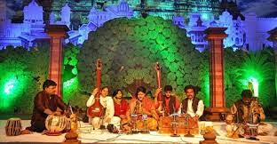

India's rural craft festivals provide a platform for artisans to showcase their skills and promote their crafts to a larger audience. These festivals also help to preserve traditional crafts and promote cultural exchange. The above-mentioned festivals are just a few examples of the many rural craft festivals that take place in India, and they highlight the diversity and richness of India's cultural heritage.
- SCOPE OF AGRITOURISM
Agritourism is the practice of visiting farms, ranches, and other agricultural enterprises for recreational, educational, and leisure purposes. Agritourism provides a unique opportunity for visitors to experience firsthand the farm life and learn about the production processes of agricultural products. This essay explores the scope of agritourism and its potential as a source of income for farmers and rural communities.
The scope of agritourism is vast and varied, ranging from farm stays and tours to festivals and events that celebrate agricultural products. Agritourism activities can include farm tours, tastings, u-pick fruit and vegetable operations, petting zoos, hayrides, corn mazes, pumpkin patches, and much more. With the growing interest in local and sustainable food systems, agritourism has become an increasingly popular way for consumers to connect with their food sources and learn about agricultural practices.
One of the significant advantages of agritourism is its potential to generate additional revenue for farmers and rural communities. Many farmers struggle to make a living solely from agricultural production due to market volatility, weather uncertainties, and other factors. Agritourism provides an additional income stream that can help farmers diversify their operations and increase their resilience to economic shocks.

Moreover, agritourism can create jobs and stimulate economic growth in rural areas. It can also help to preserve the cultural heritage of farming communities and support the conservation of farmland. By promoting sustainable agriculture practices and local food systems, agritourism can help to build more resilient and sustainable rural communities.

Agritourism can also provide educational and recreational opportunities for visitors. Through farm tours and other activities, visitors can learn about the production processes of agricultural products and gain a better understanding of the challenges that farmers face. Agritourism can also promote healthy living and outdoor recreation, providing an alternative to traditional tourist activities that are often focused on urban areas.

However, agritourism also presents some challenges. For example, it can be challenging for farmers to balance the demands of running a farm with the needs of hosting visitors. Agritourism also requires farmers to comply with local regulations and safety standards, which can be a significant barrier for some small-scale operations. Additionally, agritourism can bring increased traffic and other impacts to rural communities, which can create challenges for infrastructure and local residents.
The scope of agritourism is vast, offering a range of opportunities for visitors to connect with farming communities, learn about agricultural production, and experience rural life. Agritourism can provide farmers with an additional source of income, promote economic development in rural areas, and support the conservation of farmland and sustainable agriculture practices. While agritourism does present some challenges, with proper planning and management, it can be a valuable and sustainable way to promote rural tourism and support agricultural communities.
- AGRITOURISM'S PROSPECTS IN THE FUTURE
Agritourism, a form of tourism that involves visiting agricultural areas, is becoming increasingly popular worldwide. This trend is not surprising as more and more people are becoming interested in experiencing authentic rural life and learning about food production and agriculture. Agritourism is also an excellent way to support local farmers and rural communities, making it a win-win situation for everyone involved. In this essay, we will explore the future prospects of agritourism and the potential benefits it can bring to both tourists and the agricultural industry.

One of the most significant advantages of agritourism is that it provides farmers with an additional source of income. Farmers can generate revenue from activities such as farm tours, hayrides, and pumpkin patches, which can supplement their income from traditional farming practices. As a result, agritourism can help keep small farms in operation and prevent them from being bought out by larger, industrial farms.

Another potential benefit of agritourism is that it can create jobs in rural areas. As more tourists visit farms and agricultural areas, there will be a greater need for services such as accommodation, transportation, and food. These services can provide employment opportunities for local people, helping to revitalize rural communities that have suffered from depopulation and unemployment.

Moreover, agritourism can promote sustainable agriculture practices. By exposing visitors to different farming techniques and demonstrating the benefits of sustainable agriculture, farmers can help to educate people about the importance of responsible land use and environmental stewardship. This can also create a market for locally-grown and organic produce, which can help to support sustainable farming practices.

Additionally, agritourism can also have cultural benefits. It can provide visitors with a glimpse into the cultural traditions and lifestyles of rural communities, helping to preserve and promote local heritage. This can also lead to increased cultural exchange and understanding between different communities, which can promote tolerance and mutual respect.

Despite these potential benefits, agritourism is not without its challenges. One significant challenge is the need to balance the commercial aspects of tourism with the agricultural activities of the farm. Farmers need to ensure that tourism activities do not interfere with their farming practices and that visitors understand and respect the importance of their work. This can be challenging, especially for small farms that may not have the resources to invest in the necessary infrastructure and facilities.

Another challenge is the need to manage the environmental impact of agritourism. Increased tourism can lead to additional strain on the local environment, including increased water usage, waste production, and soil erosion. Farmers need to develop sustainable tourism practices that minimize these impacts and ensure that their farms remain productive and healthy.

In conclusion, agritourism has excellent prospects for the future. It can provide farmers with an additional source of income, create jobs in rural areas, promote sustainable agriculture practices, and have cultural benefits. However, it is essential to manage the commercial aspects of tourism carefully and to ensure that environmental impacts are minimized. With careful planning and management, agritourism has the potential to bring significant benefits to both tourists and the agricultural industry.

- RESEARCH STUDIES
I. A case study of agri tourism in Maharashtra by Chaddha and Bakere (2012) was conducted and the researchers have selected this case because it is a novel unique project- first of its kind in IndiaMalegaon - Maharashtra and can be emulated over various states in totality. 152 The Agri Developments Trust a Non Government Organisation (NGO) which was formed with the intention of training farmers on farming techniques awareness. The major objective of the trust was to increase farm productivity after deployment of advanced farming techniques. In 2004, the agri Tourism Development Corporation started agri tourism, as totally new idea over an area of 110 acres owned by agri development trust. After year 2002, tourism activities in India gained momentum due to government endeavours.

Socio-Economic Implications:
This project is replicated in three states in India. The impact factor has been phenomenal as the per capita income has seen a rise. Till date 400 farmers have taken training in agri tourism entrepreneurial aspect. Farmer feedback has revealed that there has been a minimum 33% income rise to basic agriculture income. For example a two acre farm yields Rs.300,000 to Rs.350,000 per annum. Supplementing agriculture with agri tourism activities leaves an additional margin of Rs.100,000 to Rs.150,000 generating a direct employment for 4 people, indirect to approximately 10 individuals as farm man power is always required. The project in the above case has been hailed as a successful business model and is gaining momentum with the fact that agricultural universities and students are going in for site visits to receive training. On 11th April 2012, students of Indian Administrative services received a three day training on site so that in future they could successfully replicate this model in a larger number of states. Agri tourism is a feasible proposition as:
- Agri tourism has the capacity to create a win win situation for both the farmers as well as the tourists. The farmers benefit by deriving additional source of income and tourist hunger natural environment is satiated.
- Employment generation through allied activities like Emu, organic and dairy farming.
- Gender bias is reduced as both male and female get equal opportunities to earn
- Frequency of income generation increases from once a year to once a week.

A SWOT analysis of the agri tourism in India is enumerated in the matrix:

STRENGTHS
- A Strong supplementary source of Income for farmers
- Employment generation
- Rural development
OPPORTUNITIES
- As a new branch of tourism has Immense scope for growth
- More farmers can be the beneficiaries
- Government support can increase the outreach of this tourism
- State owned land can be cultivated and converted to facilitate agri tourism
THREATS
- Climatic conditions
- Being a new area of tourism, less competition so no threats
- Rampant migration from farming to other sectors

WEAKNESS
- Growth of agri tourism is slow.
- Farmers are mostly less educated so need varied training.
- Lack of government support in the form of subsidies
- Less number of agri tourism training centre in India
- Lack of publicity

Conclusions
Tourism forms a significant aspect of the service sector which contributes largely to the Indian economic development. Indian tourism industry is growing at the rate of 10 %, which is two and a half times more than the growth rate at global level. The scope of tourism has varied branches very often depending upon the purpose and circumstances under which the activity is being taken up. In India of late the unique tourism arteries that have gained momentum are health tourism (medical tourism), religious tourism, sports tourism, educational tourism etc. Agri tourism is now an additional artery of the tourism sector in India. Though at present it is in nascent stage, with proper government incubation it can gain flight. There by introducing agritourism concept all over India not only the present growth rate can be sustained but it is also a value addition and can accelerate further growth.

- Singh and Kumar in 2016 on agri-tourism in Uttar Pradesh studied the,
CHALLENGES TO THE AGRI-TOURISM INDUSTRY
Agri-tourism is although a boom for the development of our rural society but if it can positively handled
- Quality of the service
- Complexity in the delivery of the service
- Infrastructural deficiency
- Multi level channel involved this tourism development at local and
- regional level.
- Literacy rate of the farmers and farm owners
- Government Support and Identification
AGRI-TOURISM RECOMMENDED STRATEGIES TO OVERCOME CHALLENGES
Indian farmer need to cater the concept of this agri tourism as diversifying their operation. Explaining the determinant of Agri tourism is a creative strategy for their betterment, however it will not be an easy road map to follow by the farmers or farm owners. A well defined strategy has to be implemented for the development of agri- tourism at national and state level.
The following sections identify these overriding challenges and recommend strategies to address them.

Suggested Strategies to the Indian Agri tourism Industry.

- Proper Recognition of Agri-tourism Industry.
- Government supported policy structure of Agri-tourism
- Education of the farmer and farm owner for the development of the Entrepreneurial skill in their
- work operations.
- Proper Financing Solution for its Enhancement.
- Liability and Risk Management Programs.
- Product and Service Quality Improvement: In terms of the Product quality enhancement as well as
- the delivery of the service has to be elevated up to the standards.
- A Public Private Strategic Partnership Development Model has to be created
- Proper Marketing and Promotional Assistance has to be Provided

Conclusion
Agri-tourism is a supportive system to the agricultural activities in India. It is an Innovative
practices which can be utilized by the famer and farm owners to harvest this opportunity, through a diversified approach.

- Case Analysis Of Dungrajya Village by Srivastava (2016)
This village is situated around 32 km. from Kota, a district of southeast Rajasthan. Total population of the village is 15,000-20,000. Main occupation of the villagers is agriculture. To know more about the village, the researcher visited the area and found just two sites of tourists‟ interest.
Firstly there is a small lake with lots of lotus and at the centre of lake a temple is there. We visited there and found 5 to 8 people sitting outside the temple. They went there chat with them as they were seems elder and mature people of the village. They told that our tourism minister already sanctioned lakhs of rupees for the beautification of Sarovar. There they came to know that the temple inside the Sarovar had a tradition to celebrate its foundation with some Puja on 20 January, 2016. They told that they don‟t have any staying place/ Dharamshala for any visitors. When asked about the heritage or any customs/ handicrafts, they refused that the youths and oldies are only engaged with agricultural activities. There is no other source of earning. They told about the 150 years old temple and a Bavari. The researchers visited that site and found that renovation work has done and the temple is in good shape. After visiting these sites they met Sarpanch of that village. She was innocent and ignorant about the prospects and problems of the village. The previous Sarpanch was mature and experienced. He told about the only school, medical facilities and other services of that village. They all looks very much satisfied with their entire livelihood. The females of the village are confined to only household works.
Findings
1. Kamal Sarovar has the potential to attract tourists. Beautification work had already done. Cleanliness is required around the pond.
2. There is no other source of income other than agriculture.
3. They have no peculiar traditions or cultures but people are very warmth in nature. They welcome their guest with full respect and love.
4. Older people were claiming about the heritage temple that it is older than 150 years but they don‟t have any „patta‟, pillar or any other written manuscript which may proof its heritage value. 5. They are good in agriculture practices.
Scope of Agri-Tourism:
1. An inexpensive gateway: The cost of food, accommodation, recreation and travel and tourism is low, widening the scope of tourism.
2. Curiosity for the urban about farming industry and life style: Agri-tourism, which involves villages and agriculture, has the capacity to satisfy the curiosity of the urban segment by providing scope for re-discovering the rural life, which is rich in diversity.
3. Strong family oriented recreational activities: through rural games, festivals, food, dress. 4. Finding solace with nature friendly life style: Peace and tranquility are in-built in Agri-tourism.
5. Nostalgia for their roots on the farm: For tourists it is like returning back to their roots. 6. Educational value of Agri-Tourism spreading knowledge about Agriculture science where urban students are moving with the pace of technology.

Conclusion
It was just an experiment to judge that whether agritourism will be successful in small villages or not. Tourists experience at village were great. Many tourist revert mail and send many many thanks to the villagers and tour operator for giving such a wonderful experience. University students helped the villagers to tackle the tourists at different times. There is a need to train them morally, ethically and culturally. Making them realize that they are their source of earning.

7. REFERENCES

CHADDA, D., AND BHAKARE, S, 2012, Socio-economic implications of agri tourism in India, Int. Innov. Trade Econ. 30(3)151-155.

GOPAL, R., VARMA, S., AND GOPINATHAN, R., 2008, Rural Tourism Development: Constraints and Possibilities with a special reference to Agri Tourism

KRISHNA, D. K., AND SAHOO, A. K., 2020, Overview of Agritourism in India and World. Food and Scientific Reports ISSN, 2582-5437.

PRIYANKA, S., AND KUMAR, M. M. (2016). Identifying the potential of agri-tourism in India: Overriding challenges and recommend strategies, Int. J. Climate Environ. Manage.33(2)91-95.

SRIVASTAVA, S., 2016, Agritourism as a strategy for the development of rural areas case study of Dungrajya Village, Southeast Rajasthan, India, J. Med. Dent. Sci. Res., 3(6), 35-39.

- DISCUSSION
- What is Tourism Index? What are the parameters used to find it?

Tourism Index measures “the set of factors and policies that enable the sustainable and resilient development of the Travel and Tourism (T&T) sector, which in turn contributes to the development of a country”.

It is an index which considered the challenges linked to tourism development and growth such as overcrowding, unbalanced distribution economic benefits and damage to tourism-generating natural and cultural assets that ultimately diminished liveability for residents, created a local backlash against development and harmed visitor experiences.
Indicators of tourism index are geography, climatic conditions, socio-cultural conditions, economy, psychological and technological aspects.

- What is India’s rank in Tourism Index?
India ranks 54th in Tourism Index.

- Is poaching and game hunting legally allowed in India?
Hunting was banned under the provisions of the Wild Life (Protectio) Act, 1972. It is illegal to hunt animals for sport but under specific circumstances it is legal. Those circumstances are as follows:

- Preventing crop damage
- In the event that a certain wild animal has become dangerous for human life
- Countering vermin species
- Scientific or educational reasons.
- Does every homestay contribute to agri-tourism?
No, only those which show farm and indulge the tourists in farm activities are said to contribute to agritourism.

- What is eco-tourism?
According to the UNWTO's definition, ecotourism refers to forms of tourism which have the following characteristics: All nature-based forms of tourism in which the main motivation of the tourists is the observation and appreciation of nature as well as the traditional cultures prevailing in natural areas.

- What is rural tourism?
Rural tourism in India is a form of tourism that focuses on exploring and experiencing the rural lifestyle and culture. It involves traveling to rural areas and participating in various activities such as farming, handicrafts, and village walks, to gain a deeper understanding of the local culture and way of life.

