UNIVERSITY OF AGRICULTURAL SCIENCES
College of Agriculture, Gandhi Krishi Vigyan Kendra,
Bengaluru -560065, Karnataka

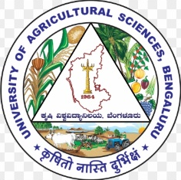

DEPARTMENT OF AGRICULTURAL EXTENSION

SEMINAR REPORT
ON
NEW GENERATION DELIVERY SYSTEM FOR SCALING UP AGRO-TECHNIQUES

Submitted to:
Dr. Y. N. Shivalingaiah (Professor and Head)
Dr. Ganesamoorthi, S. (Assoc. Professor)
Department of Agricultural Extension
UAS, GKVK, Bengaluru– 560 065

Submitted by:
Abhineeth R Harthikote
PAMB 1141, Sr. M.Sc (Agri.)
Department of Agricultural Extension
UAS, GKVK, Bengaluru– 560 065

CONTENTS

SL. NO. | PARTICULARS | PAGE NO.
 | Introduction | 1
 | Mobile connections in India | 2
 | Definition of Scaling up | 2
 | Drivers of change | 4
 | Types of Scaling up | 4
 | Strategies for Scaling up | 5
 | New generation delivery system- Expert system | 6-8
 | Mobile application | 8-12
 | Agri Start-ups | 12-18
 | Farmer Producer Organisation | 18-21
 | Kissan call centre | 21-24
 | Social media | 24-28
 | Research studies related to new generation delivery system for scaling up agro techniques | 28-35
 | Conclusion | 35
 | Bibliography | 36-37
 | Discussion | 38-39
 | Synopsis | 40-42

SL. NO. | PARTICULARS | PAGE NO.
Tables
 | List of countries by smart phone penetration | 2
 | Total budgetary allocation for FPOs | 19
 | Total number of FPOs in the country | 19
 | Number of calls received in KCC from 2018-19 to 2020-21 | 21
 | List of Nodal Agencies in Kisan Call Centre | 22
 | Statements-wise analysis of knowledge gained by the farmers with respect to agriculture | 29
 | Statements-wise analysis of knowledge gained by the farmers with respect to horticulture | 30
 | Statements-wise analysis of knowledge gained by the farmers with respect to animal husbandry | 31
 | Overall perception of farmers towards e- SAP | 32
 | Statement wise perception mean score of farmers about e-SAP | 32
 | Descriptive statistics of the development parameters | 34
 | Level of knowledge development, technical development, economic development and social development of respondents | 35
Figures
 | Diagrammatic representation of Expert system | 6
 | Various ICAR based mobile application | 11
 | Scenerio of agri startups in India | 12
 | Stages of development for Agri startups | 13

NEW GENERATION DELIVERY SYSTEM FOR SCALING UP AGRO TECHNIQUES

INTRODUCTION
Green revolution heralded the journey of Indian agriculture towards the path of self sufficiency in food grain. It also facilitated in increasing in increasing the farmers income. Further, with respect to the Indian agriculture, total food grain production has touched an all time high value of 292 million tonnes 2020. Agricultural growth rate in the 11th Five year plan (2007-12) has remained below 4.00% per year. The 12th Five year Plan (2012-17) though anticipated a minimum of 4.00% growth rate in agriculture but it again remained only 1.6%. Albeit, this glorious feat was accomplished using the tool of agricultural extension. Thus, agricultural extension acted as a pivot for realizing the growth potential of farm sector against the widening demand–supply pressures and for ensuring sustainable, inclusive, and pro-poor agricultural and economic development. Indian public sector extension system, however, has been constantly
scrutinized in the recent time because of the challenge of enhancing relevance, efficiency, and effectiveness of the public sector agricultural extension system in meeting its organizational goals and objectives remains unresolved. Agricultural extension has, therefore, been now joined with diverse players and transformed. Agricultural extension systems in the post-Independence era comprise State Departments of Agriculture, voluntary organisations, commodity boards and frontline extension of SAUs and ICAR institutes as well the KVKs network. The spatial variations in the performance of Indian agriculture necessarily direct to evolve the region- and situation specific pathways. For example, the regions receiving low and uncertain rainfall (arid and semiarid agro-eco situations) need priority for improving farm productivity and rural income. Likewise, farm producers located far-off and those unreached still suffer most from lack of access to appropriate services (credit, inputs, market, extension,etc.). Anticipating this context, for scaling up the wide range of objectives and target groups, the Indian state has to employ a wider option of approaches. Embedded extension services require to be fortified with input supply and contract farming by the private sector, and there is a need to work well for medium to large farmers in well-endowed regions. Community based method specifically holds immense potential for natural resources management and involvement in managing common property resources as well as the value chains. Mobile phone enabled information dissemination will become part of or shall complement well to all other extension services. Hence, to derive advantages to the fullest extent in moving to pluralistic systems, comparative advantages and specific functions of different actors have to be well comprehended and utilized.
Mobile connections in India

Table 1: list of countries by smart phone penetration
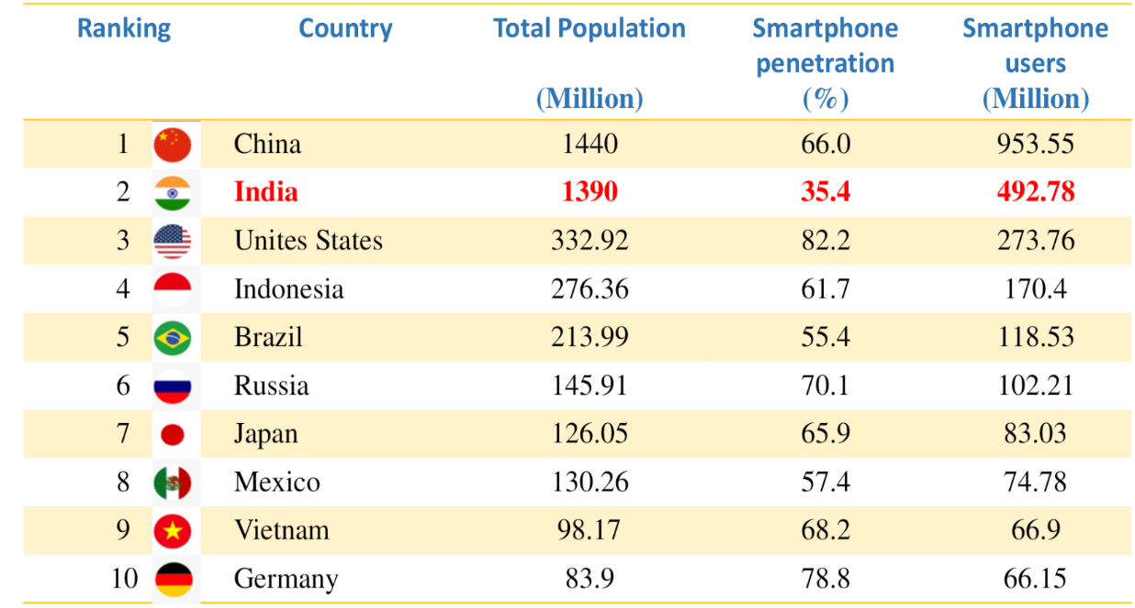

With this background the present seminar is conceptualized with following objectives
- To know the concept of scaling up
- To get an insights over new generation delivery system for scaling up Agro techniques
- To review the existing literature
DEFINITION OF SCALING UP
A WHO/ExpandNet report (2012) defines scaling up as “deliberate efforts to increase the impact of innovations, successfully tested in pilot or experimental projects so as to benefit more people and to foster policy and programme development on a lasting basis.” Both of these definitions have a number of elements in common: greater reach, successful interventions, adaptation and sustainability. However, the WHO definition states that the intent is to increase the impact of innovation and stresses the importance of fostering policy and program development.

Based on these definitions, the distinctive features of scaling up are:
- A “successfully tested” intervention is supported by locally generated evidence of programmatic effectiveness and feasibility obtained through pilot testing or experimental projects. In this sense, scaling-up does not mean simply broadening the use of existing or new practices from small to large scale without local research, evaluation or adaptation. “Successful” means the innovation is realistic to carry out, relevant and worthwhile, and that the intervention has real benefits for potential users.
- “Deliberate efforts” means that it is not spontaneous diffusion but rather a managed process.
- “Policy and programme development on a lasting basis” underlines the importance of organisational capacity-building in terms of developing, establishing and sustaining the political support, managerial structure, human and budgetary resources and service component necessary for successful large-scale programmes and policies.
- “Impact of innovation” underlines the importance of addressing and utilising the developmental objectives in terms of anticipated outcomes (immediate, intermediate and ultimate) of the intervention, not the reach alone.
For the potential scaling up to take place the innovation should possess following attributes-
- Credible in that they are based on sound evidence or advocated by respected persons or organisations.
- Observable to ensure that the potential users can see the results in practice in the real world.
- Relevant for addressing a persistent or sharply felt problem for the end users.
- Superior to existing practices so that the ultimate users are convinced that the cost of implementations is counteracted by benefits.
- Easy to understand and install, rather than complex and complicated.
- Compatible with the end users’ established values, norms and facilities (including resource base) and with the priorities and practices of the national/provincial/regional programmes.
- Testable without committing the potential users to complete adoption when results have not yet been seen.

DRIVERS OF CHANGE
The drivers push the scaling-up process forward relentlessly. The common drivers are:
• Proven ideas or models: There has to be an idea or model that works on a small scale or has been promoted successfully elsewhere.
• Vision and leadership: A vision is needed to recognise that the scaling up is necessary, desirable and feasible. Visionary leaders often drive the process.
• External catalysts: Political and economic crises or pressure from outside actors (donors, NGOs) may drive the scaling-up process forward.
• Incentives and accountability: Incentives and accountability for results are needed to drive actors and organisations. This may include rewards, competitions, political pressure, community demand, peer reviews and independent evaluations. Markets and profit can be powerful drivers in delivering private goods and services.
• Empowered rural communities: Empowered rural communities can promote scaling up and hold public agencies accountable. They can be a very strong political voice.
• Markets: Profit can be a very powerful driver in delivering private goods and services.

TYPES OF SCALING UP
Scaling up can be either spontaneous or a deliberate effort to promote innovation at a faster rate. The deliberate efforts are based on the realisation that successful scaling up rarely happens spontaneously. There are three types of deliberately guided scaling up: expansion or replications; policy/political/legal/institutional scaling up; and functional/diversification scaling up (WHO, 2012).
- Expansion or replication (also referred to as horizontal scaling up, or scaling out) is when innovations are replicated in different geographical sites or are extended to serve a larger or new set of beneficiaries. According to Cooley and Kohl (2006), expansion means “increasing the scope of operation of an organisation.” The way it expands affects the capacity of the organisation. Replication is increasing the use of the innovation, but it is done by the originating organisation. Although expansion and replication are used synonymously, successful scaling up rarely involves mechanical duplication; rather, it requires adaptation to the environmental context of the target beneficiaries.
- Institutional scaling up (also called vertical scaling up, or simply scaling up) takes place when formal government decisions are made to adopt the innovation on a national or subnational level, and it is institutionalised through national development plans. In this case, the systems and structures are adapted and resources redistributed to build the institutional mechanisms that can ensure sustainability. Vertical scaling up calls for strong advocacy to build legitimacy and enabling environments.
- Diversification (also called functional scaling up) involves testing and adding interventions to existing packages. This strategy may be used when an innovation has attained a sufficient degree of coverage and support to indicate that it is likely to continue expanding and the program could benefit from new or additional interventions.

STRATEGIES FOR SCALING UP
In social entrepreneurship and social enterprise studies, the emphasis on “scaling for impact” often reflects a product and consumer orientation, synonymous with diffusion or replication. However, scaling social innovations to bring larger-scale change involves a more complex and diverse process than simply ‘diffusing’ or spreading a product or model. It is important to learn about the process of how social systems and institutions can be deliberately impacted through the work of organizations, foundations, and other agents of change. Following strategies may be tested and acted upon.
1) Identification of potential are where technologies can be promoted.
2) Establishment of backward and forward linkages with different players.
3) Develop a model plan for the entrepreneurs and innovators in crop production.
4) Provide location specific information rather than general information for the entire zone/ region.
5) Information should be provided to the farmers about complete package of practices of latest technologies through various extension methods for better uptake and utilization.
6) Training and message through mobile phones and other associated gadgets can help for faster dissemination in the present era.
7) Blending of traditional (personal contact, demonstrations, etc.) and latest methods (expert system, radio and TV talk, video films, magazines, newspapers, etc.) should be used to communicate the message timely and repeatedly to ensure that farmers adopt the right technology.
8) Progressive farmers should be encouraged to help the extension workers in delivering the latest message to fellow farmers. Kisan Clubs, NGOs operating in various states should also be encouraged to send the messages to other farmers. In the changing global scenario, Information and Communication Technologies (ICTs) play a major role in technology storage, dissemination and adoption. Information dissemination through ICTs are quick, time saving, cheap and can be reached even in areas where humans find difficult to reach. ICTs include telecommunication technologies such as telephone, cable, satellite and radio, as well as digital technologies like computers, intranet, internet, software and mobile applications, and mobile phones.

NEW GENERATION DELIVERY SYSTEM FOR SCALING UP AGRO TECHNIQUES
- EXPERT SYSTEM
Expert Systems (ES) are intelligent computer program encoded, domain specific knowledge and reasoning of experts to produce solution. ES derived its knowledge from experts, supported by literature on application. The rule-based expert system has five components:
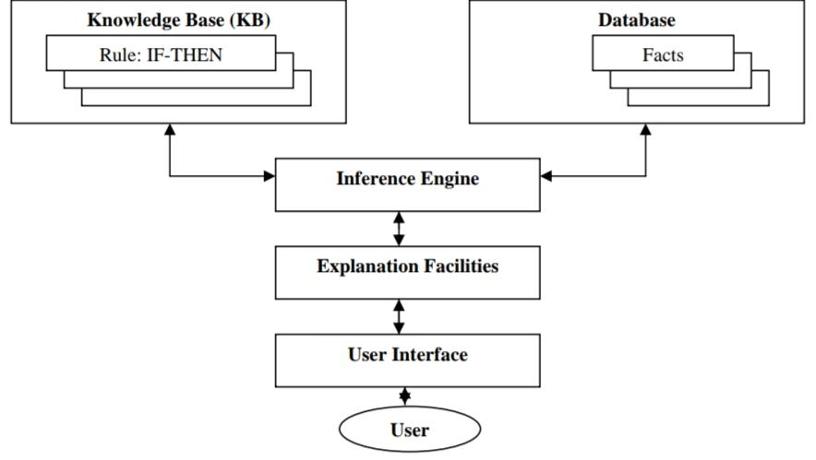
Figure 1 Digrammetic representation of Expert system
(i) Knowledge Base: It is a declarative representation of the expertise, often in IFTHEN rules including such things as simple facts about the domain, rules or constraints that describe relation or phenomena in the domain, and possibly also methods, heuristics and ideas for solving problems in this domain.
(ii) Database: It is the data or a set of facts which is specific to a problem being solved used to match against the IF (condition) parts of the rules stored in the knowledge base.
(iii) Inference Engine: It carries out the reasoning by interplaying the information or facts obtained from the user with the knowledge stored in the knowledge base whereby the expert system reaches a solution.
(iv) Explanation Facilities: It explains about how a particular conclusion is reached and why a specific fact is needed and also explains its reasoning and justifies its advice, analysis or conclusion.
(v) User Interface: It provides communication between the user and expert system.

The following ES deals with the growing of a specific crop:
(1) GRAPE is an ES for viticulture in Pennsylvania. This ES was developed at Pennsylvania State University in association with Texas A&M University to address the advisory needs of grape growers. This system provides grape growers with recommendations regarding pest management (insect, disease and weed control), fertilization, pruning and site selection. The development environment included the rule based shell called Rule master on the Macintosh microcomputer.
(2) COMAX provides information on integrated crop management in cotton. It is designed for use by farmers, farm managers, and county and oil conservation agents. The system uses a combination of expert-derived rules and result generated by the cotton – crop simulation model GOSSYM. This was the first integration of an expert system with simulation model for daily use in farm management.
(3) CUPTEX is an Expert System for cucumber production management under plastic tunnel. System currently provides services on disorder diagnosis, disorder treatment, irrigation scheduling, fertilization scheduling, and plant care subsystems used by agricultural extension of agriculture, and by the private sector. It was developed in KADS. KADS is a methodology for building knowledge-based systems (reference). KADS was used for representation of the interface and task knowledge. Finally, LEVEL 5 object was object for the implementation. It was also the first deployed Expert System in developing countries not only in agriculture but in other fields as well.
(4) CITEX is an Expert System for orange production. It provides services on assessment of farm, irrigation and fertilization scheduling, disorder diagnosis and disorder treatment. System was developed by the Central Laboratory of Agricultural Expert Systems(CLAES), Egypt.
(5) NEPER WHEAT is an Expert System for irrigated wheat management developed at the Central Laboratory of Agricultural Expert System (CLAES) is Egypt. It performs various functions viz., Advice the farmers on field preparation, control pests and weeds, manage harvests, prevent malnutrition, design schedule for irrigation and fertilization, select the appropriate variety for a specific field, diagnose disorder, suggest treatments etc. It is an easy-to-use in Microsoft Windows based application with an English and Arabic interface.
(6) LIMEX is an integrated Expert System with multimedia that has been developed to assist lime growers and extension agents in the cultivation of time for the purpose of improving their yield. The scope of LIMEX expert system includes: assessment, irrigation, fertilization and pest control. This system was augmented with multimedia capabilities as enhancing an expert system by the integration an expert image, sound, video and data, allows for a good feedback from users, assists in better understanding of the system, and allows for more flexibility in the interactive use of the system. It was developed using an adapted KADS methodology for the knowledge part. CLIPS TM Ver. 6.0 shell on Windows and CLIPS object – oriented language (COOL) was used for development of Expert System.
Advantages of Expert system
- Easy in identification of diseases
- Provide consistent answers for repetitive decisions
- Hold and maintain significant levels of information
- Combine multiple human expert intelligence
- User friendly software
Disadvantages of Expert system
- Cannot make creative responses
- Errors may occur in the knowledge base and lead to wrong decisions
- Cannot adopt to changing environments

- MOBILE APPLICATIONS
There is an increasing number of mobile apps providing access to agriculture and allied sector information. A mobile application is a software on a mobile phone handset or tablet computer that enables a user to access specific information; make payments and other transactions; send messages; etc.
The information is stored in the mobile handset itself for easy access, for example the details of package of practices, pest and disease information and scheme related information etc. Wherever the information is dynamic in nature, for example weather details, market prices, advisory services, the mobile app requires Internet connectivity to fetch the data from the back-end server databases.
Farmers need timely information in response to their specific needs. There are mobile applications that provide latest agricultural information about trends, equipment, technologies and methods being used, help identify pests and diseases, provide real-time data about weather, early warnings about storms, local markets offering best prices, seeds, fertilizers etc.
In addition, farmers can also interact and get guidance from agriculture experts across the country via the apps. These apps help in providing market information, facilitating market links, providing access to extension services, farm related information etc.
Government of India has launched a number of web and mobile based applications for dissemination of information on agriculture related activities, free of cost, for the benefit of farmers and other stakeholders.

POPULAR MOBILE APPLICATIONS IN AGRICULTURE
PRODUCTION TECHNOLOGY AND AGRO-ADVISORY SERVICES
1.Kisan Suvidha- It is an omnibus mobile app developed to help farmers get relevant information instantly. The app provide information on various details such as weather, market prices, seeds, fertilizers, pesticides, agriculture machinery etc.
2.Pusa Krishi- it was launched in the year 2016 with the aim to help farmers to get information about technologies developed by IARI in order to increase the returns of farmers.
3.Soil Health Card(SHC) Mobile App- Soil health card mobile apps are being used for registration of soil samples collected at farm fields and entry to test results. The information is then sent to the national soil health card portal
4. CCE AGRI- It is the mobile app that has been developed to digitalize the information of crop cutting experiment conducted in the field. It automatically captures the location of field through GPS.
5. IFFCO Kisan Agriculture- It is an Indian agriculture farmer suvidha app, which helps farmer to take informed decisions by accessing customised agricultural information related to their need.
6.eSAP- It is an ICT application in crop health management. The application helps in on field identification quantification and intensely based advisory related to insects, diseases and nutritional deficiency and weeds of horticulture crops.

MARKETING
1. AgriMarket- This app has been developed with an aim to keep farmers abreast with the crop prices and discourage them to carry out distress sale. Farmers can get the information related to the prices of the crop in markets within 50km of their device location using the AgriMarket App
2. Digital Mandi- - It is a unique web and cell phone based multi modal agricultural price retrival system. Its service provides the farmers alerts through SMS or voice on his mobile about selected mandi rates of selected crops.
CROP SPECIFIC APPS
1. Mobile App on Castor (ICAR-IIOR Castor)- It has features in both online and offline mode and offer valuable information to the extension workers, farmers, castor researchers and other stakeholders, including state-wise preferred varieties and hybrids, crop production and protection technologies for management of insect pests and diseases, contact details of AICRP (castor) centres across India and commodity markets.
2. Solapur Anar- Developed by ICAR- National Research on Pomogranate, Solapur this app educates the pomegranate growers about the scientific pomegranate production practices. The app includes publications for the download from ICAR_NRCP website. Weather forecast of the region, on the go daily market rates of pomegranate across India are made available to the farmers.
3. Cane Advisor- It is an app from ICAR-Sugacane Breeding Institute, Coimbatore, Tamil Nadu, with details from the planting to harvest with text and graphics. It has a scheduler app, tailor-made for each individual registered user and reminder message are popped up on real time mode. Query handler helps to raise queries as texts or in graphic form that are replied via SMS/ email.
ALLIED SECTOR APPS
- Pashu Poshan- NDDB has developed an android based software that can be used on the phones. With the help of this software balanced ration is formulated while optimizing the cost considering animal profile, i.e. cattle or buffalo, age, milk production, milk fat and feeding regime etc. and milk producers are advised to adjust the quantity of locally available feed ingredients offered to their animals along with mineral mixture.
- Fisher Friendly Mobile Application (FEMA)- It is an app that provides timely and accurate seafaring information to improve the safety and income of fisher folk. The app has designed to provide easy access to relevant information and knowledge related to fishing for small craft fishers.
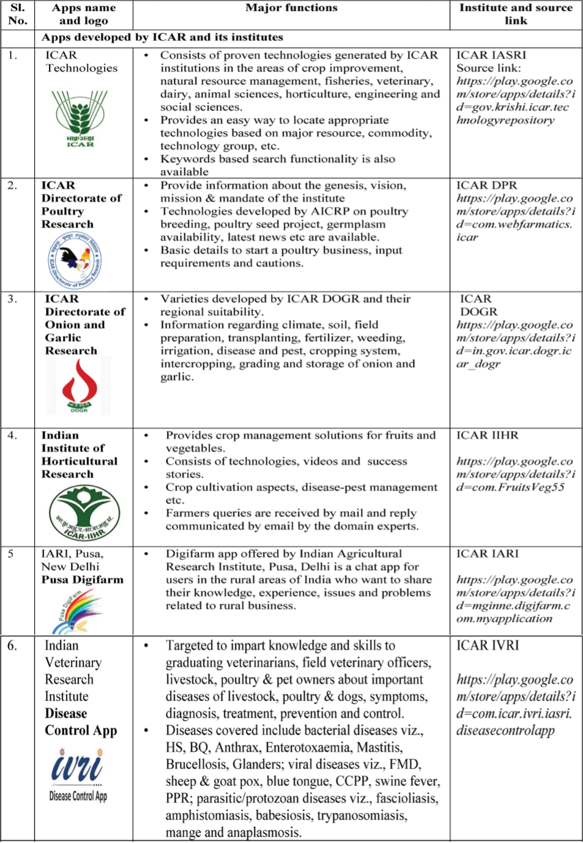
Figure 2 Various ICAR based mobile application

Advantages of Mobile application
- All types of information on crops, soil, weather, climate, rainfall, seeds, animals and machinery at any point in time, and any number of times is available on finger tips of farmers (World Bank 2012).
- Information available is localized, thereby increasing the comfort and precision as required.
- Information is updated on regular basis
- Time saving
- Commodity prices can be delivered in a real time mode.
Disadvantages of mobile application
- Non availability in regional languages.
- Farmers may not get updated and complete information due to :
  - Network issues
  - Speed of the data delivery
  - Legal restrictions
- Farmers may not be adequately equipped to afford and use the applications.

- AGRICULTURE START UP
According to Department of Industrial Policy and Promotion (DIPP), an entity shall be considered as a Startup :
  - Up to 10 years from the date of its incorporation.
  - Incorporated as a private limited company or registered as a partnership firm or a limited liability partnership.
  - Turnover should be less than INR 100 Crores in any of the previous financial years
  - Working towards innovation/ improvement of existing products, services and processes and should have the potential to generate employment/ create wealth.
  - An entity formed by splitting up or reconstruction of an existing business shall not be considered a "Startup"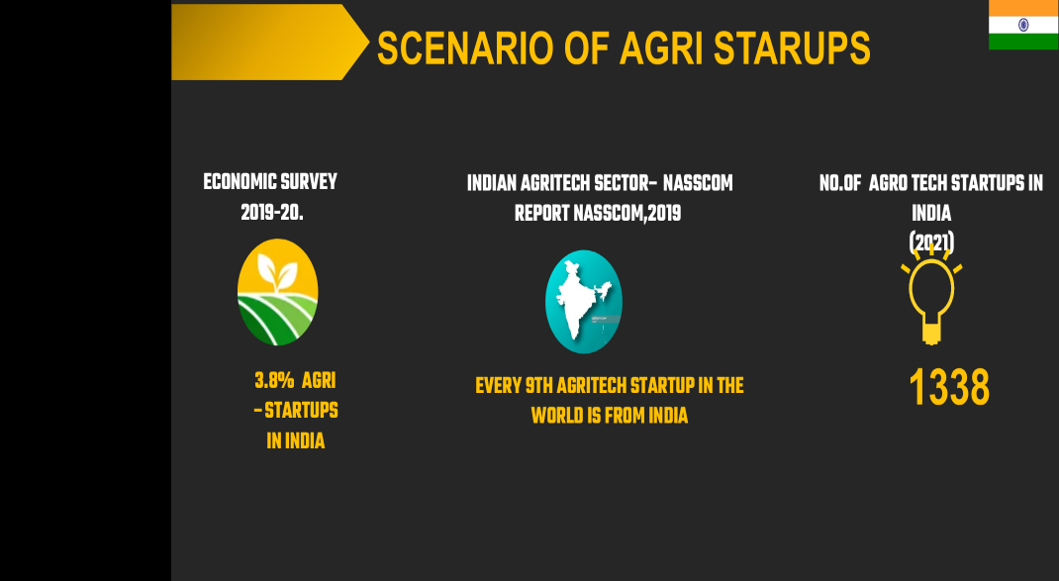
Figure 3 Scenerio of agri startups in India
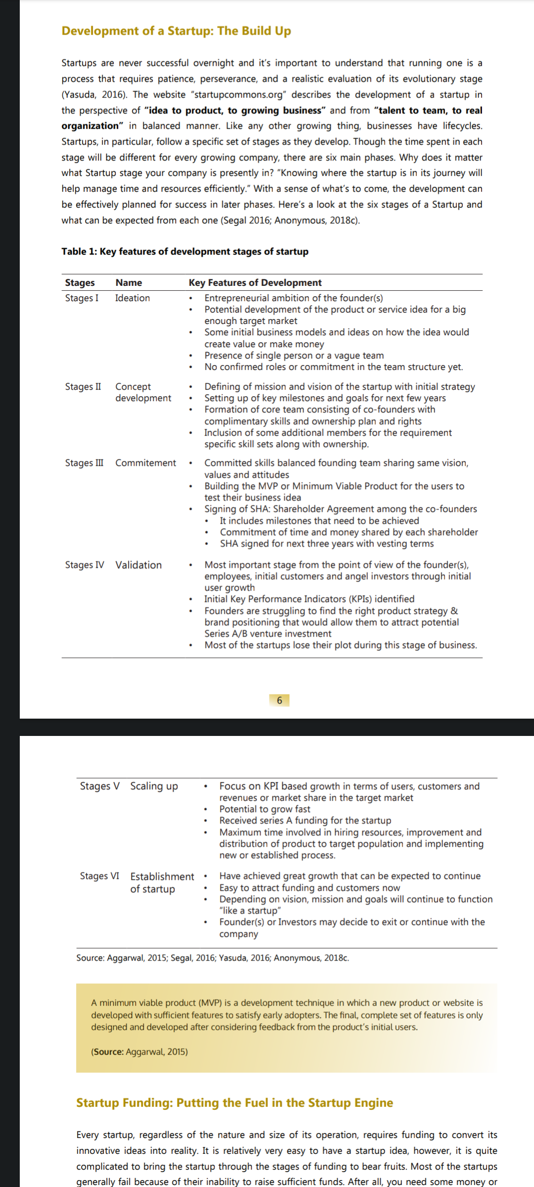.
Figure 4 Stages of development for Agri startups

Key outcomes of Indian Start up Growth story
- India 3rd largest startup ecosystem in the world
- India is home to 83 unicorns ( startups valued at$ 1Bn+) with a combined valuation of over $277.7 Billion*
- 30 States and UTS now have State Startup policy
- More than 43% of the total recognized startups have reported one or more women directors
- 39 regulations have been simplified for the startup eco system in India
- On an average 12 jobs created per startup
- The entire startup ecosystem raised $50 Billion funding between 2014-19

Oppurtunities for Agritech startups in Indian Agriculture
- Fintech platforms- Offering applications and platforms that connect farmers digitally and providesthem financial, agricultural and government-related services based on their crops and crop cycle
- Post harvest technologies- Offering technologies and machineries for cleaning, sorting and processing crops at farm, and cold storage to reduce wastage and increase shelf life of food items
- Farming as a service- Offering farming services and machinery on rent for reducing capex and increasing affordability
- Nano technology- Providing facilities such as use of nanoparticles, nanocapsules and viral capsids to cure diseases, enhancing nutrients absorption by plants
- Precision farming- Facilitating application of precise amount of inputs such as water, fertilizers and pestocides, at the right time for increasing productivity
- Smart Machines- Providing remotely operated machines, operating with greater precision, and performing specific operations using harvesting robots, seeding machines, electrostatic sprayers, etc.

Examples of some successful start ups in agriculture



Fasal – Climate Smart Precision Agriculture Solution
Founded In | 2018
Founders | Ananda Verma and Shailendra Tiwari
Headquarters | Bengaluru, Karnataka
Product Name | Fasal Microclimate System and SaaS
Technology Used | AI, Ml, IoT and Data Analytics
Objective | To increase and improve the quality of per acre yield
Startup Description
Fasal is a smart agriculture solution which when installed, starts recording variety of microclimatic parameters like temperature, humidity, air pressure, leaf wetness, soil moisture, soil temperature, wind speed, wind direction, and rainfall.

Step by Step How Fasal Works
Sense: Fasal monitors critical microclimatic parameters, including Temperature, Humidity, Rainfall, Soil moisture at various levels, Leaf wetness, Soil temperature etc., 24x7x365 from your farm and uploads it to Fasal cloud platform.
1. Analyse: The data is then analysed and presented, making your crop’s health accessible to you anytime, anywhere on any device for decision making like irrigation management, resource optimization, increasing yield, increasing quality of yield etc.
2. Predict: Captured data is used by our prediction models to predict the ideal growth conditions, resource requirements including fertilizers, Crop diseases, and microclimatic weather predictions.
3. Act: Farmer gets notified on his device and actions can be taken directly from it, like switching on drip irrigation etc.


Yuktix Technologies
Founded In | 2013
Founders | Rajeev Jha
Headquarters | Bengaluru, Karnataka
Product Name | Automatic Weather Station, Air Quality Stations, Wireless Data Logger and Sensor Catalog
Technology Used | IoT and Wireless Sensing
Objective | Providing hardware to farmers to reduce the post-harvest losses by measuring indoor environment of Cold Storages and Warehouse

Yuktix Technologies was founded in October 2013. The firm has been working to create indigenous remote monitoring solutions for emergent markets. It provides data capture and communication solutions for remote monitoring and environment sensing. Yuktix weather stations collect meteorological information such as temperature, humidity, rain, wind speed every 15 seconds and up to 12 samples are taken for each transmitted reading. They provide data parameterized to conform to standards set by the Indian Meteorological Department (IMD) and the World Meteorological Organization. The station was designed with enough flexibility to be used as an air quality or water quality-measuring device simply by adding the pertinent sensors. The stations can serve as ready-to-deploy templates for smart cities and urban monitoring. The startup is currently dealing in three sectors, namely Agriculture, Urban and Industrial. In regard to the environmental aspect, agricultural indicators are used to assess the ways in which agriculture affects environmental quality and how changes in agricultural practices change the environment. 1) Crop Disease Prevention, 2) Smarter Greenhouse, 3) Post Harvest Monitoring and Remote Management can make any agricultural activity capable of producing more and keeping the environment safe for more production. Yuktix provides sensors based smart devices for climate control and precision agriculture which can measure climate variables inside the greenhouse and control light (Lux), humidity, temperature, water pumps, cooling pads and shade nets inside your greenhouse to maintain ideal climate conditions. Yuktix has developed a device along with a compatible sensor catalog to monitor environment variables inside greenhouses. The device can interface to Temperature, Humidity, Lux, Soil Temperature and Moisture, CO2, Leaf wetness and soil pH etc. sensors. A greenhouse operator can monitor environmental conditions inside the greenhouse from anywhere on a mobile device. Yuktix also provides cellular and long range radio (wireless) communication options. The company is monetising by providing automated data. The team deploys the device, generate data and gives it to the user. Moreover, the services are charged for once during the rollout and then the company pays a recurring cost for using those services. The startup is dealing in a device subscription based model.

UAS(B)-C-CAMP Agri Innovation centre
Objectives
- Nurture agricultural innovation and entrepreneurship
- Serve as knowledge center and repository of biological material
- Foster cutting edge innovations in the agri-sector leading to economic development
- Enable innovation research with commercialization potential in the agri-sector
Thematic area of the centre
- Organic farming
- Biotechnology, tissue culture, diagnostics, transgenic, molecular breeding
- Agricultural microbiology, biocontrol, bio fertilisers, composting
- Plant breeding and seed production, mushroom cultivation
- Nutrient formulation and agro chemicals
- Value additions in food products
- Agricultural equipments
- Training and skill development

Agribusiness incubators in India
There are a total of 100 agribusiness incubators in India some of which are namely
- Pusa Krishi Incubator (ICAR-IARI)- Pusa Krishi Incubator is an Agri incubator that acts as an innovation hub that connects agri-business incubator centre of ICAR-IARI. The purpose of Pusa Krishi Incuator program is to cheer, guard, market and license the technology developed by scientist to the industry. Pusa krishi Incubator program focuses on the incubation process, including start ups and Farmer Producer Organisation.
- iHUB (ICRISAT)- The ICRISAT innovation Hub (iHUB) a creative space where agricultural technology entrepreneurs, scientists and experts can collaborate to innovate cutting edge ideas smallholder farmers
- a-IDEA (NAARM)- a-IDEA ( Association for Innovation Development of Entrepreneurship in Agriculture) is a technology Business Incubator (TBI) posted by ICAR- National Academy of Agricultural Research Management Hyderabad(ICAR-NAARM) and supported by NSTEDB, DSB and BIRAC a- IDEA since 2014 has been supporting startups across 14 domains of agricultural and allied sectors. A-IDEA aims to help entrepreneurs ideate, incubate and accelerate their innovative early stage start-ups that are scalable to become competitive food and agri-business ventures through capacity building , mentoring, networking investment and advisory support.
- CIIE (IIM, Ahmedabad)- It is an Indian startup accelerator and incubator that supports early-stage startups located at IIM Ahmedabad. It provides investements, incubation, acceleration, infrastructure, training and access to a network of collaborators. As of August 2022, it has accelerated nearly 100 startups, funded 300 and mentored and coached over 5000 startups.
- CrAdLE (EDII, Ahmedabad)- Initiated in 2016, the centre for advancing and launching Entreprises (CrAdLE) is a technology business incubator hosted by EDII, Ahmedabad. CrAdLE extends technical expertise, advise on intellectual property, mentoring and assistance in business plan, networking, sources of financing and working space to pioneering ideas in segments of manufacturing, food processing, renewable energy, health care and many healthcare and many other emerging areas.

Challenges
- Rate of return on technology investment has not been very profitable
- High priced technology solutions are unaffordable
- Difficult to retain technical talent working
- Facilitating the adoption of proven technologies through subsidy is yet to gain momentum
- Making farmers adaptive to the required skills for working on advanced technologies requires significant effort
- Technology adoption and penetration is a very slow process which certainly diminishes investors interest

- FARMER PRODUCER ORGANISATION
It is one type of Producer Organization(PO)where the members are farmers. Small farmers’ Agribusiness Consortium (SFAC) is providing support for promotion of FPOs. PO is a generic name for an organisation of producers of any produce eg., agricultural, non-farm products, artisan products, etc. FPO is a legal entity formed by group of farmers or primary producers, viz: agriculture farmers, milk producers, fisherman, small Tea growers, weavers, craftsman etc. A FPO can be a producer company, a cooperative society or any other legal form which provides for sharing of profits /benefits among the members.
Need for FPO
The main objective of FPO is to ensure better income for the producers through an organisation of their own. Small producers do not have the volume individually (both inputs and produce) to get the benefit of economies of scale. Besides, in agricultural marketing, there is a long chain of intermediaries who very often work non-transparently leading to the situation where the producer receives only a small part of the value that the ultimate consumer pays. Through aggregation, the primary producers can avail the benefit of economies of scale. They will also have better bargaining power vis-à-vis the bulk buyers of produce and bulk suppliers of inputs.
Union budget 2019-20 has announced a central sector scheme of “ Formation and Promotion of 10,000 FPO till 2027-28.

Table 2: Total budgetary allocation for FPOs
Years | Total budgetary allocation
2019-20 to 2023-24 | Rs. 4,496 crore
2024-25 to 2027-28 | Rs. 2,369 crore
Total | Rs. 6865 crore

Table 3: Total number of FPOs in the country
S.No | STATE | No. of FPOs registered | % of total FPOs
1 | Maharashtra | 1940 | 26.00
2 | Uttar Pradesh | 750 | 10.00
3 | Tamil Nadu | 528 | 7.00
4 | Madhya Pradesh | 458 | 6.00
5 | Telangana | 420 | 6.00
6 | Rajasthan | 373 | 5.00
7 | Karnataka | 367 | 5.00
8 | Odisha | 363 | 5.00
9 | Bihar | 303 | 4.00
10 | Haryana | 300 | 4.00
11 | Other States | 1571 | 21.00
 | TOTAL | 7374 | 100.00

TYPICAL SERVICES OF FPO
An indicative list of services includes:
i. Financial Services: The FPO will provide loans for crops, purchase of tractors, pump sets, construction of wells, laying of pipelines.
ii. Input Supply Services: The FPO will provide low cost and quality inputs to member farmers. It will supply fertilizers, pesticides, seeds, sprayers, pumpsets, accessories, pipelines.
iii.Procurement and Packaging Services: The FPO will procure agriculture produce from its member farmers; will do the storage, value addition and packaging.
iv.Marketing Services: The FPO will do the direct marketing after procurement of agricultural produce. This will enable members to save in terms of time, transaction costs, weighment losses, distress sales, price fluctuations, transportation, quality maintenance etc.
v.Insurance Services: The FPO will provide various insurance like crop insurance, electric motors insurance and life insurance.
vi.Technical Services: FPO will promote best practices of farming, maintain marketing information system, diversifying and raising levels of knowledge and skills in agricultural production and post-harvest processing that adds value to products.
vii.Networking Services: Making channels of information (e.g. about product specifications, market prices) and other business services accessible to rural producers; facilitating linkages with financial institutions, building linkages of producers, processors, traders and consumers, facilitating linkages with government programmes.
Advantages
- Reduction of cost of production
- Reduce marketing cost
- Access to modern technology, extension services and joint training on Good Agricultural Practices (GAP).
- Post-harvest losses can be minimised through joint storage and value addition facilities.
- Adverse price fluctuations and distress sale can be managed.
- Ease in communication for dissemination of information about farming-related advisories.
- Access to institutional credit against stock, without collateral.
Challenges
- Difficulty and delay in mobilization of farmers
- Limited organizational and management capacity
- Need for incubation and handholding support to FPOs
- Membership base
- Limited capability to autonomously invest in primary/ secondary processing, storage and custom hiring facilities.
- Inability to access institutional credit sans collateral.

- KISSAN CALL CENTRE

In order to harness the potential of ICT in Agriculture, Ministry of Agriculture & Farmers Welfare launched the scheme "Kisan Call Centres (KCCs)" on January 21, 2004. Main aim of the project is to answer farmers' queries on a telephone call in their own dialect.
A countrywide common eleven digit Toll Free number 1800-180-1551 or 1551 has been allotted for Kisan Call Centres. This number is accessible through mobile phones and landlines of all telecom networks including private service providers. Replies to the farmers' queries are given in 22 local languages. Kisan Call Center services are available from 6.00 am to 10.00 pm on all seven days of the week at each KCC location. Kisan Call Centre agents known as Farm Tele Advisors (FTAs), are graduates or above (i.e. PG or Doctorate) in Agriculture or allied areas (Horticulture, Animal Husbandry, Fisheries, Poultry, Bee-keeping, Sericulture, Aquaculture, Agricultural Engineering, Agricultural marketing, Bio-technology, Home Science etc.) and possess excellent communication skills in respective local languages.

Table 4: Number of calls received in KCC from 2018-19 to 2020-21
Sl.No | State | 2018-19 | 2019-20 | 2020-21
1 | Andaman & Nicobar | 37 | 2035 | 3301
2 | Andhra Pradesh | 92658 | 149356 | 171230
3 | Arunachal Pradesh | 816 | 744 | 1198
4 | Assam | 27287 | 26028 | 23189
5 | Bihar | 263799 | 379166 | 336394
6 | Chandigarh | 764 | 0 | 0
7 | Chattisgarh | 41798 | 82642 | 87039
8 | Dadar & Nagar Haveli | 25 | 0 | 0
9 | Daman & Diu | 13 | 6090 | 334
10 | Delhi | 34536 | 71287 | 90109
11 | Goa | 155 | 1 | 0
12 | Gujarat | 204323 | 299257 | 283866
13 | Haryana | 305446 | 391973 | 343793
14 | Himachal Pradesh | 50299 | 52834 | 43829
15 | Jammu Kashmir | 78918 | 100158 | 77635
16 | Jharkand | 16091 | 52220 | 43703
17 | Karnataka | 219037 | 230125 | 211608
18 | Kerala | 22976 | 34599 | 33866
19 | Lakshadweep | 7 | 4 | 0
20 | Madhya Pradesh | 369550 | 445027 | 459337
21 | Maharashtra | 528241 | 713790 | 560854
22 | Manipur | 1300 | 772 | 1691
23 | Meghalaya | 573 | 355 | 763
24 | Mizoram | 147 | 261 | 621
25 | Nagaland | 114 | 261 | 621
26 | Orissa | 172606 | 168918 | 185280
27 | Pondicherry | 876 | 0 | 0
28 | Punjab | 264549 | 355577 | 275590
29 | Rajasthan | 670883 | 680711 | 553193
30 | Sikkim | 1512 | 2607 | 2702
31 | Tamil Nadu | 190984 | 186054 | 191048
32 | Telangana | 99454 | 111498 | 124832
33 | Tripura | 2816 | 2012 | 3940
35 | Uttarakhand | 34010 | 60956 | 63619
36 | West Bengal | 117118 | 152092 | 118779
 | TOTAL | 4848624 | 6052767 | 5474446

Table 5: List of Nodal Agencies in Kisan Call Centre
Sl. No | Locations | Nodal agency
1 | Mumbai | The director Incharge, Director of Cotton Development
2 | New Delhi | Managing Director, National Cooperative Development cooperation
3 | Cochin | Coconut development officer, Coconut development Board
4 | Bangalore | Director, Coconut development board
5 | Hyderabad | Director General, MANAGE
6 | Chennai | Director, Coconut development board
7 | Ghaziabad | Director, Director of Wheat development, Ghaziabad
8 | Jaipur | Director General, NIAM
9 | Gurgaon | Managing director, NHB
10 | Bhopal | Director In-charge, Directorate of pulse research
11 | Kolkata | Director, Directorate of Jute development
12 | New Delhi | Managing director, SFAC
13 | Guwhati | Central Integrated Pest Management Centre, Guwhati

Features of KCC
Restructured KCCs are now providing very reliable and efficient services due to following technological innovations and state of the art hardware/software tools:
(i) Voice/Media Gateways (IPPBX based decentralized system).
(ii) Dedicated MPLS leased line network with dedicated bandwidth.
(iii) Call barging to facilitate listening of call conversation between Farm Tele Advisor and Farmer by the officer monitoring the quality of service provided by KCCs
(iv) 100% Call recording and retention of recorded calls for six months so that the call can be listened to in case of a complaint.
(v) SMS to caller farmers providing a gist of advisories given to them on phone.
(vi) Voice mail system for recording farmer’s queries during idle time of KCC or during call lines busy, with provision for call back to the caller.
(vii) Soft phones in every personal computer with caller ID facility.
(viii) Back up through Fixed Wireless Telephone (FWTs) in case of PRI failure.
ix) Up scaling the knowledge of FTAs by way of providing latest versions of guide books and booklets issued by the State Agricultural Department or the Agricultural Universities. Facility of video conferencing of each KCC for interaction of KCC agents with the Divisional/Zonal Level Officers of the State Agriculture and allied departments as well as on line monitoring for the working of KCCs.
(x) Provision for registering the farmers for receiving SMS messages on agri- advisories and mandi prices of different commodities as per their priority.
(xi) Call holding time substantially reduced to less than 30 seconds
(xii) KKMS simplified to enable FTAs to initially reply farmers query.

Different types of skills required for conducting kisan call centre
- Facilitation skill- Speak in farmers language
Diagnose the problem by probing into details
Answering the query at level of farmers knowledge
ii) Communication skill- Empathize with the farmer
Listen actively for the content
Avoid defensiveness in conversation
Avoid use of unnecessary and complex words
Close call with greetings

iii) Computer skill- Basic knowledge of key board and mouse
Basic knowledge of internet
Sending and receiving emails

- SOCIAL MEDIA
Social media are web based tools of electronic communication that allow users to personally interact with others individually or in groups for the purposes of exchanging information, sharing thoughts and opinions, influencing and facilitating decision-making by creating, storing, retrieving and exchanging information in any form (text, pictures, video, etc.,) by anyone in the virtual world. These are digital networks that are used to share and discuss user generated information - opinion, video, audio, and multimedia. Merriam-Webster (2015) defines social media as forms of electronic communication through which users can create online communities to share information, ideas, personal messages and other content. Social media is not about what each one of us does or says, but about what we do or say together, worldwide, to communicate in all directions at any time by any possible digital means. Social media is basically digital technologies facilitating communication of user generated content through constant interaction. Accessibility of social media through mobile phones and the scope of mass-personal and mass-self communication makes it a popular platform among the masses to share ideas and increase linkability and content sharing across multiple platforms.
Use of social media use in the world ( as of Janaury 2019)
- Total number of Active social media users- 448.0 million
- Social media users as a percentage of total population- 32.30%
- Annual change in the number of social media users- +21.20% and +78 million
- Number of social media users accesing via mobile phones- 445.80 million
- Percentage of social media users Accessing via mobile phones- 99.50%
Social media role in scaling up of agro-technique-
- Posts on new technologies and information
- Live telecast of different activities of the departments may be done.
- Technical platform for agricultural trade
- Regular information on modern technological development may be shared and tagged with other related accounts for wider access.
How to integrate social media in extension?
Internet based services are increasingly restructuring the daily life of people, instead of dividing them into on-line and offline experience. Rural people are using social media for connecting with friends and family, reading current news, to get information from peers. Connecting that to agriculture and leveraging it to bridge the farmer-extension gap can prove to be a boon to the agriculture sector and the farm families. A few pointers in engaging with farming community through social media are given below:

1) A thorough planning is needed before engaging online through social media, specifically about objectives, target audience, channels and approaches.
- Posting information at times when target audience are most probably active online.
- Interacting in real time to keep the interest of the involved clients alive.
- Sharing only relevant posts or information.
- Focusing on specific platforms based on clients’ preferences and engage them continuously rather than engaging in a number of platforms but failing to engage properly.
- Keeping holistic view in mind while sharing information rather than focusing on single enterprise as most smallholders have multiple enterprises on their farm.
- Tagging individual clients to whom the information might be specifically useful and share for all so that the intended audience receives it personally while others can also be benefited.
- Encouraging peer to peer communication as much as possible, so that information related to local

Facebook
Facebook is the most used social media platform in the world with more than 1.87 billion monthly active users on the site (we are social, 2017). And this means an immense potential for extension professionals. A few examples where Facebook is being used as an extension tool by individuals, professional networks, and extension organizations are given below.
- Livestock Information and Market Centre (www. facebook.com/groups/ Livestock.TN): This is a Facebook group of livestock farmers, extension personnel, scientists, local leaders, market functionaries, and consumers in the Indian state of Tamil Nadu to share information related to livestock production and management, marketing, etc..
- Mkulima Young- (https://www.facebook.com/ mkulima.young/): Meaning Young Farmer, this community page is an information sharing platform started by a young farmer to attract other youths towards agriculture and to communicate with each other.
Twitter
Microblogging site Twitter is one of the most popular social media platform globally with 320 million users. On a social context, it has been one of the major catalysts used for creating public opinions and for organizing people into groups. In agriculture too, it is one of the most used platform and some of the examples are as follows:
- E-agriculture- (https://twitter.com/e_ agriculture): e-Agriculture is a global community of practice, where people from all over the world exchange information, ideas, and resources related to the use of information and communication technologies (ICT) for sustainable agriculture
- YPARD- YPARD (Young Professionals for Agricultural and Rural Development) is an international movement by young professionals for agricultural development. It is a global network of professionals connected through online platforms encouraging young professionals to have a stronger voice and contribute to agricultural development individually and collectively across the world. The twitter handle provides a very active platform for the members to connect and share information and experiences.
Youtube
YouTube, a video sharing platform, is the third most visited website in the world. A total number of 3.25 billion videos are watched on the website each month and more than half of the views are from mobile. Many individuals, organizations, and networks are leveraging its advantages. Few agriculture related YouTube channels in India and abroad are given below.
- Peterson from Bros: This YouTube channel, created and maintained by three brothers, is about their family farm and what operations are being carried out on the farm. The videos range from parodies to informational videos to entertainment videos.
- Kissan Kerala- Kissan Kerala is an integrated, multi-modal Agriculture Information System for Kerala. Conceptualized, implemented and managed by Indian Institute of Information Technology and Management - Kerala (IIITM-K), Kissan Kerala provides several ICT enabled agricultural information services to the farming community. Information services are provided through multi-modal delivery platforms like online services, television program, mobile based information services, touch screen kiosks etc.
Blogs
Blogs contain detailed information on specific topics. They create and facilitate in-depth discussion on any issue through comments from the readers. With increased popularity, many blog competitions are also organized worldwide for rural youth to encourage them start a discussion about farming. Even organizations like World Bank, Food and Agriculture Organization (FAO) and International Food Policy Research Institute (IFPRI) have their own blogs not just to discuss issues but announce their new publications like policy papers, working papers, reports and so on; communicate summaries of important publications; and to increase awareness and discussion on important issues related to agriculture and rural development. Some interesting blogs that can be followed by extension professionals are discussed below.
- World Bank Blog- This is a very important source of information for any development practitioners with informative discussions on various issues in the domain of rural development. Archived since June, 2005, hundreds of blogs are submitted each month related to a diverse range of topics and having a wide readership all over the world. The bloggers themselves come from diverse sectors with varying range and level of experience and expertise, making them a rich resource for the development communities across the world.
- Agricultural Extension in South Asia- This blog explores the possibilities of social media in agricultural extension with examples from around the world about how it is currently being used.
Whatsapp
A messenger app for smartphones, it is an internet based messaging platform that supports text, audio, video, pdf and various other forms of files. Real time video chatting has also been integrated recently, making it more popular among users. Currently there are more than one billion users of the app in 180 countries. Though initially used for personal messaging, it is gaining more popularity among agricultural professionals and practitioners to share information, which is aided by the group messaging feature. There are few hundred thousand WhatsApp groups created for agricultural extension and advisory services in India.
- E- Horticulture- Created and maintained since 13th June, 2015 by Indian Institute of Horticulture Research (IIHR), Bengaluru, the group has 152 members and two administrators. A total of 78 posts on cultivation and management of horticultural crops, queries, press coverage, new technological innovations, etc. Experts of IIHR generally reply to the queries posted by farmers. Pictures were the most used media followed by URLs to web contents, documents, videos and audio files.
ADVANTAGES OF SOCIAL MEDIA
- Highly cost effective
- Location and client specific, problem-oriented
- User-generated content
- Easily accessed from mobile phones
- Increases internet presence of extension organizations and their client reach
- Democratization of information by making it accessible to all
- Can measure reach and success by tracking number of visitors, friends, followers, mentions, Facebook ‘likes’, conversation index and number of shares
CHALLENGES FOR SOCIAL MEDIA
- Ensuring participation
- Quality control and monitoring of posts
- Internet and IT infrastructure issues
- Satisfying heterogeneous users
- Difficulty in measuring the impact.
- Allocating time to update content.
- Continuous engagement

RESEARCH STUDIES
Research study 1- Impact of Kisan Call Centre (KCC) services in kolar district
By: Srikanth Chowadhry (2016)
Methodology- The study was carried out in purposively selected kolar district of Karnataka State. Out of five taluks of Kolar district three taluks namely Malur, Kolar and Mulbagal were purposively selected based on the maximum number of KCC calls received during 2015. Thirty respondents from each taluk was selected thus making the total sample of ninty farmers. Statistical tools such as frequency, percentage, mean, standard deviation, correlation coefficient and paired t test were used.
Table 6: Statements-wise analysis of knowledge gained by the farmers with respect to agriculture
Sl.No | Benefits | Before | After | Gain
1 | Do you have knowledge about Rragi threshing and dehusking machine | 42.2 | 75.5 | 33.3
2 | Disease and pest management practices in Ragi | 35.5 | 80.0 | 44.5
3 | Information about blast management in ragi | 40.0 | 84.4 | 44.4
4 | Knowledge about bio-pesticide and bio-fertilizer usage | 23.3 | 76.6 | 53.3
5 | Information about high yielding varieties in ragi and pigeon pea | 47.7 | 84.4 | 36.6
6 | Information on crops to be taken up in a particular season | 10.00 | 37.7 | 27.7
7 | Knowledge on late blight disease management practices in potato crop | 20.00 | 53.3 | 33.3
8 | Information on crops to be taken up in a particular season | 70.00 | 84.4 | 14.4
9 | Information on sources of credit availability | 25.5 | 74.4 | 48.9
10 | Do you know about crop insurance scheme | 42.2 | 74.4 | 32.2
11 | Knowledge on land preparation and cultural practices | 67.7 | 85.5 | 17.8
12 | Do you know the exact seed rate and recommended depth of sowing | 65.0 | 75.0 | 10.0
13 | Knowledge about availability and optimum fertilizer usage | 21.1 | 42.2 | 21.1
14 | Knowledge regarding split application of N fertilizers | 17.7 | 63.3 | 45.6
15 | Do you possess any informations regarding organic farming | 14.4 | 33.3 | 18.9
16 | Knowledge about weather conditions | 37.7 | 66.6 | 28.9
17 | Knowledge about prevailing market practices | 41.1 | 62.2 | 21.1

From Table 6 it is clear that majority of the respondents gained knowledge regarding, bio-pesticide and bio fertilizer usage (53.33%), followed by sources of credit availability (48.99%), split application of N fertilizers (45.66%) and Disease and pest management practices in ragi (44.55%).
Table 7: Statements-wise analysis of knowledge gained by the farmers with respect to horticulture
Sl.No | Benefits | Before | After | Gain
1 | Do you have knowledge about beekeeping | 20 | 57.7 | 37.7
2 | Information about cold storage facilities | 14.4 | 45.5 | 31.1
3 | Do you know about floriculture and landscaping | 17.7 | 54.4 | 36.6
4 | Knowledge regarding different government schemes | 35.5 | 74.4 | 38.9
5 | Do you possess knowledge regarding mushroom production | 13.3 | 37.7 | 24.4
6 | Do you have knowledge regarding nursery management practices | 41.1 | 72.2 | 31.1
7 | Knowledge of late blight disease management practice in tomato crop | 17.7 | 47.7 | 30
8 | Knowledge about fruit borer management in tomato | 12.2 | 76.6 | 64.4
9 | Do you have knowledge about diamond back moth management practices in cucurbits | 24.4 | 46.6 | 22.2
10 | Do you have knowledge about using trap crops in pest management | 21.1 | 30.00 | 11.1
11 | Do you know the management practices of bunchy top and panama wilt disease in banana crop | 12.2 | 41.1 | 28.9
12 | Do you have knowledge about stem bleeding and its control measure in coconut | 21.1 | 52.2 | 31.1
13 | Knowledge of coconut mite and its management | 11.1 | 57.7 | 35.5
14 | Knowledge about vegetative propagation and tissue culture | 52.2 | 35.5 | 24.4
15 | Do you know about post harvest management practices | 41.1 | 57.7 | 16.6
16 | Do you have knowledge about micro and drip irrigation | 52.2 | 64.4 | 12.2
17 | Information regarding grading and value addition | 34.4 | 63.3 | 28.9
18 | Do you have knowledge about marketing medicinal and aromatic products | 7.77 | 35.5 | 27.73

Table 7 reveals that majority of the respondents gained knowledge regarding, fruit borer management in tomato (64.4%), followed by different government schemes (38.9%), bee keeping (37.7%) and floriculture and landscaping (36.6%).
Table 8: Statements-wise analysis of knowledge gained by the farmers with respect to animal husbandry
Sl.No | Benefits | Before | After | Gain
1 | Do you have knowledge about artificial insemination | 34.4 | 87.7 | 53.3
2 | Information about animal breeding | 41.1 | 77.7 | 36.6
3 | Do you know about high yielding milch animal breeds | 48.8 | 84.4 | 35.5
4 | Disease management practices in goat and sheep | 22.2 | 70.00 | 47.8
5 | Information on foot and mouth disease control in cattle | 12.2 | 76.6 | 64.4
6 | Do you have knowledge regarding cattle shed planning and its management | 71.1 | 92.2 | 21.1
7 | Do you have knowledge about animal insurance | 32.2 | 46.6 | 14.4
8 | Knowledge on sources of credit availability | 31.1 | 40.00 | 8.9
9 | Information about animal nutrition | 54.4 | 63.3 | 8.9
10 | Do you have knowledge about processing of livestock products | 10.00 | 23.3 | 13.3

Table 8 reveals that majority of the respondents gained knowledge regarding, Information on foot and mouth disease control in cattle (64.4%), followed by artificial insemination (53.33%), disease management practices in goat and sheep (47.8%) and animal breeding (36.6%).

Research study- 2- Analysis of Stakeholders towards e-SAP-An ICT tool for Pest management- An Emperical study
By- Marradi et al. (2019)
Methodology- The research study was conducted in northeastern region of Karnataka (NEK) to assess the perception of the stake holders of e-SAP dissemination tool. The ex-post-facto research design was used for the study with 384 stakeholders. The random sampling procedure is being used in six northeastern districts to draw optimum sample size for the study. A scale was developed to measure the perception of respondents by following the standard procedure for both farmers and field facilitator. Around ten independent variables in addition to one dependent variable is being used for the research study.
Table 9: Overall perception of farmers towards e- SAP
Districts | Categories
Districts | Low perception |  | Medium perception |  | High perception
Districts | Freq | % | Freq | % | Freq | %
Raichur | 36 | 37.11 | 10 | 10.31 | 51 | 52.58
Gulbarga | 42 | 33.33 | 42 | 33.33 | 42 | 33.33
Yadgir | 30 | 36.59 | 13 | 15.85 | 39 | 47.56
Bellary | 25 | 31.65 | 22 | 27.85 | 32 | 40.51
Total | 117 | 30.47 | 142 | 36.98 | 125 | 32.55

Table 9 revealed that, overall perception of farmers towards e-sap. The trend is relatively more members of farmers belongs to high category in Raichur, Yadagir, Bellary and others except Gulbarga which has equal number in all categories of perception. Totally around 37 percent (36.98 %) of the respondents belongs to medium perception (32.55 %) and only 30.47 percent of the respondents belong to low perception category.
Table 10: Statement wise perception mean score of farmers about e-SAP
Sl. No | Statements | Mean score
Sl. No | Statements | Raichur | Gulbarga | Yadgir | Bellary | Total
1 | e-sap makes the pest and disease identification and diagnosis easier | 2.29 | 2.59 | 2.77 | 2.75 | 2.58
2 | e-sap provides latest and updated information in pest management | 2.04 | 2.50 | 2.00 | 2.39 | 2.26
3 | When new pest or disease is observed it is difficult to get timely solution through e-sap | 1.93 | 2.14 | 1.66 | 2.03 | 1.96
4 | e-sap provides timely information for the pest or disease identified | 2.28 | 2.56 | 2.68 | 2.59 | 2.52
5 | e-sap provides reliable and specific information on pest and disease management | 2.41 | 2.32 | 2.59 | 2.57 | 2.45
6 | e-sap is user friendly as it contains multimedia content | 2.23 | 2.26 | 2.61 | 2.63 | 2.40
7 | e-sap reduces the injudicious use of pesticides by farmers | 2.27 | 2.73 | 2.50 | 2.52 | 2.52
8 | e-sap provides opportunities for interaction with experts | 2.33 | 2.32 | 2.62 | 2.72 | 2.47
9 | e-sap provides opportunity for expressing opinion of farmers | 1.90 | 2.29 | 2.22 | 2.52 | 2.22
10 | e-sap provides information in local language and recommendations from e-sap are easy to understand and adopt | 2.34 | 2.48 | 2.59 | 2.67 | 2.51
11 | It reduces the cost of pest and disease management through relevant solution | 2.22 | 2.60 | 2.51 | 2.58 | 2.48
12 | e-sap enhances the rapid dissemination of pest management technologies | 2.31 | 2.40 | 2.70 | 2.63 | 2.49
13 | Information available from e-sap is credible in nature | 2.08 | 2.29 | 2.48 | 2.41 | 2.30
14 | Information on pest and disease can be accessed from anywhere and anytime | 2.26 | 2.33 | 2.59 | 2.67 | 2.43
15 | e-sap should be extended to all parts of the state | 2.16 | 2.35 | 2.66 | 2.67 | 2.43
16 | e-sap helps in increasing the yield level of identified crops | 2.13 | 2.58 | 2.41 | 2.43 | 2.40
17 | e-sap helps to reduce the extent of damage by the identified pest | 2.22 | 2.59 | 2.59 | 2.65 | 2.51

Table10 indicated that, statement of perception men score about e-sap in NEK region, that it makes pest disease identification and diagnosis easier, timely information injudicious use of pesticides by farmers, provides opportunities for interaction with experts, reduces the cost of pest and diseases management through relevant solution with the mean score of 2.48. Whereas, e-sap is credible in nature, easy to understand and adopt, increase yield raised with the mean score less than above mentioned statements. It seems maximum score 3, out of three, more than two shows the favourable perception towards e-sap. An outset, majority stands are being used to the inputs and got encouraging results.

Research study 3- A study on the Impact of Farmers Producer Organisations on its member respondents in Puri district of Odisha
By- Dash., and Mazhar S. H, 2021
Methodology- The study was conducted in Puri district of Odisha with a perpetual analysis among the member respondents of FPO with total sample size of 131 respondents selected through proportionate random sampling of three active FPOs of the district.

Table 11: Descriptive statistics of the development parameters
Sl.No | Overall benefit categories | Knowledge development | Technical development | Economic development | Social development
1 | Mean | 2.113 | 1.828 | 1.888 | 1.983
2 | Standard Deviation | 0.091 | 0.109 | 0.117 | 0.116
3 | Coefficient of variance | 0.192 | 0.199 | 0.220 | 0.231

Table 11 found higher mean score in knowledge development (mean = 2.11) followed by social development (mean=1.98). The results showed higher percentage of coefficient of variation in social development (23.1%) followed by economic development (22%).

Table 12: Level of knowledge development, technical development, economic development and social development of respondents
Sl. No | Overall benefit categories | Level of knowledge develpment |  | Level of technical development |  | Level of economic development |  | Level of Social development
Sl. No | Overall benefit categories | Freq | % | Freq | % | Freq | % | Freq | %
1 | Low  (<Mean-SD) | 15 | 11.45 | 19 | 14.50 | 19 | 14.50 | 28 | 21.37
2 | Medium  (Mean± SD) | 86 | 65.65 | 100 | 76.34 | 89 | 67.94 | 85 | 64.89
3 | High  (>Mean+SD) | 30 | 22.90 | 12 | 9.16 | 17.56 | 17.56 | 18 | 17.34

Table 12 revealed that 11.45 percentage of member respondents have showed higher knowledge development in better farming, 22.9 percentage indicated towards low level knowledge development while a majority of 65.65 percentage member respondents indicated medium level knowledge development on better farming and technology utilization due to involvement in farmer producer organization and in its activities. It was also observed that a majority of 76.34 percentage of member respondents showed medium level technical development followed by 14.5 percentage in high level and only 9.16 percentage in low level of technical development with the effect of their membership in farmer producer groups. 14.5 percentage of the member respondents realized their higher economic development while 76.94 percentage of respondents felt medium level of economic development due to the impact of FPO. And 14.5 percentage of the member respondents realized their higher economic development while 76.94 percentage of respondents felt medium level of economic development due to the impact of FPO.

CONCLUSION
Agricultural extension is envisaged as a crux for realizing the growth potential of farm sector as well as in ensuring sustainable, inclusive, and pro-poor agricultural and economic development. As a subject, agricultural extension has evolved and transformed a lot, from public to pluralistic, from top-down to bottom-up and from being a transfer of technology to a broad based and demand driven subject. In order to derive the maximum possible benefits of the tools and techniques of modern agricultural extension, it is mandatory to identify the role of different actors along the commodity value chain for comprehending and utilization. In the era of digital and smart agriculture, the latest crop production and protection technologies have to be scaled up through a right mix of conventional and pluralistic tools and approaches for benefitting the multitude clientele.

BIBLIOGRAPHY
ANANDAJAYASEKERAM, P., 2016, Scaling up and Scalability: Concepts, Frameworks and Assessment. Vuna Research Report. Pretoria.
ANONYMOUS, 2020, Key outcomes of India’s Startup growth story, National startup award report.
ANONYMOUS, 2020, Statewise total number of farmer producer orgaisations in India. National Bank for Agriculture and Rural Development.
ANONYMOUS, 2020, Addressing queries of farmers in 22 languages. Press Information Bureau, New Delhi.
ANONYMOUS, 2021, Scenario of Agri-startups in India. Available at: www.startupindia.gov.in
ANONYMOUS, 2021, Most used social media platforms in India. Available at datareportal.com/reports/digital-2021-india.
ANONYMOUS, 2021, List of Countries by smartphone penetration. Newzoo’s Global Mobile Market Report.
ANONYMOUS, 2020, Annual Report (2020-21). New Delhi: Ministry of Agriculture and Farmers Welfare. pp:98
ANONYMOUS, 2022, Agritech Startups have arrived. What will it take to scale impact and profits? Forbes. Available at: https://www.forbesindia.com/article/agritech-special-2022/agritech-startups-have-arrived-what-will-it-take-to-scale-impact-and-profits/79619/1.
ANONYMOUS, 2022, Crop disease and Insect pest expert system. Available at: https://agritech.tnau.ac.in/pdf/14.pdf
ANONYMOUS, 2022, Kissan Call Centre Locations and Languages. Delhi: Ministry of Agriculture and Farmers Welfare.
ANUPAM, A. AND SARAVANAN, R., 2019, Agritech startups: A ray of hope in Indian Agriculture. National Institute for Agricultural Extension Management, Hyderabad, India.
ARVIND, K., S. AND KARTHIKEYAN, C., 2019, Status of mobile Agricultural apps in the Global Mobil Ecosystem. Int. J. Educ. Dev. Using Inf. Commun. Tech. 15(3): 63-74.
BHASKAR, G., LAKSHMI, M. AND SHARMA, V., P., Mobile apps empowering Farmers. Extension digest, Hyderabad, pp-5.
CHANDRA, S. R., SRINIVAS, K., NEHA, P. AND RAJEEV, S., 2020, Startups with open Innovation: Accelerating technological change and food value chain flows in India. Indian. J. Agric. Econ. 75(4): 415-437.
ERENEUS, K., M., CHAUHAN, J., K. AND PYNBIANGLANG, K., 2019, Farmer Producer Organization (FPO): the need of the hour. Agri Food Magzine. 1(12): 296-315.
HAIDER, RAJKISHORE, P. AND RAJESH, K., 2014, Application of Expert system in the field of Horticulture. Int. J. Adv. Biotechnol. Res. 5(4): 725-730.
HELENA, S., MARWAN, O., RENAUD, D., P., WENDY, M. AND LAURA, H., 2019, Scaling up innovations in smallholder agriculture: lessons from the Canadian international food security research fund. Agric. Syst. 175: 58-65.
MARADDI, G. S., PRABHURAJ, A. AND HIREMATH, G. M., 2019, Analysis of stakeholders towards e-SAP-An ICT tool for pest management-An empirical study, Int. J. Curr. Microbial. App. Sci., 8(4): 1489-1497.

RAMAN, R., K., DHIRAJ, K., S., SUDIP, S., UJJWAL, K., BHARATI, R., C., NARESH, C. AND RAKESH, K., 2021, Agricultural mobile apps for transformation of Indian farming. Agriculture world. 7(4): 25-31.
SAKET, M., AKANKSHA. AND VIKAS, D., 2014, Expert systems in Agriculture: An overview. Int. J. Sci. Tech. Eng. 1(5): 45-49.
SANJEEV, S., SHIV, D. AND VIKRAM, S., 2020, Agri-business Incubation system in India: An overview of ICAR. Indian farming. 70(1): 64-68.
SARAVANAN, R. AND SUCHIRADIPTA, B., 2017, Social Media for Agricultural Extension. Extension Next. National Institute for Agricultural Extension Management, Hyderabad, India.
SIDHARTH, D. AND SYED, H. M., 2021, A study on the Impact of Farmers Producer Organizations on its member respondents in Puri district of Odisha, Int. J. Adv. Agric. Sci. Technol. 8(1): 52-65.

SRIKANTH CHOWADRY, L.V., 2016, Impact of Kisan Call Centre (KCC) services in Kolar District, M. Sc. (Agri.) Thesis (Unpub.), Univ. Agric. Sci., Bangalore.

DISCUSSION

- Farmers are illiterate to use Expert system. How can they use it?

The expert system in agriculture help a lot in increasing the crop production and reducing the yield losses. He successfully developed expert system should be demonstrated to farmers for the benefit of them. The impact studies of expert system in different crops are required to be incorporated in due course.

- What is the difference between enterpreneurship and start-ups?

Entrepreneurship refers to process of creating or starting a new business venture. It involves identifying a need in the market, developing a business model to meet that need, and taking the necessary steps to launch an grow the business. Whereas, statups refer to new and early stage companies. Startups are characterized by innovation, high growth potential, and a focus on scalability.

- What is the role of extension worker in scaling up agro-techniques?

1) Providing inofmation to the farmers about complete package of practices of latest technologies through various extension methods for better uptake and utilization.
2) Training and message through mobile phones and other associated gadgets can help for faster dissemination in the present era.
3) Blending of traditional (personal contact, demonstrations, etc.) and latest methods (expert system, radio and TV talk, video films, magazines, newspapers, etc.) should be used to communicate the message timely and repeatedly to ensure that farmers adopt the right technology.

- Why should Farmers Producer Organistaion promote organic farming?

Organic farming promotes and enhances the health of agro ecosystem, including bio diversity, biological cycles. It helps reduce green house gas emission, encourages soil and water conservation. Organic farming allows farmers to get better prices for their produce as there is a growing demand for organic products. Realizing this potential of organic farming in India Farmer Producer Organisations should promote organic farming in India.

- What is the status of Agri- startups in India?

Agritech start-ups in 2020 saw over $300 million of investments. Funding in the agri-tech startups rose from $45.80 million in 2016 to $430.60million in 2020. There has been a study growth with aroud 600-700 startups dominating the Indian agritech ecosystem. According to Ken Research report, it is estimated that $10 billion will be invested in Indian Agri-tech startups over the next 10 years.

- How the present extension can use the new generation delivery system?

Blending of traditional (personal contact, demonstrations, etc.,) and new generation systems ( expert system, mobile apps etc.) should be used to communicate the message timely and repatedly to ensure that farmers adopt the technology.
- What is the future of Agri-start ups in India?

Future of Agri startups should focus on more sustainable agriculture, moving away from the chemical heavy methods of today. This will happen when problems faced by small scale farmers receive the attention that they need. The best outcome for farmers in India would be if start-ups continue to ride the investment wave and solve the rela problems and not perceived ones.

- What is the difference between idea generation hubs and incubation centre?

An idea generation hub is a physical space that brings together researchers, creators, and innovators to nurture ideas into industry changing products and services. Whereas, an incubation centre is where transitory and facilitative assistance is given to startups.it is geared towards small business development, innovation and application of technology, and promotion of growth from within the local economies, while additionally giving the tool for technology transmission.

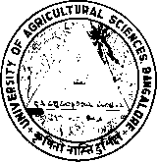
UNIVERSITY OF AGRICULTURAL SCIENCES, BANGALORE

DEPARTMENT OF AGRICULTURAL EXTENSION

COLLEGE OF AGRICULTURE, GKVK, BENGALURU-560065

Name: ABHINEETH R HARTHIKOTE. Date: 21-01-23
ID.No: PAMB 1141 Time: 9:30 AM
Class: Sr. M.Sc. Venue: Dwarakinath Hall

Seminar I

on
New generation delivery system for scaling up agro-techniques

Synopsis
Indian agricultural extension system has acted as a pivot for realizing the growth potential of farm sector against widening demand-supply pressures, and for ensuring sustainable, inclusive, and pro-poor agricultural and economic development. Indian public sector extension system, however has been constantly scrutinized in the recent time because of the challenge of enhancing relevance, efficiency, and effectiveness of the public sector agricultural extension in meeting its organizational goals and objectives remains unresolved. For scaling up wide range of objectives and target groups, the Indian states have to employ a wider options of approaches. Community based methods specifically holds immense potential for the natural resources management and involvement in managing common property resources as well as value chains. Hence, to derive advantages to the fullest extent in moving to pluralistic extension systems, comparative advantages and specific functions of different actors have to be well comprehended and utilized. With this background the present seminar is conceptualized with the following objectives:
- To understand the concept of scaling up.
- To get the insights of new generation delivery system for scaling up of agro techniques
- To review the existing literature
Concept of Scaling up
WHO defined scaling up as a deliberate efforts to increase the impact of innovations, successfully tested in pilot or experimental projects so as to benefit more people and to foster policy and programme development on a long lasting basis. It aims to directly impact the socio-economic impact of the technology to smallholder farmers and increase in scale of coverage of that technology. For up scaling foremost priority should be given to strengthening of innovation, for which knowledge should be generated, disseminated and adopted at full scale. Low sustainability of technologies could be a major hindrance in upscaling the technologies because they have limited scale as well as low impact of adoption.
Strategies for scaling up
Identification of potential area, establishment of forward and backward linkages, development of model plan, provide location specific information, provide information of complete package of practice, training and message through mobile phones, blending of traditional and latest methods of communication and Encourage progressive farmers to help extension agents

New generation delivery system for technology upscaling:
- Use of expert system- A computer program designed to model the problem solving ability of a human expert.
- Mobile applications- It is a software on a mobile phone handset or tablet computer that enables a user to access specific information.
- Agri startups- Agriculture sector is witnessing a number of startups in India, including everything from organic farming and equipment rentals to connected supply chains and cloud based analytics. Total number of Agri startups in India is 1822 on 2022-23.
- Farmer’s producer’s organization- There is a need to mobilize the farmers for the formation of farmers group such as organic crop growers association and conservation agriculture association for the benefit of the farming community.
- Linking farmers with toll free numbers- Many institutions have developed their toll free number for the use by the farmers.
- Use of Social media- Many institutions and departments are having their own social media pages.
Review of the research studies

Srikanth (2016) revealed that, more than half of the respondents gained knowledge in horticulture (52.08%) followed by animal husbandry (51.76%) and agriculture (44.08%). More than three-fifth of the respondents gained knowledge about fruit borer management in tomato (64.4%) in horticulture and information on foot and mouth disease (64.4%) in animal husbandry and more than half of the respondents gained knowledge about use of bio-pesticides and bio-fertilizers (53.3%) in agriculture.

Marradi et al., (2019) revealed that more than one-third (36.98%) of the facilitator had medium perception of e-SAP dissemination tool, whereas nearly equal percentage of farmers shared and identified in low and high category (30.47% and 32.55%). The statement-wise perception analysis is skewed towards higher side for both field facilitator and farmers.

Sidharth and Syed (2021) observed that more than three-fifth of the members of FPO had medium level of knowledge development (65.65%), economic development (67.34%) and social development (64.89%) and slightly more than three-fourth (76.34%) of the members had medium level of technical development.

Conclusion

As a subject Agricultural extension has evolved and transformed a lot, from public to pluralistic, from top-down to bottom up-up and from being a transfer of technology to a broad based and demand driven subject. In order to derive maximum benefits from tools and techniques of modern agricultural extension, it is mandatory to identify the role of different actors along the commodity value chain for comprehending and utilization.

References

MARADDI, G. S., PRABHURAJ, A. AND HIREMATH, G. M., 2019, Analysis of stakeholders towards e-SAP-An ICT tool for pest management-An empirical study, Int. J. Curr. Microbial. App. Sci., 8(4): 1489-1497.

SRIKANTH CHOWADRY, L.V., 2016, Impact of Kisan Call Centre (KCC) services in Kolar District, M. Sc. (Agri.) Thesis (Unpub.), Univ. Agric. Sci., Bangalore.

SIDHARTH, D. AND SYED, H. M., 2021, A study on the Impact of Farmers Producer Organizations on its member respondents in Puri district of Odisha, Int. J. Adv. Agric. Sci. Technol. 8(1): 52-65.

